**Page -** [**https://frobity.com/intellectual-property-law**](https://frobity.com/intellectual-property-law)

**Need to create “intellectual property law” section in below and add link on it –**

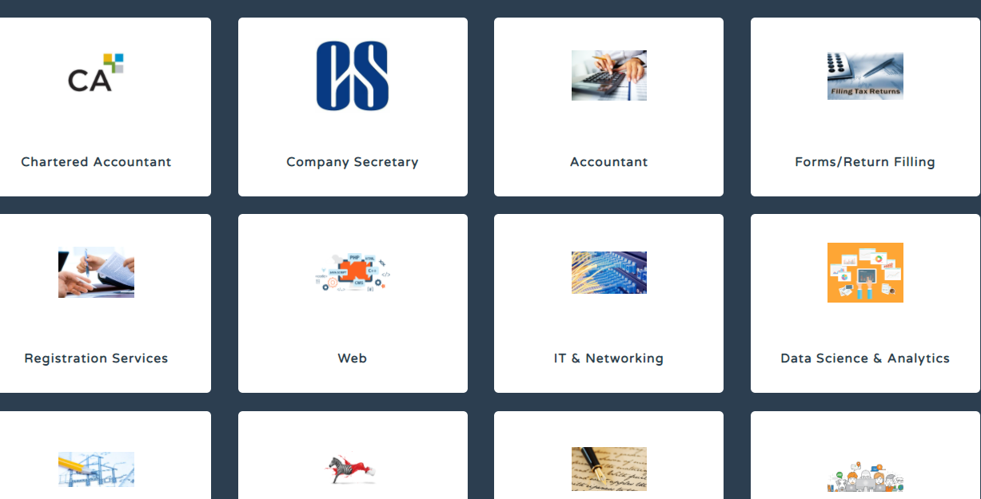

**<h2> To Hire Freelancers with Experience in Intellectual Property Law, Come To Frobity </h2>**

As innovations become a part of our lives, the risks of trespassing and infringing on discoveries are becoming a rising threat. As an owner of an innovation, you have used your creativity and resources to devise a new and fresh product, but with the risk of others infringing on it, you need to seek protection.

For the business world, the protection comes in the form of **intellectual property law**. Most countries have their specific laws, and India has a detailed law drawn out to protect the intellectual property of businesses and their owners.

The domain of **intellectual property law** is quite complex involving multiple steps, detailed paperwork, and more. It is not a thing that business entities should do on their own. Firstly, you have no experience, and secondly, you could be making major blunders and errors that would make the process delayed. Often, such errors can cost you exclusive rights to your creative ideas and innovations.

Use [www.frobity.com](http://www.frobity.com) to search for **intellectual property law specialists**.

Are you looking to hire professionals to help you with intellectual property? Then, you have arrived at the right place. We have an extensive list of professional experts in this domain who can assist you with the entire process, ensuring that you get protected at the earliest.

Frobity.com is one of India’s trusted and advanced freelancing websites known for its superior quality of professional freelancers. We are known for exclusive freelancing expertise in 16 domains. Our freelancers are qualified, trained, working professionals who are keen to take up independent projects because they want to work autonomously. It gives them the freedom to work at will and optimize their performance while ensuring a quality work-life.

**Frobity offers top experts on a freelancing basis in 16 niches**

* Experts with specialization in **intellectual property law.**
* Proficient freelance chartered accountants and company secretary
* Trained and experienced accountants and IT Return filing professionals
* Freelance registration services
* Freelance web design and development services
* Freelance IT & Networking specialists
* Data Science & Analytics freelancers
* Freelance architecture and designing services
* Freelance writers
* Professional translators keen to work as freelancers
* Freelance legal and admin support experts
* Freelance Sales and marketing experts and customer service representatives.

Our freelancing community is healthily growing, and all of us are marching forward with renewed enthusiasm. Hiring freelancers from [www.frobity.com](http://www.frobity.com) guarantees superior work quality, delivered on time, and at the most competitive prices.