2015-05-26

Brainstorm smartvote-DQN

## 1) Comparative outlook on 2015 parties’ candidates

* Dropdown / tab: smartvote question
  + See Jan’s sketch, basically show for different smartvote questions the average position of each party. Interactivity to show the breakdown by gender, age, ...

## document2015-05-27-102720.png

## 

## 2) Evolution of candidates’ profiles

* At the most global level: animated smartmap of political parties (2007, 2011, 2015)
  + Q: Are there global changes? Are some parties’ candidates less left/right-wing than in the past.
  + Jan will know in July if it is possible/relevant?
  + Interactivity to allow to zoom in on party and see the underlying candidates?
* Have for different topics the evolution of parties’ opinions on particular topic/smartvote question (as with the example under)

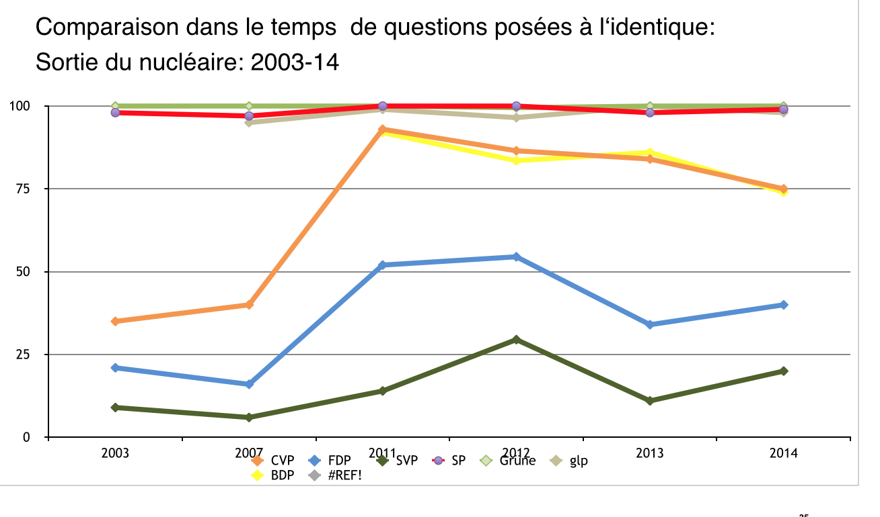

**3) Cantonal variations of candidates’ profiles**

* smartmap by political party (excluding small cantons)
  + Q: Are french socialists more left wing than the german-speaking? …
  + Interactivity to drill down
* cantonal choropleth with dropdown menus: topic/question and then party (see smartvote example under)

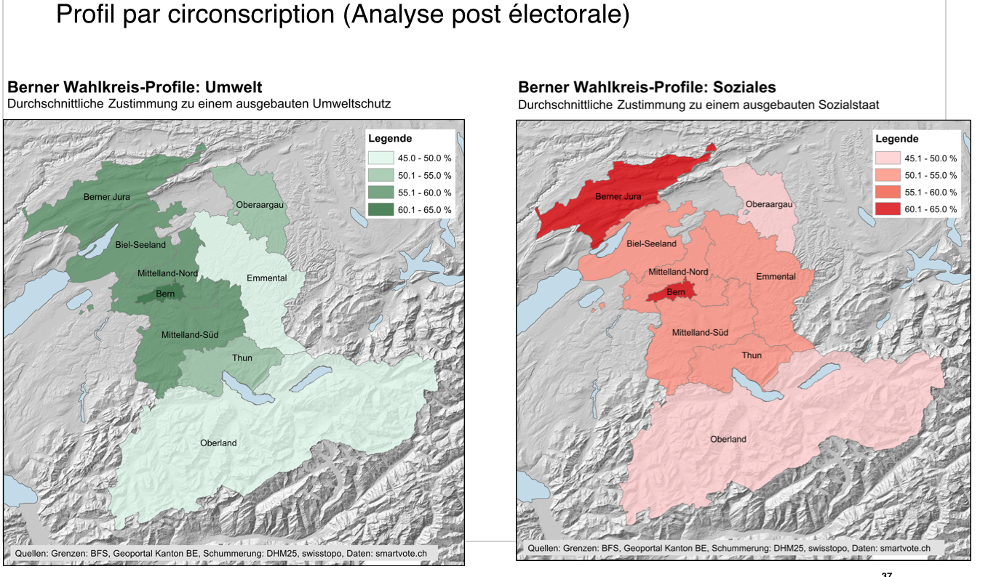

## 4) Candidates’ residence

* Investigate the relationship between candidates’ municipality of residence and the muncipality’s salary distribution (GINI index), unemployment, … by party and/or regions.