Social Media proposals

2015: la vague migratoire atteint l’Europe

TPT 18.2015 data story

# General

I would suggest for this 2015 retrospective data story to have a one tweet every 1 or 2 days from the publication date until the end of the year (so about 6 - 10 tweets). For Facebook, maybe less posts: 3-6

# Hashtags & mentions (for twitter)

Think to add the appropriate hashtags for this story on twitter.

* Have at least one of these hashtags to tag it as a story about migrants/refugees: #refugees, #migrant, #migrantcrisis, #asylum
* Have at least one of these hashtags to tag it as data/graphics-driven story: #ddj, #dataviz
* Furthermore on the 18th of December, it is the International migrants day. So you could also add this hashtag: #InternationalMigrantsDay

It would be a good idea to notify some the data providers used for this story, we can do it by adding their twitter handle in the tweet. Maybe do this only once, we don’t want to spam people.

* @EU_eurostat (the main data provider used in this story)
* @refugees (UNCHR twitter)

## Tweet/FB post suggestions

General one

2015 the year of the #migrationcrisis, check out our retrospective in graphics. #ddj #dataviz

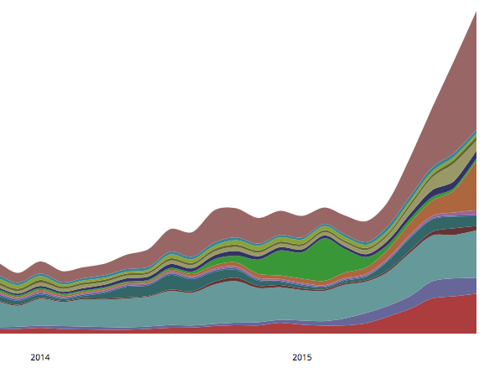

Ones to be used with a picture

This is how the influx of monthly #asylum seekers in 2015 in Europe looks like.

A spike of 170,000+ #asylum applications in Sept 2015 in Europe. The breakdown by country of origin:

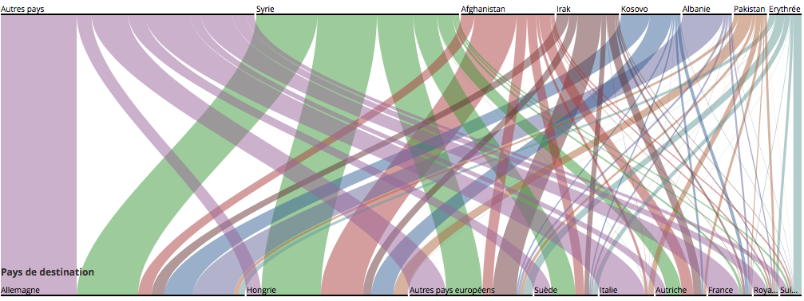Or as a gif: http://g.recordit.co/5IT2bBrN7S.gif

About 1 million #asylum applications in Europe in 2015, here are their origins and destinations

Switzerland received 3% of all #asylum applications in Europe in 2015, but only 1% of Syrian applications.

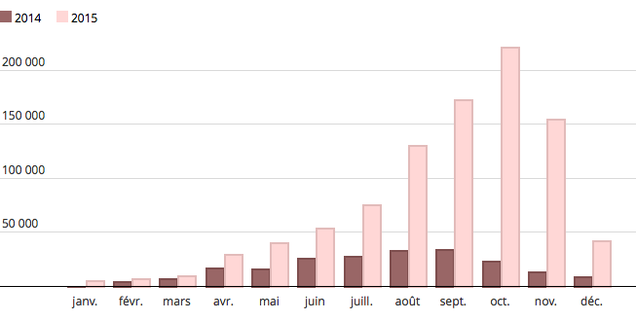

900,000+ #migrants crossed the Mediterranean sea in 2015. On average, 10 per day died. #migrantcrisis

900,000+ #migrants crossed the Mediterranean sea in 2015, 4 times more than in 2014.

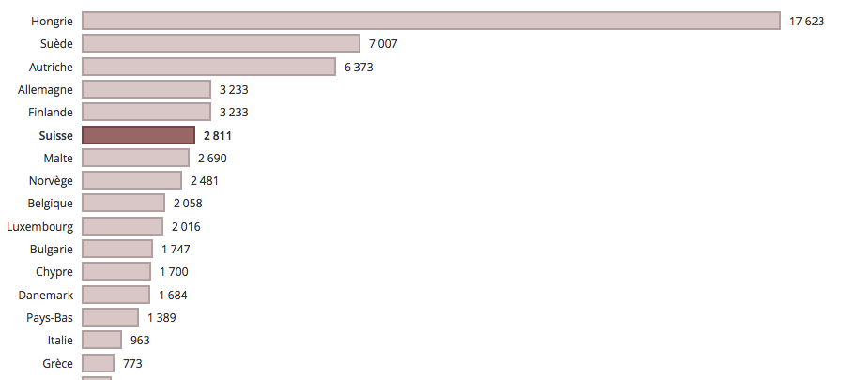

Or as a gif: http://recordit.co/VkytezzcsY

If Germany received the most #asylum applications in 2015 in Europe, Hungary got far more applications by capita.

Switzerland is the 6th European country in #asylum applications by capita in 2015. It was 4th in 2014.

How do European countries compare with the number of #asylum applications received in 2015? Check this in our interactive graphic.