### Hashtags to use

**#refugees**

**#migrant**

**#dataviz**

**#ddj**

And on the 18th of December, it is the International migrants day. So we could also use this hashtag:

**#InternationalMigrantsDay**

### General tweets

* 2015 the year of the #migrationcrisis, check out our retrospective in graphics

### 

* **This is how the influx of monthly #asylum seekers in 2015 in Europe looks like.**
* **A spike of 170,000+ #asylum applications in Sept 2015 in Europe. The breakdown by country of origin.**

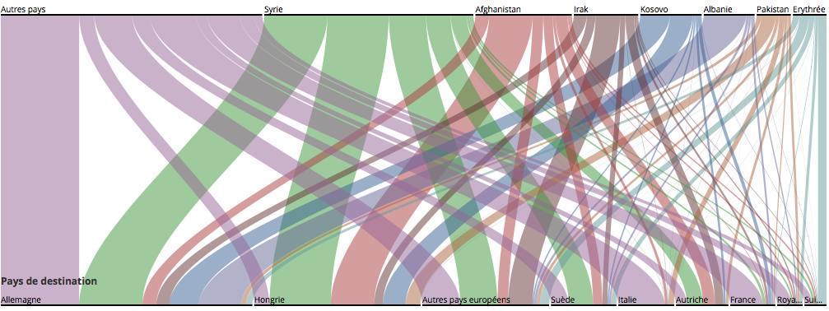

Or as a gif: <http://g.recordit.co/5IT2bBrN7S.gif>

* **About 1 million #asylum applications in Europe in 2015, here are their origins and destinations**
* **Switzerland received 3% of all #asylum applications in Europe in 2015, but only 1% of Syrian applications.**

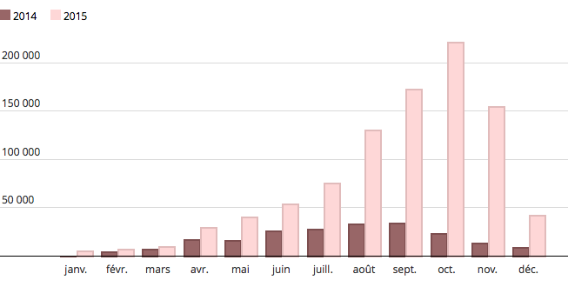

* **900,000+ #migrants crossed the Mediterranean sea in 2015. On average, about 10 per day died** **#migrantcrisis**
* **900,000+ #migrants crossed the Mediterranean sea in 2015, 4 times more than in 2014.**

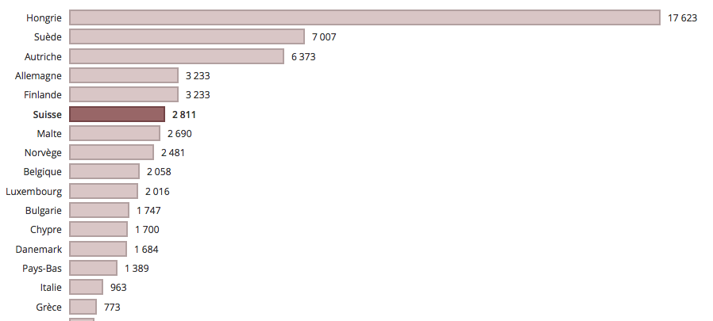

Or as a gif: <http://recordit.co/VkytezzcsY>

* **If Germany received the most #asylum applications in 2015 in Europe, Hungary got far more applications by capita.**
* **Switzerland is the 6th European country in #asylum applications by capita in 2015. It was 4th in 2014.**