
KRG TECHNOLOGIES INDIA PVT. LTD. INTERNSHIP

A SUMMER INTERNSHIP REPORT

by

Shirish D S
715523104047
in partial fulfillment for the award of the degree
of

BACHELOR OF ENGINEERING
IN
COMPUTER SCIENCE

PSG INSTITUTE OF TECHNOLOGY AND APPLIED RESEARCH
(An Autonomous institution)

JULY 2026

PSG INSTITUTE OF TECHNOLOGY AND APPLIED RESEARCH
(An Autonomous Institution)

BONAFIDE CERTIFICATE

Certified that this Internship Report on "KRG Technologies India Pvt. Ltd" is the bonafide work of Mr. Shirish D S, who belongs to IV Year, Computer Science, submitted during the seventh Semester of the Academic Year 2026–2027.

FACULTY IN-CHARGE HEAD OF THE DEPARTMENT

Certified that the candidate was examined by us for CS3511 – Summer Internship Viva held on __________________________ at PSG Institute of Technology and Applied Research, Neelambur, Coimbatore – 641 062.

INTERNAL EXAMINER EXTERNAL EXAMINER

ACKNOWLEDGEMENT

I would like to express my deepest gratitude to our beloved Principal, Dr. N. Saravanakumar, B.E. (Hons), M.Tech., Ph.D., for his overwhelming support and encouragement throughout this project.

I extend my sincere thanks to Mr. Rajagopalan Kumar, Head – HR Strategy & workforce governance, KRG Technologies India Pvt. Ltd., Chennai, India, for providing us with the opportunity and support that were instrumental in the successful completion of this project.

I also express my heartfelt gratitude to my industry mentor, Miss. Hemalatha Rajagopalan, KRG Technologies India Pvt. Ltd., Chennai, India, for her technical guidance, valuable suggestions, and constant supervision, without which this project could not have been completed successfully.

I am greatly indebted to Dr. B. Gomathy, M.E., Ph.D., Head of the Department, Computer Science and Engineering, for her continuous guidance, encouragement, and unwavering support throughout the course of this project.

I also express my sincere gratitude to Dr. Sathya Balaji, M.E., Ph.D., Faculty In-charge, Department of Computer Science and Engineering, for her valuable guidance, encouragement, and continuous support, which greatly contributed to the successful completion of this project.

Shirish D S

Offer Letter:

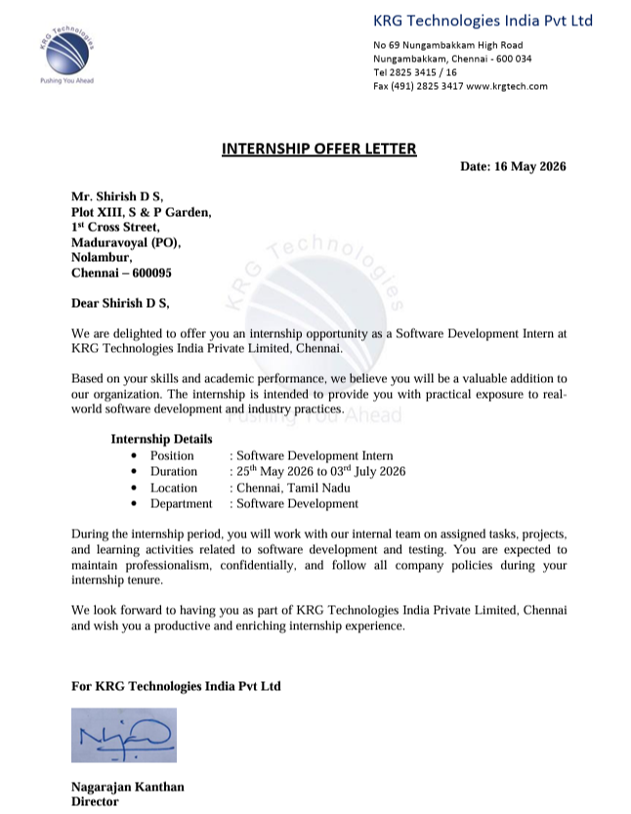

Internship Certificate:

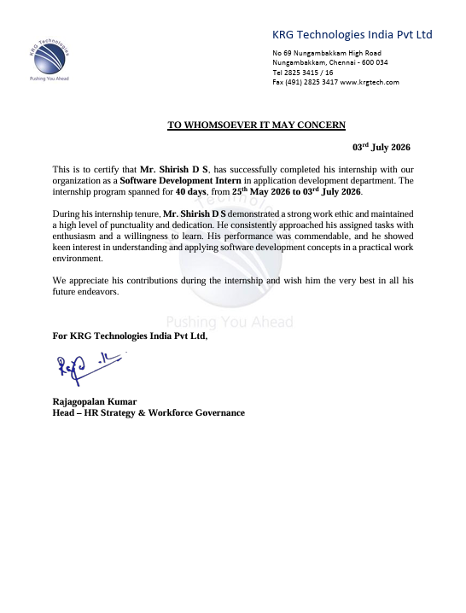

ABSTRACT
Internal IT support is one of the most common operational needs across technology and services companies: employees regularly encounter issues such as network connectivity failures, hardware faults, or software access requests, and organisations need a structured, auditable way to log, route, and resolve these issues rather than relying on ad-hoc phone calls or messages. This internship project, undertaken at KRG Technologies India Pvt. Ltd., focused on the design and implementation of an IT Help Desk Ticket Management System – a full-stack web application that lets employees raise support tickets, lets administrators triage and assign those tickets to support engineers, and lets engineers track and resolve them, with every action recorded in an auditable history.
The system is built around three role-based user types – Employee, Admin, and Engineer – each with a distinct set of permissions enforced at the API level. Employees can log in, raise tickets with a problem description and priority, track the status of their own tickets, and close them once resolved. Administrators have visibility over every ticket in the system, can assign an engineer to a ticket, change its priority, manage the employee and engineer directory, and view an aggregated reporting dashboard. Engineers can view only the tickets assigned to them, add progress notes, and update ticket status within the permissions appropriate to their role. Every significant action – ticket creation, assignment, priority change, and status transition – automatically generates a system log entry attached to the ticket, producing a complete audit trail without any manual effort from the user.
The backend was implemented in Python using Flask, with Flask-SQLAlchemy as the ORM layer modelling four related entities – Employee, Engineer, Ticket, and TicketNote – and Werkzeug's security utilities for password hashing. Authentication is session-based, and Flask-CORS is used to keep the API accessible to a decoupled frontend. The application supports both MySQL (for production-style deployment) and a zero-configuration SQLite fallback for local development, selected automatically based on environment configuration. The frontend was implemented using HTML, CSS, and JavaScript, consuming the REST API as JSON.
Through this project, practical exposure was gained in REST API design, relational database modelling with foreign keys and cascading relationships, session-based authentication, role-based access control, SQL aggregation queries for reporting, and full-stack integration between a Flask backend and a JavaScript frontend. The resulting prototype demonstrates the core workflow used by real IT service-desk products at companies such as Infosys, TCS, Cognizant, Accenture, Wipro, and Capgemini, scoped appropriately for an internship-level deliverable.

TABLE OF CONTENTS
Offer Letter iii
Internship Certificate: iv
ABSTRACT v
TABLE OF CONTENTS vi
LIST OF FIGURES x
LIST OF ABBREVIATIONS xi
COMPANY & INTERNSHIP DETAILS xii
CHAPTER 1 1
1.1 Acceptance Criteria 1
1.2 Technologies Used 2
1.3 Domains Covered 3
CHAPTER 2 4
2.1 Features Implemented 4
Employee Module 4
Admin Module 4
Engineer Module 4
2.2 Database Design 5
2.3 Ticket Status Lifecycle 6
2.4 Pre-Requisites 7
2.5 Implementation Steps 7
Step 1: Design the Database Schema 7
Step 2: Implement Secure Authentication 8
Step 3: Build the Role-Aware /api/auth Endpoints 8
Step 4: Implement Ticket Creation 8
Step 5: Implement Role-Scoped Ticket Retrieval 8
Step 6: Implement Assignment and Priority Management 8
Step 7: Implement the Status Transition Rules 9
Step 8: Implement the Notes / Audit Trail 9
Step 9: Build the Admin Reporting Aggregation 9
Step 10: Seed Realistic Demo Data 9
Advantages of the Approach 9
CHAPTER 3 11
3.1 Testing Overview 11
3.2 Frontend Output 12
3.3 Sample Seeded Dataset 17
3.4 Discussion 18
CHAPTER 4 19
4.1 Project Learning Outcomes 19
4.2 Internship Learning Outcomes 19
4.3 Skills Acquired 20
4.4 Best Learning from this Internship 20
CHAPTER 5 21
5.1 Conclusion 21
5.2 Feedback 21
5.3 Declaration & Signature 22
REFERENCES 23

LIST OF FIGURES
Figure No. | Title | Page No.
Fig. 2.1 | System Architecture of the Help Desk Application | 5
Fig. 2.2 | Entity-Relationship Diagram of the Database | 6
Fig. 2.3 | Ticket Status Lifecycle State Diagram | 7
Fig. 3.1 | Login Page | 10
Fig. 3.2 | Employee Dashboard – Raise and Track Tickets | 10
Fig. 3.3 | Admin Dashboard – Assign Engineer and Manage Priority | 11
Fig. 3.4 | Admin Reports – Ticket Analytics Dashboard | 11
Fig. 3.5 | Engineer Dashboard – Assigned Tickets and Notes | 12

LIST OF ABBREVIATIONS
Abbreviation | Expansion
API | Application Programming Interface
REST | Representational State Transfer
ORM | Object-Relational Mapping
CRUD | Create, Read, Update, Delete
RBAC | Role-Based Access Control
CORS | Cross-Origin Resource Sharing
SQL | Structured Query Language
JSON | JavaScript Object Notation
HTML | HyperText Markup Language
CSS | Cascading Style Sheets
JS | JavaScript
PK / FK | Primary Key / Foreign Key
IDE | Integrated Development Environment
UI/UX | User Interface / User Experience

COMPANY & INTERNSHIP DETAILS
Field | Details
Company Name | KRG Technologies India Pvt. Ltd.
Industry Sector | Information Technology (IT)
Mode of Internship | Online / Remote
Company Address | No. 69, Nungambakkam High Road, Chennai – 600034, Tamil Nadu, India
Supervisor Name & Designation | Hemalatha Rajagopalan (Industry Mentor)
Supervisor Email / Phone | Support@krgtech.com / +91 044-2825-3415
Project Title | IT Help Desk Ticket Management System
Internship Start Date | 25 May 2026
Internship End Date | 03 July 2026
Total Working Days | 40 working days (approx. 6 weeks, online mode)
Stipend (if any) | None

CHAPTER 1
INTRODUCTION
Internal IT support tickets are one of the most common software systems built and maintained by IT services companies. Organisations such as Infosys, TCS, Cognizant, Accenture, Wipro, and Capgemini – as well as smaller technology companies such as KRG Technologies – rely on some form of internal help desk portal so that employees can report issues (a laptop that will not connect to Wi-Fi, a printer jam, a software licence request) in a structured, trackable way instead of informally calling around the office. Every ticket needs to be logged, prioritised, routed to the right support engineer, and tracked through to resolution, with a record of what was done and by whom.
The objective of this internship project was to design and build a working IT Help Desk Ticket Management System covering this entire workflow: an employee can log in and raise a ticket describing a problem and its priority; an administrator can view all incoming tickets and assign the appropriate support engineer; the engineer can update progress and mark the ticket resolved; and the employee can confirm the fix and close the ticket. Every step in this lifecycle is recorded automatically as a system log note attached to the ticket, so the full history of a ticket – who raised it, who it was assigned to, and what happened – is always available.
This chapter presents the acceptance criteria that guided the development of the system, the technologies adopted for the implementation, and the technical domains that the internship touched upon.

1.1 Acceptance Criteria
The following criteria were defined at the outset of the project to serve as measurable checkpoints for the successful completion of the system. Each criterion reflects a functional or non-functional requirement that the final deliverable was expected to satisfy:
- Authentication: Employees, administrators, and engineers must be able to log in with an email and password, with the system correctly distinguishing between the three roles and issuing a persistent session on successful login.
- Ticket Raising: An employee must be able to submit a new ticket with a problem title, a description, and a priority level (Low / Medium / High), which is recorded with an initial status of “Open”.
- Assignment Workflow: An administrator must be able to view every ticket in the system and assign an available support engineer to it, automatically transitioning its status to “Assigned”.
- Status Tracking: A ticket must move through a well-defined lifecycle – Open → Assigned → In Progress → Resolved → Closed – with each role permitted to make only the transitions appropriate to it (for example, only an employee or admin may mark a ticket “Closed”).
- Role-Based Access Control: Every API endpoint must enforce that a user can only view or modify data appropriate to their role – employees see only their own tickets, engineers see only tickets assigned to them, and only admins see and manage everything.
- Audit Trail: Every significant action on a ticket (creation, assignment, priority change, status change, and manually added notes) must produce a timestamped note visible to everyone with access to that ticket.
- Reporting Dashboard: An administrator must be able to view aggregated statistics – total tickets, tickets raised today, resolved/closed/pending counts, priority breakdown, department-wise ticket volume, a daily trend for the last seven days, and per-engineer workload.

1.2 Technologies Used
A combination of backend, database, and frontend web technologies was used to build the end-to-end application. Each technology was chosen for a specific purpose within the system, as summarised below:
Technology | Version / Type | Purpose in the Project
Python | 3.x | Primary backend programming language used to implement the Flask application.
Flask | Micro web framework | Used to define and serve the REST API endpoints for authentication, tickets, and admin/report operations.
Flask-SQLAlchemy | ORM extension | Used to model the Employee, Engineer, Ticket, and TicketNote database tables as Python classes and manage relationships between them.
Flask-CORS | Extension | Used to enable Cross-Origin Resource Sharing so the API can be safely called from a separately served frontend.
Werkzeug Security | Password hashing utility | Used to hash and verify user passwords (generate_password_hash / check_password_hash) instead of storing them in plain text.
MySQL / PyMySQL | Relational database | Used as the production database; connection string is built dynamically from environment variables.
SQLite | Embedded database | Used automatically as a zero-configuration fallback database for local development and testing.
HTML / CSS / JavaScript | HTML5, CSS3, ES6 | Used to build the frontend dashboards for each role and to consume the backend's JSON API via fetch calls.
Visual Studio Code | IDE | Used as the primary development environment for writing, running, and debugging the application.

1.3 Domains Covered
The internship provided exposure to several interconnected technical domains, each contributing a distinct piece to the overall solution:
- Backend Web Development: Designing and implementing a RESTful API using Flask, including route design, request validation, and structured JSON responses.
- Database Design: Modelling a normalised relational schema with primary keys, foreign keys, and cascading relationships across four related entities.
- Authentication & Security: Implementing session-based login, logout, and “current user” endpoints, and hashing passwords rather than storing them in plain text.
- Role-Based Access Control: Enforcing per-endpoint authorisation rules so that each of the three user roles can only perform actions appropriate to it.
- Data Analytics / Reporting: Writing SQL aggregation queries (counts, group-by, joins, date-range filters) to power an administrative reporting dashboard.
- Frontend Web Development: Building role-specific dashboards using HTML, CSS, and JavaScript that consume the backend API.

CHAPTER 2
PROJECT ARCHITECTURE, DESIGN & IMPLEMENTATION
This chapter describes the overall architecture of the IT Help Desk Ticket Management System, the database design behind it, the features implemented for each user role, and a detailed account of the implementation process.

2.1 Features Implemented
The system implements three role-based modules – Employee, Admin, and Engineer – all built on top of a common REST API and shared ticket data model.

Employee Module
- Log in and log out using a session-based authentication flow.
- Raise a new ticket with a problem title, description, and priority (defaulting to Medium if unspecified).
- View the status and full note history of their own tickets only.
- Reply to an engineer by adding a note to an open ticket.
- Close a ticket once it has been marked Resolved.

Admin Module
- View every ticket in the system, sorted by most recently created.
- Assign (or unassign) a support engineer to a ticket, which automatically updates its status.
- Change a ticket's priority level at any time.
- Manage the employee and engineer directory – add new accounts, and remove existing ones (with tickets automatically reassigned to “Open” if their engineer is removed).
- View a consolidated reporting dashboard covering ticket volume, status breakdown, department-wise distribution, a 7-day trend, and engineer workload.

Engineer Module
- View only the tickets currently assigned to them.
- Add progress notes visible to the employee and admin.
- Update a ticket's status within the permissions granted to the engineer role (for example, marking a ticket “In Progress” or “Resolved”, but not “Closed” unless it is already Resolved).
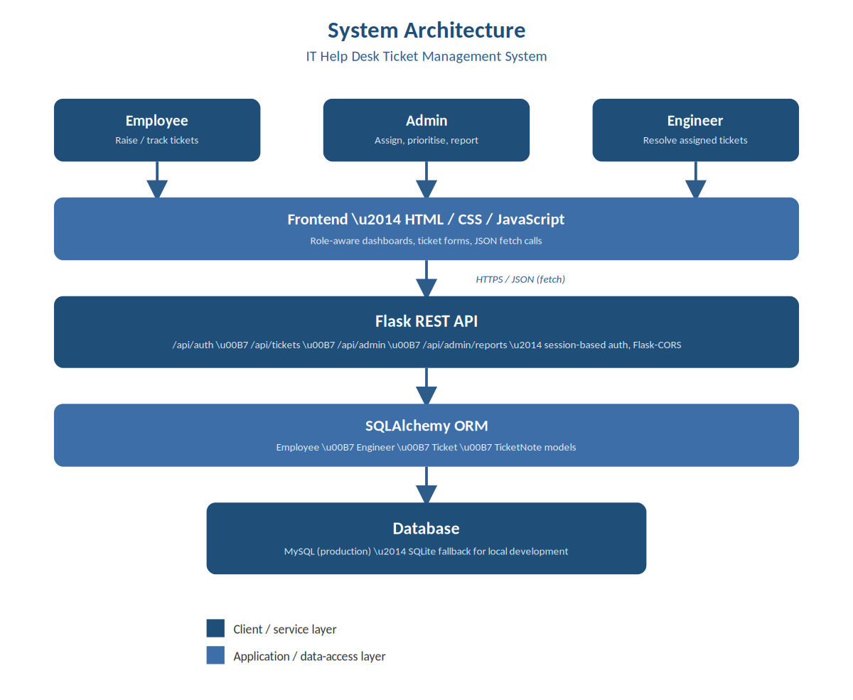
Fig. 2.1: System architecture: role-based clients → Flask REST API → SQLAlchemy ORM → database.
The frontend, built with HTML, CSS, and JavaScript, presents a different dashboard per role but talks to a single, shared Flask REST API over JSON. The API layer enforces authentication and role checks on every request, delegates data access to SQLAlchemy models, and those models are backed by either MySQL or SQLite depending on the deployment environment.

2.2 Database Design
The application's data model is built around four related tables. An Employee can raise many Tickets; an Engineer can be assigned many Tickets; and each Ticket can accumulate many TicketNote entries that together form its audit trail. Deleting an Employee cascades to delete their tickets (and each of those tickets' notes in turn), while removing an Engineer instead unassigns their tickets and returns them to the “Open” queue rather than deleting them, since a ticket's underlying problem is still unresolved.
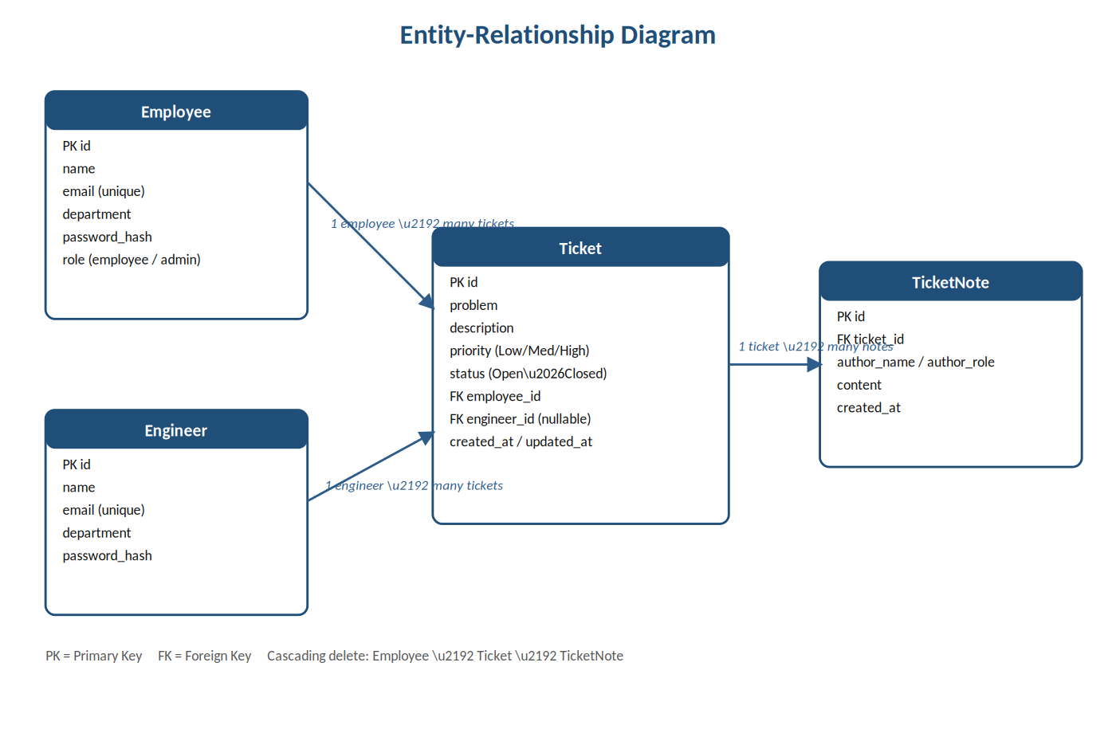
Fig. 2.2: Entity-Relationship Diagram showing the Employee, Engineer, Ticket, and TicketNote tables and their relationships.
Table | Key Fields | Notes
Employee | id (PK), name, email (unique), password_hash, department, role | role distinguishes an ordinary employee from an admin account.
Engineer | id (PK), name, email (unique), password_hash, department | Kept as a separate table from Employee since engineers authenticate and operate under a distinct permission set.
Ticket | id (PK), problem, description, priority, status, employee_id (FK), engineer_id (FK, nullable), created_at, updated_at | engineer_id is nullable since a newly raised ticket has no engineer until an admin assigns one.
TicketNote | id (PK), ticket_id (FK), author_name, author_role, content, created_at | Used both for human replies and automatically generated “System Log” entries, forming a single combined audit trail per ticket.

2.3 Ticket Status Lifecycle
A ticket moves through five statuses, and the backend enforces which role is permitted to make each transition rather than trusting the frontend alone:
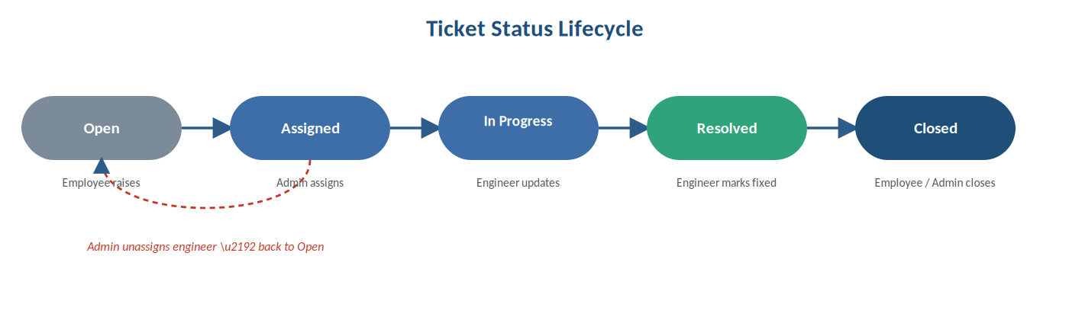
Fig. 2.3: The ticket status lifecycle, with the role responsible for each transition.
- Open: The default status when an employee raises a new ticket; no engineer is assigned yet.
- Assigned: Set automatically when an admin assigns an engineer to an Open ticket.
- In Progress: Set by the assigned engineer once they begin working on the issue.
- Resolved: Set by the assigned engineer once the fix has been applied.
- Closed: Set by the employee (or an admin) to confirm the issue is fully resolved – an engineer cannot close a ticket directly unless it is already Resolved, ensuring the employee gets the final say that their problem is actually fixed.
If an admin unassigns an engineer from a ticket, its status is reset to “Open” and a system note records the reason, so the ticket re-enters the assignment queue rather than being silently lost.

2.4 Pre-Requisites
- Installation of Python 3.x and configuration of a virtual environment for dependency isolation.
- Installation of Visual Studio Code for an integrated coding and debugging experience.
- Installation of Flask, Flask-SQLAlchemy, Flask-CORS, and PyMySQL via pip.
- A running MySQL server for production-style testing, or no additional setup at all when relying on the automatic SQLite fallback for local development.
- A modern web browser to exercise the HTML/CSS/JavaScript frontend.

2.5 Implementation Steps

Step 1: Design the Database Schema
Problem: The system needed to represent employees, engineers, tickets, and their conversation history in a way that supported fast, correctly-scoped queries per role. Approach: Four SQLAlchemy models were defined – Employee, Engineer, Ticket, and TicketNote – with foreign keys linking tickets to their raising employee and (optionally) an assigned engineer, and notes linked back to their parent ticket, using db.relationship() with cascading deletes configured where appropriate.

Step 2: Implement Secure Authentication
Problem: User passwords could not be stored or compared in plain text, and the system needed to remember who was logged in across requests. Approach: Each model stores only a password_hash, set and checked using Werkzeug's generate_password_hash and check_password_hash. On successful login, the user's id, role, and name are stored in Flask's server-side session, which is marked permanent so the login persists across requests without needing to re-authenticate on every call.

Step 3: Build the Role-Aware /api/auth Endpoints
Problem: The same login form needed to authenticate three different kinds of users against two different database tables. Approach: The login endpoint accepts an explicit role selection (employee / admin / engineer) alongside the credentials, queries the Employee table for employee/admin logins and the Engineer table for engineer logins, and rejects the attempt if the selected role does not match the account's actual role – for example, an ordinary employee cannot log in through the admin option.

Step 4: Implement Ticket Creation
Problem: Only employees should be able to raise new tickets, and every new ticket needed a consistent starting state. Approach: The POST /api/tickets endpoint checks that the current session belongs to an employee, validates that a problem title and description were provided, defaults the priority to Medium if omitted or invalid, and creates the ticket with status Open. A TicketNote is immediately generated recording who raised the ticket and at what priority, seeding the audit trail from the very first action.

Step 5: Implement Role-Scoped Ticket Retrieval
Problem: Each role should see a different slice of the ticket data – admins see everything, engineers see only their assignments, and employees see only their own tickets. Approach: The GET /api/tickets endpoint branches on the current user's role and applies a different SQLAlchemy filter for each case, so the same endpoint serves all three roles without exposing data outside their permission boundary. Individual ticket lookups repeat this check, returning a 403 Forbidden response if a user requests a ticket they should not be able to see.

Step 6: Implement Assignment and Priority Management
Problem: Administrators needed a controlled way to route tickets to engineers and to re-prioritise them as circumstances changed. Approach: The POST /api/tickets/<id>/assign endpoint is restricted to admins, sets the ticket's engineer_id, automatically advances an Open ticket to Assigned, and logs a system note; a matching un-assign path resets the ticket back to Open. A separate /priority endpoint, also admin-only, updates the priority field and logs the change.

Step 7: Implement the Status Transition Rules
Problem: Without server-side enforcement, any user could set any ticket to any status, breaking the intended workflow. Approach: The /status endpoint checks the requester's role against the ticket's ownership (employee_id or engineer_id) and applies explicit rules – employees may only transition a ticket they own to Closed, engineers may only update tickets assigned to them and cannot close a ticket that is not yet Resolved, and admins are unrestricted. Every successful transition writes a system note capturing the old status, the new status, and who made the change.

Step 8: Implement the Notes / Audit Trail
Problem: Both human replies and automated system events needed to appear together, in order, as a single readable history per ticket. Approach: A single TicketNote model is used for both purposes, distinguished by author_role (‘employee’, ‘engineer’, ‘admin’ for human notes) and system-generated log entries authored as “System Log”. Notes are always retrieved sorted by created_at ascending, so the ticket detail view reads as a chronological conversation.

Step 9: Build the Admin Reporting Aggregation
Problem: Administrators needed a quick, high-level view of help desk load and performance rather than having to read through individual tickets. Approach: The /api/admin/reports endpoint runs a series of SQLAlchemy aggregate queries – total and today's ticket counts, status and priority breakdowns, a department-wise count computed via a join between Employee and Ticket, a 7-day daily trend built by iterating over the last seven calendar days, and an active-ticket count per engineer – and returns them as a single structured JSON payload for the dashboard to render.

Step 10: Seed Realistic Demo Data
Problem: Testing role-based permissions and the reporting dashboard convincingly required a reasonably-sized, varied dataset rather than one or two manually created tickets. Approach: A dedicated seed.py script resets the database and populates it with four employees (including one admin), three engineers, and twelve tickets spanning every status, priority level, and originating department, each with a realistic note history – giving the reporting dashboard and permission tests meaningful data to work against.

Advantages of the Approach
- Centralised & Auditable: Every ticket action is logged automatically, producing a complete history without relying on anyone remembering to document what happened.
- Secure by Design: Passwords are always hashed, and every API endpoint independently re-checks the caller's role rather than trusting the frontend to hide unauthorised actions.
- Deployment-Flexible: The same codebase runs against MySQL in production or SQLite locally with zero configuration changes, purely based on environment variables.
- Extensible: The clear separation between models, API routes, and role-based checks makes it straightforward to add further roles, ticket fields, or reporting dimensions in future iterations.

CHAPTER 3
RESULTS AND ANALYSIS
This chapter presents the outcomes obtained after implementing and testing the IT Help Desk Ticket Management System. The system was evaluated using the seeded demo dataset of twelve tickets across four employees, three engineers, and every status/priority combination, to verify that the acceptance criteria defined in Chapter 1 were satisfied.

3.1 Testing Overview
Testing focused on three areas: correctness of the ticket lifecycle and its role-based transition rules, correctness of role-scoped data visibility (that a user genuinely cannot see or modify data outside their permission boundary), and correctness of the aggregated reporting queries against the seeded dataset.
Test Scenario | Expected Behaviour | Observed Result
Employee logs in and raises a ticket | Ticket created with status Open; a creation note is logged | As expected – ticket appeared with Open status and a System Log entry
Employee attempts to view another employee's ticket | 403 Forbidden returned | As expected – request rejected, confirming role-scoped access
Admin assigns an engineer to an Open ticket | Status changes to Assigned; assignment note logged | As expected – status and note both updated correctly
Engineer attempts to close a ticket that is not yet Resolved | 403 Forbidden – only employees/admins may close, and only once Resolved | As expected – request rejected with the correct error message
Employee closes a Resolved ticket | Status changes to Closed | As expected – transition succeeded and was logged
Admin removes an engineer with active tickets | Those tickets revert to Open with an explanatory note | As expected – tickets were unassigned and reset correctly
Admin requests the reports dashboard | Aggregated counts match the seeded dataset | As expected – totals, status counts, and department counts reconciled with the 12 seeded tickets

3.2 Frontend Output
Fig. 3.1 – Login Page

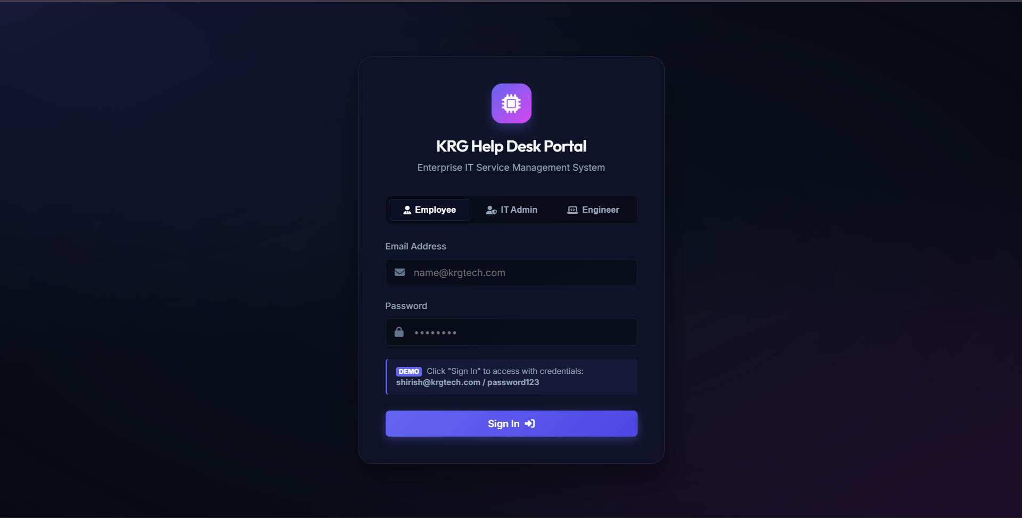
Fig. 3.1: The shared login page, where the user selects their role alongside their email and password.
Fig. 3.2 – Employee Dashboard – Raise and Track Tickets

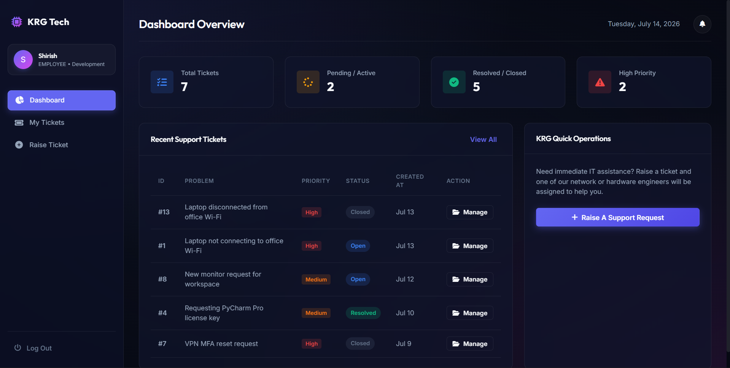
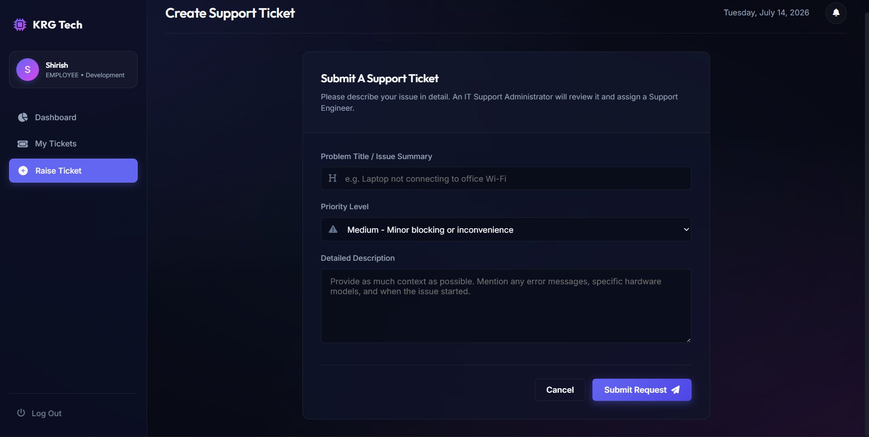

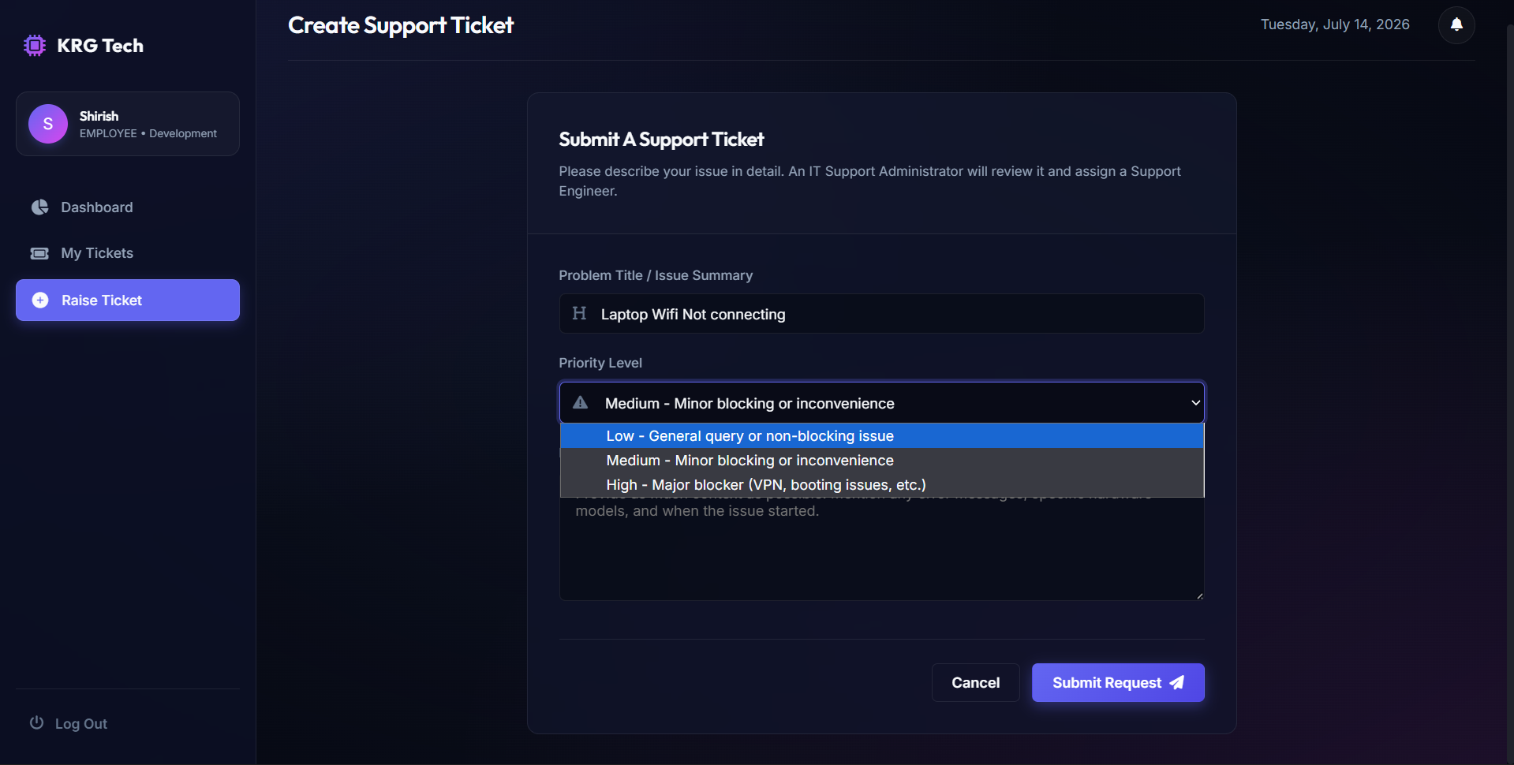

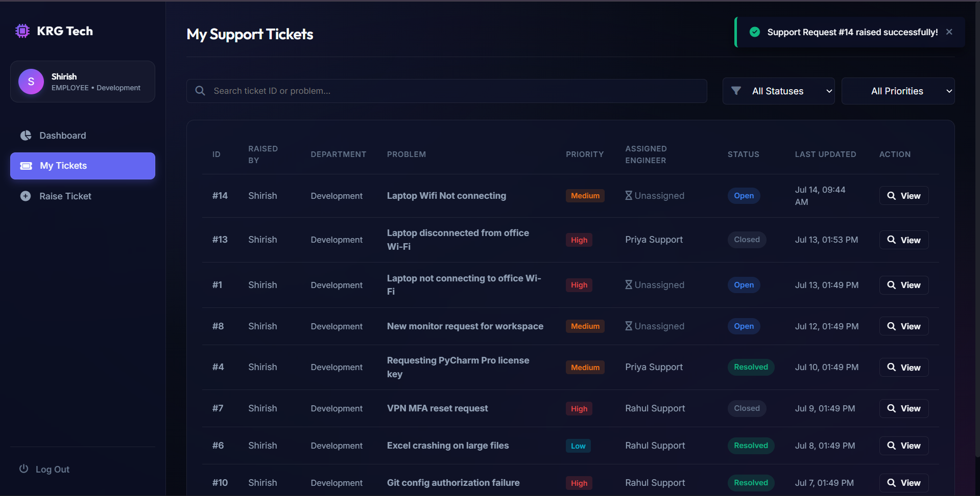
Fig. 3.2: The employee dashboard, showing the ticket-raising form and the status of previously raised tickets.
Fig. 3.3 – Admin Dashboard – Assign Engineer and Manage Priority

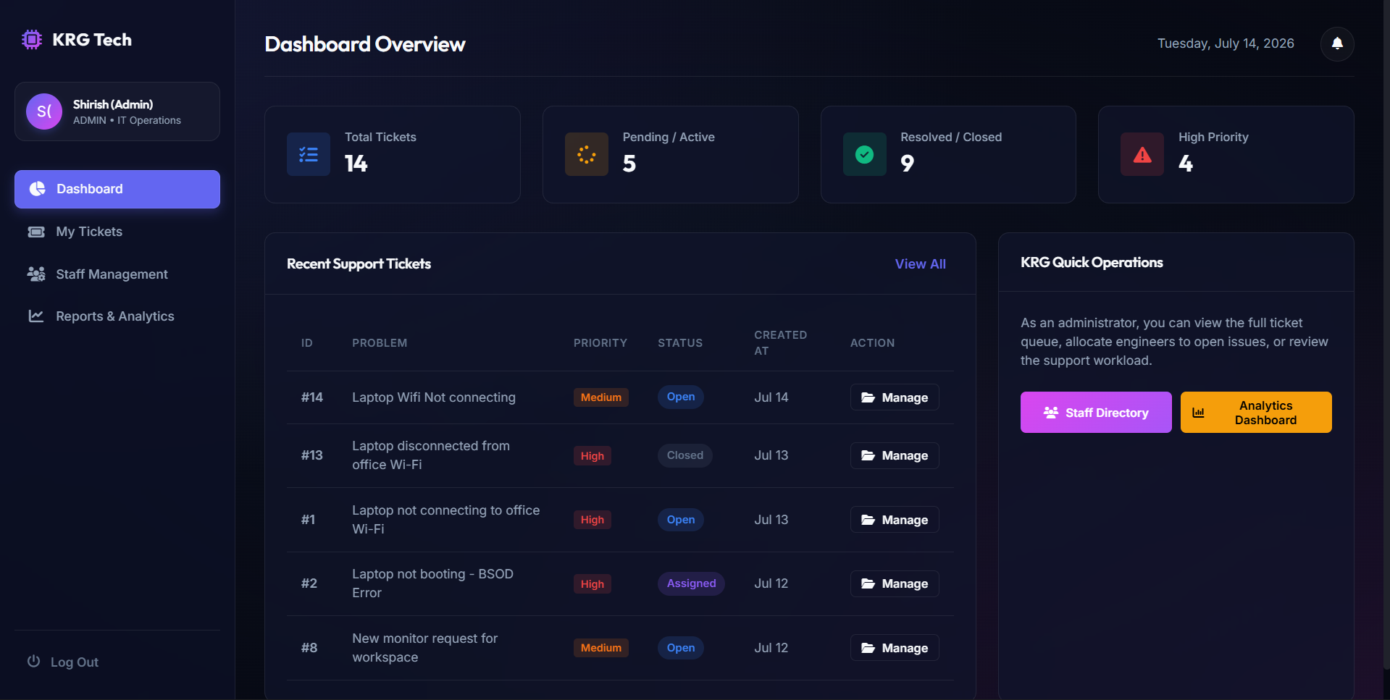

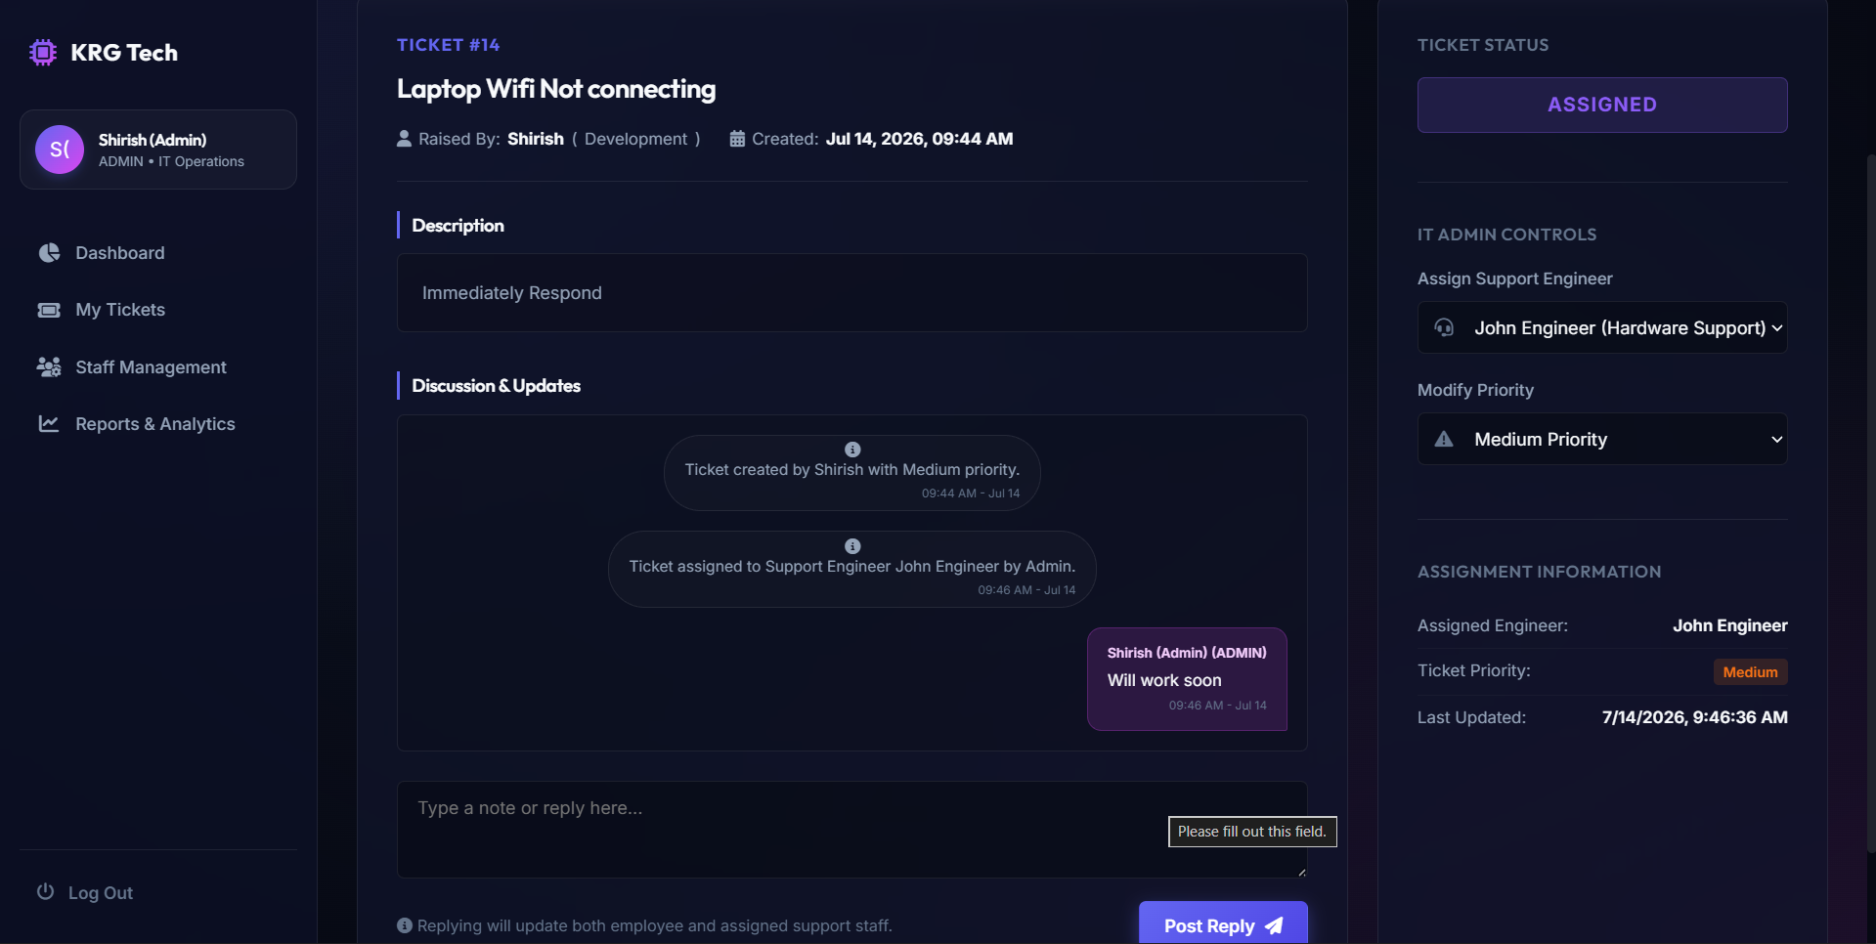
Fig. 3.3: The admin dashboard, listing every ticket with controls to assign an engineer or change priority.
Fig. 3.4 – Admin Reports – Ticket Analytics Dashboard

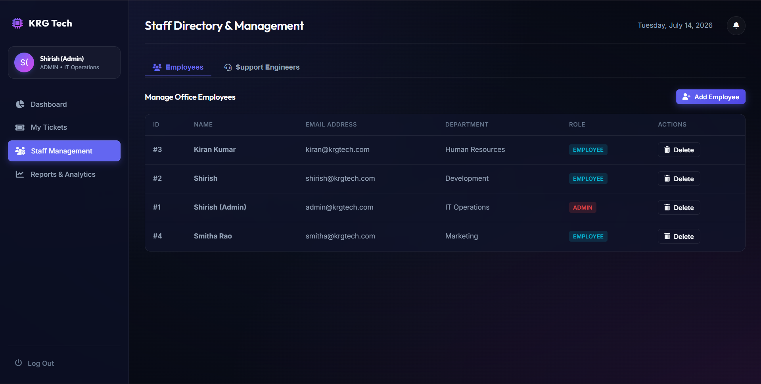

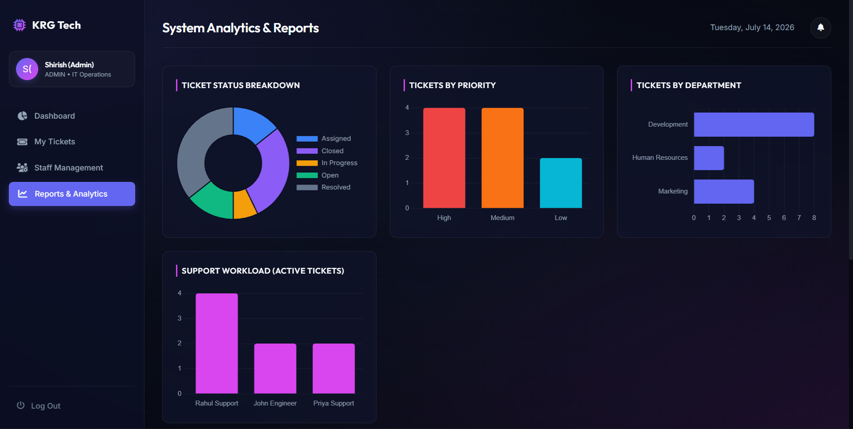
Fig. 3.4: The reporting dashboard, summarising ticket volume, status, department, and engineer workload.
Fig. 3.5 – Engineer Dashboard – Assigned Tickets and Notes

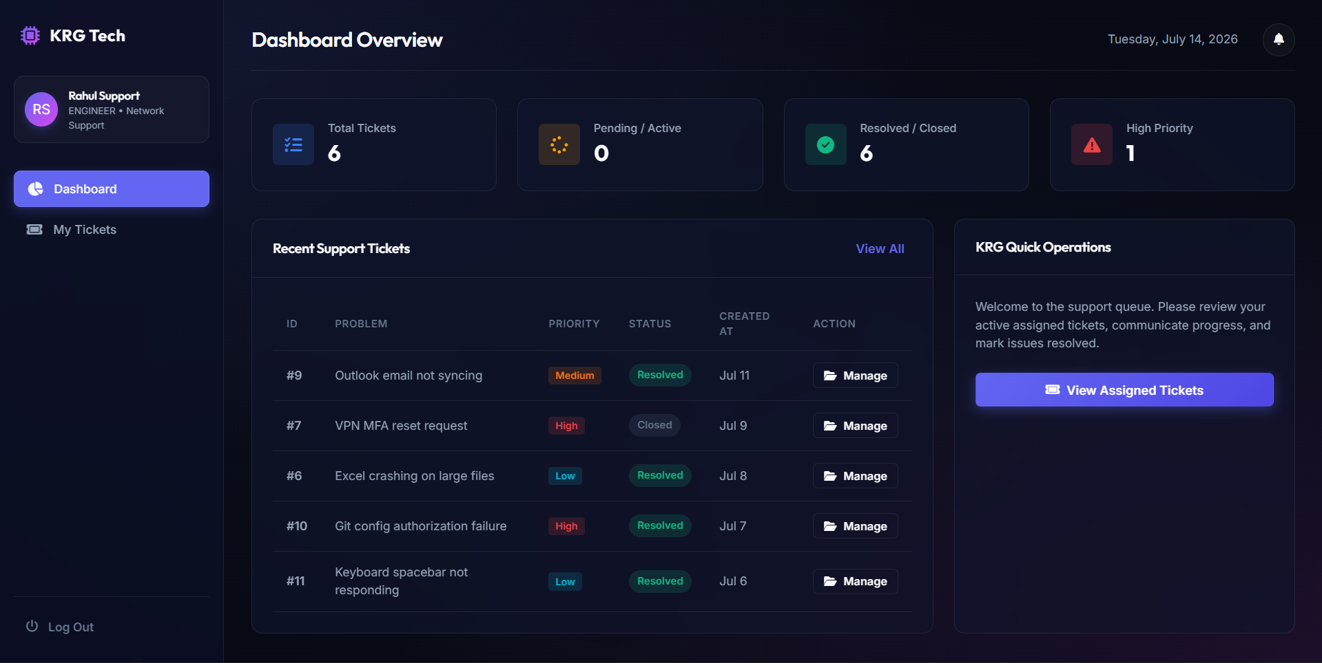
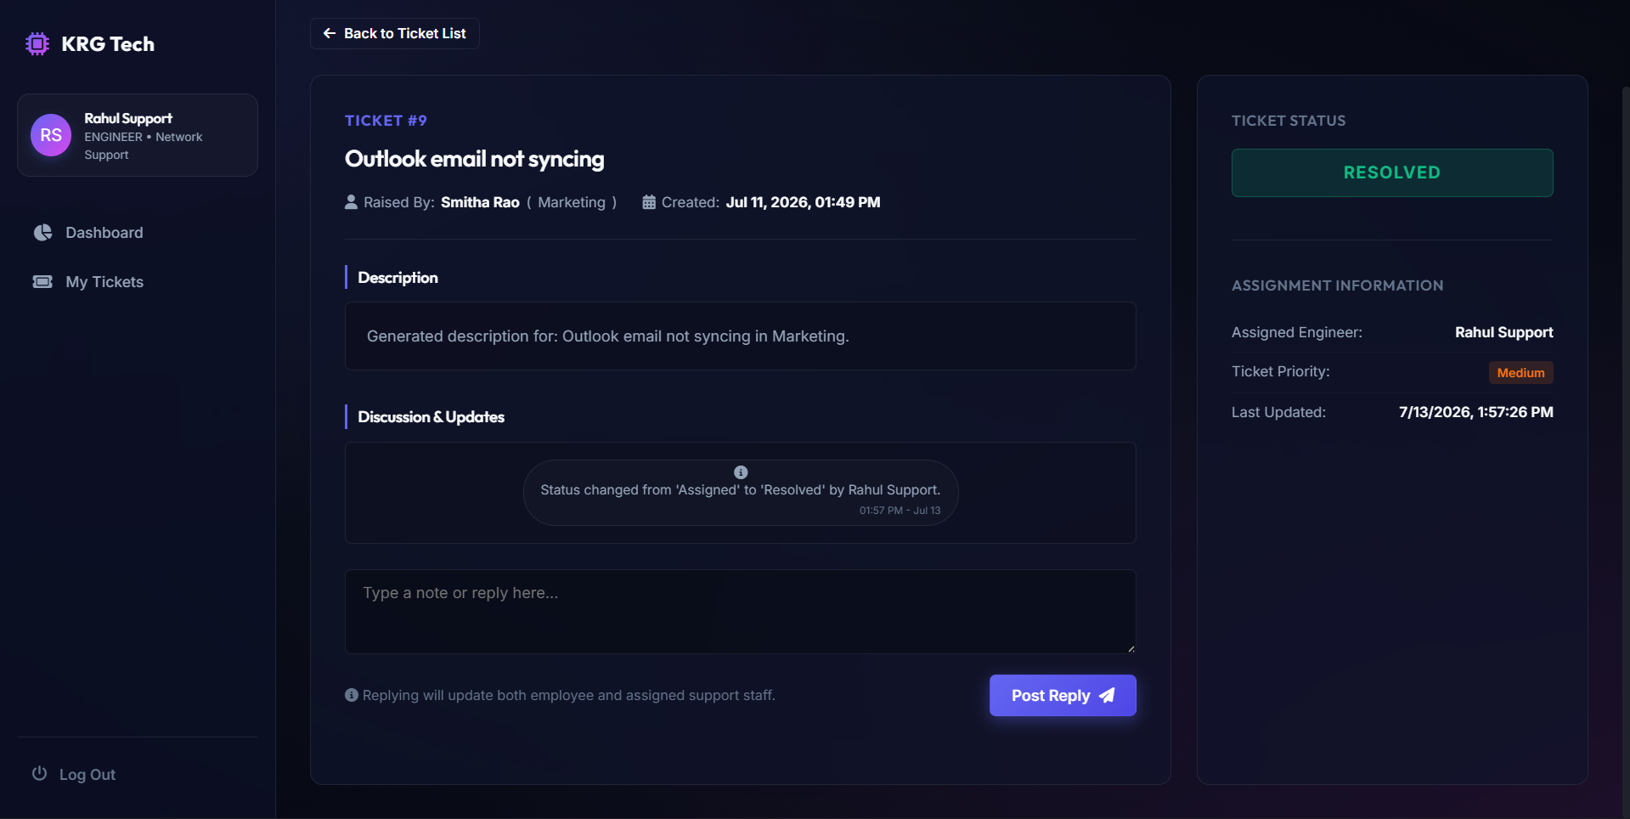
Fig. 3.5: The engineer dashboard, showing only tickets assigned to the logged-in engineer, with a note/status update panel.

3.3 Sample Seeded Dataset
For consistent testing and demonstration, the seed script populates the database with twelve tickets spanning every status and priority level, raised across five different departments (Development, Human Resources, Marketing, Finance) and assigned across three engineers, so the dashboard and reports are never tested against an empty or trivial dataset.
Status | Approx. Count in Seed Data | Example
Open | 2 | “Laptop not connecting to office Wi-Fi” (High priority)
Assigned | 2 | “Laptop not booting – BSOD Error” (High priority)
In Progress | 1 | “Printer paper jam on Floor 3” (Low priority)
Resolved | 3 | “Requesting PyCharm Pro licence key” (Medium priority)
Closed | 4 | “Slack desktop app crashing constantly” (Medium priority)

3.4 Discussion
The results confirm that all the acceptance criteria defined at the start of the project were met: authentication correctly distinguishes the three roles, the ticket lifecycle enforces its intended transition rules server-side rather than relying on the frontend, role-scoped data access prevents users from viewing or modifying tickets outside their permission boundary, every significant action produces an audit-trail note automatically, and the reporting endpoint returns aggregated statistics that reconcile correctly with the underlying data. The clearest lesson from testing was the importance of enforcing permission rules on the backend for every single endpoint independently – several early implementation attempts correctly hid actions in the frontend UI but still allowed them via a direct API call, which was only caught by deliberately testing the API directly rather than only clicking through the interface.

CHAPTER 4
LEARNING OUTCOMES

4.1 Project Learning Outcomes
Working on this project provided direct, hands-on exposure to a range of technical concepts that are central to full-stack, database-backed web applications:
- Gained practical experience designing a normalised relational schema with SQLAlchemy, including foreign keys, nullable relationships, and cascading deletes.
- Learned to implement session-based authentication and password hashing correctly, rather than storing or comparing credentials in plain text.
- Understood how to enforce role-based access control independently at every API endpoint, rather than assuming the frontend is a sufficient security boundary.
- Developed a working understanding of REST API design conventions – resource-oriented URLs, appropriate HTTP methods and status codes, and consistent JSON response shapes.
- Gained experience writing SQL aggregation queries (counts, group-by, joins, and date-range filtering) to power a reporting dashboard.
- Practised structuring a Flask application across separate config, models, seed, and route files for maintainability.

4.2 Internship Learning Outcomes
Beyond the technical aspects of the project, the internship as a whole contributed significantly to broader professional and personal development:
- Improved verbal and written communication skills through regular status updates and review discussions with the industry mentor.
- Gained a first-hand understanding of a structured software development lifecycle, from schema design through implementation, testing, and documentation.
- Enhanced debugging skills, particularly for diagnosing permission and authorisation bugs that only manifest when testing the API directly rather than through the UI.
- Improved time-management skills through working independently to defined milestones within a remote/online internship setting.
- Developed adaptability and self-direction, since an online internship required proactively seeking clarification and managing one's own schedule without in-person supervision.

4.3 Skills Acquired
Technical Skills | Soft Skills
Python & Flask (REST API development) | Communication
Flask-SQLAlchemy (ORM & relational modelling) | Teamwork
Session-based authentication & password hashing | Time Management
Role-based access control design | Problem Solving
SQL aggregation & reporting queries | Attention to Detail
HTML / CSS / JavaScript (frontend integration) | Workplace professionalism

4.4 Best Learning from this Internship
The single most valuable takeaway from this internship was the importance of enforcing security and business rules on the server, independently of the user interface. It is easy to build a frontend that only shows an employee their own tickets or only lets an engineer update the tickets assigned to them – but that alone is not security, since anyone can call the underlying API directly. Building this system reinforced the discipline of treating every API endpoint as a boundary that must independently verify who is calling it and what they are allowed to do, which is a foundational principle in any real-world backend system, not just a help desk application.

CHAPTER 5
CONCLUSION

5.1 Conclusion
The IT Help Desk Ticket Management System developed during this internship successfully achieved its primary objective of digitising the internal support workflow used across IT service organisations: an employee can raise a ticket, an administrator can triage and assign it, an engineer can resolve it, and the employee can confirm and close it, with every step recorded automatically. By enforcing role-based access control and status-transition rules at the API level rather than only in the frontend, the system reflects the kind of security discipline expected of production backend software, scoped appropriately for an internship-level deliverable.
Over the course of the internship, practical understanding was gained in relational database design, REST API development, authentication and authorisation, SQL-based reporting, and full-stack integration between a Flask backend and a JavaScript frontend. Working in an online/remote internship setting also strengthened independent problem-solving ability, communication with the industry mentor, and the discipline required to manage and document a technical project from schema design through to a working, demonstrable product. Overall, the internship met its intended learning objectives and produced a project directly comparable to systems used in production by IT services companies.

5.2 Feedback
The internship at KRG Technologies India Pvt. Ltd. was well organised, with clear milestones and regular opportunities for review and feedback from the industry mentor. Working through the full lifecycle of a database-backed web application – schema design, API implementation, permission enforcement, and reporting – gave a much more complete picture of backend engineering than any single classroom exercise could. The guidance received on both the technical implementation and the documentation of the work was constructive and helped in producing a more polished final outcome. Overall, the internship is considered to have been a valuable and rewarding learning experience.

5.3 Declaration & Signature
DECLARATION
I hereby declare that this internship report titled “IT Help Desk Ticket Management System” is a genuine record of the work carried out by me at KRG Technologies India Pvt. Ltd. under the guidance of my Industry Mentor, and that this report has not been submitted elsewhere, in part or in full, for the award of any degree or diploma.
Student Name & Roll Number:
1. SHIRISH D S — 715523104047
Place: Chennai
Date: ____________________
Signature: ________________________________________

REFERENCES
- Flask Documentation, https://flask.palletsprojects.com
- Flask-SQLAlchemy Documentation, https://flask-sqlalchemy.palletsprojects.com
- SQLAlchemy ORM Documentation, https://docs.sqlalchemy.org
- Werkzeug Security Utilities Documentation, https://werkzeug.palletsprojects.com/en/latest/utils/#module-werkzeug.security
- Flask-CORS Documentation, https://flask-cors.readthedocs.io
- MySQL 8.0 Reference Manual, https://dev.mysql.com/doc/refman/8.0/en/
- PyMySQL Documentation, https://pymysql.readthedocs.io
- Python Software Foundation, Python 3 Documentation, https://docs.python.org/3/
- MDN Web Docs, JavaScript Reference, https://developer.mozilla.org/en-US/docs/Web/JavaScript
- Fielding, R., “Architectural Styles and the Design of Network-based Software Architectures,” Doctoral dissertation, UC Irvine, 2000 (foundational definition of REST).

