**Website User Guide**

**For**

**“Reaching For English”**

Version 1.0

**Developed By:**

Daric Sage

Jared Regan

Jordan Lambert

Justin O’Neel

Table of Contents

Overview of the website: 3

What the site does: 3

How the site is set up: 3

*Descriptions of Database Data: 3

Country: 3

Grade: 3

Topic: 3

Country Grade: 3

Country Grade Topic: 4

Lesson: 4

*Example: 4

Login Page 5

How the Login Page is set up: 5

How to: 5

Add Page 6

How the Add Page is set up: 6

Descriptions: 6

Navigation Button: 7

Log/Message Box: 7

Main Add Area: 7

Lesson Display Area: 9

Delete/Edit Page 11

How the Delete/Edit Page is set up: 11

Descriptions: 11

Navigation Button: 11

Log/Message Box: 12

Main Delete/Edit Area: 12

Deleting: 14

Editing: 15

File Viewer Page 16

How the File View Page is set up 16

Descriptions: 16

Links Table 16

Survey Section 17

# Overview of the website:

## What the site does:

The website is the companion to the ‘Reaching For English’ mobile application. This site is the access point for the administrators to the app who make the lessons for the app to access. Here the countries, grades, topics, and lessons are added and configured based on the curriculum/created lessons. All mentioned sections can be added or deleted, and in some instances edited. This site is only for the administrators/creators of the curriculum in order to maintain and update the app for its users.

## How the site is set up:

When accessing the site, the user is brought to a login page. Given the correct credentials will provide access to the rest of the site. Beyond the login page is both the ‘add page’ and ‘delete/edit page’. Separated in to their distinct functionality, adding to the database and removing or editing the database, respectively. The two pages refer to one another to provide easy maneuverability. In addition to the mentioned pages, there is a ‘file viewer’ page. The purpose for this is to allow access to the files associated with each lesson, either an mp3 or a pdf file. These can be downloaded or viewed through the browser.

## *Descriptions of Database Data:

### Country:

* ‘**Country**’: this is a Country in the database such as ‘Nicaragua’. When data is desired to be added to a certain Country, that Country needs to be in the database (needs to be added prior to trying to add data to that Country). A Country only needs to be added to the database once, then it can be referenced as many times as desired until removed from the database through the ‘delete page’.

### Grade:

* ‘**Grade**’: this is a Grade in the database such as ‘12’. The database is pre-filled with Grades 1-12. The admin does not need to worry about adding or deleting Grades to and from the database. Grades are used as a basic data type for association.

### Topic:

* ‘**Topic**’: this is a Topic in the database such as ‘Occupation’ or ‘Health’. When data is desired to be added to a certain Topic, that Topic needs to be in the database (needs to be added prior to trying to add data associated with that Topic). A Topic only needs to be added to the database once, then it can be referenced as many times as desired until removed from the database through the ‘delete page’.

### Country Grade:

* ‘**Country Grade**’: this is a Grade associated with a Country in the database such as ‘Grade 12 for Nicaragua’. When data is desired to be added to a certain Country’s Grade, that Grade needs to be associated with the desired Country first, meaning that the association needs to be in the database (needs to be added prior to trying to add data to that Country’s Grade). A Country’s Grade only needs to be added to the database once, then it can be referenced as many times as desired until removed from the database through the ‘delete page’.

### Country Grade Topic:

* ‘**Country Grade Topic**’: this is a Topic associated with a Country’s Grade in the database such as ‘Health for Grade 12 for Nicaragua’. When data is desired to be added to a Topic associated with a certain Country’s Grade, that Topic needs to be associated with the desired Country’s Grade first, meaning that the association needs to be in the database (needs to be added prior to trying to add data to that Topic in the Country’s Grade). A Country Grade Topic only needs to be added to the database once, then it can be referenced as many times as desired until removed from the database through the ‘delete page’.

### Lesson:

* ‘**Lesson**’: this is a Lesson associated with a Country Grade Topic in the database such as ‘Sick with a sick.mp3’. When a Lesson is desired to be added to a Country Grade Topic, that association needs to be in the database (needs to be added prior to trying to add a Lesson to a Country Grade Topic). Once a Lesson is added to the database, the app users have access to its contents. It is available until removed from the database through the ‘delete page’.

### *Example:

Say the admin wants a Lesson ‘Sick’ with a ‘sick.mp3’ file in a Topic called ‘Health’ for Grade ‘12’ in the Country ‘Nicaragua’.

1. The Country ‘Nicaragua’ needs to be added to the database if it has not been added yet before.
2. The Topic ‘Sick’ needs to be added to the database if it has not been added yet before.
3. The Country Grade association ‘Nicaragua 12’needs to be added to the database if it has not been added yet before.
4. The Country Grade Topic association ‘Nicaragua 12 Sick’ needs to be added to the database if it has not been added yet before.
5. The Lesson ‘Sick’ with ‘sick.mp3’ needs to be added to the database to the ‘Nicaragua 12 Sick’ Country Grade Topic association.

\***Conclusion**: After that is complete the Lesson is available. And if any other Lesson or association uses any of the other already added associations, then the previously added associations do not need to be added again, they can be reused.

# Login Page

## How the Login Page is set up:

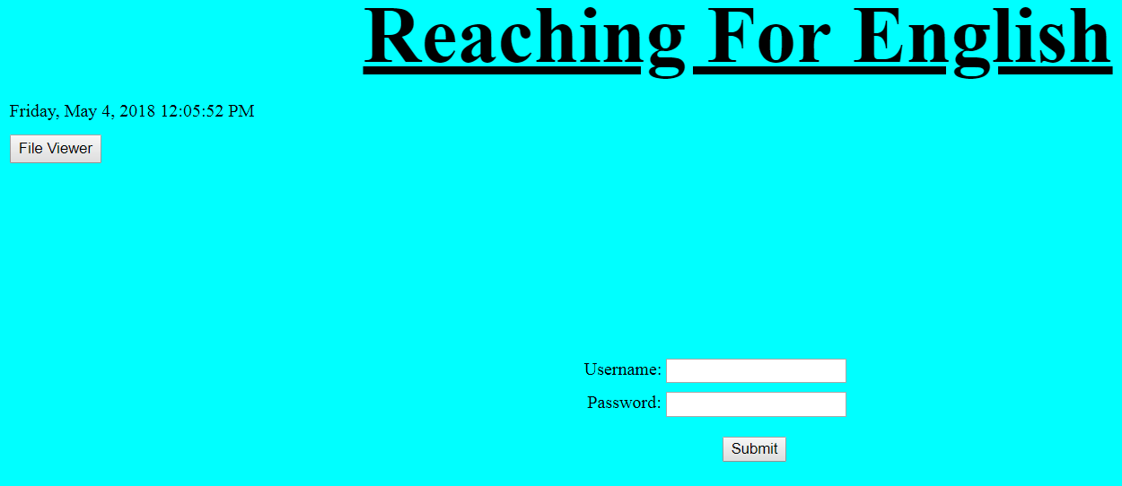

The above image shows the beginning / normal state of the login page. Very simple with a Date and ‘File Viewer’ button in the left corner and the ‘Username’ and ‘Password’ input in the center.

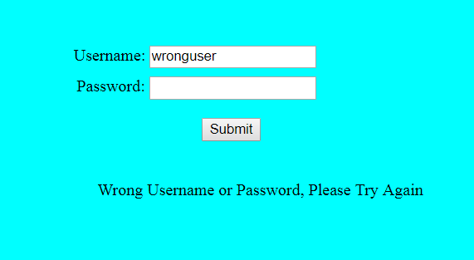

The above image is the display that will be provided if either a wrong username or wrong password is entered.

## How to:

All that is required from the login page is a valid username and password. After the ‘Submit’ button is selected, the user will gain access to the ‘Add’ and ‘Delete/Edit’ pages.

# Add Page

## How the Add Page is set up:

The add page has two sections: a top and a bottom. The top portion is for the adding to the database, while the bottom is to display the lessons that already exist in the database.

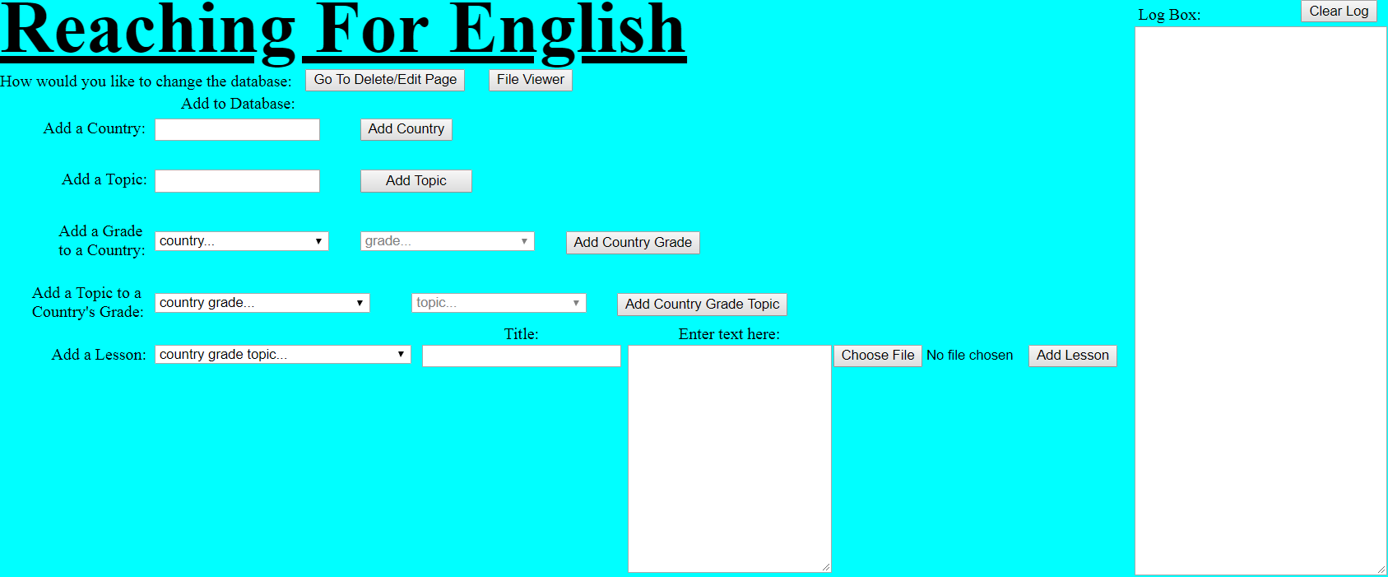

The above image shows the top portion of the add page. (explanation of everything is detailed later)

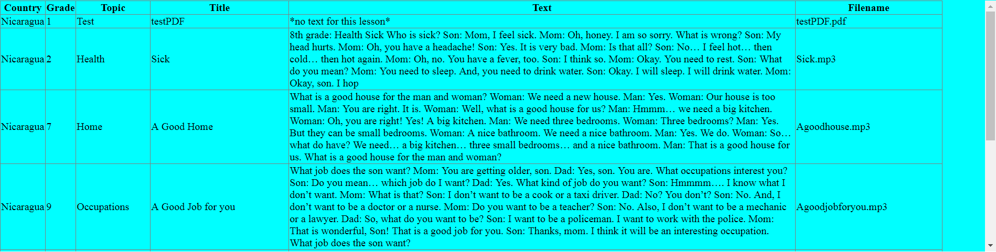

The above image shows how the bottom portion displays the lessons data that is already in the database. (explanation of everything is detailed later)

## Descriptions:

In order to explain and understand the add page, refer to the following images and the listed descriptions:

### Navigation Button:



1. At the top left of the page this button is found. This button is used to navigate between the ‘add page’ and the ‘delete/edit page’. Once clicked, the browser will navigate to the ‘delete/edit page’.
2. This button ‘File Viewer’ is used to navigate to the ‘File Viewer’ page to view the files in the browser.

### Log/Message Box:

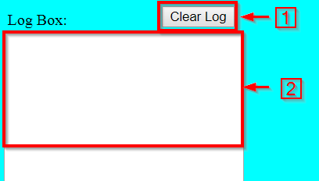

In the top right of the page this is found. It is a log or message box that will display any and all information that is necessary for the user to view. Such as: error messages, failures, or successes. The user should keep an eye on this after every action to ensure they do not miss any valuable information.

1. This button that reads ‘Clear Log’ clears the log box to a blank state.
2. This white portion is the area in which the messages populate. Every new message is displayed on the next line preceded by a ‘~’ (tilde).

### Main Add Area:

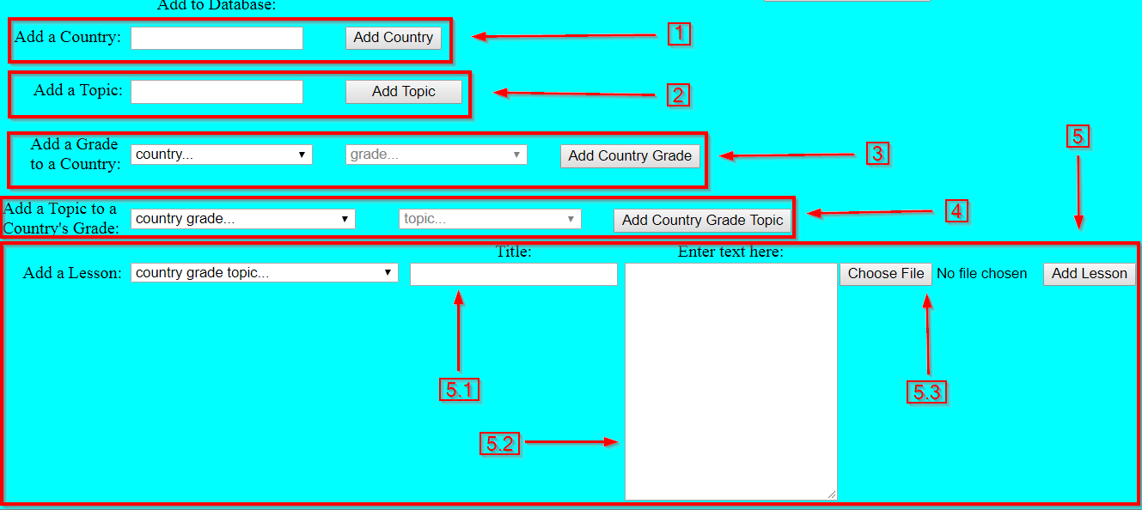

The main portion of the add page is this large area shown above. This is where all of the user interaction occurs in order to add new content to the database for the app to use.

1. This portion refers to adding a new ‘Country’ to the database. Once a ‘Country is added, then that new Country can be referred to in order to add content (grades, topics, lessons) to it for the app to access. So for ‘Grades’, ‘Topics’, ‘Lessons’ to be added to a ‘Country’, the ‘Country’ must first be added to the database through area 1.
   * The area has one textbox for user entry, here is where the name of the new ‘Country’ will be placed.
   * Once typed, the user will click the button to the right labeled ‘Add Country’ to attempt to add to the database. Anything that occurs will be reported to the log box.
2. This portion refers to adding a new ‘Topic’ to the database. Once a ‘Topic’ is added, then that new ‘Topic’ can be referred to in order to add new content relating to a ‘Topic’. So in order for a ‘lesson’ or a ‘Country’s grade’ to be associated with a ‘Topic’, it first must be added to the database through area 2.
   * The area has one textbox for user entry, here is where the name of the new ‘Topic’ will be placed.
   * Once typed, the user will click the button to the right labeled ‘Add Topic’ to attempt to add to the database. Anything that occurs will be reported to the log box.
3. This portion refers to associating a Grade with a given Country. Here is where the user first selects the ‘Country’ that they want to add a ‘Grade’ to, then the user selects the Grade that they want associated with the previously selected ‘Country’. So in order to add a ‘Topic’ or ‘Lesson’ associated with a given ‘Country’s Grade’, the user must first add the ‘Country’s Grade’ through area 3.
   * The area has two items: a dropbox that contains all ‘Countries’ in the database and another dropbox that will be populated with all available ‘Grades’ that can be associated with the selected Country.
   * First the user uses the first dropbox to select their ‘Country’.
   * After selection, the second dropbox will automatically populate with all ‘Grades’ that are able to be associated with that ‘Country’. Be sure to check the log box in case of information output.
   * After both are selected, the user clicks the button to the right labeled ‘Add Country Grade’ in attempt to add the association. Anything that occurs will be reported to the log box.
4. This portion refers to associating a ‘Topic’ with a given ‘Country’s Grade’. Here is where the user first selects the ‘Country Grade’ association that they want to add a ‘Topic’ to, then the user selects the ‘Topic’ that they want associated with the previously selected ‘Country Grade’. So in order to add ‘Lessons’ associated with a given ‘Country’s Grade’, the user must first add the ‘Country Grade Topic’ association through area 4.
   * The area has two items: a dropbox that contains all ‘Country Grade’ associations in the database and another dropbox that will be populated with all available ‘Topics’ that can be associated with the selected ‘Country Grade’.
   * First the user uses the first dropbox to select their ‘Country Grade’.
   * After selection, the second dropbox will automatically populate with all ‘Topics’ that are able to be associated with that ‘Country Grade’. Be sure to check the log box in case of information output.
   * After both are selected, the user clicks the button to the right labeled ‘Add Country Grade Topic’ in attempt to add the association. Anything that occurs will be reported to the log box.
5. This portion refers to associating a ‘Lesson’ with a given ‘Country Grade Topic’. Here is where the user first selects the ‘Country Grade Topic’ association that they want to add a ‘Lesson’ to, then the user fills in the remaining areas that relate to the ‘Lesson’ that will be added. The area has three additional items:
   1. a textbox for the entry of the ‘Lesson’ title.
   2. textbox for the entry of the text that goes along with the audio file
   3. a file upload button to navigate to the mp3 or pdf file for the ‘Lesson’.

* First the user uses the dropbox to select their ‘Country Grade Topic’. After selection, the user will enter the title for the ‘Lesson’ in the first textbox.
* Next, the user will enter the text that goes with the audio file in the second textbox.
* Lastly, the user will click the button for the file upload and navigate and select the desired mp3 or pdf file. Be sure to check the log box in case of information output.
* After all content is selected and entered, the user clicks the button to the right labeled ‘Add Lesson’ in attempt to add the ‘Lesson’ with all the given information. Anything that occurs will be reported to the log box.

### Lesson Display Area:

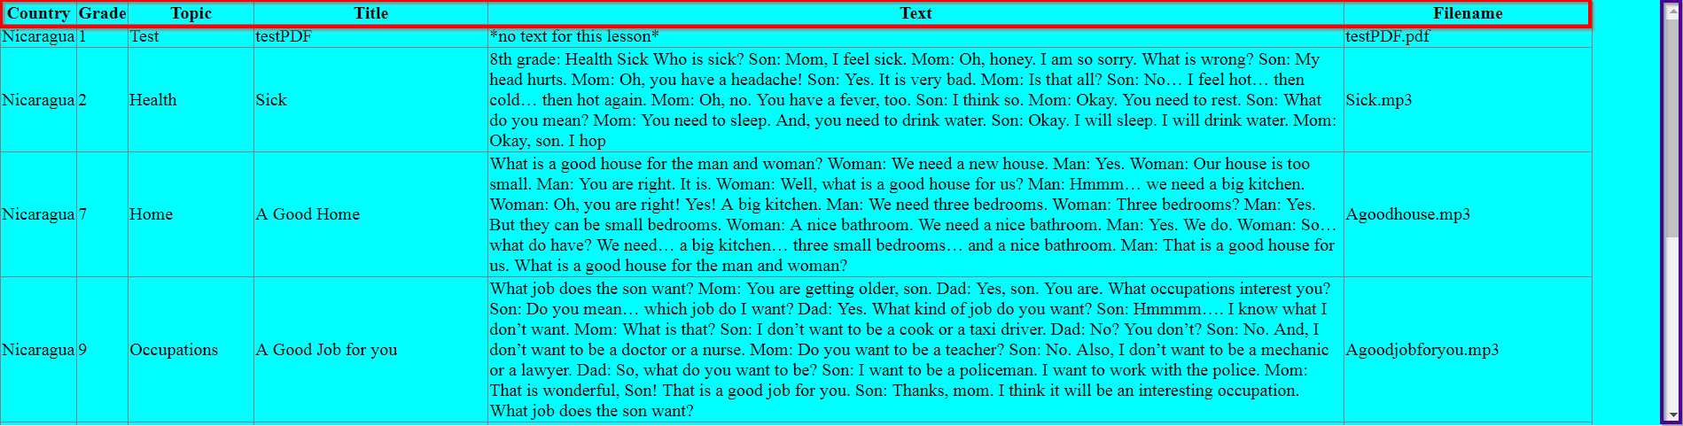

The sub-main portion of the ‘add page’ is the display of the ‘Lessons’ data from the database. This is put in place to easily see what ‘Lessons’ are in the database for the app to use without having to navigate to the ‘delete/edit page’ or ‘File Viewer’.

There are a few items to note:

* The red boxed area refers to the header information associated with the ‘Lessons’. They read in order:
  + Country: the country that the given lesson is associated with.
  + Grade: the grade in which the lesson is associated with in relation to the country.
  + Topic: the topic in which the lesson is associated with in relation to the ‘Country Grade’.
  + Title: the title that was given to the associated Lesson.
  + Text: the text that goes with the audio associated with the Lesson.
  + Filename: the file that is associated with the Lesson.
* The area under the red boxed area is a table that contains the ‘Lessons’.
* The purple boxed area on the right shows a scroll bar. This allows the Lesson content to grow while keeping the site page the same size. So in order to see more Lessons, the user only needs to use the scroll bar.

# Delete/Edit Page

## How the Delete/Edit Page is set up:

The delete page is basically one section but divided up according to the type of data in the database. There is a separate table with its own scroll bar for each piece of data: ‘Country’, ‘Topic’, ‘Country Grade’, ‘Country Grade Topic’, and ‘Lesson’. This way the whole ‘delete/edit page’ fits on to one page and to maneuver through the data, the user uses the scroll bar for each individual table.

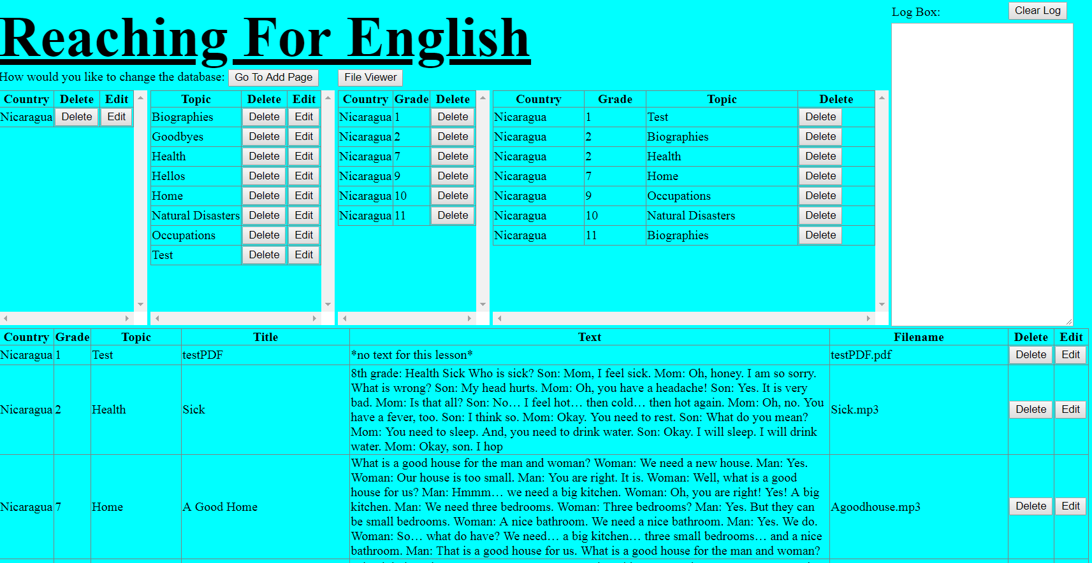

## Descriptions:

In order to explain and understand the delete/edit page, refer to the following images and the listed descriptions:

### Navigation Button:



1. At the top left of the page this button is found. This button is used to navigate between the ‘delete/edit page’ and the ‘add page’. Once clicked, the browser will navigate to the ‘add page’.
2. This button ‘File Viewer’ is used to navigate to the ‘File Viewer’ page to view the files in the browser.

### Log/Message Box:



In the top right of the page this is found. It is a log or message box that will display any and all information that is necessary for the user to view. Such as: error messages, failures, or successes. The user should keep an eye on this after every action to ensure they do not miss any valuable information.

1. This button that reads ‘Clear Log’ clears the log box to a blank state.
2. This white portion is the area in which the messages populate. Every new message is displayed on the next line preceded by a ‘~’ (tilde).

### Main Delete/Edit Area:

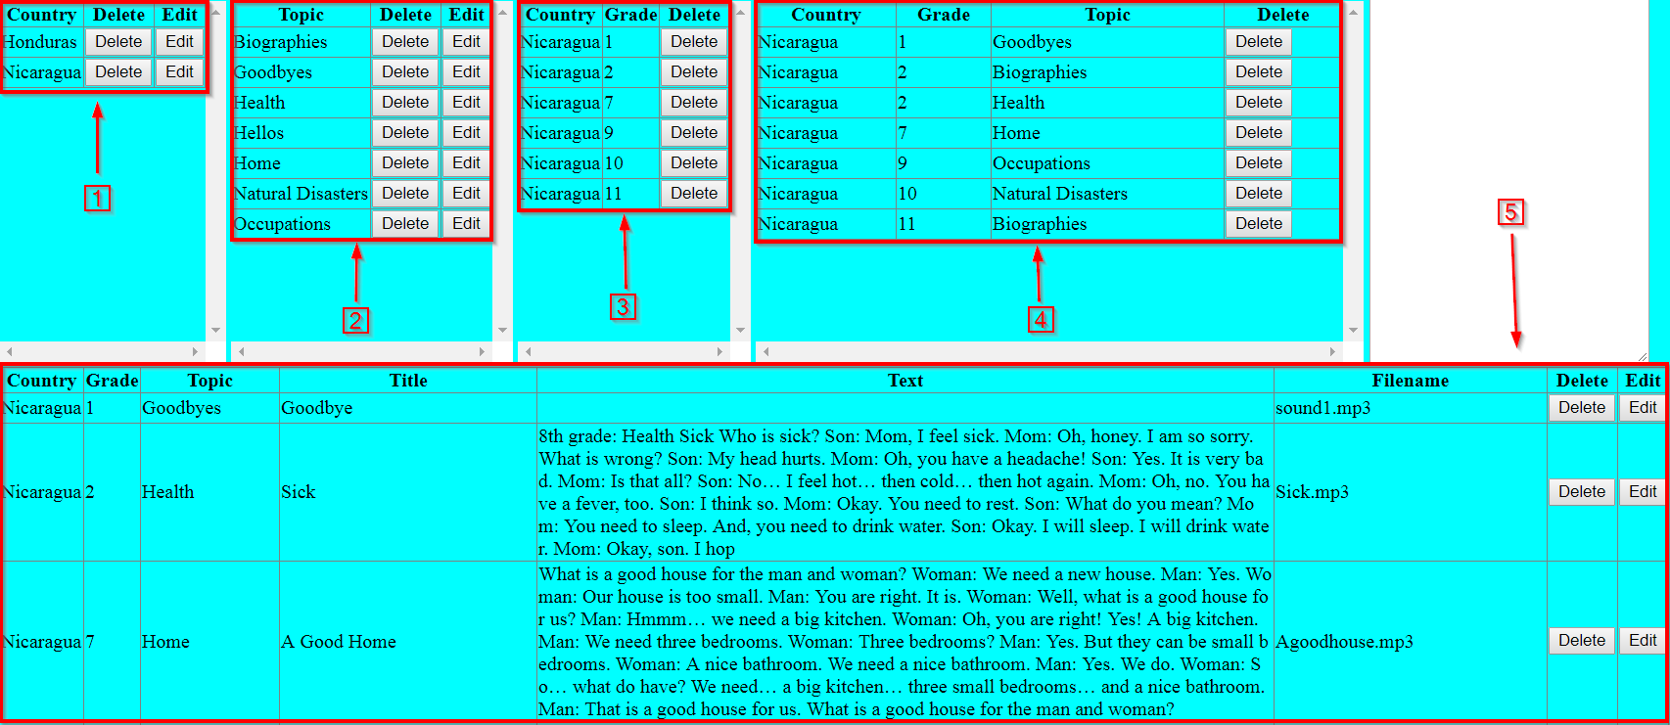

This is where all the functionality of the ‘delete/edit page’ is, the large area shown above. This is where all of the user interaction occurs in order to delete or edit existing content in the database for the app to use. The way it is set up is there is a table displaying all the content inside of the database. Each table represents a different piece of data (each explained below). This allows the user to delete or possibly edit every entry in the database that is currently available to the app.

*Some of the tables do not allow editing. This is because in order to edit pieces of data the user must do that through one of the basic data pieces such as ‘Country’ or ‘Topic’, or through pieces that are not bound to any other piece of data such as ‘Title’ or ‘Text’ inside of ‘Lessons’ (more on that below: all #’s).

*Some tables do not allow the removal of a row if there is data associated with it. This makes it so that the user cannot accidently remove one row from a high-level table which would result in every row associated with the deleted row in a low-level table to be removed as well (more on that below: #’s 1,2,3). In order to do so, all data must be removed that is associated with it first, then it can be removed (one exception explained below: #4).

1. This area shows all the ‘Countries’ in the database. On the app, these ‘Countries’ will show up for the app users to select. These are also the ‘Countries’ that can be associated with on the ‘add page’.
   1. A ‘Country’ cannot be deleted unless there is no content associated with that given ‘Country’.
   2. The name of the Country can be edited, which will propagate down through the database and replace where the previous ‘Country’ name was listed to the new edited version.
2. This area shows all the ‘Topics’ in the database. These are the ‘Topics’ that can be associated with on the ‘add page’.
   1. A ‘Topic’ cannot be deleted unless there is no content associated with that given ‘Topic’.
   2. The name of the ‘Topic’ can be edited, which will propagate down through the database and replace where the previous ‘Topic’ name was listed to the new edited version.
3. This area shows all the ‘Country Grade’ associations in the database. On the app, these ‘Country Grade’ associations will show up for the app users to select. These are also the ‘Country Grades’ that can be associated with on the ‘add page’.
   1. A ‘Country Grade’ cannot be deleted unless there is no content associated with that given ‘Country Grade’.
   2. The ‘Country Grade’ cannot be edited, since it relies on the basic datatypes: ‘Country’ and ‘Grade’. Changing either of these would put the database in an invalid state.
4. This area shows all the ‘Country Grade Topic’ associations in the database. On the app, these ‘Country Grade Topic’ associations will show up for the app users to select. These are also the ‘Country Grade Topic’ that can be associated with on the ‘add page’ for adding ‘Lessons’.
   1. A ‘Country Grade Topic’ may be deleted at the expense of all the ‘Lessons’ associated with the selected ‘Country Grade Topic’ to be deleted as well. This is a table where it can remove data from the table even though there is data associated with it. It will remove the ‘Country Grade Topic’ and every ‘Lesson’ associated with it.
   2. The ‘Country Grade Topic’ cannot be edited, since it relies on the basic datatypes: ‘Country’, ‘Grade’ and ‘Topic’. Changing any of these would put the database in an invalid state.
5. This area shows all the ‘Lessons’ in the database. On the app, these ‘Lessons’ will show up for the app users to select.
   1. A ‘Lesson’ may be removed since it is the lowest level table. Removing the ‘Lesson’ will make it so the app users will not see the Lesson anymore and the mp3 or pdf file is removed from the database.
   2. The ‘Title’ and the ‘Text’ of the ‘Lesson’ can be edited. So that if a title change is desired by the user or the text was incorrect it can be edited and updated.

### Deleting:

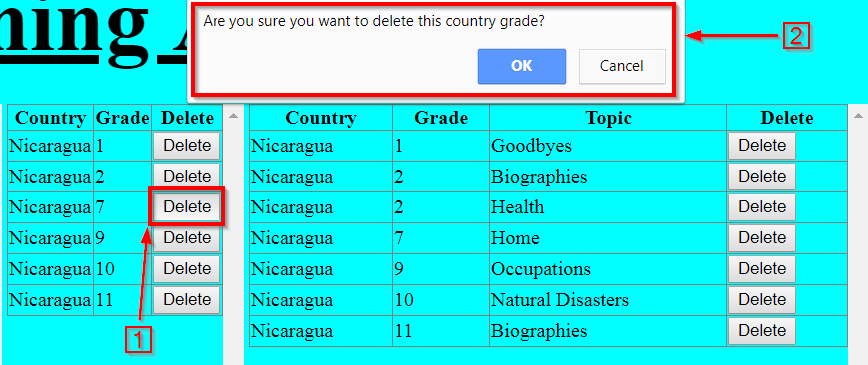

1. In order to delete an item/row the button labeled ‘Delete’ is clicked by the user corresponding to the desired row to be deleted.
2. A confirm box will drop down from the top of the browser to ask for confirmation from the user to ensure that the user wants to remove that row. Selecting ‘OK’ will proceed to attempt to delete the row. ‘Cancel’ will cancel the deleting action. Always check the log box after performing actions.

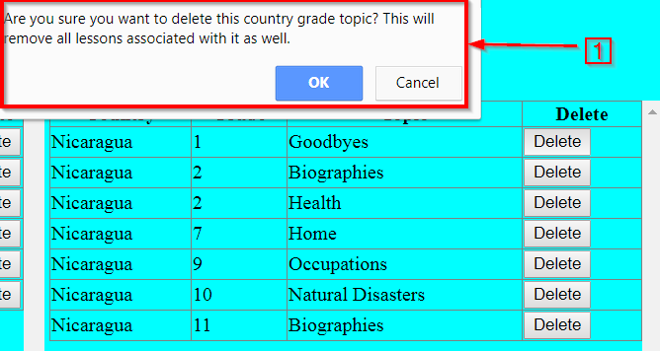

1. Refer to #4 in the ‘Main Delete/Edit Area’ image. When a ‘Country Grade Topic’ is to be removed, it will remove the ‘Country Grade Topic’ along with all the associated ‘Lessons’. This pop up box gives a little more information to the user of the process.

### Editing:

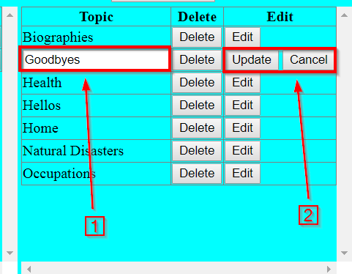

1. In order to edit an item/row the button labeled ‘Edit’ is clicked by the user corresponding to the desired row to be edited. When clicked, fields that are able to be edited are changed to a textbox that can be edited by typing in them.
2. If the user is satisfied with the change, the ‘Update’ button is clicked and the edit is propagated down through the database and changes all occurrences of the old field to the newly edited one. If the user decides not to edit that row, ‘Cancel’ is selected and the table returns to its originally state. Check the log box after every action.

# File Viewer Page

## How the File View Page is set up

The file viewer page has two purposes: access the actual mp3 or pdf files that have been associated with a ‘Lesson’, and to provide/edit a survey link. The link table contains all the ‘Lessons’ in the database with the filename being clickable for the admin or any other user to be able to access those files through a link. They are brought up through the browser in which they can be viewed, saved or printed. The survey portion allows for the admin (if logged in as admin) to edit a link to a survey provided by a site that creates surveys through links. For any user however, the link can be clicked to navigate to the survey.

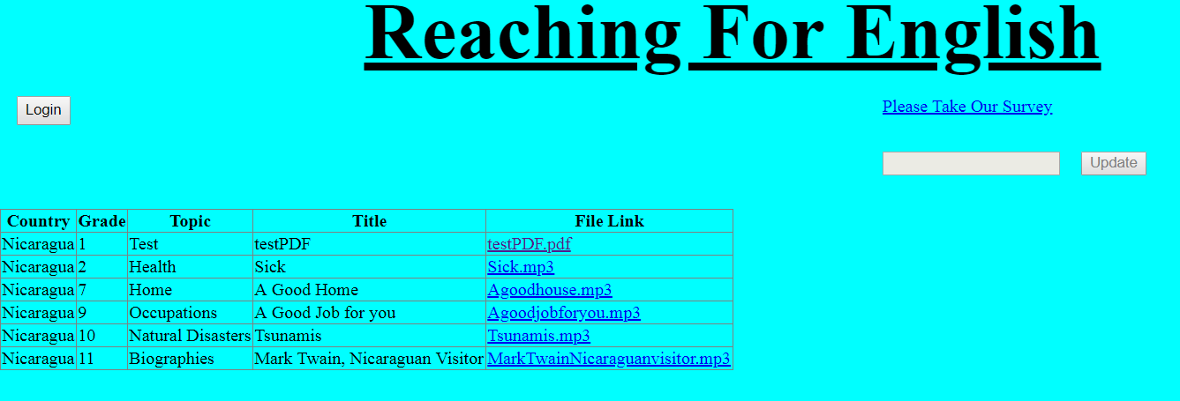

## Descriptions:

In order to explain and understand the file viewer page, refer to the following images and the listed descriptions:

### Links Table

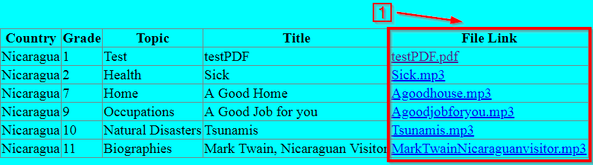

1. The last column in the table displays the filename associated with the ‘Lesson’ in each row. The filename is a link (clickable). When clicked the browser will navigate to that file and open it in the browser for the user to view/listen to it, save it or print it (if pdf).

### Survey Section

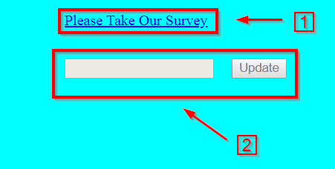

1. The text that reads ‘Please Take Our Survey’ is a link to a survey provided by the admin. Sites that generate surveys and provide a url for users to access the survey can be navigated to through clicking this link.
2. *If logged in as admin, this area will not be grayed out and can be edited. The textbox is where the new survey url will be entered. After entering the survey url, the button that reads ‘Update’ is clicked. That will replace the old survey url. The new survey url will be placed in #1 (the link to the survey).