**JAVA SCRIPTS:**

**Browsers have javascript engines by default so we can directly use browser console throught inspect.**

**But we need to run multiple line of codes for which we would need a nodejs software to run our code on OS through .js file**

**NodeJS is a runtime environment for running the js codes.**

**Visual studio code for writing , show output and debugging the code**

**NodeJS for executing the code**

**VARIABLES IN JS:**

Variables are used for storing the data.

Use Keyword let while declaring the variable for the first time in your code.

Rules for naming the variable:

Use character ex: username

Use number but not at the start example: username1 and not 1username

Use special characters $ and _ : $username or user_name

For better readability use snake casing user_name or camel casing username

Example:

````````````````````````````````````````````

let num = 4

console.log(num)

num = 9

console.log(num)

let username = “Divya”

console.log(username)

````````````````````````````````````````````

output:

4

9

Divya

**CONSTANTS:**

Keyword used : const

Example:

Code to find area of circle:

let radius = 4

const pi = 3.14

let area

area = pi*radius*radius

**DATA TYPES:**

DataTypes

Primitive Object

Number

Int range: 9007199254740991

Bigint : Beyond that int range for big int

* To use BigInt just add n at the end of that big number

Ex: 1505050505050508309802480234n

String : “ Divya Singhal “

Escape character \ to nullify the meaning the “ ” : “divya Singhal \”telusco \” “

\n for new line ,

\t for tab,

\v vertical

\b backspace delete the extra character similar to backspace

Boolean : true or false

Null : null object

Undefined : when the variable is not defined it gives type as undefined

Symbol

Intervie quest:

Console.log(5 / “divya”)s

Output = Nan (not a number)

But

Console.log(typeof (5/ “divya”)

Output = number

**TYPE CONVERSION AND TYPE COERSION**

Let x = string(1)

Type coercion:

Let num = 1 + “divya”

Console.log(typeof (num))

Output >> string

**Arithmetic operator:**

+,-,/,*

Math.pow(3,2)

** = power ex 3**2 = 9

++num // pre increment

Num++ //post increment

Let x = 4

Let num = x++

Let num1 = ++x

Console.log(num, x, num1)

Output >> 4, 5, 6

**RELATIONALL OPERATOR**

=== in case of comparison

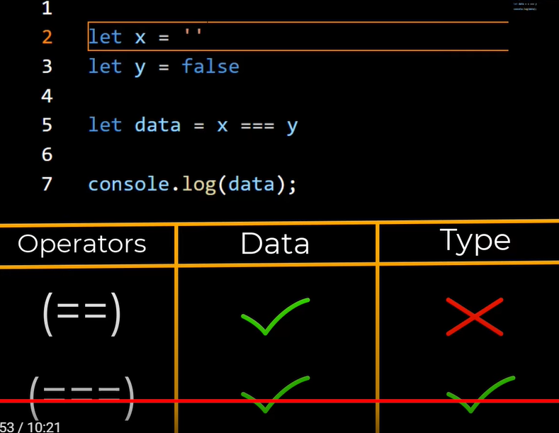

X==y gives true

X===y gives false

**ARITHMETIC OPERATOR**:

> , < , >=, <= , =, == , ===

let A=’2’

let B=2

A == B 🡪 true (string A will be converted into int , lossely coule equality operator)

A===B 🡪 False(String quality operator. It will compare as it is.)

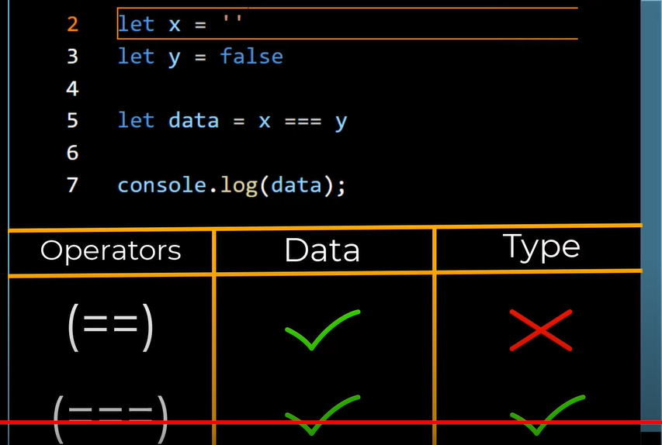

**LOGICAL OPERATOR:**

AND - &&

OR - ||

Not - !

**CONDITIONAL STATEMENT :**

Let num1 = 4

Let num2 = 6

If (num1 > num2)

Console.log(“true”)

Else

console.log(“false”)

console.log(“helloo”)

In javascript the scope of if and else only ramins for one statement. SO to execte multiple statement within if and else use {}

If (num1 > num2){

Console.log(“true”)}

Else{

console.log(“false”)

console.log(“helloo”)

}

If {} else if{} else{}

**TERNARY OPERATOR :**

Result = num%2 ? “EVEN” : “ODD”

Output = condition ? if : else

**SWITCH CONDITION:**

Day = “ Monday“

Switch(day){

Case ‘ Monday’:

Console.log(‘7am’)

Break

Case ‘Tuesday’:

case ‘Wednesday’:

console.log('8am’)

break

case ‘ Sunday’:

console.log(‘10am)

break

default:

console.log(‘No alaram’)

**TEMPLATE LITERAL**

Num1 = 1

Num2 = 2

Let res = num1+num2

Console.log(`the addition of ${num1} and ${nume2} is ${result}`)

Use `` and just use ${} for all variables.

**LOOPS:**

**While** -- check then execute

Initialize, condition, increment

Ex:

i = 5

while(1<5)

{

console.log(i)

I++

}

**Do while** 🡪 fist execute then check

Ex:

Do

{

}

While ()

**FOR LOOP 🡪**

For (let i = 1 ; i<=5; i++)

{

Console.log(i)

For (let j =1; j<=5;j++)

Console.log(“hello” + i)

}

**### which loops works best when:**

**When starting and ending point is known – for loop**

**When starting ending is unknown – while loop**