A Course Project Report

on

**BANKING SYSTEM**

**Course:** Programming for Problem Solving

Class: B.E CSE(AI&ML) Semester: I

By

**VAMSI KRISHNA DESINEEDI**

**1602-21-748-059**



**Department of Computer Science & Engineering**

**Vasavi College of Engineering (Autonomous)**

**Ibrahimbagh, Hyderabad-31**

**2022**

INTRODUCTION

This is a Small Mini-Project Based on BANKING SYSTEM written in C language. It has Covered maximum all the major concepts of C language.

LIST OF FEATURES

This Project provides quite a few features. We can Deposit and withdraw the money directly by just entering the credentials of the account. We can even transfer Money to others and even check our current balance time to time. We even have the facility to Change the Password whenever required.

---------------------------------------------------------------------------

---------------------------------------------------------------------------

FUNCTIONS USED

* printf()-formats and prints characters and values

to stdout.

* scanf()-reads data from stdin into locations given

by arg-list.

* system()-passes string to the system command

analyzer.

* fopen()- opens the specific file.
* fwrite()- writes up to count items of size length

from buffer to stream.

* strcat()- concatenates string 2 to string 1.
* fclose()-closes the specified stream.
* fread()- reads up to count items of size length from

the input stream,and stores them in buffer.

* strcmp()-compares the value of string 1to string 2.
* sizeof()- used to calculate the size in bytes that a

data type occupies in the computer’s

memory.

* strcpy()-copies string 2 into string 1.
* switch()-tests a value and compares it with

Multiple cases.

----------------------------------------------------------------------------------------------------------------------------

----------------------------------------------------------------------------------------------------------------------------------------------------

SOURCE CODE

/***************MINI PROJECT ON BANKING SYSTEM IN C LANGUAGE*******************/

/*******developed by- VAMSI KRISHNA DESINNEDI(1602-21-748-059)*****************/

//Header Files

#include <stdio.h>

#include <string.h>

#include <stdlib.h>//for using system("clear")function

//Structure to store user Data

struct user

{

char phn_no[15];

char ac_no[20];

char pwd[20];

float bal;

};

//Driver Code

void main()

{

struct user user1,user2;

int cnst=1;

char fname[15],phn[15],pass[20],phn2[15];

FILE *fp1,*fp2;

int opt,ch,amt;

printf("**********WELCOME TO DVK ONLINE BANKING SYSTEM**********\n");

printf("--------------------------------------------------------");

printf("\nIf NEW USER, To create a BANK ACCOUNT ------> enter 1");

printf("\nIf already a USER, To LOG IN ------> enter 2");

printf("\n\nENTER YOUR CHOICE..\n");

scanf("%d",&opt);

if(opt == 1)

{

system("clear");//Function to Clear the output Screen (or) Console

printf("\nEnter the Account Number you want(only digits are advised):");

scanf("%s",user1.ac_no);

printf("Enter your Phone number(Excluding Country Code):");

scanf("%s",user1.phn_no);

printf("Enter your Password(Can be digits and characters):");

scanf("%s",user1.pwd);

user1.bal=0;//intially balance will be 0

strcpy(fname,user1.phn_no);

fp1=fopen(strcat(fname,".txt"),"w");//Phone Number as file Name

fwrite(&user1,sizeof(user1),1,fp1);

if(fwrite != 0)

{

printf("\n\nSuccesfully registered...!!");

}

}

if(opt == 2)

{

system("clear");

printf("\nEnter Registerd Phone Number:");

scanf("%s",phn);

printf("Enter Password:");

scanf("%s",pass);

fp1 = fopen(strcat(phn,".txt"),"r");

if(fp1 == NULL)

{

printf("NO DATA ATTACHED WITH THE ENTERED PHONE NUMBER..\nCHECK THE ENTERED PHONE NUMBER");

}

else

{

fread(&user1,sizeof(struct user),1,fp1);

fclose(fp1);

if(!strcmp(pass,user1.pwd))

//Checking whether the password set before and entered now are same or not

{

while(cnst == 1)

{

system("clear");

printf("\n!!!!!*****WELCOME*****!!!!!");

printf("\nHELLO, %s",user1.phn_no);

printf("\nFor knowing CURRENT BALANCE ------> enter 1");

printf("\nFor DEPOSIT ------> enter 2");

printf("\nFor WITHDRAW ------> enter 3");

printf("\nFor ONLINE TRANSACTIONS ------> enter 4");

printf("\nFor PASSWORD CHANGE ------> enter 5");

printf("\n-------------------------------------------");

printf("\n\nEnter Any option from the Above mentioned list:\n");

scanf("%d",&ch);

switch(ch)

{

case 1://For Checking Current Balance

printf("CURRENT BALANCE is Rs. %.2f",user1.bal);

break;

case 2://For Deposit of Money

system("clear");

printf("Enter the amount you want to DEPOSIT:");

scanf("%d",&amt);

user1.bal += amt;

fp1= fopen(phn,"w");

fwrite(&user1,sizeof(struct user),1,fp1);

if(fwrite !=0)

{

printf("\n\nDEPOSITION OF Rs.%d is SUCCESSFUL",amt);

}

fclose(fp1);

break;

case 3://For Withdraw of Money

system("clear");

printf("Enter the amount you want to WITHDRAWL:");

scanf("%d",&amt);

if(amt % 500 != 0)

{

printf("\nPlease enter the Amount in Multiples of 500");

}

else if(amt>user1.bal)

{

printf("\nINSUFFICIENT BALANCE... CHECK AND TRY AGAIN!!!");

}

else

{

user1.bal -= amt;

fp1 = fopen(phn,"w");

fwrite(&user1,sizeof(struct user),1,fp1);

if(fwrite !=0)

{

printf("\n\nWITHDRAWL of Rs.%d is SUCCESSFUL",amt);

}

fclose(fp1);

}

break;

case 4://For transfer of Money

printf("ENTER THE REGISTERED PHONE NUMBER OF THE PERSON TO WHOM YOU WANT TO TRANSFER:");

scanf("%s",phn);

printf("HOW MUCH AMOUNT DO YOU WANT TO TRANSFER:");

scanf("%d",&amt);

if(amt > user1.bal)

{

printf("\n*****INSUFFICIENT BALANCE*****");

}

else

{

fp2 = fopen(strcat(phn,".txt"),"r");

if(fp2==NULL)

{

printf("\n!!!ENTER A REGISTERED A NUMBER!!!");

}

else

{

fread(&user2,sizeof(struct user),1,fp2);

fclose(fp2);

user2.bal += amt;

fp2 = fopen(phn,"w");

fwrite(&user2,sizeof(struct user),1,fp2);

if(fwrite != 0)

{

printf("\nPHONE NUMBER:%s",user2.phn_no);

printf("\nYour trasfer is completed\nYou have trasnfered Rs.%d to %s",amt,user2.phn_no);

fclose(fp2);

user1.bal -= amt;

strcpy(fname,user1.phn_no);

fp1 = fopen(strcat(fname,".txt"),"w");

fwrite(&user1,sizeof(struct user),1,fp1);

fclose(fp1);

}

}

}

break;

case 5://For Changing Password

printf("\n\nEnter the CURRENT PASSWORD:");

scanf("%s",pass);

if(!strcmp(pass,user1.pwd))//Comparing passwords

{

printf("\n\nEnter the NEW PASSWORD:");

scanf("%s",pass);

strcpy(user1.pwd,pass);

strcpy(fname,user1.phn_no);

fp1 = fopen(strcat(fname,".txt"),"w");

fwrite(&user1,sizeof(struct user),1,fp1);

fclose(fp1);

printf("\nPASSWORD HAS BEEN SUCCESFULLY CHANGED..!!");

}

else

{

printf("\nSORRY!!! ENTER CORRECT PASSWORD");

}

default:

break;

}

printf("\n----------------------------------------------------------------");

printf("\nIf you want to do more Transactions\nENTER ------> 1\nelse ENTER ------> 0:");

scanf("%d",&cnst);

}

}

else

{

printf("---------------------------\n");

printf("*****INVALID PASSWORD*****");

}

}

}

if(opt!=1&&opt!=2)

{

printf("!!.....Enter Only from the above mentioned List.....!!");

}

printf("\n^^^^^^^^^^^^^^^^^^^^^^^^^^^^^^^^^^^^^^^^");

printf("\n******THANKYOU FOR BANKING WITH US******");

}

END OF CODE

------------------------------------------------------------------------------------------------------------------------------------------------------------------------------------------------------------------------------------------------------

TEST CASES

* This is the output screen the User gets when the user run’s and compile’s the above Source code: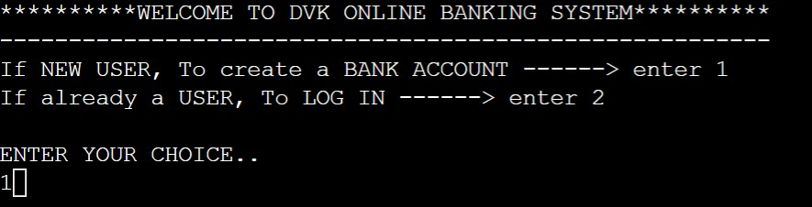
* After the User chooses the 1st option as his/her choice, he/she enters the details and the account is generated: 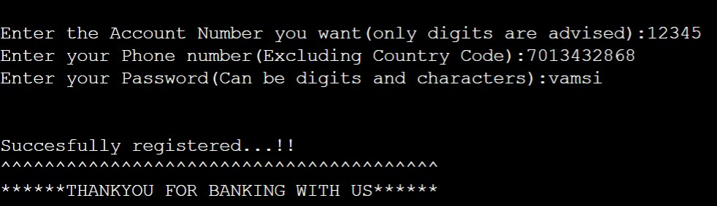
* A New text file with the phone number as the filename has been generated:

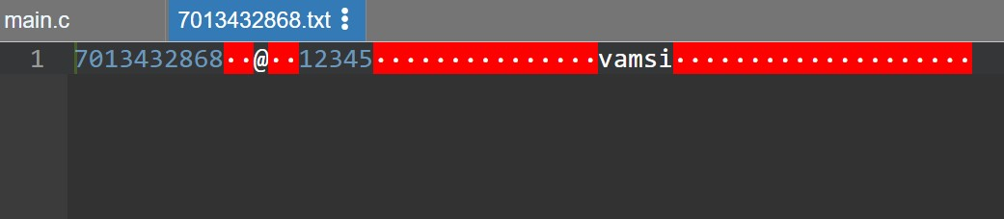

* If the User has Chosen 2nd Option:

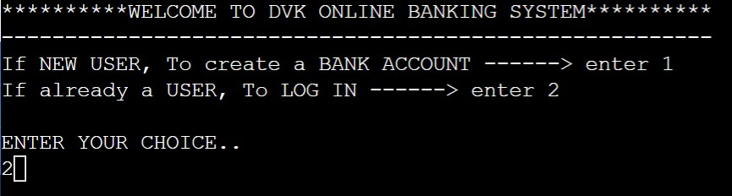

* The Following Screen occurs and the user enters login credentials.

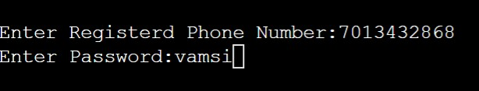

* If the login credentials are correct then the output screen displays:

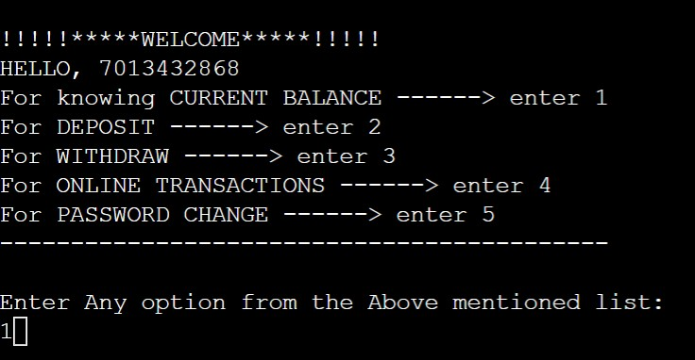

* If the Login Credentials were wrong:

1.Entered Phone Number is Wrong:

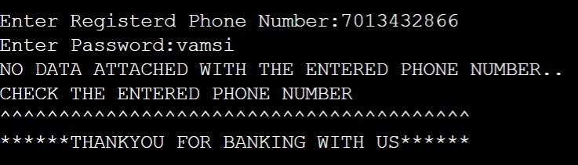

2.Entered Password is Wrong:

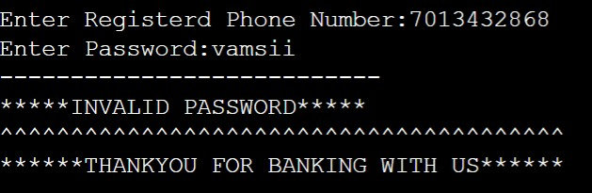

* If the Entered Login Credentials are right and the user chooses option 1:

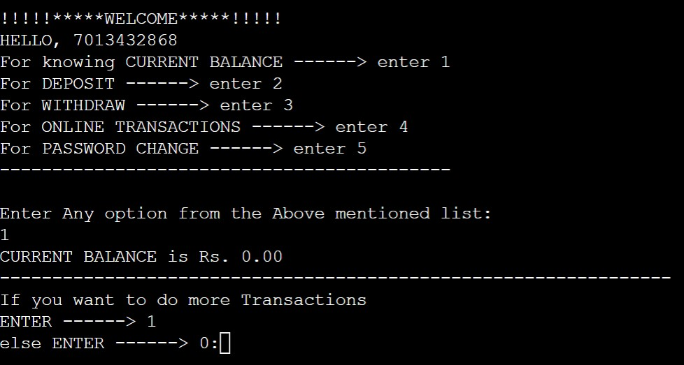

* If the User Chooses Option 2:

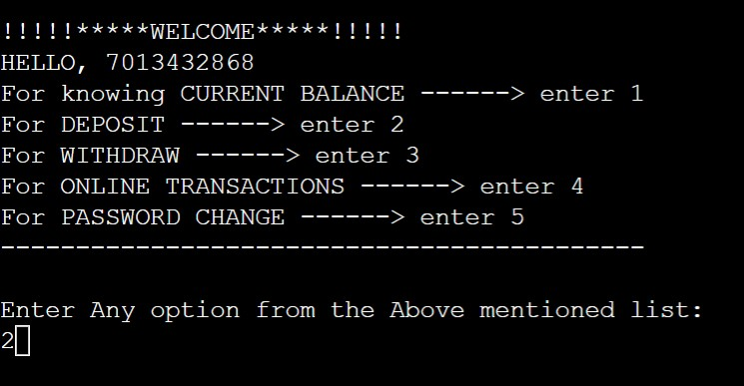

* It Displays a message saying that Enter The Amount You Want to Deposit:

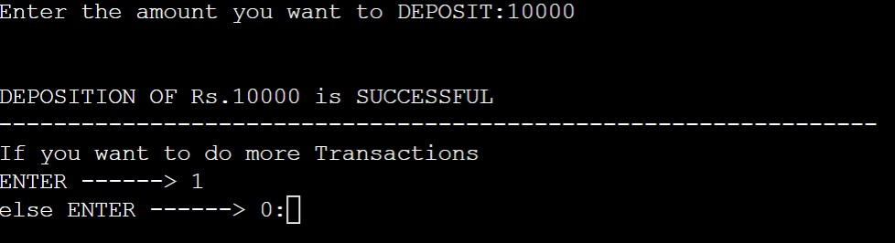

* If the user Chooses Option 3:

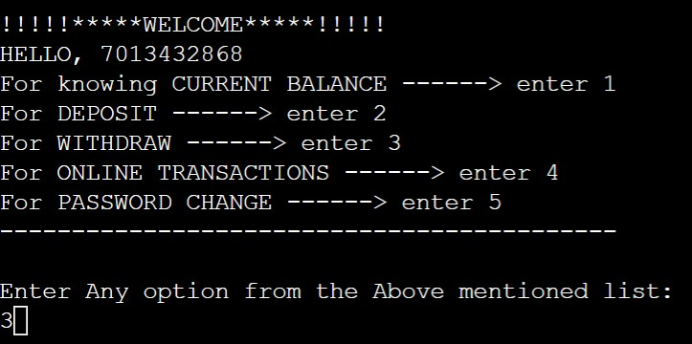

* The Following Screen is Followed After Option 3 Is chosen:

1.If Entered Amount is not multiple of 500:

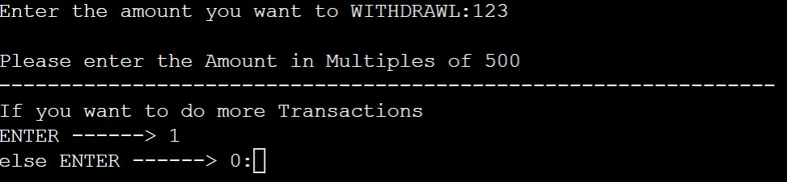

2.If Entered Amount is greater than The Current Balance:

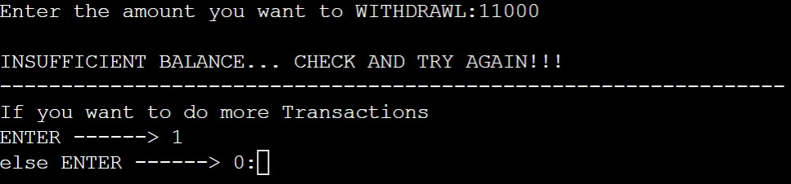

3.If the withdrawal amount is multiple of 500 and is in the scope of

Current balance, you are eligible for withdrawal:

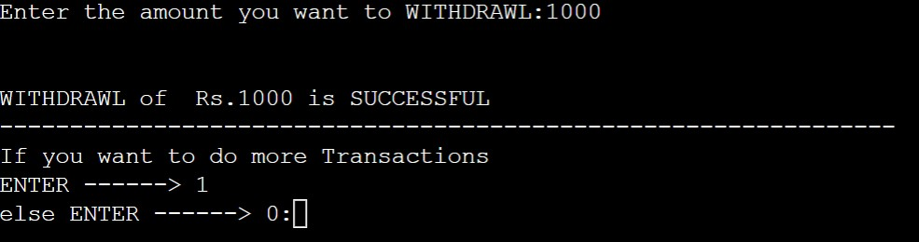

* If 4th Option is Chosen:

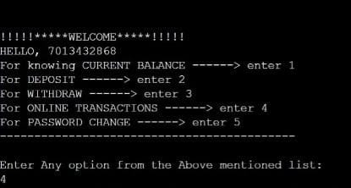

1.If the Number is not registered with the bank:

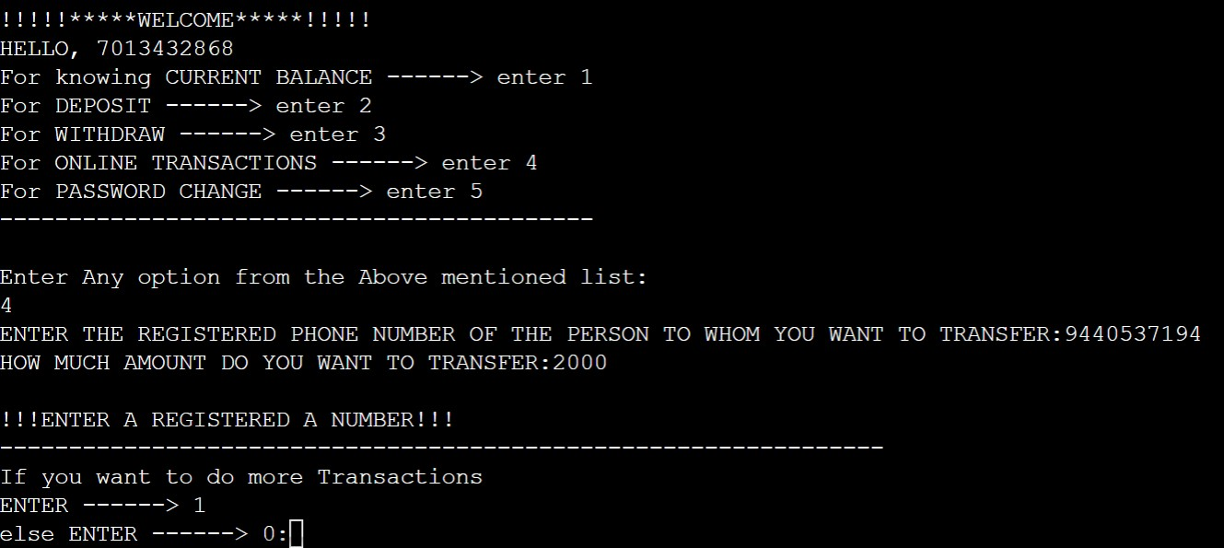

So, first create a new user same as done earlier:

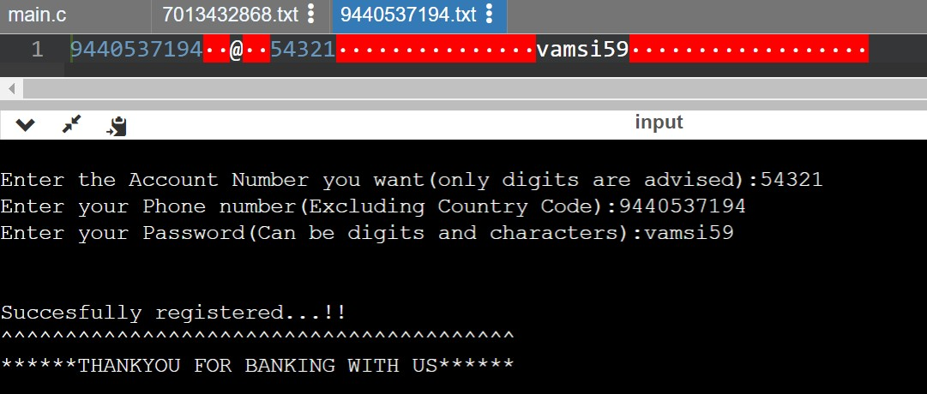

2.Even if number is registered, the amount you want to transfer is more than the balance:

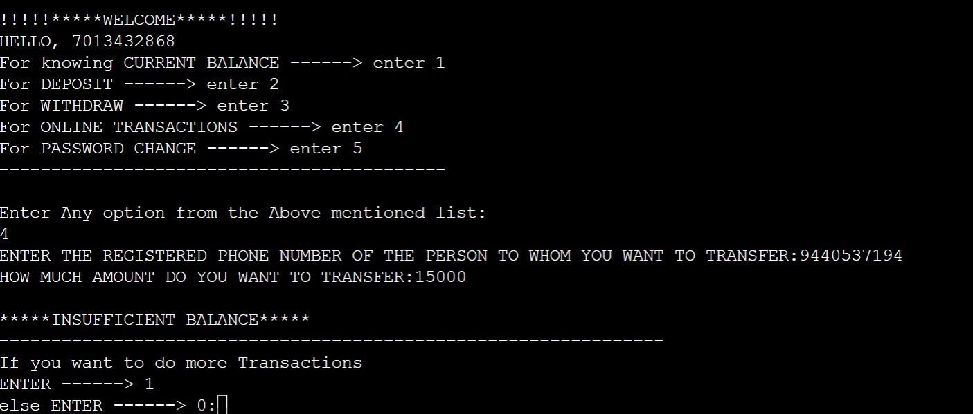

3.If the number entered is registered and the amount is in the limit of current Balance:

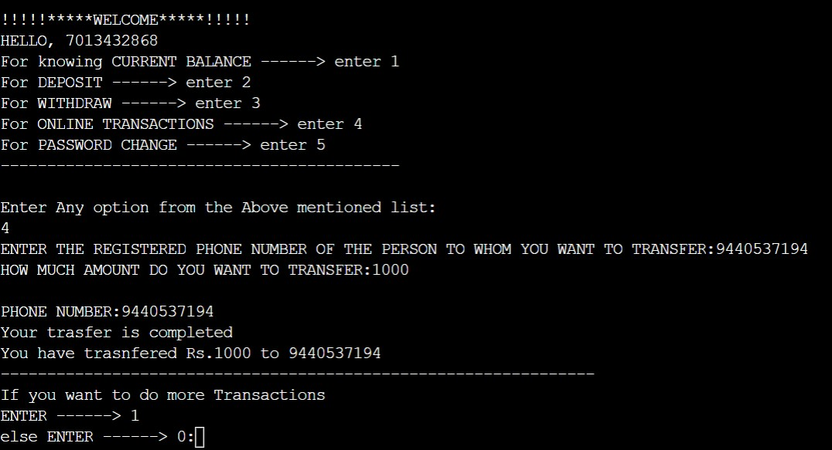

* The User has chosen 5th Option

1.If entered WRONG PASSWORD:

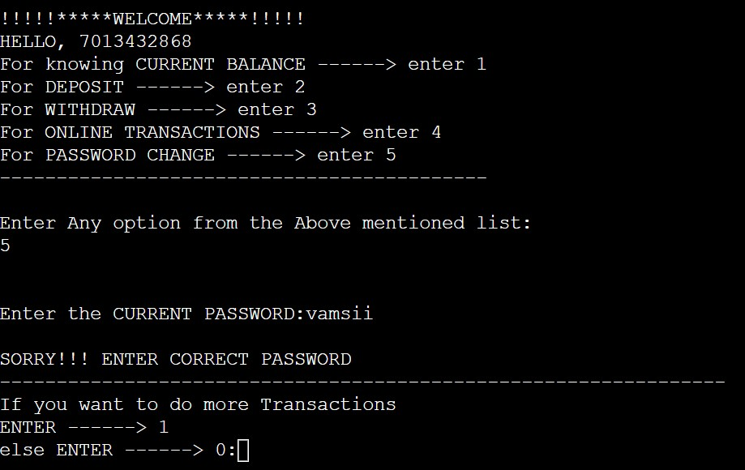

2.If entered CORRECT PASSWORD:

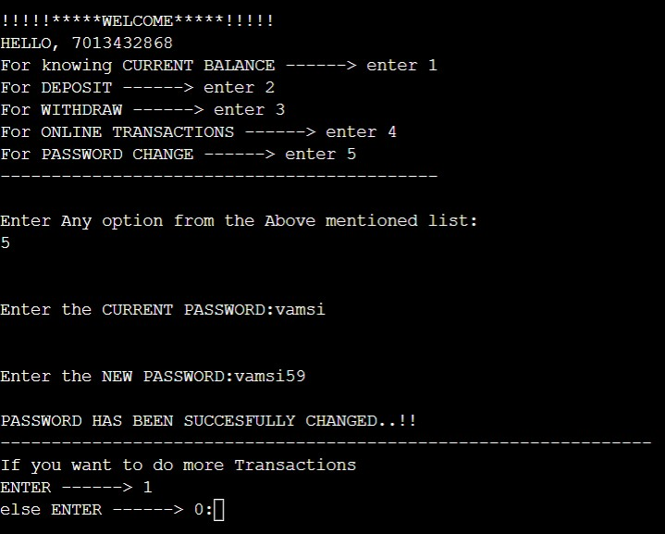

* If the User, has not entered either 1 or 2 at the starting:

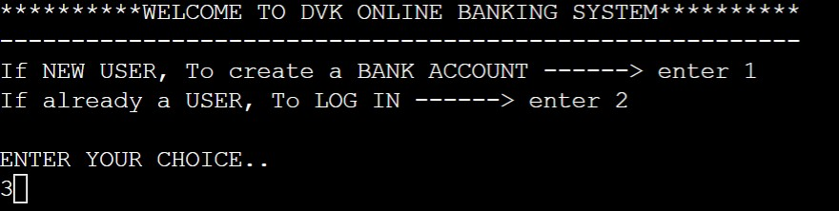

The Output Screen Would Look Like:

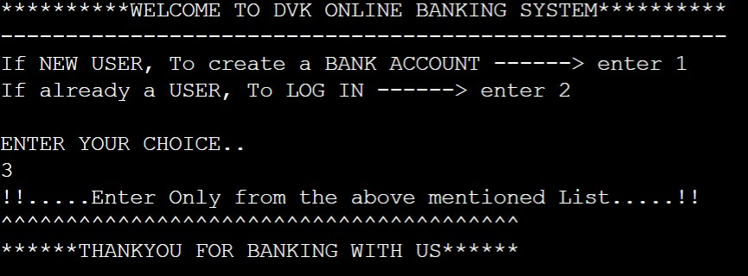

------------------------------------------------------------------------------------------------------------------------------------------------------------------------------------------------------------------------------------------

CONCLUSION

I have understood how all the concepts in C can be used in real life applications, even though it takes time to write Program it will be best option in going time. It reduces time in future and even Paper Work and data can be stored for long run and increases productivity and there is very less chances of mistakes happening. Through this project, I have learned the actual purpose of all the topics.

FUTURE SCOPE

Even though there are better programs than this, used in real life. This Project is simple and clear that it would be easily habituated to the customers since it is very easy to understand. Customer’s Satisfaction and comfort is the first priority.

------------------------------------------------------------------------------------------------------------------------------------------------------------------------------------------------------------------------------------------------------