Vasavi College of Engineering

GNI - National Hackathon 2023

Draft Idea Submission

Team Name: **Team EcoVision**

Theme: Waste Management

Team Members:

1. **Akshitha Pottumuthu**

2. **Konduri Gagana Kumar**

3. **Namratha Jaggavarapu**

4. **Vamsi Krishna Desineedi**

Title of the Project:

**EcoWaste: Empowering Sustainable Waste Management**

Problem Statement:

**Developing a web-based application for effective Waste management through smart bin monitoring systems, optimize collection routes, waste-segregation system and effective waste management practices**

Objective:

**The main objective of the project is to implement a comprehensive waste management system. It aims to reduce health and pollution problems caused by improper waste management. The solution includes IoT bins for efficient waste collection, optimized waste transportation, efficient waste sorting using IoT and ML, and sustainable waste management methods. In addition, the project promotes environmental protection and a sense of community through various initiatives**.

Proposed Solution:

**India faces many waste management problems such as collection and disposal leading to health and pollution problems.**

**Here we offer an idea for implementing a solution that reduces the impact of an improper waste management system:**

**Garbage collection:**

**First, we set up IoT bins according to the amount of waste. They are designed in two ways, one for small scale and the other for large scale.**

**Small scale (small household):**

**We install small IoT trash bins (using ultrasonic sensors and GSM modems) that detect waste levels and the location of trash bins.**

**We encourage people to use the IoT bins provided by offering certain rewards like money and gift vouchers. (A small portion of obtained profits)**

**Large scale (Community or large waste generator):**

**Here we have installed large IoT bins (using ultrasonic sensors, GSM modem) with solar panels that detect the level and location of the bin, and generate electrical power.**

**In this case, we get people's interest by providing free electricity for common uses like parking lights, street lights, etc. (which is a small portion of the energy generated from solar panels and the remaining energy is sent to the power stations to get benefit commercially)**

**To reduce the overflow of IoT bins, we implement it in such a way that the bins are automatically closed when the level of the trash in the bin reaches more than 95% on both large- and small-scale levels but the person who collects it can override this condition.**

**Transportation of collected waste:**

**By knowing the level and location of the IoT Bin, we develop an algorithm that guides us through the garbage collection route. (Here we try to choose roads connecting places where the waste level is greater than 80% so that we can reduce the frequent travel distance.)**

**We collect garbage with trucks where the level of the garbage is >80%, not where the level of the garbage is below 80%, because there is still space left to fill the bin and also saves time for the person who collects it and shortens the journey.**

**If people can leave home for holidays, keeping this scenario in mind, we give the user an option to contact the number mentioned on our website so that the person will be allotted to collect the waste, if the stated request by the user is valid even when the waste is <80%.**

**Waste Segregation:**

**We classify the collected waste into two stages.**

**1. Level 1 classification using IoT:**

**Here, we separate the collected waste into two parts using the Moisture Sensor:**

**a. Dry waste**

**b. Wet waste**

**2. Level 2 using Machine Learning algorithm:**

**Using ML algorithm and image recognition, we further classify dry waste into 3 categories:**

**a. Biodegradable waste**

**b. Recyclable waste**

**c. Non-Recyclable Waste**

**Waste Disposal:**

**From the classified categories, we follow different processes for each category:**

**1. Biodegradable waste (Wet-Waste + Biodegradable Dry Waste):**

**We turn this biodegradable waste into Biogas (Sent to Power Stations for commercial purposes) and Digestate (Fertilizer, Soil Amendments, and Live Stock Bedding which are available for purchase from our website).**

**2. Recyclable waste:**

**We send recyclable waste to our connected recycling units (For Commercial purposes).**

**3. Non-Recyclable Waste:**

**We burn this non-recyclable waste and generate electricity (Some part of the generated electricity is used for internal operations and the excess is sent to Power Stations for Commercial purpose). During this process, some toxic gases may be released into the environment. To avoid this and make it eco-friendly, we use wet-packed scrubber systems so that they absorb toxic gases.**

**We wish to donate saplings to NGOs for plantation once in 3 months based on the amount of waste collected. (10 saplings per ton)**

**Apart from all this, we will develop a website with certain features like:**

**1. We provide the ability for people or authorities to contact us if they want to donate food (leftovers from parties or hotels) to those in need.**

**2. To create or participate in waste reduction campaigns (Participants will be rewarded)**

**3. Providing videos on effective waste management practices.**

**In this way, we are trying to find a solution that can improve the waste management system.**

**For Detailed Video Explanation:** [**Click Here**](https://drive.google.com/file/d/1Se_RHrXmfDEhTpUAXoObFg4cZ0ATjNyu/view?usp=sharing)

**Flow Chart:**

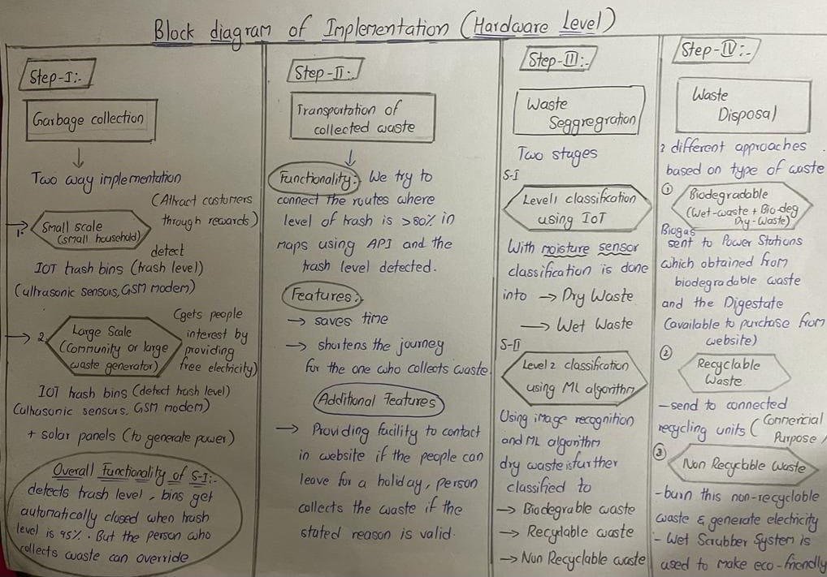

Key Features and Functionality:

**1. IoT Bins for Garbage Collection:**

**- Small-scale bins with ultrasonic sensors and GSM modems for detecting waste levels and location.**

**- Large-scale bins with solar panels, ultrasonic sensors, and GSM modems, providing free electricity for common uses.**

**- Automatic closure of bins at 95% capacity to prevent overflow, with an override option for collectors.**

**2. Optimal Waste Transportation:**

**- Algorithm-guided garbage collection route, prioritizing areas with waste levels above 80%.**

**- Collection trucks deployed where garbage levels are high (>80%) to minimize travel distance and save time.**

**3. IoT and ML-based Waste Segregation:**

**- Level 1 classification using Moisture Sensor: Segregation into dry and wet waste.**

**- Level 2 classification using ML and image recognition:**

**a. Biodegradable waste**

**b. Recyclable waste**

**c. non-recyclable waste**

**4. Sustainable Waste Disposal Methods:**

**- Biodegradable waste converted to Biogas and Digestate for commercial and agricultural purposes.**

**- Recyclable waste is sent to connected recycling units for commercial recycling.**

**- Non-recyclable waste burned with wet-packed scrubber systems to minimize toxic gas emissions.**

**5. Environmental Initiatives:**

**- Donation of saplings to NGOs for plantation, based on the amount of waste collected (10 saplings per ton).**

**6. Community Engagement and Website Features:**

**- Option for people and authorities to donate excess food to those in need.**

**- Participation in waste reduction campaigns with rewards for participants.**

**- Provision of educational videos on effective waste management practices.**

**These key features and functionalities collectively aim to address India's waste management problems by promoting proper waste disposal, efficient transportation, effective segregation, and sustainable disposal methods. Additionally, the project encourages community participation and awareness to foster responsible waste management practices and environmental conservation.**

Expected Outcomes:

**1. Improved Waste Management: The project's implementation is expected to result in a significant improvement in waste management practices. With IoT bins, optimized transportation routes, and waste segregation through advanced technologies, the collection and disposal process will become more efficient and streamlined.**

**2. Health and Pollution Reduction: By addressing the problem of improper waste disposal, the project aims to reduce health risks and pollution caused by overflowing garbage and indiscriminate waste burning. Proper waste disposal and recycling will lead to cleaner and healthier environments for the target audience.**

**3. Sustainable Energy Generation: The integration of solar panels with large IoT bins allows for the generation of renewable energy, promoting sustainability and reducing dependency on non-renewable energy sources.**

**4. Environmental Conservation: The project's emphasis on waste segregation and recycling helps conserve natural resources by diverting recyclable materials away from landfills. The donation of saplings for plantation further contributes to environmental preservation.**

**5. Community Empowerment: Through its various features, the project empowers the community to actively participate in waste reduction efforts. By donating excess food to those in need and engaging in waste reduction campaigns, individuals and authorities can make a positive impact on their surroundings.**

**6. Economic Benefits: The project's approach of converting biodegradable waste into biogas and digestate, and recycling materials for commercial purposes, can offer economic benefits by creating revenue streams and reducing waste management costs.**

**Overall, the expected outcomes of this project are to create cleaner and healthier communities, promote sustainable practices, and foster a sense of responsibility and involvement in waste management among the target audience. By addressing waste-related challenges, the project aims to have a positive impact on both the environment and the quality of life for the people of India.**

Technical Approach:

**IoT:**

**1. Ultrasonic Sensor and GSM modem:**

**To detect the level of trash and the location of the bin.**

**2. Moisture Sensor:**

**To Segregate the waste into dry and wet.**

**ML:**

**ML Algorithms and Image Processing for further classification of waste into Biodegradable, Recyclable, and Non- Recyclable.**

**Web Technologies:**

**HTML, CSS, Django and JS.**

Resources Required:

**Available Online Datasets for Classification of Waste.**

**Google Maps API for finding optimized routes.**

**IoT components (Ultra Sonic Sensors, GSM modem, etc.)**

Timeline:

**In the 4-week timeline, the project begins with initial research, planning, and resource acquisition for the development of IoT bins and a machine learning model. During the first week, the team focuses on web development and setting up the database. By the second week, small-scale IoT bins equipped with waste level sensors and GSM modems are developed and tested, and the waste segregation dataset is prepared for training the ML model. In the third week, the ML model is integrated with the small-scale IoT bins for waste segregation, while also implementing an algorithm for optimized waste transportation routes. The final week entails full system integration and testing, including large-scale IoT bins with solar panels and renewable energy management. User feedback is gathered for further refinements and improvements based on the testing results. Although this timeline offers a general outline, complex projects may require more time for comprehensive testing and fine-tuning.**

Conclusion:

**In conclusion, our proposed waste management solution aims to address world’s pressing waste management problems by implementing an innovative and comprehensive approach. Through the integration of IoT bins, machine learning algorithms, optimized waste transportation, and sustainable waste disposal methods, we are determined to significantly reduce the impact of improper waste management on public health and the environment. Our project's key features include efficient garbage collection, waste segregation, and renewable energy generation, all contributing to cleaner and healthier communities. Moreover, the community engagement features on our website, along with the donation of saplings for plantation, reflect our commitment to fostering a sense of responsibility and environmental stewardship among the public. We are enthusiastic about taking on this challenge and are confident that our technical expertise, dedication, and collaborative efforts will lead to a successful waste management solution that positively impacts the lives of people in India and contributes to a cleaner and sustainable future for all.**

Please attach this completed document along with your registration details by the submission deadline.

Note: This is a sample template; feel free to modify and customize it according to your specific hackathon guidelines and requirements.

Remember to provide clear instructions to participants on how and where to submit their draft ideas, including the deadline and any additional information you may need from them.