FRM System
Use-Case Specification: Register

Version 1.2
Revision History
Date | Version | Description | Author
02/11/16 | 1.0 | Creation of Document | Daniel Raiser
14/11/16 | 1.1 | added link to .features file | Daniel Wagner
23/11/16 | 1.2 | updated the UML activity diagram | Daniel Wagner

Table of Contents
1. Register 4
1.1 Brief Description 4
2. Flow of Events 4
2.1 Basic Flow 4
3. Special Requirements 6
3.1 Functionality 6
3.2 Usability 6
3.3 Reliability 6
3.4 Performance 6
3.5 Supportability 6
3.6 Design Constraints 6
3.7 On-line User Documentation and Help System Requirements 6
3.8 Purchased Components 6
3.9 Interfaces 6
4. Preconditions 7
4.1 Open Website 7
5. Postconditions 7
6. Extension Points 7

Use-Case Specification: Register

- Register
  - Brief Description
The purpose of this use case is to enable guests who do not have an account on the website to create one with which the user will be able to log in. This will allow him to use the full functionality of the website. On successful account creation, the user will receive an E-Mail to inform him, that his account has been created.
- Flow of Events
  - Basic Flow
Any visitor on the website will be able to click the “Register” button in order to begin with the registration process. To successfully create an account, the user has to insert his name and E-Mail address into the corresponding fields, create a password and agree to the general terms and conditions. The E-Mail address and password will be used for the login.
After clicking the “Submit” button, the system checks whether all information stated meet the requirements. If the validation is not successful, the fields that are not filled properly are marked red and the user is asked to correct them. If the validation is successful, the user will receive an E-Mail for verification, containing an activation link for his account. After clicking on this link, the user's account will be unlocked and the user can use the website. He will also automatically logged in. If the user does not receive the E-Mail for some reason, he is reminded, to check his spam folder and whether the E-Mail provided was typed in correctly. If the E-Mail address was correct and the mail was also not found in the spam folder, the user can choose to resend the mail.
The user also has the possibility to click the “Cancel Registration” button in the registration screen if he wants to do so. In this case none of the user's data will be stored and the browser will navigate back to the main page of the website.
The user's data will be temporarily stored when the “Submit” button is pressed and all data provided is valid. If the the validation link in the E-Mail is not used in 24 hours, the data will be deleted again. If it is used in this time frame, the data will be stored permanently (until the associated account is deleted).
In order to ensure that all data of temporary accounts which were not activated in time will be deleted after 24 hours, the system will periodically check if there is data which needs to be deleted and then delete it.

Link to the full size UML Activity Diagram: Registration
Link to the corresponding .features Gherkin file: Registration
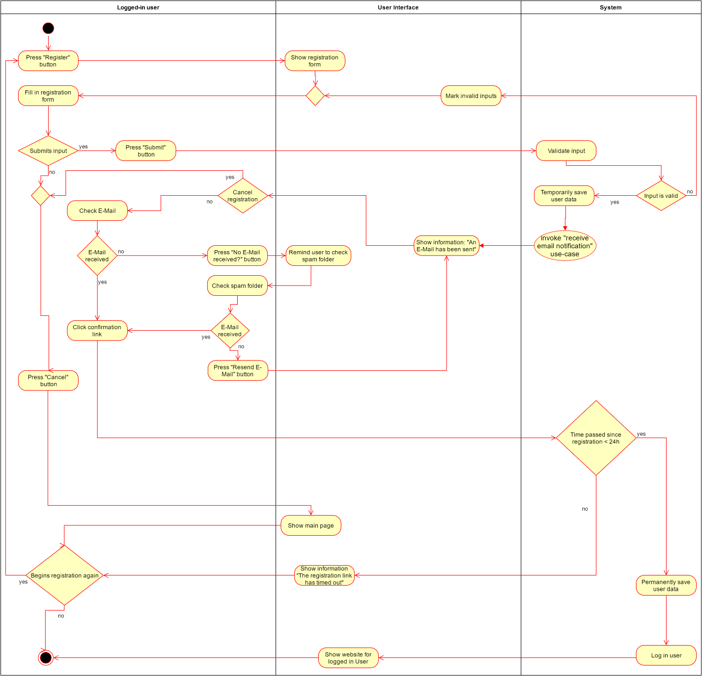
- Special Requirements
  - Functionality
  - Usability
  - Reliability
  - Performance
  - Supportability
  - Design Constraints
  - On-line User Documentation and Help System Requirements
  - Purchased Components
  - Interfaces

- 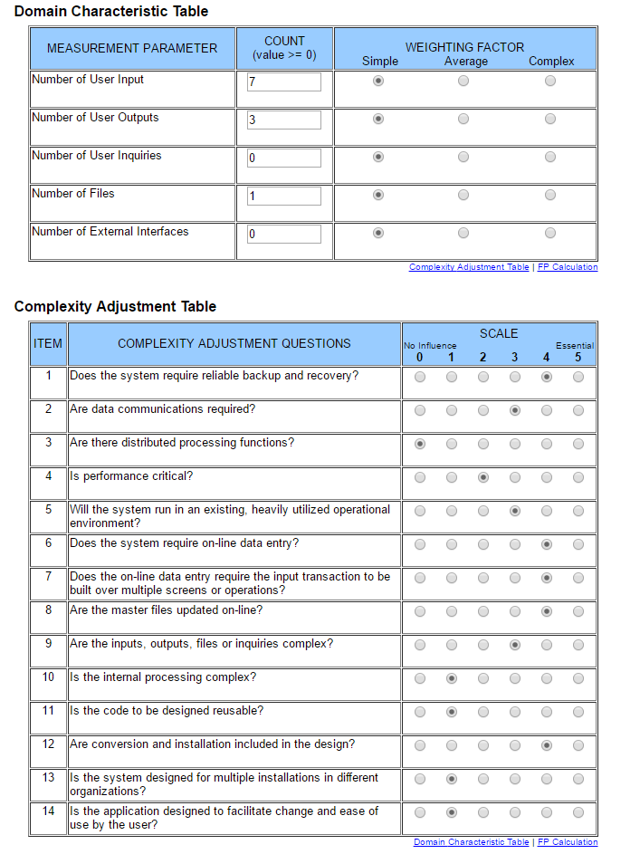
Function Points: 40
- Preconditions
  - Open Website
To register on the website, the user has to open it and click on the “Register” Button on the start page.
- Postconditions
- Extension Points

