FRM System
Use-Case Specification: Confirm Relationship/Group-Requests

Version 1.1
Revision History
Date | Version | Description | Author
06.04.2017 | 1.0 | Creation of Document | Karl Spickermann
19.04.2017 | 1.1 | Added function points and estimation | Daniel Wagner

Viewle of Contents
1. Register 4
1.1 Brief Description 4
2. Flow of Events 4
2.1 Basic Flow 4
3. Special Requirements 6
3.1 Functionality 6
3.2 Usability 6
3.3 Reliability 6
3.4 Performance 6
3.5 SupporViewility 6
3.6 Design Constraints 6
3.7 On-line User Documentation and Help System Requirements 6
3.8 Purchased Components 6
3.9 Interfaces 6
4. Preconditions 7
4.1 Open Website 7
5. Postconditions 7
6. Extension Points 7

Use-Case Specification: Confirm Relationship/Group-Requests

- Register

1.1 Brief Description
The purpose of this use case is to enable users to accept invitations to group and friendship requests which were send to them by other FRM-users.
  - Basic Flow
Any user on the website will be able to click the “My Groups” button on his start page to visit the My Groups View. Here he/she can find a list of every open invitation which were to send to them by other users. Next to every invitation are two buttons “decline” and “accept”. To accept the invitation the user must click the “accept” button and to decline the “decline” button.
After clicking the “accept” button, the system saves the new group member in the database and the Group moves from the top of the My Group View to the bottom with all other accepted groups. The sender of the invitation will be notified that the user joint the group.
After clicking the “decline” button the Group will be removed from the My Groups View of the user and the sender of the invitation will be notified that the user declined his request.
Any user on the website will be able to click the “My Contacts” button on his start page to visit the My Contacts View. Here he/she can find a list of every open friendship request which were to send to them by other users. Next to every request are two buttons “decline” and “accept”. To accept the friendship, request the user must click the “accept” button and to decline the “decline” button.
After clicking the “accept” button, the system saves the new relationship in the database and the accepted contact moves from the top of the My Friends View to the bottom with all other accepted contacts. The sender of the friendship request will be notified that the user has accepted his request.
After clicking the “decline” button the request will be removed from the My Friends View of the user and the sender of the friendship request will be notified that the user declined his request.

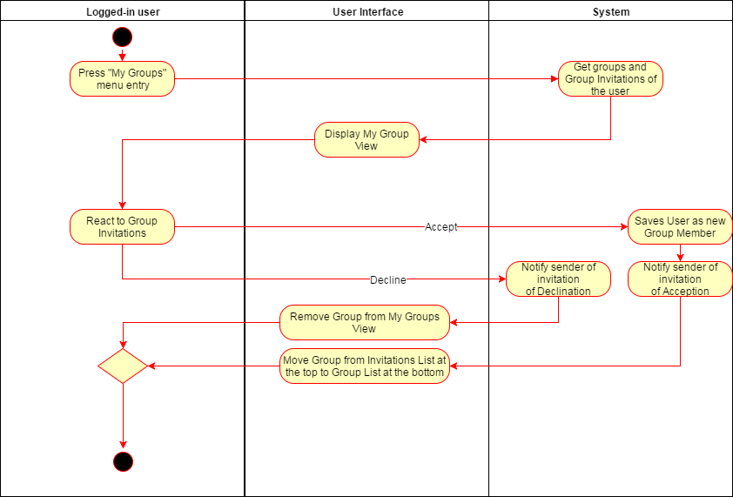
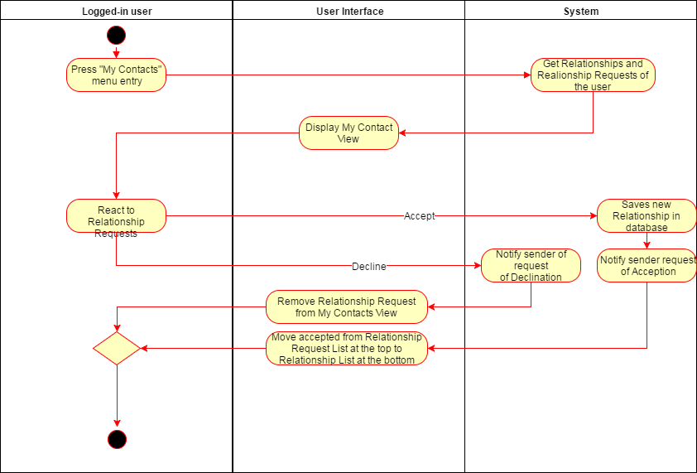

Special Requirements

Functionality
Transaction | Number of | Complexity | DET | RET | FTR | FP
External Inputs | 4 | low | 4 | 0 | 0 | 26
External Outputs | 0 | low
External Inquiries | 0 | low
Internal Logical Files | 2 | low
External Interface Files | 0 | low

Estimation overall: 8 hours

Usability

Reliability

Performance

SupporViewility

Design Constraints

On-line User Documentation and Help System Requirements

Purchased Components

Interfaces

- Preconditions

Logged in on Website
The user must have an account on the FRM system. He has to be logged in and must have received friendship requests or/and group invitations from other users of the same FRM system.
- Postconditions
- Extension Points

