FRM System

Use-Case Specification: Maintain Contacts

Version 1.1

Revision History
Date | Version | Description | Author
10.04.2017 | 1.0 | Initial version | Daniel Wagner
19.04.2017 | 1.1 | Added estimation and function points | Daniel Wagner

Table of Contents
1. Use-Case Name 4
1.1 Brief Description 4
2. Flow of Events 4
2.1 Basic Flow 4
2.2 Alternative Flows 4
2.2.1 < First Alternative Flow > 4
2.2.2 < Second Alternative Flow > 4
3. Special Requirements 4
3.1 < First Special Requirement > 4
4. Preconditions 4
4.1 < Precondition One > 4
5. Postconditions 4
5.1 < Postcondition One > 4
6. Extension Points 4
6.1 <Name of Extension Point> 4

Use-Case Specification: Maintain Contacts

Use-Case Name

Brief Description
This screen mainly functions as home for other functions, the main functionality of this use case, is to be able to delete existing relationships.

Flow of Events

Basic Flow
The user can get to the screen via the navigation drowdown at the top right.

The screen will contain a lot of other functionality from other use cases, the functionality that this use case provides is the ability to delete existing relationships.
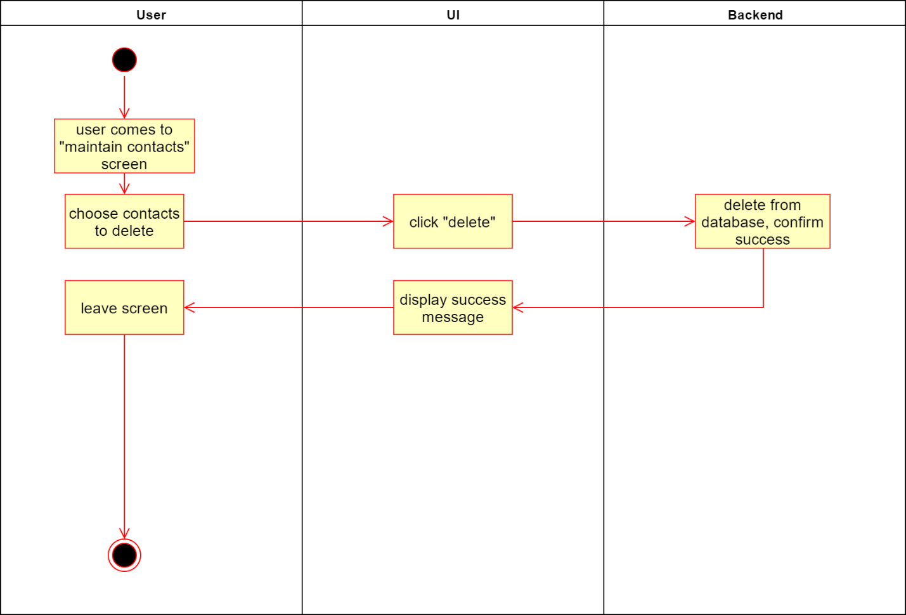

Special Requirements
User interface:
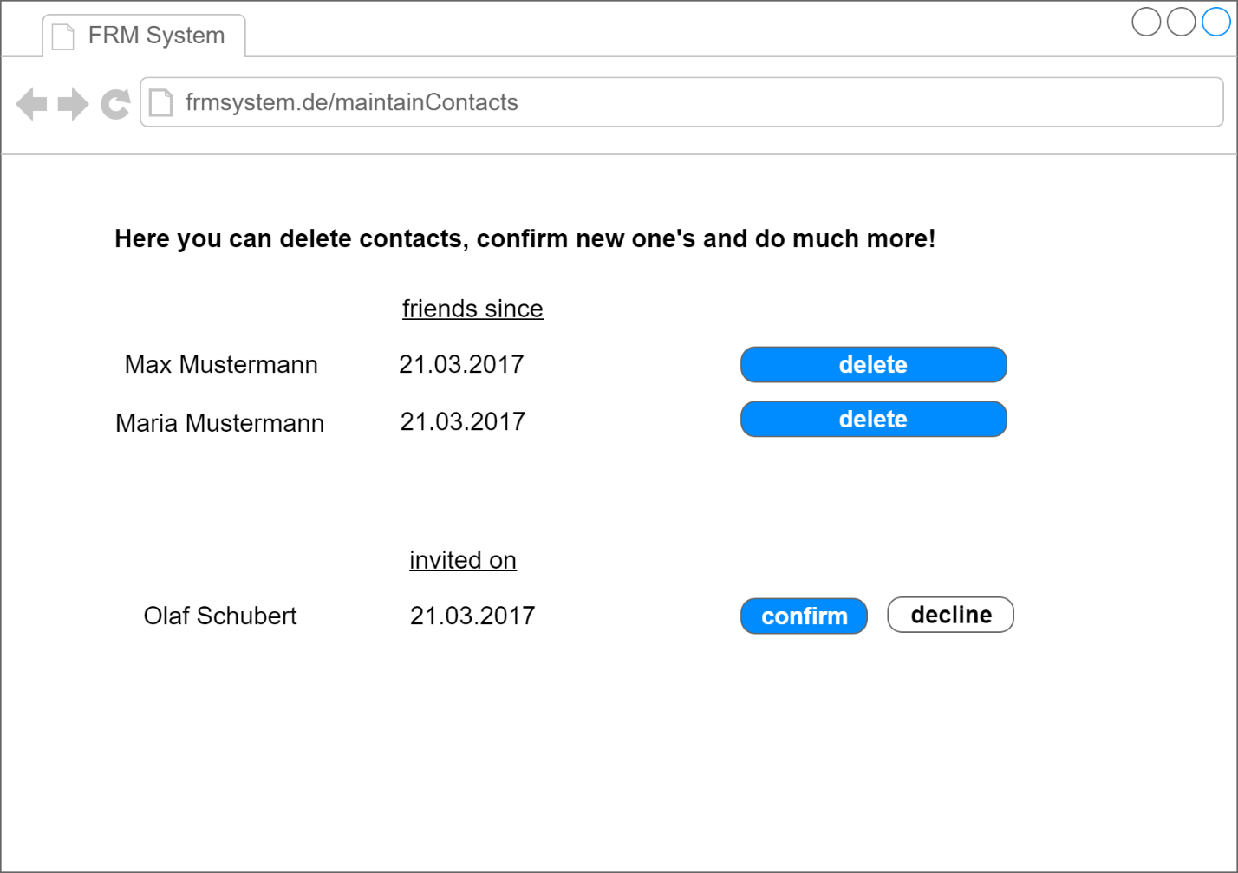

Transaction | Number of | Complexity | DET | RET | FTR | FP
External Inputs | 5 | low | 2 | 2 | 1 | 26
External Outputs | 1 | low
External Inquiries | 0 | low
Internal Logical Files | 1 | low
External Interface Files | 0 | low

Estimation overall: 9 hours

Preconditions

Postconditions

Extension Points

