FRM System
Use-Case Specification: Manage shared Information

Version 1.2
Revision History
Date | Version | Description | Author
04/06/17 | 1.0 | Creation of Document | Karl Spickermann

1. Register 4
1.1 Brief Description 4
1.2 Basic Flow 4
1.3 5
2. Special Requirements 6
2.1 Functionality 6
2.2 Usability 6
2.3 Reliability 6
2.4 Performance 6
2.5 SupporViewility 6
2.6 Design Constraints 6
2.7 On-line User Documentation and Help System Requirements 6
2.8 Purchased Components 6
2.9 Interfaces 6
3. Preconditions 7
3.1 Logged in on Website 7
4. Postconditions 7
5. Extension Points 7

Use-Case Specification: Manage shared Information

- Register
  - Brief Description
The purpose of this use case is to enable users to configure which of his information is visible to other group or contacts in the FRM system.
  - Basic Flow
Any user on the website will be able to click the “My Groups” button on his start page to visit the My Groups View. Here he/she can find a list of every group which he joined. Next to every group is an arrow to expand the view with a new menu. In this new menu, the user can configure which information should be shared with the selected group. The menu consists of a list of all the user information with buttons to either “show” or hide the information.
After clicking the “show” button, the system saves the changed settings in the database and the other users of the group can now view the information in the profile of the user.
After clicking the “hide” button, the system saves the changed settings in the database and other users of the group can no longer view the information in the profile of the user.
Any user on the website will be able to click the “My Contacts” button on his start page to visit the My Contacts View. Here he/she can find a list of every contact with which he engaged in a relationship. Next to every contact is an arrow to expand the view with a new menu. In this new menu, the user can configure which information should be shared with the selected contact. The menu consists of a list of all the user information with buttons to either “show” or hide the information.
After clicking the “show” button, the system saves the changed settings in the database and the contact can now view the information in the profile of the user.
After clicking the “hide” button, the system saves the changed settings in the database and the contact can no longer view the information in the profile of the user.
  - UML
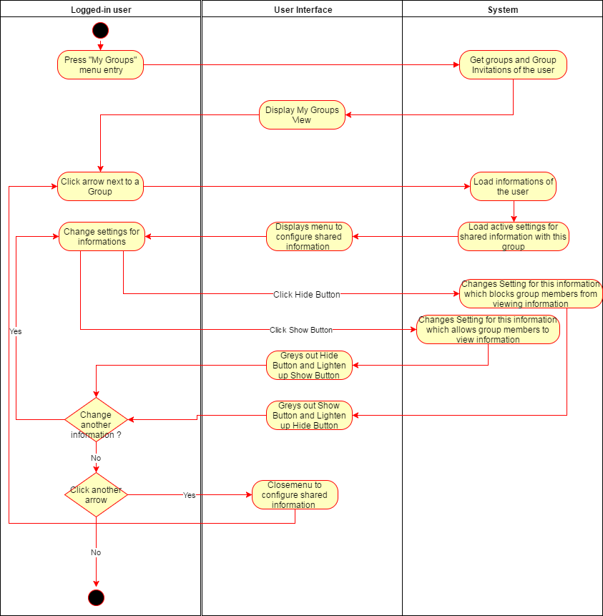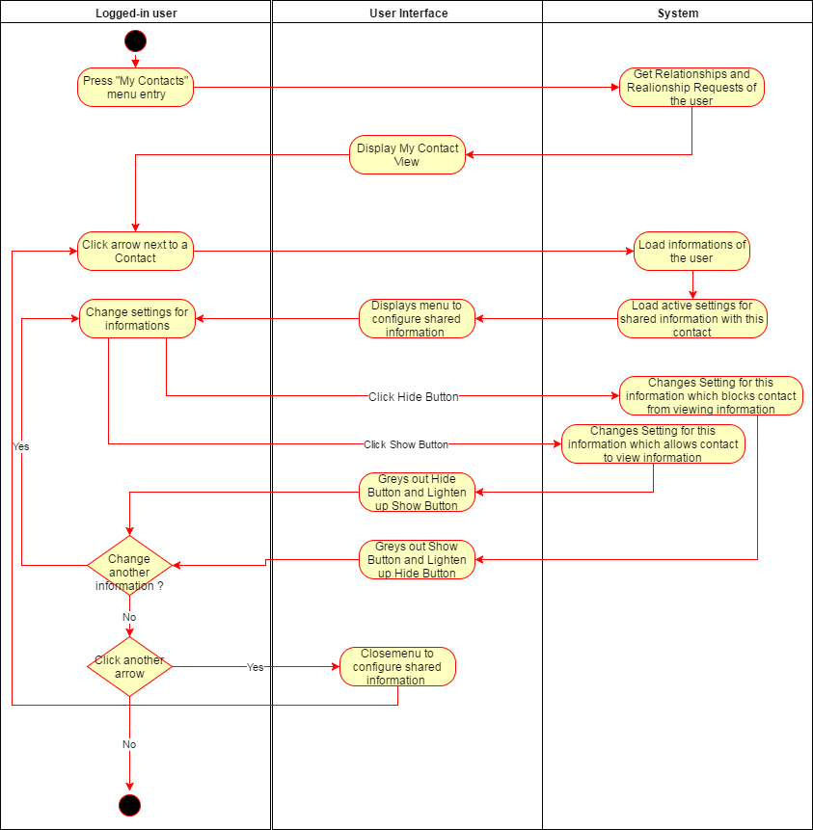

- Special Requirements
  - Functionality
  - Usability
  - Reliability
  - Performance
  - SupporViewility
  - Design Constraints
  - On-line User Documentation and Help System Requirements
  - Purchased Components
  - Interfaces

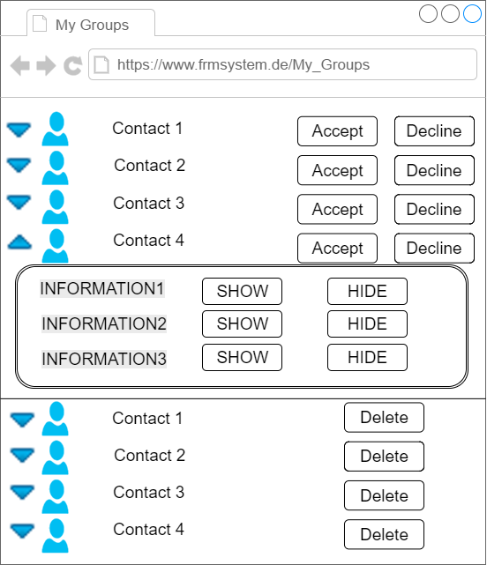
- Preconditions
  - Logged in on Website
The user must have a user on the FRM system. He has to be logged in and must have at least engaged in one relationship or joined one group from other users of the same FRM system.
- Postconditions
- Extension Points

