FRM System
Use-Case Specification: Create Group

Version 1.2
Revision History
Date | Version | Description | Author
04/06/17 | 1.0 | Creation of Document | Karl Spickermann

Viewle of Contents
1. Register 4
1.1 Brief Description 4
2. Flow of Events 4
2.1 Basic Flow 4
3. Special Requirements 6
3.1 Functionality 6
3.2 Usability 6
3.3 Reliability 6
3.4 Performance 6
3.5 SupporViewility 6
3.6 Design Constraints 6
3.7 On-line User Documentation and Help System Requirements 6
3.8 Purchased Components 6
3.9 Interfaces 6
4. Preconditions 7
4.1 Open Website 7
5. Postconditions 7
6. Extension Points 7

Use-Case Specification: Create Group

- Register
- 1.1 Brief Description
The purpose of this use case is to enable users to create new groups.
  - Basic Flow
Any user on the website will be able to click the “My Contacts” button on his start page to visit the My Contacts View. Here he/she can find a list of every contact with which he engaged in a relationship. Next to every contact is a checkbox. To create a group the user has to check the checkbox of one or more contacts. If at least one checkbox is clicked a “Create Group” button will be visible at the top of the view.
After clicking the “Create Group” button a popup will appear which asked the user for the settings for the group. The user can configure all settings and click the “Accept” button or he can click “Cancel”.
If he clicks Accept the the popup closes and the system creates a new group in the database and adds all contacts which checkboxes were clicked. After that all checkboxes will be automatically unchecked.
If he clicks Cancel the the popup closes.
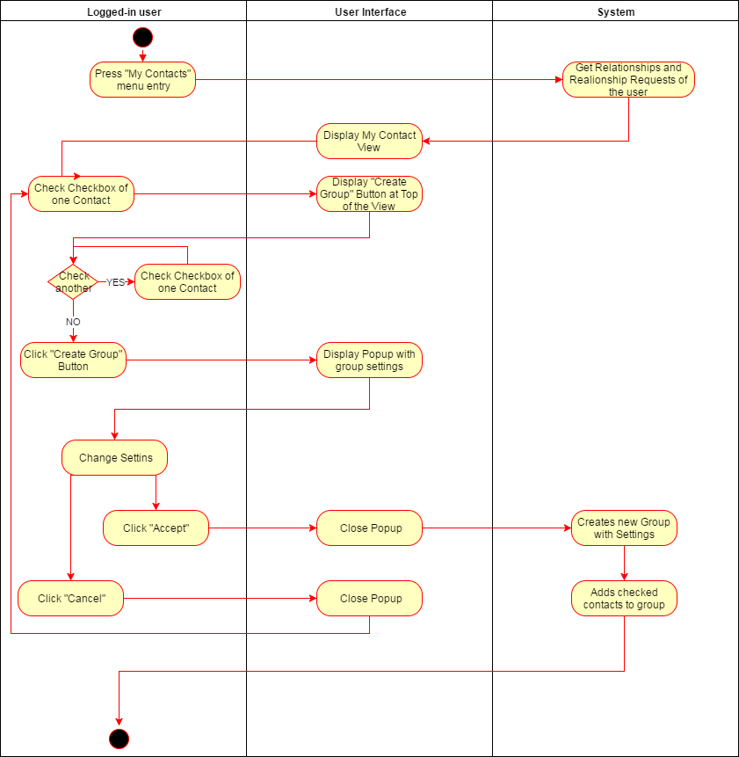

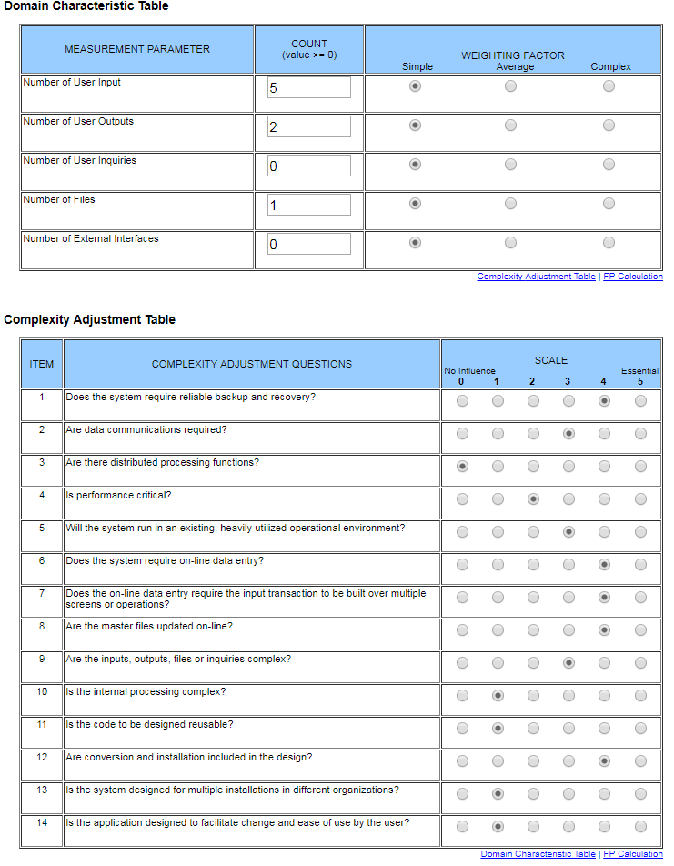
Function Points: 30

Special Requirements
- Functionality
- Usability
- Reliability
- Performance
- SupporViewility
- Design Constraints
- On-line User Documentation and Help System Requirements
- Purchased Components

- Interfaces
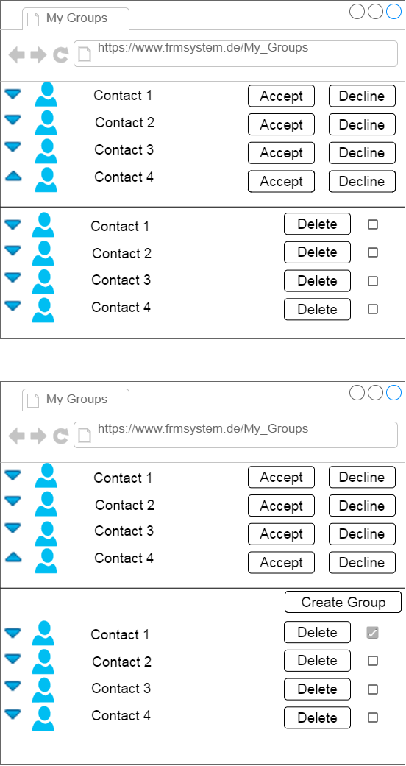
- Preconditions
- Logged in on Website
The user must have a user on the FRM system. He has to be logged in and must have been sent friendship requests or/and group invitations from other users of the same FRM system.
- Postconditions
- Extension Points

