FRM System
Show Relationship Information

Version 1.0

Revision History
Date | Version | Description | Author
10.04.2017 | 1.0 | Initial version | Daniel Wagner

Table of Contents
1. Use-Case Name 4
1.1 Brief Description 4
2. Flow of Events 4
2.1 Basic Flow 4
2.2 Alternative Flows 4
2.2.1 < First Alternative Flow > 4
2.2.2 < Second Alternative Flow > 4
3. Special Requirements 4
3.1 < First Special Requirement > 4
4. Preconditions 4
4.1 < Precondition One > 4
5. Postconditions 4
5.1 < Postcondition One > 4
6. Extension Points 4
6.1 <Name of Extension Point> 4
Use-Case Specification: <Use-Case Name>

- Use-Case Name
  - Brief Description
This usecase allows the user to take advantage of the previously engaged friendships or group relationships and view the contact information of the other member(s).
- Flow of Events
  - Basic Flow
To get to the information screen, the user can navigate through the dropdown menu at the top right. There will also be links to the screen at key positions like the start screen or from the “edit shared information”-screen, so that the information of the other person(s) in the relationship is easy to access. It will mostly be realized by making there names a link that leads to their profile specific page.
The only thing that the user can do from this screen in the currently planned scope, is to view the information. If there will be integrated support for other services like social networks (facebook) or integration of contact apps, the user would be able to access them from this screen. Also, the user can get to the screen, where he is able to edit the information, that he shares in this relationship from this screen.

Because there is nothing apart from viewing information, this document does not contain an activity diagram.

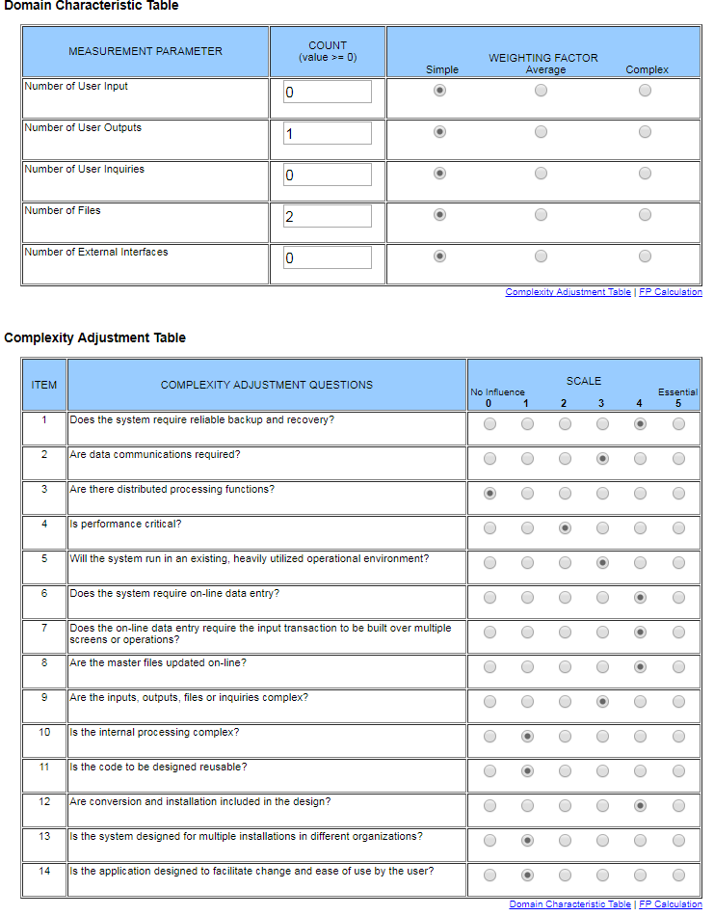

Function Points: 18

- Special Requirements
User Interface:
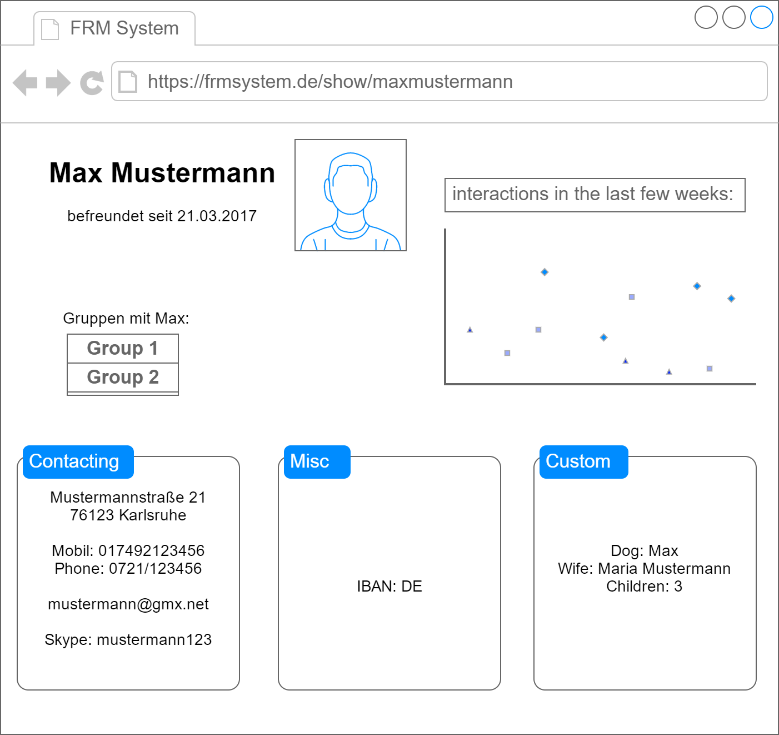
- Preconditions
- Postconditions
- Extension Points

