FRM System

Software Requirements Specification

Version 1.3

Revision History

|  |  |  |  |
| --- | --- | --- | --- |
| **Date** | **Version** | **Description** | **Author** |
| 22/10/2016 | 1.0 | initial version | Karl Spickermann |
| 11/11/2016 | 1.1 | formatting and content | Daniel Raiser |
| 12/11/2016 | 1.2 | formatting | Daniel Raiser |
| 12/12/2016 | 1.3 | updated OUCD | Daniel Wagner |

Table of Contents

1. Introduction 4

1.1 Purpose 4

1.2 Scope 4

1.3 Definitions, Acronyms, and Abbreviations 4

1.4 References 4

1.5 Overview 4

2. Overall Description 4

3. Specific Requirements 7

3.1 Functionality 7

3.1.1 Contact Management 7

3.1.2 Reports and Dashboards 7

3.1.3 Customizable HomeScreen 7

3.1.4 Chat integration 7

3.1.5 API Access 7

3.1.6 Email Integration 7

3.2 Usability 7

3.2.1 Using a browser 7

3.2.2 Contact Sharing 7

3.2.3 Setting up an account 7

3.3 Reliability 8

3.3.1 App availability 8

3.3.2 Mean Time Between Failures 8

3.3.3 Mean Time To Repair 8

3.3.4 Bugs 8

3.4 Performance 8

3.4.1 Capacity 8

3.4.2 Response time 8

3.5 Supportability 8

3.5.1 Language Support 8

3.5.2 Maintenance 8

3.6 Design Constraints 8

3.7 On-line User Documentation and Help System Requirements 9

3.8 Purchased Components 9

3.9 Interfaces 9

3.9.1 User Interfaces 9

3.9.2 Hardware Interfaces 9

3.9.3 Software Interfaces 9

3.9.4 Communications Interfaces 9

3.10 Licensing Requirements 9

3.11 Legal, Copyright, and Other Notices 9

3.12 Applicable Standards 9

4. Supporting Information 9

# Introduction

## Purpose

This SRS describes all specifications for the “Friend-Relationship-Management System”. The Friend-Relationship-Management System (FRM) will be an application that helps users who have many friends to manage their contacts and sensible contact information. We aim to invent a system that is the Outlook-Exchange address book for private persons with the maximum amount of control over your information. In this document the usage of the "FRM System"-web-application will be explained. Furthermore reliability, reaction speed and other important characteristics of this project will be specified. This includes design and architectural decisions regarding optimization of these criteria as well.

## Scope

This software specification applies to the whole "FRM System" web-application. The application provides all the features business people already know from their CRM Systems – for example contact management, reports and dashboards, customizable home screen, chat integration, API access and email Integration. All of this brought down to a user-friendly and uncomplicated level with easy access via internet browsers. The system will be set up in a way, that allows for expansion onto mobile platforms like Android and iOS with use of an applicable framework but it will not integrate these features from the beginning on.

## Definitions, Acronyms, and Abbreviations

UC Use Case

UCD Use Case Diagram

OUCD Overall Use Case Diagram

SAD Software Architecture Document

RFC Request for Comments

## References

|  |  |
| --- | --- |
| **Title** | **Date** |
| [FRM System Website](http://www.frmsystem.de) | 11/23/2016 |
| [FRM System Blog](http://wordpress.frm.bplaced.net/) | 10/24/2016 |

## Overview

The following chapters are about our vision and perspective, the requirements for deploying the software on our side and accessing the software on the user side, the demands we have, licensing and the technical realization of this project.

# Overall Description

Our goal is to make the application as secure and easy to use as possible. In a user-ready state we guarantee that all the sensible information that you store and share with our application is secure. The FRM System will be a place, where you can safely store addresses, bank account information, private telephone numbers and other information that you do not want to put on networks like Facebook but want to share with certain people.

What you can do once you uploaded your information is requesting certain information from other users. You can engage in a “friendship” with a person to e.g. get his address and to share yours. The other person will then receive an email, notifying him about your request. With one click on a link the user can share the requested information. Sharing more or less information than the person requested is of course possible as well, these settings can be handled all individually. Another useful feature are groups: To create a group you get everybody’s user name or email address and add them. When someone accepts the invitation, everybody in this group can access a certain level of information of this person. These individual relationships can also be edited individually on their own to extend the level of information that someone can view, as long as you are in a group relationship. The system will offer notifications for birthdays or custom alarms which remind you that you had no contact with someone for a long time. The system will also offer a basic messaging feature to make communication easier and more central if you wish to. If not you can still use services like Whatsapp and store the preferred way of communication in your profile, so everybody knows how you can be reached the fastest.

The picture on the following page shows the overall use case diagram for our software:

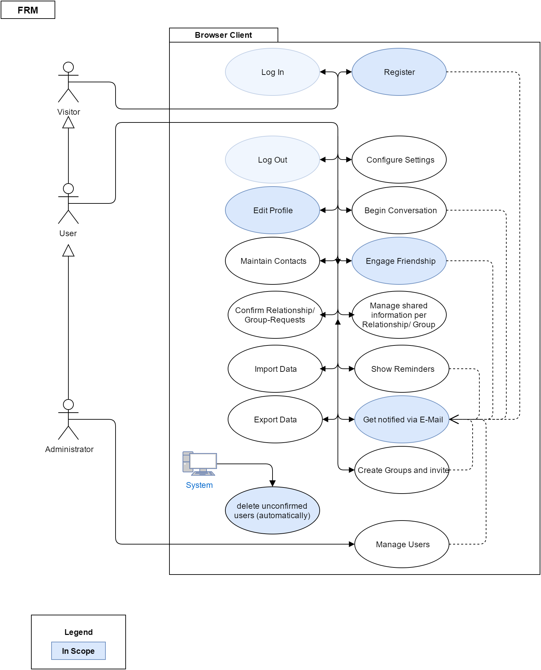

Use Cases:

[Register](https://github.com/d-wagner/frmsystem/blob/docs/docs/published/UC_Registration.pdf)

[Edit Profile](https://github.com/d-wagner/frmsystem/blob/docs/docs/published/UC_EditProfile.pdf)

Engage [Friendship](https://github.com/d-wagner/frmsystem/blob/docs/docs/published/UC_engageFriendship.pdf)

receive e-[mail](https://github.com/d-wagner/frmsystem/blob/docs/docs/published/receiveEmailNotification.pdf) notifications

[search for unconfirmed users](https://github.com/d-wagner/frmsystem/blob/docs/docs/published/UC_Cronjob.pdf)

# Specific Requirements

## Functionality

### Contact Management

This feature allows you to organize your contacts into groups and into any context that you see fit. Within this feature you can set up access to information on a contact-to-contact basis and see, who is able to access your information.

### Reports and Dashboards

Users can view statistics in a highly visual, engaging perspective using customized reports and dashboards. This is mainly used to see upcoming birthdays, the time when you last contacted persons and so on, but there will be many possible views to choose from.

### Customizable HomeScreen

The UI of the application is flexible enough to accommodate the visual perspective of everything including the home screen. Layouts can also be changed as well as colors based on preferences.

### Chat integration

You can chat with friends, partners and provide emotional support from the UI directly. We also aim to invent groupchats with several persons. The ability to message a person is also part of the preferences, you can change whether only friends or anyone can message you.

### API Access

Attach your FRM to various services that extend capabilities. In a release-ready state of the app you can integrate your contacts directly into the contacts app of your android phone, query the system for user information and user data etc.

### Email Integration

Pull in all the features and possibilities of your dedicated email client. We aim to integrate

a synchronization feature for outlook exchange active sync address books.

## Usability

### Using a browser

The user of our web application has to know how to open and operate a modern browser like Chrome, Firefox or Opera. He is free to use mobile versions as well since we will provide a mobile-friendly interface.

### Contact Sharing

One of the most important features for our user is to share information and add new contacts. The needed time for this needs to be as short as possible, ideally within the click of a link. The maximum needed time to form a request to another user should not exceed the time needed, to ask the other person via a social network to reveal the needed information (excluding the time to answer, since that is not a task for the user in the first place).

### Setting up an account

The time for this should not exceed the time needed on normal social networks, excluding the additional information that our system is able to store. The process should be simple and streamlined, it should be clear what has to be entered and what does not have to be entered.

## Reliability

### App availability

Our Service should ensure a 98% up-time. This is mainly depending on the ensured up-time by our serverhoster and the time needed to update and maintain the site

### Mean Time Between Failures

3 Months.

### Mean Time To Repair

The user needs the saved data in his everyday life, therefore a fix should not need more than 12 hours in severe cases.

### Bugs

The system should not contain bugs in critical areas where user data is handled or displayed, all data must be safe and bugs in the backend processing are not acceptable. Minor UI bugs are tolerable if they get fixed within a reasonable amount of time and are not mission-critical when it comes to safely handling user data.

## Performance

### Capacity

A limit of 1000 manageable contacts per user is planned. We plan to have a server ready, which can deal with at least 500 user at the start of the service without performance issues but plan to upgrade this quickly, depending on how frequented the service is

### Response time

The processing of user data and displaying it should not exceed maximum times of 1 second during normal use on average days and 2 seconds when displaying big amounts of data with many users online at the same time.

## Supportability

### Language Support

We will use following languages, which will be well supported in the future:

* PHP (Laravel)
* HTML
* CSS
* JavaScript
* MySQL

### Maintenance

Basic Maintenance access for administrators will be possible with a very basic web UI that serves as a utility and should be secure but does not need to be pretty. Access to the backend components and architecture will only be possible via heavily secured SSH access and secure FTP connections.

## Design Constraints

All information about the architectural design of our application stack can be found in our [technology and roles blog](http://frm.bplaced.net/wordpress/?p=32) entry, the main part being the server running the application

## On-line User Documentation and Help System Requirements

The whole application is programmed for an intuitive and easy use, so the user shouldn’t have any problems with controlling it. However, should there be problems with complicated features in the future, we will surely implement a help page in the app. We are also going to implement small tool tips or information texts on the page itself from the beginning on, to instruct the user what to do with as few words as possible. Furthermore we document all of the features on our own blog, on which users can find information and ask us questions.

## Purchased Components

To deploy the system we are renting a Server4you virtual server. Should we see the need in the future we can upgrade it to better specifications with the click of a button.

## Interfaces

### User Interfaces

tbd

### Hardware Interfaces

n/a

### Software Interfaces

tbd

### Communications Interfaces

n/a

## Licensing Requirements

At the time of writing this we don’t use any code which is subject to license requirements except for Open Source such as [Linux Debian](https://www.debian.org/legal/licenses/), [Apache License 2.0](http://www.apache.org/licenses/LICENSE-2.0) and so on.

## Legal, Copyright, and Other Notices

n/a

## Applicable Standards

* HTTP standards for communication client 🡨🡪 Server
* HTML and JavaScript / PHP Standards

# Supporting Information