FRM System

Version 1.0

Revision History

|  |  |  |  |
| --- | --- | --- | --- |
| **Date** | **Version** | **Description** | **Author** |
| 23/11/2016 | 1.0 | initial version | Daniel Wagner |
|  |  |  |  |
|  |  |  |  |
|  |  |  |  |

Table of Contents

1. Engage friendship 4

1.1 Brief Description 4

2. Flow of Events 4

2.1 Basic Flow 4

3. Special Requirements 4

4. Preconditions 4

5. Postconditions 4

6. Extension Points 4

# Engage friendship

## Brief Description

This is one of the basic functionalities of the system. The user can search for other users either with their name or e-mail address. He can then select a user from a list and send him a friendship invitation.

# Flow of Events

## Basic Flow

The user opens the “search” site to access this functionality. He then enters a name in the search fields and users that match the information that was entered and that allow other users to find them will be shown by the system. The user can then select one of them and hit “send friendship invitation”. The system will save this request and trigger an email notification for the other user.

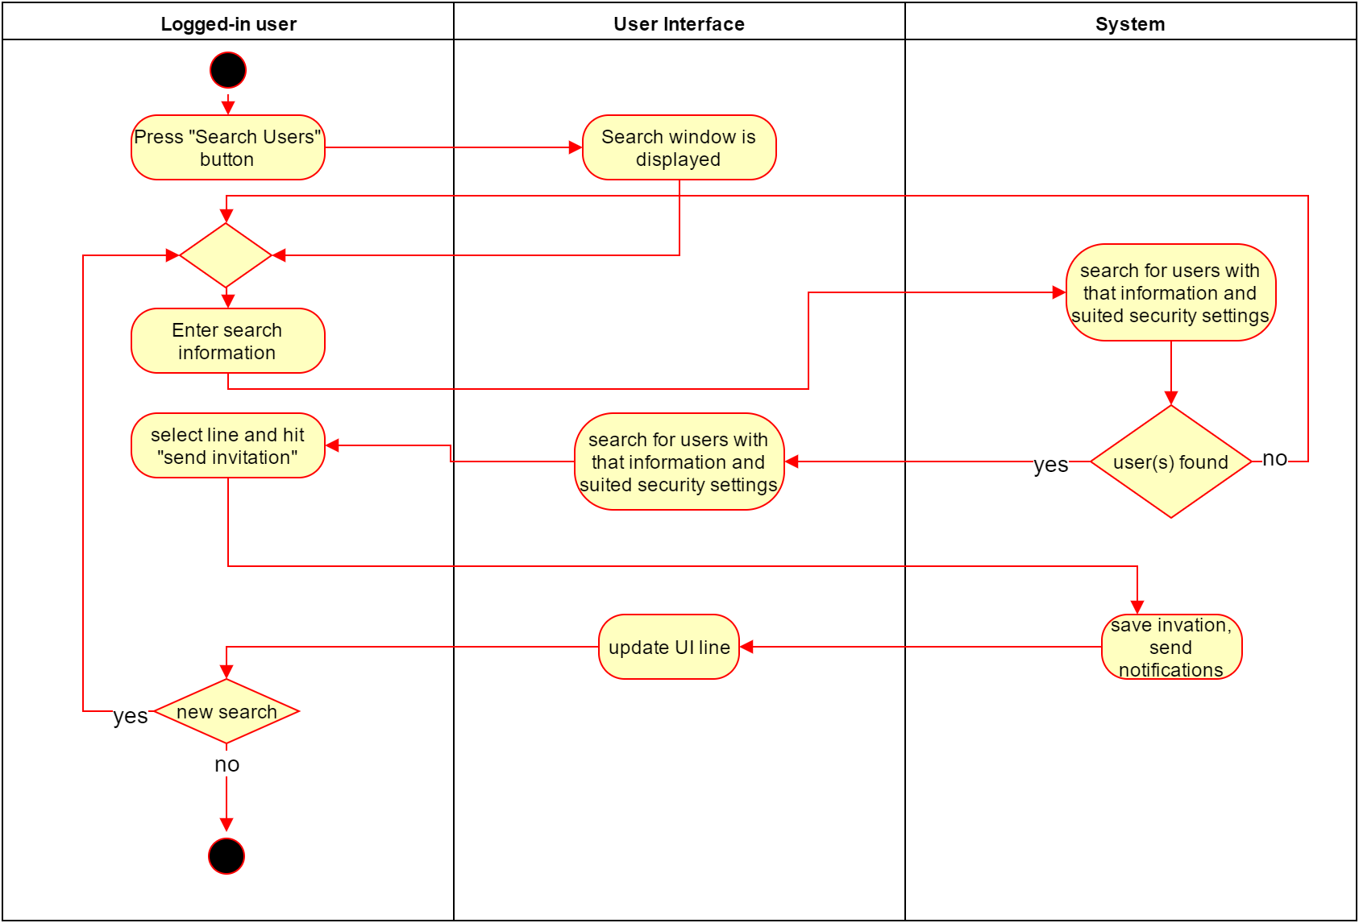

# 

Function Points: 35

# Special Requirements

# Preconditions

A precondition for engaging a relationship is, that there are profiles matching the information that the user has. Otherwise he cannot send an invitation. Also he is not allowed to send more than 5 request in a specified amount of time, to prevent spam

# Postconditions

# Extension Points