FRM System

Use-Case Specification: receive e-mail notification

Version 1.0

Revision History

|  |  |  |  |
| --- | --- | --- | --- |
| **Date** | **Version** | **Description** | **Author** |
| 23/11/2016 | 1.0 | initial version | Daniel Wagner |
|  |  |  |  |
|  |  |  |  |
|  |  |  |  |

Table of Contents

1. Receive e-mail notification 4

1.1 Brief Description 4

2. Flow of Events 4

2.1 Basic Flow 4

2.2 Alternative Flows 4

2.2.1 User setting is set to “do not send emails” 4

3. Special Requirements 5

4. Preconditions 5

5. Postconditions 5

6. Extension Points 5

Use-Case Specification: receive e-mail notification

# Receive e-mail notification

## Brief Description

This use-case will be invoked mainly in other use-cases where the system needs to inform the user of something. It will then send an e-mail to the address which the user confirmed upon registration. Receiving these notifications will be dependent on settings that the user can edit, to prohibit the system sending these. If the user chooses to not receive e-mails from the system in case of certain events, the system will not send him an e-mail.

# Flow of Events

## Basic Flow

Depending on what triggers the email notification, either a UI action or the system will trigger the system to send an email. The system will then look up whether the user chose to receive emails for this particular event that triggered the mail to be send. If the user did not switch off the option, the email will proceed to send an email. 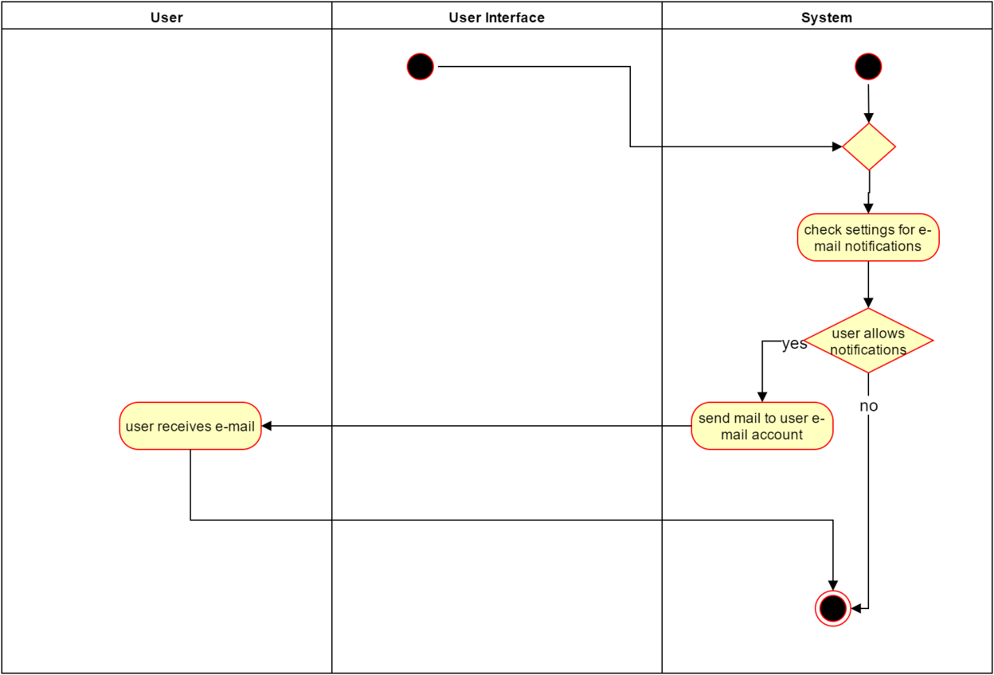

## 

Function Points: 23

## Alternative Flows

### User setting is set to “do not send emails”

In this case the email will not be sent.

# Special Requirements

# Preconditions

The precondition for receiving the e-mails is, that the users e-mail address that he confirmed upon registration is still valid. Otherwise the system will have trouble sending the mail. Also the use-case has to be triggered in other use-cases or functions of the system to start.

# Postconditions

# Extension Points