The influence of different autologous tendons on the recovery of knee muscle strength following anterior cruciate ligament reconstruction: a systematic review and network meta-analysis

Chengyu Liu ^{1,2, #}, Wenhao Lu ^{1,3, #}, Xu Liu ^{1,3}, Dongliang Yuan ^{1,3}, Zheping Hong ⁴, Qing Bi ⁴, Yusheng Li ^{1,3,*}, Wenfeng Xiao ^{1,3,*}

Author affiliations
1 Department of Orthopedics, Xiangya Hospital, Central South University, Changsha, China.
2 Xiangya School of Medicine, Central South University, Changsha, China
3 National Clinical Research Center for Geriatric Disorders, Xiangya Hospital, Central South University, Changsha, China.
4 Department of sports Medicine, Zhejiang Provincial People’s Hospital and People’s Hospital of Hangzhou Medical College, Hangzhou, Zhejiang, China.
# Chengyu Liu and Wenhao Lu contributed equally to this work.
* Correspondence to:
Yusheng Li: liyusheng@csu.edu.cn, Wenfeng xiao: xiaowenfeng@csu.edu.cn.
Supplementary files
Supplementary Figure 1: Quality assessment of the included randomized controlled trials
Supplementary Figure 2: Subgroup analysis of network analysis of knee extensor limb symmetry index (LSI) at 60 °/s
Supplementary Figure 3: Subgroup analysis of network analysis of knee extensor LSI at 180 °/s
Supplementary Figure 4: Subgroup analysis of network analysis of knee flexor LSI at 60 °/s
Supplementary Figure 5: Subgroup analysis of network analysis of knee flexor LSI at 180 °/s
Supplementary Figure 6: Network analysis of knee extensor peak torque at 60 °/s
Supplementary Figure 7: Network analysis of knee extensor peak torque at 180 °/s
Supplementary Figure 8: Network analysis of knee flexor peak torque at 60 °/s
Supplementary Figure 9: Network analysis of knee flexor peak torque at 180 °/s
Supplementary Figure 10: Network analysis of knee hamstring-to-quadriceps (H/Q) ratio at 60 °/s
Supplementary Figure 11: Network analysis of knee H/Q ratio at 180 °/s
Supplementary Figure 12: Network analysis of knee extensor side-to-side deficit at 60 °/s
Supplementary Figure 13: Network analysis of knee extensor side-to-side deficit at 180 °/s
Supplementary Figure 14: Network analysis of knee flexor side-to-side deficit at 60 °/s
Supplementary Figure 15: Network analysis of knee flexor side-to-side deficit at 180 °/s
Supplementary Figure 16: Assessment of publication bias
Supplementary Table 1: Detailed search entries for 4 databases from PubMed, Embase, Web of Science, and Cochrane Library.
Supplementary Table 2: The results of data extraction.
Supplementary Table 3: The reasons for exclusion from the study.
Supplementary Table 4: General information about included literature.
Supplementary Table 5: Risk of bias assessment for the included observational studies based on the Risk of Bias Assessment tool for Non-randomized Studies (RoBANS).
Supplementary Table 6: The Certainty of evidence of Studies implementing the Grading of Recommendations Assessment, Development and Evaluation (GRADE) approach.
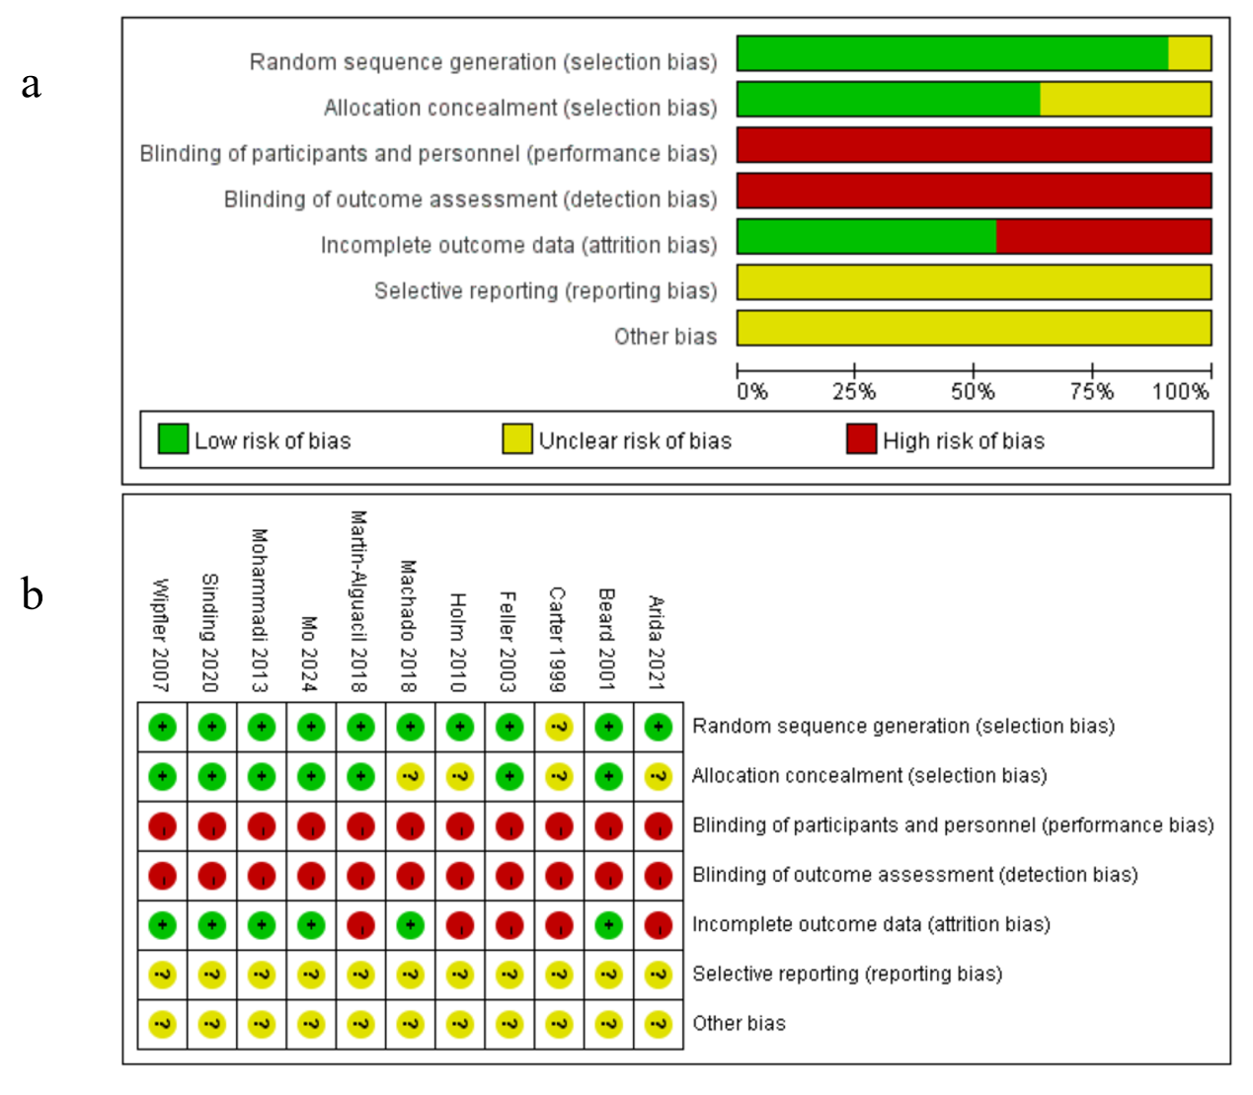
Supplementary Figure 1: Quality assessment of the included randomized controlled trial. (a) Risk of bias: independent reviewers’ judgments about each risk of bias item are presented as percentages across all included studies. (b) Risk of bias summary: independent reviewers’ judgments about each risk of bias item for each included study.

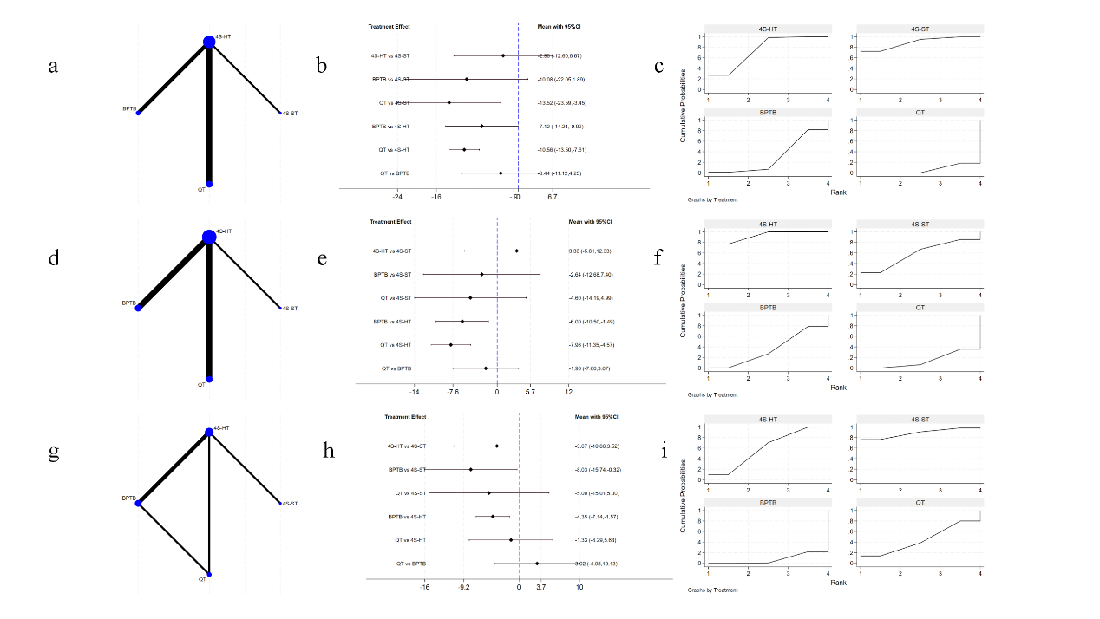
Supplementary Figure 2: Subgroup analysis of network analysis of knee extensor limb symmetry index (LSI) at 60 °/s. (a) Network map of knee extensor LSI at 60 °/s of Subgroup 1 (follow-up ≤ 6 months) (b) Forest plot (mean difference) of knee extensor LSI at 60 °/s of Subgroup 1 (follow-up ≤ 6 months) (c) Probability rankings of knee extensor LSI at 60 °/s Subgroup 1 (follow-up ≤ 6 months) (d) Network map of knee extensor LSI at 60 °/s of Subgroup 2 (6 - 12 months) (e) Forest plot (mean difference) of knee extensor LSI at 60 °/s of Subgroup 2 (6 - 12 months) (f) Probability rankings of knee extensor LSI at 60 °/s Subgroup 2 (6 - 12 months) (g) Network map of knee extensor LSI at 60 °/s of Subgroup 3 (follow-up ≥ 18 months) (h) Forest plot (mean difference) of knee extensor LSI at 60 °/s of Subgroup 3 (follow-up ≥ 18 months) (i) Probability rankings of knee extensor LSI at 60 °/s Subgroup 3 (follow-up ≥ 18 months). BPTB autograft, Bone-patella tendon-bone autograft, 4S-ST autograft, Four-strand semitendinosus tendon autograft, 4S-HT autograft, Four-strand hamstring tendon autograft, QT autograft, Quadriceps tendon autograft.

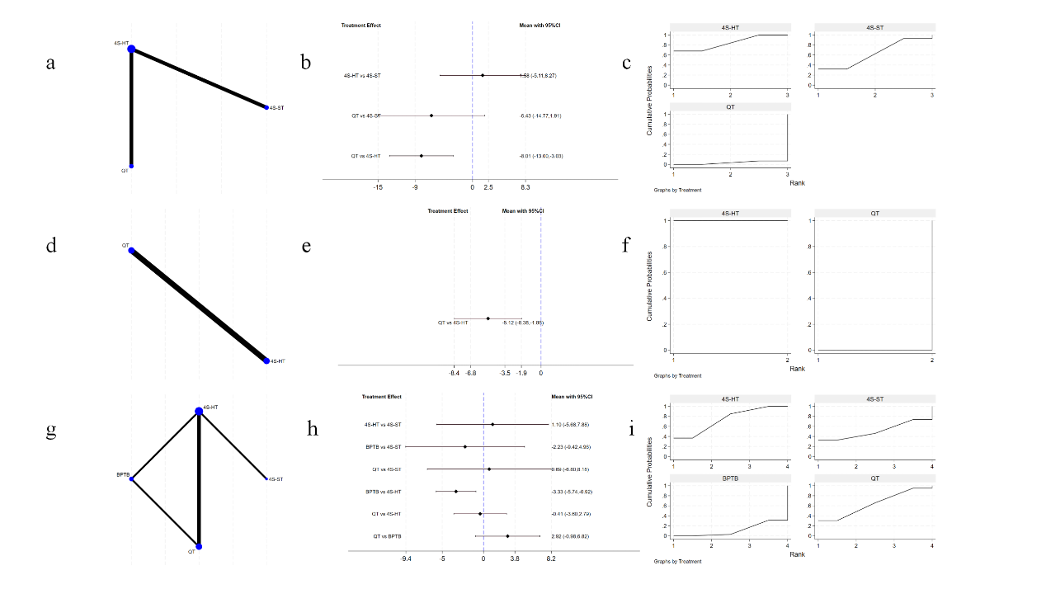
Supplementary Figure 3: Subgroup analysis of network analysis of knee extensor limb symmetry index (LSI) at 180 °/s. (a) Network map of knee extensor LSI at 180 °/s of Subgroup 1 (follow-up ≤ 6 months) (b) Forest plot (mean difference) of knee extensor LSI at 180 °/s of Subgroup 1 (follow-up ≤ 6 months) (c) Probability rankings of knee extensor LSI at 180 °/s Subgroup 1 (follow-up ≤ 6 months) (d) Network map of knee extensor LSI at 180 °/s of Subgroup 2 (6 - 12 months) (e) Forest plot (mean difference) of knee extensor LSI at 180 °/s of Subgroup 2 (6 -12 months) (f) Probability rankings of knee extensor LSI at 180 °/s Subgroup 2 (6 - 12 months) (g) Network map of knee extensor LSI at 180 °/s of Subgroup 3 (follow-up ≥ 18 months) (h) Forest plot (mean difference) of knee extensor LSI at 180 °/s of Subgroup 3 (follow-up ≥ 18 months) (i) Probability rankings of knee extensor LSI at 180 °/s Subgroup 3 (follow-up ≥ 18 months). BPTB autograft, Bone-patella tendon-bone autograft, 4S-ST autograft, Four-strand semitendinosus tendon autograft, 4S-HT autograft, Four-strand hamstring tendon autograft, QT autograft, Quadriceps tendon autograft.

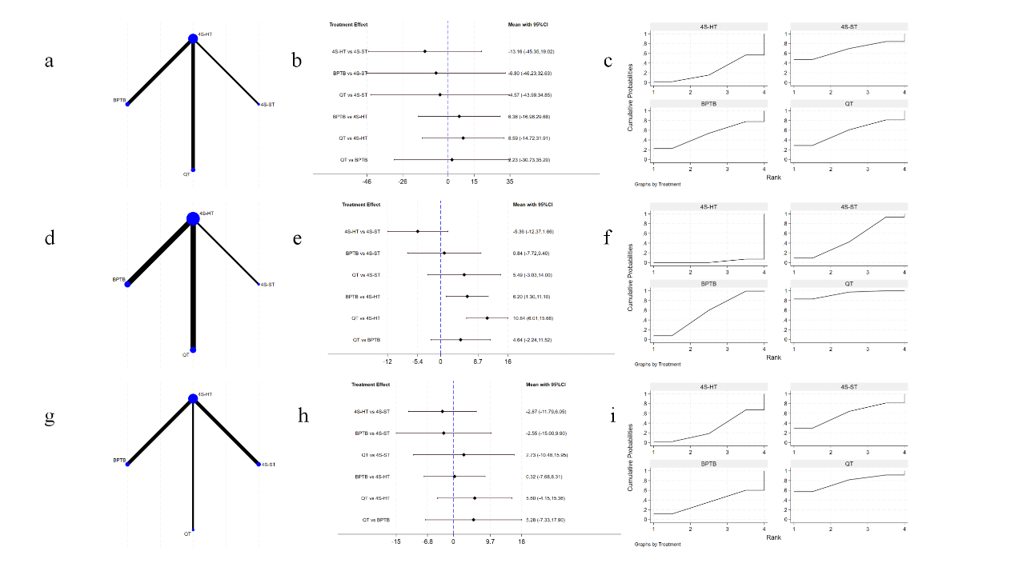
Supplementary Figure 4: Subgroup analysis of network analysis of knee flexor limb symmetry index (LSI) at 60 °/s. (a) Network map of knee flexor LSI at 60 °/s of Subgroup 1 (follow-up ≤ 6 months) (b) Forest plot (mean difference) of knee flexor LSI at 60 °/s of Subgroup 1 (follow-up ≤ 6 months) (c) Probability rankings of knee flexor LSI at 60 °/s Subgroup 1 (follow-up ≤ 6 months) (d) Network map of knee flexor LSI at 60 °/s of Subgroup 2 (6 - 12 months) (e) Forest plot (mean difference) of knee flexor LSI at 60 °/s of Subgroup 2 (6 - 12 months) (f) Probability rankings of knee flexor LSI at 60 °/s Subgroup 2 (6 - 12 months) (g) Network map of knee flexor LSI at 60 °/s of Subgroup 3 (follow-up ≥ 18 months) (h) Forest plot (mean difference) of knee flexor LSI at 60 °/s of Subgroup 3 (follow-up ≥ 18 months) (i) Probability rankings of knee flexor LSI at 60 °/s Subgroup 3 (follow-up ≥ 18 months). BPTB autograft, Bone-patella tendon-bone autograft, 4S-ST autograft, Four-strand semitendinosus tendon autograft, 4S-HT autograft, Four-strand hamstring tendon autograft, QT autograft, Quadriceps tendon autograft.

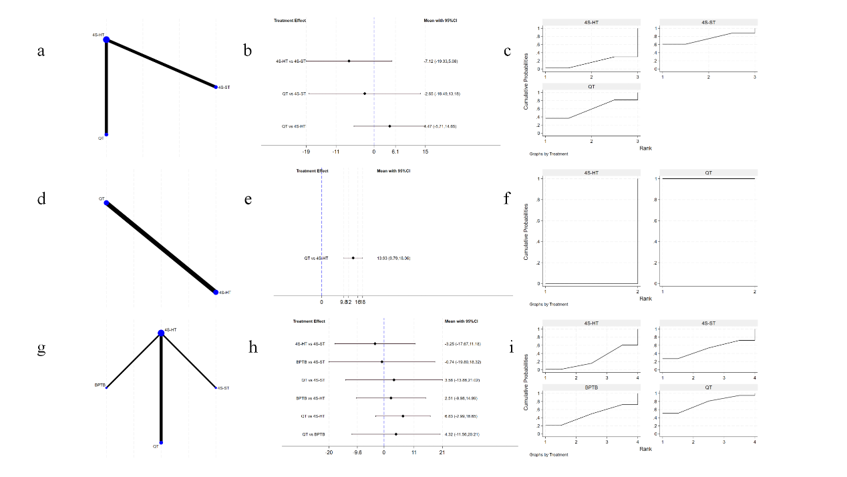
Supplementary Figure 5: Subgroup analysis of network analysis of knee flexor limb symmetry index (LSI) at 180 °/s. (a) Network map of knee flexor LSI at 180 °/s of Subgroup 1 (follow-up ≤ 6 months) (b) Forest plot (mean difference) of knee flexor LSI at 180 °/s of Subgroup 1 (follow-up ≤ 6 months) (c) Probability rankings of knee flexor LSI at 180 °/s Subgroup 1 (follow-up ≤ 6 months) (d) Network map of knee flexor LSI at 180 °/s of Subgroup 2 (6 - 12 months) (e) Forest plot (mean difference) of knee flexor LSI at 180 °/s of Subgroup 2 (6 - 12 months) (f) Probability rankings of knee flexor LSI at 180 °/s Subgroup 2 (6 - 12 months) (g) Network map of knee flexor LSI at 180 °/s of Subgroup 3 (follow-up ≥ 18 months) (h) Forest plot (mean difference) of knee flexor LSI at 180 °/s of Subgroup 3 (follow-up ≥ 18 months) (i) Probability rankings of knee flexor LSI at 180 °/s Subgroup 3 (follow-up ≥ 18 months). BPTB autograft, Bone-patella tendon-bone autograft, 4S-ST autograft, Four-strand semitendinosus tendon autograft, 4S-HT autograft, Four-strand hamstring tendon autograft, QT autograft, Quadriceps tendon autograft.

Supplementary Figure 6. Network analysis of knee extensor peak torque at 60 °/s. (a) Network map of knee extensor peak torque at 60 °/s. (b) Forest plot (mean difference) of knee extensor peak torque at 60 °/s. BPTB-auto, Bone-patella tendon-bone autograft, PT-auto, Patella tendon autograft without bone block, 4S-ST-auto, Four-strand semitendinosus tendon autograft, 5S-ST-auto, Five-strand semitendinosus tendon autograft, 4S-HT-auto, Four-strand hamstring tendon autograft, QT-auto, Quadriceps tendon autograft.

Supplementary Figure 7. Network analysis of knee extensor peak torque at 180 °/s. (a) Network map of knee extensor peak torque at 180 °/s. (b) Forest plot (mean difference) of knee extensor peak torque at 180 °/s. BPTB-auto, Bone-patella tendon-bone autograft, 4S-HT-auto, Four-strand hamstring tendon autograft, QT-auto, Quadriceps tendon autograft.

Supplementary Figure 8. Network analysis of knee flexor peak torque at 60 °/s. (a) Network map of knee flexor peak torque at 60 °/s. (b) Forest plot (mean difference) of knee flexor peak torque at 60 °/s. BPTB-auto, Bone-patella tendon-bone autograft, PT-auto, Patella tendon autograft without bone block, 4S-ST-auto, Four-strand semitendinosus tendon autograft, 4S-HT-auto, Four-strand hamstring tendon autograft, QT-auto, Quadriceps tendon autograft.

Supplementary Figure 9. Network analysis of knee flexor peak torque at 180 °/s. (a) Network map of knee flexor peak torque at 180 °/s. (b) Forest plot (mean difference) of knee flexor peak torque at 180 °/s. BPTB-auto, Bone-patella tendon-bone autograft, 4S-ST-auto, Four-strand semitendinosus tendon autograft, 5S-ST-auto, Five-strand semitendinosus tendon autograft, 4S-HT-auto, Four-strand hamstring tendon autograft, QT-auto, Quadriceps tendon autograft.

Supplementary Figure 10. Network analysis of knee hamstring-to-quadriceps (H/Q) ratio at 60 °/s. (a) Network map of knee H/Q ratio at 60 deg/. (b) Forest plot (mean difference) of knee H/Q ratio at 60 °/s. BPTB-auto, Bone-patella tendon-bone autograft, 4S-ST-auto, Four-strand semitendinosus tendon autograft, 4S-HT-auto, Four-strand hamstring tendon autograft, QT-auto, Quadriceps tendon autograft.

Supplementary Figure 11. Network analysis of knee hamstring-to-quadriceps (H/Q) ratio at 180 °/s. (a) Network map of knee H/Q ratio at 180 deg/. (b) Forest plot (mean difference) of knee H/Q ratio at 180 deg/. BPTB-auto, Bone-patella tendon-bone autograft, 4S-ST-auto, Four-strand semitendinosus tendon autograft, 4S-HT-auto, Four-strand hamstring tendon autograft, QT-auto, Quadriceps tendon autograft.

Supplementary Figure 12. Network analysis of knee extensor side-to-side deficit at 60 °/s. (a) Network map of knee extensor side-to-side deficit at 60 °/s. (b) Forest plot (mean difference) of knee extensor side-to-side deficit at 60 °/s. BPTB-auto, Bone-patella tendon-bone autograft, PT-auto, Patella tendon autograft without bone block, 4S-ST-auto, Four-strand semitendinosus tendon autograft, 4S-HT-auto, Four-strand hamstring tendon autograft, QT-auto, Quadriceps tendon autograft.

Supplementary Figure 13. Network analysis of knee extensor side-to-side deficit at 180 °/s. (a) Network map of knee extensor side-to-side deficit at 180 °/s. (b) Forest plot (mean difference) of knee extensor side-to-side deficit at 180 °/s. BPTB-auto, Bone-patella tendon-bone autograft, 4S-ST-auto, Four-strand semitendinosus tendon autograft, 4S-HT-auto, Four-strand hamstring tendon autograft, QT-auto, Quadriceps tendon autograft.

Supplementary Figure 14. Network analysis of knee flexor side-to-side deficit at 60 °/s. (a) Network map of knee flexor side-to-side deficit at 60 °/s. (b) Forest plot (mean difference) of knee flexor side-to-side deficit at 60 °/s. BPTB-auto, Bone-patella tendon-bone autograft, PT-auto, Patella tendon autograft without bone block, 4S-ST-auto, Four-strand semitendinosus tendon autograft, 4S-HT-auto, Four-strand hamstring tendon autograft, QT-auto, Quadriceps tendon autograft.

Supplementary Figure 15. Network analysis of knee flexor side-to-side deficit at 180 °/s. (a) Network map of knee flexor side-to-side deficit at 180 °/s. (b) Forest plot (mean difference) of knee flexor side-to-side deficit at 180 °/s. BPTB-auto, Bone-patella tendon-bone autograft, 4S-ST-auto, Four-strand semitendinosus tendon autograft, 4S-HT-auto, Four-strand hamstring tendon autograft, QT-auto, Quadriceps tendon autograft.

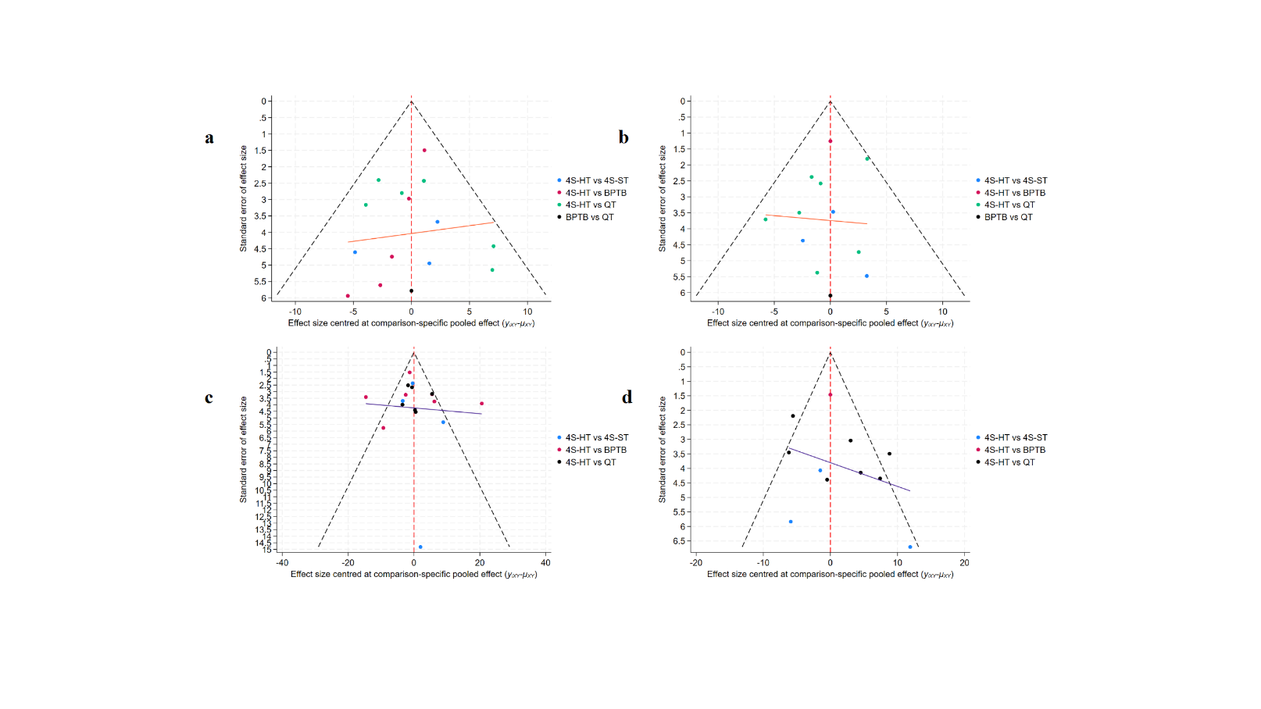
Supplementary Figure 16. Assessment of publication bias. a, extensor Limb symmetry index (LSI) at 60 °/s, b, extensor LSI at 180 °/s, c, flexor LSI at 60 °/s, d, flexor LSI at 180 °/s. BPTB autograft, Bone-patella tendon-bone autograft, 4S-ST autograft, Four-strand semitendinosus tendon autograft, 4S-HT autograft, Four-strand hamstring tendon autograft, QT autograft, Quadriceps tendon autograft.
Supplementary Table 1: Detailed search entries for 4 databases from PubMed, Embase, Web of Science, and Cochrane Library.
(("randomized controlled trial"[pt] OR "controlled clinical trial"[pt] OR randomized[tiab] OR placebo[tiab] OR "drug therapy"[sh] OR randomly[tiab] OR trial[tiab] OR groups[tiab]) OR ("cohort studies"[mesh] OR "case-control studies"[mesh] OR "comparative study"[pt] OR "risk factors"[mesh] OR "cohort"[tw] OR "compared"[tw] OR "groups"[tw] OR "case control"[tw] OR "multivariate"[tw])) AND ("Anterior Cruciate Ligament Reconstruction"[MeSH Terms] AND ("Muscle Strength"[MeSH Terms] OR ("strength muscle"[All Fields] OR "Arthrogenic Muscle Inhibition"[All Fields] OR ("Muscle Strength"[MeSH Terms] OR ("muscle"[All Fields] AND "strength"[All Fields]) OR "Muscle Strength"[All Fields] OR ("arthrogenic"[All Fields] AND "muscle"[All Fields] AND "inhibitions"[All Fields])) OR "inhibition arthrogenic muscle"[All Fields] OR "muscle inhibition arthrogenic"[All Fields])) AND ("Autografts"[MeSH Terms] OR ("Autograft"[All Fields] OR "Autologous Transplants"[All Fields] OR "Autologous Transplant"[All Fields] OR "transplant autologous"[All Fields] OR "transplants autologous"[All Fields] OR "Autotransplants"[All Fields] OR "Autotransplant"[All Fields]) OR ("quadriceps autograft"[All Fields] OR "quadriceps tendon"[All Fields] OR "QT"[All Fields] OR "patellar autograft"[All Fields] OR "patellar tendon"[All Fields] OR "PT"[All Fields] OR "semitendinosus-gracilis autograft"[All Fields] OR "semitendinosus-gracilis tendon"[All Fields] OR "STG"[All Fields] OR "semitendinosus autograft"[All Fields] OR "semitendinosus tendon"[All Fields] OR "ST"[All Fields] OR "hamstring autograft"[All Fields] OR "hamstring tendon"[All Fields] OR "HT"[All Fields]))) | PubMed
(('randomized controlled trial'/exp OR 'randomized controlled trial' OR 'controlled clinical trial'/exp OR 'controlled clinical trial' OR randomized:ti,ab OR placebo:ti,ab OR 'drug therapy':lnk OR randomly:ti,ab OR trial:ti,ab OR groups:ti,ab) OR ('clinical article'/exp OR 'controlled study'/exp OR 'major clinical study'/exp OR 'prospective study'/exp OR 'cohort analysis'/exp OR 'cohort':ti,ab OR 'compared':ti,ab OR 'groups':ti,ab OR 'case control':ti,ab OR 'multivariate':ti,ab)) AND (('acl reconstruction'/exp OR 'acl reconstruction' OR 'acl repair'/exp OR 'acl repair' OR 'acl surgery'/exp OR 'acl surgery' OR 'anterior cruciate ligament repair'/exp OR 'anterior cruciate ligament repair' OR 'anterior cruciate ligament surgery'/exp OR 'anterior cruciate ligament surgery' OR 'anterior cruciate ligament reconstruction'/exp OR 'anterior cruciate ligament reconstruction') AND ('dynamic strength, muscle'/exp OR 'dynamic strength, muscle' OR 'dynamic strength, muscular'/exp OR 'dynamic strength, muscular' OR 'force, muscle'/exp OR 'force, muscle' OR 'muscle dynamic strength'/exp OR 'muscle dynamic strength' OR 'muscle force'/exp OR 'muscle force' OR 'muscle force velocity relationship'/exp OR 'muscle force velocity relationship' OR 'muscle power'/exp OR 'muscle power' OR 'muscular dynamic strength'/exp OR 'muscular dynamic strength' OR 'muscular force'/exp OR 'muscular force' OR 'muscular power'/exp OR 'muscular power' OR 'muscular strength'/exp OR 'muscular strength' OR 'strength, muscle'/exp OR 'strength, muscle' OR 'muscle strength'/exp OR 'muscle strength') AND (('autogenous graft'/exp OR 'autogenous graft' OR 'autografts'/exp OR 'autografts' OR 'autotransplant'/exp OR 'autotransplant' OR 'autotransplants'/exp OR 'autotransplants' OR 'graft, auto'/exp OR 'graft, auto' OR 'autograft'/exp OR 'autograft') OR ('quadriceps autograft' OR 'quadriceps tendon'/exp OR 'quadriceps tendon' OR 'qt' OR 'patellar autograft' OR 'patellar tendon'/exp OR 'patellar tendon' OR 'pt' OR 'semitendinosus-gracilis autograft' OR 'semitendinosus-gracilis tendon' OR 'stg' OR 'semitendinosus autograft' OR 'semitendinosus tendon'/exp OR 'semitendinosus tendon' OR 'st'/exp OR 'st' OR 'hamstring autograft'/exp OR 'hamstring autograft' OR 'hamstring tendon'/exp OR 'hamstring tendon' OR 'ht'))) | Embase
(TS=("randomized controlled trial" OR "controlled clinical trial" OR randomized OR placebo OR "drug therapy" OR randomly OR trial OR groups) OR TS=("cohort studies" OR "case-control studies" OR "comparative study" OR "risk factors" OR "cohort" OR "compared" OR "groups" OR "case control" OR "multivariate")) AND ((TS=(Anterior Cruciate Ligament Reconstruction)) AND ((TS=(Muscle Strength)) OR (TS=("Strength, Muscle" OR "Arthrogenic Muscle Inhibition" OR "Arthrogenic Muscle Inhibitions" OR "Inhibition, Arthrogenic Muscle" OR "Muscle Inhibition, Arthrogenic"))) AND ((TS=("quadriceps autograft" OR "quadriceps tendon" OR "QT" OR "patellar autograft" OR "patellar tendon" OR "PT" OR "semitendinosus-gracilis autograft" OR "semitendinosus-gracilis tendon" OR "STG" OR "semitendinosus autograft" OR "semitendinosus tendon" OR "ST" OR "hamstring autograft" OR "hamstring tendon" OR "HT")) OR ((TS=(Autografts)) OR (TS=("Autograft" OR "Autologous Transplants" OR "Autologous Transplant" OR "Transplant, Autologous" OR "Transplants, Autologous" OR "Autotransplants" OR "Autotransplant"))))) | Web of Science
((MeSH descriptor: [Anterior Cruciate Ligament Reconstruction] explode all trees) AND (MeSH descriptor: [Muscle Strength] explode all trees) AND ((MeSH descriptor: [Autografts] explode all trees) OR (MeSH descriptor: [Patellar Ligament] explode all trees) OR (MeSH descriptor: [Hamstring Tendons] explode all trees) OR((quadriceps autograft) OR (quadriceps tendon) OR (QT) OR (patellar autograft) OR (patellar tendon) OR (PT) OR (semitendinosus-gracilis autograft) OR (semitendinosus-gracilis tendon) OR (STG) OR (semitendinosus autograft) OR (semitendinosus tendon) OR (ST) OR (hamstring autograft) OR (hamstring tendon) OR (HT)))) AND (("randomized controlled trial" OR "controlled clinical trial" OR randomized OR placebo OR "drug therapy" OR randomly OR trial OR groups) OR ("cohort studies" OR "case-control studies" OR "comparative study" OR "risk factors" OR "cohort" OR "compared" OR "groups" OR "case control" OR "multivariate")) | Cochrane Library

Supplementary Table 2: The results of data extraction.
Study number* | Type of tendon graft | Mean | Standard deviations (SD) | N
Extensor limb symmetry index (LSI) at 60 °/s (follow-up time ≤ 6 months)
8 | BPTB autograft | 76.8 | 15.3 | 17
8 | 4S-HT autograft | 83.5 | 16.7 | 32
11 | 4S-ST autograft | 98.2 | 24.3 | 41
11 | 4S-HT autograft | 95.2 | 20.3 | 41
15 | QT autograft | 70.4 | 14.2 | 61
15 | 4S-HT autograft | 82.2 | 12.5 | 63
19 | QT autograft | 84.7 | 11.2 | 33
19 | 4S-HT autograft | 92.6 | 11.7 | 65
20 | BPTB autograft | 74.9 | 25.3 | 25
20 | 4S-HT autograft | 82.6 | 13.7 | 32
25 | QT autograft | 70.1 | 15.6 | 37
25 | 4S-HT autograft | 83 | 15.9 | 74
Extensor LSI at 60 °/s (6 months < follow-up time ≤ 12 months)
4 | QT autograft | 74 | 13.6 | 43
4 | 4S-HT autograft | 83.8 | 12.2 | 42
8 | BPTB autograft | 76.8 | 15.3 | 17
8 | 4S-HT autograft | 83.5 | 16.7 | 32
19 | QT autograft | 84.7 | 11.2 | 33
19 | 4S-HT autograft | 92.6 | 11.7 | 65
20 | BPTB autograft | 74.9 | 25.3 | 25
20 | 4S-HT autograft | 82.6 | 13.7 | 32
23 | QT autograft | 71.9 | 24.4 | 48
23 | 4S-HT autograft | 73.9 | 26 | 48
28 | BPTB autograft | 86.66 | 10.5 | 31
28 | 4S-HT autograft | 91.9 | 12.8 | 31
30 | 4S-ST autograft | 74.9 | 16.7 | 44
30 | 4S-HT autograft | 78.3 | 24.7 | 41
Extensor LSI at 60 °/s (follow-up time ≥ 18 months)
3 | BPTB autograft | 74 | 20 | 15
3 | QT autograft | 78 | 13 | 25
13 | 4S-ST autograft | 86.8 | 14.9 | 49
13 | 4S-HT autograft | 83.1 | 15 | 25
17 | BPTB autograft | 90.3 | 12.4 | 175
17 | 4S-HT autograft | 94.2 | 12.4 | 113
22 | BPTB autograft | 89.6 | 10.3 | 28
22 | 4S-HT autograft | 100.1 | 30.2 | 29
23 | QT autograft | 81 | 17.7 | 48
23 | 4S-HT autograft | 82.9 | 25 | 48
Extensor LSI at 180 °/s (follow-up time ≤ 6 months)
11 | 4S-HT autograft | 101.2 | 24.7 | 41
11 | 4S-ST autograft | 103.1 | 24.9 | 41
16 | 4S-ST autograft | 74.3 | 20.3 | 33
16 | 4S-HT autograft | 78.1 | 15.2 | 35
19 | QT autograft | 79.3 | 17.7 | 33
19 | 4S-HT autograft | 88.9 | 16.6 | 65
31 | 4S-HT autograft | 88.7 | 14 | 40
31 | QT autograft | 82.1 | 16 | 35
Extensor LSI at 180 °/s (6 months < follow-up time ≤ 12 months)
3 | BPTB autograft | 76 | 22 | 15
3 | QT autograft | 82 | 11 | 25
9 | QT autograft | 87.64 | 5.9 | 22
9 | 4S-HT autograft | 88.19 | 6.75 | 27
13 | 4S-ST autograft | 88.4 | 14.5 | 49
13 | 4S-HT autograft | 89.5 | 13.9 | 25
17 | BPTB autograft | 91.5 | 10.2 | 175
17 | 4S-HT autograft | 94.7 | 10.5 | 113
23 | QT autograft | 83.8 | 17.8 | 48
23 | 4S-HT autograft | 85.1 | 27.5 | 48
Extensor LSI at 180 °/s (follow-up time ≥ 18 months)
3 | BPTB autograft | 76 | 22 | 15
3 | QT autograft | 82 | 11 | 25
9 | QT autograft | 87.64 | 5.9 | 22
9 | 4S-HT autograft | 88.19 | 6.75 | 27
13 | 4S-ST autograft | 88.4 | 14.5 | 49
13 | 4S-HT autograft | 89.5 | 13.9 | 25
17 | BPTB autograft | 91.5 | 10.2 | 175
17 | 4S-HT autograft | 94.7 | 10.5 | 113
23 | QT autograft | 83.8 | 17.8 | 48
23 | 4S-HT autograft | 85.1 | 27.5 | 48
Flexor LSI at 60 °/s (follow-up time ≤ 6 months)
8 | BPTB autograft | 89.8 | 12.3 | 17
8 | 4S-HT autograft | 65.9 | 14.2 | 32
11 | 4S-HT autograft | 105.6 | 19 | 41
11 | 4S-ST autograft | 120.3 | 28.3 | 41
15 | QT autograft | 93.6 | 13.4 | 61
15 | 4S-HT autograft | 86.3 | 14.6 | 63
19 | QT autograft | 95.7 | 21.4 | 33
19 | 4S-HT autograft | 86.1 | 21 | 65
20 | BPTB autograft | 76 | 11.9 | 25
20 | 4S-HT autograft | 87.3 | 13.8 | 32
Flexor LSI at 60 °/s (6 months < follow-up time ≤ 12 months)
4 | QT autograft | 95.9 | 15.4 | 43
4 | 4S-HT autograft | 81.3 | 13.8 | 42
8 | BPTB autograft | 98.2 | 11.2 | 17
8 | 4S-HT autograft | 88.7 | 14.6 | 32
19 | QT autograft | 97.8 | 12.9 | 33
19 | 4S-HT autograft | 89.3 | 11.6 | 65
20 | BPTB autograft | 92.8 | 12.4 | 25
20 | 4S-HT autograft | 92 | 11.8 | 32
23 | QT autograft | 87 | 15.7 | 48
23 | 4S-HT autograft | 77.6 | 26.1 | 48
28 | BPTB autograft | 99.14 | 15.9 | 31
28 | 4S-HT autograft | 90.34 | 7.98 | 31
30 | 4S-ST autograft | 85.3 | 15.4 | 44
30 | 4S-HT autograft | 79.9 | 2.9 | 41
Flexor LSI at 60 °/s (follow-up time ≥ 18 months)
2 | 4S-ST autograft | 85.8 | 30 | 10
2 | 4S-HT autograft | 78 | 36 | 10
13 | 4S-ST autograft | 93.7 | 12.8 | 49
13 | 4S-HT autograft | 91.3 | 16.1 | 25
17 | BPTB autograft | 98.5 | 12.4 | 175
17 | 4S-HT autograft | 96.5 | 12.9 | 113
22 | BPTB autograft | 92 | 12 | 28
22 | 4S-HT autograft | 98 | 28.5 | 29
23 | QT autograft | 92.2 | 17 | 48
23 | 4S-HT autograft | 86.6 | 21.8 | 48
Flexor LSI at 180 °/s (follow-up time ≤ 6 months)
11 | 4S-HT autograft | 106.2 | 24.6 | 41
11 | 4S-ST autograft | 122.9 | 35.2 | 41
16 | 4S-ST autograft | 80.6 | 28.3 | 33
16 | 4S-HT autograft | 81.7 | 18.5 | 35
19 | QT autograft | 97.5 | 18.2 | 33
19 | 4S-HT autograft | 90 | 24.5 | 65
31 | 4S-HT autograft | 95.8 | 16.2 | 40
31 | QT autograft | 97.6 | 13.7 | 35
Flexor LSI at 180 °/s (6 months < follow-up time ≤ 12 months)
4 | QT autograft | 100.2 | 14.9 | 43
4 | 4S-HT autograft | 83.4 | 17.2 | 42
19 | QT autograft | 100 | 15.2 | 33
19 | 4S-HT autograft | 89 | 12.1 | 65
23 | QT autograft | 94.6 | 17.1 | 48
23 | 4S-HT autograft | 79.2 | 24.8 | 48
Flexor LSI at 180 °/s (follow-up time ≥ 18 months)
9 | QT autograft | 89.14 | 7.34 | 22
9 | 4S-HT autograft | 86.73 | 7.99 | 27
13 | 4S-ST autograft | 89.4 | 14.3 | 49
13 | 4S-HT autograft | 86.1 | 17.6 | 25
17 | BPTB autograft | 97.5 | 11.8 | 175
17 | 4S-HT autograft | 95 | 12.3 | 113
23 | QT autograft | 99.6 | 15 | 48
23 | 4S-HT autograft | 87.1 | 24.5 | 48
Extensor peak torque at 60 °/s
1 | BPTB autograft | 153.17 | 50.84 | 29
1 | 4S-HT autograft | 138.08 | 48.91 | 24
5 | 4S-ST autograft | 189.1 | 43.6 | 60
5 | 4S-HT autograft | 183.5 | 46.9 | 60
6 | BPTB autograft | 198 | 34 | 24
6 | 4S-HT autograft | 213 | 46 | 27
7 | BPTB autograft | 123.12 | 41.24 | 17
7 | 4S-HT autograft | 116.24 | 43.15 | 17
14 | PT autograft | 107 | 32 | 30
14 | 4S-HT autograft | 105 | 30 | 30
15 | QT autograft | 123.9 | 40.2 | 61
15 | 4S-HT autograft | 144.3 | 40.7 | 63
17 | BPTB autograft | 159 | 53 | 175
17 | 4S-HT autograft | 173 | 53 | 113
19 | QT autograft | 166.3 | 34.8 | 33
19 | 4S-HT autograft | 170.1 | 37.6 | 65
26 | QT autograft | 139.5 | 47.3 | 19
26 | 5S-ST autograft | 144.94 | 51.4 | 18
27 | BPTB autograft | 160 | 21 | 21
27 | 4S-HT autograft | 180 | 19 | 21
Extensor peak torque at 180 °/s
1 | BPTB autograft | 109.9 | 33.52 | 29
1 | 4S-HT autograft | 99.79 | 30.32 | 24
6 | BPTB autograft | 142 | 26 | 24
6 | 4S-HT autograft | 149 | 29 | 27
7 | BPTB autograft | 105.82 | 31.7 | 17
7 | 4S-HT autograft | 96.76 | 31.71 | 17
17 | BPTB autograft | 121 | 38 | 175
17 | 4S-HT autograft | 129 | 40 | 113
19 | QT autograft | 126.1 | 31.2 | 33
19 | 4S-HT autograft | 124.4 | 28.3 | 65
27 | BPTB autograft | 114 | 12 | 21
27 | 4S-HT autograft | 133 | 13 | 21
Flexor peak torque at 60 °/s
1 | BPTB autograft | 104.28 | 31.72 | 29
1 | 4S-HT autograft | 86.17 | 27.84 | 24
5 | 4S-ST autograft | 102.3 | 25.3 | 60
5 | 4S-HT autograft | 95.2 | 22.4 | 60
6 | BPTB autograft | 147 | 21 | 24
6 | 4S-HT autograft | 147 | 32 | 27
7 | BPTB autograft | 101.59 | 22.89 | 17
7 | 4S-HT autograft | 72.29 | 18.01 | 17
14 | PT autograft | 100 | 32 | 30
14 | 4S-HT autograft | 92 | 33 | 30
15 | QT autograft | 98.1 | 25.4 | 61
15 | 4S-HT autograft | 93.9 | 26 | 63
17 | BPTB autograft | 92 | 30 | 175
17 | 4S-HT autograft | 96 | 30 | 113
19 | QT autograft | 110.7 | 26.5 | 33
19 | 4S-HT autograft | 96.3 | 23 | 65
27 | BPTB autograft | 96 | 13 | 21
27 | 4S-HT autograft | 97 | 14 | 21
29 | 4S-ST autograft | 88.7 | 32.6 | 20
29 | 4S-HT autograft | 91.5 | 33.3 | 30
Flexor peak torque at 180 °/s
1 | BPTB autograft | 85.83 | 22.36 | 29
1 | 4S-HT autograft | 71.38 | 24.62 | 24
6 | BPTB autograft | 114 | 17 | 24
6 | 4S-HT autograft | 115 | 21 | 27
7 | BPTB autograft | 91.59 | 23.57 | 17
7 | 4S-HT autograft | 70 | 13.47 | 17
17 | BPTB autograft | 78 | 26 | 175
17 | 4S-HT autograft | 80 | 25 | 113
19 | QT autograft | 81.1 | 22.4 | 33
19 | 4S-HT autograft | 68.3 | 18.3 | 65
26 | QT autograft | 127.4 | 34.1 | 19
26 | 5S-ST autograft | 112.2 | 29.3 | 18
27 | BPTB autograft | 81 | 9 | 21
27 | 4S-HT autograft | 83 | 11 | 21
29 | 4S-ST autograft | 62.4 | 27 | 20
29 | 4S-HT autograft | 67.4 | 29.9 | 30
H/Q ratio at 60 °/s
10 | QT autograft | 78 | 18 | 25
10 | 4S-ST autograft | 77 | 30 | 19
11 | 4S-HT autograft | 50 | 9 | 41
11 | 4S-ST autograft | 53 | 13 | 41
15 | QT autograft | 82 | 18 | 61
15 | 4S-HT autograft | 67 | 16 | 63
21 | BPTB autograft | 59 | 8 | 16
21 | 4S-HT autograft | 58 | 10 | 28
H/Q ratio at 180 °/s
10 | QT autograft | 78 | 13 | 25
10 | 4S-ST autograft | 73 | 23 | 19
11 | 4S-HT autograft | 59 | 12 | 41
11 | 4S-ST autograft | 67 | 13 | 41
21 | BPTB autograft | 64 | 13 | 16
21 | 4S-HT autograft | 64 | 10 | 28
Extensor side-to-side deficit at 60 °/s
10 | QT autograft | 33 | 11 | 25
10 | 4S-ST autograft | 28 | 12 | 19
12 | 4S-ST autograft | 10.9 | 19.3 | 23
12 | 4S-HT autograft | 18.3 | 11.7 | 23
21 | BPTB autograft | 10 | 11 | 16
21 | 4S-HT autograft | 7 | 15 | 28
24 | PT autograft | 22.7 | 26.9 | 21
24 | 4S-HT autograft | 11.1 | 16.5 | 18
Extensor side-to-side deficit at 180 °/s
10 | QT autograft | 28 | 15 | 25
10 | 4S-ST autograft | 26 | 16 | 19
12 | 4S-ST autograft | 11.6 | 13.4 | 23
12 | 4S-HT autograft | 15.3 | 12.8 | 23
18 | BPTB autograft | 14.9 | 9.3 | 87
18 | 4S-HT autograft | 11.8 | 6.4 | 66
21 | BPTB autograft | 5 | 12 | 16
21 | 4S-HT autograft | 2 | 15 | 28
Flexor side-to-side deficit at 60 °/s
10 | QT autograft | 5 | 12 | 25
10 | 4S-ST autograft | 12 | 13 | 19
12 | 4S-ST autograft | 9 | 13.3 | 23
12 | 4S-HT autograft | 21.3 | 12.1 | 23
21 | BPTB autograft | 1 | 16 | 16
21 | 4S-HT autograft | 3 | 10 | 28
24 | PT autograft | 1.7 | 28.4 | 21
24 | 4S-HT autograft | 8.7 | 17.1 | 18
29 | 4S-ST autograft | 2.9 | 23.2 | 20
29 | 4S-HT autograft | 5 | 18.4 | 30
Flexor side-to-side deficit at 180 °/s
10 | QT autograft | 5 | 11 | 25
10 | 4S-ST autograft | 14 | 7 | 19
12 | 4S-ST autograft | 6.7 | 13.7 | 23
12 | 4S-HT autograft | 9.6 | 11.3 | 23
21 | BPTB autograft | 1 | 12 | 16
21 | 4S-HT autograft | 0 | 10 | 28
*The study number can be found in Supplementary Table 4
4S-HT autograft, Four-strand hamstring tendon autograft, 4S-ST autograft, Four-strand semitendinosus tendon autograft, BPTB autograft, Bone-patella tendon-bone autograft, QT autograft, Quadriceps tendon autograft.
Supplementary Table 3: The reasons for exclusion from the study.
Study | Reasons
Gobbi A., et al., 2004(1) | No data available
Królikowska A., et al., 2015(2) | The outcome measure is the strength of muscles responsible for shin rotation
Barie A., et al., 2020(3) | No data available
Arundale A. J. H., et al., 2015(4) | The outcome measure is the medial and lateral hamstring muscle activity
Milutinovic A., et al., 2024(5) | No data available
Heijne A., et al., 2007(6) | The outcome measure is the extension and flexion LSI at 90 °/s
Heijne A., et al., 2010(7) | No data available
Heijne A., et al., 2015(8) | The outcome measure is the extension and flexion LSI at 90 °/s
Yoldaş B., et al., 2024(9) | The outcome measure is the SLHTs
Vijay C., et al., 2022(10) | No data available
Tibesku C. O., et al., 2003(11) | No data available
Holmgren D., et al., 2024(12) | No data available
Sherman D., et al., 2020(13) | The type of autograft is not a variable
Taylor D. C., et al., 2009 (14) | Muscle strength is not the outcome measure
Biuk E., et al., 2015(15) | No data available
Vaillant E. R., et al., 2017(16) | No data available
Ageberg E., et al., 2009(17) | Unit does not comply (W)
Zaccherotti G., et al., 2015(18) | The type of autograft is not a variable
Yapali G., et al., 2022(19) | Unit does not comply (W)
Maletis G. B., et al., 2007(20) | Incomplete data (SD)
Hart L. M., et al., 2022(21) | No data available
Horstmann H., et al., 2022(22) | No data available
Yosmaoglu H. B., et al., 2017(23) | Muscle strength is not the outcome measure
Segawa H, et al, 2002(24) | Unit does not comply (Nm/ kg)
Manchado I., et al., 2022(25) | Incomplete data (SD)
Condouret J., et al., 2008(26) | Muscle strength is not the outcome measure
Parisaux J. M., et al., 2004(27) | The type of autograft is not a variable
Hunnicutt J. L., et al., 2019(28) | Incomplete data (SD)
Drogset J. O., et al., 2010(29) | No data available
Hughes J. D., et al., 2018(30) | No data available
Miles J. J., et al., 2019(31) | No data available
Karanikas K., et al., 2007(32) | No data available
Yasuda K., et al., 1992(33) | Peak torque is not the outcome measure
Jansson K. A., et al., 2003(34) | No data available
Kuliński K., et al., 2023(35) | Muscle strength is not the outcome measure
Ejerhed L., et al., 2003(36) | Muscle strength is not the outcome measure
Hiemstra L. A., et al., 2000(37) | Muscle strength is not the outcome measure
Yaari L., et al., 2024(38) | Muscle strength is not the outcome measure
Dauty M., et al., 2011(39) | The type of autograft is not a variable
Popovic M., et al., 2024(40) | Unit does not comply
Lind M., et al., 2020(41) | Muscle strength is not the outcome measure
Torry M. R., et al., 2004(42) | Unit does not comply (Nm/ kg)
Lesevic M., et al., 2020(43) | No data available
Bi M. G., et al., 2018(44) | Muscle strength is not the outcome measure
Tang N., et al., 2024(45) | Unit does not comply
Schwery N. A., et al., 2022(46) | Unit does not comply (Nm/ kg)
Wada O., et al., 2019(47) | Muscle strength is not the outcome measure
Kouloumentas P., et al., 2019(48) | No data available
Aglietti P., et al., 2004(49) | Incomplete data (SD)
Huber R., et al., 2019(50) | No data available
Cristiani R., et al., 2021(51) | Incomplete data (SD)
Cristiani R., et al., 2024(52) | Muscle strength is not the outcome measure
Dwidmuthe S., et al., 2024(53) | Muscle strength is not the outcome measure
Keays S. L., et al., 2007(54) | Unit does not comply (ft/ lb)
de Jong S. N., et al., 2007(55) | No data available
Sanada T., et al., 2021(56) | Muscle strength is not the outcome measure
Rudroff T., et al., 2003(57) | No data available
Lo Y. P., et al., 2009(58) | Muscle strength is not the outcome measure
Inagaki Y., et al., 2011(59) | No data available

Supplementary Table 4: General information about included literature.
Study | Study number | Study type | Country | Type of tendon graft | Patients(N) | Dropped patients  (N) | Male  (%) | Age (years), Mean/  Mean ± SD | Duration of follow-up (months),  Mean/  Mean ± SD | Outcomes Measures
Arida C., et al., 2021(60) | 1 | Randomized controlled trial | Greece | BPTB autograft | 30 | 1 | 77 | 29.83 ± 11.11 | 6, 12 | Extensor and flexor peak torque at 60, 180 °/s (Nm), using the Cybex dynamometer
 |  |  |  | 4S-HT autograft | 30 | 6 | 60 | 30.03 ± 11.70 | 6, 12
Barenius B., et al., 2013(61) | 2 | Observational study | Australia | 4S-ST autograft | 10 | 0 | 80 | 26 ± 9 | 37 ± 6 | Flexor LSI at 60 °/s (%), using the Biodex dynamometer (Biodex Medical Systems, Shirley, NY)
 |  |  |  | 4S-HT autograft | 10 | 0 | 80 | 26 ± 7 | 36 ± 4
Han H. S., et al., 2008(62) | 3 | Observational study | Korea | BPTB autograft | 72 | 57 | 94 | 27.8 | 42.1 | Extensor LSI at 60, 180 °/s (%), using the Cybex II isokinetic testing device (Cybex, Ronkonkoma, NY)
 |  |  |  | QT autograft | 72 | 47 | 94 | 27.8 | 39.7
Sinding K. S., et al., 2020(63) | 4 | Randomized controlled trial | Denmark | QT autograft | 43 | 0 | 60 | 28.7 ± 6.4 | 12 | Extensor and flexor LSI at 60, 180 °/s (%), using the isokinetic dynamometer (Humac Norm, CSMI, Stroughton, USA)
 |  |  |  | 4S-HT autograft | 42 | 0 | 53 | 28.3 ± 6.2 | 12
Lee D. W., et al., 2019(64) | 5 | Observational study | Korea | 4S-ST autograft | 60 | 0 | 95 | 27.4 ± 6.6 | 37.5 ± 5.9 | Extensor and flexor peak torque at 60 °/s (Nm), using the Biodex System III dynamometer (Biodex Medical Systems, Shirley, NY, USA)
 |  |  |  | 4S-HT autograft | 60 | 0 | 92 | 26.9 ± 7.3 | 36.8 ± 6.1
Engelen-van Melick N., et al., 2017(65) | 6 | Observational study | Netherlands | BPTB autograft | 43 | 19 | 100 | 36.9 ± 8.9 | 63.5 ± 23.3 | Extensor and flexor peak torque at 60, 180 °/s (Nm), H/Q ratio at 60, 180 °/s (%), using the Humac (Cybex) Norm dynamometer (CSMi, Stoughton, MA, USA)
 |  |  |  |  | 34 | 11 | 0 | 26.0 ± 11.0 | 64.8 ± 25.3
 |  |  |  | 4S-HT autograft | 57 | 30 | 100 | 37.6 ± 9.8 | 41.1 ± 13.5
 |  |  |  |  | 50 | 27 | 0 | 33.5 ± 10.0 | 52.0 ± 20.6
Machado F., et al., 2018(66) | 7 | Randomized controlled trial | Brazil | BPTB autograft | 17 | 0 | 71 | 31.9 | 6 | Extensor and flexor LSI at 60, 240 °/s (%), using the Cybex 350 isokinetic dynamometer
 |  |  |  | 4S-HT autograft | 17 | 0 | 82 | 37.7 | 6
Witvrouw E., et al., 2001(67) | 8 | Observational study | Belgium | BPTB autograft | 17 | 0 | 59 | 24.3 | 6, 12 | Extensor and flexor LSI at 180 °/s (%), using the Cybex 340 dynamometer (Cybex, New York, NY)
 |  |  |  | 4S-HT autograft | 32 | 0 | 53 | 24.6 | 6, 12
Chen C. H., et al., 2002(68) | 9 | Observational study | China | QT autograft | 24 | 2 | 64 | 29 | 24 | Extensor and flexor LSI at 180 °/s (%)
 |  |  |  | 4S-HT autograft | 30 | 3 | 66 | 27 | 24
Horteur C., et al., 2022(69) | 10 | Observational study | France | QT autograft | 25 | 0 | 80 | 31.6 ± 11 | 7.3 ± 2 | Extensor and flexor side-to-side deficit (percent peak torque deficit) at 60, 180, 240 °/s (%), H/Q ratios at 60, 180, 240 °/s (%), using the machine (HUMAC® NORM™ isokinetic extremity system)
 |  |  |  | 4S-ST autograft | 19 | 0 | 37 | 35 ± 12 | 6.8 ± 1.5
Sengoku T., et al., 2022(70) | 11 | Observational study | Japan | 4S-HT autograft | 41 | 0 | 51 | 19.6 ± 7.0 | 6 | Extensor and flexor LSI at 60, 180 °/s (%), H/Q ratios at 60, 180 °/s (%), using the isokinetic dynamometer (BIODEX System 4; BIODEX Company, USA)
 |  |  |  | 4S-ST autograft | 41 | 0 | 51 | 21.7 ± 9.2 | 6
Yosmaoglu H. B., et al., 2011(71) | 12 | Observational study | Turkey | 4S-ST autograft | 23 | 0 | NA | 29 ± 7 | 12 | Extensor and flexor side-to-side deficit at 60, 180 °/s (%), using the horizontal leg press machine (Functional Squat System, Monitored Rehab Systems, Haarlem, The Netherlands)
 |  |  |  | 4S-HT autograft | 23 | 0 | NA | 28 ± 9 | 12
Nakamura N., et al., 2002(72) | 13 | Observational study | Japan | 4S-ST autograft | 49 | 0 | 57 | 24.3 | 24 | Extensor and flexor LSI at 60, 180 °/s (%), using the Cybex II dynamometer (Lumex, Ronkonkoma, NY)
 |  |  |  | 4S-HT autograft | 25 | 0 | 24 | 25.7 | 24
Beard D. J., et al., 2001(73) | 14 | Randomized controlled trial | UK | PT autograft | 30 | 0 | NA | NA | 6, 12 | Extensor and flexor peak torque at 60 °/s (Nm), using the Kincom 125 (Chattanooga Group, Hixson, TN, USA)
 |  |  |  | 4S-HT autograft | 30 | 0 | NA | NA | 6, 12
Fischer F., et al., 2018(74) | 15 | Observational study | Austria | QT autograft | 61 | 0 | 56 | 21.7 ± 7.4 | 5.6 ± 1.1 | Extensor and flexor peak torque at 60 °/s (Nm), LSI at 60 °/s (%), H/Q ratio at 60 °/s (%), using the isokinetic dynamometer (Con-Trex® MJ; CMV AG, Zurich, Switzerland)
 |  |  |  | 4S-HT autograft | 63 | 0 | 75 | 21.5 ± 6.9 | 5.4 ± 1.3
Carter T. R., et al., 1999(75) | 16 | Randomized controlled trial | USA | BPTB autograft | 38 | 0 | NA | NA | 6 | Extensor and flexor LSI at 180, 300 °/s (%), using the Cybex II isokinetic  dynamometer with Data Reduction Computer (Lumex Inc, Ronkonkoma, NY)
 |  |  |  | 4S-ST autograft | 33 | 0 | NA | NA | 6
 |  |  |  | 4S-HT autograft | 35 | 0 | NA | NA | 6
Lautamies R., et al., 2008(76) | 17 | Observational study | Finland | BPTB autograft | 175 | 0 | 52 | 28 | 60 | Extensor and flexor peak torque at 60, 180 °/s (Nm), LSI at 60, 180 °/s (%), using the Lido Multijoint II dynamometer (West Sacramento, California, USA)
 |  |  |  | 4S-HT autograft | 113 | 0 | 58 | 29 | 60
Bizzini M., et al., 2006(77) | 18 | Observational study | Switzerland | BPTB autograft | 87 | 0 | 62 | 33.7 | 11 | Extensor and flexor side-to-side deficit at 180, 300 °/s (%), using the Biodex Multi Joint System 2 (Biodex Medical System, Shirley, NY)
 |  |  |  | 4S-HT autograft | 66 | 0 | 68 | 31.3 | 11
Johnston P. T., et al., 2022(78) | 19 | Observational study | Australia | QT autograft | 37 | 2 | 80 | 20 ± 8 | 6,12 | Extensor and flexor peak torque at 60, 180 °/s (Nm), LSI at 60, 180 °/s (%), using the HUMAC NORM Dynamometer (Computer Sports Medicine Inc., MA, USA)
 |  |  |  | 4S-HT autograft | 74 | 4 | 77 | 20 ± 9 | 6,12
Hanada M., et al., 2019(79) | 20 | Observational study | Japan | BPTB autograft | 25 | 0 | 60 | NA | 6, 12 | Extensor and flexor LSI at 60 °/s (%), using the Biodex isokinetic dynamometer
 |  |  |  | 4S-HT autograft | 32 | 0 | 53 | NA | 6, 12
Moisala A. S., et al., 2007(80) | 21 | Observational study | Finland | BPTB autograft | 21 | 5 | 81 | 32 | 69 | Extensor and flexor side-to-side deficit (ACL-reconstructed knee minus contralateral knee/contralateral knee×100%) at 60,180 °/s (%), H/Q ratio at 60, 180 °/s (%), using the testing apparatus (Dynacom, Oy Diter-Elektroniikka Ab, Turku, Finland)
 |  |  |  | 4S-HT autograft | 37 | 9 | 81 | 32 | 69
Holm I., et al., 2010(81) | 22 | Randomized controlled trial | Norway | BPTB autograft | 35 | 7 | 64 | 25 ± 7 | 122.4 ± 4.8 | Extensor and flexor LSI at 60, 240 °/s (%), using the Cybex 6000 dynamometer (Lumex Inc, Ronkonkoma, New York)
 |  |  |  | 4S-HT autograft | 37 | 8 | 52 | 27 ± 9 | 128.4 ± 4.8
Lee J. K., et al., 2016(82) | 23 | Observational study | Korea | QT autograft | 48 | 0 | 92 | 31.1 | 12, 24 | Extensor and flexor LSI at 60, 180 °/s (%), using the Cybex II isokinetic  testing device (Cybex)
 |  |  |  | 4S-HT autograft | 48 | 0 | 92 | 29.9 | 12, 24
Feller J. A., et al., 2003(83) | 24 | Randomized controlled trial | USA | PT autograft | 31 | 10 | 74 | 25.8 ± 6 | 4, 8, 12 | Extensor and flexor side-to-side deficit at 60, 240 °/s (%), using the Cybex II dynamometer (Lumex, Ronkonkoma, New York)
 |  |  |  | 4S-HT autograft | 34 | 16 | 70 | 26.3 ± 6 | 4, 8, 12
Johnston P. T., et al., 2021(84) | 25 | Observational study | Australia | QT autograft | 37 | 0 | 78 | 20.0 | 6 | Extensor LSI at 60 °/s (%), using the HUMAC NORM Dynamometer (Computer Sports Medicine Inc., MA, USA)
 |  |  |  | 4S-HT autograft | 74 | 0 | 78 | 20.5 | 6
Martin-Alguacil J. L., et al., 2018(85) | 26 | Randomized controlled trial | Spain | QT autograft | 28 | 9 | 89 | 18.7 ± 3.6 | 6, 12 | Extensor and flexor peak torque at 60, 180, 300 °/s (Nm), H/Q ratio at 60, 180, 300 °/s (%), using the Genu 3 (Easytech, Firenze, Italy) dynamometer
 |  |  |  | 5S-ST autograft | 28 | 10 | 64 | 19.2 ± 3.6 | 6, 12
Mohammadi F., et al., 2013(86) | 27 | Randomized controlled trial | Iran | BPTB autograft | 21 | 0 | NA | 24.9 ± 2.8 | 8.1 ± 1.4 | Extensor and flexor peak torque at 60, 180 °/s (Nm), using the dynamometer (Cybex International, Medway, Massachusetts)
 |  |  |  | 4S-HT autograft | 21 | 0 | NA | 25.2 ± 2.4 | 8.2 ± 1.8
Wipfler B., et al., 2007(87) | 28 | Randomized controlled trial | Germany | BPTB autograft | 31 | 0 | 61 | 29.87 | 12 | Extensor and flexor LSI at 60 °/s (%), using the Lidoactive (LOREDAN Biomedical, Davis, CA)
 |  |  |  | 4S-HT autograft | 31 | 0 | 58 | 34.23 | 12
Ardern C. L., et al., 2010(88) | 29 | Observational study | Australia | 4S-ST autograft | 20 | 0 | 75 | 24.4 ± 4.9 | 33.5±4.1 | Flexor peak torque (Nm), side-to-side deficit (%) at 60, 180 °/s, using the Biodex dynamometer (Biodex Medical Systems, Shirley, NY)
 |  |  |  | 4S-HT autograft | 30 | 0 | 66 | 26.1 ± 6.9 | 31.4±7.0
Mo I. F., et al., 2024(89) | 30 | Randomized controlled trial | Norway | 4S-ST autograft | 44 | 0 | 45.8 | 34.2 ± 9.5 | 9 | Extensor and flexor LSI at 60 °/s (%), using the Biodex System 3 Dynamometer (Biodex Medical Systems Inc)
 |  |  |  | 4S-HT autograft | 41 | 0 | 59.2 | 34.1 ± 10.1 | 9
Bram J. T., et al., 2024(90) | 31 | Observational study | USA | 4S-HT autograft | 44 | 4 | 34 | 15.8 ± 1.6 | 6 | Extensor and flexor LSI at 180 °/s (%), H/Q ratios at 180 °/s, using the Biodex dynamometer (Biodex Medical Systems, Shirley, NY)
 |  |  |  | QT autograft | 40 | 5 | 63 | 15.8 ± 1.5 | 6
4S-HT autograft, Four-strand hamstring tendon autograft, 4S-ST autograft, Four-strand semitendinosus tendon autograft, BPTB autograft, Bone-patella tendon-bone autograft, QT autograft, Quadriceps tendon autograft, 5S-ST autograft, Five-strand semitendinosus tendon autograft, PT autograft, Patella tendon autograft without bone block.
References
1. Gobbi A, Domzalski M, Pascual J. Comparison of anterior cruciate ligament reconstruction in male and female athletes using the patellar tendon and hamstring autografts. Knee Surgery, Sports Traumatology, Arthroscopy. 2004;12(6):534-9.
2. Królikowska A, Czamara A, Kentel M. Does Gracilis Tendon Harvest During ACL Reconstruction with a Hamstring Autograft Affect Torque of Muscles Responsible for Shin Rotation? Med Sci Monit. 2015;21:2084-93.
3. Barie A, Sprinckstub T, Huber J, Jaber A. Quadriceps tendon vs. patellar tendon autograft for ACL reconstruction using a hardware-free press-fit fixation technique: comparable stability, function and return-to-sport level but less donor site morbidity in athletes after 10 years. ARCHIVES OF ORTHOPAEDIC AND TRAUMA SURGERY. 2020;140(10):1465-74.
4. Arundale AJH, Lapham K, Silvers HJ, Marmon A, Snyder-Mackler L. Medial and lateral hamstring muscle activity differs for ACL graft types. Orthopaedic Journal of Sports Medicine. 2015;3(7):1.
5. Milutinovic A, Jakovljevic V, Dabovic M, Scanlan AT, Radovanovic D, Orlova A, et al. A comparison in knee flexor and extensor strength following ACL reconstruction in international, male soccer players receiving patellar tendon or hamstrings grafts. BIOLOGY OF SPORT. 2024;41(1):107-17.
6. Heijne A, Werner S. Early versus late start of open kinetic chain quadriceps exercises after ACL reconstruction with patellar tendon or hamstring grafts: A prospective randomized outcome study. Knee Surgery, Sports Traumatology, Arthroscopy. 2007;15(4):402-14.
7. Heijne A, Werner S. A 2-year follow-up of rehabilitation after ACL reconstruction using patellar tendon or hamstring tendon grafts: A prospective randomised outcome study. Knee Surgery, Sports Traumatology, Arthroscopy. 2010;18(6):805-13.
8. Heijne A, Hagströmer M, Werner S. A two- and five-year follow-up of clinical outcome after ACL reconstruction using BPTB or hamstring tendon grafts: a prospective intervention outcome study. KNEE SURGERY SPORTS TRAUMATOLOGY ARTHROSCOPY. 2015;23(3):799-807.
9. Yoldaş B, Yılmaz AK, Yılmaz C, Akdemir E, Anıl B, Benli MD, et al. Functional outcome and single hop test results of ACL reconstruction in athletes at a follow-up of 6 and 12 months: modified all-inside versus conventional hamstring autograft. Journal of Men's Health. 2024;20(9):118-30.
10. Vijay C, Santosh MS, Avinash C, Adarsh T. Is Peroneus longus autograft a better alternative to the Hamstring autograft for anterior cruciate ligament reconstruction? – A randomised control study. Journal of Orthopaedics, Trauma and Rehabilitation. 2022;29(1).
11. Tibesku CO, Springer J, Mastrokalos DS, Pässler HH. Internal rotational strength of the thigh after ACL reconstruction prospective comparison of harvesting of the semitendinosus and gracilis tendons and the patella tendon. Sportverletzung-Sportschaden. 2003;17(3):137-41.
12. Holmgren D, Noory S, Mostroem E, Grindem H, Stalman A, Woerner T. Weaker Quadriceps Muscle Strength With a Quadriceps Tendon Graft Compared With a Patellar or Hamstring Tendon Graft at 7 Months After Anterior Cruciate Ligament Reconstruction. AMERICAN JOURNAL OF SPORTS MEDICINE. 2024;52(1):69-76.
13. Sherman D, Birchmeier T, Kuenze CM, Garrison C, Hannon J, Bothwell J, et al. Thigh-Muscle and Patient-Reported Function Early After Anterior Cruciate Ligament Reconstruction: Clinical Cutoffs Unique to Graft Type and Age. J Athl Train. 2020;55(8):826-33.
14. Taylor DC, DeBerardino TM, Nelson BJ, Duffey M, Tenuta J, Stoneman PD, et al. Patellar tendon versus hamstring tendon autografts for anterior cruciate ligament reconstruction: a randomized controlled trial using similar femoral and tibial fixation methods. Am J Sports Med. 2009;37(10):1946-57.
15. Biuk E, Zelić Z, Rapan S, Ćurić G, Biuk D, Radić R. Analysis of biomechanical properties of patellar ligament graft and quadruple hamstring tendon graft. Injury. 2015;46 Suppl 6:S14-7.
16. Vaillant ER, Parks BG, Camire LM, Hinton RY. Five-Strand versus Four-Strand Hamstring Tendon Graft Technique for Anterior Cruciate Ligament Reconstruction: A Biomechanical Comparison. Journal of Knee Surgery. 2017;30(9):916-9.
17. Ageberg E, Roos HP, Silbernagel KG, Thomeé R, Roos EM. Knee extension and flexion muscle power after anterior cruciate ligament reconstruction with patellar tendon graft or hamstring tendons graft: a cross-sectional comparison 3 years post surgery. Knee Surg Sports Traumatol Arthrosc. 2009;17(2):162-9.
18. Zaccherotti G, Olmastroni M. Muscle strength recovery versus semitendinosus and gracilis tendon regeneration after harvesting for anterior cruciate ligament reconstruction. J Sports Sci. 2015;33(20):2149-56.
19. Yapali G, Kürklü GB. Effects of the Graft Type Used for Anterior Cruciate Ligament Reconstruction on Isokinetic Muscle Strength and Quality of Life. J Knee Surg. 2022;35(8):858-61.
20. Maletis GB, Cameron SL, Tengan JJ, Burchette RJ. A prospective randomized study of anterior cruciate ligament reconstruction: A comparison of patellar tendon and quadruple-strand semitendinosus/gracilis tendons fixed with bioabsorbable interference screws. American Journal of Sports Medicine. 2007;35(3):384-94.
21. Hart LM, Izri E, King E, Daniels KAJ. Angle-specific analysis of knee strength deficits after ACL reconstruction with patellar and hamstring tendon autografts. Scand J Med Sci Sports. 2022;32(12):1781-90.
22. Horstmann H, Petri M, Tegtbur U, Felmet G, Krettek C, Jagodzinski M. Quadriceps and hamstring tendon autografts in ACL reconstruction yield comparably good results in a prospective, randomized controlled trial. Arch Orthop Trauma Surg. 2022;142(2):281-9.
23. Yosmaoglu HB, Baltaci G, Sönmezer E, Özer H, Dogan D. Do peak torque angles of muscles change following anterior cruciate ligament reconstruction using hamstring or patellar tendon graft? EKLEM HASTALIKLARI VE CERRAHISI-JOINT DISEASES AND RELATED SURGERY. 2017;28(3):182-7.
24. Segawa H, Omori G, Koga Y, Kameo T, Iida S, Tanaka M. Rotational muscle strength of the limb after anterior cruciate ligament reconstruction using semitendinosus and gracilis tendon. Arthroscopy. 2002;18(2):177-82.
25. Manchado I, Motta LM, Blanco G, González J, Garcés GL. Isometric Knee Muscle Strength and Patient-Reported Measures Five Years after Anterior Cruciate Ligament Reconstruction: Comparison of Single versus Dual Autograft Hamstring Tendon Harvesting. Journal of Clinical Medicine. 2022;11(19).
26. Condouret J, Cohn J, Ferret JM, Lemonsu A, Vasconcelos W, Dejour D, et al. Isokinetic assesment with two years follow-up of anterior cruciate ligament reconstruction with patellar tendon or hamstring tendons. REVUE DE CHIRURGIE ORTHOPEDIQUE ET REPARATRICE DE L APPAREIL MOTEUR. 2008;94(8):S375-S82.
27. Parisaux JM, Boileau P, Desnuelle C. Isokinetic evaluation of the knee flexor muscles after anterior cruciate ligament reconstruction using gracilis and semitendinous tendon grafts. Revue de Chirurgie Orthopedique et Reparatrice de l'Appareil Moteur. 2004;90(1):33-9.
28. Hunnicutt JL, Gregory CM, McLeod MM, Woolf SK, Chapin RW, Slone HS. Quadriceps Recovery After Anterior Cruciate Ligament Reconstruction With Quadriceps Tendon Versus Patellar Tendon Autografts. Orthopaedic Journal of Sports Medicine. 2019;7(4).
29. Drogset JO, Strand T, Uppheim G, Odegård B, Bøe A, Grøntvedt T. Autologous patellar tendon and quadrupled hamstring grafts in anterior cruciate ligament reconstruction: a prospective randomized multicenter review of different fixation methods. Knee Surg Sports Traumatol Arthrosc. 2010;18(8):1085-93.
30. Hughes JD, Burnham JM, Hirsh A, Musahl V, Fu FH, Irrgang JJ, et al. Comparison of short-term biodex results after anatomic ACL reconstruction between three autografts. Orthopaedic Journal of Sports Medicine. 2018;6(7).
31. Miles JJ, King E, Falvey É, Daniels KAJ. Patellar and hamstring autografts are associated with different jump task loading asymmetries after ACL reconstruction. Scandinavian journal of medicine & science in sports. 2019;29(8):1212-22.
32. Karanikas K, Arampatzis A, Brüggemann GP. Graft type-related versus graft type-unrelated ACL treatment: Influence on adaptation of muscle strength and motor skills. Zeitschrift fur Orthopadie und Unfallchirurgie. 2007;145(5):615-21.
33. Yasuda K, Ohkoshi Y, Tanabe Y, Kaneda K. Quantitative evaluation of knee instability and muscle strength after anterior cruciate ligament reconstruction using patellar and quadriceps tendon. American Journal of Sports Medicine. 1992;20(4):471-5.
34. Jansson KA, Linko E, Sandelin J, Harilainen A. A prospective randomized study of patellar versus hamstring tendon autografts for anterior cruciate ligament reconstruction. American Journal of Sports Medicine. 2003;31(1):12-8.
35. Kuliński K, Waśko MK, Tramś E, Malesa K, Pomianowski S, Kamiński R. Anterior Cruciate Ligament Reconstruction Using a 4-Strand Semitendinosus Tendon Graft or a Doubled Semitendinosus and Gracilis Tendon Graft: A 4.5-Year Prospective, Randomized, Double-Blind, Parallel-Group Study. Am J Sports Med. 2023;51(3):615-26.
36. Ejerhed L, Kartus J, Sernert N, Köhier K, Karlsson J. Patellar tendon or semitendinosus tendon autografts for anterior cruciate ligament reconstruction? A prospective randomized study with a two-year follow-up. American Journal of Sports Medicine. 2003;31(1):19-25.
37. Hiemstra LA, Webber S, MacDonald PB, Kriellaars DJ. Knee strength deficits after hamstring tendo and patellar tendon anterior cruciate ligament reconstruction. Medicine and Science in Sports and Exercise. 2000;32(8):1472-9.
38. Yaari L, Singer J, Goldberg D, Yassin M, Agar G, Lindner D, et al. Eighteen-year outcome of anterior cruciate ligament reconstruction with patellar tendon or hamstring autograft. Archives of Orthopaedic and Trauma Surgery. 2024;144(5):2189-95.
39. Dauty M, Menu P, Rousseau B, Dubois C. Muscular strength recovery after revision knee ligamentoplasty. Annals of Physical and Rehabilitation Medicine. 2011;54:e84.
40. Popovic M, Myhre JR, Holen JIH, Gifstad T, Strand IL, Strand T, et al. Reduced Knee Flexion Strength 18 Years After ACL Reconstruction With Hamstring Tendon Versus Patellar Tendon. Am J Sports Med. 2024;52(11):2750-7.
41. Lind M, Nielsen TG, Soerensen OG, Mygind-Klavsen B, Faunø P. Quadriceps tendon grafts does not cause patients to have inferior subjective outcome after anterior cruciate ligament (ACL) reconstruction than do hamstring grafts: a 2-year prospective randomised controlled trial. Br J Sports Med. 2020;54(3):183-7.
42. Torry MR, Decker MJ, Jockel JR, Viola R, Sterett WI, Steadman JR. Comparison of tibial rotation strength in patients' status after anterior cruciate ligament reconstruction with hamstring versus patellar tendon autografts. Clinical Journal of Sport Medicine. 2004;14(6):325-31.
43. Lesevic M, Kew ME, Bodkin SG, Diduch DR, Brockmeier SF, Miller MD, et al. The Affect of Patient Sex and Graft Type on Postoperative Functional Outcomes After Primary ACL Reconstruction. ORTHOPAEDIC JOURNAL OF SPORTS MEDICINE. 2020;8(6).
44. Bi MG, Zhao C, Zhang SJ, Yao B, Hong ZP, Bi Q. All-Inside Single-Bundle Reconstruction of the Anterior Cruciate Ligament with the Anterior Half of the Peroneus Longus Tendon Compared to the Semitendinosus Tendon: A Two-Year Follow-Up Study. JOURNAL OF KNEE SURGERY. 2018;31(10):1022-30.
45. Tang N, Eren M, Gurpinar T, Ozturkmen Y. A prospective randomized controlled study of hamstring and bone-free quadriceps tendons autografts in arthroscopic ACL reconstruction. European Journal of Orthopaedic Surgery and Traumatology. 2024;34(1):293-301.
46. Schwery NA, Kiely MT, Larson CM, Wulf CA, Heikes CS, Hess RW, et al. Quadriceps Strength following Anterior Cruciate Ligament Reconstruction: Normative Values based on Sex, Graft Type and Meniscal Status at 3, 6 & 9 Months. INTERNATIONAL JOURNAL OF SPORTS PHYSICAL THERAPY. 2022;17(3):434-44.
47. Wada O, Gamada K, Aoyama N, Mizuno K, Iwasaki Y. A difference in rotational alignment of the tibio-femoral joint after anterior cruciate ligament reconstruction between the bone-patellar tendon-bone and semitendinosus-gracilis grafts. CLINICAL BIOMECHANICS. 2019;65:45-50.
48. Kouloumentas P, Kavroudakis E, Charalampidis E, Kavroudakis D, Triantafyllopoulos GK. Superior knee flexor strength at 2 years with all-inside short-graft anterior cruciate ligament reconstruction vs a conventional hamstring technique. Knee Surg Sports Traumatol Arthrosc. 2019;27(11):3592-8.
49. Aglietti P, Giron F, Buzzi R, Biddau F, Sasso F. Anterior cruciate ligament reconstruction: Bone-patellar tendon-bone compared with double semitendinosus and gracilis tendon grafts - A prospective, randomized clinical trial. Journal of Bone and Joint Surgery. 2004;86(10):2143-55.
50. Huber R, Viecelli C, Bizzini M, Friesenbichler B, Dohm-Acker M, Rosenheck T, et al. Knee extensor and flexor strength before and after anterior cruciate ligament reconstruction in a large sample of patients: influence of graft type. Phys Sportsmed. 2019;47(1):85-90.
51. Cristiani R, Mikkelsen C, Wange P, Olsson D, Stålman A, Engström B. Autograft type affects muscle strength and hop performance after ACL reconstruction. A randomised controlled trial comparing patellar tendon and hamstring tendon autografts with standard or accelerated rehabilitation. Knee Surg Sports Traumatol Arthrosc. 2021;29(9):3025-36.
52. Cristiani R, Forssblad M, Edman G, Eriksson K, Stålman A. The Addition of the Gracilis Tendon to a Semitendinosus Tendon Autograft Is Not Associated With Knee Muscle Strength, Subjective Knee Function, or Revision Surgery After Anterior Cruciate Ligament Reconstruction. Arthroscopy. 2024;40(6):1824-32.
53. Dwidmuthe S, Roy M, Math SAB, Sah S, Bhavani P, Sadar A. Functional Outcome of Single-Bundle Arthroscopic Anterior Cruciate Ligament Reconstruction using Peroneus Longus Graft and Hamstring Graft: An Open-Label, Randomized, Comparative Study. CUREUS JOURNAL OF MEDICAL SCIENCE. 2024;16(5).
54. Keays SL, Bullock-Saxton JE, Keays AC, Newcombe PA, Bullock MI. A 6-year follow-up of the effect of graft site on strength, stability, range of motion, function, and joint degeneration after anterior cruciate ligament reconstruction: Patellar tendon versus semitendinosus and gracilis tendon graft. American Journal of Sports Medicine. 2007;35(5):729-39.
55. de Jong SN, van Caspel DR, van Haeff MJ, Saris DBF. Functional Assessment and Muscle Strength Before and After Reconstruction of Chronic Anterior Cruciate Ligament Lesions. Arthroscopy - Journal of Arthroscopic and Related Surgery. 2007;23(1):21-8.e3.
56. Sanada T, Iwaso H, Fukai A, Honda E, Yoshitomi H, Inagawa M. Anatomic Anterior Cruciate Ligament Reconstruction Using Rectangular Bone–Tendon– Bone Autograft Versus Double-Bundle Hamstring Tendon Autograft in Young Female Athletes. Arthroscopy, Sports Medicine, and Rehabilitation. 2021;3(1):e47-e55.
57. Rudroff T. Functional capability is enhanced with semitendinosus than patellar tendon ACL repair. Medicine and Science in Sports and Exercise. 2003;35(9):1486-92.
58. Lo YP, Hsu KY, Chen LH, Wang CJ, Yeh WL, Chan YS, et al. Simultaneous arthroscopic reconstruction of the anterior and posterior cruciate ligament using hamstring and quadriceps tendon autografts. Journal of Trauma - Injury, Infection and Critical Care. 2009;66(3):780-8.
59. Inagaki Y, Kondo E, Kitamura N, Tohyama H, Yagi T, Tanaka Y, et al. Prospective clinical comparisons of semitendinosus versus semitendinosus and gracilis tendon autografts for anatomic double-bundle anterior cruciate ligament reconstruction. Arthroscopy - Journal of Arthroscopic and Related Surgery. 2011;27(10):e243-e5.
60. Arida C, Tsikrikas CG, Mastrokalos DS, Panagopoulos A, Vlamis J, Triantafyllopoulos IK. Comparison of Bone-Patella Tendon-Bone Four-Strand Hamstring Tendon Grafts for Anterior Cruciate Ligament Reconstruction: A Prospective Study. CUREUS JOURNAL OF MEDICAL SCIENCE. 2021;13(11).
61. Barenius B, Webster WK, McClelland J, Feller J. Hamstring tendon anterior cruciate ligament reconstruction: does gracilis tendon harvest matter? Int Orthop. 2013;37(2):207-12.
62. Han HS, Seong SC, Lee S, Lee MC. Anterior cruciate ligament reconstruction : quadriceps versus patellar autograft. Clin Orthop Relat Res. 2008;466(1):198-204.
63. Sinding KS, Nielsen TG, Hvid LG, Lind M, Dalgas U. Effects of Autograft Types on Muscle Strength and Functional Capacity in Patients Having Anterior Cruciate Ligament Reconstruction: A Randomized Controlled Trial. Sports Med. 2020;50(7):1393-403.
64. Lee DW, Shim JC, Yang SJ, Cho SI, Kim JG. Functional Effects of Single Semitendinosus Tendon Harvesting in Anatomic Anterior Cruciate Ligament Reconstruction: Comparison of Single versus Dual Hamstring Harvesting. Clin Orthop Surg. 2019;11(1):60-72.
65. Engelen-van Melick N, van Cingel REH, van Tienen TG, Nijhuis-van der Sanden MWG. Functional performance 2-9 years after ACL reconstruction: cross-sectional comparison between athletes with bone-patellar tendon-bone, semitendinosus/gracilis and healthy controls. KNEE SURGERY SPORTS TRAUMATOLOGY ARTHROSCOPY. 2017;25(5):1412-23.
66. Machado F, Debieux P, Kaleka CC, Astur D, Peccin MS, Cohen M. Knee isokinetic performance following anterior cruciate ligament reconstruction: patellar tendon versus hamstrings graft. Physician and Sportsmedicine. 2018;46(1):30-5.
67. Witvrouw E, Bellemans J, Verdonk R, Cambier D, Coorevits P, Almqvist F. Patellar tendon vs. doubled semitendinosus and gracilis tendon for anterior cruciate ligament reconstruction. International Orthopaedics. 2001;25(5):308-11.
68. Chen CH, Chen WJ, Shih CH. Arthroscopic reconstruction of the posterior cruciate ligament: A comparison of quadriceps tendon autograft and quadruple hamstring tendon graft. ARTHROSCOPY-THE JOURNAL OF ARTHROSCOPIC AND RELATED SURGERY. 2002;18(6):603-12.
69. Horteur C, Rubens Duval B, Merlin A, Cognault J, Ollivier M, Pailhe R. Comparison of knee extensor strength after anterior cruciate ligament reconstruction using either quadriceps tendon or hamstring tendon autografts. Eur J Orthop Surg Traumatol. 2022;32(5):857-65.
70. Sengoku T, Nakase J, Asai K, Yoshimizu R, Sakurai G, Yoshida S, et al. The effect of gracilis tendon harvesting in addition to semitendinosus tendon harvesting on knee extensor and flexor strength after anterior cruciate ligament reconstruction. Arch Orthop Trauma Surg. 2022;142(3):465-70.
71. Yosmaoglu HB, Baltaci G, Ozer H, Atay A. Effects of additional gracilis tendon harvest on muscle torque, motor coordination, and knee laxity in ACL reconstruction. Knee Surg Sports Traumatol Arthrosc. 2011;19(8):1287-92.
72. Nakamura N, Horibe S, Sasaki S, Kitaguchi T, Tagami M, Mitsuoka T, et al. Evaluation of active knee flexion and hamstring strength after anterior cruciate ligament reconstruction using hamstring tendons. Arthroscopy-the Journal of Arthroscopic and Related Surgery. 2002;18(6):598-602.
73. Beard DJ, Anderson JL, Davies S, Price AJ, Dodd CAF. Hamstrings vs. patella tendon for anterior cruciate ligament reconstruction: A randomised controlled trial. Knee. 2001;8(1):45-50.
74. Fischer F, Fink C, Herbst E, Hoser C, Hepperger C, Blank C, et al. Higher hamstring-to-quadriceps isokinetic strength ratio during the first post-operative months in patients with quadriceps tendon compared to hamstring tendon graft following ACL reconstruction. Knee Surgery Sports Traumatology Arthroscopy. 2018;26(2):418-25.
75. Carter TR, Edinger S. Isokinetic evaluation of anterior cruciate ligament reconstruction: Hamstring versus patellar tendon. Arthroscopy. 1999;15(2):169-72.
76. Lautamies R, Harilainen A, Kettunen J, Sandelin J, Kujala UM. Isokinetic quadriceps and hamstring muscle strength and knee function 5 years after anterior cruciate ligament reconstruction: comparison between bone-patellar tendon-bone and hamstring tendon autografts. Knee Surg Sports Traumatol Arthrosc. 2008;16(11):1009-16.
77. Bizzini M, Gorelick M, Munzinger U, Drobny T. Joint laxity and lsokinetic thigh muscle strength characteristics after anterior Cruciate ligament reconstruction - Bone patellar tendon bone versus quadrupled hamstring autografts. CLINICAL JOURNAL OF SPORT MEDICINE. 2006;16(1):4-9.
78. Johnston PT, Feller JA, McClelland JA, Webster KE. Knee strength deficits following anterior cruciate ligament reconstruction differ between quadriceps and hamstring tendon autografts. Knee Surg Sports Traumatol Arthrosc. 2022;30(4):1300-10.
79. Hanada M, Yoshikura T, Matsuyama Y. Muscle recovery at 1 year after the anterior cruciate ligament reconstruction surgery is associated with preoperative and early postoperative muscular strength of the knee extension. European Journal of Orthopaedic Surgery and Traumatology. 2019;29(8):1759-64.
80. Moisala AS, Järvelä T, Kannus P, Järvinen M. Muscle strength evaluations after ACL reconstruction. International Journal of Sports Medicine. 2007;28(10):868-72.
81. Holm I, Oiestad BE, Risberg MA, Aune AK. No difference in knee function or prevalence of osteoarthritis after reconstruction of the anterior cruciate ligament with 4-strand hamstring autograft versus patellar tendon-bone autograft: a randomized study with 10-year follow-up. Am J Sports Med. 2010;38(3):448-54.
82. Lee JK, Lee S, Lee MC. Outcomes of Anatomic Anterior Cruciate Ligament Reconstruction: Bone-Quadriceps Tendon Graft Versus Double-Bundle Hamstring Tendon Graft. Am J Sports Med. 2016;44(9):2323-9.
83. Feller JA, Webster KE. A randomized comparison of patellar tendon and hamstring tendon anterior cruciate ligament reconstruction. American Journal of Sports Medicine. 2003;31(4):564-73.
84. Johnston PT, Feller JA, McClelland JA, Webster KE. Strength deficits and flexion range of motion following primary anterior cruciate ligament reconstruction differ between quadriceps and hamstring autografts. J isakos. 2021;6(2):88-93.
85. Martin-Alguacil JL, Arroyo-Morales M, Martín-Gomez JL, Monje-Cabrera IM, Abellán-Guillén JF, Esparza-Ros F, et al. Strength recovery after anterior cruciate ligament reconstruction with quadriceps tendon versus hamstring tendon autografts in soccer players: A randomized controlled trial. Knee. 2018;25(4):704-14.
86. Mohammadi F, Salavati M, Aldibari B, Mazaheri M, Mir SM, Etemadi Y. Comparison of Functional Outcome Measures After ACL Reconstruction in Competitive Soccer Players A Randomized Trial. JOURNAL OF BONE AND JOINT SURGERY-AMERICAN VOLUME. 2013;95A(14):1271-7.
87. Wipfler B, Donner S, Zechmann CM, Springer J, Siebold R, Paessler HH. Anterior cruciate ligament reconstruction using patellar tendon versus hamstring tendon: a prospective comparative study with 9-year follow-up. Arthroscopy. 2011;27(5):653-65.
88. Ardern CL, Webster KE, Taylor NF, Feller JA. Hamstring Strength Recovery After Hamstring Tendon Harvest for Anterior Cruciate Ligament Reconstruction: A Comparison Between Graft Types. Arthroscopy - Journal of Arthroscopic and Related Surgery. 2010;26(4):462-9.
89. Mo IF, Harlem T, Faleide AGH, Strand T, Vindfeld S, Solheim E, et al. ACL Reconstruction Using Quadrupled Semitendinosus Versus Double-Stranded Semitendinosus and Gracilis Autograft: 2-Year Results From a Prospective Randomized Controlled Study. Am J Sports Med. 2024;52(8):1927-36.
90. Bram JT, Stevens AC, Greenberg E, DeFrancesco CJ, Gans I, Parisien RL, et al. Postoperative Strength Differences at Short-Term Follow-Up Vary Based on Autograft Harvest Site After Adolescent Transphyseal Anterior Cruciate Ligament Reconstruction. Arthroscopy. 2024;40(5):1591-8.

Supplementary Table 5: Risk of bias assessment for the included observational studies based on the Risk of Bias Assessment tool for Non-randomized Studies (RoBANS)
Study, year | Selection of participants | Confounding variables | Measurement of exposure | Blinding of outcome assessments | Incomplete outcome data | Selective outcome reporting
Barenius B., et al., 2013(61) | High | High | Low | High | Low | Unclear
Han H. S., et al., 2008(62) | High | Low | Low | High | High | Unclear
Lee D. W., et al., 2019(64) | High | High | Low | High | Low | Unclear
Engelen-van Melick N., et al., 2017(65) | High | Low | Low | High | High | Unclear
Witvrouw E., et al., 2001(67) | High | Low | Low | High | Low | Unclear
Chen C. H., et al., 2002(68) | Unclear | Low | Low | High | High | Unclear
Horteur C., et al., 2022(69) | High | High | Low | High | Low | Unclear
Sengoku T., et al., 2022(70) | High | Low | Low | High | Low | Unclear
Yosmaoglu H. B., et al., 2011(71) | High | Low | Low | High | Low | Unclear
Nakamura N., et al., 2002(72) | High | High | Low | High | Low | Unclear
Fischer F., et al., 2018(74) | High | Unclear | Low | High | Low | Unclear
Lautamies R., et al., 2008(76) | Unclear | Low | Low | High | Low | Unclear
Bizzini M., et al., 2006(77) | High | Unclear | Low | High | Low | Unclear
Johnston P. T., et al., 2022(78) | Unclear | Low | Low | High | High | Unclear
Hanada M., et al., 2019(79) | High | Low | Low | High | Low | Unclear
Moisala A. S., et al., 2007(80) | High | Low | Low | High | High | Unclear
Lee J. K., et al., 2016(82) | High | Low | Low | High | Low | Unclear
Johnston P. T., et al., 2021(84) | High | Low | Low | High | Low | Unclear
Ardern C. L., et al., 2010(88) | High | Unclear | Low | High | Low | Unclear
Bram J. T., et al., 2024(90) | High | Low | Low | High | High | Unclear

Supplementary Table 6: The Certainty of evidence of Studies implementing the Grading of Recommendations Assessment, Development and Evaluation (GRADE) approach.

GRADE assessment criteria:
1. If a surgery cannot be double-blinded, the Risk of bias is rated as serious.
2. For comparisons with indirect pathways, if the P-value of the inconsistency test is less than 0.05, inconsistency is considered to exist, and the inconsistency is rated as serious; if a comparison has no indirect pathways, the inconsistency is rated as no serious inconsistency.
3. If a comparison has indirect pathways, the indirectness is rated as serious.
4. If the total sample size is less than 400, the imprecision is rated as serious.
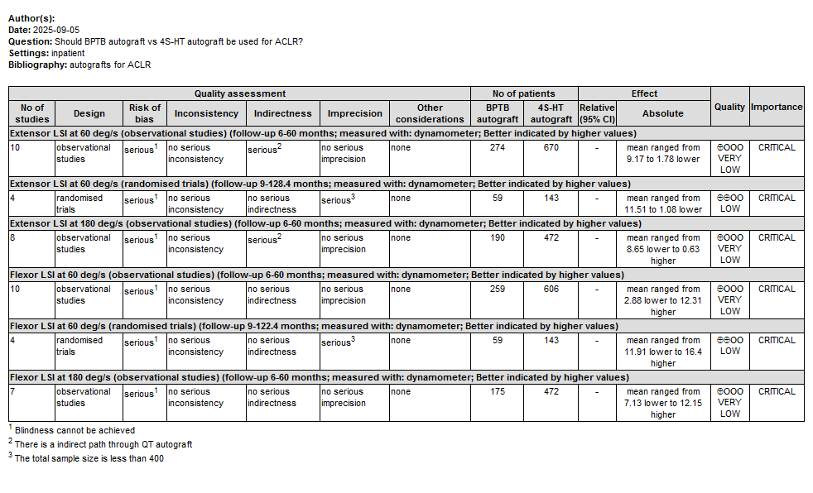
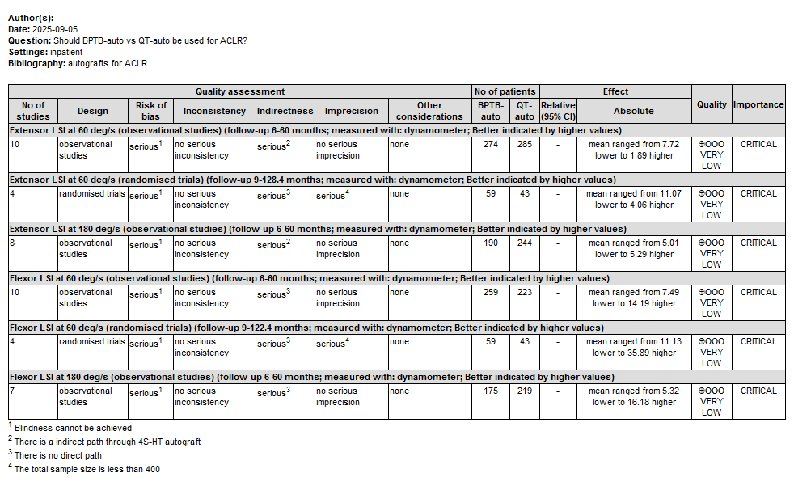
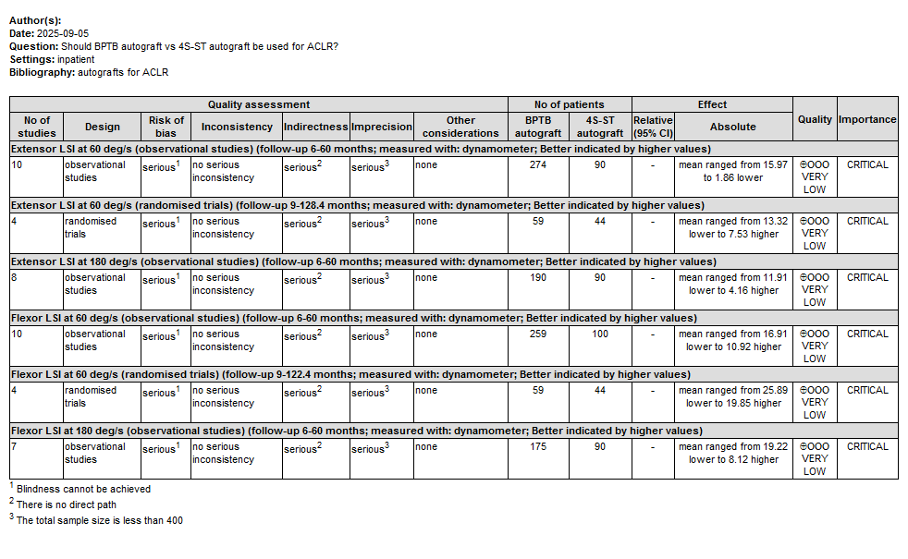
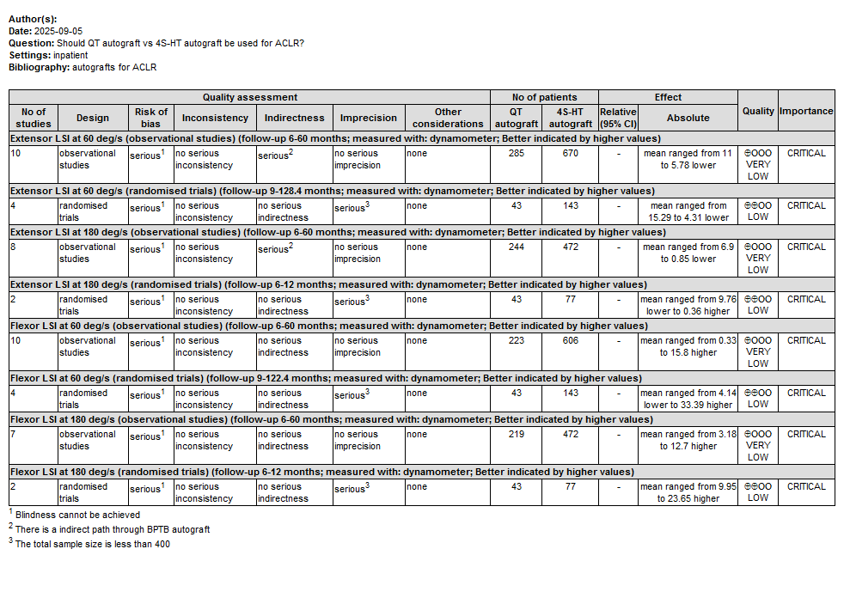
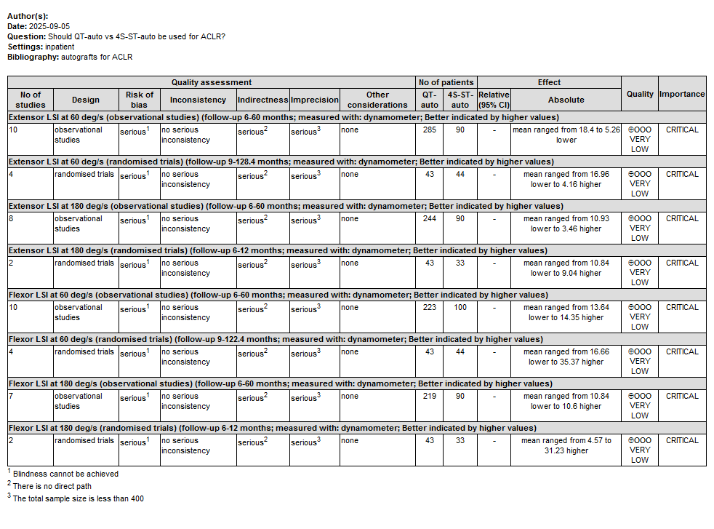
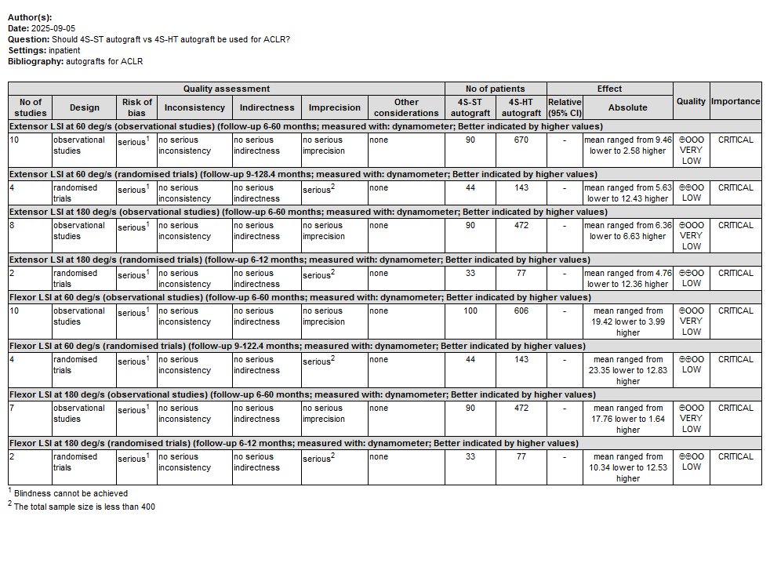
4S-HT autograft, Four-strand hamstring tendon autograft, 4S-ST autograft, Four-strand semitendinosus tendon autograft, BPTB autograft, Bone-patella tendon-bone autograft, QT autograft, Quadriceps tendon autograft.
There are indirect paths in the comparison of extensor strength recovery outcomes between observational studies on 4S-HT autografts and QT autografts. The inconsistency test results showed a p-value of 0.1800 at 60 °/s and 0.3216 at 180 °/s, with no statistical significance, indicating good result consistency.

