**-: Practical Set – 10 :-**

1. Write a Python program to search a specific value from a given list of values using binary search method.

def binary_search(values, search_value):  
 left = 0  
 right = len(values) - 1  
 while left <= right:  
 mid = (left + right) // 2  
 if values[mid] == search_value:  
 return mid  
 elif values[mid] < search_value:  
 left = mid + 1  
 else:  
 right = mid - 1  
 return -1  
  
values = [0, 1, 1, 3, 5, 7, 9, 13, 15, 18, 20]  
search_value = 5  
index = binary_search(values, search_value)  
if index == -1:  
 print(f"{search_value} not found in the list")  
else:  
 print(f"{search_value} found at index {index}")

**OUTPUT :**

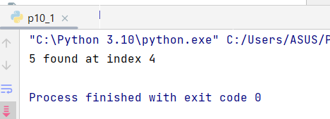

1. Write a python program to sort the elements of list values using selection sort.

def selection_sort(values):  
 for i in range(len(values)):  
 min_index = i  
 for j in range(i+1, len(values)):  
 if values[j] < values[min_index]:  
 min_index = j  
 values[i], values[min_index] = values[min_index], values[i]  
 return values  
  
values = [9, 4, 7, 2, 8, 5, 1, 6, 3, 0, 1]  
sorted_values = selection_sort(values)  
print(sorted_values)

**OUTPUT :**

