**-: Practical set – 2 :-**

1. WAP to check whether entered number is even or odd.

n = int(input("Enter the number : "))

print(f"{n} is Odd") if n % 2 else print(f"{n} is Even")

**OUTPUT:**

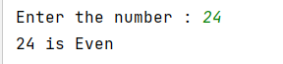

1. WAP to find whether entered number is positive, negative or zero.

n = int(input("Enter the number : "))

print(f"{n} is positive") if n > 0 else print(f"{n} negative") if n<0 else print(f"{n} is zero")

**OUTPUT:**

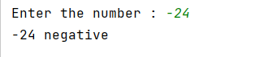

1. WAP to find roots of quadratic equations if roots are real.

a, b, c = [float(s) for s in input("Enter coefficients of x2, x and a constant term : ").split()]

d = (b ** 2) - (4 * a * c)

print(f"{(-b + d*0.5)/(2*a)} and {(-b - d*0.5)/(2*a)} are real roots of the equation") if d >= 0 else print("No real roots possible")

**OUTPUT:**

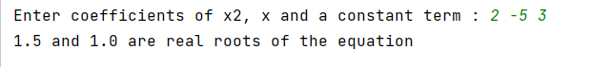

1. WAP to check whether entered character is vowel or consonant.

string = input("Enter the character : ")

print(f"{string[0]} is Vowel") if string.lower() in ['a', 'e', 'i', 'o', 'u'] else print(f"{string[0]} is Consonant")

**OUTPUT:**

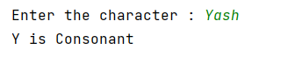

1. WAP to find maximum of three numbers (nested if-else).

a, b, c = [int(s) for s in input("Enter three numbers : ").split()]

if a >= b:

print(f"{a} is Maximum") if a > c else print(f"{c} is Maximum")

else:

print(f"{b} is Maximum") if b > c else print(f"{c} is Maximum")

**OUTPUT:**

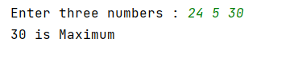

1. WAP to calculate the salary of an employee based on following conditions (nested if-else):

1. if degree = B.E. and experience < 5 years, salary=30000

2. if degree = B.E. and experience >= 5 years, salary=40000

3. if degree = M.E. and experience < 5 years, salary=50000

4. if degree = M.E. and experience >= 5 years, salary= 60000

deg, exp = input("Enter degree(BE or ME) & experience : ").split()

if deg.lower() == "be":

print("Salary : 30k") if int(exp) < 5 else print("Salary : 40k")

else:

print("Salary : 50k") if int(exp) < 5 else print("Salary : 60k")

**OUTPUT:**

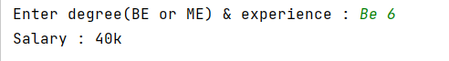

1. WAP to check whether entered input is character, digit or special symbol using ladder if-else.

inp = input("Enter the charcter : ")

print(f"{inp[0]} is a Character") if inp[0].isalpha() else print(f"{inp[0]} is Digit") if inp[0].isdigit() else print(f"{inp[0]} is Special Character")

**OUTPUT:**

