**-: Practical set – 3 :-**

1. WAP to find sum of first N numbers.

n = int(input("Enter the number : "))

total = 0

for i in range(1, n+1):

total += i

print(f"Sum : {total}")

**OUTPUT:**

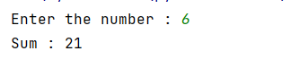

1. WAP to find sum of N scanned numbers.

n = int(input("Enter the number : "))

total = 0

for i in range(1, n+1):

total += int(input(""))

print(f"Sum : {total}")

**OUTPUT:**

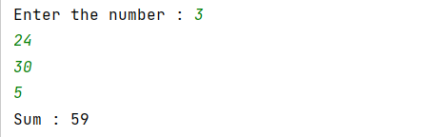

1. WAP to find N!.

# import math

n = int(input("Enter the number : "))

# print(f"Factorial : {math.factorial(n)}")

fact = 1

for i in range(n, 0, -1):

fact *= i

print(f"Factorial : {fact}")

**OUTPUT:**

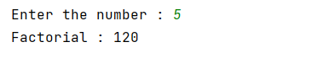

1. WAP to print Fibonacci series upto n terms

n = int(input('Enter the number :'))

fibonacci = (0, 1)

for i in range(2, n):

fibonacci += (fibonacci[i-2]+fibonacci[i-1],)

print(fibonacci)

**OUTPUT:**

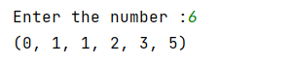

1. WAP to find the reverse of given numbers.

n = (input("Enter the nunber : "))

rev = n[::-1]

print(f"Reversed number : {rev}")

**OUTPUT:**



1. WAP to check whether entered number is prime or not.

import math

n = int(input("Enter the number : "))

prime_flag = 0

if n > 1:

for i in range(2, int(math.sqrt(n)) + 1):

if n % i == 0:

prime_flag = 1

break

print(f"{n} is Prime") if prime_flag == 0 else print(f"{n} is not Prime")

else:

print(f"{n} is not Prime")

**OUTPUT:**

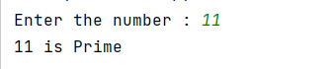

1. WAP to print all even numbers b\w 1 to n except the numbers divisible by 6.

n = int(input("Enter the number : "))

for i in range(2, n+1, 2):

print("", end='') if i % 6 == 0 else print(f"{i}", end=' ')

**OUTPUT:**



1. WAP to calculate N!. (Same as no. 3)
2. WAP to check whether given number is Armstrong or not.

number = int(input("Enter the number : "))

num = number

digit, total = 0, 0

length = len(str(num))

for i in range(length):

digit = int(num % 10)

num = num/10

total += pow(digit, length)

if total == number:

print(f"{number} is Armstrong")

else:

print(f"{number} is not Armstrong"

**OUTPUT :**

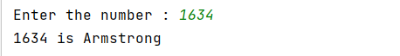

1. WAP to check whether given number is Palindrome or not.

n = int(input("Enter the number : "))

if str(n)[::-1] == str(n):

print(f"{n} is Palindrome")

else:

print(f"{n} is not Palindrome")

**OUTPUT:**

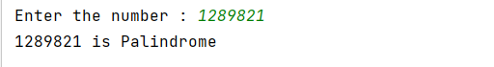

1. WAP print the patterns.

n = int(input("Enter the no. of rows : "))

for i in range(1, n+1):

for j in range(1, i+1):

print(j, end='')

print("")

print("")

for i in range(1, n+1):

for j in range(n+1, i, -1):

print('*', end='')

    print("")

**OUTPUT:**

