**-: Practical set – 4 :-**

1. Write a python program which covers all the methods (functions) of list.

l1 = [24, 1, 5, 30, 56]

l1.sort()

print(f"{l1}")

print(f"\nl1.index(56) --> {l1.index(56)}")

print(f"l1.pop() --> {l1.pop()}")

l1.insert(4, 11)

print(f"l1.insert(4, 11) --> {l1}")

l1.append(24)

print(f"l1.append(24) --> {l1}")

print(f"l1.count(24) --> {l1.count(24)}")

l2 = l1.copy()

**OUTPUT:**

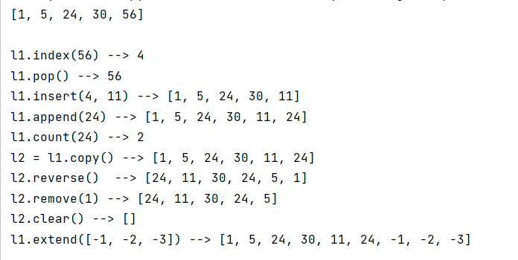

1. Write a Python program to append a list to the second list.

l1 = [1, 5, 8, 3, 6]

l1.extend([24, 21, 30, 33])

print(l1)

**OUTPUT:**



1. Write a python program to check whether the given list is palindrome or not.

og_list = [int(s) for s in input("Enter the list: ").split()]

rev_list = og_list.copy()

rev_list.reverse()

print("List is Palindrome") if og_list == rev_list else print("List is not Palindrome")

**OUTPUT:**

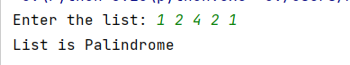

1. Write a python program to store strings in list and then print them.

li = [str(s) for s in input("Enter the strings : ").split()]

print(li)

**OUTPUT:**

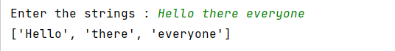

1. Write a python program to print list of prime numbers upto *N* using loop and else clause.

import sympy as sp

n = int(input("Enter the number : "))

# li = []

# for i in range(2, n+1):

# prime_flag = True

# for j in range(2, i):

# if i % j == 0:

# prime_flag = False

# break

# if prime_flag == True:

# li.append(i)

li = [x for x in range(2, n) if sp.isprime(x)]

print(f"List of Prime : {li}")

**OUTPUT:**

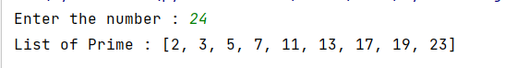

1. Write python program to check whether the given list is palindrome or no. (Same as 3).
2. Write a Python program to multiply all the items in a list.

import math

li = [int(s) for s in input("Enter the list : ").split()]

print(f"Product of {li} = {math.prod(li)}")

**OUTPUT:**

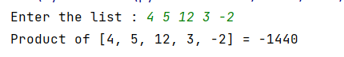

1. Write a Python program to get the largest number from a list.

li = [int(s) for s in input("Enter the list : ").split()]

print(f"Maximum : {max(li)}")

**OUTPUT:**

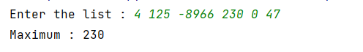

1. Write a Python program to find the second smallest number in a list.

li = [int(s) for s in input("Enter the list: ").split()]

li = list(set(li))

li.sort()

print(f"Second smalles element : {li[1]}")

**OUTPUT :**

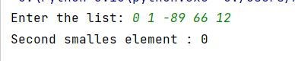

1. Write a Python program to count the number of strings where he string length is 2 or more and the first and last character are same from a given list of strings.

li = [str(s) for s in input("Enter the list : ").split()]

count = 0

for i in li:

if len(i) >= 2 and i[0] == i[-1]:

count += 1

print(f"Strings : {count}")

**OUTPUT:**



1. Write a Python program to remove duplicates from a list.

li = [str(s) for s in input("Enter the list : ").split()]

li = list(set(li))

print(f"List after removing duplicates : {li}")

**OUTPUT:**

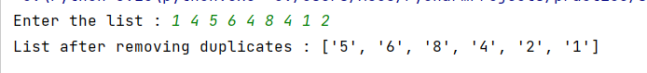

1. Write a Python program to find the list of words that are longer than n from a given string.

str_list = [str(s) for s in input("Enter the list : ").split()]

n = int(input("Enter the value of n : "))

str_list = [x for x in str_list if len(x) > n]

print(str_list)

**OUTPUT:**

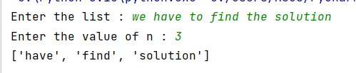

1. Write a Python function that takes two lists and returns True if they have at least one common member.

def is_common(li1, li2):

for i in li1:

if i in li2:

return True

else:

return False

li1 = [str(s) for s in input("Enter the list : ").split()]

li2 = [str(s) for s in input("Enter the list : ").split()]

print(is_common(li1, li2))

**OUTPUT:**

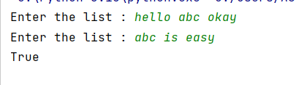

1. Write a Python program to print the numbers of a specified list after removing even numbers from it.

li = [int(s) for s in input("Enter the list: ").split()]

li = [x for x in li if x%2!=0]

print(li)

**OUTPUT:**

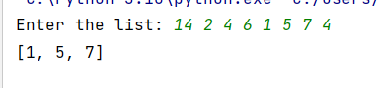

1. Write a Python program to add two matrices.

li = [str(s) for s in input("Enter the list : ").split()]

count = 0

for i in li:

if len(i) >= 2 and i[0] == i[-1]:

count += 1

print(f"Strings : {count}")

**OUTPUT:**

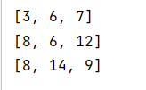

1. Write a Python program to transpose a given matrix

x = [[2, 3, 4], [4, 5, 6], [6, 7, 8]]

transpose = [[x[j][i] for j in range(len(x[0]))] for i in range(len(x))]

for i in transpose: print(i)

**OUTPUT:**

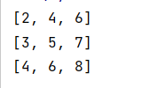

1. Flatten a nested list structure. Example: if list1=[1, [2,3], [4, 5, [6, 7]]] then try to convert it in 1-dimensional [1,2,3,4,5,6,7].

my_list = [1, [2,3], [4, 5, [6, 7]]]

fList = []

def flattenList(my_list):

for element in my_list:

if type(element) is list:

flattenList(element)

else:

fList.append(element)

flattenList(my_list)

print("Flatten list:", fList)

**OUTPUT:**



1. Write a Python program to split a list every Nth element

n = int(input("Enter n: "))

myList = [1, 2, 3, 4, 5, 6, 7, 8, 9, 10]

newList = []

for i in range(n): newList.append(myList[i::n])

print(newList)

**OUTPUT:**

