**-: Practical Set – 8 :-**

1. Write a Python program which will throw exception if the value entered by user is less than zero.

try:  
 num = int(input("Enter a number: "))  
 result = 100 / num  
except ValueError:  
 print("Please enter a valid integer.")  
except ZeroDivisionError:  
 print("Cannot divide by zero.")  
else:  
 print("Result:", result)  
finally:  
 print("Program execution completed.")

**OUTPUT :**

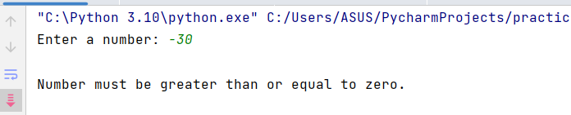

1. Write a python program to demonstrate use of finally and else keywords.

try:  
 num = int(input("Enter a number: "))  
 result = 100 / num  
except ValueError:  
 print("Please enter a valid integer.")  
except ZeroDivisionError:  
 print("Cannot divide by zero.")  
else:  
 print("Result:", result)  
finally:  
 print("Program execution completed.")

**OUTPUT:**

