GENE THERAPY: THE FUTURE OF PERSONOLIZED MEDICINE

Michael Huss

Sponsor – Dr. Christina Steel

BIO 405W

Spring 2019

**Abstract**

Gene therapy is a procedure that works to alter the DNA of a patient in order to treat disease. This kind of treatment is relatively new in the field of medicine and has underwent much scrutiny and research as a concern for altering a person’s DNA would obviously carry risks and challenges. It is only recently that the FDA has approved a few treatments for certain diseases in the United States. Hopefully this number will increase in the years to come as more research is done.

**Introduction**

The development of modern medicine has treated millions of patients who suffer from a seemingly endless list of health problems, but there has always been a class of diseases that has been seemingly impossible to cure: Diseases that stem from genetic disorders and abnormalities. Genetic disorders are not limited to those who have inherited genetic abnormalities but also to patients that may develop genetic disorders as a result of mutations and gene altering factors. For example, Cystic Fibrosis is a monogenetic disorder linked with an abnormality singular gene on chromosome 7 (Bobadilla et al., 2002), while Multiple Sclerosis is an autoimmune disorder that is not considered hereditary and may be linked with multiple genes on chromosome 6 (Compston and Coles, 2008). In both cases there is not an effective “cure”, treatments work to improve quality of life of patients but do not treat the underlying cause of their symptoms. Numerous other human diseases also stem from not only abnormalities within chromosomes, various cancers and immunological disorders.

The treatment of genetic disorders, known as Gene Therapy, has seen its proof of concept back in 1989 (Rosenberg et al., 1990) and only recently has treatments progressed past clinical trials and have been approved for use in patients in the United States. Simply stated, “gene therapy is a field of medicine that utilizes genetic modification of cells to produce therapeutic effects” (Mulligan, 1993). Researchers recognized that gene therapy could provide a single treatment to effectively cure patients and prevent symptoms.

**Background**

To understand genetic disorders and gene therapy one must first understand genes. A gene is a sequence of nucleotides on DNA that encode for a molecule of biological function. From DNA, RNA takes the genetic code out of the nucleus and into the cytoplasm where it becomes translated into a biological functioning protein. Proteins are the biological molecules composed of chains of amino acids. These proteins serve many functions and take part in regulating essential cell functions such as metabolism for energy, replicating DNA, transporting molecules, providing cell structure and responding to stimuli. Given all these important functions that proteins serve within the cell, any problems in the synthesis of these proteins would lead to complications. This is where instances of disease and disorder occur. DNA holds the essential instructions needed to synthesize proteins at the exact time and in exact amounts to maintain normal biological function; abnormalities in DNA cause proteins to form incorrectly or not form at all. As a result, a patient that suffers from genetic disorders may be unable to properly respond to stimuli.

In theory the prospect of gene therapy was an enticing alternative to long term symptom management. In the dawn of gene therapy research, the basic principle was to go into the DNA of a patient and change the part that was abnormal. Unfortunately, the first clinical trials either had little effect or resulted in unforeseen consequences. Instances of patient death resulted from immune reactions and toxicity (Jenks, 2000). The lack of knowledge of the vectors that were used to introduce DNA into the targeted cells caused gene therapy to fall out of favor until comprehensive research could be done. Over the years gene therapy research has improved the safety of gene vectors and improved therapeutic results and resulted in approval of several gene therapies by the FDA. In this paper major developmental milestones will be discussed to follow the development of gene therapy as it moves from a concept to full-fledged treatment.

**Vectors**

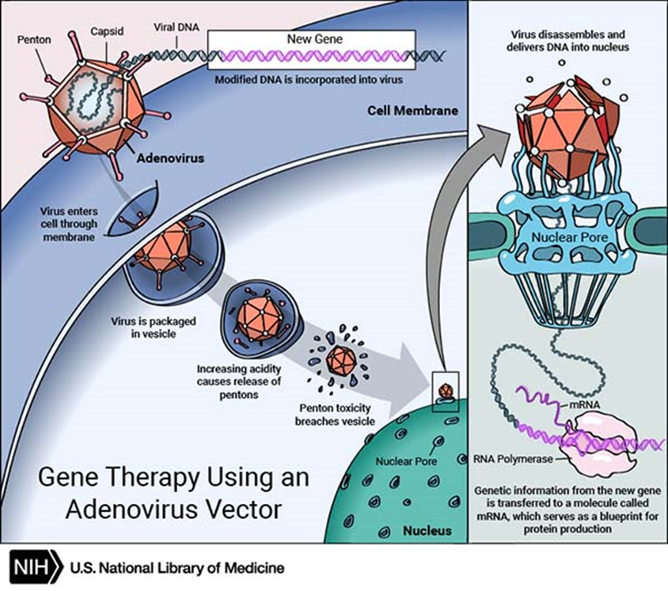Viruses have been understood to be non-living biological packets that have the capacity to essentially take over host cells in order to replicate. Viruses may vary in their methods of replication but are significant for gene therapy because some viruses can insert pieces of DNA that lead to the synthesis of proteins that assemble into more viruses. Scientists speculated that they could exploit this property of viruses to insert DNA sequences that were otherwise missing or abnormal and effectively cure a genetic disorder. The challenge was to alter these viruses to remove the genetic material that were either pathological or allowed for uncontrolled replication (Thomas et al., 2003). The discovery of a naturally-occurring Adeno-associated Virus opened the doors to a reliable vector that could be utilized in gene therapy. What makes Adeno-associated Viruses so special is that they cannot replicate on their own and rely on other viral species to replicate (Asokan et al., 2012). New Adeno-associated Viral Vectors (AVVs) were developed, removing all viral encoding genetic material and allowed for the integration of target genes to be expressed. In figure 1 we can see the general mechanism. Successful gene transfers were observed in mice models using the AVVs, with sustained expression in the target tissues in cells of the liver, cardiac muscle and central nervous system (Kessler et al., 1996; Xiao et al., 1996).

Figure 1, Credit: U.S. National Library of Medicine

**Gene Editing**

While viral vectors showed promise in various models, they only addressed the possibility of adding genes into the genome of a target but lacked the ability to remove genes from the genome. Early forms of gene editing utilized various nucleases such as Zinc Finger Nucleases (ZFN) or Meganucleases to induce DNA breaks (Silva et al., 2011). These methods required specific nuclease effector proteins and limited their application for specific DNA sequences. But during 2012 the realm of gene editing was revolutionized by the discovery of CRISPR-Cas9 technology, often described as the “word processor of DNA” (Ran et al., 2013). CRISPR-Cas9 provided an effective tool that could create specific DNA sequences with ease and quickly found its way into gene therapy research. With this new tool in the arsenal of researchers, clinical applications of CRISPR-Cas9 created methods of controlling gene expression that could effectively turn genes on or off (Qi et al., 2013). Diseases arising from dominant gene expression, such as muscular dystrophy, could not be treated by genome insertion but know have shown improvement in mouse models by in vivo gene editing (Nelson et al., 2016).

**Clinical Trials**

After vast improvements in the safety of gene therapy since the 1990s, research of various gene therapies has moved into clinical trial phases. In clinical trials therapeutic benefits have been noted in gene therapies involving monogenetic disorders. Patients exhibiting Leber’s Congenital Amaurosis, a form of inherited blindness caused by a mutation in the RPE65 gene have shown various level of improvement of visual acuity, after treatment with retinal injections containing AVVs holding DNA encoding for RPE65, with therapeutic effects lasting up to 3 years (Bainbridge et al., 2008; Bennett et al., 2016). These studies have led to the FDA approving the first in vivo gene therapy, Luxturna™.

Research into degenerative neuromuscular disorders have also been a popular research topic in gene therapy, however, prove to be a challenge due to the complex nature of genes that influence the progression of the disease along with the risks of viral vectors infiltrating the nervous system. Preliminary trials looking at primate models has established the relative safety of AVVs that can effectively cross the blood brain barrier (Marks et al., 2010). Spinal Muscular Atrophy (SMA) is a neuromuscular disorder in which mutations result in loss-of-function in Survival Motor Neuron 1 (SMN) gene and usually result in the death during the early years of development. Clinical trials have been carried out in 15 infants and children where an AVV carrying the SMN1 gene was able to extend the lifespans of these children with improvement of motor functions in some of the children (Mendell et al., 2017). The FDA has since approved the first gene therapy for SMA, known as Spinraza®.

**CAR Therapy**

Chimeric Antigen Receptor (CAR) therapy is perhaps one of the most well-known forms of gene therapy, as it has emerged as a treatment for cancer, specifically B cell lymphomas and leukemias. The mechanism for CAR therapy is rather different from the other forms of gene therapy discussed previously. Gene manipulation to alter gene expression directly resulted in therapeutic effect, in CAR therapy viral vectors alter the genes of T lymphocytes to create T cell receptors specific for surface markers of cancer cells. The therapeutic effect results from the T cells being able to recognize and destroy these cells. Figure 2 illustrates the general process of developing CAR T cells for use in a patient. What makes CAR therapy different from normal physiological T lymphocytes is the ability for CARs to encode antigens that recognize other proteins, HLA-complexes, and glycolipids that T cells would not normally have, this allows T cells to specifically target cancer cells (Jensen and Riddell, 2015). The most common target for CAR T cells is CD19 and has seen beneficial effects in Acute Lymphoblastic Leukemia (ALL) and Diffuse Large B-Cell Lymphoma (DLBCL) (Brentjens et al., 2003). CAR 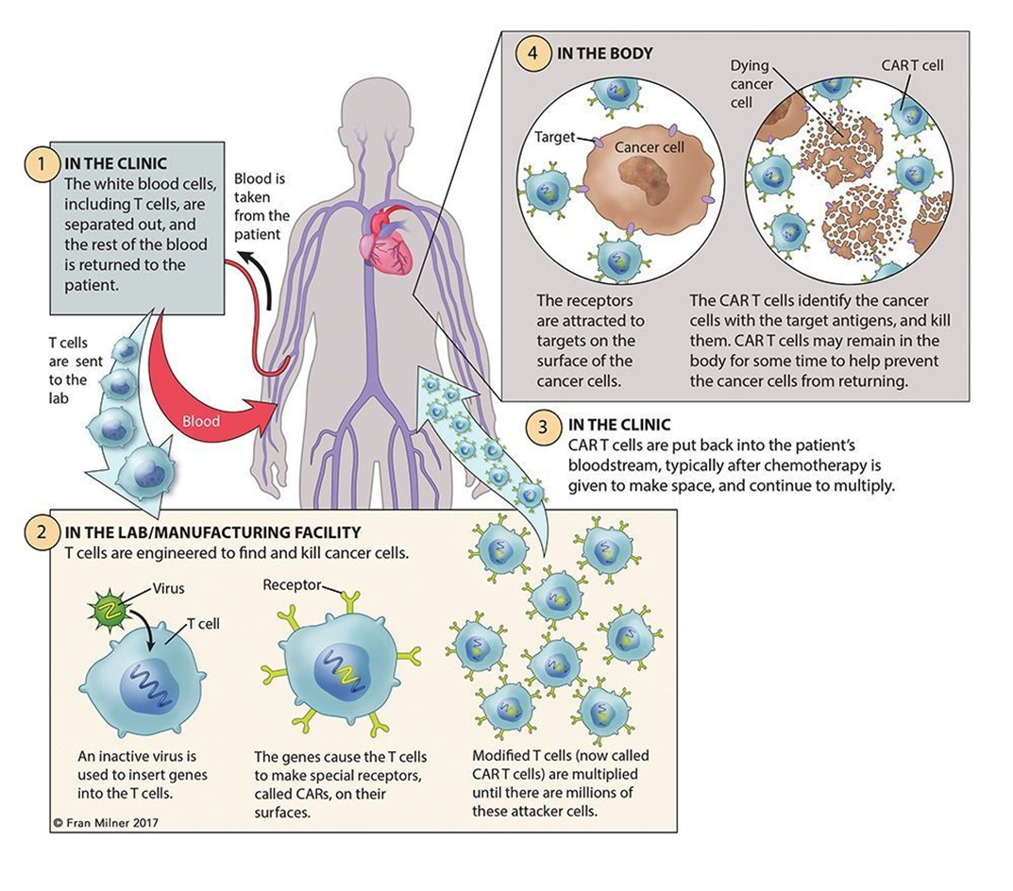has been approved by the FDA (Boyiadzis et al., 2018) Research has been expanding to target solid tumors and provides a promising treatment alternative for other forms of cancers while providing a basis for T cell based treatments for other diseases such as AIDS (Ellebrecht et al., 2016).

Figure 2, Source: Leukemia & Lymphoma Society

**Limitations**

The ability to induce genetic modifications in vivo has been a goal for researchers as the transplanting of modified cells cultured in vitro is a tedious task. As mentioned previously, gene expression mediated by AVVs has been observed in target tissues of mice models after local injection (Kessler et al., 1996; Xiao et al., 1996) but only persisted for several weeks. Another issue was the destruction of cells modified by AVVs by the immune system of patients that had anti-bodies for AVVs (Mingozzi et al., 2007). At the present time there is no concrete solution to circumvent this from happening and must be addressed in future research. Gene therapy has only scratched the surface of monogenetic disorders and little research has worked with multigenetic disorders due to complexity of gene interactions in vivo and must be fully understood before any gene altering treatments are perused.

**Conclusions**

Gene therapy is a very exciting field of medicine that is seeing rapid growth, despite the setbacks and challenges encountered while gene therapy was in its infancy. While gene therapy is very much in the research and development phase, new treatments show promise to expand beyond experimental trials. The advances in genetic manipulation has expanded the possibilities for creating gene therapies for other diseases. Gene therapy still has its challenges regarding in vivo interaction with viral vectors and immune system response but has great potential for becoming the go to treatment for a wide range of diseases and disorders.

**Works Cited**

Asokan, A., Schaffer, D.V., and Samulski, R.J. (2012). The AAV vector toolkit: poised at the clinical crossroads. Molecular therapy : the journal of the American Society of Gene Therapy *20*, 699-708.

Bainbridge, J.W., Smith, A.J., Barker, S.S., Robbie, S., Henderson, R., Balaggan, K., Viswanathan, A., Holder, G.E., Stockman, A., Tyler, N.*, et al.* (2008). Effect of gene therapy on visual function in Leber's congenital amaurosis. N Engl J Med *358*, 2231-2239.

Bennett, J., Wellman, J., Marshall, K.A., McCague, S., Ashtari, M., DiStefano-Pappas, J., Elci, O.U., Chung, D.C., Sun, J., Wright, J.F.*, et al.* (2016). Safety and durability of effect of contralateral-eye administration of AAV2 gene therapy in patients with childhood-onset blindness caused by RPE65 mutations: a follow-on phase 1 trial. Lancet (London, England) *388*, 661-672.

Bobadilla, J.L., Macek Jr, M., Fine, J.P., and Farrell, P.M. (2002). Cystic fibrosis: A worldwide analysis of CFTR mutations—correlation with incidence data and application to screening. Human Mutation *19*, 575-606.

Boyiadzis, M.M., Dhodapkar, M.V., Brentjens, R.J., Kochenderfer, J.N., Neelapu, S.S., Maus, M.V., Porter, D.L., Maloney, D.G., Grupp, S.A., Mackall, C.L.*, et al.* (2018). Chimeric antigen receptor (CAR) T therapies for the treatment of hematologic malignancies: clinical perspective and significance. Journal for immunotherapy of cancer *6*, 137-137.

Brentjens, R.J., Latouche, J.B., Santos, E., Marti, F., Gong, M.C., Lyddane, C., King, P.D., Larson, S., Weiss, M., Riviere, I.*, et al.* (2003). Eradication of systemic B-cell tumors by genetically targeted human T lymphocytes co-stimulated by CD80 and interleukin-15. Nature medicine *9*, 279-286.

Compston, A., and Coles, A. (2008). Multiple sclerosis. The Lancet *372*, 1502-1517.

Ellebrecht, C.T., Bhoj, V.G., Nace, A., Choi, E.J., Mao, X., Cho, M.J., Di Zenzo, G., Lanzavecchia, A., Seykora, J.T., Cotsarelis, G.*, et al.* (2016). Reengineering chimeric antigen receptor T cells for targeted therapy of autoimmune disease. Science *353*, 179-184.

Jenks, S. (2000). Gene Therapy Death -- "Everyone Has to Share in the Guilt", Vol 92.

Jensen, M.C., and Riddell, S.R. (2015). Designing chimeric antigen receptors to effectively and safely target tumors. Current Opinion in Immunology *33*, 9-15.

Kessler, P.D., Podsakoff, G.M., Chen, X., McQuiston, S.A., Colosi, P.C., Matelis, L.A., Kurtzman, G.J., and Byrne, B.J. (1996). Gene delivery to skeletal muscle results in sustained expression and systemic delivery of a therapeutic protein. Proceedings of the National Academy of Sciences of the United States of America *93*, 14082-14087.

Marks, W.J., Jr., Bartus, R.T., Siffert, J., Davis, C.S., Lozano, A., Boulis, N., Vitek, J., Stacy, M., Turner, D., Verhagen, L.*, et al.* (2010). Gene delivery of AAV2-neurturin for Parkinson's disease: a double-blind, randomised, controlled trial. The Lancet Neurology *9*, 1164-1172.

Mendell, J.R., Al-Zaidy, S., Shell, R., Arnold, W.D., Rodino-Klapac, L.R., Prior, T.W., Lowes, L., Alfano, L., Berry, K., Church, K.*, et al.* (2017). Single-Dose Gene-Replacement Therapy for Spinal Muscular Atrophy. N Engl J Med *377*, 1713-1722.

Mingozzi, F., Maus, M.V., Hui, D.J., Sabatino, D.E., Murphy, S.L., Rasko, J.E., Ragni, M.V., Manno, C.S., Sommer, J., Jiang, H.*, et al.* (2007). CD8(+) T-cell responses to adeno-associated virus capsid in humans. Nature medicine *13*, 419-422.

Mulligan, R. (1993). The basic science of gene therapy. Science *260*, 926-932.

Nelson, C.E., Hakim, C.H., Ousterout, D.G., Thakore, P.I., Moreb, E.A., Castellanos Rivera, R.M., Madhavan, S., Pan, X., Ran, F.A., Yan, W.X.*, et al.* (2016). In vivo genome editing improves muscle function in a mouse model of Duchenne muscular dystrophy. Science *351*, 403-407.

Qi, L.S., Larson, M.H., Gilbert, L.A., Doudna, J.A., Weissman, J.S., Arkin, A.P., and Lim, W.A. (2013). Repurposing CRISPR as an RNA-guided platform for sequence-specific control of gene expression. Cell *152*, 1173-1183.

Ran, F.A., Hsu, P.D., Wright, J., Agarwala, V., Scott, D.A., and Zhang, F. (2013). Genome engineering using the CRISPR-Cas9 system. Nature Protocols *8*, 2281.

Rosenberg, S.A., Aebersold, P., Cornetta, K., Kasid, A., Morgan, R.A., Moen, R., Karson, E.M., Lotze, M.T., Yang, J.C., Topalian, S.L.*, et al.* (1990). Gene Transfer into Humans — Immunotherapy of Patients with Advanced Melanoma, Using Tumor-Infiltrating Lymphocytes Modified by Retroviral Gene Transduction. New England Journal of Medicine *323*, 570-578.

Silva, G., Poirot, L., Galetto, R., Smith, J., Montoya, G., Duchateau, P., and Paques, F. (2011). Meganucleases and other tools for targeted genome engineering: perspectives and challenges for gene therapy. Current gene therapy *11*, 11-27.

Thomas, C.E., Ehrhardt, A., and Kay, M.A. (2003). Progress and problems with the use of viral vectors for gene therapy. Nature Reviews Genetics *4*, 346-358.

Xiao, X., Li, J., and Samulski, R.J. (1996). Efficient long-term gene transfer into muscle tissue of immunocompetent mice by adeno-associated virus vector. Journal of virology *70*, 8098-8108.