Eliott Orr

Nik White

Final UX Process

## Understand

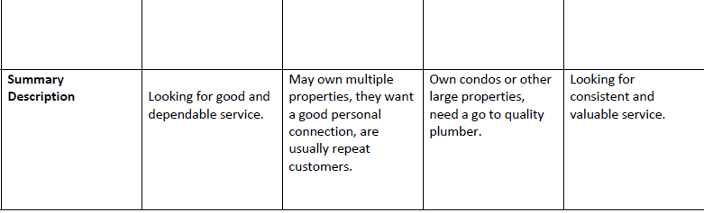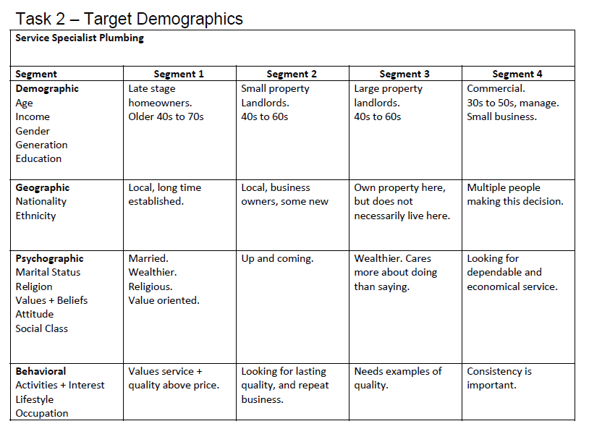

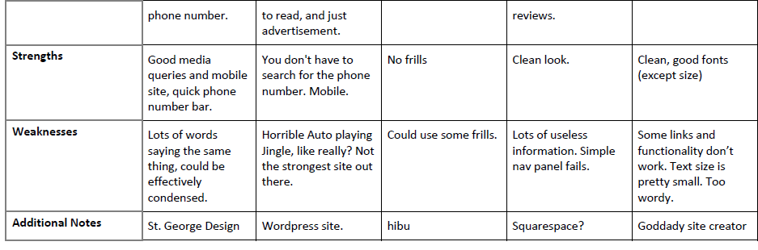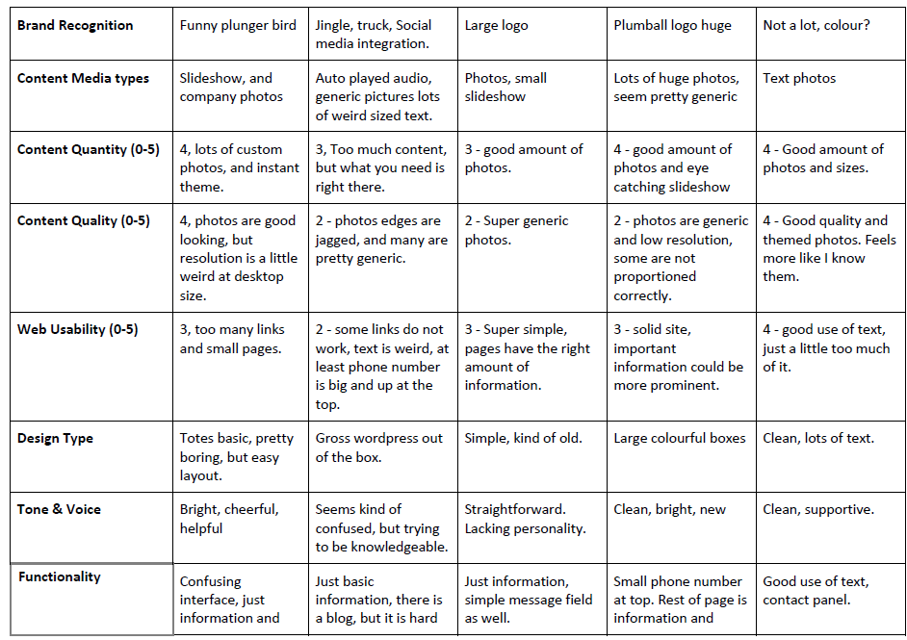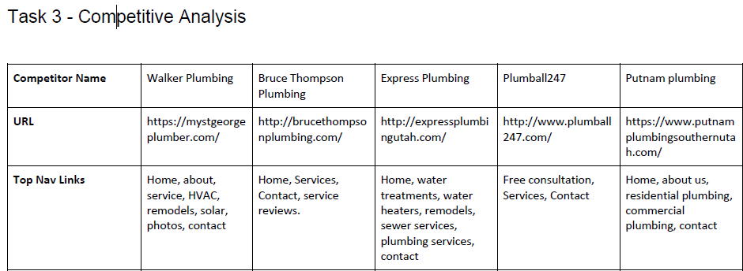

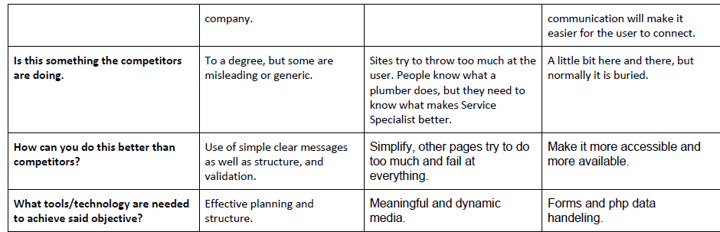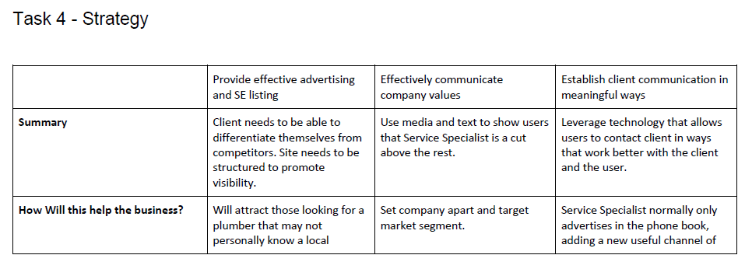

## Sketch

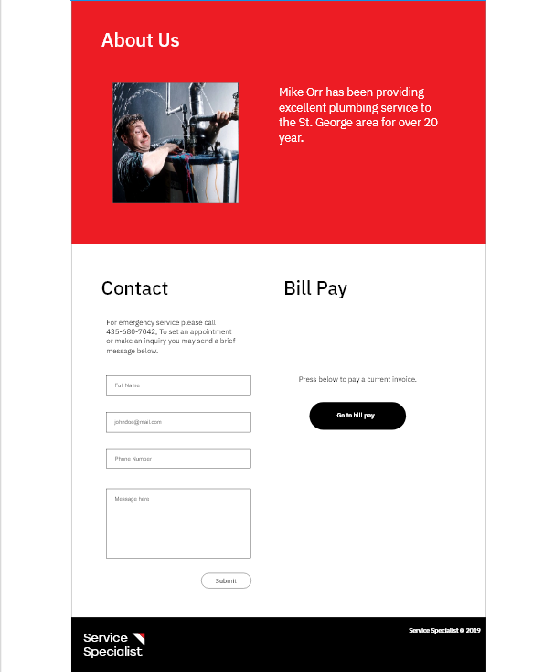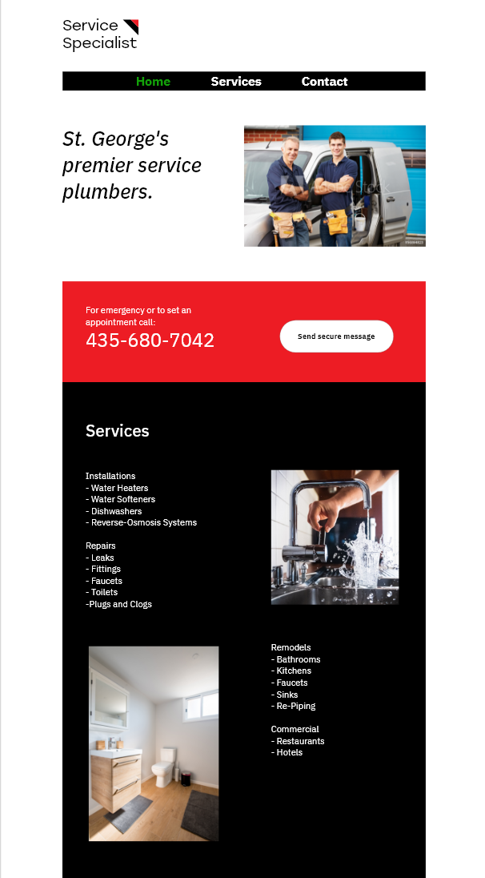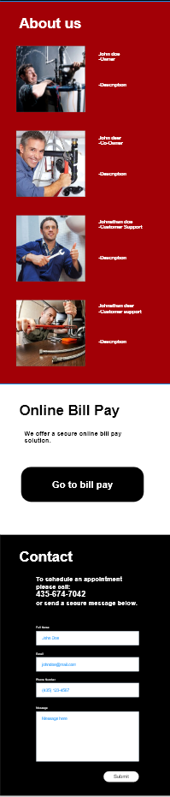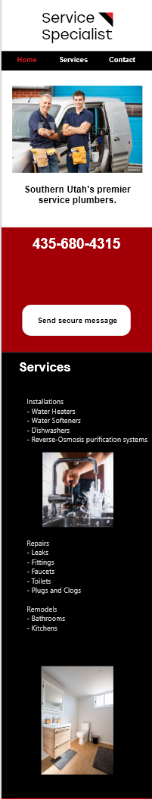

## Feedback

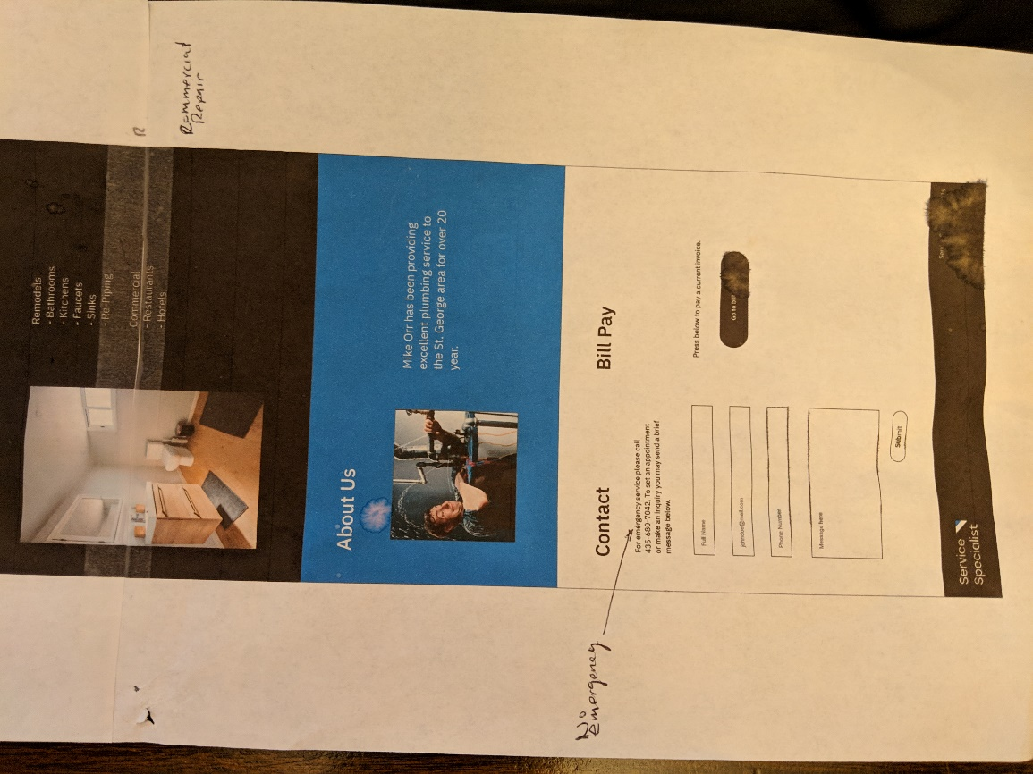

## Evaluate

1. Background:
   1. Ability to navigate website, find contact info, and sending secure message.
   2. If it were easy for older generations to be able to navigate through the website and find what they needed.
   3. Older homeowners: Courtney, Kerry, Nathanial, Devon, Kyle
   4. Business owners: Geri, Matthew
   5. Younger Homeowners: Jared, Greg, Luke.
2. Tested every link, Navigation link, Secure Message link, and Submitting forms.
3. Test Results & Findings:
   1. 60% of the testers didn’t like the single page method. They said they didn’t like the long scrolling (Even though the navigation took them to the three main points of the page). Too much info in one page that makes it a little intimidating to even look at and attempt to navigate.
   2. 40% suggested using a little bit bigger font.
   3. 100% of all users said the mobile design needed a little bit of work. Things looked disorganized and unprofessional.
   4. 100% of all users said that the form font needed to have padding from the border of the input boxes and the font needed to be a bit bigger as well.
   5. 20% said that certain elements on the page had too much of a gap between each element.
   6. 40% said the design was a little too Spartan.
   7. 80% said site could communicate purpose better.
   8. 90% agreed that the site could be more personal, it was currently too generic.
4. Recommendations:
   1. The pictures are a little too big, no one likes to scroll for a mile...the send secure button needs to move to the right, you need smaller tables....
   2. Use bigger font, especially on the "for questions or to set an appointment" bigger font size.
   3. I would suggest having separate pages for the services and contact links. You want the home page to be inviting enough to keep them there, but not so intimidating with a ton of info. Scrolling is not the best thing if it can be avoided.
   4. If you compare About Is section and Services, the gap is a lot larger in Services than About Us
   5. Home page looks good, but when you click send secure message I would give "Full name" and other fillers a little bit more space at the beginning so it's not touching the box
   6. You got some merging and you have to zoom out to see all of it
   7. The css on the phone is needs a bit more work
   8. Site needs better images, pictures that communicate the brand.
5. Summary:
   1. Definitely need to fix the design for smaller viewports of smartphones. Instead of using grid, us block display.
   2. Make the font size a bit bigger.
   3. Add padding to the form within the input boxes.
   4. Possibly discuss more about the one-page layout.