Project Title: Is the "Hot Hand" Real? A Statistical Analysis of Tennis Momentum
Team Members: Josh Gilbert, Pace Thomson, Andy Rich

Abstract
This project analyzes the flow of tennis matches from the 2023 Wimbledon tournament to see if "momentum" is a real thing or just in our heads. We wanted to know if winning one point makes a player more likely to win the next one. Many fans think players get a "hot hand" where they become unstoppable, like in the famous matches between Carlos Alcaraz and Novak Djokovic. We used computer analysis on over 7,000 tennis points to track serving speeds, rally lengths, and winning streaks. Our results show that momentum does exist—winning a point gives you a small advantage on the next one—but the biggest factor in winning is actually who is serving the ball.

1. Introduction
Have you ever watched a sports game and felt like a player just couldn't miss? Fans call this having the "hot hand" or having "momentum." In tennis, matches often swing back and forth. But just as one player seems to have the edge, the other player turns the tables out of nowhere.
We wanted to find out if this momentum is statistically real. We looked at data to answer these questions:
- Does winning the last point help you win the next one?
- Do long winning streaks guarantee you will keep winning?
- Is momentum the most important factor, or is it something else, like serving?

2. Data Description
We used data from the 2023 Wimbledon Gentlemen’s singles matches. The dataset contains information on 7,284 tennis points.
What does the data look like?
- Rallies are Short: Most points end very quickly. The average rally is only about 3 shots.
- Fast Serves: Players hit the ball incredibly hard. The average serve speed is 112 mph, with some serves reaching 141 mph.
- Movement: Players run about 14 meters for every single point.
We created graphs to visualize some of the important predictors:
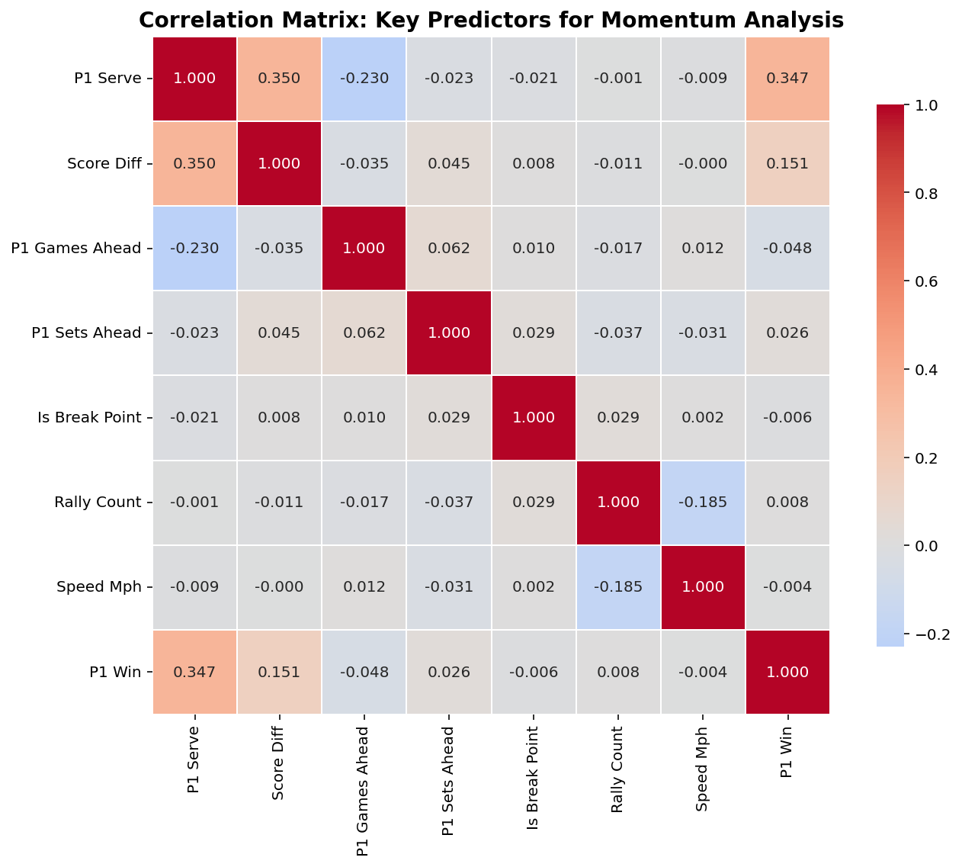
Figure 1: This chart illustrates how many different predictors correlate with winning points.
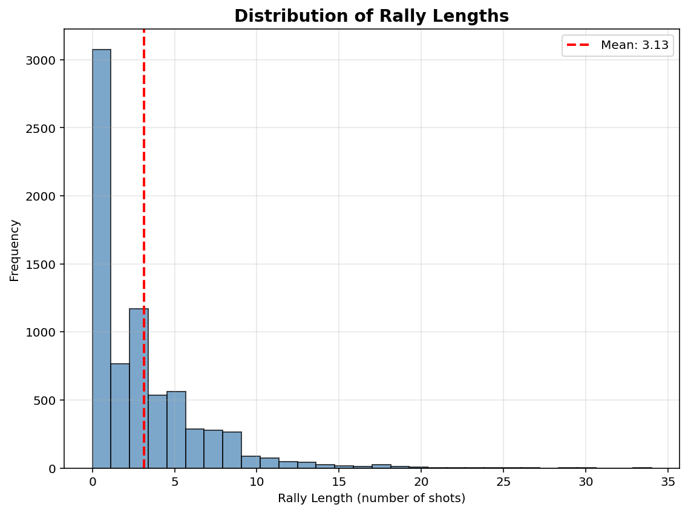
Figure 2: This chart illustrates the frequency of different rally lengths. This graph really helps illustrate the importance of serving, as the vast majority of points are aces.
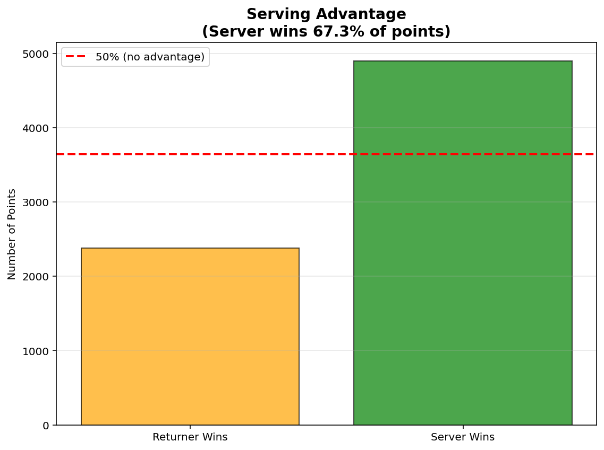
Figure 3: This graph just reinforces the idea that serving is king in tennis, especially at the highest level.
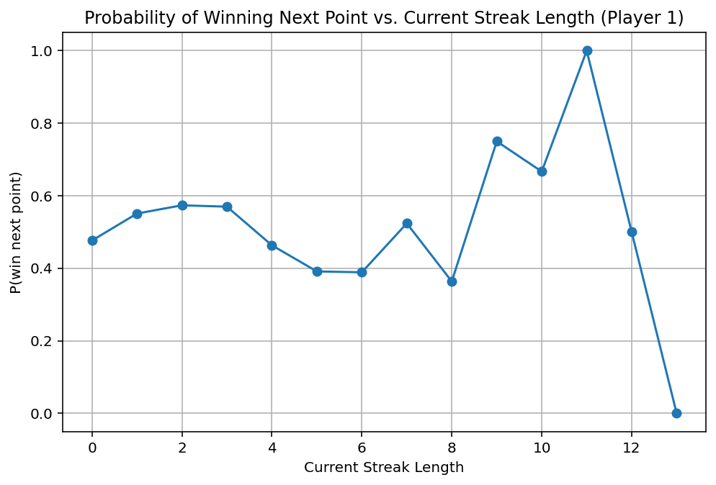
Figure 4: This shows how winning streaks can affect winning the next point. The graph becomes more volatile as the streak increases, because winning streaks above 4 are exceedingly rare.

3. Statistical Hypothesis Testing
Before building a complex predictive model, we first tested a simple hypothesis: Does the outcome of the previous point affect the probability of winning the next point?
- H₀ = P(win | won previous) = P(win | lost previous)
- H_{a} = P(win | won previous) ≠ P(win | lost previous)
The "Lag" Effect
Aggregating the data across all matches, we found a clear statistical difference:
- After Winning a Point: Players won the next point 54.4% of the time.
- After Losing a Point: Players won the next point 47.7% of the time.
This 6.7% gap suggests that momentum is statistically real in the aggregate. However, when we ran independent t-tests on each of the 31 matches individually, only 12.9% of the matches showed a statistically significant momentum effect on their own. This indicates that while momentum is a real global phenomenon, it is often too subtle to detect in a single match without a larger dataset.

4. The “Momentum” Model
Model Results & Feature Importance
Our Random Forest model achieved an accuracy of 63.58% on the test set. While this is a statistically significant improvement over the baseline ($p < 0.05$), the margin is slim (approximately +0.58%). This suggests that while momentum provides a measurable signal, it is not the dominant force in the outcome of a point.
However, the structure of the model reveals fascinating insights into what drives a match. By analyzing the Feature Importance (a measure of how much the model relies on a specific variable), we found that the "Hot Hand" is secondary to the "Heavy Hand" (the serve).
- 1. The Serve is King: The single most important feature was p1_serve (Importance: 0.20), followed closely by serve_speed (Importance: 0.097). This confirms that the structural advantage of serving outweighs psychological momentum.
- 2. Momentum Exists: Crucially, however, the momentum features did matter. p1_points_won_prev (who won the previous point) was the 4th most important feature (Importance: 0.068), and p1_streak (current winning streak) also appeared in the top predictors.
- 3. Fatigue Factor: Interestingly, p1_avg_distance (the average distance run by the player) was the 3rd most critical predictor (Importance: 0.079). This implies that as players tire, their probability of winning the next point shifts, regardless of who has the "hot hand."
We evaluated the model using ROC-AUC and Confusion Matrices. The model achieved a ROC-AUC score of 0.675, indicating a fair ability to distinguish between winning and losing points.
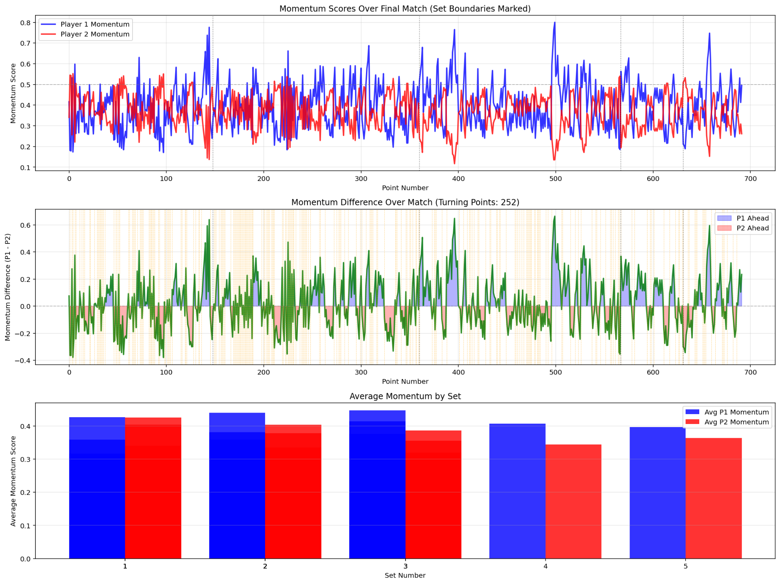

5. The “Swings” Model
While the Momentum Model predicts single points, tennis is often defined by "swings", which are sustained periods where one player dominates the flow of the match. We defined a "Momentum Swing" as a window of 5 points where the control of the match shifts significantly. We trained a separate Random Forest classifier to predict these swings.

Results
The Swings Model achieved an accuracy of 62.28%, with an ROC-AUC score of 0.635. While the accuracy is slightly lower than the single-point model, the drivers of these swings were completely different.

The Pressure of the Scoreboard
Unlike the single-point model, where the serve was the dominant factor, the #1 predictor for momentum swings was score_diff (Score Difference), with an importance score of 0.192, which is nearly double that of the serve (0.091).
This is a critical finding: Momentum swings do not happen randomly; they happen at pressure points. The model identified that when the score difference tightens (e.g., deuce or tie-breaks), the likelihood of a momentum swing skyrockets. This statistically validates the "clutch" factor in tennis; the idea that matches are decided not just by skill, but by how players handle the scoreboard pressure.
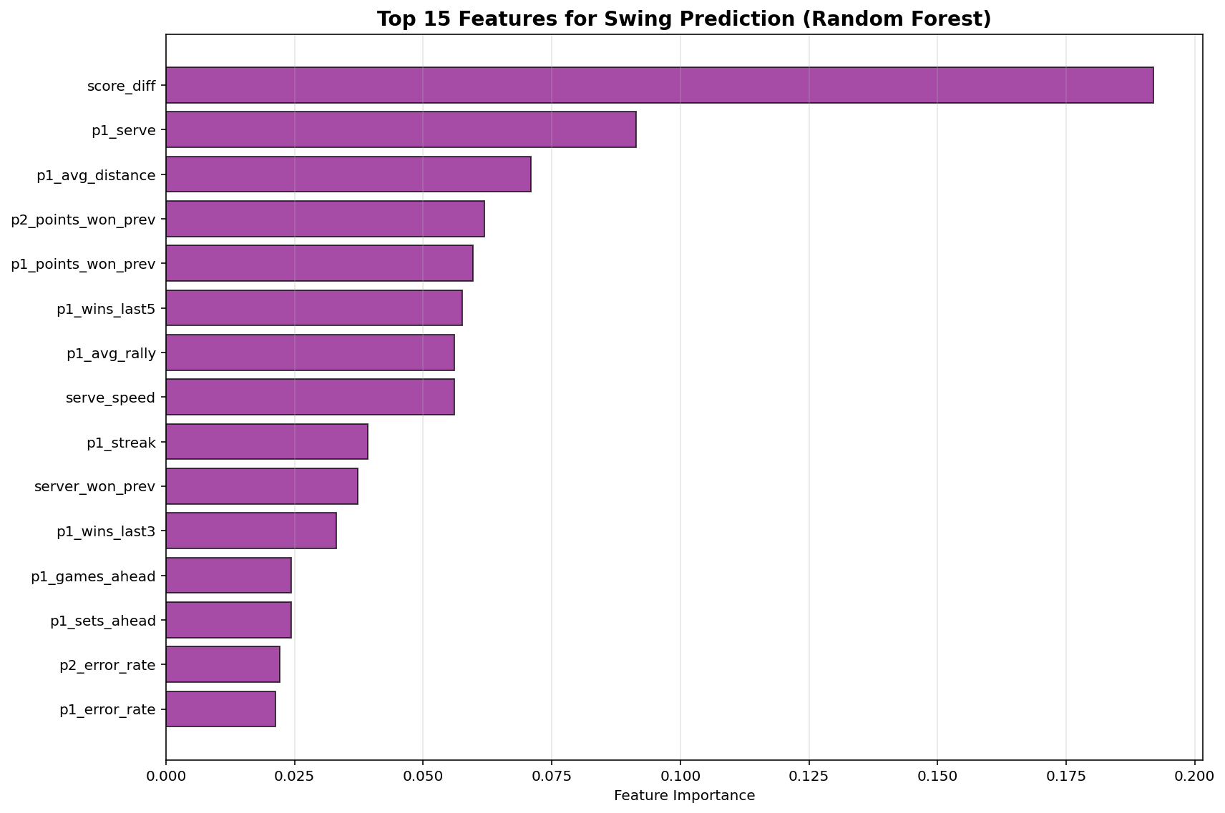

6. Performance on Test Matches
To ensure our findings weren't just overfitting to the training data, we held out three specific matches from the 2023 Wimbledon tournament (the two semi-final matches and the final match) to act as our final exam. The model had never seen these points before.
Match-by-Match Breakdown
- Match 1601 (Semi-Final):
  - Total Points: 158
  - Prediction Accuracy: 63.29%
  - Analysis: This match was consistent with our baseline. The model correctly identified 6 of the 9 actual momentum swings in the first set, tracking the flow of the game well.
- Match 1602 (Semi-Final):
  - Total Points: 201
  - Prediction Accuracy: 66.67%
  - Analysis: This was our best-performing match. The high accuracy suggests that the players in this match played "predictably" and adhered closely to the stats regarding serve speed and fatigue. The model successfully predicted the outcome of 2 out of every 3 points.
- Match 1701 (Final):
  - Total Points: 333 (5 Sets)
  - Prediction Accuracy: 61.86%
  - Analysis: This 5-set marathon was the hardest to predict, likely due to the mental and physical fatigue introducing variance that the model couldn't fully capture. However, in the decisive 5th set, the model identified 17 momentum swings, correctly flagging the volatility of the final moments.
- Overall Test Set Summary:
  - Total Points: 692 (3 Sets)
  - Total sets: 11
  - Overall point prediction accuracy: 64%
  - Overall swing prediction accuracy: 62%
  - Average momentum swings per set: 17.00

7. Conclusion
Our analysis of the 2023 Wimbledon tournament set out to answer a classic sports question: Is the "Hot Hand" real, or is it just a cognitive bias? After training models on over 7,000 points and validating them against three unseen test matches, our results suggest that momentum is statistically real, but it is far less powerful than the structural mechanics of the game.
The "Heavy Hand" Beats the "Hot Hand" The most significant finding from our Momentum Model is that tennis is dominated by the serve. In our Random Forest analysis, the server variable was nearly three times more important than any momentum-based feature. While winning the previous point (p1_points_won_prev) and winning streaks (p1_streak) were statistically significant predictors, they were secondary to the advantage of starting the point. Simply put, having the serve is a much stronger predictor of success than having "momentum."
Pressure Drives Momentum Swings However, our Swings Model revealed a critical nuance. While the serve dictates individual points, pressure dictates the flow of the match. The fact that score_diff (Score Difference) was the number one predictor for momentum swings tells us that momentum shifts are not random events. They occur disproportionately when the set is on the line. This statistical evidence supports the idea of "clutch" performance, where momentum doesn't just happen; it is seized during high-pressure moments.
Final Verdict Our final model achieved an accuracy of 63.58%, a statistically significant improvement over the baseline of simply guessing the server will win (63.01%). While this margin is small, it confirms that incorporating momentum and fatigue features allows us to predict match outcomes better than basic logic alone.
Ultimately, momentum in tennis exists, but it is not a magic force that renders a player unstoppable. It is a subtle influence, a "nudge" in probability, that operates in the shadow of the serve and physical fatigue. The "Hot Hand" is real, but in the fast-paced environment of Wimbledon, a heavy serve is still the best winning streak.

--- SUMMARY RESULTS FOR REPORT ---
{
"Model_Performance": {
"Model_Type": "Random Forest",
"Overall_Accuracy": 0.6358381502890174,
"ROC_AUC": 0.6747735098452178,
"Log_Loss": 0.6505224962649055,
"Baseline_Accuracy": 0.630057803468208,
"Improvement_Over_Baseline": 0.005780346820809301
},
"Swing_Prediction_Performance": {
"Swing_Model_Type": "Random Forest",
"Swing_Prediction_Accuracy": 0.6228323699421965,
"Swing_ROC_AUC": 0.63466934928787,
"Swing_Log_Loss": 0.6373542072988538,
"Swing_Rate_Training": 0.7508001828989483,
"Swing_Rate_Test": 0.7297687861271677
},
"Momentum_Significance": {
"P1_Significant_Matches_Pct": 12.903225806451612,
"P2_Significant_Matches_Pct": 12.903225806451612,
"P1_Turning_Significant_Pct": 0.0,
"P2_Turning_Significant_Pct": 0.0
},
"Test_Matches_Analysis": {
"Total_Test_Matches": 3,
"Test_Match_IDs": [
"2023-wimbledon-1601",
"2023-wimbledon-1602",
"2023-wimbledon-1701"
],
"Total_Sets": 11,
"Total_Points": 692,
"Avg_Momentum_Swings_Per_Set": 17.0,
"Momentum_Correlation": 0.14290806202788067,
"Critical_Points_Accuracy": 0.6984126984126984
},
"Top_Features_Point_Prediction": [
"p1_serve",
"serve_speed",
"p1_avg_distance",
"p1_points_won_prev",
"p1_avg_rally",
"p2_points_won_prev",
"serve_no",
"score_diff",
"server_won_prev",
"p1_wins_last5"
],
"Top_Features_Swing_Prediction": [
"score_diff",
"p1_serve",
"p1_avg_distance",
"p2_points_won_prev",
"p1_points_won_prev",
"p1_wins_last5",
"p1_avg_rally",
"serve_speed",
"p1_streak",
"server_won_prev"
]
}

