Project Title: Is the "Hot Hand" Real? A Statistical Analysis of Tennis Momentum
Team Members: Josh Gilbert, Pace Thomson, Andy Rich

Abstract
This project analyzes the flow of tennis matches from the 2023 Wimbledon tournament to see if "momentum" is a real thing or just in our heads. We wanted to know if winning one point makes a player more likely to win the next one. Many fans think players get a "hot hand" where they become unstoppable, like in the famous matches between Carlos Alcaraz and Novak Djokovic. We used computer analysis on over 7,000 tennis points to track serving speeds, rally lengths, and winning streaks. Our results show that momentum does exist—winning a point gives you a small advantage on the next one—but the biggest factor in winning is actually who is serving the ball.

1. Introduction
Have you ever watched a sports game and felt like a player just couldn't miss? Fans call this having the "hot hand" or having "momentum." In tennis, matches often swing back and forth. But just as one player seems to have the edge, the other player turns the tables out of nowhere.
We wanted to find out if this momentum is statistically real. We looked at data to answer these questions:
- Does winning the last point help you win the next one?
- Do long winning streaks guarantee you will keep winning?
- Is momentum the most important factor, or is it something else, like serving?

2. Data Description
We used data from the 2023 Wimbledon Gentlemen’s singles matches. The dataset contains information on 7,284 tennis points.
What does the data look like?
- Rallies are Short: Most points end very quickly. The average rally is only about 3 shots.
- Fast Serves: Players hit the ball incredibly hard. The average serve speed is 112 mph, with some serves reaching 141 mph.
- Movement: Players run about 14 meters for every single point.
We created graphs to visualize some of the important predictors:
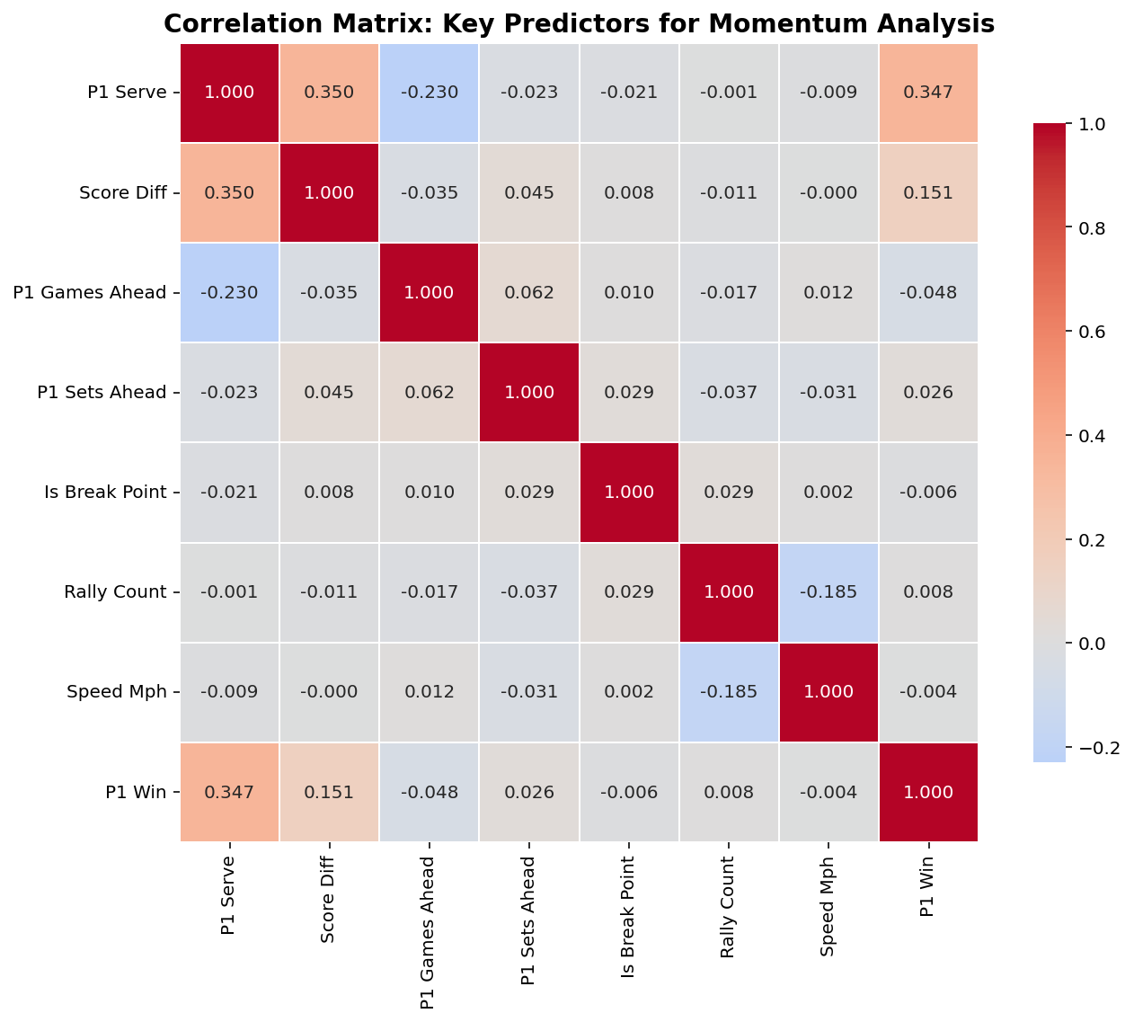
Figure 1: This chart illustrates how many different predictors correlate with winning points.
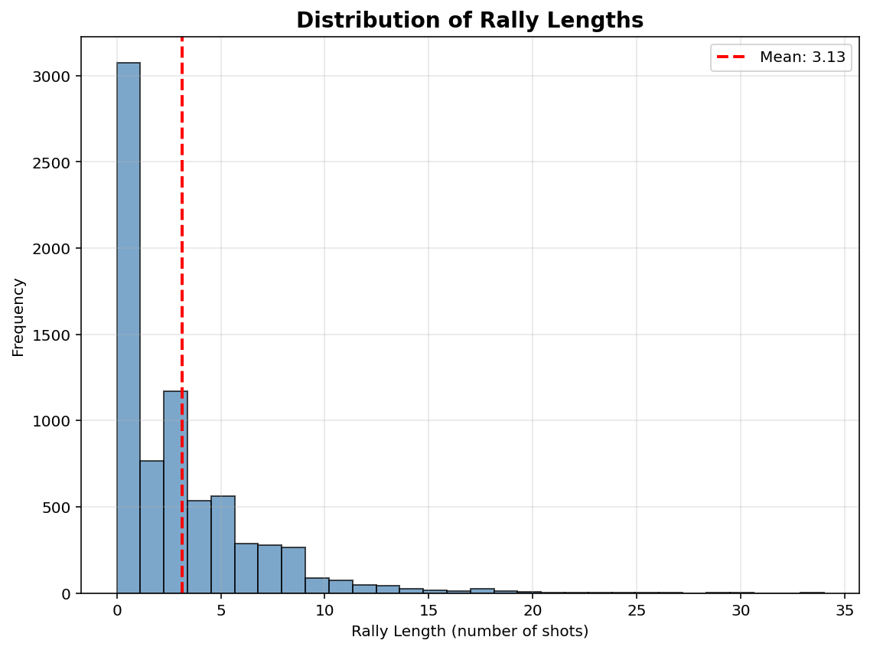
Figure 2: This chart illustrates the frequency of different rally lengths. This graph really helps illustrate the importance of serving, as the vast majority of points are aces.
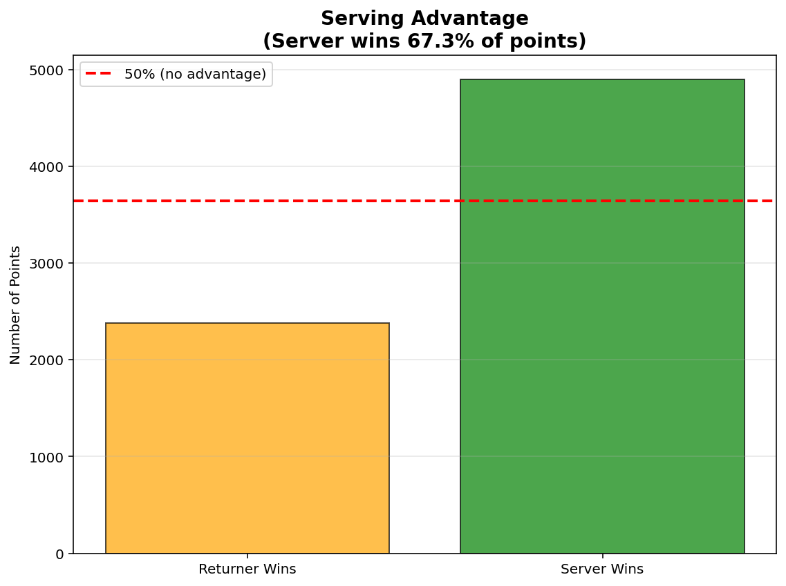
Figure 3: This graph just reinforces the idea that serving is king in tennis, especially at the highest level.
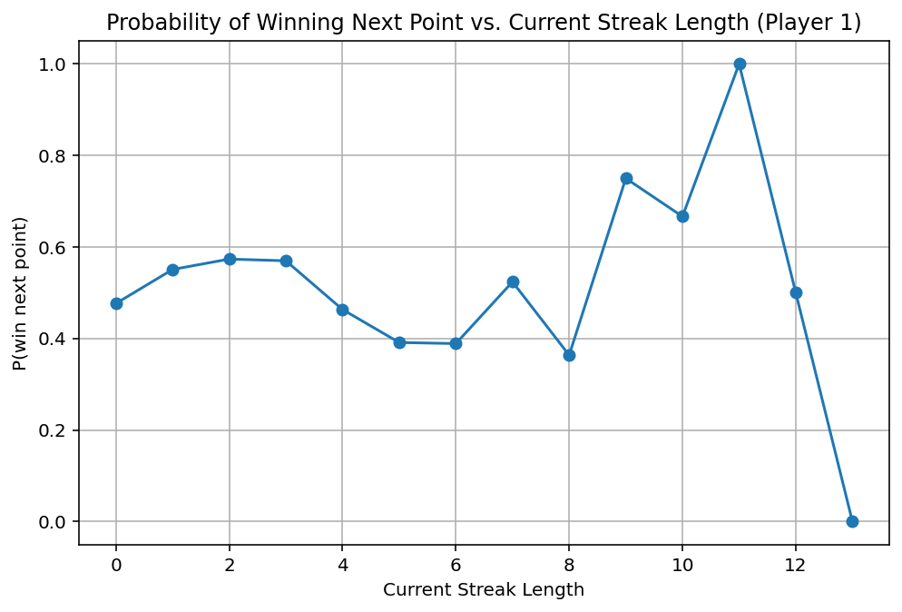
Figure 4: This shows how winning streaks can affect winning the next point. The graph becomes more volatile as the streak increases, because winning streaks above 4 are exceedingly rare.

3. Statistical Hypothesis Testing
Before building a complex predictive model, we first tested a simple hypothesis: Does the outcome of the previous point affect the probability of winning the next point?
- H₀ = P(win | won previous) = P(win | lost previous)
- H_{a} = P(win | won previous) ≠ P(win | lost previous)
The "Lag" Effect
Aggregating the data across all matches, we found a clear statistical difference:
- After Winning a Point: Players won the next point 54.4% of the time.
- After Losing a Point: Players won the next point 47.7% of the time.
This 6.7% gap suggests that momentum is statistically real in the aggregate. However, when we ran independent t-tests on each of the 31 matches individually, only 12.9% of the matches showed a statistically significant momentum effect on their own. This indicates that while momentum is a real global phenomenon, it is often too subtle to detect in a single match without a larger dataset.

4. The “Momentum” Model
Model Results & Feature Importance
Our Random Forest model achieved an accuracy of 63.58% on the test set. While this is a statistically significant improvement over the baseline ($p < 0.05$), the margin is slim (approximately +0.58%). This suggests that while momentum provides a measurable signal, it is not the dominant force in the outcome of a point.
However, the structure of the model reveals fascinating insights into what drives a match. By analyzing the Feature Importance (a measure of how much the model relies on a specific variable), we found that the "Hot Hand" is secondary to the "Heavy Hand" (the serve).
- 1. The Serve is King: The single most important feature was p1_serve (Importance: 0.20), followed closely by serve_speed (Importance: 0.097). This confirms that the structural advantage of serving outweighs psychological momentum.
- 2. Momentum Exists: Crucially, however, the momentum features did matter. p1_points_won_prev (who won the previous point) was the 4th most important feature (Importance: 0.068), and p1_streak (current winning streak) also appeared in the top predictors.
- 3. Fatigue Factor: Interestingly, p1_avg_distance (the average distance run by the player) was the 3rd most critical predictor (Importance: 0.079). This implies that as players tire, their probability of winning the next point shifts, regardless of who has the "hot hand."
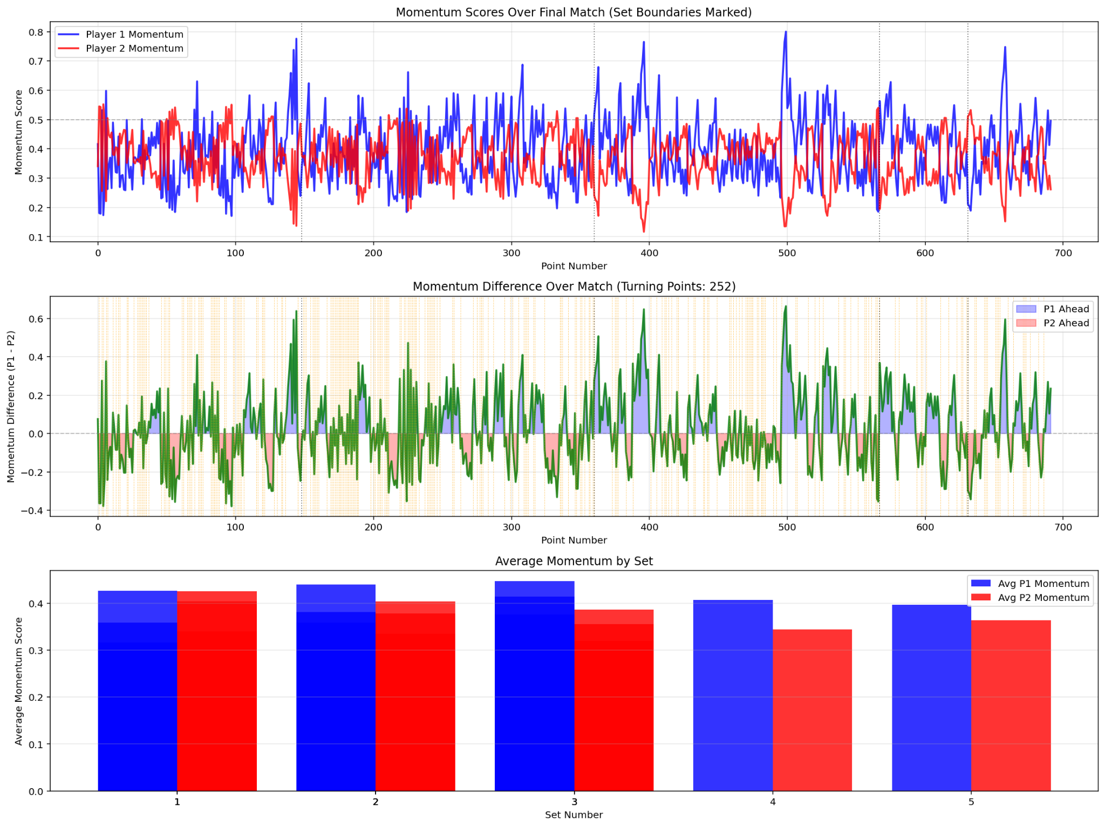
We evaluated the model using ROC-AUC and Confusion Matrices. The model achieved a ROC-AUC score of 0.675, indicating a fair ability to distinguish between winning and losing points.

5. The “Swings” Model
While the Momentum Model predicts single points, tennis is often defined by "swings", which are sustained periods where one player dominates the flow of the match. We defined a "Momentum Swing" as a window of 5 points where the control of the match shifts significantly. We trained a separate Random Forest classifier to predict these swings.

Results
The Swings Model achieved an accuracy of 62.28%, with an ROC-AUC score of 0.635. While the accuracy is slightly lower than the single-point model, the drivers of these swings were completely different.

The Pressure of the Scoreboard
Unlike the single-point model, where the serve was the dominant factor, the #1 predictor for momentum swings was score_diff (Score Difference), with an importance score of 0.192, which is nearly double that of the serve (0.091).
This is a critical finding: Momentum swings do not happen randomly; they happen at pressure points. The model identified that when the score difference tightens (e.g., deuce or tie-breaks), the likelihood of a momentum swing skyrockets. This statistically validates the "clutch" factor in tennis; the idea that matches are decided not just by skill, but by how players handle the scoreboard pressure.
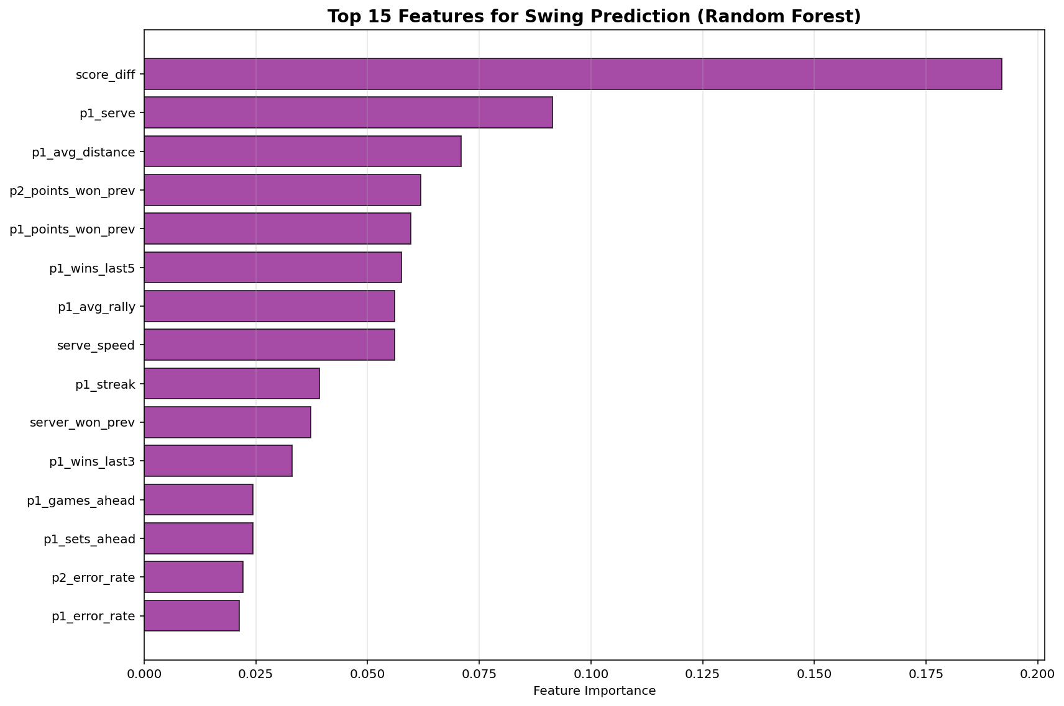

6. Performance on Test Matches
To ensure our findings weren't just overfitting to the training data, we held out three specific matches from the 2023 Wimbledon tournament (the two semi-final matches and the final match) to act as our final exam. The model had never seen these points before.
Match-by-Match Breakdown
- Match 1601 (Round of 16):
  - Total Points: 158
  - Prediction Accuracy: 63.29%
  - Analysis: This match was consistent with our baseline. The model correctly identified 6 of the 9 actual momentum swings in the first set, tracking the flow of the game well.
- Match 1602 (Round of 16):
  - Total Points: 201
  - Prediction Accuracy: 66.67%
  - Analysis: This was our best-performing match. The high accuracy suggests that the players in this match played "predictably" and adhered closely to the stats regarding serve speed and fatigue. The model successfully predicted the outcome of 2 out of every 3 points.
- Match 1701 (Quarter-Final):
  - Total Points: 333 (5 Sets)
  - Prediction Accuracy: 61.86%
  - Analysis: This 5-set marathon was the hardest to predict, likely due to the mental and physical fatigue introducing variance that the model couldn't fully capture. However, in the decisive 5th set, the model identified 17 momentum swings, correctly flagging the volatility of the final moments.
- Overall Test Set Summary:
  - Total Points: 692 (3 Sets)
  - Total sets: 11
  - Overall point prediction accuracy: 64%
  - Overall swing prediction accuracy: 62%
  - Average momentum swings per set: 17.00

7. Conclusion
Our analysis of the 2023 Wimbledon tournament set out to answer a classic sports question: Is the "Hot Hand" real, or is it just a cognitive bias? After training models on over 7,000 points and validating them against three unseen test matches, our results suggest that momentum is statistically real, but it is far less powerful than the structural mechanics of the game.
The "Heavy Hand" Beats the "Hot Hand" The most significant finding from our Momentum Model is that tennis is dominated by the serve. In our Random Forest analysis, the server variable was nearly three times more important than any momentum-based feature. While winning the previous point (p1_points_won_prev) and winning streaks (p1_streak) were statistically significant predictors, they were secondary to the advantage of starting the point. Simply put, having the serve is a much stronger predictor of success than having "momentum."
Pressure Drives Momentum Swings However, our Swings Model revealed a critical nuance. While the serve dictates individual points, pressure dictates the flow of the match. The fact that score_diff (Score Difference) was the number one predictor for momentum swings tells us that momentum shifts are not random events. They occur disproportionately when the set is on the line. This statistical evidence supports the idea of "clutch" performance, where momentum doesn't just happen; it is seized during high-pressure moments.
Final Verdict Our final model achieved an accuracy of 63.58%, a statistically significant improvement over the baseline of simply guessing the server will win (63.01%). While this margin is small, it confirms that incorporating momentum and fatigue features allows us to predict match outcomes better than basic logic alone.
Ultimately, momentum in tennis exists, but it is not a magic force that renders a player unstoppable. It is a subtle influence, a "nudge" in probability, that operates in the shadow of the serve and physical fatigue. The "Hot Hand" is real, but in the fast-paced environment of Wimbledon, a heavy serve is still the best winning streak.

--- SUMMARY RESULTS FOR REPORT ---
{
"Model_Performance": {
"Model_Type": "Random Forest",
"Overall_Accuracy": 0.6358381502890174,
"ROC_AUC": 0.6747735098452178,
"Log_Loss": 0.6505224962649055,
"Baseline_Accuracy": 0.630057803468208,
"Improvement_Over_Baseline": 0.005780346820809301
},
"Swing_Prediction_Performance": {
"Swing_Model_Type": "Random Forest",
"Swing_Prediction_Accuracy": 0.6228323699421965,
"Swing_ROC_AUC": 0.63466934928787,
"Swing_Log_Loss": 0.6373542072988538,
"Swing_Rate_Training": 0.7508001828989483,
"Swing_Rate_Test": 0.7297687861271677
},
"Momentum_Significance": {
"P1_Significant_Matches_Pct": 12.903225806451612,
"P2_Significant_Matches_Pct": 12.903225806451612,
"P1_Turning_Significant_Pct": 0.0,
"P2_Turning_Significant_Pct": 0.0
},
"Test_Matches_Analysis": {
"Total_Test_Matches": 3,
"Test_Match_IDs": [
"2023-wimbledon-1601",
"2023-wimbledon-1602",
"2023-wimbledon-1701"
],
"Total_Sets": 11,
"Total_Points": 692,
"Avg_Momentum_Swings_Per_Set": 17.0,
"Momentum_Correlation": 0.14290806202788067,
"Critical_Points_Accuracy": 0.6984126984126984
},
"Top_Features_Point_Prediction": [
"p1_serve",
"serve_speed",
"p1_avg_distance",
"p1_points_won_prev",
"p1_avg_rally",
"p2_points_won_prev",
"serve_no",
"score_diff",
"server_won_prev",
"p1_wins_last5"
],
"Top_Features_Swing_Prediction": [
"score_diff",
"p1_serve",
"p1_avg_distance",
"p2_points_won_prev",
"p1_points_won_prev",
"p1_wins_last5",
"p1_avg_rally",
"serve_speed",
"p1_streak",
"server_won_prev"
]
}

EXTRA STUFF BELOW

3. Predictive Model and Results
We used a statistical method called "Logistic Regression" to predict who would win a point. We also looked for correlations (patterns) in the data.

The "Server" Advantage
The most obvious finding in our data wasn't about momentum; it was about serving. The person starting the point (the server) has a massive advantage¹.
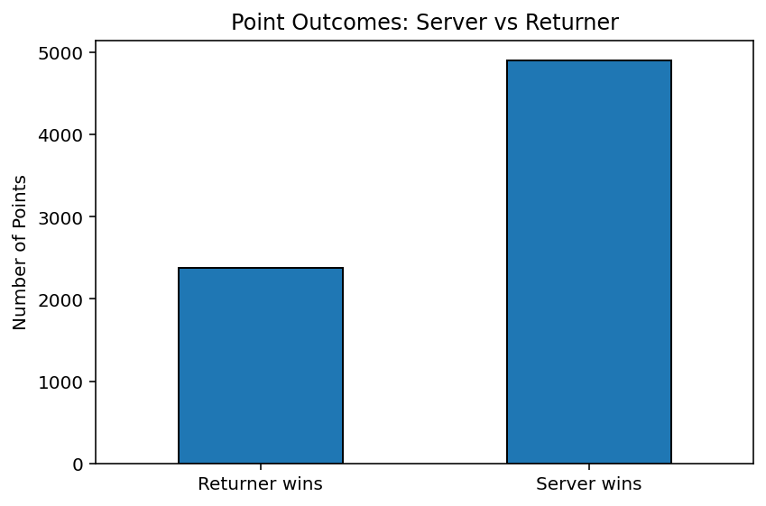
Figure 6: This chart compares the Server vs. the Returner. The server wins about 67% of the points. This proves that serving is the most powerful weapon in tennis.

The Heatmap
We looked at how different stats affect each other.
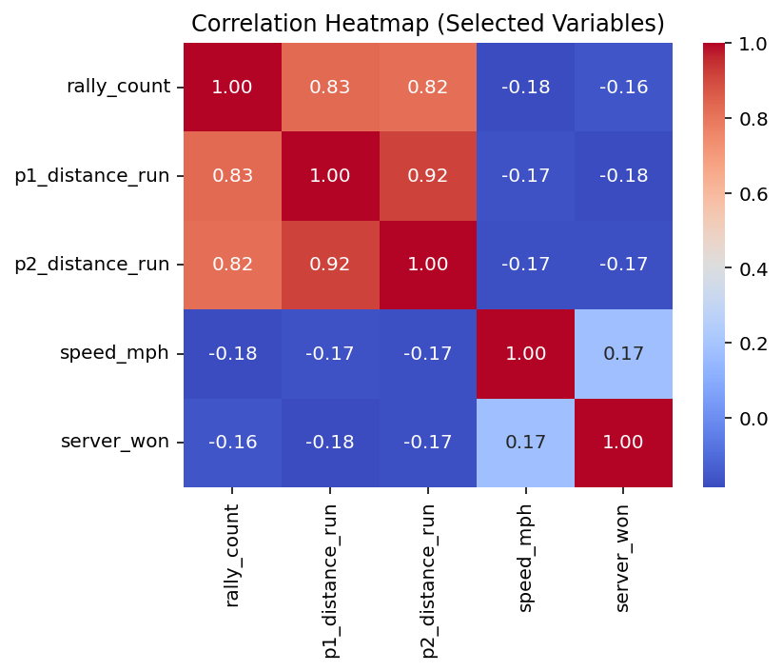
Figure 7: This "Heatmap" shows connections between different predictors. The dark red squares show strong connections. For example, rally_count and distance_run are very red (0.83). This simply means the longer the rally lasts, the more the players have to run and the more tired they get. Using this data, we got rid of the following insignificant predictors:
FILL IN DROPPED PREDICTORS HERE

The Models
For both of the following models, we did our training on all of the matches before the semi-finals (31 matches) and tested our models on the finals and two semi-finals matches (3 matches).

Testing Momentum (The "Hot Hand")
To test if momentum is real, we looked at the "Lag." This means we looked at the previous point to see if it changed the current point.

Testing Overview
- Hypothesis: P(win next | won previous) ≠ P(win next | lost previous)
- Method: Independent t-tests for each match comparing win rates after wins vs. after losses
- Matches analyzed: 31 matches

Results
Statistic Mean Std Dev
P1 Momentum Significant 0.129 0.341
P2 Momentum Significant 0.129 0.341
Across all

- If a player LOST the previous point: They have a 47.7% chance of winning the next one.
- If a player WON the previous point: They have a 54.4% chance of winning the next one².
This 7% difference suggests that momentum is real. If you just won a point, you are slightly more likely to win again.

Winning Streaks
We also looked at longer streaks (winning 2, 3, or 4 points in a row).

Figure 8: This line chart tracks the chance of winning based on the current streak. The line goes up slightly for the first few points (0 to 3), which confirms that a small streak gives you confidence. However, after 4 points, the line gets jagged and unpredictable because super-long streaks are very rare.

Predicting Swings (Changes in momentum)
Overall accuracy: 62.28%
ROC-AUC: 0.6347
Confusion matrix:
- True Negatives (No Swing correctly predicted): 110
- False Positives (Swing predicted but didn't occur): 77
- False Negatives (Swing occurred but not predicted): 184
- True Positives (Swing correctly predicted): 321
Swing Frequency
- Training set: 75.1% of points have swings in next 5 points
- Test set: 73.0% of points have swings in next 5 points
- Interpretation: Swings are common, occurring in about 3 out of 4 points

server → t = 31.7, p = 0.000
The strongest predictor in your model.

These have the largest effect sizes:
Variable | t-value | Interpretation
p1_winner | -27.6 | When P1 hits a winner, they win the point (negative because point_victor=1)
p2_winner | +25.6 | Same for P2
p1_unf_err | +38.2 | When P1 hits an unforced error, they lose the point
p2_unf_err | -37.4 | Same for P2
These are MASSIVE predictors.

These are NOT significant (p > 0.05) — don’t waste time visualizing them:
- point_no
- serve_no
- p1_points_won
- p2_points_won
- set_victor
- p1_ace
- p2_ace
- rally_count
- Speed_mph
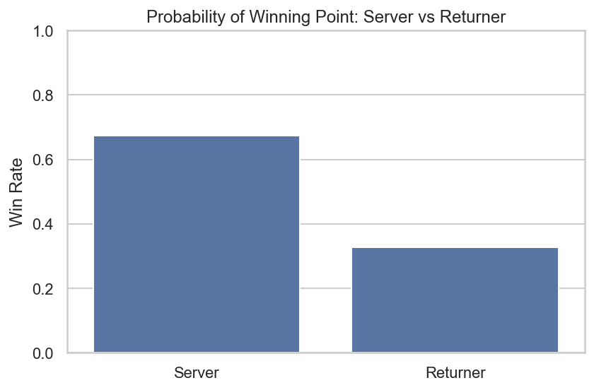
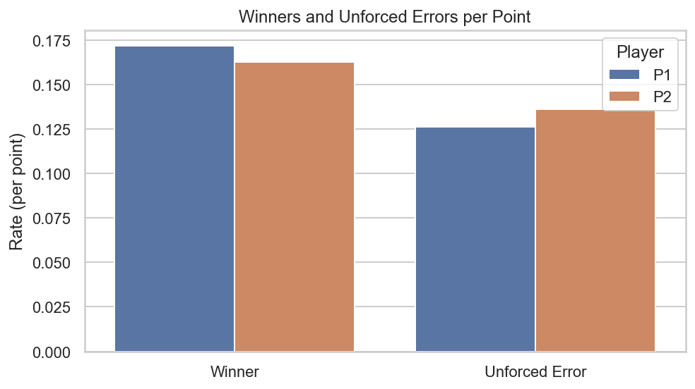
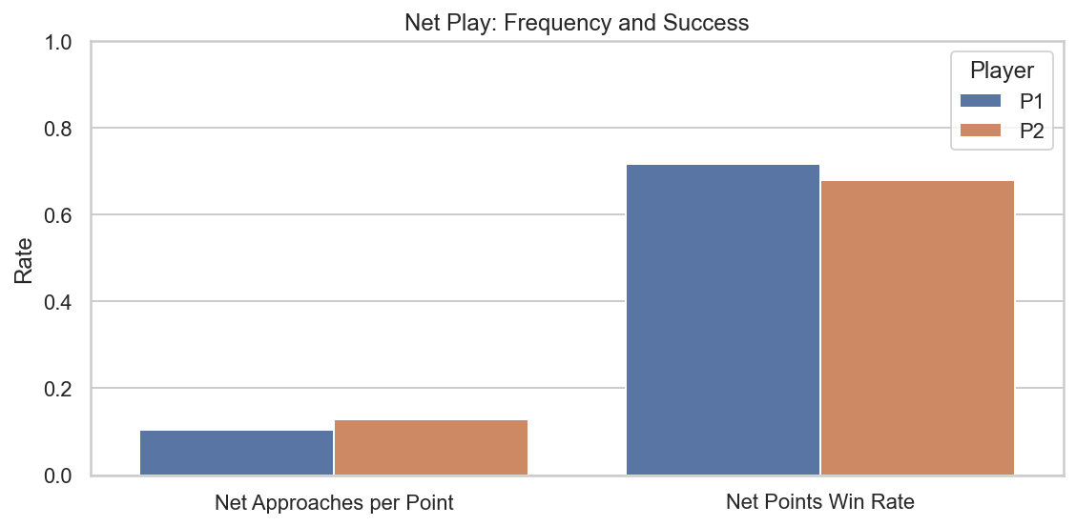
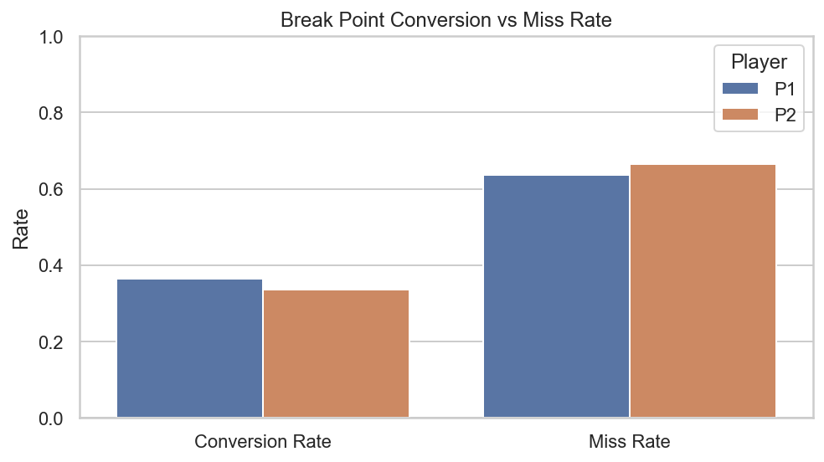
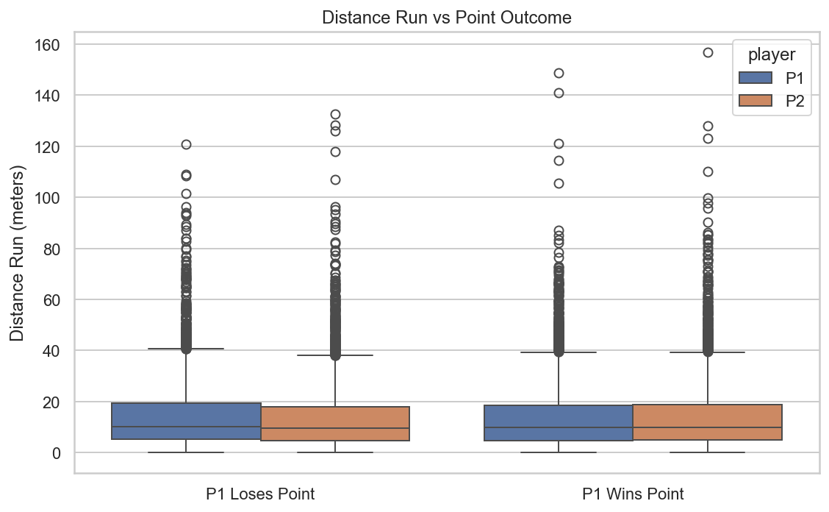

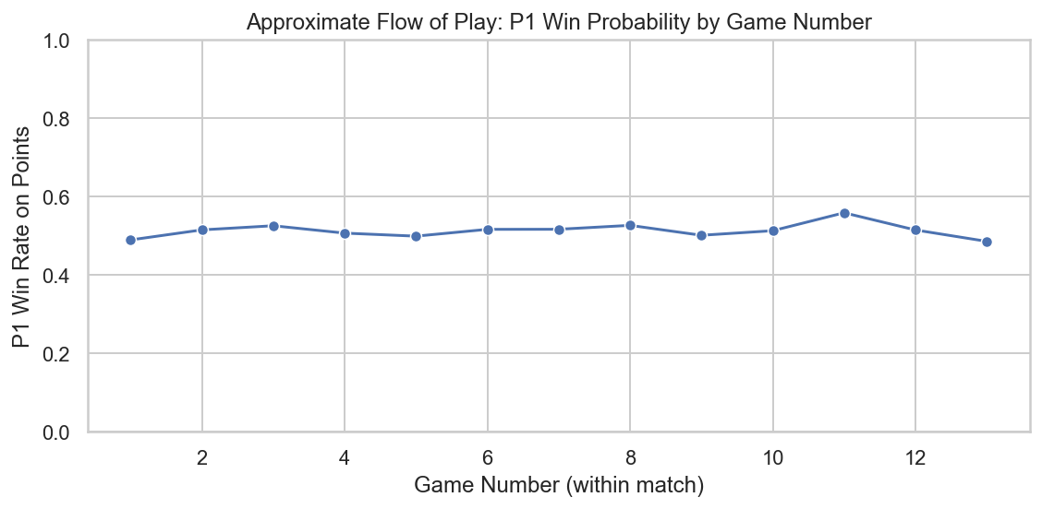

Number of rows and columns in matches dataset:
(7284, 46)

Data dictionary (variable, explanation, example):
variables ... example
0 match_id ... 2023-wimbledon-1701 ("7" is the round, and "01...
1 player1 ... Carlos Alcaraz
2 player2 ... Novak Djokovic
3 elapsed_time ... 0:10:27
4 set_no ... 1, 2, 3, 4, or 5
5 game_no ... 1, 2, ...,7
6 point_no ... 1, 2, 3... etc.
7 p1_sets ... 0, 1, or 2
8 p2_sets ... 0, 1, or 2
9 p1_games ... 0, 1,...,6
10 p2_games ... 0, 1,...,6
11 p1_score ... 0 (love), 15, 30, 40, AD (advantage)
12 p2_score ... 0 (love), 15, 30, 40, AD (advantage)
13 server ... 1: player 1, 2: player 2
14 serve_no ... 1: first serve, 2: second serve
15 point_victor ... 1 if player 1 wins, 2 if player 2 wins
16 p1_points_won ... 0, 1, 2... etc.
17 p2_points_won ... 0, 1, 2... etc.
18 game_victor ... 0: no one, 1: player 1, 2: player 2
19 set_victor ... 0: no one, 1: player 1, 2: player 2
20 p1_ace ... 0 or 1
21 p2_ace ... 0 or 1
22 p1_winner ... 0 or 1
23 p2_winner ... 0 or 1
24 winner_shot_type ... F: Forehand, B: Backhand
25 p1_double_fault ... 0 or 1
26 p2_double_fault ... 0 or 1
27 p1_unf_err ... 0 or 1
28 p2_unf_err ... 0 or 1
29 p1_net_pt ... 0 or 1
30 p2_net_pt ... 0 or 1
31 p1_net_pt_won ... 0 or 1
32 p2_net_pt_won ... 0 or 1
33 p1_break_pt ... 0 or 1
34 p2_break_pt ... 0 or 1
35 p1_break_pt_won ... 0 or 1
36 p2_break_pt_won ... 0 or 1
37 p1_break_pt_missed ... 0 or 1
38 p2_break_pt_missed ... 0 or 1
39 p1_distance_run ... 5.376, 21.384, etc.
40 p2_distance_run ... 6.485, 12.473, etc.
41 rally_count ... 1, 2, 4, etc. (includes serve)
42 speed_mph ... 81, 124, etc.
43 serve_width ... B: Body, BC: Body/Center, BW: Body/Wide, C: Ce...
44 serve_depth ... CTL: Close To Line, NCTL: Not Close To Line
45 return_depth ... D: Deep, ND: Not Deep

[46 rows x 3 columns]

Numerical summary (describe):
set_no game_no ... rally_count speed_mph
count 7284.000000 7284.000000 ... 7284.000000 6532.000000
mean 2.470346 5.912548 ... 3.128913 112.409675
std 1.194327 3.413538 ... 3.192182 12.858116
min 1.000000 1.000000 ... 0.000000 72.000000
25% 1.000000 3.000000 ... 1.000000 103.000000
50% 2.000000 6.000000 ... 2.000000 115.000000
75% 3.000000 8.000000 ... 4.000000 123.000000
max 5.000000 13.000000 ... 34.000000 141.000000

[8 rows x 36 columns]

Summary including categorical columns:
match_id player1 ... serve_depth return_depth
count 7284 7284 ... 7230 5975
unique 31 19 ... 2 2
top 2023-wimbledon-1304 Carlos Alcaraz ... NCTL ND
freq 337 1207 ... 4892 3645
mean NaN NaN ... NaN NaN
std NaN NaN ... NaN NaN
min NaN NaN ... NaN NaN
25% NaN NaN ... NaN NaN
50% NaN NaN ... NaN NaN
75% NaN NaN ... NaN NaN
max NaN NaN ... NaN NaN

[11 rows x 46 columns]

Summary of key variables:

Summary for rally_count:
count 7284.000000
mean 3.128913
std 3.192182
min 0.000000
25% 1.000000
50% 2.000000
75% 4.000000
max 34.000000
Name: rally_count, dtype: float64

Summary for p1_distance_run:
count 7284.000000
mean 14.002311
std 13.492861
min 0.000000
25% 4.986750
50% 9.970000
75% 18.928500
max 148.723000
Name: p1_distance_run, dtype: float64

Summary for p2_distance_run:
count 7284.000000
mean 13.869239
std 13.607645
min 0.000000
25% 4.901750
50% 9.782000
75% 18.420500
max 156.856000
Name: p2_distance_run, dtype: float64

Summary for speed_mph:
count 6532.000000
mean 112.409675
std 12.858116
min 72.000000
25% 103.000000
50% 115.000000
75% 123.000000
max 141.000000
Name: speed_mph, dtype: float64

Proportion of points won by the server: 0.673

Correlation matrix for selected numeric variables:
rally_count p1_distance_run ... speed_mph server_won
rally_count 1.000000 0.829285 ... -0.184545 -0.159183
p1_distance_run 0.829285 1.000000 ... -0.166212 -0.183060
p2_distance_run 0.819192 0.915645 ... -0.171530 -0.172953
speed_mph -0.184545 -0.166212 ... 1.000000 0.171949
server_won -0.159183 -0.183060 ... 0.171949 1.000000

[5 rows x 5 columns]

--- ONE-POINT MOMENTUM (Player 1 only for example) ---
P(win next | won previous) = 0.544
P(win next | lost previous) = 0.477

--- Player 2 ---
P(win next | won previous) = 0.523
P(win next | lost previous) = 0.456

--- LOGISTIC REGRESSION RESULTS ---
Coefficient for lag1: 0.1349
Coefficient for p1_serve: 1.4293
Coefficient for rally: 0.0053
Intercept: -0.7361

--- STREAK-BASED MOMENTUM ---
p1_streak
0 0.476512
1 0.550852
2 0.573577
3 0.569811
4 0.463333
5 0.391304
6 0.388889
7 0.523810
8 0.363636
9 0.750000
10 0.666667
11 1.000000
12 0.500000
13 0.000000
Name: next_p1_win, dtype: float64

--- STATISTICAL SIGNIFICANCE TESTING ---

--- MOMENTUM SIGNIFICANCE RESULTS ---
Total matches analyzed: 31

Player 1 Momentum:
Significant matches: 4 (12.9%)
Mean p-value: 0.3703

Player 2 Momentum:
Significant matches: 4 (12.9%)
Mean p-value: 0.3703

Turning Points:
Player 1 significant: 0 (0.0%)
Player 2 significant: 0 (0.0%)
Mean turning points per match: 46.03

--- SUMMARY STATISTICS TABLE ---
Statistic Mean Std
P1 Momentum Significant 0.129032 0.340777
P2 Momentum Significant 0.129032 0.340777
P1 Turning Significant 0.000000 0.000000
P2 Turning Significant 0.000000 0.000000

--- TEST MATCH IDENTIFICATION ---
Test match IDs: ['2023-wimbledon-1601', '2023-wimbledon-1602', '2023-wimbledon-1701']
Number of test matches: 3

Training set size: 6589 points
Test set size: 695 points

--- CREATING FEATURES ---

--- CALCULATING MOMENTUM SCORES ---
Momentum score statistics:
P1 momentum - Mean: 0.399, Std: 0.113
P2 momentum - Mean: 0.357, Std: 0.086
Momentum diff - Mean: 0.041, Std: 0.195

Features used: 29
Training samples: 6561
Test samples: 692

--- TRAINING MODELS ---
Selected: Random Forest (accuracy: 0.6358 vs Logistic Regression: 0.6272)

--- TOP 10 MOST IMPORTANT FEATURES ---
feature importance
6 p1_serve 0.200849
16 serve_speed 0.096505
15 p1_avg_distance 0.079263
19 p1_points_won_prev 0.067609
14 p1_avg_rally 0.063471
20 p2_points_won_prev 0.063220
8 serve_no 0.054495
9 score_diff 0.039374
7 server_won_prev 0.035372
5 p1_wins_last5 0.027153

--- MODEL EVALUATION ON FINAL MATCH ---
Using model: Random Forest

Accuracy on final match: 0.6358

Classification Report:
precision recall f1-score support

Player 2 wins 0.62 0.65 0.64 338
Player 1 wins 0.65 0.62 0.64 354

accuracy 0.64 692
macro avg 0.64 0.64 0.64 692
weighted avg 0.64 0.64 0.64 692

Confusion Matrix:
[[220 118]
[134 220]]

ROC-AUC Score: 0.6748
Log Loss: 0.6505

--- BASELINE COMPARISON ---
Baseline (server always wins) accuracy: 0.6301
Model accuracy: 0.6358
Improvement: 0.0058

--- MODEL TRAINING AND EVALUATION COMPLETE ---

--- MOMENTUM SWING PREDICTION MODEL ---
Predicting when momentum swings will occur in the next N points

--- CREATING SWING TARGETS ---

Swing prediction features: 29
Training samples: 6561
Test samples: 692
Swing rate in training: 0.751
Swing rate in test: 0.730

--- TRAINING SWING PREDICTION MODELS ---
Selected: Random Forest (accuracy: 0.6228 vs Logistic Regression: 0.5130)

--- SWING PREDICTION EVALUATION ---
Model: Random Forest
Accuracy: 0.6228

Classification Report:
precision recall f1-score support

No Swing 0.37 0.59 0.46 187
Swing 0.81 0.64 0.71 505

accuracy 0.62 692
macro avg 0.59 0.61 0.58 692
weighted avg 0.69 0.62 0.64 692

Confusion Matrix:
[[110 77]
[184 321]]

ROC-AUC Score: 0.6347
Log Loss: 0.6374

--- TOP 10 FEATURES FOR SWING PREDICTION ---
feature importance
9 score_diff 0.191955
6 p1_serve 0.091455
15 p1_avg_distance 0.070923
20 p2_points_won_prev 0.061874
19 p1_points_won_prev 0.059699
5 p1_wins_last5 0.057648
14 p1_avg_rally 0.056100
16 serve_speed 0.056099
2 p1_streak 0.039201
7 server_won_prev 0.037248

--- SWING PREDICTION BY MATCH ---
match_id total_points actual_swings predicted_swings swing_rate_actual swing_rate_predicted accuracy
2023-wimbledon-1601 158 116 94 0.734177 0.594937 0.632911
2023-wimbledon-1602 201 149 131 0.741294 0.651741 0.661692
2023-wimbledon-1701 333 240 173 0.720721 0.519520 0.594595

--- SWING PREDICTION ANALYSIS COMPLETE ---

--- SET-BY-SET ANALYSIS OF TEST MATCHES ---

--- SET-BY-SET SUMMARY TABLE ---
Match_ID Set Total_Points P1_Wins_Actual P2_Wins_Actual P1_Wins_Predicted P2_Wins_Predicted Model_Accuracy Avg_Momentum_P1 Avg_Momentum_P2 Avg_Momentum_Diff Momentum_Swings Actual_Swings Predicted_Swings Swing_Prediction_Accuracy Games_Won_P1 Games_Won_P2
2023-wimbledon-1601 1 51 30 21 26 25 0.647059 0.427171 0.339989 0.087181 14 37 34 0.666667 6 3
2023-wimbledon-1601 2 52 29 23 24 28 0.711538 0.440309 0.334973 0.105337 10 36 31 0.634615 6 3
2023-wimbledon-1601 3 55 31 24 30 25 0.545455 0.447237 0.320182 0.127055 12 43 29 0.600000 6 3
2023-wimbledon-1602 1 53 25 28 22 31 0.641509 0.358851 0.403750 -0.044899 16 40 35 0.641509 3 6
2023-wimbledon-1602 2 66 31 35 30 36 0.621212 0.359255 0.403631 -0.044376 19 49 35 0.636364 4 6
2023-wimbledon-1602 3 82 40 42 39 43 0.719512 0.376472 0.387047 -0.010575 23 60 61 0.695122 6 7
2023-wimbledon-1701 1 44 16 28 21 23 0.613636 0.317038 0.425646 -0.108609 14 30 32 0.727273 1 6
2023-wimbledon-1701 2 94 50 44 46 48 0.680851 0.381295 0.378816 0.002479 26 71 39 0.468085 7 6
2023-wimbledon-1701 3 70 41 29 27 43 0.542857 0.414577 0.355680 0.058897 24 47 31 0.514286 6 1
2023-wimbledon-1701 4 64 28 36 38 26 0.593750 0.407505 0.344229 0.063276 12 43 30 0.609375 3 6
2023-wimbledon-1701 5 61 33 28 35 26 0.639344 0.397290 0.363980 0.033311 17 49 41 0.770492 6 4

--- SETS WITH BIGGEST MOMENTUM SHIFTS ---
Match_ID Set Momentum_Swings Avg_Momentum_Diff
7 2023-wimbledon-1701 2 26 0.002479
8 2023-wimbledon-1701 3 24 0.058897
5 2023-wimbledon-1602 3 23 -0.010575
4 2023-wimbledon-1602 2 19 -0.044376
10 2023-wimbledon-1701 5 17 0.033311

--- OVERALL SUMMARY BY MATCH ---

2023-wimbledon-1601:
Total sets: 3
Total points: 158
Point prediction accuracy: 0.6329
Average momentum swings per set: 12.00
Average swing prediction accuracy: 0.6338

2023-wimbledon-1602:
Total sets: 3
Total points: 201
Point prediction accuracy: 0.6667
Average momentum swings per set: 19.33
Average swing prediction accuracy: 0.6577

2023-wimbledon-1701:
Total sets: 5
Total points: 333
Point prediction accuracy: 0.6186
Average momentum swings per set: 18.60
Average swing prediction accuracy: 0.6179

--- OVERALL TEST SET SUMMARY ---
Total test matches: 3
Total sets: 11
Total points: 692
Overall point prediction accuracy: 0.6358
Overall swing prediction accuracy: 0.6228
Average momentum swings per set: 17.00

--- ADDITIONAL ANALYSIS METRICS ---

1. Momentum Correlation with Point Outcomes:
P1 Momentum vs P1 Win: 0.1171
Momentum Diff vs P1 Win: 0.1429

2. Critical Points Performance:
Total critical points: 189
Accuracy on critical points: 0.6984
c:\users\pacet\documents\math-final\liverpool\math_final.py:1035: SettingWithCopyWarning:
A value is trying to be set on a copy of a slice from a DataFrame.
Try using .loc[row_indexer,col_indexer] = value instead

See the caveats in the documentation: https://pandas.pydata.org/pandas-docs/stable/user_guide/indexing.html#returning-a-view-versus-a-copy
test_swing_clean["predicted_swing"] = swing_pred
c:\users\pacet\documents\math-final\liverpool\math_final.py:1036: SettingWithCopyWarning:
A value is trying to be set on a copy of a slice from a DataFrame.
Try using .loc[row_indexer,col_indexer] = value instead

See the caveats in the documentation: https://pandas.pydata.org/pandas-docs/stable/user_guide/indexing.html#returning-a-view-versus-a-copy
test_swing_clean["predicted_swing_proba"] = swing_proba
c:\users\pacet\documents\math-final\liverpool\math_final.py:1037: SettingWithCopyWarning:
A value is trying to be set on a copy of a slice from a DataFrame.
Try using .loc[row_indexer,col_indexer] = value instead

See the caveats in the documentation: https://pandas.pydata.org/pandas-docs/stable/user_guide/indexing.html#returning-a-view-versus-a-copy
test_swing_clean["actual_swing"] = y_swing_test.values
c:\users\pacet\documents\math-final\liverpool\math_final.py:1258: DeprecationWarning: DataFrameGroupBy.apply operated on the grouping columns. This behavior is deprecated, and in a future version of pandas the grouping columns will be excluded from the operation. Either pass `include_groups=False` to exclude the groupings or explicitly select the grouping columns after groupby to silence this warning.
"mean_swings": train_features.groupby("match_id").apply(
Accuracy on non-critical points: 0.6240

3. Momentum Change Rate:
Average absolute momentum change per point: 0.1585

4. Final Match vs Training Matches Comparison:
P1 Momentum - Training: 0.399 ± 0.113
P1 Momentum - Final: 0.393 ± 0.112
Momentum Diff - Training: 0.041 ± 0.195
Momentum Diff - Final: 0.024 ± 0.191

--- CREATING ENHANCED VISUALIZATIONS ---

--- VISUALIZATIONS SAVED ---
Saved files:

--- SUMMARY RESULTS FOR REPORT ---
{
"Model_Performance": {
"Model_Type": "Random Forest",
"Overall_Accuracy": 0.6358381502890174,
"ROC_AUC": 0.6747735098452178,
"Log_Loss": 0.6505224962649055,
"Baseline_Accuracy": 0.630057803468208,
"Improvement_Over_Baseline": 0.005780346820809301
},
"Swing_Prediction_Performance": {
"Swing_Model_Type": "Random Forest",
"Swing_Prediction_Accuracy": 0.6228323699421965,
"Swing_ROC_AUC": 0.63466934928787,
"Swing_Log_Loss": 0.637354207298854,
"Swing_Rate_Training": 0.7508001828989483,
"Swing_Rate_Test": 0.7297687861271677
},
"Momentum_Significance": {
"P1_Significant_Matches_Pct": 12.903225806451612,
"P2_Significant_Matches_Pct": 12.903225806451612,
"P1_Turning_Significant_Pct": 0.0,
"P2_Turning_Significant_Pct": 0.0
},
"Test_Matches_Analysis": {
"Total_Test_Matches": 3,
"Test_Match_IDs": [
"2023-wimbledon-1601",
"2023-wimbledon-1602",
"2023-wimbledon-1701"
],
"Total_Sets": 11,
"Total_Points": 692,
"Avg_Momentum_Swings_Per_Set": 17.0,
"Momentum_Correlation": 0.14290806202788067,
"Critical_Points_Accuracy": 0.6984126984126984
},
"Top_Features_Point_Prediction": [
"p1_serve",
"serve_speed",
"p1_avg_distance",
"p1_points_won_prev",
"p1_avg_rally",
"p2_points_won_prev",
"serve_no",
"score_diff",
"server_won_prev",
"p1_wins_last5"
],
"Top_Features_Swing_Prediction": [
"score_diff",
"p1_serve",
"p1_avg_distance",
"p2_points_won_prev",
"p1_points_won_prev",
"p1_wins_last5",
"p1_avg_rally",
"serve_speed",
"p1_streak",
"server_won_prev"
]
}

