CS 298

Global Smartphones Shipment

1. Introduction

We choose this topic because smartphone is a part of everyone’s life now. Smartphone is no longer an expensive product like it used to be so everyone can own a smartphone easily. That’s why our team is very interested to find out the number of smartphones in the future. Since there are a lot of vendors of smartphone, we divide them based on their operating system and we predict their shipment’s amount until 2025. Our choices of operating system are: Windows Phone (Microsoft), Android (Google), IOS (Apple), Blackberry, and Symbian (Nokia). With the current growth rate, we can predict the future of each operating system’s market accurately.

II. Data Selection

In order to calculate the recent growth rate of each OS, we found a report for years 2012, 2013 and 2014 from a Wikipedia reference page. In the report, we found all the number we need: the number of shipment for each OS.

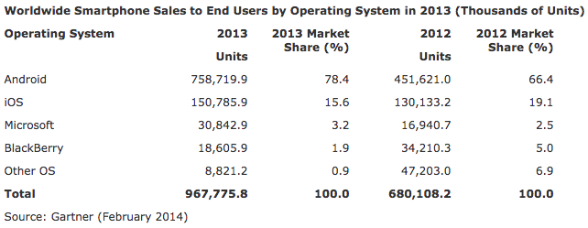

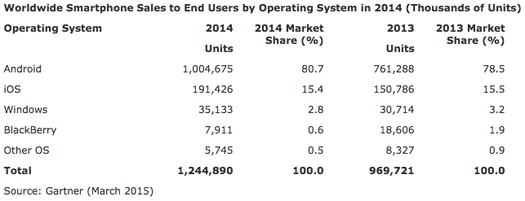

From the data, we are able to figure out the growth rate by using this equation:

eq1.gif

III. Motivation:

The smartphone is able to perform many of the functions of a computer, typically having a relatively large screen and an operating system capable of running general-purpose applications. As we continue to develop the infrastructure necessary to provide Internet access globally, smartphones provide the functionality and price points desirable by most people world-wide.

It would be reasonable to imagine that (along with a smartphones' mobile capabilities) eventually even the overarching 'tech world' may even favor utilizing smartphones over stationary, desktop computers.

Furthermore, and with onset of cloud computing, computational devices can be utilized to depend on lessened (on-site) resources - furthering the capabilities of smartphones.

Most importantly for developers (like ourselves), smartphones have captivated the consumer market and are being employed more than ever for download software, specifically. Our hope is that, in examining shipment data for the various smartphone devices, we can better conclude which mobile platforms may be more favorable for software developers.

IV. Modeling approach:

Since smartphones growth is unconstrained growth, we decide to use Runge-Kutta 2 method for our prediction. Below is an example of how we use the equation to calculate for Android.

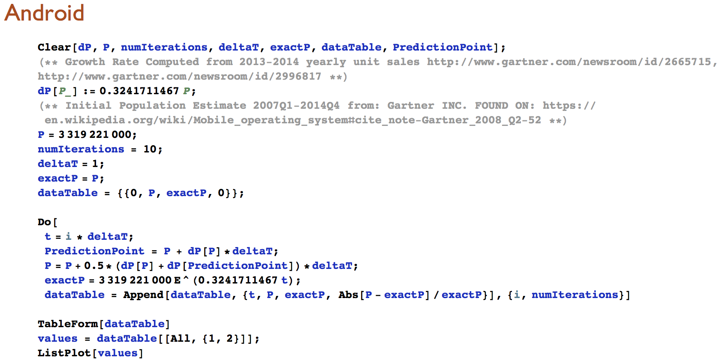

By setting the numIterations to 10, we can predict the growth of Android (and various other Operating Systems) with current growth rate by 2025. The result of the prediction is shown in the table (Fig1) and the prediction can be seen from the graph (Fig2) below:

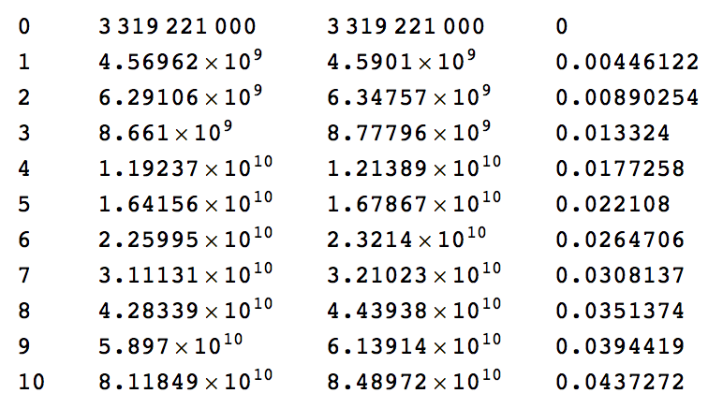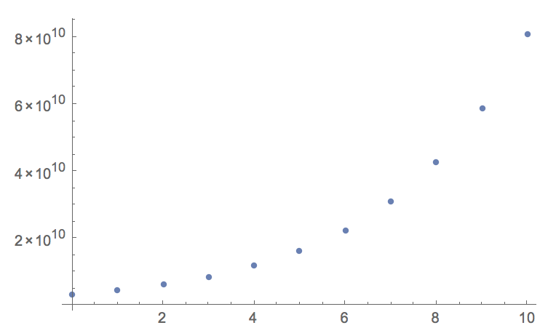

Fig1: Android prediction table in 10 years Fig2: Android prediction graph in 10 years

The reason why we choose Runge-Kutta 2 method for our project is because we identified that our data is a unconstrained growth, so by using Runge-Kutta 2 method, our predictions can be much more accurate than by using the other methods.

V. Model conclusions

**Android Graph/Data:**

**Initial Population (0) -- 3,319,221,000**

**2015: 4,590,100,000**

**2024: 84,897,200,000**

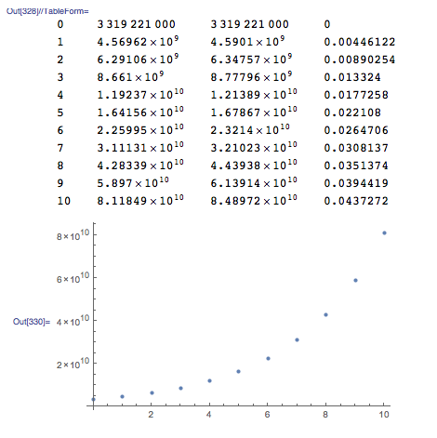

The simulations for Android, iOS and Windows all show the growth rate of total shipments over time; that is, they predict (along w/ the initial population estimates and growth rates) the total shipments for years 2015-2024. With Blackberry and Symbian, we took a different approach - by utilizing their declining growth rates (as a decreasing popularity rate for the OS in general) and initial populations, we were able to predict exactly when the total smartphone population would reach zero (in the case of symbian) and the population estimates for 2015-2024 (for Blackberry).

VI. Discussion

On multiple occasions we encountered issues pertaining to inconclusive data, regarding our specific phenomenon. To remedy this we cross referenced multiple sources such as with data regarding the initial population of symbian smartphones.

We feel strongly about our predictions even while using unconstrained growth methodology. By utilizing shipment data, we think that our accumulated error is partially minimized.

VII. Conclusion

When implementing unconstrained growth methodology to simulate a constrained phenomenon, users will always encounter accumulation errors -- even still, by utilizing the total shipment data (per OS) we feel strongly that our simulation maintains decent accuracy.

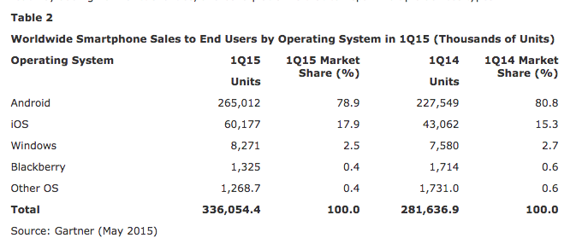

In order to examine the accuracy of our results, we compared our simulated estimates w/ potential estimates from real data for Quarter 1 2015.

**\*\*\*\*\*\*\*\*\*\*\*\*\*\*For** **Apple:**  **[Estimate from initial population + 2015 data]\*\*\*\*\*\*\*\*\*\*\*\*\***

946058000 + (60,177 * 4 * 1000)

**= 1,186,766,00**

**VS. Simulated Actual: 1,235,400,000**

**\*\*\*\*\*\*\*\*\*\*\*\*\*\*For Android: [Estimate from initial population + 2015 data]\*\*\*\*\*\*\*\*\*\*\*\***

3319221000 + (256,012 * 4 * 1000)

**= 4,379,269,000**

**VS. Simulated Actual: 4,569,200,000**

As readers will notice, the relative error between the two amounts is quite low - and does not factor in potentially *higher* quarters to come (and hence could actually be much closer to our simulated value). In all, we were quite surprised with our results - though after considering it for some days now, it is within reason that our ending simulated estimates (2024) may be quite close to reality -- this showcases the importance of mobile software development moving forward.