# Physics 1, Project 2

By David Zuniga Navarro

## How to build:

1. Project is made and compiled in VS2019.
2. Open the solution file, and make sure configuration is set to x64, Debug/Release.
3. Release is recommended for a better experience.

## How to use:

* WASD - Move the camera in X and Z axis
* QE - Move the camera in the Y axis
* TFGH - Move the player in X and Z axis
* RY - Move the player in the Y axis
* C - Enables/Disable the camera following the player
* Arrows - Yaw/Pitch Up, down, left and right
  + (has effect on velocity) (looks nice but difficult to control the player using these)
* Mouse - While left clicking moves the camera

AABB drawing triangles of each AABB:

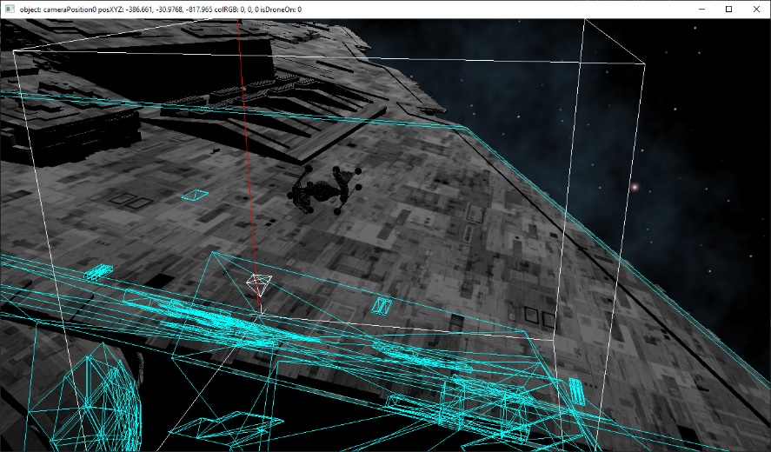Also, colliders are drawn as spheres (not actual size of colliders)

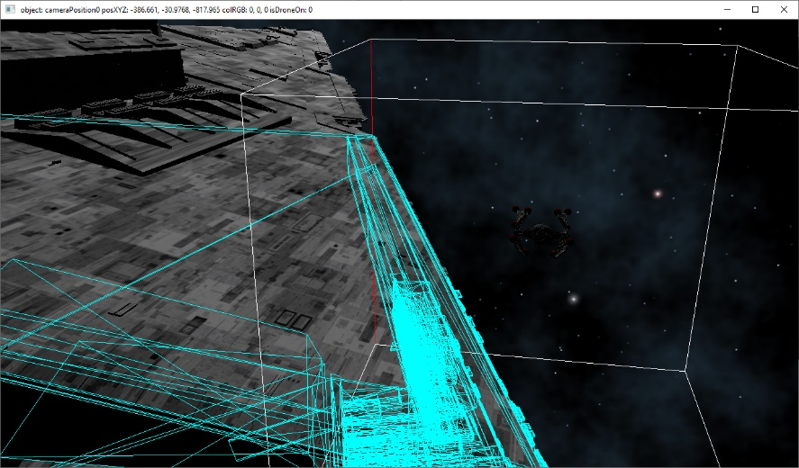

Function for generating AABBs

