How to Hackerman

This guide covers the basics on how to be hackerman.

# Table of Contents

URL Specifications - 2

How to Type Port in Browsers - 2

Google Chrome - 2

Mozilla Firefox - 2

Others - 3

Works Cited - 3

# URL Specifications

Every HTTP URL conforms to the syntax of a generic URI. The *URI generic syntax* consists of a hierarchical sequence of five *components* (Wikipedia, 2019):

URI = scheme:[//authority]path[?query][#fragment]

where the authority component divides into three *subcomponents*:

authority = [userinfo@]host[:port]

An example of a URL, with a port and path

https://who.dis.tk:6767/a947d78ba75ca4c58625857289f2a081/

As illustrated above, a URL can have a port. In the next section, we will be covering how to type ports into various browsers.

# How to Type Port in Browsers

## Google Chrome

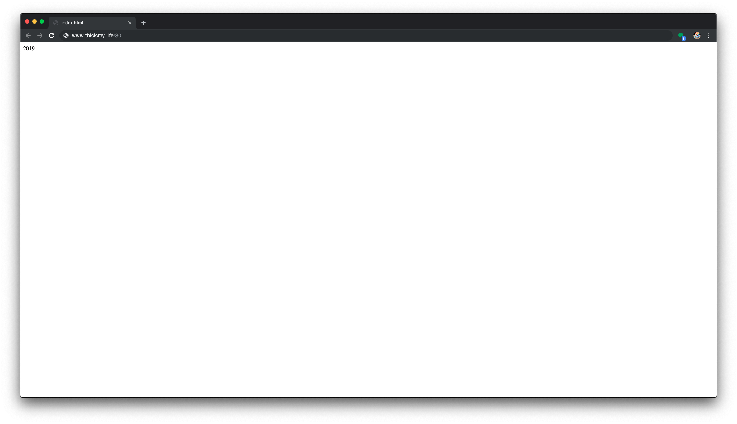

As illustrated in the image above, a port is typed after the address, after the dividing colon.

## 

## Mozilla Firefox

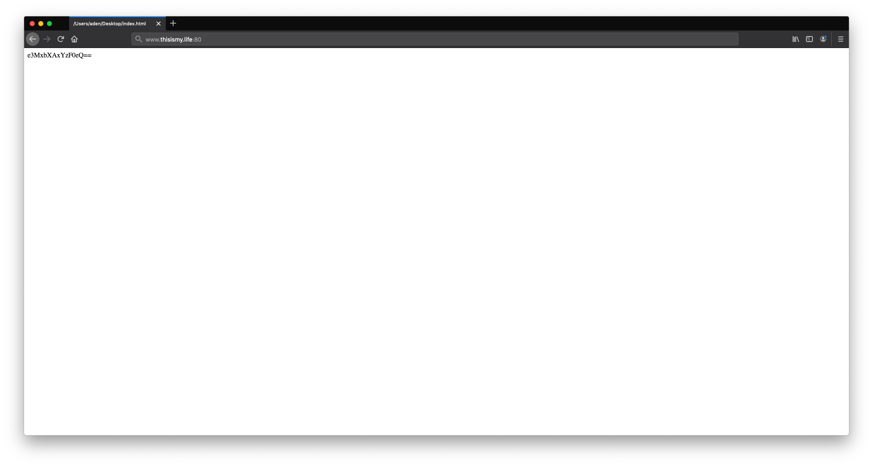

Same thing different town, port is type where it is.

## Others

We don’t really have the budget to have all the screenshots in here sorry. Bet it helped it enough to find the _k3y_ tho.

# Works Cited

Wikipedia, 2019. Wikipedia. [Online]

Available at: https://en.wikipedia.org/wiki/URL

[Accessed 20 4 2019].