Small Unmanned Aircraft Systems
sUAS Proposal

August 29, 2025

ARC has developed the following proposal based upon requirements set forth by the James City County Police Department. This proposal serves as an estimation for a Statement of Work (SOW) discussed. The information provided in this proposal is accurate and does not withhold information relevant to the SOW as described herein.

USE AND DISCLOSURE OF DATA

This proposal includes data that shall not be disclosed outside the James City County Police Department and shall not be duplicated, used, or disclosed – in whole or in part – for any purpose other than to evaluate this proposal or quotation. If, however, a contract is awarded to this offeror as a result of – or in connection with – the submission of this data, the James City County Police Department shall have the right to duplicate, use, or disclose the data to the extent provided in the resulting subcontract. This restriction does not limit Freedom the right to use the information contained in this data if it is obtained from another source without restriction.

The data subject to this restriction are contained in sheets marked “Use or disclosure of data contained on this sheet is subject to the restrictions on the title page of this volume.

1. EXECUTIVE SUMMARY
ARC Aero Inc. (hereinafter called “ARC”) has developed an efficient, reliable, and safe small, unmanned aircraft system (sUAS) to perform various missions to include, but are not limited to routine air carrier drone delivery operations, critical infrastructure inspection, security and ISR. To date, ARC has established its operations in various regions around the world, scaling air operations, hiring services, and training. For each customer, ARC utilizes a customer-driven approach, remaining flexible to the specific operational requirements, tailoring aircraft configuration, and supporting flight operations. As flight operations commence, ARC provides dedicated support to the Customer, providing on-call service for support, training, troubleshooting, and, when necessary, on-site retraining and professional engineering services.

The ARC design team will be evaluating operational standards and limitations while establishing aircraft configuration for beyond line of sight operations

- ARC has a history of delivering high-quality, timely, responsive, and cost-effective services to a wide variety of clients.
- Our pricing reflects demonstrated technical and trade expertise, management credentials, and vast experience training and overseeing Air Operations.
- Salient characteristics of the ARC proposal include:
  - Exceptional technical qualifications and demonstrated superior performance.
  - Solid management and operations credentials in support of other sUAS Operations.
  - A highly dedicated & responsive company that is accountable to its Customers.
  - Highly flexible aircraft configuration based upon mission need

2. COMPANY INFORMATION
Proposal Expiration Statement
This proposal remains valid for 30 calendar days.

Company Information
ARC AERO, INC
440 N Wolfe Rd, Sunnyvale, CA 94085
Phone: (510) 203-3825, (765) 293-7829

Authorized Offeror Personnel
Persons authorized to commit on behalf of ARC are:

CEO – Asel Tursun asel@arcaero.ai
CTO - Alibek Yertay alibek@arcaero.ai

3. REPRESENTATIONS AND CERTIFICATIONS

Small Business Concern Representation
Per Federal Acquisition Regulations (FAR) 52.219-1, ARC represents and certifies as part of its offer that it is a small business concern and is qualified as a Small Business.

4. SCOPE OF WORK

The following scope of work has been developed through bid specifications and includes assumptions made by ARC. These assumptions have been made using an aerospace engineering perspective to evaluate the mission requirements, operating environment, budget, aircraft configuration and payload limitations, and general engineering and integration experience.

5. AIRIS 3 - AIRCRAFT CONFIGURATION

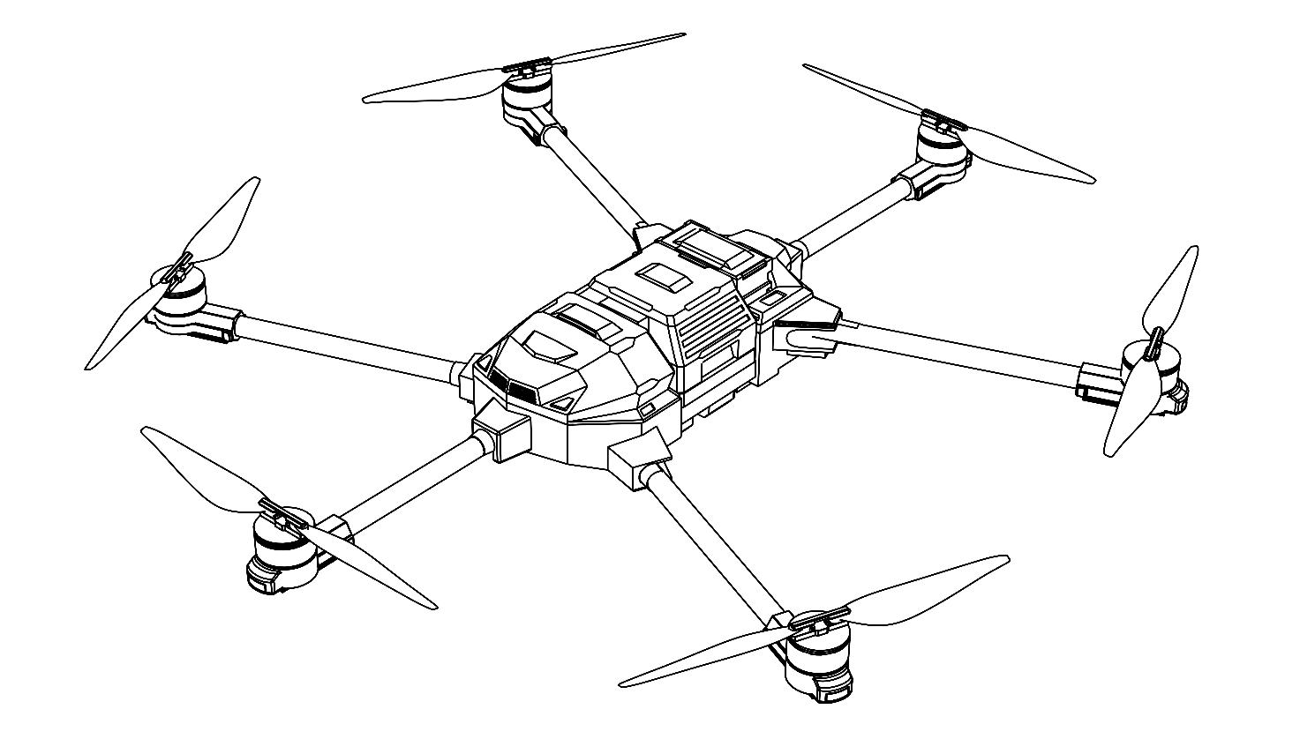

5.1. SPECIFICATIONS
Unmanned Aircraft (UA) Specifications
Max Gross Takeoff Weight | 24.9 kg
Weight | 13.5 kg (without battery)  18.4 kg (with battery)
Max Payload | 10 kg
Dimensions | 1362*1498*673mm (unfolded)  806*505*673mm (folded)
Propulsion System | Electric Powered Rotors
Max Flight Speed | 20 m/s
Wind Resistance | 11 m/s
Operating Temperature | -20 C to 40 C
GNSS | GPS, BeiDou, Galileo, GLONASS
Dual GPS Receiver | Installed
IMU | Triple Redundant IMU
White Strobe Light for Night Operations | Installed; 3 mile visibility
Aircraft Position Lights | Installed
Remote ID | Installed
Camera | A gimbal camera with 1080P resolution
Delivery Winch System
Max Delivery Weight | 23 lbs
Delivery Height | 100 ft
Payload Release | Installed; Gravity Release
Batteries and Charger
Battery Capacity | 30 Ah
Charge Time | < 60 mins

Ground Control Station (GCS) Specifications
Primary C2 Connectivity | LTE
Secondary C2 Connectivity | 900MHz FCC approved

5.2. AIRIS 3 PACKAGE CONFIGURATION

The following table is representative of the components that have been selected for this package pricing but does not intend to represent the final configuration of the UAS. Our team will work directly with the James City County Police Department to select components that meet the mission requirements and configure the aircraft according to the capabilities that must be present.

DELIVERABLE | QTY
AIRIS 3 sUAS | 1
Remote Control Unit | 1
AIRIS 3 Toolkit | 1
Travel Case | 1

5.3. GENERAL TERMS

Lead Times
ARC will deliver units 45 days after receiving order and payment for aircraft.

Returns
Terms and Conditions of Return policy is stated in the Appendix.

5.4. REPAIRS, SERVICE, AND PARTS
Repairs & Service
For repair services that cannot be completed by the Operator, customers will need to ship the aircraft or components requiring repair to ARC's facility located at 440 N Wolfe Rd, Sunnyvale, CA 94085. Buyer is responsible for shipping costs to return Product to ARC. The shipping costs must be prepaid and the Product should be shipped in its original container, or an equivalent, properly packed to withstand the hazards of shipment and be fully insured.

All repairs will be performed at this ARC repair depot by our trained technicians. Key details regarding the repair process:

- To initiate a repair, the customer must first obtain a Return Merchandise Authorization (RMA) from ARC.
- The aircraft/components must be shipped to the ARC repair facility with the provided RMA number.
- Upon receipt, ARC will evaluate the repair requirements and provide a quote for parts and labor costs to the customer.
- Once the repair quote is approved by the customer, the repair work will be performed at the ARC facility.
- Repaired items will be shipped back to the customer upon completion of work. Buyer is responsible for shipping costs to return Product to Buyer.

Repair Labor Rates:
- Standard Repair Technician: $125/hour (billed in 15-min increments, 1-hr minimum)
- Engineering Support (if required): $175/hour

Replacement Parts Pricing:
Any required replacement components/parts will be charged at current OEM list price plus a 15% handling fee.

By having customers ship products to our centralized repair depot, ARC can ensure consistent quality control in accordance with ARC specifications, efficient repair workflows, and availability of specialized tools/equipment required for maintenance of our aircraft systems.

5.5. DATA RIGHTS AND INTELLECTUAL PROPERTY

ARC, as the Original Equipment Manufacturer (OEM), retains exclusive ownership and all proprietary rights, titles and interests in the intellectual property related to the aircraft design, avionics systems, software, firmware, trade secrets, and any other technical data or proprietary information associated with the unmanned aircraft systems being offered.

No rights or ownership in ARC's intellectual property are transferred or licensed to the buyer under this agreement. The buyer is strictly prohibited from reverse engineering, decompiling, disassembling or otherwise attempting to derive the source code, designs or technical information from the aircraft, components or associated software/firmware provided.

Any unauthorized copying, reproduction, distribution or disclosure of ARC's proprietary information, whether in whole or in part, is expressly forbidden and would constitute a violation of ARC's intellectual property rights.

The buyer is granted a limited, non-exclusive, non-transferable license to use the provided software and firmware solely for the operation of the purchased aircraft in accordance with the end-user license agreement (EULA). No other rights are granted.

ARC reserves the right to pursue all available legal remedies, including but not limited to injunctive relief and monetary damages, against any party found to be infringing upon its intellectual property rights.

By incorporating robust intellectual property protection clauses, we safeguard ARC's valuable proprietary assets and mitigate the risk of our designs being replicated or reverse-engineered by the buyer or any third parties. This language establishes clear boundaries and legal recourse should any infringement occur.

This agreement and its intellectual property protections are enforceable under the laws of the State of California, without regard to its conflict of laws principles. In the event of any infringement or breach of ARC’s intellectual property rights, ARC reserves the right to pursue all available legal remedies

6. PRICING & ESTIMATING PROCEDURES

6.1. Escalation Rates

ARC shall estimate escalation on an annual basis.

6.2. PRICING
We offer the following pricing for the Airis 3 Package and associated components:

ITEM | QTY | UNIT PRICE | TOTAL
AIRIS 3 Package | 1 | $15,990 | $15,990
Winch System | 1 | $4,990 | $4,990
Battery Unit | 2 | $1535 | $3070
Battery Charging Unit | 1 | $700 | $700
Parachute Recovery System | 1 | $5,999 | $5,999
Travel Case | 1 | $2999 | $2999
Software Suite Annual Support per 1 system  (2 months free) for 2 years | 1 | $175/month | $4200
Training/Customer On-board (Days) | 3 | $400 | $1200
Standard 1-Year UA Warranty | 1 | $0 | $0
1-Year Extended UA Warranty | 2 | $2,499 | $4,998
RFQ Total Package cost |  |  | $44146

Additional add-ons / Optional services
ITEM | QTY | UNIT PRICE | TOTAL
Additional Training (on site) | 7 | $400/day | $2800
On-site support after training |  | $300/day

Note 1: Annual Aircraft Inspection Service allows Customers to ship aircraft to ARC for inspection and parts replacement. ARC will provide a quote for necessary repairs post inspection. This service provides the Customer a means of maintaining continued airworthiness when UAS is operated in accordance with manufacturer's guidelines. Pricing
Note 2: Software Suite pricing is per vehicle

6.3. SHIPPING COST

Domestic shipping cost is $600.
International shipping cost is $1300. The price does not include customs clearance. The buyer is responsible for customs clearance.

6.4. BILLING SCHEDULE

Payment Terms
ARC requires payment in advance for all aircraft orders and associated services. The billing schedule will be as follows:

1. Initial Payment:
- 30% upon acceptance of proposal

2. Final Payment:
- 70% payment due prior to delivery
Payment terms will be Net 30 days of invoicing.
Payment Methods
Acceptable payment methods include wire transfer, corporate check, or letter of credit. Credit card payments may be accepted for orders below $50,000 with a 3% processing fee.

Late Payments
Payments not received by the due date are subject to late fees of 1.5% per month on the outstanding balance.

7. ACCEPTANCE
If you are satisfied with the terms of this proposal, please sign below to indicate your acceptance. We look forward to the opportunity to work with you.
Accepted by:
Name: ___________________________
Title: ____________________________
Date: ____________________________

8. CONCLUSION
ARC understands the purchasing and mission objectives of the James City County Police Department. We have quoted prices that are extremely competitive and reasonable considering the robust capability of our sUAS.

ARC has alleviated any cost realism concerns ensuring our offer:
- Is based on accurate and realistic costs based on actual experience to support scaled sUAS production.
- Highlights our understanding of the requirements and ability to manufacture an sUAS to perform its mission.

ARC has evaluated component manufacturers, competitive solutions, and the mission requirements to build an aircraft configuration that is extremely competitive. Additionally, our business model and offering to the James City County Police Department allows for unmatched flexibility with regards to reselling, future customization, and white labeling the product for this and other efforts. Our team is poised to serve as your preeminent supplier for unmanned systems around the globe.

APPENDIX - RETURN POLICY

Eligibility for Returns
- Time Frame:
  - Products must be returned within 14 days from the date of purchase.
- Condition of the Product:
  - The product must be in its original condition, unused, and include all accessories, manuals, and packaging.
  - Items damaged due to improper use or mishandling are not eligible for return.

Return Process
- Contact Us:
  - Before returning an item, contact our customer support team at alibek@arcaero.ai to initiate the process.
  - You will receive a Return Authorization (RA) number, which must be included with your return.
- Packaging:
  - Ensure the product is securely packaged to prevent damage during transit.
- Shipping:
  - Ship the product to the address provided by our support team. Customers are responsible for return shipping costs unless the return is due to a defective or incorrect product.

Refunds
- Refunds will be processed within 7–10 business days of receiving the returned item.
- Refunds will be issued to the original payment method used at the time of purchase.

Exchanges
If you wish to exchange your product for a different model or replacement, please contact our support team. Exchanges are subject to product availability and must meet the return eligibility criteria.

Defective or Damaged Products
- If your product arrives damaged or defective, please contact us within 7 days of receipt for assistance. We will provide a replacement or full refund after verifying the issue.

