Data Visualization CA2
Student Name: Domantas Prialgauskas
Student ID: C00285607
Program Title: Cybercrime & IT Security
Program Code: CW_KCCYB_B
Module Title: Data Visualization
Lecturer’s Name: Agnes Maciocha
Word Count: 6521

Data Visualization CA2
Domantas Prialgauskas C00285607
2026-04-02

1.Introduction
My data visualization essay will be on the topic of my final year project which is titled “Acoustic Side Channel Attacks: Keystroke Classification from Microphone Recordings”. In essence my final year cyber security project is to be able to extract the audio of a keystroke and be able to identify what a user has typed based on the information that the acoustic features of that keystroke represent. [1] [4]
This topic is worth examining because acoustic side channel attacks represent a significant cyber security concern, showing how unintended sound leakage can be used to identify what a user types. The data used to classify the keystroke is not naturally interpretable by humans, particularly when features such as MFCC [2] are used, Mel-Frequency Cepstral Coefficient which is defined as “Features used in speech and speaker recognition applications that provide a smoothed representation of the audio signal’s spectrum while accounting for the non-linear characteristics of human hearing”.
Since these features are effective for machine learning but difficult to understand directly, information visualization becomes a rather important way of revealing patterns, evaluating performance and communicating findings.
A further reason to indicate this topic being suitable for analysis is that even testing the system is not naturally easy to interpret [7] , experimental results have been presented as dense tables of text showing per letter classification accuracy across multiple runs, which contains useful information however it makes patterns difficult to quickly identify, in this such case, proper information visualization can transform raw output into more accessible, readable and easy to understand formats including heat maps and other methods to allow clearer understanding of classification performance.

2.Research Question / Problem:
The research problem to address in this essay will be how the visualization of information can support the interpretation, evaluation and communication of findings regarding acoustic keystroke classification data when the underlying audio features, particularly MFCCs are not directly interpretable pieces of data by humans

3. Data Presentation
This section presents the main forms of data used in the project before any detailed manipulation and analysis. The data set will include raw keystroke audio recordings in WAV format, transformed acoustic feature representations mainly containing MFCC [2] representations and finally classification performance outputs generated during system testing. I will discuss representations we can create of the three levels of data with some basic academic takeaways from that, without going into major detail just to show what we can do in the context of R studio to represent these forms of data, before going into much more detail in the data manipulation section.

3.1 Raw Acoustic Data
The first type of data we will work with is the raw acoustic data, that is the raw microphone recordings of individual keystrokes, at this stage audio exists as a waveform signal [5] in which amplitude changes over time. Presenting this form of data is important to show the original structure of the key stroke before further processing as it can lead to diagnostics that reveal problems with classification for reasons that are not yet algorithmic such as a key stroke window is being extracted too long or too short.
#{r} #install.packages("tuneR") #install.packages("ggplot2") #

3.2 Feature Representation
The second form of data is the processed and represented raw recording in a format that is going to be useful for the machine learning model. Visualization at this level is important due to the fact that the type of feature representations such as MFCCs [2] are not naturally interpretable to humans[7] , this is data primarily for the machine learning model to learn from therefore finding a way to visually represent that can be useful, it is important to mention that representation of data at this level is merely educational, similarities or lack of similarities between classes will not necessarily explain system behavior, which I will expand on in the data manipulation section.
#{r} #install.packages("seewave") #install.packages("viridis") #

3.3 Performance Output
This section will show and highlight how the accuracy of the system can be visualized, the metrics for tracking accuracy, improvements or lack thereof within the system. I will highlight ways to quickly and efficiently interpret a raw log of performance output data in a nice informative manner and expand in detail in the data manipulation section.

4. Data Manipulation
In this section we will look at detailed representations of the three forms of data presented, raw acoustic data, feature representation and finally the performance output section. While the data presentation section introduces the main types of data, this section will show detailed visualizations and how those results can be interpreted within the context of my acoustic side channel attack cyber security project.

4.1 Raw Acoustic Data
In this section I will look at some far more detailed visualizations of the raw acoustic data, for this I will provide in depth visualizations and explanations of code and usability of these, the first visualization will be a comparison of clean vs noisy waveform view to prove visualization can immediately reveal signal quality differences and noise changes which alter how easy it would be to identify key stroke events as well as diagnosing the quality of data before sending it for machine learning after it has been transformed to the relevant feature representation. Secondly, I will show a zoomed waveform of a single keystroke, and compare individual key strokes to each other to show how tight a time window around one key stroke actually is and how important it is to capture the perfect size of window. Thirdly, I will show an amplitude envelope instead of just plotting the raw waveform to prove how the envelope makes it easier to identify events and to highlight the importance of preprocessing in my project.
library(tuneR)
library(ggplot2)
w_clean <- readWave("data/wav/A01.wav")
w_noisy <- readWave("data/wav/noisy.wav")
sig_clean <- w_clean@left / 2^(w_clean@bit - 1)
time_clean <- seq(0, length(sig_clean) - 1) / w_clean@samp.rate
sig_noisy <- w_noisy@left / 2^(w_noisy@bit - 1)
time_noisy <- seq(0, length(sig_noisy) - 1) / w_noisy@samp.rate
wave_df_clean <- data.frame(
time = time_clean,
amplitude = sig_clean,
Sample = "Clean (A01)"
)
wave_df_noisy <- data.frame(
time = time_noisy,
amplitude = sig_noisy,
Sample = "Noisy"
)
wave_compare <- rbind(wave_df_clean, wave_df_noisy)
wave_compare_short <- subset(wave_compare, time >= 0 & time <= 3)
ggplot(wave_compare_short, aes(x = time, y = amplitude)) +
geom_line() +
facet_wrap(~Sample, ncol = 1) +
labs(
title = "Clean vs Noisy Raw Waveform Comparison",
x = "Time (seconds)",
y = "Amplitude"
) +
theme_minimal()
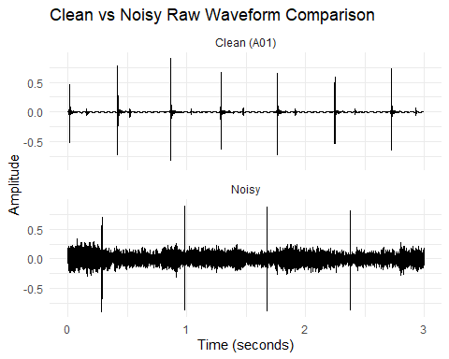
In this code, the readWave() [14] function loads the clean and noisy WAV files we then extract the scale and waveform amplitudes from both clean and noisy samples, seq() creates the time axis for each file while data.frame() function stores each waveform in a table with time, amplitude and a label then rbind() function combines the labels into one data set and subset() limits the comparison to the first three seconds of each recording to show a more detailed view of individual key stroke events and finally facet_wrap(~Sample) puts the clean and noisy recordings into separate panels for direct comparison.[15]
Directly comparing side by side the noisy and clean samples provides a clear view of how important diagnostics are at this level of data, we must be able to extract a clean key stroke window in order to have usable data for the machine learning model to learn from, this includes not only the peak on the event but also the small riffles before and after the event, even in the noisy sample we can see that we always find the peak of the keystroke, however, in the cyber security project it is essential to be able to capture the entire keystroke window, not just the peak sound, therefore we can easily diagnose the noisy sample and note that this recording is not one that will be usable for machine learning.
library(tuneR)
library(ggplot2)
w_clean <- readWave("data/wav/A01.wav")
sig_clean <- w_clean@left / 2^(w_clean@bit - 1)
time_clean <- seq(0, length(sig_clean) - 1) / w_clean@samp.rate
wave_df_clean <- data.frame(
time = time_clean,
amplitude = sig_clean
)
wave_zoom <- subset(wave_df_clean, time >= 0.18 & time <= 0.30)
ggplot(wave_zoom, aes(x = time, y = amplitude)) +
geom_line() +
labs(
title = "Zoomed Waveform of a Single Keystroke",
x = "Time (seconds)",
y = "Amplitude"
) +
theme_minimal()
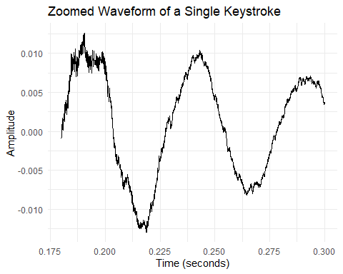 In this code readWave() [14] loads the clean audio sample, the amplitude values are extracted and scaled, seq() creates the matching time axis, data.frame() stores the waveform in a plottable format, subset() isolates a small time window around a specific keystroke and ggplot()[17] [18] alongside geom_line() are used to draw the zoomed waveform[13]
We can see how truly detailed a singular keystroke event actually is and how the intensity of key stroke press changes, even though this recording contains the same key stroke being repeatedly pressed, we can highlight the distinct differences between all three key stroke events.
library(tuneR)
library(ggplot2)
w_noisy <- readWave("data/wav/noisy.wav")
sig_noisy <- w_noisy@left / 2^(w_noisy@bit - 1)
time_noisy <- seq(0, length(sig_noisy) - 1) / w_noisy@samp.rate
wave_df_noisy <- data.frame(
time = time_noisy,
amplitude = sig_noisy
)
wave_zoom_noisy <- subset(wave_df_noisy, time >= 0.18 & time <= 0.30)
ggplot(wave_zoom_noisy, aes(x = time, y = amplitude)) +
geom_line() +
labs(
title = "Zoomed Waveform of a Single Noisy Keystroke",
x = "Time (seconds)",
y = "Amplitude"
) +
theme_minimal()
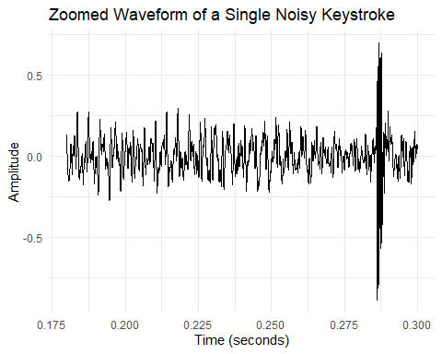 This code works identically to the previous example, except this one is for the noisy sample, now we can note immediately the peak around 0.285 seconds which shows the key stroke event itself, but the entire recording is so noisy that you essentially miss most of the key stroke event itself, only really capturing the peak.
library(tuneR)
library(ggplot2)
w_clean <- readWave("data/wav/A01.wav")
w_noisy <- readWave("data/wav/noisy.wav")
sig_clean <- w_clean@left / 2^(w_clean@bit - 1)
time_clean <- seq(0, length(sig_clean) - 1) / w_clean@samp.rate
sig_noisy <- w_noisy@left / 2^(w_noisy@bit - 1)
time_noisy <- seq(0, length(sig_noisy) - 1) / w_noisy@samp.rate
# find strongest peak in each sample
peak_idx_clean <- which.max(abs(sig_clean))
peak_idx_noisy <- which.max(abs(sig_noisy))
peak_time_clean <- time_clean[peak_idx_clean]
peak_time_noisy <- time_noisy[peak_idx_noisy]
# take a small window around each peak
window_size <- 0.03
wave_df_clean <- data.frame(
time = time_clean,
amplitude = sig_clean,
Sample = "Clean (A01)"
)
wave_df_noisy <- data.frame(
time = time_noisy,
amplitude = sig_noisy,
Sample = "Noisy"
)
wave_zoom_clean <- subset(
wave_df_clean,
time >= peak_time_clean - window_size & time <= peak_time_clean + window_size
)
wave_zoom_noisy <- subset(
wave_df_noisy,
time >= peak_time_noisy - window_size & time <= peak_time_noisy + window_size
)
# re-center time so both peaks are at 0
wave_zoom_clean$time_centered <- wave_zoom_clean$time - peak_time_clean
wave_zoom_noisy$time_centered <- wave_zoom_noisy$time - peak_time_noisy
wave_zoom_compare <- rbind(wave_zoom_clean, wave_zoom_noisy)
ggplot(wave_zoom_compare, aes(x = time_centered, y = amplitude)) +
geom_line() +
facet_wrap(~Sample, ncol = 1) +
labs(
title = "Peak-Centered Clean vs Noisy Keystroke Comparison",
x = "Time relative to peak (seconds)",
y = "Amplitude"
) +
theme_minimal()
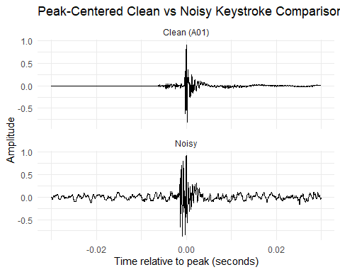 This code is quite a bit more complicated, let me explain. Since both keystrokes have their peaks at different moments, this visualization centers the strongest keystroke peak of each sample. We use readWave() [14] to extract the noisy and clean samples, then extract and scale the waveform amplitudes and using seq() we create the corresponding time axis for each recording based on sample rate.[15] The function which.max(abs(sig_clean) is used to locate the index of the largest amplitude value in both recordings. This works by first applying abs() so that both strong and positive negative spikes can be treated as equally important and then which.max() returns the position of the largest value. Those positions calculated are then converted into actual times using time_clean[peak_idx_clean] and time_noisy[peak_idx_noisy], giving the time location of both samples’ strongest spike.
We then use a variable called window_size to define how much audio should be kept for each sample, the waveform data is stored in data.frame() and subset() is then used to include only the region around the key stroke event. This means each samples peak is at different times in each recording, so we use time_centered created for both data sets to shift the strongest spike in each waveform to time zero, so both recordings are aligned around their main key stroke event. We then combine these two peak centered waveform tables with rbind() then ggplot() draws the result. Inside the plot aes() maps the centered time to the x-axis and amplitude to the y-axis. Geom_line() function draws the waveform and we use facet_wrap() to place the clean and noisy versions in separate stacked panels. [17] [18]
The result is a comparison of both noisy and clean key stroke events, and analyzing this data shows that in the example of the noisy sample, it would be virtually impossible to extract the perfect window for the noisy sample because of the noise in the sample corrupting the before, during and after of the event itself. This has diagnostic value again, because taking a deeper look at my raw recordings like this, I can immediately note that the noisy sample is not one that can be sent for machine learning, because the entire key stroke window is necessary for efficient machine learning, not only the peak of the event.
library(tuneR)
library(ggplot2)
w_clean <- readWave("data/wav/A01.wav")
w_noisy <- readWave("data/wav/noisy.wav")
sig_clean <- w_clean@left / 2^(w_clean@bit - 1)
time_clean <- seq(0, length(sig_clean) - 1) / w_clean@samp.rate
sig_noisy <- w_noisy@left / 2^(w_noisy@bit - 1)
time_noisy <- seq(0, length(sig_noisy) - 1) / w_noisy@samp.rate
moving_average <- function(x, n = 1000) {
as.numeric(stats::filter(abs(x), rep(1 / n, n), sides = 2))
}
env_clean <- moving_average(sig_clean, n = 1000)
env_noisy <- moving_average(sig_noisy, n = 1000)
wave_df_clean <- data.frame(
time = time_clean,
amplitude = sig_clean,
envelope = env_clean,
Sample = "Clean (A01)"
)
wave_df_noisy <- data.frame(
time = time_noisy,
amplitude = sig_noisy,
envelope = env_noisy,
Sample = "Noisy"
)
env_compare <- rbind(wave_df_clean, wave_df_noisy)
env_compare_short <- subset(env_compare, time >= 0 & time <= 3)
ggplot(env_compare_short, aes(x = time)) +
geom_line(aes(y = amplitude), alpha = 0.4) +
geom_line(aes(y = envelope), linewidth = 1, na.rm = TRUE) +
facet_wrap(~Sample, ncol = 1) +
labs(
title = "Clean vs Noisy Waveform with Amplitude Envelope",
x = "Time (seconds)",
y = "Amplitude"
) +
theme_minimal()
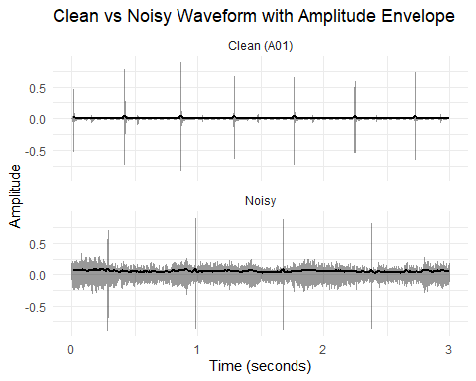 This code compares the clean and noisy recordings using both the raw waveform and a smoothed amplitude envelope. The function moving_average() is used to smooth the absolute waveform values with filter(), producing an envelope highlights the broader energy pattern of the single rather than every small fluctuation. The code works pretty similarly to every other visualization shown before, however we overlap the envelop as a second line, making the key stroke event easier to identify visually.
Again, the value here is diagnostics, we can see how much easier it is to identify key stroke events in the clean sample where the envelope or thick black line really only fluctuates for an actual key stroke event, however for the noisy sample we see fluctuations throughout the entire recording, which is another piece of evidence that can be used to diagnose and identify that the noisy sample is not one that can be used for machine learning at least not without some sort of background noise filtration system in place.

4.2 Feature Representation
This section will contain a deeper look at feature representations of the raw acoustic data, primarily MFCC data. MFCC data [2] is not naturally interpretable by humans and is primarily used for machine learning models to learn differences between different classes, finding a way to represent the data that is actually being used for machine learning in my project is very important, I will focus on comparing different MFCC heat maps, first between two clean samples of lengthy key stroke recordings, then compare with clean and noisy sample as well as individual key stroke heat maps and finally a visualization to compare average MFCC coefficient profiles between samples.
library(tuneR)
library(ggplot2)
library(viridis)
## Loading required package: viridisLite
w_a01 <- readWave("data/wav/A01.wav")
w_a02 <- readWave("data/wav/A02.wav")
mfcc_a01 <- melfcc(w_a01, numcep = 13)
## Warning in melfcc(w_a01, numcep = 13): Processing for more than one channel not
## yet implemented, using the first channel only ...
mfcc_a02 <- melfcc(w_a02, numcep = 13)
## Warning in melfcc(w_a02, numcep = 13): Processing for more than one channel not
## yet implemented, using the first channel only ...
min_frames <- min(nrow(mfcc_a01), nrow(mfcc_a02))
mfcc_a01_trim <- mfcc_a01[1:min_frames, ]
mfcc_a02_trim <- mfcc_a02[1:min_frames, ]
mfcc_df_a01 <- expand.grid(
Frame = 1:nrow(mfcc_a01_trim),
Coefficient = 1:ncol(mfcc_a01_trim)
)
mfcc_df_a01$Value <- as.vector(mfcc_a01_trim)
mfcc_df_a01$Sample <- "A01"
mfcc_df_a02 <- expand.grid(
Frame = 1:nrow(mfcc_a02_trim),
Coefficient = 1:ncol(mfcc_a02_trim)
)
mfcc_df_a02$Value <- as.vector(mfcc_a02_trim)
mfcc_df_a02$Sample <- "A02"
mfcc_compare <- rbind(mfcc_df_a01, mfcc_df_a02)
ggplot(mfcc_compare, aes(x = Frame, y = Coefficient, fill = Value)) +
geom_tile() +
scale_fill_viridis_c() +
facet_wrap(~Sample, ncol = 1) +
labs(
title = "MFCC Comparison: A01 vs A02",
x = "Frame",
y = "MFCC Coefficient"
) +
theme_minimal() +
theme(panel.grid = element_blank())
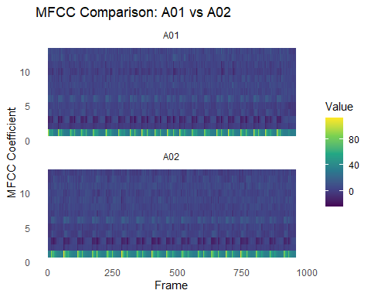 This code compares two different heat maps. This is done by forcing both recordings to use the same number of frames before plotting. The line min_frames <- min(nrow(mfcc_a01)) , nrow(mfcc_a02) checks the nubmer of rows in each MFCC matrix and selects the smaller value. Since each row represents a time frame, this ensures both recordings will be compared over the same frame length. The next two lines trim both MFCC matrices so they each contain only that shared number of frames. Then we use the function expand.grid() to create all combinations of frame number and coefficient number for each trimmed matrix while as.vector() converts the matrix values into a single column that can be plotted. Then a sample column is added to identify which data belongs to A01 and A02, rbind() combines both tables into one data set. Finally ggplot() [17] [18] is used to create the heat map, geom_tile() draws the tiles, viridis is used to provide a color scale that is most easy to read and facet_wrap() places two samples into separate panels. [19] [20]
The result is the comparison of two separate heat maps for two clean samples. The academic benefit of analyzing this data is to simply see how it looks, MFCCs are not naturally interpretable to humans so visualizing them in a meaningful way is difficult, but in this case heat maps are an effective way to visualize the type of data that the machine learning model is in taking [7] . Notably even if we notice similarities between recordings, that doesn’t mean the model will behave in the particular way we think. Also to consider is that this is the MFCC heat map of two bulk recordings, which is not actually what we feed the model, the model receives individual keys stroke MFCC data, therefore, next, we will next take a look at a comparison of the heat maps of individual keys strokes.
library(tuneR)
library(ggplot2)
library(viridis)
w_d1 <- readWave("data/wav/D1_Individual.wav")
w_d2 <- readWave("data/wav/D2_individual.wav")
mfcc_d1 <- melfcc(w_d1, numcep = 13)
mfcc_d2 <- melfcc(w_d2, numcep = 13)
min_frames <- min(nrow(mfcc_d1), nrow(mfcc_d2))
mfcc_d1_trim <- mfcc_d1[1:min_frames, ]
mfcc_d2_trim <- mfcc_d2[1:min_frames, ]
mfcc_df_d1 <- expand.grid(
Frame = 1:nrow(mfcc_d1_trim),
Coefficient = 1:ncol(mfcc_d1_trim)
)
mfcc_df_d1$Value <- as.vector(mfcc_d1_trim)
mfcc_df_d1$Sample <- "D1 Individual"
mfcc_df_d2 <- expand.grid(
Frame = 1:nrow(mfcc_d2_trim),
Coefficient = 1:ncol(mfcc_d2_trim)
)
mfcc_df_d2$Value <- as.vector(mfcc_d2_trim)
mfcc_df_d2$Sample <- "D2 Individual"
mfcc_compare_d <- rbind(mfcc_df_d1, mfcc_df_d2)
ggplot(mfcc_compare_d, aes(x = Frame, y = Coefficient, fill = Value)) +
geom_tile() +
scale_fill_viridis_c() +
facet_wrap(~Sample, ncol = 1) +
labs(
title = "MFCC Comparison: D1 vs D2 Individual Keystrokes",
x = "Frame",
y = "MFCC Coefficient"
) +
theme_minimal() +
theme(panel.grid = element_blank())
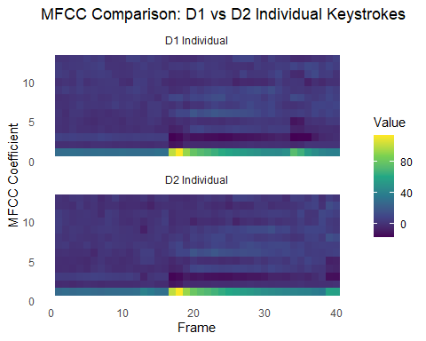 This code compares the MFCC heat maps of two individual key stroke recordings. The readWave() [14] function imports both files, while melfcc() extracts 13 MFCC coefficients from each one. Because two recordings may contain slightly different numbers of frames, min() is used to find the shorter frame length and both matrices are trimmed to match. Expand.grid() and as.vector() then reshape the MFCC matrices into data frames that can be plotted with ggplot2 [17] [18] . Finally, geom_tile() creates the heat maps and facet_wrap() function places the two samples into separate panels for direct comparison.[19] [20]
Now, looking at the individual key strokes themselves, we can see even though they are of the same key stroke being pressed, the heat maps are not quite identical, there are noticeable differences and that can be for many different reasons, the academic takeaway at analyzing this data is to highlight that even if we do see differences visually between classes, that will not necessarily predict model behavior, however there is some important insight to have here, we can now begin to understand what the data that the model is learning from actually looks like, now every key stroke sample will provide a slighlty different heat map, but the model will learn the subtle differences that can separate classes, from my perspective this is again, mainly a diagnostic tool to visualize and see if the key strokes are similar enough to conclude that there was no issue with the generation of the MFCC, because like mentioned, MFCC features are not naturally interpretable to humans, therefore to sanity check them you would have to create a sort of visualization such as this one.
library(tuneR)
library(ggplot2)
library(viridis)
w_d1 <- readWave("data/wav/D1_Individual.wav")
w_d3_noisy <- readWave("data/wav/D3_Individual_Noisy.wav")
mfcc_d1 <- melfcc(w_d1, numcep = 13)
mfcc_d3_noisy <- melfcc(w_d3_noisy, numcep = 13)
## Warning in melfcc(w_d3_noisy, numcep = 13): Processing for more than one
## channel not yet implemented, using the first channel only ...
min_frames <- min(nrow(mfcc_d1), nrow(mfcc_d3_noisy))
mfcc_d1_trim <- mfcc_d1[1:min_frames, ]
mfcc_d3_noisy_trim <- mfcc_d3_noisy[1:min_frames, ]
mfcc_df_d1 <- expand.grid(
Frame = 1:nrow(mfcc_d1_trim),
Coefficient = 1:ncol(mfcc_d1_trim)
)
mfcc_df_d1$Value <- as.vector(mfcc_d1_trim)
mfcc_df_d1$Sample <- "D1 Individual (Clean)"
mfcc_df_d3_noisy <- expand.grid(
Frame = 1:nrow(mfcc_d3_noisy_trim),
Coefficient = 1:ncol(mfcc_d3_noisy_trim)
)
mfcc_df_d3_noisy$Value <- as.vector(mfcc_d3_noisy_trim)
mfcc_df_d3_noisy$Sample <- "D3 Individual (Noisy)"
mfcc_compare_noise <- rbind(mfcc_df_d1, mfcc_df_d3_noisy)
ggplot(mfcc_compare_noise, aes(x = Frame, y = Coefficient, fill = Value)) +
geom_tile() +
scale_fill_viridis_c() +
facet_wrap(~Sample, ncol = 1) +
labs(
title = "MFCC Comparison: Clean vs Noisy Individual Keystroke",
x = "Frame",
y = "MFCC Coefficient"
) +
theme_minimal() +
theme(panel.grid = element_blank())
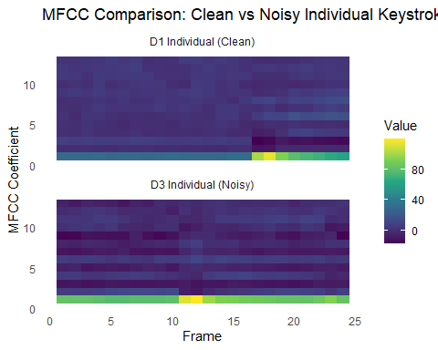 This code works similarly to the previous ones, we load the clean and noisy samples with readWave(), [14] extract their MFCC features with melfcc(), trim both feature matrices to the same number of frames using min(). The matrices are then reshaped into plottable data frames with expand.grid() and as.vector() functions, labelled by type and combined with rbind(). Finally ggplot() and geom_tile() creates the heat maps and facet_wrap() keeps them in separate panels.[17] [18] [19]
The resulting visualization shows the massive difference between a clean and noisy samples MFCC features, in the clean sample you can pretty much guess where the key stroke event happens and to be fair you can do the same with the noisy sample however you can see much more activity in the noisy sample. This noisy sample again, you can diagnose pretty easy visually, would not be suitable for machine learning as it would fully confuse the model because the clean and noisy sample simply do not look similar at all.
library(tuneR)
library(ggplot2)
w_d1 <- readWave("data/wav/D1_Individual.wav")
w_d3_noisy <- readWave("data/wav/D3_Individual_Noisy.wav")
mfcc_d1 <- melfcc(w_d1, numcep = 13)
mfcc_d3_noisy <- melfcc(w_d3_noisy, numcep = 13)
## Warning in melfcc(w_d3_noisy, numcep = 13): Processing for more than one
## channel not yet implemented, using the first channel only ...
mean_d1 <- colMeans(mfcc_d1)
mean_d3_noisy <- colMeans(mfcc_d3_noisy)
mfcc_profile_df <- data.frame(
Coefficient = rep(1:13, 2),
MeanValue = c(mean_d1, mean_d3_noisy),
Sample = c(rep("D1 Individual (Clean)", 13),
rep("D3 Individual (Noisy)", 13))
)
ggplot(mfcc_profile_df, aes(x = Coefficient, y = MeanValue, color = Sample)) +
geom_line(linewidth = 1) +
geom_point(size = 2) +
labs(
title = "Average MFCC Coefficient Profile: Clean vs Noisy",
x = "MFCC Coefficient",
y = "Mean Value"
) +
theme_minimal()
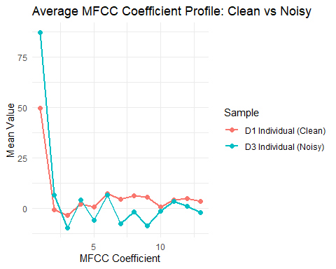 This visualization creates a simplified summary of the MFCC features for the clean and noisy individual key stroke events. The file is loaded with readWave() [14] and melfcc() extracts the 13 MFCC coefficients from each sample across multiple time frames. The function colMeans() is applied to each MFCC matrix, which calculates the average value of each coefficient across all frames in that sample. This reduces the heat map to a single average profile for each recording. Data.frame() function is used to store the coefficient numbers, their mean values, and the sample labels in a plottable manner. Ggplot()[17] [18] and aes() maps the coefficient number to the x-axis and the mean to the y-axis, then the sample label to color. The functions geom_line() and geom_point() are used together to show the overall MFCC profile for each sample as a line with visible marker points.
This visualization shows for each average MFCC coefficient, what the average value over the whole key stroke is, essentially providing me the overall MFCC shape of each sample. The noisy key stroke visibly changes the average MFCC profile, especially in the lower order coefficients which suggests that noise is affecting the overall spectral representation seen by the model. Again, we can highlight the clear differences between the noisy versus clean key stroke and show how the background noise can pollute and distort the overall shape of the sound which in turn again, would corrupt any machine learning if that noisy sample would be fed to the model.

4.3 Performance Output
For performance output, we have to more deeply analyze the results of the system in terms of accuracy, I will do this by first creating a top misclassification pairs graphic where we can visually see which letters get confused with which letters, this data can be extracted from the existing confusion matrix. I will also look at precision[10] , F1 [11] and recall accuracies which I will explain in higher detail what those actually are alongside the visualization and finally we will create a more normalized confusion matrix [8] which will highlight the proportion of each true class going to each predicted class which will make it easier to compare classes fairly and removes the effect of class size.
library(reticulate)
library(ggplot2)
np <- import("numpy")
cm_mat <- py_to_r(np$load("data/results/confusion_matrix_live.npy"))
cm_mat <- as.matrix(cm_mat)
labels <- c("A","B","C","D","E","F","G","H","I","J","K","L","M",
"N","O","P","Q","R","S","T","U","V","W","X","Y","Z","Space")
cm_df <- expand.grid(
Actual = 1:nrow(cm_mat),
Predicted = 1:ncol(cm_mat)
)
cm_df$Freq <- as.vector(cm_mat)
cm_df$Actual <- labels[cm_df$Actual]
cm_df$Predicted <- labels[cm_df$Predicted]
misclass_df <- cm_df[cm_df$Actual != cm_df$Predicted & cm_df$Freq > 0, ]
misclass_df$Pair <- paste(misclass_df$Actual, "→", misclass_df$Predicted)
top_misclass <- misclass_df[order(-misclass_df$Freq), ][1:10, ]
ggplot(top_misclass, aes(x = reorder(Pair, Freq), y = Freq)) +
geom_col() +
coord_flip() +
labs(
title = "Top 10 Misclassification Pairs",
x = "Misclassification Pair",
y = "Count"
) +
theme_minimal()
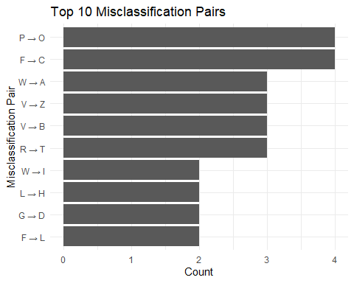
This code loads the confusion matrix from the saved NumPy file [21] [22] [23] , converts it into an R matrix, then reshapes it into a table of actual class, predicted class and frequency count. The numeric class positions are replaced with the real letter labels, and all correct predictions are removed so that only missclassifications remain. Then the data is sorted by frequency and the ten most common error pairs are selected and displayed in a horizontal bar chart using ggplot().[17] [18]
The most common missclassifications are neighboring letters, which is pretty much expected, letters that are next to each other on the keyboard will provide similar acoustic features and will be confused with each other. I used a graphic like this to find the commonly mistaken letters and create a cost substitution decoding function in the cyber security project to allow my system to know that if we are close to decoding a real word, then the commonly missclassified pairs are cheap to substitute, for example, if a user types “peak” but the system returns “oeak”, then we make sure the system knows that the p->o is a common missclassification, and we can create a substitution matrix where we allow the system to make the change of o->p if we can decode to a legitimate word. This makes this graphic very useful for not only tracking the performance output, but also allows us to create fixes to make the system more accurate. Another academic takeaway from this graphic is that if the letters being missclassified are not near neighbors then that could point me in the direction of potential class imbalance, or some sort of diagnostic issue with the data being trained, because letters on opposite sides of the keyboard should not be commonly missclassified.
library(reticulate)
library(ggplot2)
np <- import("numpy")
cm_mat <- py_to_r(np$load("data/results/confusion_matrix_live.npy"))
cm_mat <- as.matrix(cm_mat)
labels <- c("A","B","C","D","E","F","G","H","I","J","K","L","M",
"N","O","P","Q","R","S","T","U","V","W","X","Y","Z","Space")
true_positive <- diag(cm_mat)
false_negative <- rowSums(cm_mat) - true_positive
false_positive <- colSums(cm_mat) - true_positive
precision <- true_positive / (true_positive + false_positive)
recall <- true_positive / (true_positive + false_negative)
f1 <- 2 * (precision * recall) / (precision + recall)
metrics_df <- data.frame(
Letter = rep(labels, 3),
Metric = rep(c("Precision", "Recall", "F1"), each = length(labels)),
Value = c(precision, recall, f1)
)
ggplot(metrics_df, aes(x = Letter, y = Value, fill = Metric)) +
geom_col(position = "dodge") +
coord_flip() +
labs(
title = "Precision, Recall, and F1 Score by Letter",
x = "Letter",
y = "Score"
) +
theme_minimal()
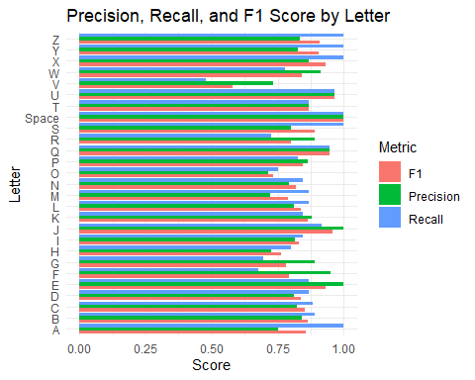 This code calculates three class-level performance metrics from the confusion matrix[21] [22] [23] [12] , specifically, F1 score[11] , precision and recall[10] . Diag(cm_mat) function extracts true positives for each class, meaning the correctly predicted samples on the diagonal of the confusion matrix. rowSums(cm_mat) - true_positive gives the false negatives, which are the true samples that were predicted as something else, while colSums(cm_mat) - true_positive gives the false positives, which are samples predicted as that class incorrectly. Precision is then calculated as true positives divided by true positives plus false positives, recall is calculated as true positives divided by true positives plus false negatives, and F1 is calculated as the mean of precision and recall. These values are stored in metrics_df, where each letter is repeated for the three different metrics. Finally ggplot() function with geom_col() are used to plot the three scores side by side for each letter and coord_flip() rotates the chart to make the labels easier to read.[21] [17] [18]
To understand the usefulness of this data, we have to understand what the metrics that we are tracking actually are. Precision[10] measures how reliable a predicted class is, basically asking out of all the times the model predicted a certain letter, how many of those predictions were correct. Recall measures how the model identifies a class, asking out of all the true examples of a certain letter, how many of those letters did the model predict. F1 score [11] combines both precision and recall into a single measure by taking their mean, which makes it useful to consider if a class is performing well on one metric compared to another. By visualizing all three performance metrics can we can a more detailed look at the true performance of the model. Let’s take the example of the A class, the recall is is 100%, however the precision is a lot lower at about 70%, this tells me that every time the letter A was present, it was predicted correctly with F1 score, however for precision, we see that at 70% precision, 30% of the time the model guessed A, it was actually a different letter. This tells me that the model has learned to predict A very aggressively but not very cleanly, again highlighting the importance of tracking multiple metrics, had I only tracked the recall accuracy, I would be under the impression that the model is performing much better for A than it actually is.
library(reticulate)
library(ggplot2)
library(viridis)
np <- import("numpy")
cm_mat <- py_to_r(np$load("data/results/confusion_matrix_live.npy"))
cm_mat <- as.matrix(cm_mat)
labels <- c("A","B","C","D","E","F","G","H","I","J","K","L","M",
"N","O","P","Q","R","S","T","U","V","W","X","Y","Z","Space")
cm_norm <- cm_mat / rowSums(cm_mat)
cm_norm_df <- expand.grid(
Actual = 1:nrow(cm_norm),
Predicted = 1:ncol(cm_norm)
)
cm_norm_df$Value <- as.vector(cm_norm)
cm_norm_df$Actual <- labels[cm_norm_df$Actual]
cm_norm_df$Predicted <- labels[cm_norm_df$Predicted]
ggplot(cm_norm_df, aes(x = Predicted, y = Actual, fill = Value)) +
geom_tile() +
scale_fill_viridis_c() +
labs(
title = "Normalised Confusion Matrix Heatmap",
x = "Predicted Letter",
y = "Actual Letter",
fill = "Proportion"
) +
theme_minimal()
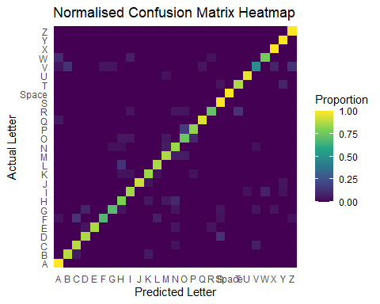 This code loads the confusion matrix [12] and normalizes each row by dividing it by its row total using cm_mat divided by rowSums(cm_mat). This converts the matrix from raw counts into proportions, so each row now shows how the predictions are distributed for a given true class. Expand.grid() created an all actual versus predicted label combination, as.vector() fills them with the normalized values, and the numeric indices are replaced with real letter lablels. Ggplot() [17] [18] and geom_tile() are used to plot the result as a heat map, where darker or more intense tiles represent a larger proportion of predictions for that class.[21] [20]
The difference between this heat map and the previous one created, is that this is a normalized confusion matrix heat map, this removes the effect of class size and allows misclassification behavior to be compared more fairly across the board. In a raw confusion matrix heat map such as the one generated before, classes with more testing samples can dominate the visualization, making it harder to judge relative performance. By normalizing each row, we remove any bias and show a more true representation of how the model is performing.

5. Conclusions
In conclusion, when taking a deeper look at the three levels of data that we are working with, we can clearly see the benefit of analyzing the first level of raw acoustic data is for diagnostic purposes and checking whether or not our data is clean and ready to be sent to a machine learning model. The second level of data we worked with is the transformed feature representation, again to mention that MFCCs, are data that is built for machine learning models, are not naturally interpretable to humans, so finding a meaningful way to visualize them is very beneficial, we can note how different acoustic environments produce wildly different MFCC heat maps, a noisy sample can quickly be diagnosed and visually seen that it is not something we can send for machine learning, however again to reiterate, you can make educated guesses based on differences in MFCC heat maps but they won’t always necessarily prove or define the systems behavior, for example our comparison of two D class heat maps shows incredible similarity between the keystrokes, however overall F1 accuracy is only at about 80% as denoted from our performance metric visualizations. The final level of data was the performance output which I think the biggest take away would be the usefulness of the combination pair misclassifications as it shows me which letters are confused with which letters and that allows me to create functions such as the mentioned one in which I can make it a very cheap substitution to change near neighbor misclassifications. Also, to note the importance of calculating multiple metrics such as F1, recall and precision to ensure we get a true representation of accuracy per class and not just using one metric to track accuracy across the board is really important to make sure my view isn’t skewed to believe the model is performing worse or better.
The closing note from me, is that in order to get a clear understanding of the entire models performance, diagnostics and academic takeaways, you must look much deeper and analyze the three levels of data and understand the story that the data is trying to tell us.

References:
[1] Asonov, D. and Agrawal, R. (2004)
‘Keyboard acoustic emanations’, IBM Almaden Research Center.
Available at: https://web.eecs.umich.edu/~genkin/teaching/fall2019/EECS598-12_files/kbdacoustic.pdf
(Accessed: 10/03/2026).

[2] Logan, B. (2000)
‘Mel Frequency Cepstral Coefficients for Music Modelling’, Cambridge Research Laboratory, Compaq Computer Corporation, 23–25 October.
Available at: https://ismir2000.ismir.net/papers/logan_paper.pdf
(Accessed: 10/03/2026).

[3] Librosa development team (2025)
‘Glossary — librosa 0.11.0 documentation’, librosa documentation.
Available at: https://librosa.org/doc/0.11.0/glossary.html
(Accessed: 10/03/2026).

[4] Zhuang, L., Zhou, F. and Tygar, J.D. (2009)
‘Keyboard acoustic emanations revisited’, ACM Transactions on Information and System Security, 13(1).
Available at: https://people.eecs.berkeley.edu/~tygar/papers/Keyboard_Acoustic_Emanations_Revisited/TISSEC.pdf
(Accessed: 10/03/2026).

[5] Fessler, J. (2024)
‘Eng. 100: Music Signal Processing DSP Lecture 6 Lab 3’, University of Michigan.
Available at: https://web.eecs.umich.edu/~fessler/course/100/l/l06-lab3-spectrogram.pdf
(Accessed: 10/03/2026).

[6] librosa development team (2025)
‘librosa.feature.mfcc’, librosa documentation.
Available at: https://librosa.org/doc/main/generated/librosa.feature.mfcc.html
(Accessed: 10/03/2026).

[7] Olah, C. et al. (2018)
‘The Building Blocks of Interpretability’, Distill.
Available at: https://distill.pub/2018/building-blocks/
(Accessed: 10/03/2026).

[8] Scikit-learn developers (n.d.)
‘confusion_matrix’, scikit-learn documentation.
Available at: https://scikit-learn.org/stable/modules/generated/sklearn.metrics.confusion_matrix.html
(Accessed: 10/03/2026).

[9] scikit-learn developers (n.d.)
‘Metrics and scoring: quantifying the quality of predictions’, scikit-learn documentation.
Available at: https://scikit-learn.org/stable/modules/model_evaluation.html
(Accessed: 10/03/2026).

[10] scikit-learn developers (n.d.)
‘precision_recall_fscore_support’, scikit-learn documentation.
Available at: https://scikit-learn.org/stable/modules/generated/sklearn.metrics.precision_recall_fscore_support.html
(Accessed: 10/03/2026).
[11] scikit-learn developers (n.d.)
‘f1_score’, scikit-learn documentation.
Available at: https://scikit-learn.org/stable/modules/generated/sklearn.metrics.f1_score.html
(Accessed: 10/03/2026).

[12] Kaderabek, E. (2016)
‘Confusion Matrix Viz’, University of Vienna.
Available at: https://teaching.vda.univie.ac.at/vis/16w/Final_Report/05.pdf
(Accessed: 10/03/2026).

[13] Ligges, U. and Schnackenberg, S. (2025)
‘tuneR: Analysis of Music and Speech’, CRAN R package documentation.
Available at: https://cran.r-project.org/web/packages/tuneR/tuneR.pdf
(Accessed: 05/04/2026).

[14] Ligges, U. and Schnackenberg, S. (n.d.)
‘readWave: Reading Wave files’, tuneR documentation.
Available at: https://search.r-project.org/CRAN/refmans/tuneR/html/readWave.html
(Accessed: 05/04/2026).

[15] Sueur, J. (2025)
‘A very short introduction to sound analysis for those who want to do bioacoustics in R’, seewave vignette.
Available at: https://cran.r-project.org/web/packages/seewave/vignettes/seewave_analysis.pdf
(Accessed: 05/04/2026).

[16] Sueur, J., Aubin, T. and Simonis, C. (2025)
‘seewave: Sound Analysis and Synthesis’, CRAN R package documentation.
Available at: https://cran.r-project.org/web/packages/seewave/seewave.pdf
(Accessed: 06/04/2026).

[17] Wickham, H. (2009)
ggplot2: Elegant Graphics for Data Analysis. New York: Springer.
Available at: https://ggplot2.tidyverse.org/reference/ggplot2-package.html
(Accessed: 06/04/2026).

[18] Wickham, H. et al. (2026)
‘ggplot2: Create Elegant Data Visualisations Using the Grammar of Graphics’, CRAN R package documentation.
Available at: https://cran.r-project.org/web/packages/ggplot2/ggplot2.pdf
(Accessed: 08/04/2026).

[19] Garnier, S. et al. (2024)
‘Introduction to the viridis color maps’, viridis vignette.
Available at: https://cran.r-project.org/web/packages/viridis/vignettes/intro-to-viridis.html
(Accessed: 09/04/2026).

[20] Garnier, S. (n.d.)
‘viridis: Colorblind-Friendly Color Maps for R’, viridis package page.
Available at: https://sjmgarnier.r-universe.dev/viridis
(Accessed: 09/04/2026).

[21] Posit Software, PBC (2026)
‘reticulate: Interface to Python’, CRAN R package documentation.
Available at: https://cran.r-project.org/web/packages/reticulate/reticulate.pdf
(Accessed: 10/04/2026).

[22] Posit Software, PBC (n.d.)
‘Import a Python module’, reticulate reference.
Available at: https://rstudio.github.io/reticulate/reference/import.html
(Accessed: 10/04/2026).

[23] Posit Software, PBC (2026)
‘Convert between Python and R objects’, reticulate documentation.
Available at: https://rdrr.io/cran/reticulate/man/r-py-conversion.html
(Accessed: 12/04/2026).

