United States Cyber Command (USCYBERCOM), the nation’s cyber warrior, operates daily in cyberspace against capable adversaries, some of whom are now near-peer competitors. To maintain a decisive advantage, their forces must be agile, partnerships operational, and operations continuous. Policies, doctrine, and processes must keep pace with the speed of events in cyberspace.
Superior strategic effects depend on the alignment of operations, capabilities, and processes, as well as the seamless integration of intelligence with operations. Given the pace and complexity of their mission and platforms, effective solutions must seamlessly integrate, rapidly scale, and provide interfaces that allow independent evolution. Segmented standard interfaces, automation, and autonomy are key elements of any security-based solution.
If an outside organization is interested in a challenge problem, USCYBERCOM requires, at aa minimum, knowledge of who is working on it and regular updates on their progress. As solutions materialize, the Command may provide more detailed guidance to developers. Successfully addressing a challenge problem will not directly result in funding, but it will increase the chances that appropriate acquisition and/or transition processes will be employed.

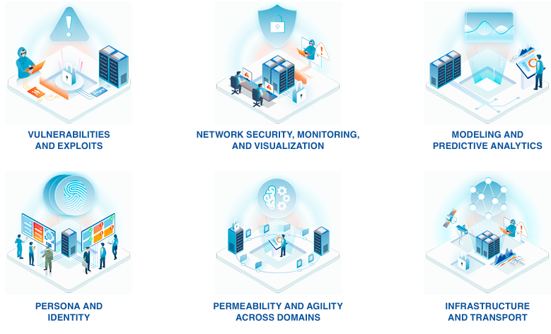

The Challenge Problems USCYBERCOM Faces
The Challenge Problems have been divided into six categories, each encapsulating specific areas of expertise and skill sets. This categorization aligns with external commercial and academic research, development, and product portfolios.
Vulnerabilities exist across various domains, including network protocols, web-based services, software implementations, host machine applications, and even machine hardware. While countless vulnerabilities are published daily, others are discovered and kept secret for zero-day attacks. Not all vulnerabilities are exploitable, but those that present both defensive challenges and offensive opportunities are.
Challenge problems in this focus area include:
- Discovering exploitable vulnerabilities before adversaries.
- Decreasing the time to defensive patching.
- Implementing defensive measures.
- Detecting and attributing specific exploits to adversaries.
This category encompasses reverse engineering, malware fingerprint and signature detection, attribution, binary diversity, offensive opportunities, and defensive patching.
Key Words: vulnerabilities, exploits, Common Vulnerabilities and Exposures (CVE), malware, signature detection, zero-day, binary diversity, reverse engineering, Industrial Control System (ICS), Supervisory Control and Data Acquisition (SCADA), Internet of Things (IoT), attribution, patching, exploitability, Indicator of Compromise (IOC), binary signature, binary fingerprint
USCYBERCOM seeks novel and innovative solutions to the following challenge problems:
  - Rapidly Generate Defensive Capabilities
Develop mechanisms to rapidly generate defensive capabilities and patch newly discovered vulnerabilities. These mechanisms should deploy patch’s reliability in an automated or accelerated way to reduce or eliminate the need for human operator intervention.
  - Vulnerability Discovery
Create analytical methods that can rapidly analyze software and its functions to identify vulnerabilities in software and hardware of interest.
  - Holistic Insight Into Adversarial Exploits
Discover anomalous network activity and other indicators of malicious intrusion rapidly and accurately. This includes innovative ways to analyze relevant metadata or Packet Capture (PCAP) files, such as employing automated extraction of essential information and automated summarization of PCAP files to allow for more efficient and faster triage.
  - Polymorphic Malware / Countering Adversarial Signature Diversity
Defenders need to recognize polymorphic malware in real-time, both at network perimeters and when malware has penetrated perimeter security.
  - Strengthen the Security of ICS and SCADA Networks
Identify ways to analyze and harden legacy ICS/SCADA critical infrastructure systems with minimal impact to operations.

Network Security, Monitoring, and Visualization
USCYBERCOM is responsible for securing Department of Defense (DoD) infrastructure and repelling adversarial intrusions. This involves a range of technical challenges: detecting intruders, tracking their every move, assessing network-wide risk, implementing defensive countermeasures, and evaluating damage and information exposure. Effective cyber operations require a comprehensive understanding of both the DoD’s internal network and the global network landscape from which adversaries launch their attacks.
Key challenges in this domain include mapping network topologies, network connections and interconnected technologies, communities, and influential entities. Solutions often center on large-scale graphy theory, graph analytics, and network visualization. While some problems may involve vulnerabilities and malware propagation, the primary focus in this category is on node-to-node interactions.
Throughout this section, “network” serves as shorthand for both traditional networks and ongoing efforts to protect data and data access.
Key Words: networks, monitoring, visualization, graph theory, graph analytics, intrusion detection, lateral movement, damage assessment, traffic redirection, cyber terrain, Zero-Trust, situational awareness, operational security (OPSEC).
USCYBERCOM seeks novel and innovative solutions to the following challenge problems:
2.1 Automated Network Mapping
Automated tools that produce physical, logical, and functional network maps and blueprints by integrating multiple data sources and including real-time analysis. The depth and breadth of complex networks make it challenging for defender’s to achieve intended cyber security effects. The ability to overlay these network maps and understand relationships and behaviors is critical.
2.2 Deep Network Knowledge and Awareness
Tools that describe complex networks (including device identification, software and firmware updates

