**Laboratory work 2**

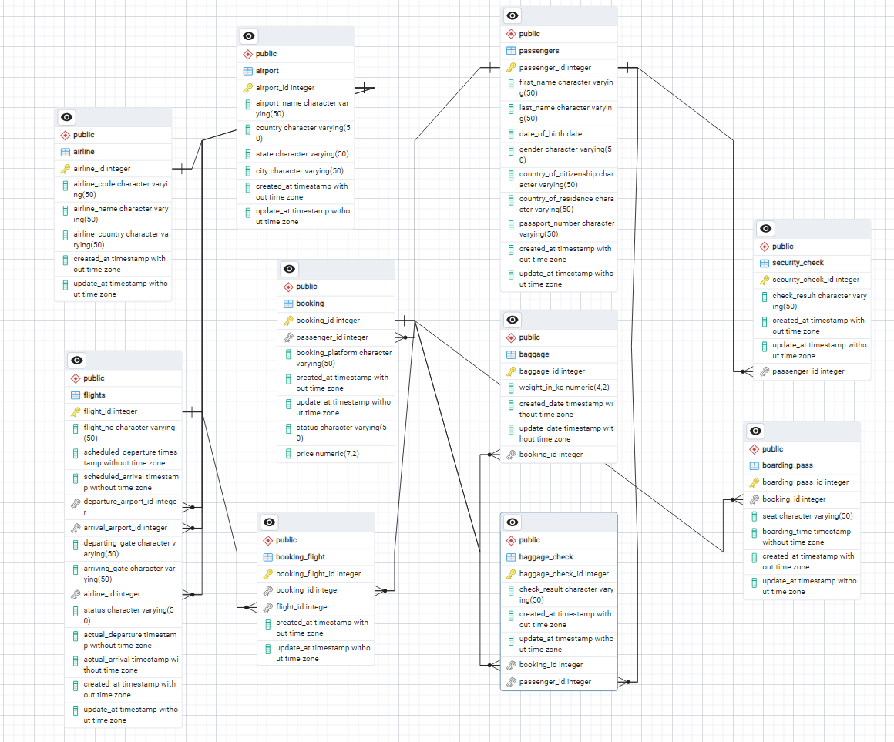

Make a relationship between following tables **(20%):**

- Passengers with Secuitiry_check, Booking, Baggage_check by passenger_id;

-Booking with Baggage_check, Baggage, Boarding_pass, Booking_flight by booking_id;

- Flights with Booking_flight by flight_id;

- Airport with Flights by departing_airport_id;

- Airport with Flights by arriving_airport_id;

- Airline with Flights by airline_id;

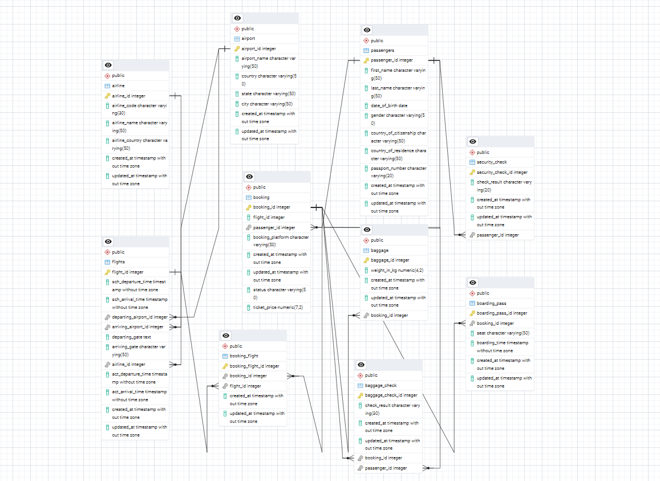

**DML – Data Manipulation Language**

1. Generate and insert 100 random rows in your airline database using mockaroo service ([https://www.mockaroo.com/).**(10%**](https://www.mockaroo.com/).(10%25)**)**

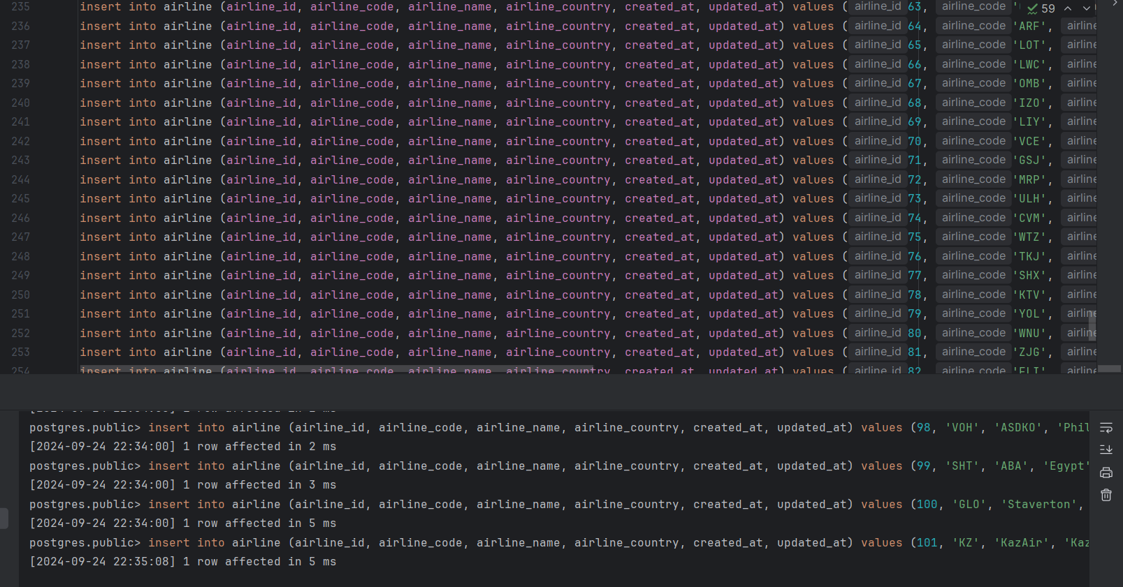

1. Add a new airline named "KazAir" based in "Kazakhstan" to the airline table.(**10%** )

insert into airline (airline_id, airline_code, airline_name, airline_country, created_at, updated_at) values (101, 'KZ', 'KazAir', 'Kazakhstan', '2006-07-27 12:03:35', '2022-12-22 02:08:20');



1. Update the airline country "KazAir" to "Turkey".(**10%** )

UPDATE airline SET airline_country = 'Turkey' WHERE airline_name = 'KazAir';



1. Remove the airline named "SIT" from the airline table. (**10%** )

DELETE FROM airline WHERE airline_name = 'Tok';



1. Add three airlines at once: "AirEasy" in "France", "FlyHigh" in "Brazil" and "FlyFly" in "Poland". (**10%** )

insert into airline(airline_id, airline_code, airline_name, airline_country, created_at, updated_at) values (102,'AE', 'AirEasy', 'France', '2001-10-19 22:49:40', '2024-08-26 13:02:29');  
insert into airline(airline_id, airline_code, airline_name, airline_country, created_at, updated_at) values (103,'FH', 'FlyHigh', 'Brazil', '2002-11-19 22:49:40', '2005-08-21 13:02:29');  
insert into airline(airline_id, airline_code, airline_name, airline_country, created_at, updated_at) values (104,'FF', 'FlyFly', 'Poland', '1999-10-19 22:49:40', '2006-08-26 13:02:29');

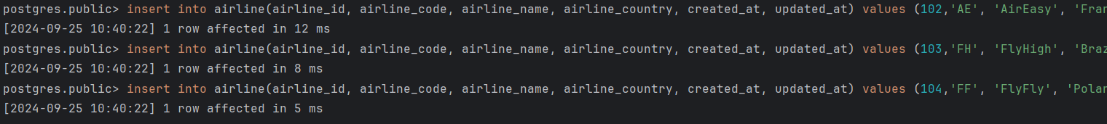

1. Delete all flights whose arrival in 2024 year. (**10%** )

DELETE FROM airline WHERE *EXTRACT*(YEAR FROM updated_at ) = 2024;



1. Increase the price of all tickets in booking table for flights by 10%.(**10%** )
2. UPDATE booking SET ticket_price = ticket_price * 1.10 WHERE ticket_price > 0;
3. Delete all tickets whose price is less than 1000 units. (**10%** )

DELETE FROM booking WHERE ticket_price < 1000;