GitLab:-- https://topgear-training-gitlab.wipro.com/RA20068676/DevOpsProfessional_ILP_CI_CD_BookStore.git

1)Tool Configuration

a)JAVA and Maven

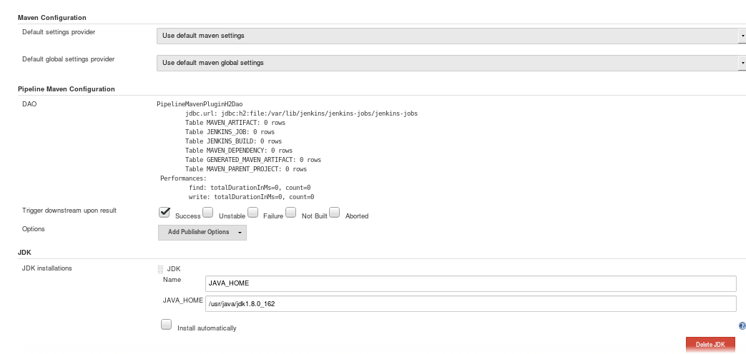
b) GIT

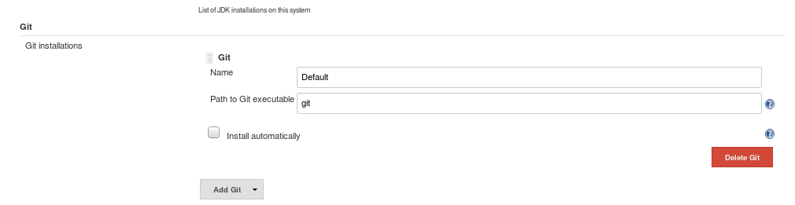
c) SonarQube Scanner

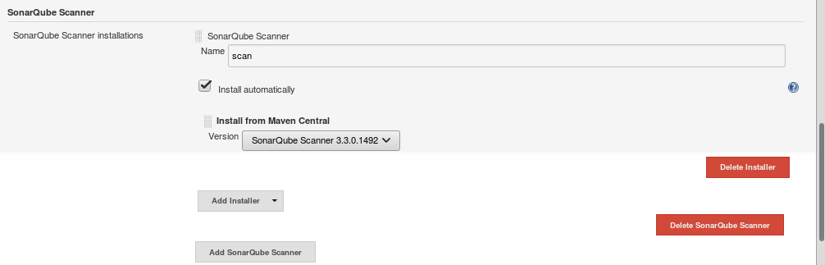
2) System Configuration

a) GitLab

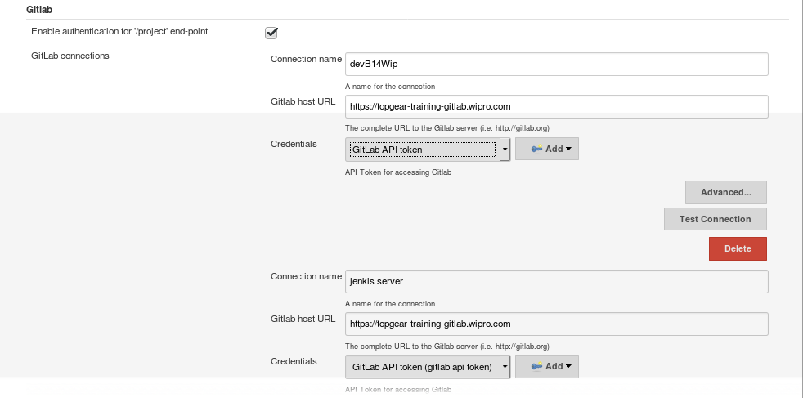
b) Jfrog

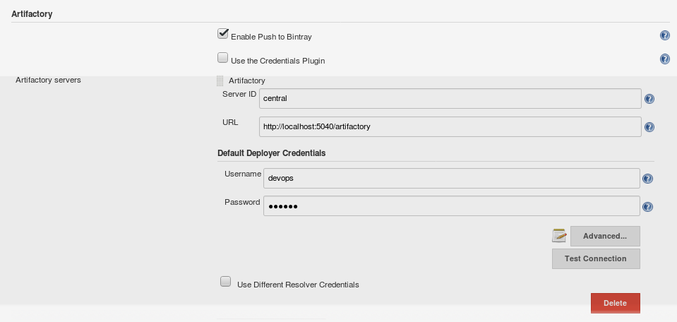

c)Email Notifications

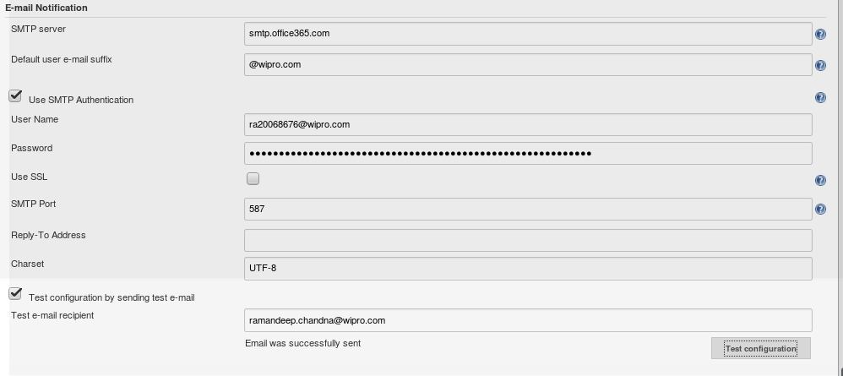

d) Sonar server

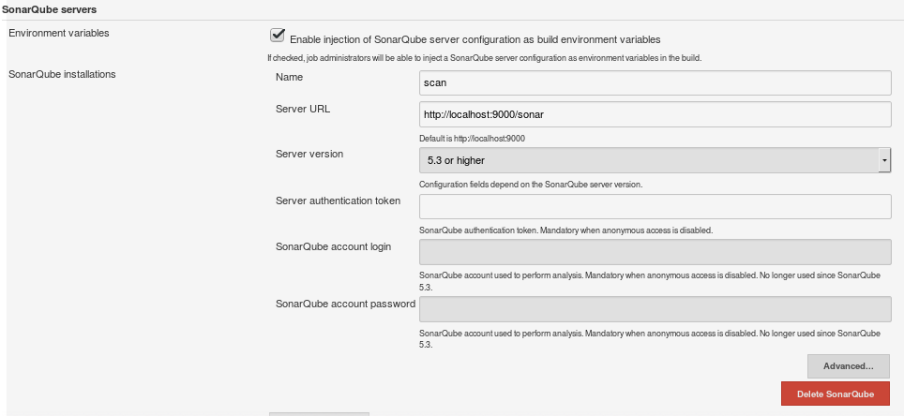
3) Jenkins

a) Job Configuration

RA20068676/DevOpsProfessional_ILP_CI_CD_BookStore

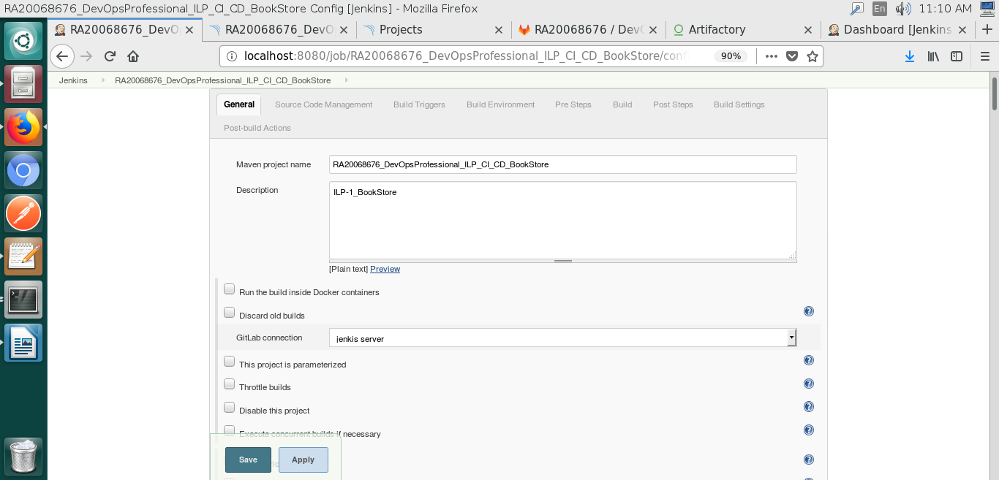
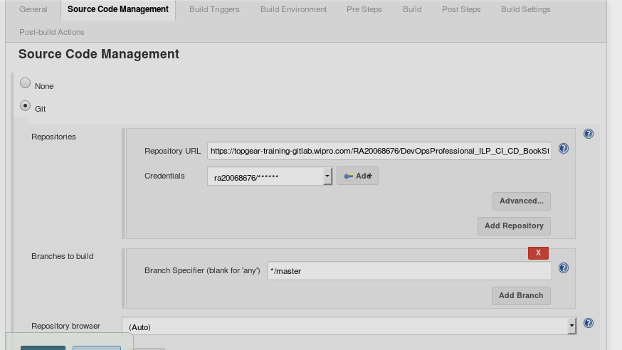
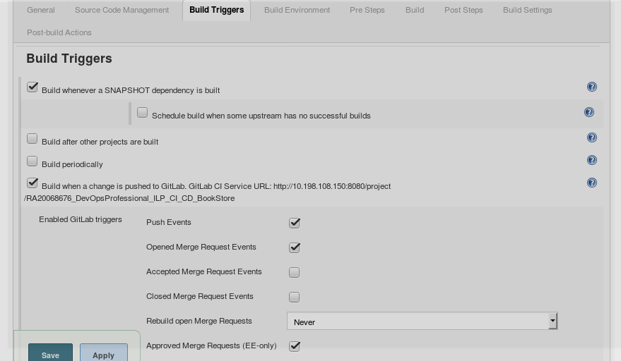
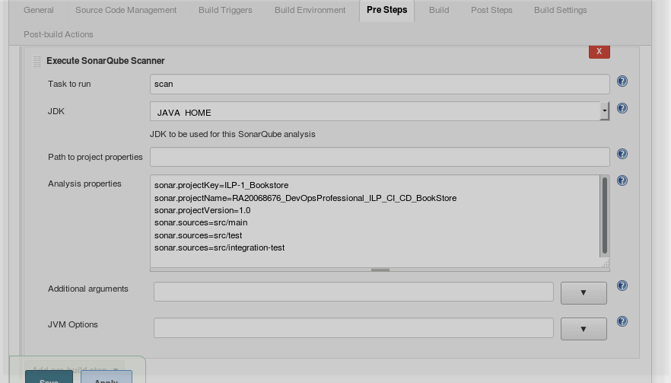
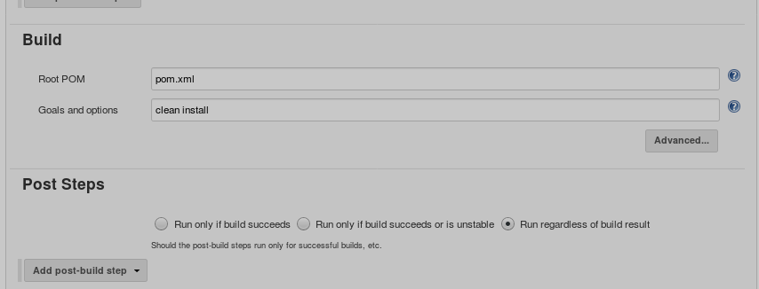
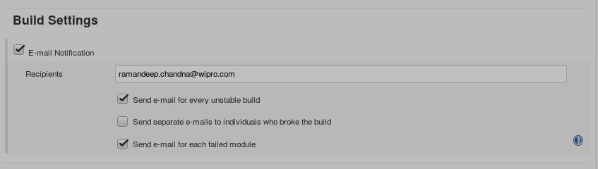

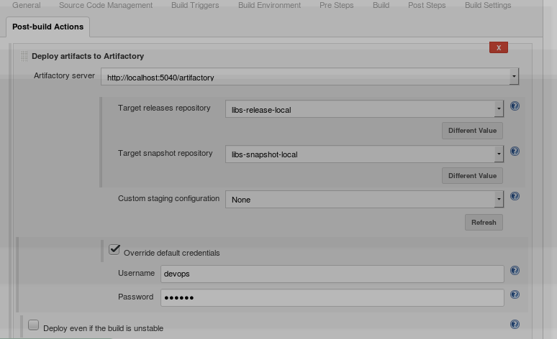

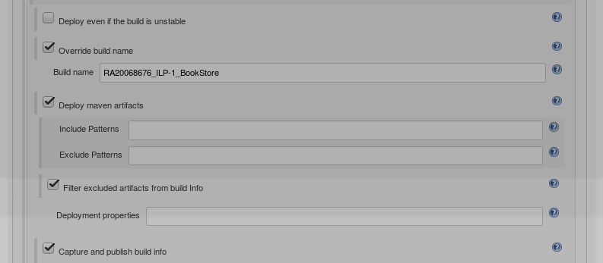

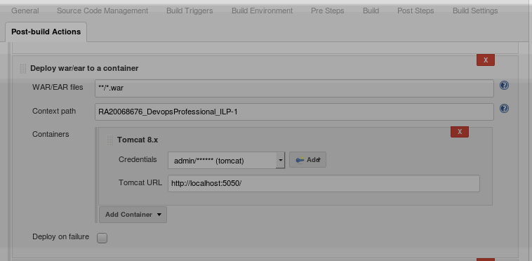
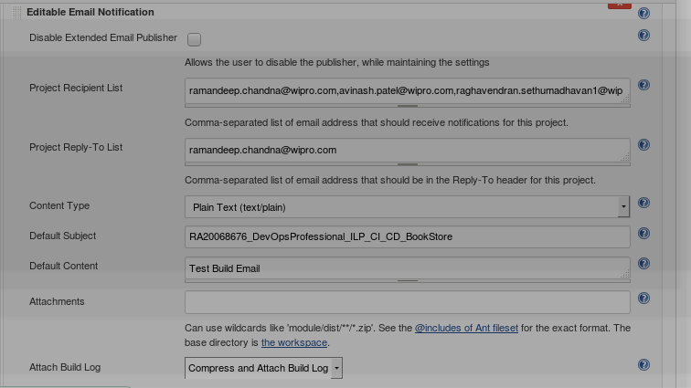

b)Job Build History

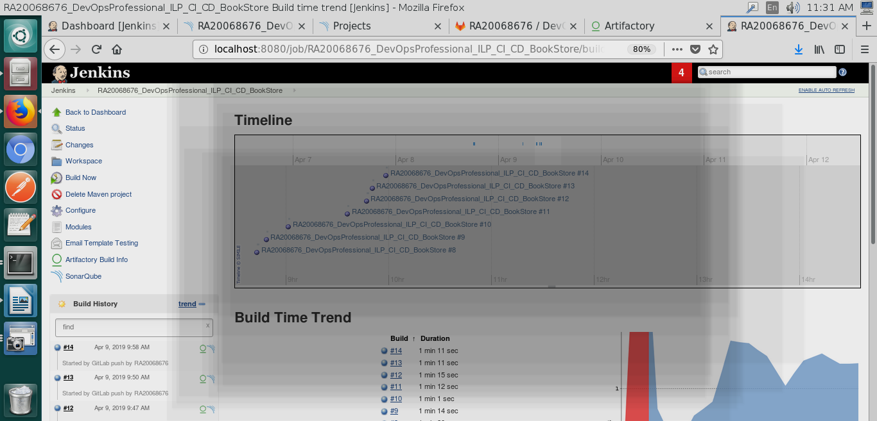

c)Sample Console Output

BUILD-Console Output

Started by GitLab push by RA20068676
Building in workspace /var/lib/jenkins/workspace/RA20068676_DevOpsProfessional_ILP_CI_CD_BookStore
> git rev-parse --is-inside-work-tree # timeout=10
Fetching changes from the remote Git repository
> git config remote.origin.url https://topgear-training-gitlab.wipro.com/RA20068676/DevOpsProfessional_ILP_CI_CD_BookStore.git # timeout=10
Fetching upstream changes from https://topgear-training-gitlab.wipro.com/RA20068676/DevOpsProfessional_ILP_CI_CD_BookStore.git
> git --version # timeout=10
using GIT_ASKPASS to set credentials
> git fetch --tags --progress https://topgear-training-gitlab.wipro.com/RA20068676/DevOpsProfessional_ILP_CI_CD_BookStore.git +refs/heads/*:refs/remotes/origin/*
skipping resolution of commit remotes/origin/master, since it originates from another repository
> git rev-parse refs/remotes/origin/master^{commit} # timeout=10
> git rev-parse refs/remotes/origin/origin/master^{commit} # timeout=10
Checking out Revision 373d1dc3a06e43c670d281b92dd94d65b8e87188 (refs/remotes/origin/master)
> git config core.sparsecheckout # timeout=10
> git checkout -f 373d1dc3a06e43c670d281b92dd94d65b8e87188
Commit message: "Add README.md"
> git rev-list --no-walk e10dc804b0a7972324acdd7092a964f7d64de0b7 # timeout=10
No emails were triggered.
[RA20068676_DevOpsProfessional_ILP_CI_CD_BookStore] $ /var/lib/jenkins/tools/hudson.plugins.sonar.SonarRunnerInstallation/scan/bin/sonar-scanner scan -e -Dsonar.host.url=http://localhost:9000/sonar -Dsonar.projectName=RA20068676_DevOpsProfessional_ILP_CI_CD_BookStore -Dsonar.projectVersion=1.0 -Dsonar.projectKey=ILP-1_Bookstore -Dsonar.sources=src/integration-test -Dsonar.projectBaseDir=/var/lib/jenkins/workspace/RA20068676_DevOpsProfessional_ILP_CI_CD_BookStore
INFO: Option -e/--errors is no longer supported and will be ignored
INFO: Scanner configuration file: /var/lib/jenkins/tools/hudson.plugins.sonar.SonarRunnerInstallation/scan/conf/sonar-scanner.properties
INFO: Project root configuration file: NONE
INFO: SonarQube Scanner 3.3.0.1492
INFO: Java 1.8.0_162 Oracle Corporation (64-bit)
INFO: Linux 4.4.0-112-generic amd64
INFO: User cache: /var/lib/jenkins/.sonar/cache
INFO: SonarQube server 6.4.0
INFO: Default locale: "en_IN", source code encoding: "UTF-8" (analysis is platform dependent)
INFO: Load global settings
INFO: Load global settings (done) | time=315ms
INFO: User cache: /var/lib/jenkins/.sonar/cache
INFO: Load plugins index
INFO: Load plugins index (done) | time=14ms
INFO: Process project properties
INFO: Load project repositories
INFO: Load project repositories (done) | time=197ms
INFO: Load quality profiles
INFO: Load quality profiles (done) | time=163ms
INFO: Load active rules
INFO: Load active rules (done) | time=1494ms
INFO: Load metrics repository
INFO: Load metrics repository (done) | time=237ms
INFO: Publish mode
INFO: Project key: ILP-1_Bookstore
INFO: ------------- Scan RA20068676_DevOpsProfessional_ILP_CI_CD_BookStore
INFO: Load server rules
INFO: Load server rules (done) | time=156ms
INFO: Initializer GenericCoverageSensor
INFO: Initializer GenericCoverageSensor (done) | time=1ms
INFO: Base dir: /var/lib/jenkins/workspace/RA20068676_DevOpsProfessional_ILP_CI_CD_BookStore
INFO: Working dir: /var/lib/jenkins/workspace/RA20068676_DevOpsProfessional_ILP_CI_CD_BookStore/.scannerwork
INFO: Source paths: src/integration-test
INFO: Source encoding: UTF-8, default locale: en_IN
INFO: Index files
INFO: 2 files indexed
INFO: Quality profile for java: Sonar way
INFO: Sensor JavaSquidSensor [java]
INFO: Configured Java source version (sonar.java.source): none
INFO: JavaClasspath initialization
WARN: Bytecode of dependencies was not provided for analysis of source files, you might end up with less precise results. Bytecode can be provided using sonar.java.libraries property
INFO: JavaClasspath initialization (done) | time=1ms
INFO: JavaTestClasspath initialization
INFO: JavaTestClasspath initialization (done) | time=0ms
INFO: Java Main Files AST scan
INFO: 2 source files to be analyzed
INFO: 2/2 source files have been analyzed
INFO: Java Main Files AST scan (done) | time=1379ms
INFO: Java Test Files AST scan
INFO: 0 source files to be analyzed
INFO: Java Test Files AST scan (done) | time=0ms
INFO: Sensor JavaSquidSensor [java] (done) | time=2326ms
INFO: Sensor SurefireSensor [java]
INFO: parsing /var/lib/jenkins/workspace/RA20068676_DevOpsProfessional_ILP_CI_CD_BookStore/target/surefire-reports
INFO: 0/0 source files have been analyzed
WARN: Resource not found: devops.ilp1.controllerWithoutDb.RegisterTest
WARN: Resource not found: devops.ilp1.controllerWithoutDb.LoginTest
WARN: Resource not found: devops.ilp1.controllerWithoutDb.ChangePasswordTest
WARN: Resource not found: devops.ilp1.service.UserServiceTest
INFO: Sensor SurefireSensor [java] (done) | time=161ms
INFO: Sensor JaCoCoSensor [java]
INFO: Sensor JaCoCoSensor [java] (done) | time=1ms
INFO: Sensor SonarJavaXmlFileSensor [java]
INFO: Sensor SonarJavaXmlFileSensor [java] (done) | time=0ms
INFO: Sensor Analyzer for "php.ini" files [php]
INFO: Sensor Analyzer for "php.ini" files [php] (done) | time=8ms
INFO: Sensor Zero Coverage Sensor
INFO: Sensor Zero Coverage Sensor (done) | time=14ms
INFO: Sensor CPD Block Indexer
INFO: Sensor CPD Block Indexer (done) | time=35ms
INFO: 1 file had no CPD blocks
INFO: Calculating CPD for 1 file
INFO: CPD calculation finished
INFO: Analysis report generated in 126ms, dir size=29 KB
INFO: Analysis reports compressed in 8ms, zip size=10 KB
INFO: Analysis report uploaded in 79ms
INFO: ANALYSIS SUCCESSFUL, you can browse http://localhost:9000/sonar/dashboard/index/ILP-1_Bookstore
INFO: Note that you will be able to access the updated dashboard once the server has processed the submitted analysis report
INFO: More about the report processing at http://localhost:9000/sonar/api/ce/task?id=AWoAzd2KBFv2kGsEE8Ld
INFO: Task total time: 7.862 s
INFO: ------------------------------------------------------------------------
INFO: EXECUTION SUCCESS
INFO: ------------------------------------------------------------------------
INFO: Total time: 11.327s
INFO: Final Memory: 10M/177M
INFO: ------------------------------------------------------------------------
Parsing POMs
Established TCP socket on 36355
[RA20068676_DevOpsProfessional_ILP_CI_CD_BookStore] $ /usr/java/jdk1.8.0_162/bin/java -cp /var/lib/jenkins/plugins/maven-plugin/WEB-INF/lib/maven35-agent-1.12-alpha-1.jar:/opt/apache-maven-3.5.2/boot/plexus-classworlds-2.5.2.jar:/opt/apache-maven-3.5.2/conf/logging jenkins.maven3.agent.Maven35Main /opt/apache-maven-3.5.2 /var/cache/jenkins/war/WEB-INF/lib/remoting-3.14.jar /var/lib/jenkins/plugins/maven-plugin/WEB-INF/lib/maven35-interceptor-1.12-alpha-1.jar /var/lib/jenkins/plugins/maven-plugin/WEB-INF/lib/maven3-interceptor-commons-1.12-alpha-1.jar 36355
<===[JENKINS REMOTING CAPACITY]===>���channel started
Executing Maven: -B -f /var/lib/jenkins/workspace/RA20068676_DevOpsProfessional_ILP_CI_CD_BookStore/pom.xml clean install
[INFO] Scanning for projects...
[INFO] Initializing Artifactory Build-Info Recording
[HUDSON] Collecting dependencies info
[INFO]
[INFO] ------------------------------------------------------------------------
[INFO] Building ILP1UserMgmt Maven Webapp 0.0.1-SNAPSHOT
[INFO] ------------------------------------------------------------------------
[INFO]
[INFO] --- maven-clean-plugin:2.5:clean (default-clean) @ ILP-1 ---
[INFO] Deleting /var/lib/jenkins/workspace/RA20068676_DevOpsProfessional_ILP_CI_CD_BookStore/target
[INFO]
[INFO] --- maven-resources-plugin:2.6:resources (default-resources) @ ILP-1 ---
[WARNING] Using platform encoding (UTF-8 actually) to copy filtered resources, i.e. build is platform dependent!
[INFO] skip non existing resourceDirectory /var/lib/jenkins/workspace/RA20068676_DevOpsProfessional_ILP_CI_CD_BookStore/src/main/resources
[INFO]
[INFO] --- maven-compiler-plugin:3.1:compile (default-compile) @ ILP-1 ---
[INFO] Changes detected - recompiling the module!
[WARNING] File encoding has not been set, using platform encoding UTF-8, i.e. build is platform dependent!
[INFO] Compiling 6 source files to /var/lib/jenkins/workspace/RA20068676_DevOpsProfessional_ILP_CI_CD_BookStore/target/classes
[INFO]
[INFO] --- build-helper-maven-plugin:1.9.1:add-test-source (add-integration-test-sources) @ ILP-1 ---
[INFO] Test Source directory: /var/lib/jenkins/workspace/RA20068676_DevOpsProfessional_ILP_CI_CD_BookStore/src/integration-test/java added.
[INFO]
[INFO] --- build-helper-maven-plugin:1.9.1:add-test-resource (add-integration-test-resources) @ ILP-1 ---
[INFO]
[INFO] --- maven-resources-plugin:2.6:testResources (default-testResources) @ ILP-1 ---
[WARNING] File encoding has not been set, using platform encoding UTF-8, i.e. build is platform dependent!
[WARNING] Using platform encoding (UTF-8 actually) to copy filtered resources, i.e. build is platform dependent!
[INFO] skip non existing resourceDirectory /var/lib/jenkins/workspace/RA20068676_DevOpsProfessional_ILP_CI_CD_BookStore/src/test/resources
[INFO] skip non existing resourceDirectory /var/lib/jenkins/workspace/RA20068676_DevOpsProfessional_ILP_CI_CD_BookStore/src/integration-test/resources
[INFO]
[INFO] --- maven-compiler-plugin:3.1:testCompile (default-testCompile) @ ILP-1 ---
[INFO] Changes detected - recompiling the module!
[WARNING] File encoding has not been set, using platform encoding UTF-8, i.e. build is platform dependent!
[INFO] Compiling 6 source files to /var/lib/jenkins/workspace/RA20068676_DevOpsProfessional_ILP_CI_CD_BookStore/target/test-classes
[INFO]
[INFO] --- maven-surefire-plugin:2.18.1:test (default-test) @ ILP-1 ---
[INFO] Surefire report directory: /var/lib/jenkins/workspace/RA20068676_DevOpsProfessional_ILP_CI_CD_BookStore/target/surefire-reports
[INFO] parallel='none', perCoreThreadCount=true, threadCount=0, useUnlimitedThreads=false, threadCountSuites=0, threadCountClasses=0, threadCountMethods=0, parallelOptimized=true

-------------------------------------------------------
T E S T S
-------------------------------------------------------
Running devops.ilp1.service.UserServiceTest
Number of records available: 4
Tests run: 3, Failures: 0, Errors: 0, Skipped: 0, Time elapsed: 0.007 sec - in devops.ilp1.service.UserServiceTest
Running devops.ilp1.controllerWithoutDb.RegisterTest
Number of records available: 5
Tests run: 2, Failures: 0, Errors: 0, Skipped: 0, Time elapsed: 0.381 sec - in devops.ilp1.controllerWithoutDb.RegisterTest
Running devops.ilp1.controllerWithoutDb.LoginTest
Tests run: 1, Failures: 0, Errors: 0, Skipped: 0, Time elapsed: 0.004 sec - in devops.ilp1.controllerWithoutDb.LoginTest
Running devops.ilp1.controllerWithoutDb.ChangePasswordTest
successfuly updated
Tests run: 1, Failures: 0, Errors: 0, Skipped: 0, Time elapsed: 0.005 sec - in devops.ilp1.controllerWithoutDb.ChangePasswordTest

Results :

Tests run: 7, Failures: 0, Errors: 0, Skipped: 0

[JENKINS] Recording test results
[INFO]
[INFO] --- maven-war-plugin:2.2:war (default-war) @ ILP-1 ---
[INFO] Packaging webapp
[INFO] Assembling webapp [ILP-1] in [/var/lib/jenkins/workspace/RA20068676_DevOpsProfessional_ILP_CI_CD_BookStore/target/ILP_Bookstore]
[INFO] Processing war project
[INFO] Copying webapp resources [/var/lib/jenkins/workspace/RA20068676_DevOpsProfessional_ILP_CI_CD_BookStore/src/main/webapp]
[INFO] Webapp assembled in [91 msecs]
[INFO] Building war: /var/lib/jenkins/workspace/RA20068676_DevOpsProfessional_ILP_CI_CD_BookStore/target/ILP_Bookstore.war
[INFO] WEB-INF/web.xml already added, skipping
[INFO]
[INFO] >>> tomcat7-maven-plugin:2.2:run (start-tomcat) > process-classes @ ILP-1 >>>
[INFO]
[INFO] --- maven-resources-plugin:2.6:resources (default-resources) @ ILP-1 ---
[WARNING] Using platform encoding (UTF-8 actually) to copy filtered resources, i.e. build is platform dependent!
[INFO] skip non existing resourceDirectory /var/lib/jenkins/workspace/RA20068676_DevOpsProfessional_ILP_CI_CD_BookStore/src/main/resources
[INFO]
[INFO] --- maven-compiler-plugin:3.1:compile (default-compile) @ ILP-1 ---
[INFO] Nothing to compile - all classes are up to date
[WARNING] Failed to getClass for org.apache.tomcat.maven.plugin.tomcat7.run.RunMojo
[INFO]
[INFO] <<< tomcat7-maven-plugin:2.2:run (start-tomcat) < process-classes @ ILP-1 <<<
[INFO]
[INFO]
[INFO] --- tomcat7-maven-plugin:2.2:run (start-tomcat) @ ILP-1 ---
[INFO] Running war on http://localhost:6080/ILP_Bookstore
[INFO] Creating Tomcat server configuration at /var/lib/jenkins/workspace/RA20068676_DevOpsProfessional_ILP_CI_CD_BookStore/target/tomcat
[INFO] create webapp with contextPath: /ILP_Bookstore
[INFO] Initializing ProtocolHandler ["http-bio-6080"]
[INFO] Starting service Tomcat
[INFO] Starting Servlet Engine: Apache Tomcat/7.0.47
[INFO] Starting ProtocolHandler ["http-bio-6080"]
[INFO]
[INFO] --- maven-failsafe-plugin:2.19.1:integration-test (default) @ ILP-1 ---

-------------------------------------------------------
T E S T S
-------------------------------------------------------
Apr 09, 2019 12:04:46 PM org.openqa.selenium.firefox.FirefoxOptions toCapabilities
INFO: Preferring the firefox binary in these options (/usr/lib/firefox/firefox rather than /usr/lib/firefox/firefox)
Apr 09, 2019 12:04:46 PM org.openqa.selenium.firefox.FirefoxOptions toCapabilities
INFO: Preferring the firefox binary in these options (/usr/lib/firefox/firefox rather than /usr/lib/firefox/firefox)
1554791686181 geckodriver INFO geckodriver 0.19.1
1554791686186 geckodriver INFO Listening on 127.0.0.1:3872
1554791686633 mozrunner::runner INFO Running command: "/usr/lib/firefox/firefox" "-marionette" "--headless" "-profile" "/tmp/rust_mozprofile.moQvWlADp5Dg"
*** You are running in headless mode.
1554791687937 Marionette INFO Enabled via --marionette
1554791690123 Marionette INFO Listening on port 43270
Apr 09, 2019 12:04:50 PM org.openqa.selenium.remote.ProtocolHandshake createSession
INFO: Detected dialect: W3C
Running devops.ilp1.LoginFunctionalTest
successfuly updated
Number of records available: 4
Tests run: 3, Failures: 0, Errors: 0, Skipped: 0, Time elapsed: 3.327 sec - in devops.ilp1.LoginFunctionalTest

Results :

Tests run: 3, Failures: 0, Errors: 0, Skipped: 0

[WARNING] File encoding has not been set, using platform encoding UTF-8, i.e. build is platform dependent! The file encoding for reports output files should be provided by the POM property ${project.reporting.outputEncoding}.
[JENKINS] Recording test results
[INFO]
[INFO] --- tomcat7-maven-plugin:2.2:shutdown (stop-tomcat) @ ILP-1 ---
[INFO] Pausing ProtocolHandler ["http-bio-6080"]
[INFO] Stopping service Tomcat
[INFO] Stopping ProtocolHandler ["http-bio-6080"]
[INFO]
[INFO] --- maven-failsafe-plugin:2.19.1:verify (default) @ ILP-1 ---
[WARNING] File encoding has not been set, using platform encoding UTF-8, i.e. build is platform dependent! The file encoding for reports output files should be provided by the POM property ${project.reporting.outputEncoding}.
[JENKINS] Recording test results
[INFO]
[INFO] --- maven-install-plugin:2.4:install (default-install) @ ILP-1 ---
[INFO] Installing /var/lib/jenkins/workspace/RA20068676_DevOpsProfessional_ILP_CI_CD_BookStore/target/ILP_Bookstore.war to /var/lib/jenkins/.m2/repository/devops/ilp1/ILP-1/0.0.1-SNAPSHOT/ILP-1-0.0.1-SNAPSHOT.war
[INFO] Installing /var/lib/jenkins/workspace/RA20068676_DevOpsProfessional_ILP_CI_CD_BookStore/pom.xml to /var/lib/jenkins/.m2/repository/devops/ilp1/ILP-1/0.0.1-SNAPSHOT/ILP-1-0.0.1-SNAPSHOT.pom
[INFO] Artifactory Build Info Recorder: Saving Build Info to '/var/lib/jenkins/workspace/RA20068676_DevOpsProfessional_ILP_CI_CD_BookStore/target/build-info.json'
[INFO] Deploying artifact: http://localhost:5040/artifactory/libs-snapshot-local/devops/ilp1/ILP-1/0.0.1-SNAPSHOT/ILP-1-0.0.1-SNAPSHOT.war
[INFO] Deploying artifact: http://localhost:5040/artifactory/libs-snapshot-local/devops/ilp1/ILP-1/0.0.1-SNAPSHOT/ILP-1-0.0.1-SNAPSHOT.pom
[INFO] Artifactory Build Info Recorder: Deploying build info ...
[INFO] Deploying build descriptor to: http://localhost:5040/artifactory/api/build
[INFO] Build successfully deployed. Browse it in Artifactory under http://localhost:5040/artifactory/webapp/builds/RA20068676_ILP-1_BookStore/16
[INFO] ------------------------------------------------------------------------
[INFO] BUILD SUCCESS
[INFO] ------------------------------------------------------------------------
[INFO] Total time: 34.588 s
[INFO] Finished at: 2019-04-09T12:04:58+05:30
[INFO] Final Memory: 42M/278M
[INFO] ------------------------------------------------------------------------
[JENKINS] Archiving /var/lib/jenkins/workspace/RA20068676_DevOpsProfessional_ILP_CI_CD_BookStore/pom.xml to devops.ilp1/ILP-1/0.0.1-SNAPSHOT/ILP-1-0.0.1-SNAPSHOT.pom
[JENKINS] Archiving /var/lib/jenkins/workspace/RA20068676_DevOpsProfessional_ILP_CI_CD_BookStore/target/ILP_Bookstore.war to devops.ilp1/ILP-1/0.0.1-SNAPSHOT/ILP-1-0.0.1-SNAPSHOT.war
channel stopped
Deploying /var/lib/jenkins/workspace/RA20068676_DevOpsProfessional_ILP_CI_CD_BookStore/target/ILP_Bookstore.war to container Tomcat 8.x Remote with context RA20068676_DevopsProfessional_ILP-1
Redeploying [/var/lib/jenkins/workspace/RA20068676_DevOpsProfessional_ILP_CI_CD_BookStore/target/ILP_Bookstore.war]
Undeploying [/var/lib/jenkins/workspace/RA20068676_DevOpsProfessional_ILP_CI_CD_BookStore/target/ILP_Bookstore.war]
Deploying [/var/lib/jenkins/workspace/RA20068676_DevOpsProfessional_ILP_CI_CD_BookStore/target/ILP_Bookstore.war]
Email was triggered for: Always
Sending email for trigger: Always
Request made to compress build log
Sending email to: ramandeep.chandna@wipro.com avinash.patel@wipro.com raghavendran.sethumadhavan1@wipro.com
Finished: SUCCESS

d)Project Structure

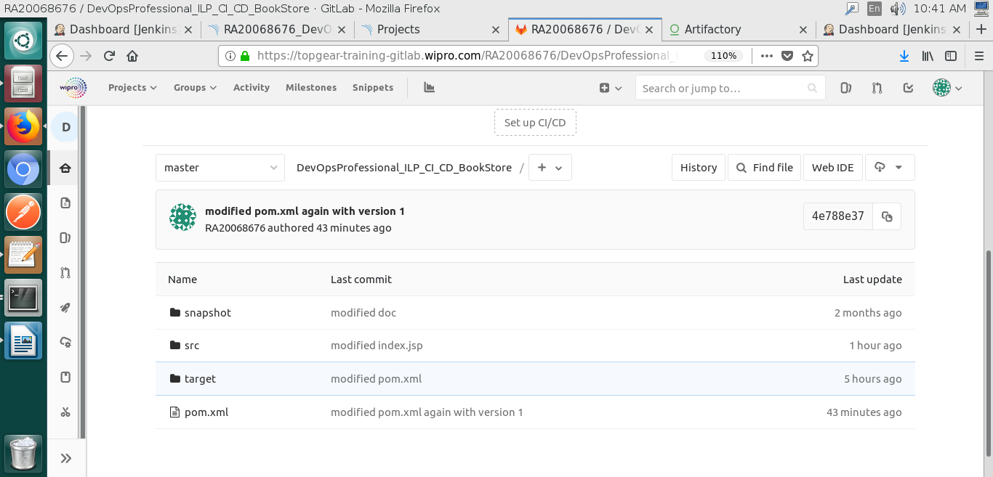

4)Gitlab History

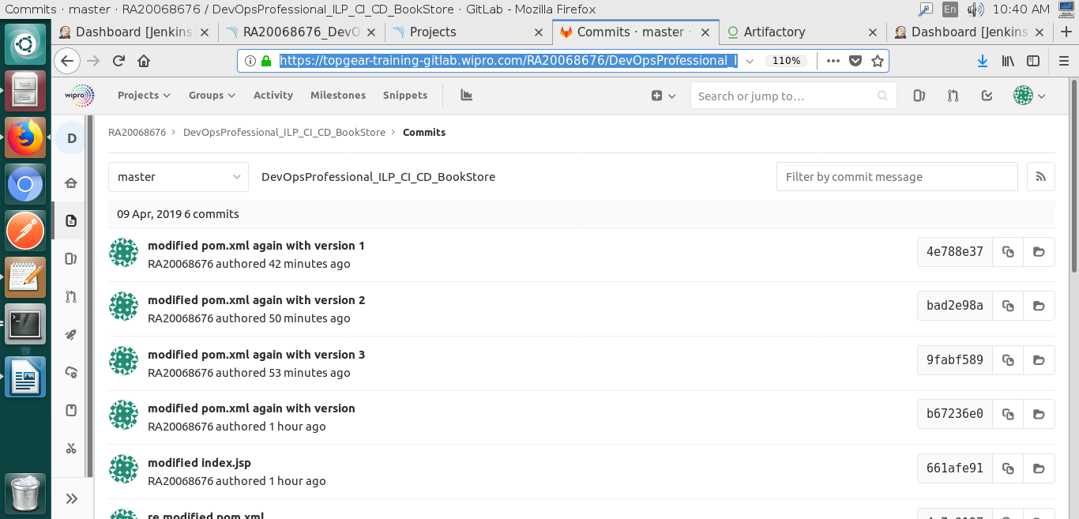

5)Jfrog Artifactory

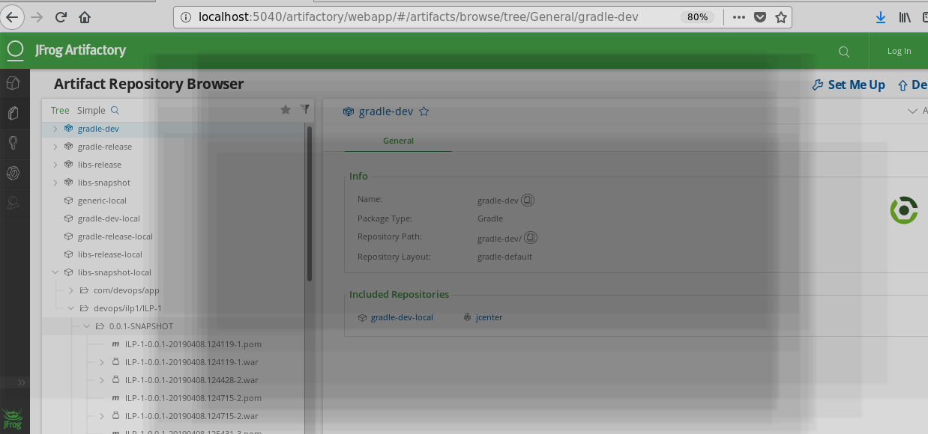
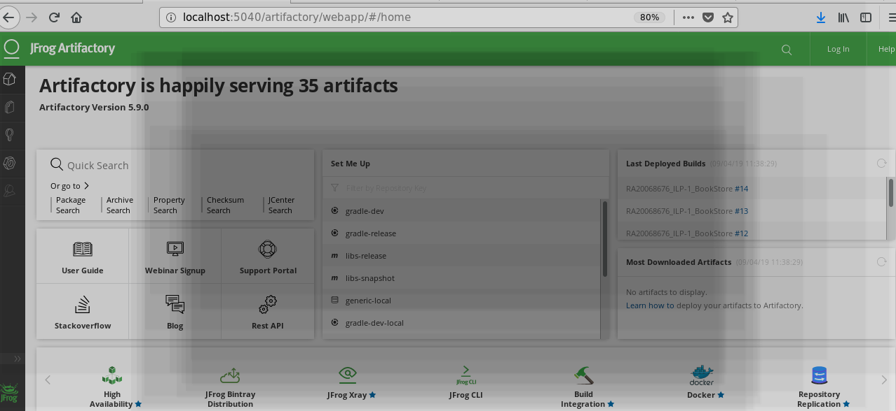
6)Code review report from Sonar Qube

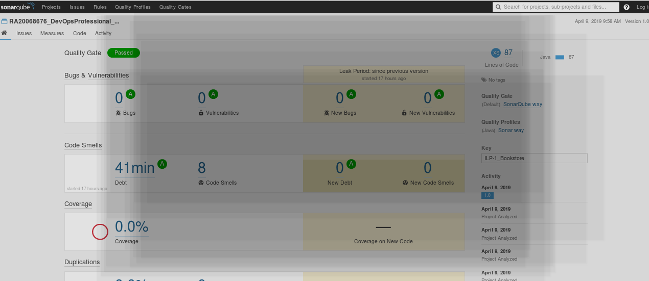
7) Unit Integration Test Report

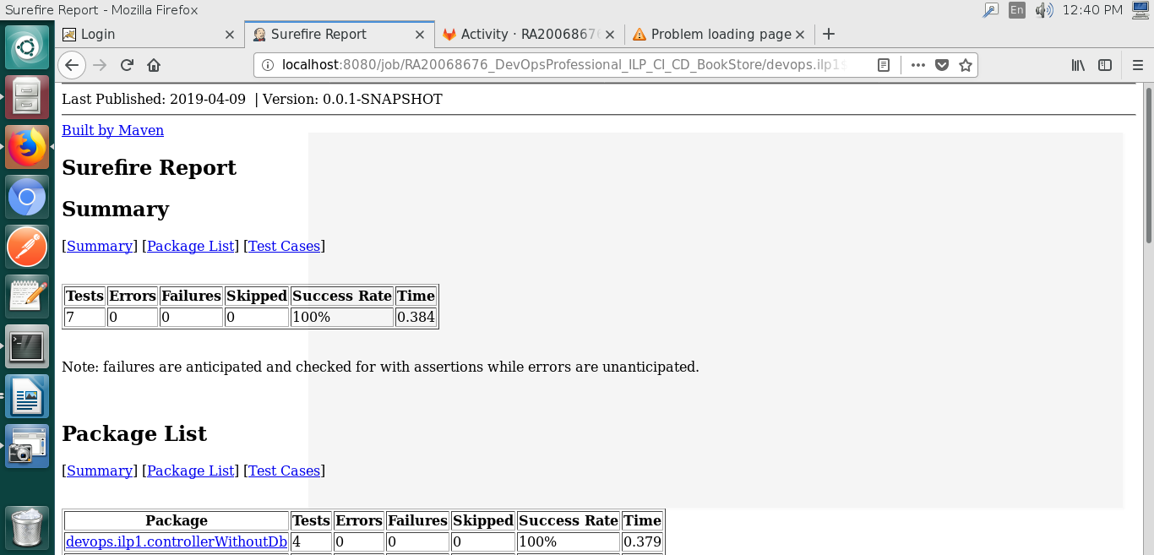
8) Selenium test report from jenkins

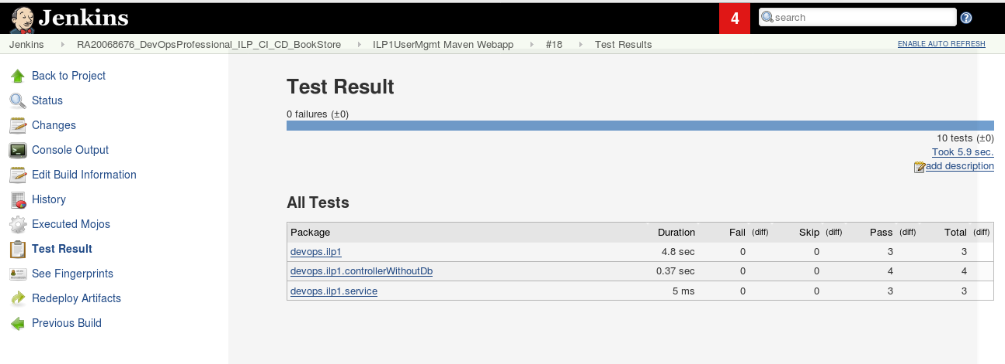

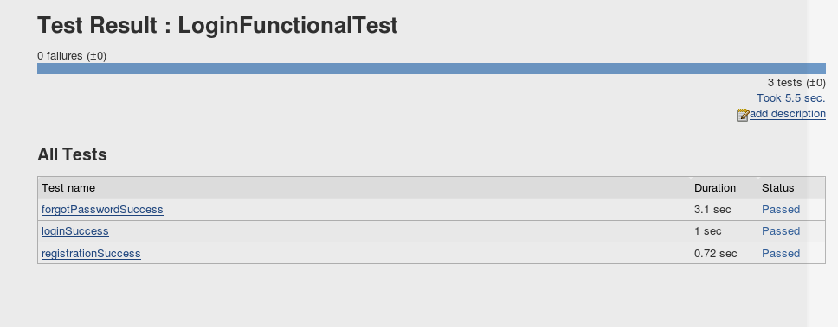
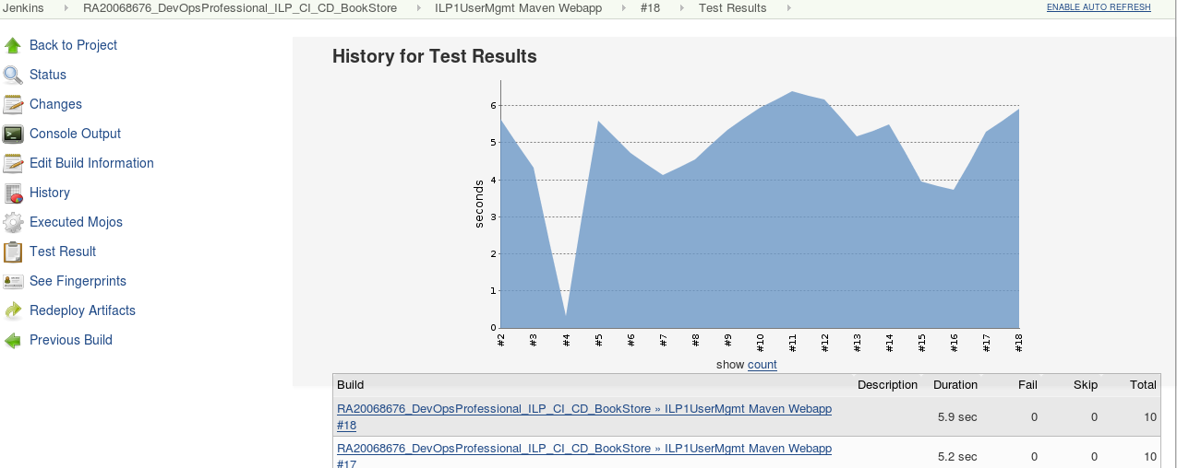

9) Tomcat Configuration

10) Application Output

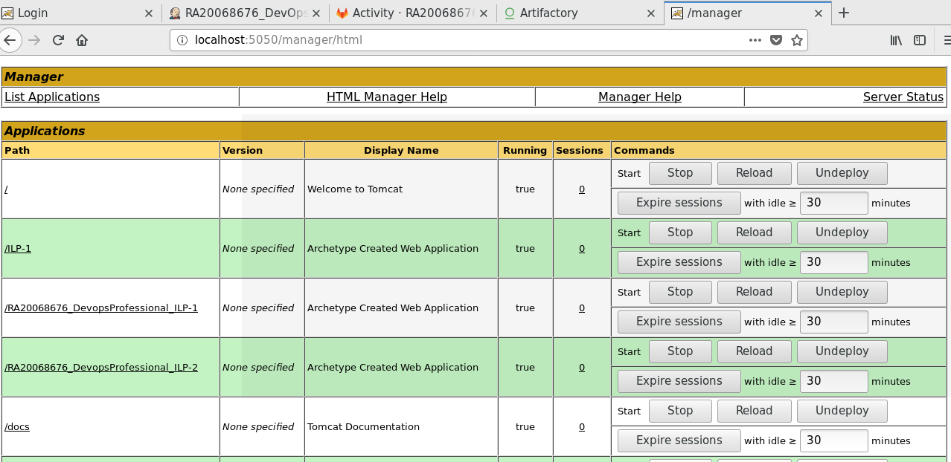
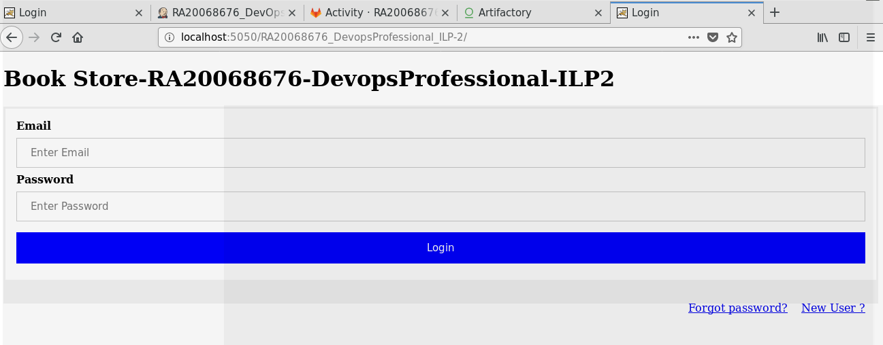

FINISHED

