Install Instructions for MyShowcase Moodle Plugin

Author : Garry Willits Revision 1.1 07/10/2010
Overview
MyShowcase is a content aggregator tool designed to facilitate the sharing of a wide range of evidence streams as proof of competency and skills. It can provide a history of achievements and learning across an individual’s entire professional career.
The Moodle plugin allows you to embed the MyShowcase tool within the Moodle Learning Management System as a service for learners.
Installation Instructions
Step 1: Install Files
After receiving a zip package of the MyShowcase Moodle plugin, the first task is to unzip the package and install the files in the correct directory.
You can either unzip this package and copy the resulting files to your Moodle installation or extract the files directly into the correct directory. The location of the Moodle installation will vary depending on your website setup and whether you are using Apache or IIS as a web server. For example, this could be C:\inetpub\wwwroot\moodle.
The next step is to copy the plugin into the blocks directory of your Moodle environment. The structure should be moodle/blocks/myshowcase .
Step 2: Test installation
Now you need to test that the install has worked. Log in to Moodle as administrator and click on the `notifications` link from the `Site Administration` menu. You should receive a notification that Moodle has successfully installed the MyShowcase plugin. If you do not see this message, check carefully that you have installed the MyShowcase plugin folder into the directory outlined in Step 1.
Step 3: Customise settings
The next step is to provide a Moodle instance name that matches the one you received when you were sent the plugin.
You must enter this information into the block settings for MyShowcase. From the `Site Administration` menu click Modules->Blocks-> Manage blocks
You will see a screen similar to Figure 1 which contains all the settings for all the blocks in Moodle.
Locate the row which belongs to MyShowcase and check that the eye icon is open. This shows that the plugin is visible and available for use.
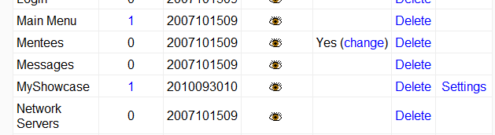
Figure 1
IMPORTANT: You must complete the next instruction correctly or your MyShowcase plugin will not work.
Click the `settings` link for MyShowcase and enter the Moodle Instance Name (the one you created in your MyShowcase installation) into the input box ( Figure 2). Please refer to the MyShowcase documentation for instructions on how to do this. Do NOT use the word MKM shown in the image below.

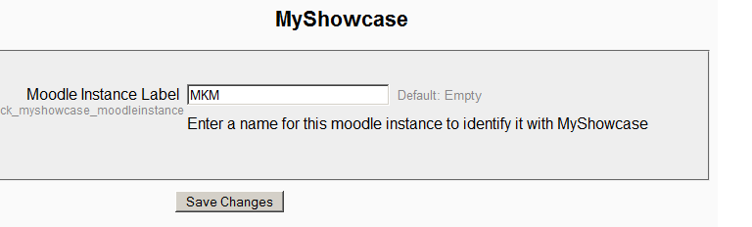
Figure 2
Click `Save Changes` to save this setting. You can revisit this screen at any time if you need to change the instance name for any reason.
Step 4: Add the block to Moodle
Now you need to add the block to Moodle. You can put the block anywhere where blocks are allowed. This might be as part of a course or directly on the landing page. With the correct admin rights and with editing set to `on` you should see a control that looks like Figure 3.
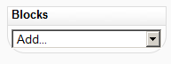
Figure 3
Click on the select box and select `MyShowcase` from the drop down list. A block is added with a button that launches the MyShowcase content. If you can see the control shown in Figure 4, your install has been successful and you are ready to start working with the MyShowcase tool.
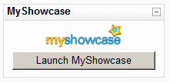
Figure 4
About Single Sign-on
A student launching the MyShowcase tool for the first time must register their details on the system. There is a short form to enter details of name, email and date of birth.
The student only needs to register once. After they have registered, the system will log them in automatically.

