**Лабараторна робота №3**

Завдання 1

import math

import numpy as np

a = 0.5

b = 1

e = 0.0001

def d(x):

return x ** 3 + x - 1

def d1(x): #производная

return 3 * x ** 2 + 1

def d2(x): #вторая производная

return 6 * x

f = d(a)

f2 = d2(a)

if f * f2 > 0:

x = b

z = a

else:

x = a

z = b

fz = d(z)

h = x - ((d(x)) / d(x) - d(a)) * (x - a)

while abs(h) >= e:

f = d(x)

h = ((x - z) * f) / (f - fz)

x = x - h

f = d(x)

print('Metod Hord\nx =', x, '\nf(x) =', f)

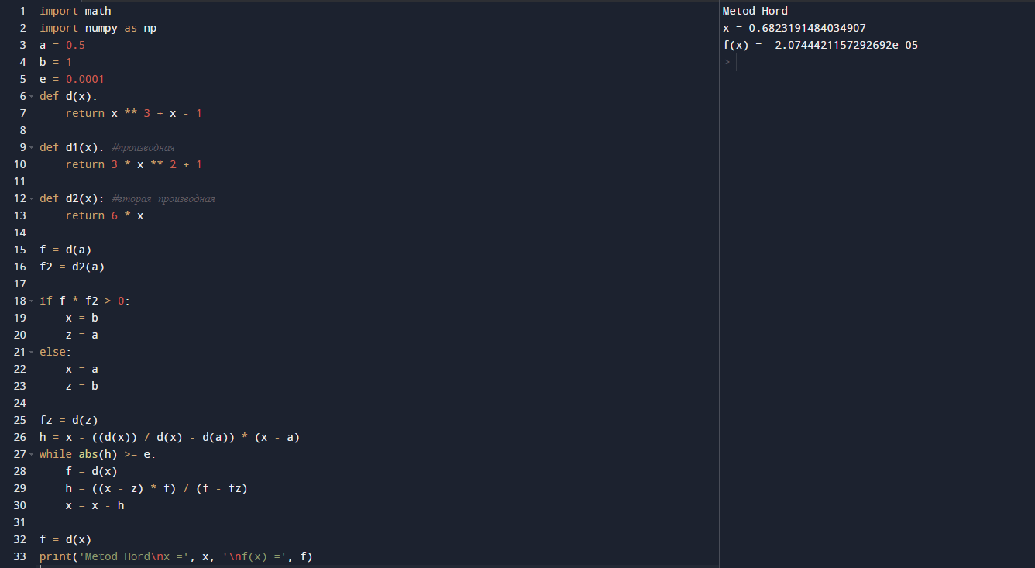

Завдання 2

import math

import numpy as np

a = 4.85

b = 5.2

e = 0.05

def d(x):

return x ** 3 - 3 * x - 0.4

while abs(b - a) >= e:

if d(a) * d((a + b) / 2) < 0:

b = (a + b) / 2

else:

a = (a + b) / 2

x = (a + b) / 2

print('Metod Polovinnogo Dilennya\nx =', x,)

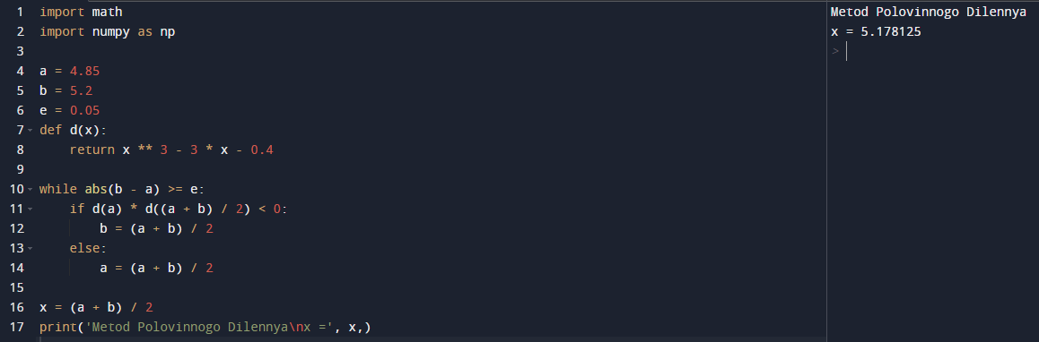

Завдання 3

import math

import numpy as np

a = 4.85

b = 5.2

e = 0.001

def d(x):

return x ** 3 - 3 * x - 0.4

def d1(x): #производная

return 3 * x ** 2 - 3

def d2(x): #вторая производная

return 6 * x

while abs(a - b) < 2 * e:

if d(a) * d2(a) < 0:

a = a - d(a) * (a - b) / (d(a) / d(b))

else:

a = a = d(a) / d1(a)

if d(b) * d2(b ) > 0:

b = b - d(b) * (b - a) / (d(b) - d(a))

else:

b = b - d(b) / d1(b)

x = (a + b) / 2

print('Metod Combinovanui\nx =', x)

