

Energy Consumption Analysis and Predictive Maintenance

*Submitted by*

Name of the Student  
Diksha Singh  
Roll No  
OKYPS3836N

School of Computer Engineering

KIIT Deemed To Be University  
Bhubaneswar

**Practical Training Certificate**

(The scanned copy of the certificate with signature from the competent authority should be included here as an image.)

**Abstract**

The abstract of the internship/training should be elaborated within a word limit of seven hundred and fifty

**Table of Contents**

1 Introduction 2

2 Basic Concepts 2

2.1 Subsection 2

2.2 Subsection 3

2.2.1 Sub-subsection 3

2.2.2 Sub-subsection 3

3 Section 3 3

3.1 How to Place a Figure and Table inside the Document 3

3.1.1 Inserting a Table into your Document 4

3.1.2 Sub-sub section about including an Equation 4

4 Conclusion 5

5 References 5

6 Appendix 5

# Introduction

Type text of your abstract here. Type text of your abstract here. Type text of your abstract here. Type text of your abstract here. Type text of your abstract here. Type text of your abstract here. Type text of your abstract here. Type text of your abstract here. Type text of your abstract here. Type text of your abstract here. Type text of your abstract here. Type text of your abstract here.

Type text of your abstract here. Type text of your abstract here. Type text of your abstract here. Type text of your abstract here. Type text of your abstract here. Type text of your abstract here. Type text of your abstract here. Type text of your abstract here. Type text of your abstract here. Type text of your abstract here. Type text of your abstract here. Type text of your abstract here. Type text of your abstract here. Type text of your abstract here. Type text of your abstract here. Type text of your abstract here. Type text of your abstract here. Type text of your abstract here. Type text of your abstract here. Type text of your abstract here. Type text of your abstract here. Type text of your abstract here. Type text of your abstract here. Type text of your abstract here.

# Basic Concepts

Type here Type here Type here Type here Type here Type here Type here Type here Type here Type here Type here Type here Type here Type here Type here Type here Type here Type here Type here Type here Type here Type here Type here Type here Type here Type here Type here Type here Type here Type here Type here Type here Type here Type here Type here Type here Type here Type here Type here Type here Type here Type here Type here Type here Type here Type here Type here Type here

Type here Type here Type here Type here Type here Type here Type here Type here Type here Type here Type here Type here Type here Type here Type here Type here Type here Type here Type here Type here Type here Type here Type here Type here Type here Type here Type here Type here Type here Type here Type here Type here Type here Type here Type here Type here Type here Type here Type here Type here Type here Type here Type here Type here Type here Type here Type here Type here Type here Type here Type here Type here Type here Type here Type here Type here Type here Type here

## Subsection

Type here Type here Type here Type here Type here Type here Type here Type here Type here Type here Type here Type here Type here Type here Type here Type here Type here Type here Type here Type here Type here Type here Type here Type here Type here Type here Type here Type here Type here Type here Type here Type here Type here Type here Type here Type here Type here Type here Type here Type here Type here Type here Type here Type here Type here Type here Type here Type here Type here Type here Type here

## Subsection

Type here Type here Type here Type here Type here Type here Type here Type here Type here Type here Type here Type here Type here Type here Type here Type here Type here Type here Type here Type here Type here Type here Type here Type here Type here Type here Type here Type here Type here Type here Type here Type here Type here Type here Type here Type here Type here Type here Type here Type here Type here Type here Type here Type here Type here Type here Type here Type here Type here Type here

### Sub-subsection

Type here Type here Type here Type here Type here Type here Type here Type here Type here Type here Type here Type here Type here Type here Type here Type here Type here Type here Type here Type here Type here Type here Type here Type here Type here Type here Type here Type here Type here Type here Type here Type here Type here Type here Type here Type here Type here Type here Type here Type here Type here Type here Type here Type here Type here Type here Type here Type here Type here Type here

### Sub-subsection

Type here Type here Type here Type here Type here Type here Type here Type here Type here Type here Type here Type here Type here Type here Type here Type here Type here Type here Type here Type here Type here Type here Type here Type here Type here Type here Type here Type here Type here Type here Type here Type here Type here Type here Type here Type here Type here Type here Type here Type here Type here Type here Type here Type here Type here Type here Type here Type here Type here Type here

# Section 3

Type here Type here Type here Type here Type here Type here Type here Type here Type here Type here Type here Type here Type here Type here Type here Type here Type here Type here Type here Type here Type here Type here Type here Type here Type here Type here Type here

## How to Place a Figure and Table inside the Document

Place the figure at the appropriate position of a section, where you want to discuss about that figure. Avoid placing them in the middle of a Section. Figure captions should be centered below the figures; Avoid placing figures and tables before their first mention in the text. Use the abbreviation “Fig. 1,” even at the beginning of a sentence.

Figure axis labels are often a source of confusion. Use words rather than symbols. For example, write “Magnetization,” or “Magnetization, M,” not just “M.” Put units in parentheses. Do not label axes only with units. In the example, write “Magnetization (A/m)” or “Magnetization (A ⋅ m1).” Do not label axes with a ratio of quantities and units. For example, write “Temperature (K),” not “Temperature/K.”

Multipliers can be especially confusing. Write “Magnetization (kA/m)” or “Magnetization (103 A/m).” Figure labels should be legible, about 10-point type.

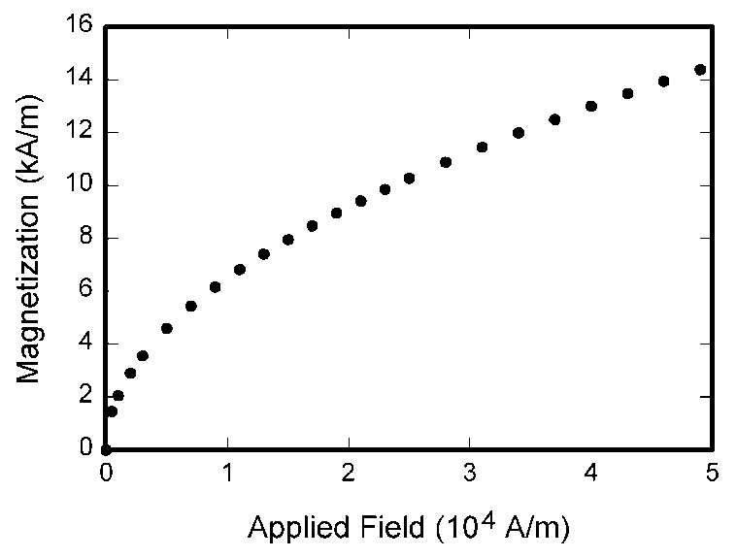

**Figure 1. Magnetization as a function of applied test**

### Inserting a Table into your Document

Table captions should be centered above.

**Table 1. This is the Table Caption (i.e write down the name of the Table here)**

| Paragraph Style | Size  (pts) | Font | Font Style | Description |
| --- | --- | --- | --- | --- |
| IEEE Title | 24 | Times New Roman | regular | Title of paper |
| IEEE Author | 11 |  | regular | Author names |
| IEEE Abstract | 9 |  | *italics* | Abstract of paper |
| IEEE Heading 1 | 8 |  | Small Caps | Section headings |
| IEEE Heading 2 | 10 |  | *Italics, Capitalize Words* | Sub-headings |
| IEEE Text | 10 |  | regular | All body text |
| IEEE List | 10 |  | *Italics # and topic:* regular text | Lists |
| IEEE Table Number | 8 |  | ALL CAPS | Table Number |
| IEEE Table Title | 8 |  | Small Caps | Table Title |
| IEEE Table Content | 8 |  | regular | Table content |
| IEEE Caption | 8 |  | regular | Figure caption |
| IEEE Equation | 10 |  | regular | Equation |
| IEEE Reference Head | 8 |  | Small Caps | Reference section heading |
| IEEE Reference | 8 |  | regular | Reference entry |

### Sub-sub section about including an Equation

Number equations consecutively with equation numbers in parentheses flush with the right margin, as in (1). To make your equations more compact, you may use the solidus ( / ), the exp function, or appropriate exponents. Italicize Roman symbols for quantities and variables, but not Greek symbols. Use an en dash (–) rather than a hyphen for a minus sign. Use parentheses to avoid ambiguities in denominators. Punctuate equations with commas or periods when they are part of a sentence, as given below sentence.

(1)

Symbols in your equation should be defined before the equation appears or immediately following. Use “(1),” not “Eq. (1)” or “equation (1),” except at the beginning of a sentence: “Equation (1) is …”

# Conclusion

Type here Type here Type here Type here Type here Type here Type here Type here Type here Type here Type here Type here Type here Type here Type here Type here Type here Type here Type here Type here Type here Type here Type here Type here Type here Type here

# References

1. Author Name1, “Document/Paper Title”, *Publication/Conference or Journal Title*, Vol. #, Issue No. #, pp. 56-63, 1999.
2. Author Name1, Author Name2, “Document/Paper Title”, *Publication/Conference or Journal Title*, Vol. #, Issue No. #, pp. 90-98, 2006.
3. Author Name1, Author Name2, Author Name3, “Document/Paper Title”, *Publication/Conference or Journal Title*, Vol. #, Issue No. #, pp. 123-128, 2009.
4. <http://www.somesite.com/somepage.html>, downloaded on dd/mm/yyyy at hh:mm.
5. Author Name1, Author Name2, Author Name3, “Book Name”, *Publisher Name*, Edition 5, pp. 302-343, 2010.

# Appendix

Enclose the printout of your slides in portrait format with 6 slides printed on each page. It must start from a new page. The border line of the slides must be shown in the document. The samples of positioning of the slides are given in the next page.



