#7TotaldescriptivaClean5.Rmd #install.packages(“rmarkdown”) #library(“rmarkdown”)

READING CREDSCO.CSV. NOTE: Change the path of the file for the proper one in your computer.

Remember that subfolders must be indicated by “/” and not by “"

Here you can write the introduction of your report and include some text that will be transferred to the word file every time you re-run this Markdown

WARNING: data must have been properly declared before (factors, dates…)

# dd <- read.table("D:/karina/docencia/areferenciesPPT/0DadesPractiques/CREDSCO/credscoCategoriques2.csv",header=T, sep=";", dec=",")  
#dd<- read.csv("D:/karina/TFGs/GrauEstadistica/MarcPinar/data.csv", sep=";")  
  
#dataset<-"platjaDaro"  
#dataset<-"futbol"  
  
#setwd("D:/karina/projectes/ON/a2020INSESSCOVIDisocial/18DadesTallers")  
#dd<- read.table("2Formulari5TPlataDarov1.csv",header=T, sep=",", dec=".", na.strings="*");  
#dataset<-"planta"  
  
dataset<-"CREDSCO"

Set the folder where the word file is going to be generated

setwd("/Users/davidmorais/Desktop/PARS-GEI-FIB/Obligatories/Q7/MD")  
dd<- read.table("hotel_sample_5000.csv",header=T, sep=",", dec=".")

Check the type of the R object created for the dataset

class(dd)

## [1] "data.frame"

without including the R instruction in the final document

## [1] "data.frame"

Get dimensions of the dataset

dim(dd)

## [1] 5000 32

n<-dim(dd)[1]  
K<-dim(dd)[2]  
  
n

## [1] 5000

K

## [1] 32

Check the variables

names(dd)

## [1] "hotel" "is_canceled"   
## [3] "lead_time" "arrival_date_year"   
## [5] "arrival_date_month" "arrival_date_week_number"   
## [7] "arrival_date_day_of_month" "stays_in_weekend_nights"   
## [9] "stays_in_week_nights" "adults"   
## [11] "children" "babies"   
## [13] "meal" "country"   
## [15] "market_segment" "distribution_channel"   
## [17] "is_repeated_guest" "previous_cancellations"   
## [19] "previous_bookings_not_canceled" "reserved_room_type"   
## [21] "assigned_room_type" "booking_changes"   
## [23] "deposit_type" "agent"   
## [25] "company" "days_in_waiting_list"   
## [27] "customer_type" "adr"   
## [29] "required_car_parking_spaces" "total_of_special_requests"   
## [31] "reservation_status" "reservation_status_date"

Decide if you need to declare some more factor or date

descriptiva<-function(X, nom){  
 if (!(is.numeric(X) || class(X)=="Date")){   
 frecs<-table(as.factor(X), useNA="ifany")  
 proportions<-frecs/n  
 #ojo, decidir si calcular porcentages con o sin missing values  
 pie(frecs, cex=0.6, main=paste("Pie of", nom))  
 barplot(frecs, las=3, cex.names=0.7, main=paste("Barplot of", nom), col=listOfColors)  
 print(paste("Number of modalities: ", length(frecs)))  
 print("Frequency table")  
 print(frecs)  
 print("Relative frequency table (proportions)")  
 print(proportions)  
 print("Frequency table sorted")  
 print(sort(frecs, decreasing=TRUE))  
 print("Relative frequency table (proportions) sorted")  
 print(sort(proportions, decreasing=TRUE))  
 }else{  
 if(class(X)=="Date"){  
 print(summary(X))  
 print(sd(X))  
 #decide breaks: weeks, months, quarters...  
 hist(X,breaks="weeks")  
 }else{  
 hist(X, main=paste("Histogram of", nom))  
 boxplot(X, horizontal=TRUE, main=paste("Boxplot of",nom))  
 print("Extended Summary Statistics")  
 print(summary(X))  
 print(paste("sd: ", sd(X, na.rm=TRUE)))  
 print(paste("vc: ", sd(X, na.rm=TRUE)/mean(X, na.rm=TRUE)))  
 }  
 }  
}  
  
dataset<-dd  
actives<-c(1:K)  
colDate<-1

Basic descriptive analysis for numerical variables

(decide the maximum number of colors you can need in a graph based on your metadata file)

## [1] "variable 1 : hotel"

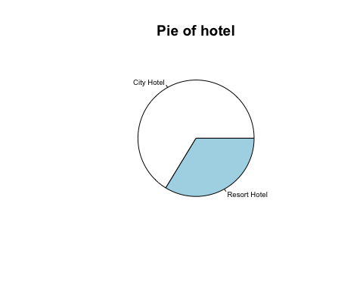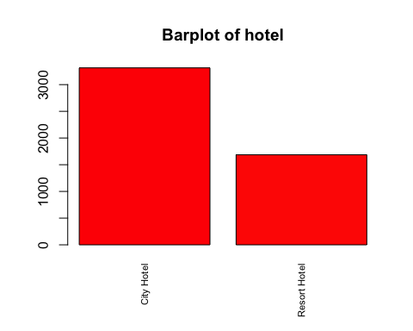

## [1] "Number of modalities: 2"  
## [1] "Frequency table"  
##   
## City Hotel Resort Hotel   
## 3314 1686   
## [1] "Relative frequency table (proportions)"  
##   
## City Hotel Resort Hotel   
## 0.6628 0.3372   
## [1] "Frequency table sorted"  
##   
## City Hotel Resort Hotel   
## 3314 1686   
## [1] "Relative frequency table (proportions) sorted"  
##   
## City Hotel Resort Hotel   
## 0.6628 0.3372   
## [1] "variable 2 : is_canceled"

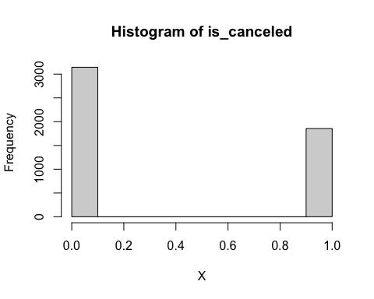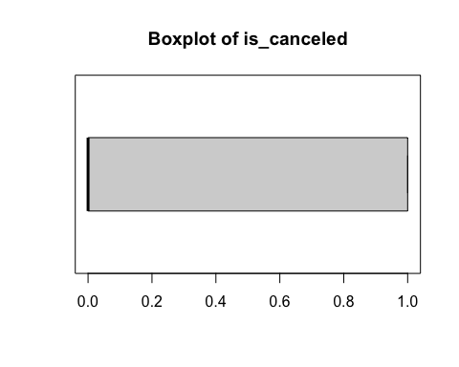

## [1] "Extended Summary Statistics"  
## Min. 1st Qu. Median Mean 3rd Qu. Max.   
## 0.0000 0.0000 0.0000 0.3712 1.0000 1.0000   
## [1] "sd: 0.483174141951212"  
## [1] "vc: 1.30165447723926"  
## [1] "variable 3 : lead_time"

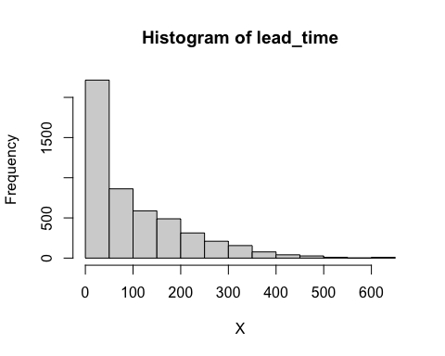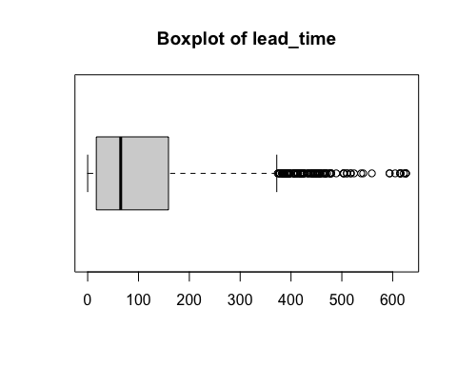

## [1] "Extended Summary Statistics"  
## Min. 1st Qu. Median Mean 3rd Qu. Max.   
## 0.0 17.0 65.0 101.7 159.0 626.0   
## [1] "sd: 107.203701323954"  
## [1] "vc: 1.0545795041282"  
## [1] "variable 4 : arrival_date_year"

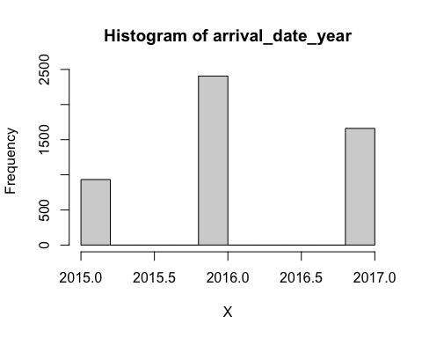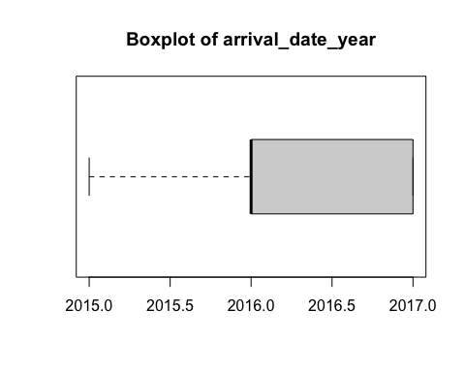

## [1] "Extended Summary Statistics"  
## Min. 1st Qu. Median Mean 3rd Qu. Max.   
## 2015 2016 2016 2016 2017 2017   
## [1] "sd: 0.705478688576776"  
## [1] "vc: 0.000349914554076241"  
## [1] "variable 5 : arrival_date_month"

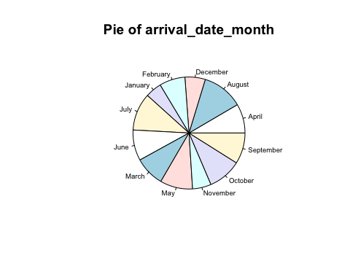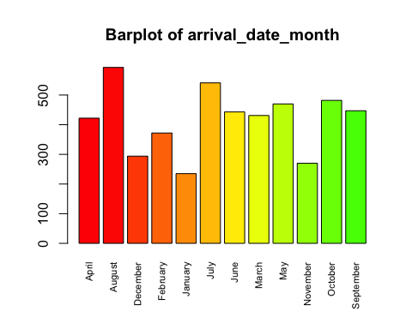

## [1] "Number of modalities: 12"  
## [1] "Frequency table"  
##   
## April August December February January July June March   
## 422 593 294 372 235 541 443 431   
## May November October September   
## 470 270 482 447   
## [1] "Relative frequency table (proportions)"  
##   
## April August December February January July June March   
## 0.0844 0.1186 0.0588 0.0744 0.0470 0.1082 0.0886 0.0862   
## May November October September   
## 0.0940 0.0540 0.0964 0.0894   
## [1] "Frequency table sorted"  
##   
## August July October May September June March April   
## 593 541 482 470 447 443 431 422   
## February December November January   
## 372 294 270 235   
## [1] "Relative frequency table (proportions) sorted"  
##   
## August July October May September June March April   
## 0.1186 0.1082 0.0964 0.0940 0.0894 0.0886 0.0862 0.0844   
## February December November January   
## 0.0744 0.0588 0.0540 0.0470   
## [1] "variable 6 : arrival_date_week_number"

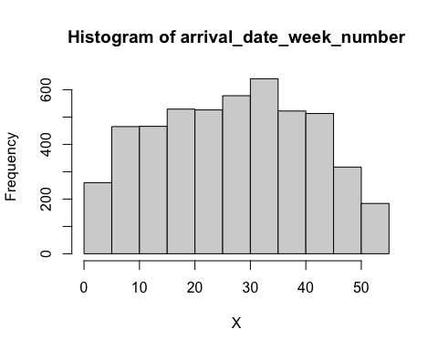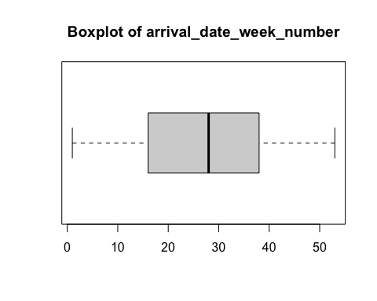

## [1] "Extended Summary Statistics"  
## Min. 1st Qu. Median Mean 3rd Qu. Max.   
## 1.00 16.00 28.00 27.27 38.00 53.00   
## [1] "sd: 13.6901524569619"  
## [1] "vc: 0.502066645284582"  
## [1] "variable 7 : arrival_date_day_of_month"

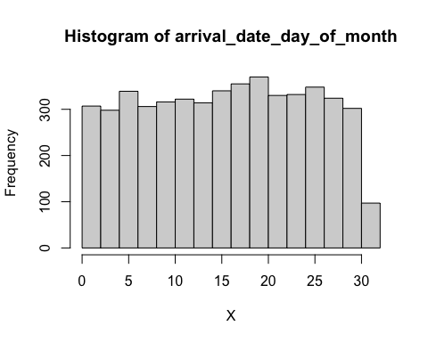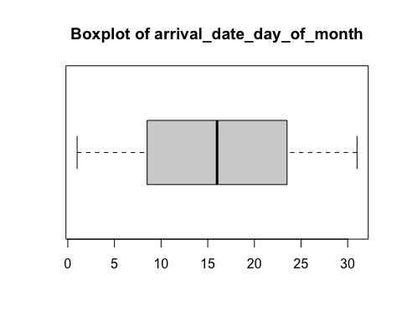

## [1] "Extended Summary Statistics"  
## Min. 1st Qu. Median Mean 3rd Qu. Max.   
## 1.00 8.75 16.00 16.00 23.25 31.00   
## [1] "sd: 8.71030173020695"  
## [1] "vc: 0.544536799047685"  
## [1] "variable 8 : stays_in_weekend_nights"

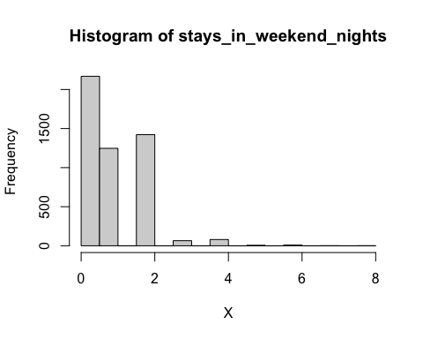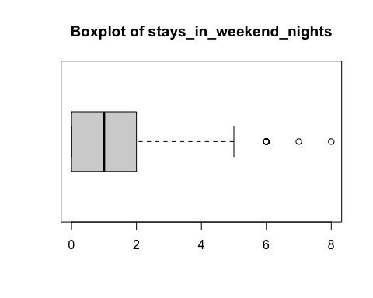

## [1] "Extended Summary Statistics"  
## Min. 1st Qu. Median Mean 3rd Qu. Max.   
## 0.000 0.000 1.000 0.941 2.000 8.000   
## [1] "sd: 0.996050914102636"  
## [1] "vc: 1.05850256546508"  
## [1] "variable 9 : stays_in_week_nights"

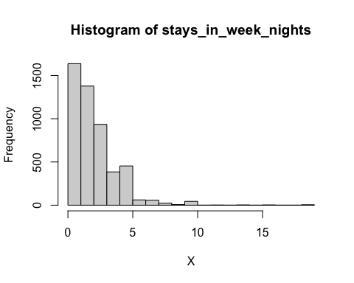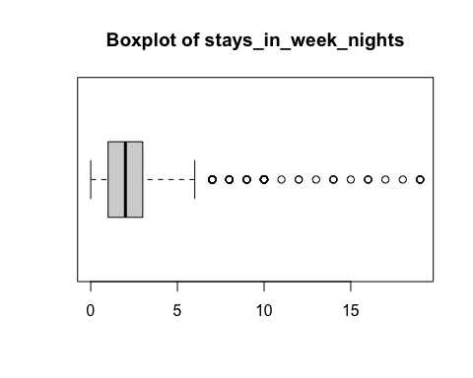

## [1] "Extended Summary Statistics"  
## Min. 1st Qu. Median Mean 3rd Qu. Max.   
## 0.000 1.000 2.000 2.487 3.000 19.000   
## [1] "sd: 1.89159896101839"  
## [1] "vc: 0.760594676726334"  
## [1] "variable 10 : adults"

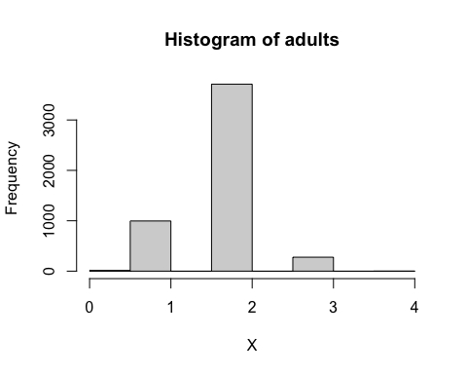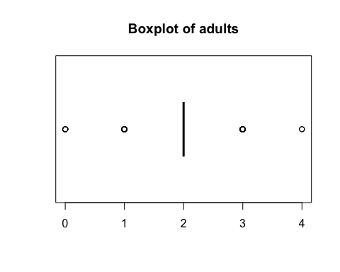

## [1] "Extended Summary Statistics"  
## Min. 1st Qu. Median Mean 3rd Qu. Max.   
## 0.000 2.000 2.000 1.851 2.000 4.000   
## [1] "sd: 0.495345448573705"  
## [1] "vc: 0.26755182487507"  
## [1] "variable 11 : children"

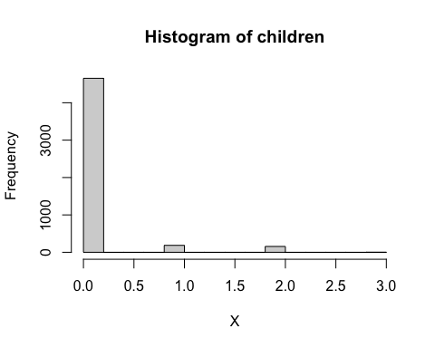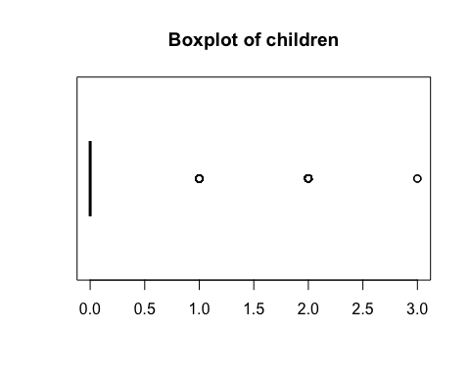

## [1] "Extended Summary Statistics"  
## Min. 1st Qu. Median Mean 3rd Qu. Max.   
## 0.0000 0.0000 0.0000 0.1018 0.0000 3.0000   
## [1] "sd: 0.397326482463393"  
## [1] "vc: 3.90301063323569"  
## [1] "variable 12 : babies"

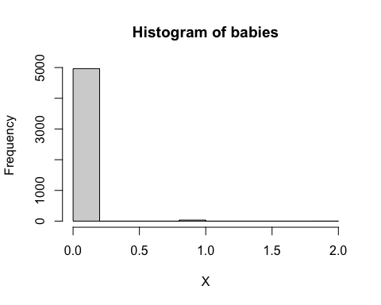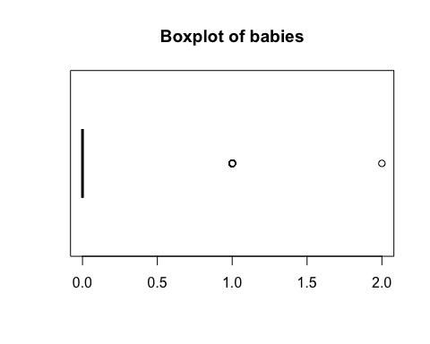

## [1] "Extended Summary Statistics"  
## Min. 1st Qu. Median Mean 3rd Qu. Max.   
## 0.0000 0.0000 0.0000 0.0072 0.0000 2.0000   
## [1] "sd: 0.0868888366476776"  
## [1] "vc: 12.0678939788441"  
## [1] "variable 13 : meal"

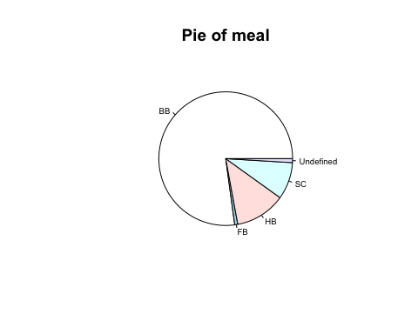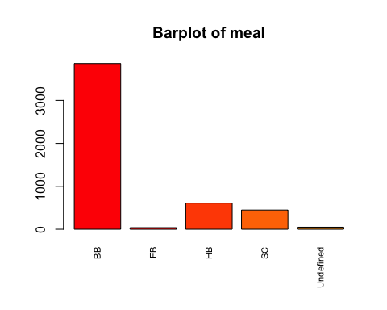

## [1] "Number of modalities: 5"  
## [1] "Frequency table"  
##   
## BB FB HB SC Undefined   
## 3858 37 609 448 48   
## [1] "Relative frequency table (proportions)"  
##   
## BB FB HB SC Undefined   
## 0.7716 0.0074 0.1218 0.0896 0.0096   
## [1] "Frequency table sorted"  
##   
## BB HB SC Undefined FB   
## 3858 609 448 48 37   
## [1] "Relative frequency table (proportions) sorted"  
##   
## BB HB SC Undefined FB   
## 0.7716 0.1218 0.0896 0.0096 0.0074   
## [1] "variable 14 : country"

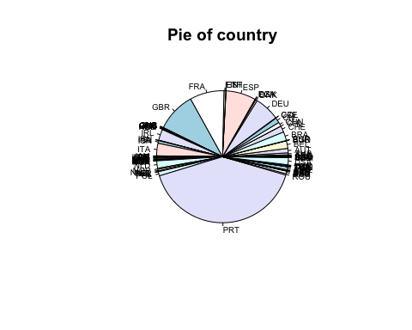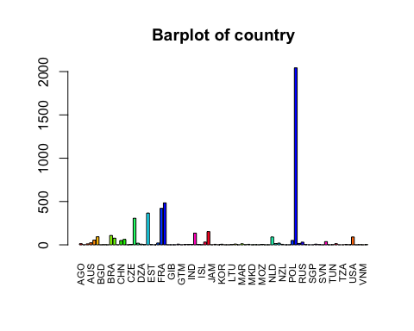

## [1] "Number of modalities: 86"  
## [1] "Frequency table"  
##   
## AGO ARE ARG AUS AUT BEL BGD BGR BHR BRA CHE CHL CHN CN COL CZE   
## 13 1 11 23 54 93 1 2 1 108 77 1 50 63 1 4   
## DEU DNK DZA EGY ESP EST ETH FIN FRA GBR GHA GIB GNB GRC GTM HRV   
## 307 19 8 3 367 3 1 21 421 484 1 1 1 8 1 4   
## HUN IND IRL IRN ISL ISR ITA JAM JPN KAZ KOR LBN LIE LTU LUX LVA   
## 5 5 135 4 2 32 153 1 6 1 7 1 1 3 9 1   
## MAR MDV MEX MKD MLT MNE MOZ MYS NGA NLD NOR NULL NZL PER PHL POL   
## 12 2 6 1 2 1 5 1 1 91 14 20 6 1 1 51   
## PRT ROU RUS SAU SEN SGP SRB SVK SVN SWE THA TUN TUR TWN TZA UKR   
## 2043 16 31 3 1 1 8 3 1 37 1 2 13 1 1 4   
## URY USA UZB VEN VNM ZAF   
## 2 91 1 2 1 3   
## [1] "Relative frequency table (proportions)"  
##   
## AGO ARE ARG AUS AUT BEL BGD BGR BHR BRA CHE   
## 0.0026 0.0002 0.0022 0.0046 0.0108 0.0186 0.0002 0.0004 0.0002 0.0216 0.0154   
## CHL CHN CN COL CZE DEU DNK DZA EGY ESP EST   
## 0.0002 0.0100 0.0126 0.0002 0.0008 0.0614 0.0038 0.0016 0.0006 0.0734 0.0006   
## ETH FIN FRA GBR GHA GIB GNB GRC GTM HRV HUN   
## 0.0002 0.0042 0.0842 0.0968 0.0002 0.0002 0.0002 0.0016 0.0002 0.0008 0.0010   
## IND IRL IRN ISL ISR ITA JAM JPN KAZ KOR LBN   
## 0.0010 0.0270 0.0008 0.0004 0.0064 0.0306 0.0002 0.0012 0.0002 0.0014 0.0002   
## LIE LTU LUX LVA MAR MDV MEX MKD MLT MNE MOZ   
## 0.0002 0.0006 0.0018 0.0002 0.0024 0.0004 0.0012 0.0002 0.0004 0.0002 0.0010   
## MYS NGA NLD NOR NULL NZL PER PHL POL PRT ROU   
## 0.0002 0.0002 0.0182 0.0028 0.0040 0.0012 0.0002 0.0002 0.0102 0.4086 0.0032   
## RUS SAU SEN SGP SRB SVK SVN SWE THA TUN TUR   
## 0.0062 0.0006 0.0002 0.0002 0.0016 0.0006 0.0002 0.0074 0.0002 0.0004 0.0026   
## TWN TZA UKR URY USA UZB VEN VNM ZAF   
## 0.0002 0.0002 0.0008 0.0004 0.0182 0.0002 0.0004 0.0002 0.0006   
## [1] "Frequency table sorted"  
##   
## PRT GBR FRA ESP DEU ITA IRL BRA BEL NLD USA CHE CN AUT POL CHN   
## 2043 484 421 367 307 153 135 108 93 91 91 77 63 54 51 50   
## SWE ISR RUS AUS FIN NULL DNK ROU NOR AGO TUR MAR ARG LUX DZA GRC   
## 37 32 31 23 21 20 19 16 14 13 13 12 11 9 8 8   
## SRB KOR JPN MEX NZL HUN IND MOZ CZE HRV IRN UKR EGY EST LTU SAU   
## 8 7 6 6 6 5 5 5 4 4 4 4 3 3 3 3   
## SVK ZAF BGR ISL MDV MLT TUN URY VEN ARE BGD BHR CHL COL ETH GHA   
## 3 3 2 2 2 2 2 2 2 1 1 1 1 1 1 1   
## GIB GNB GTM JAM KAZ LBN LIE LVA MKD MNE MYS NGA PER PHL SEN SGP   
## 1 1 1 1 1 1 1 1 1 1 1 1 1 1 1 1   
## SVN THA TWN TZA UZB VNM   
## 1 1 1 1 1 1   
## [1] "Relative frequency table (proportions) sorted"  
##   
## PRT GBR FRA ESP DEU ITA IRL BRA BEL NLD USA   
## 0.4086 0.0968 0.0842 0.0734 0.0614 0.0306 0.0270 0.0216 0.0186 0.0182 0.0182   
## CHE CN AUT POL CHN SWE ISR RUS AUS FIN NULL   
## 0.0154 0.0126 0.0108 0.0102 0.0100 0.0074 0.0064 0.0062 0.0046 0.0042 0.0040   
## DNK ROU NOR AGO TUR MAR ARG LUX DZA GRC SRB   
## 0.0038 0.0032 0.0028 0.0026 0.0026 0.0024 0.0022 0.0018 0.0016 0.0016 0.0016   
## KOR JPN MEX NZL HUN IND MOZ CZE HRV IRN UKR   
## 0.0014 0.0012 0.0012 0.0012 0.0010 0.0010 0.0010 0.0008 0.0008 0.0008 0.0008   
## EGY EST LTU SAU SVK ZAF BGR ISL MDV MLT TUN   
## 0.0006 0.0006 0.0006 0.0006 0.0006 0.0006 0.0004 0.0004 0.0004 0.0004 0.0004   
## URY VEN ARE BGD BHR CHL COL ETH GHA GIB GNB   
## 0.0004 0.0004 0.0002 0.0002 0.0002 0.0002 0.0002 0.0002 0.0002 0.0002 0.0002   
## GTM JAM KAZ LBN LIE LVA MKD MNE MYS NGA PER   
## 0.0002 0.0002 0.0002 0.0002 0.0002 0.0002 0.0002 0.0002 0.0002 0.0002 0.0002   
## PHL SEN SGP SVN THA TWN TZA UZB VNM   
## 0.0002 0.0002 0.0002 0.0002 0.0002 0.0002 0.0002 0.0002 0.0002   
## [1] "variable 15 : market_segment"

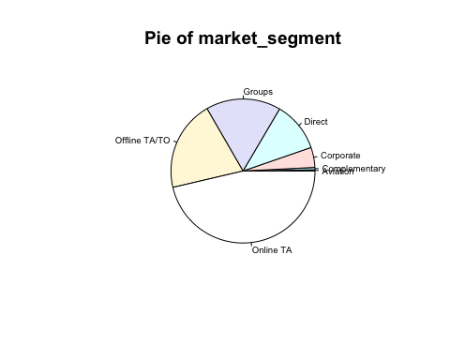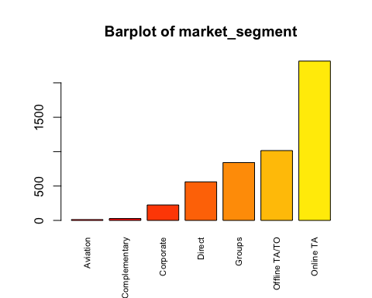

## [1] "Number of modalities: 7"  
## [1] "Frequency table"  
##   
## Aviation Complementary Corporate Direct Groups   
## 12 28 225 561 841   
## Offline TA/TO Online TA   
## 1016 2317   
## [1] "Relative frequency table (proportions)"  
##   
## Aviation Complementary Corporate Direct Groups   
## 0.0024 0.0056 0.0450 0.1122 0.1682   
## Offline TA/TO Online TA   
## 0.2032 0.4634   
## [1] "Frequency table sorted"  
##   
## Online TA Offline TA/TO Groups Direct Corporate   
## 2317 1016 841 561 225   
## Complementary Aviation   
## 28 12   
## [1] "Relative frequency table (proportions) sorted"  
##   
## Online TA Offline TA/TO Groups Direct Corporate   
## 0.4634 0.2032 0.1682 0.1122 0.0450   
## Complementary Aviation   
## 0.0056 0.0024   
## [1] "variable 16 : distribution_channel"

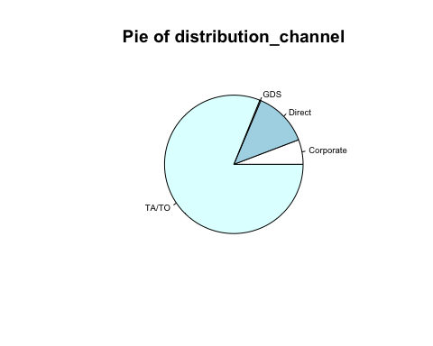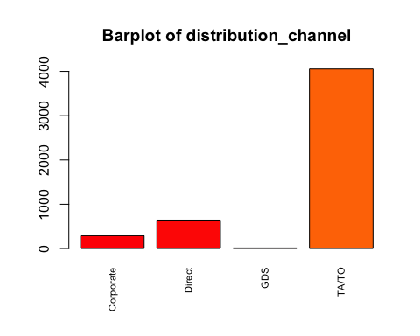

## [1] "Number of modalities: 4"  
## [1] "Frequency table"  
##   
## Corporate Direct GDS TA/TO   
## 289 643 12 4056   
## [1] "Relative frequency table (proportions)"  
##   
## Corporate Direct GDS TA/TO   
## 0.0578 0.1286 0.0024 0.8112   
## [1] "Frequency table sorted"  
##   
## TA/TO Direct Corporate GDS   
## 4056 643 289 12   
## [1] "Relative frequency table (proportions) sorted"  
##   
## TA/TO Direct Corporate GDS   
## 0.8112 0.1286 0.0578 0.0024   
## [1] "variable 17 : is_repeated_guest"

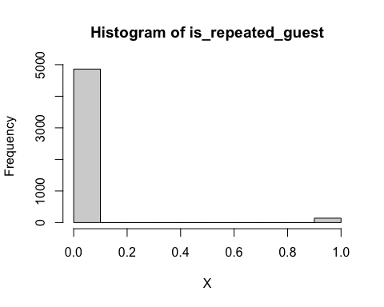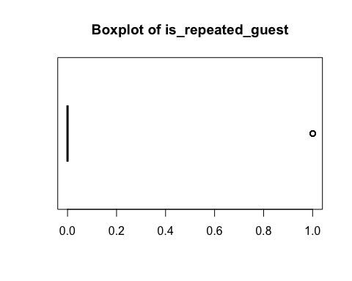

## [1] "Extended Summary Statistics"  
## Min. 1st Qu. Median Mean 3rd Qu. Max.   
## 0.0000 0.0000 0.0000 0.0278 0.0000 1.0000   
## [1] "sd: 0.164415834131943"  
## [1] "vc: 5.91423863783968"  
## [1] "variable 18 : previous_cancellations"

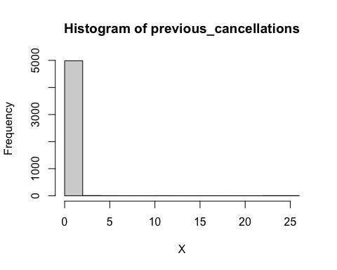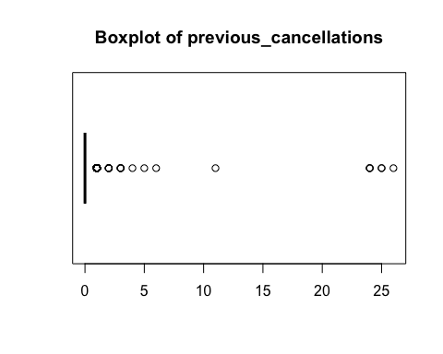

## [1] "Extended Summary Statistics"  
## Min. 1st Qu. Median Mean 3rd Qu. Max.   
## 0.00 0.00 0.00 0.09 0.00 26.00   
## [1] "sd: 0.908220773267491"  
## [1] "vc: 10.0913419251943"  
## [1] "variable 19 : previous_bookings_not_canceled"

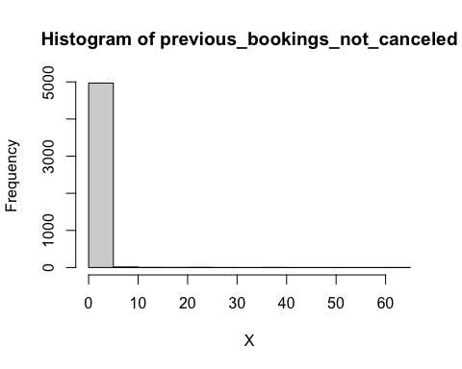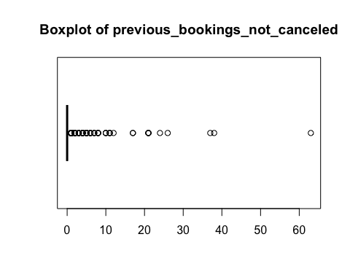

## [1] "Extended Summary Statistics"  
## Min. 1st Qu. Median Mean 3rd Qu. Max.   
## 0.000 0.000 0.000 0.137 0.000 63.000   
## [1] "sd: 1.56828661429629"  
## [1] "vc: 11.4473475496079"  
## [1] "variable 20 : reserved_room_type"

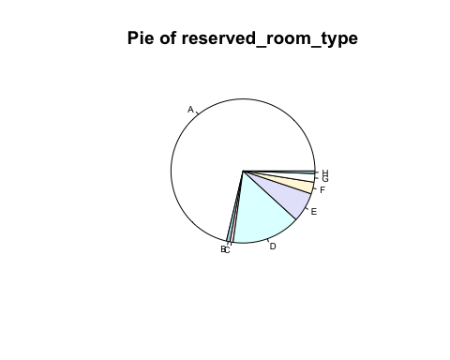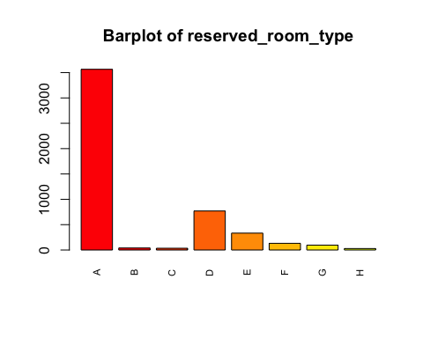

## [1] "Number of modalities: 8"  
## [1] "Frequency table"  
##   
## A B C D E F G H   
## 3565 40 35 770 333 132 96 29   
## [1] "Relative frequency table (proportions)"  
##   
## A B C D E F G H   
## 0.7130 0.0080 0.0070 0.1540 0.0666 0.0264 0.0192 0.0058   
## [1] "Frequency table sorted"  
##   
## A D E F G B C H   
## 3565 770 333 132 96 40 35 29   
## [1] "Relative frequency table (proportions) sorted"  
##   
## A D E F G B C H   
## 0.7130 0.1540 0.0666 0.0264 0.0192 0.0080 0.0070 0.0058   
## [1] "variable 21 : assigned_room_type"

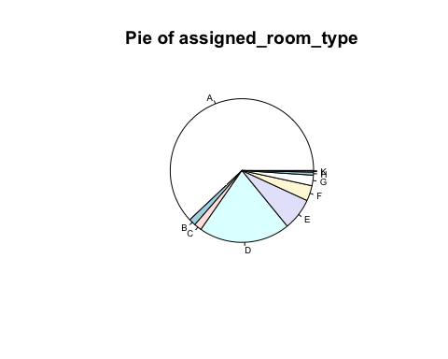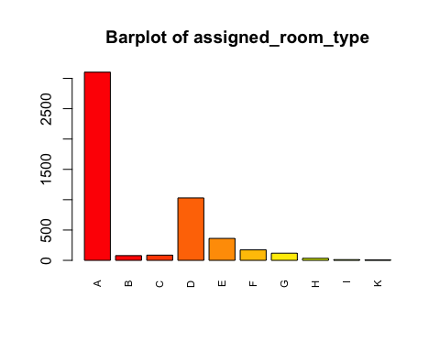

## [1] "Number of modalities: 10"  
## [1] "Frequency table"  
##   
## A B C D E F G H I K   
## 3102 78 86 1029 362 173 118 34 12 6   
## [1] "Relative frequency table (proportions)"  
##   
## A B C D E F G H I K   
## 0.6204 0.0156 0.0172 0.2058 0.0724 0.0346 0.0236 0.0068 0.0024 0.0012   
## [1] "Frequency table sorted"  
##   
## A D E F G C B H I K   
## 3102 1029 362 173 118 86 78 34 12 6   
## [1] "Relative frequency table (proportions) sorted"  
##   
## A D E F G C B H I K   
## 0.6204 0.2058 0.0724 0.0346 0.0236 0.0172 0.0156 0.0068 0.0024 0.0012   
## [1] "variable 22 : booking_changes"

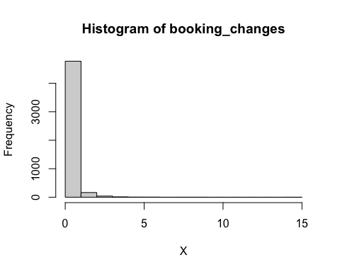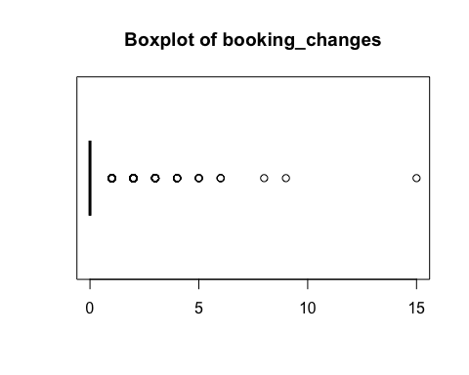

## [1] "Extended Summary Statistics"  
## Min. 1st Qu. Median Mean 3rd Qu. Max.   
## 0.0000 0.0000 0.0000 0.2114 0.0000 15.0000   
## [1] "sd: 0.638115568134534"  
## [1] "vc: 3.01852208199874"  
## [1] "variable 23 : deposit_type"

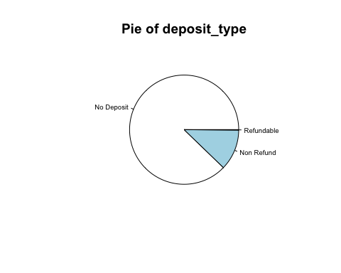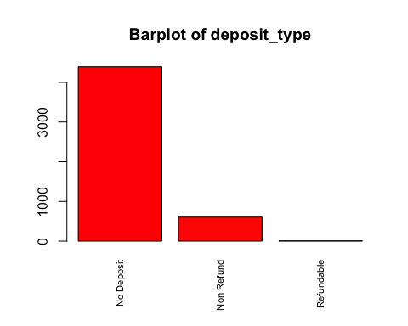

## [1] "Number of modalities: 3"  
## [1] "Frequency table"  
##   
## No Deposit Non Refund Refundable   
## 4389 605 6   
## [1] "Relative frequency table (proportions)"  
##   
## No Deposit Non Refund Refundable   
## 0.8778 0.1210 0.0012   
## [1] "Frequency table sorted"  
##   
## No Deposit Non Refund Refundable   
## 4389 605 6   
## [1] "Relative frequency table (proportions) sorted"  
##   
## No Deposit Non Refund Refundable   
## 0.8778 0.1210 0.0012   
## [1] "variable 24 : agent"

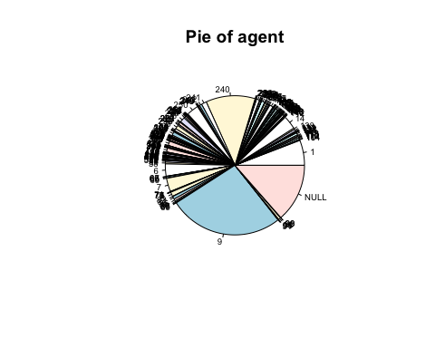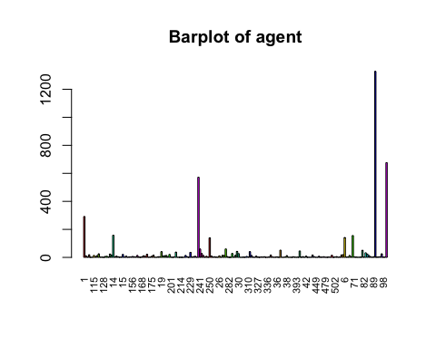

## [1] "Number of modalities: 189"  
## [1] "Frequency table"  
##   
## 1 10 104 11 111 112 115 118 119 12 121 126 128 13 132 133   
## 292 11 4 19 1 1 14 6 13 26 2 2 1 7 8 2   
## 134 138 14 142 143 146 147 149 15 151 152 153 154 155 156 157   
## 24 16 158 4 9 5 2 2 21 3 9 1 4 4 7 5   
## 159 16 162 167 168 17 170 171 173 174 175 177 181 183 184 185   
## 4 14 2 1 6 12 7 22 1 3 8 16 1 1 5 5   
## 19 191 195 196 2 20 201 205 208 21 210 213 214 215 219 22   
## 41 9 12 14 5 21 2 1 4 38 1 1 1 1 1 14   
## 220 223 229 23 234 236 24 240 241 242 243 245 248 249 250 251   
## 5 1 36 2 6 8 1 572 60 28 14 2 8 2 140 10   
## 252 253 254 257 26 262 27 273 28 281 282 286 29 296 298 3   
## 2 5 2 1 11 1 15 14 60 6 1 1 28 2 15 43   
## 30 305 306 307 308 31 310 314 315 323 325 326 327 328 33 330   
## 27 1 1 2 2 7 3 41 14 2 1 9 2 1 4 3   
## 332 334 336 339 34 35 350 359 36 368 37 371 375 378 38 385   
## 5 1 1 4 17 3 1 2 4 1 52 1 1 3 13 1   
## 387 388 39 390 393 394 40 41 410 411 42 423 430 436 44 440   
## 1 1 5 2 1 2 46 2 6 1 9 1 1 1 17 5   
## 449 459 464 467 468 47 479 492 495 497 5 50 502 52 53 531   
## 1 1 8 2 3 5 1 1 3 1 15 1 4 6 1 3   
## 56 58 6 66 67 68 69 7 71 74 75 77 79 8 82 83   
## 18 20 142 3 3 14 5 156 4 2 1 1 2 51 3 33   
## 85 86 87 88 89 9 91 94 95 96 98 99 NULL   
## 24 14 6 1 5 1328 2 4 5 26 2 3 676   
## [1] "Relative frequency table (proportions)"  
##   
## 1 10 104 11 111 112 115 118 119 12 121   
## 0.0584 0.0022 0.0008 0.0038 0.0002 0.0002 0.0028 0.0012 0.0026 0.0052 0.0004   
## 126 128 13 132 133 134 138 14 142 143 146   
## 0.0004 0.0002 0.0014 0.0016 0.0004 0.0048 0.0032 0.0316 0.0008 0.0018 0.0010   
## 147 149 15 151 152 153 154 155 156 157 159   
## 0.0004 0.0004 0.0042 0.0006 0.0018 0.0002 0.0008 0.0008 0.0014 0.0010 0.0008   
## 16 162 167 168 17 170 171 173 174 175 177   
## 0.0028 0.0004 0.0002 0.0012 0.0024 0.0014 0.0044 0.0002 0.0006 0.0016 0.0032   
## 181 183 184 185 19 191 195 196 2 20 201   
## 0.0002 0.0002 0.0010 0.0010 0.0082 0.0018 0.0024 0.0028 0.0010 0.0042 0.0004   
## 205 208 21 210 213 214 215 219 22 220 223   
## 0.0002 0.0008 0.0076 0.0002 0.0002 0.0002 0.0002 0.0002 0.0028 0.0010 0.0002   
## 229 23 234 236 24 240 241 242 243 245 248   
## 0.0072 0.0004 0.0012 0.0016 0.0002 0.1144 0.0120 0.0056 0.0028 0.0004 0.0016   
## 249 250 251 252 253 254 257 26 262 27 273   
## 0.0004 0.0280 0.0020 0.0004 0.0010 0.0004 0.0002 0.0022 0.0002 0.0030 0.0028   
## 28 281 282 286 29 296 298 3 30 305 306   
## 0.0120 0.0012 0.0002 0.0002 0.0056 0.0004 0.0030 0.0086 0.0054 0.0002 0.0002   
## 307 308 31 310 314 315 323 325 326 327 328   
## 0.0004 0.0004 0.0014 0.0006 0.0082 0.0028 0.0004 0.0002 0.0018 0.0004 0.0002   
## 33 330 332 334 336 339 34 35 350 359 36   
## 0.0008 0.0006 0.0010 0.0002 0.0002 0.0008 0.0034 0.0006 0.0002 0.0004 0.0008   
## 368 37 371 375 378 38 385 387 388 39 390   
## 0.0002 0.0104 0.0002 0.0002 0.0006 0.0026 0.0002 0.0002 0.0002 0.0010 0.0004   
## 393 394 40 41 410 411 42 423 430 436 44   
## 0.0002 0.0004 0.0092 0.0004 0.0012 0.0002 0.0018 0.0002 0.0002 0.0002 0.0034   
## 440 449 459 464 467 468 47 479 492 495 497   
## 0.0010 0.0002 0.0002 0.0016 0.0004 0.0006 0.0010 0.0002 0.0002 0.0006 0.0002   
## 5 50 502 52 53 531 56 58 6 66 67   
## 0.0030 0.0002 0.0008 0.0012 0.0002 0.0006 0.0036 0.0040 0.0284 0.0006 0.0006   
## 68 69 7 71 74 75 77 79 8 82 83   
## 0.0028 0.0010 0.0312 0.0008 0.0004 0.0002 0.0002 0.0004 0.0102 0.0006 0.0066   
## 85 86 87 88 89 9 91 94 95 96 98   
## 0.0048 0.0028 0.0012 0.0002 0.0010 0.2656 0.0004 0.0008 0.0010 0.0052 0.0004   
## 99 NULL   
## 0.0006 0.1352   
## [1] "Frequency table sorted"  
##   
## 9 NULL 240 1 14 7 6 250 241 28 37 8 40 3 19 314   
## 1328 676 572 292 158 156 142 140 60 60 52 51 46 43 41 41   
## 21 229 83 242 29 30 12 96 134 85 171 15 20 58 11 56   
## 38 36 33 28 28 27 26 26 24 24 22 21 21 20 19 18   
## 34 44 138 177 27 298 5 115 16 196 22 243 273 315 68 86   
## 17 17 16 16 15 15 15 14 14 14 14 14 14 14 14 14   
## 119 38 17 195 10 26 251 143 152 191 326 42 132 175 236 248   
## 13 13 12 12 11 11 10 9 9 9 9 9 8 8 8 8   
## 464 13 156 170 31 118 168 234 281 410 52 87 146 157 184 185   
## 8 7 7 7 7 6 6 6 6 6 6 6 5 5 5 5   
## 2 220 253 332 39 440 47 69 89 95 104 142 154 155 159 208   
## 5 5 5 5 5 5 5 5 5 5 4 4 4 4 4 4   
## 33 339 36 502 71 94 151 174 310 330 35 378 468 495 531 66   
## 4 4 4 4 4 4 3 3 3 3 3 3 3 3 3 3   
## 67 82 99 121 126 133 147 149 162 201 23 245 249 252 254 296   
## 3 3 3 2 2 2 2 2 2 2 2 2 2 2 2 2   
## 307 308 323 327 359 390 394 41 467 74 79 91 98 111 112 128   
## 2 2 2 2 2 2 2 2 2 2 2 2 2 1 1 1   
## 153 167 173 181 183 205 210 213 214 215 219 223 24 257 262 282   
## 1 1 1 1 1 1 1 1 1 1 1 1 1 1 1 1   
## 286 305 306 325 328 334 336 350 368 371 375 385 387 388 393 411   
## 1 1 1 1 1 1 1 1 1 1 1 1 1 1 1 1   
## 423 430 436 449 459 479 492 497 50 53 75 77 88   
## 1 1 1 1 1 1 1 1 1 1 1 1 1   
## [1] "Relative frequency table (proportions) sorted"  
##   
## 9 NULL 240 1 14 7 6 250 241 28 37   
## 0.2656 0.1352 0.1144 0.0584 0.0316 0.0312 0.0284 0.0280 0.0120 0.0120 0.0104   
## 8 40 3 19 314 21 229 83 242 29 30   
## 0.0102 0.0092 0.0086 0.0082 0.0082 0.0076 0.0072 0.0066 0.0056 0.0056 0.0054   
## 12 96 134 85 171 15 20 58 11 56 34   
## 0.0052 0.0052 0.0048 0.0048 0.0044 0.0042 0.0042 0.0040 0.0038 0.0036 0.0034   
## 44 138 177 27 298 5 115 16 196 22 243   
## 0.0034 0.0032 0.0032 0.0030 0.0030 0.0030 0.0028 0.0028 0.0028 0.0028 0.0028   
## 273 315 68 86 119 38 17 195 10 26 251   
## 0.0028 0.0028 0.0028 0.0028 0.0026 0.0026 0.0024 0.0024 0.0022 0.0022 0.0020   
## 143 152 191 326 42 132 175 236 248 464 13   
## 0.0018 0.0018 0.0018 0.0018 0.0018 0.0016 0.0016 0.0016 0.0016 0.0016 0.0014   
## 156 170 31 118 168 234 281 410 52 87 146   
## 0.0014 0.0014 0.0014 0.0012 0.0012 0.0012 0.0012 0.0012 0.0012 0.0012 0.0010   
## 157 184 185 2 220 253 332 39 440 47 69   
## 0.0010 0.0010 0.0010 0.0010 0.0010 0.0010 0.0010 0.0010 0.0010 0.0010 0.0010   
## 89 95 104 142 154 155 159 208 33 339 36   
## 0.0010 0.0010 0.0008 0.0008 0.0008 0.0008 0.0008 0.0008 0.0008 0.0008 0.0008   
## 502 71 94 151 174 310 330 35 378 468 495   
## 0.0008 0.0008 0.0008 0.0006 0.0006 0.0006 0.0006 0.0006 0.0006 0.0006 0.0006   
## 531 66 67 82 99 121 126 133 147 149 162   
## 0.0006 0.0006 0.0006 0.0006 0.0006 0.0004 0.0004 0.0004 0.0004 0.0004 0.0004   
## 201 23 245 249 252 254 296 307 308 323 327   
## 0.0004 0.0004 0.0004 0.0004 0.0004 0.0004 0.0004 0.0004 0.0004 0.0004 0.0004   
## 359 390 394 41 467 74 79 91 98 111 112   
## 0.0004 0.0004 0.0004 0.0004 0.0004 0.0004 0.0004 0.0004 0.0004 0.0002 0.0002   
## 128 153 167 173 181 183 205 210 213 214 215   
## 0.0002 0.0002 0.0002 0.0002 0.0002 0.0002 0.0002 0.0002 0.0002 0.0002 0.0002   
## 219 223 24 257 262 282 286 305 306 325 328   
## 0.0002 0.0002 0.0002 0.0002 0.0002 0.0002 0.0002 0.0002 0.0002 0.0002 0.0002   
## 334 336 350 368 371 375 385 387 388 393 411   
## 0.0002 0.0002 0.0002 0.0002 0.0002 0.0002 0.0002 0.0002 0.0002 0.0002 0.0002   
## 423 430 436 449 459 479 492 497 50 53 75   
## 0.0002 0.0002 0.0002 0.0002 0.0002 0.0002 0.0002 0.0002 0.0002 0.0002 0.0002   
## 77 88   
## 0.0002 0.0002   
## [1] "variable 25 : company"

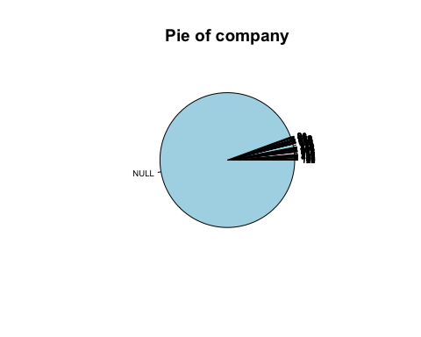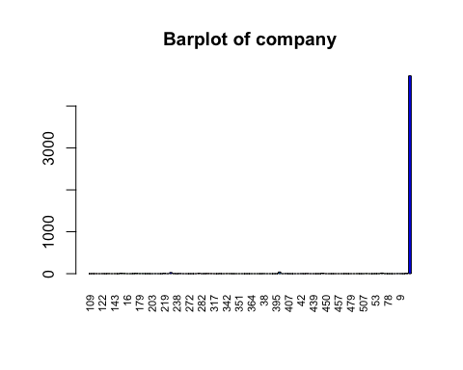

## [1] "Number of modalities: 104"  
## [1] "Frequency table"  
##   
## 109 110 113 12 122 130 135 142 143 148 153 154 16 165 169 174   
## 1 2 2 1 2 1 3 1 2 1 11 5 1 1 3 6   
## 179 197 20 202 203 207 216 217 219 221 223 233 238 242 263 269   
## 3 3 2 2 1 2 1 1 7 1 27 3 1 4 1 1   
## 272 28 280 281 282 286 307 308 317 329 331 337 342 343 346 348   
## 1 1 1 8 1 2 4 3 1 1 3 1 3 2 1 1   
## 351 355 356 358 364 367 37 379 38 380 385 388 395 40 401 405   
## 1 1 1 1 1 1 1 1 2 1 1 1 1 40 1 3   
## 407 408 409 412 42 424 43 435 439 443 448 45 450 451 452 455   
## 1 1 1 1 2 1 4 1 1 1 1 11 1 1 1 1   
## 457 458 47 477 479 481 485 498 507 51 513 525 53 62 67 72   
## 1 1 2 1 1 1 2 1 1 4 1 1 2 2 15 2   
## 78 82 85 86 9 91 94 NULL   
## 1 1 1 3 2 1 7 4721   
## [1] "Relative frequency table (proportions)"  
##   
## 109 110 113 12 122 130 135 142 143 148 153   
## 0.0002 0.0004 0.0004 0.0002 0.0004 0.0002 0.0006 0.0002 0.0004 0.0002 0.0022   
## 154 16 165 169 174 179 197 20 202 203 207   
## 0.0010 0.0002 0.0002 0.0006 0.0012 0.0006 0.0006 0.0004 0.0004 0.0002 0.0004   
## 216 217 219 221 223 233 238 242 263 269 272   
## 0.0002 0.0002 0.0014 0.0002 0.0054 0.0006 0.0002 0.0008 0.0002 0.0002 0.0002   
## 28 280 281 282 286 307 308 317 329 331 337   
## 0.0002 0.0002 0.0016 0.0002 0.0004 0.0008 0.0006 0.0002 0.0002 0.0006 0.0002   
## 342 343 346 348 351 355 356 358 364 367 37   
## 0.0006 0.0004 0.0002 0.0002 0.0002 0.0002 0.0002 0.0002 0.0002 0.0002 0.0002   
## 379 38 380 385 388 395 40 401 405 407 408   
## 0.0002 0.0004 0.0002 0.0002 0.0002 0.0002 0.0080 0.0002 0.0006 0.0002 0.0002   
## 409 412 42 424 43 435 439 443 448 45 450   
## 0.0002 0.0002 0.0004 0.0002 0.0008 0.0002 0.0002 0.0002 0.0002 0.0022 0.0002   
## 451 452 455 457 458 47 477 479 481 485 498   
## 0.0002 0.0002 0.0002 0.0002 0.0002 0.0004 0.0002 0.0002 0.0002 0.0004 0.0002   
## 507 51 513 525 53 62 67 72 78 82 85   
## 0.0002 0.0008 0.0002 0.0002 0.0004 0.0004 0.0030 0.0004 0.0002 0.0002 0.0002   
## 86 9 91 94 NULL   
## 0.0006 0.0004 0.0002 0.0014 0.9442   
## [1] "Frequency table sorted"  
##   
## NULL 40 223 67 153 45 281 219 94 174 154 242 307 43 51 135   
## 4721 40 27 15 11 11 8 7 7 6 5 4 4 4 4 3   
## 169 179 197 233 308 331 342 405 86 110 113 122 143 20 202 207   
## 3 3 3 3 3 3 3 3 3 2 2 2 2 2 2 2   
## 286 343 38 42 47 485 53 62 72 9 109 12 130 142 148 16   
## 2 2 2 2 2 2 2 2 2 2 1 1 1 1 1 1   
## 165 203 216 217 221 238 263 269 272 28 280 282 317 329 337 346   
## 1 1 1 1 1 1 1 1 1 1 1 1 1 1 1 1   
## 348 351 355 356 358 364 367 37 379 380 385 388 395 401 407 408   
## 1 1 1 1 1 1 1 1 1 1 1 1 1 1 1 1   
## 409 412 424 435 439 443 448 450 451 452 455 457 458 477 479 481   
## 1 1 1 1 1 1 1 1 1 1 1 1 1 1 1 1   
## 498 507 513 525 78 82 85 91   
## 1 1 1 1 1 1 1 1   
## [1] "Relative frequency table (proportions) sorted"  
##   
## NULL 40 223 67 153 45 281 219 94 174 154   
## 0.9442 0.0080 0.0054 0.0030 0.0022 0.0022 0.0016 0.0014 0.0014 0.0012 0.0010   
## 242 307 43 51 135 169 179 197 233 308 331   
## 0.0008 0.0008 0.0008 0.0008 0.0006 0.0006 0.0006 0.0006 0.0006 0.0006 0.0006   
## 342 405 86 110 113 122 143 20 202 207 286   
## 0.0006 0.0006 0.0006 0.0004 0.0004 0.0004 0.0004 0.0004 0.0004 0.0004 0.0004   
## 343 38 42 47 485 53 62 72 9 109 12   
## 0.0004 0.0004 0.0004 0.0004 0.0004 0.0004 0.0004 0.0004 0.0004 0.0002 0.0002   
## 130 142 148 16 165 203 216 217 221 238 263   
## 0.0002 0.0002 0.0002 0.0002 0.0002 0.0002 0.0002 0.0002 0.0002 0.0002 0.0002   
## 269 272 28 280 282 317 329 337 346 348 351   
## 0.0002 0.0002 0.0002 0.0002 0.0002 0.0002 0.0002 0.0002 0.0002 0.0002 0.0002   
## 355 356 358 364 367 37 379 380 385 388 395   
## 0.0002 0.0002 0.0002 0.0002 0.0002 0.0002 0.0002 0.0002 0.0002 0.0002 0.0002   
## 401 407 408 409 412 424 435 439 443 448 450   
## 0.0002 0.0002 0.0002 0.0002 0.0002 0.0002 0.0002 0.0002 0.0002 0.0002 0.0002   
## 451 452 455 457 458 477 479 481 498 507 513   
## 0.0002 0.0002 0.0002 0.0002 0.0002 0.0002 0.0002 0.0002 0.0002 0.0002 0.0002   
## 525 78 82 85 91   
## 0.0002 0.0002 0.0002 0.0002 0.0002   
## [1] "variable 26 : days_in_waiting_list"

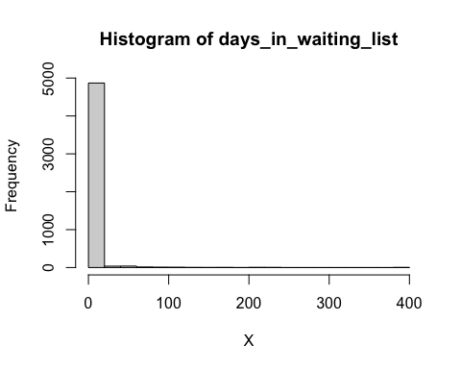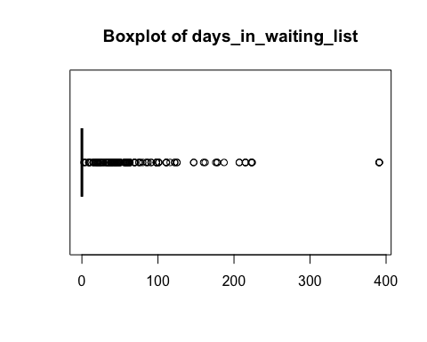

## [1] "Extended Summary Statistics"  
## Min. 1st Qu. Median Mean 3rd Qu. Max.   
## 0.000 0.000 0.000 2.285 0.000 391.000   
## [1] "sd: 18.3618433829091"  
## [1] "vc: 8.03511438075841"  
## [1] "variable 27 : customer_type"

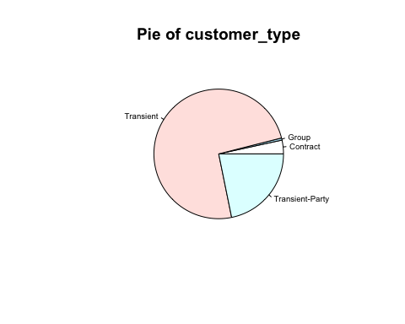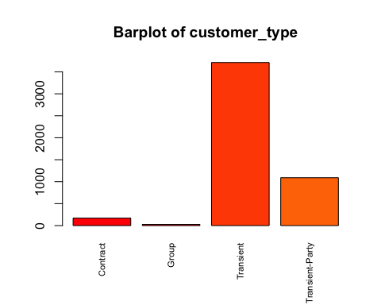

## [1] "Number of modalities: 4"  
## [1] "Frequency table"  
##   
## Contract Group Transient Transient-Party   
## 171 27 3712 1090   
## [1] "Relative frequency table (proportions)"  
##   
## Contract Group Transient Transient-Party   
## 0.0342 0.0054 0.7424 0.2180   
## [1] "Frequency table sorted"  
##   
## Transient Transient-Party Contract Group   
## 3712 1090 171 27   
## [1] "Relative frequency table (proportions) sorted"  
##   
## Transient Transient-Party Contract Group   
## 0.7424 0.2180 0.0342 0.0054   
## [1] "variable 28 : adr"

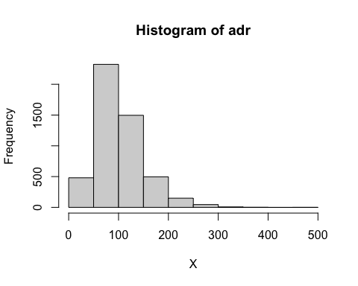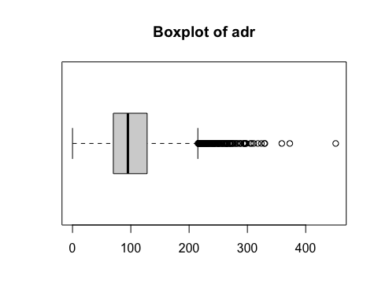

## [1] "Extended Summary Statistics"  
## Min. 1st Qu. Median Mean 3rd Qu. Max.   
## 0.0 70.0 95.0 102.7 128.0 451.5   
## [1] "sd: 48.0999813579638"  
## [1] "vc: 0.468546740818426"  
## [1] "variable 29 : required_car_parking_spaces"

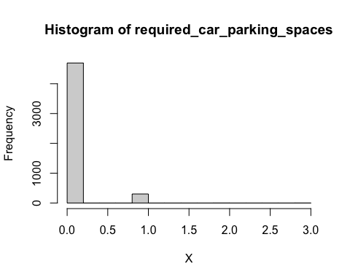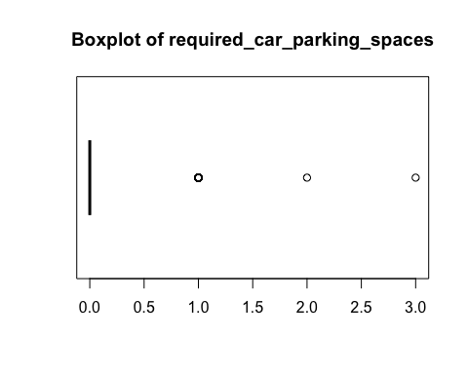

## [1] "Extended Summary Statistics"  
## Min. 1st Qu. Median Mean 3rd Qu. Max.   
## 0.0000 0.0000 0.0000 0.0616 0.0000 3.0000   
## [1] "sd: 0.243756689066563"  
## [1] "vc: 3.95708910822342"  
## [1] "variable 30 : total_of_special_requests"

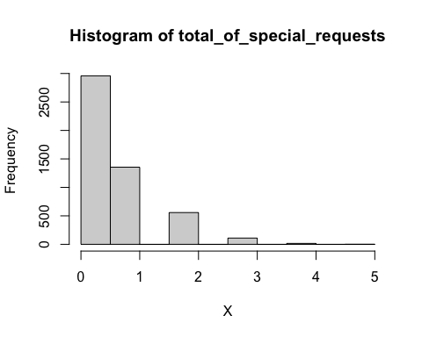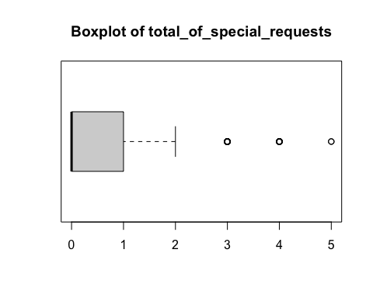

## [1] "Extended Summary Statistics"  
## Min. 1st Qu. Median Mean 3rd Qu. Max.   
## 0.000 0.000 0.000 0.575 1.000 5.000   
## [1] "sd: 0.803806084104972"  
## [1] "vc: 1.39792362453039"  
## [1] "variable 31 : reservation_status"

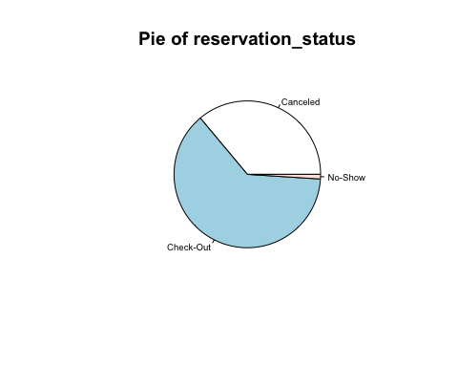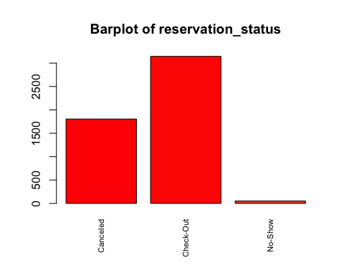

## [1] "Number of modalities: 3"  
## [1] "Frequency table"  
##   
## Canceled Check-Out No-Show   
## 1805 3144 51   
## [1] "Relative frequency table (proportions)"  
##   
## Canceled Check-Out No-Show   
## 0.3610 0.6288 0.0102   
## [1] "Frequency table sorted"  
##   
## Check-Out Canceled No-Show   
## 3144 1805 51   
## [1] "Relative frequency table (proportions) sorted"  
##   
## Check-Out Canceled No-Show   
## 0.6288 0.3610 0.0102   
## [1] "variable 32 : reservation_status_date"

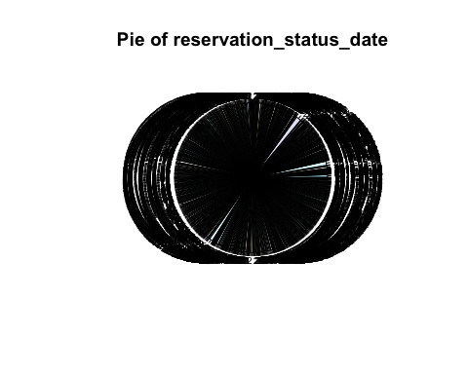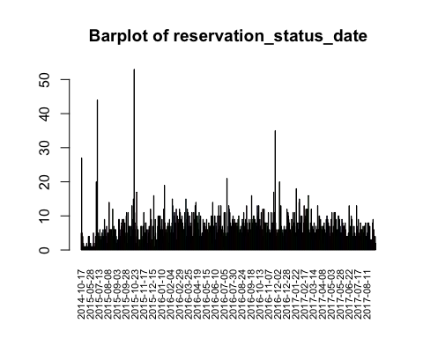

## [1] "Number of modalities: 825"  
## [1] "Frequency table"  
##   
## 2014-10-17 2015-01-01 2015-01-21 2015-01-22 2015-01-30 2015-02-19 2015-03-03   
## 5 27 5 1 4 1 2   
## 2015-03-25 2015-04-03 2015-04-05 2015-04-06 2015-04-11 2015-04-13 2015-04-14   
## 1 1 1 1 1 1 1   
## 2015-04-15 2015-04-28 2015-04-29 2015-05-06 2015-05-09 2015-05-13 2015-05-14   
## 1 2 1 1 1 1 4   
## 2015-05-18 2015-05-19 2015-05-20 2015-05-27 2015-05-28 2015-05-29 2015-06-01   
## 2 4 2 1 1 2 1   
## 2015-06-08 2015-06-09 2015-06-12 2015-06-13 2015-06-15 2015-06-16 2015-06-17   
## 1 1 1 1 1 2 5   
## 2015-06-19 2015-06-23 2015-06-25 2015-06-26 2015-06-27 2015-06-29 2015-06-30   
## 1 1 1 1 2 4 2   
## 2015-07-02 2015-07-03 2015-07-04 2015-07-06 2015-07-08 2015-07-09 2015-07-10   
## 20 12 1 44 4 2 5   
## 2015-07-12 2015-07-13 2015-07-14 2015-07-15 2015-07-16 2015-07-17 2015-07-18   
## 2 3 4 6 2 3 3   
## 2015-07-19 2015-07-20 2015-07-22 2015-07-23 2015-07-24 2015-07-25 2015-07-26   
## 4 3 5 4 2 6 4   
## 2015-07-27 2015-07-28 2015-07-29 2015-07-30 2015-07-31 2015-08-01 2015-08-02   
## 1 2 9 3 6 5 2   
## 2015-08-03 2015-08-04 2015-08-05 2015-08-06 2015-08-07 2015-08-08 2015-08-09   
## 4 7 2 1 5 4 4   
## 2015-08-10 2015-08-11 2015-08-12 2015-08-13 2015-08-14 2015-08-15 2015-08-16   
## 5 14 6 4 6 4 6   
## 2015-08-17 2015-08-18 2015-08-19 2015-08-20 2015-08-21 2015-08-22 2015-08-23   
## 6 4 4 3 12 6 3   
## 2015-08-24 2015-08-25 2015-08-26 2015-08-27 2015-08-28 2015-08-29 2015-08-30   
## 7 6 2 6 2 6 3   
## 2015-08-31 2015-09-01 2015-09-03 2015-09-04 2015-09-05 2015-09-06 2015-09-07   
## 4 2 2 3 2 3 3   
## 2015-09-08 2015-09-09 2015-09-10 2015-09-11 2015-09-12 2015-09-13 2015-09-14   
## 9 9 5 6 4 4 2   
## 2015-09-15 2015-09-16 2015-09-17 2015-09-18 2015-09-19 2015-09-20 2015-09-21   
## 7 8 3 9 3 6 9   
## 2015-09-22 2015-09-23 2015-09-24 2015-09-25 2015-09-26 2015-09-27 2015-09-28   
## 9 6 6 8 2 4 5   
## 2015-09-29 2015-09-30 2015-10-01 2015-10-02 2015-10-03 2015-10-04 2015-10-05   
## 10 11 1 2 5 11 7   
## 2015-10-06 2015-10-07 2015-10-08 2015-10-09 2015-10-10 2015-10-11 2015-10-12   
## 7 3 6 6 7 4 4   
## 2015-10-13 2015-10-14 2015-10-15 2015-10-16 2015-10-17 2015-10-18 2015-10-19   
## 7 4 13 6 1 9 15   
## 2015-10-20 2015-10-21 2015-10-22 2015-10-23 2015-10-24 2015-10-25 2015-10-26   
## 8 53 11 8 6 4 2   
## 2015-10-27 2015-10-28 2015-10-29 2015-10-30 2015-10-31 2015-11-01 2015-11-02   
## 2 17 7 3 4 6 1   
## 2015-11-03 2015-11-04 2015-11-05 2015-11-06 2015-11-07 2015-11-08 2015-11-09   
## 1 3 1 3 3 3 7   
## 2015-11-10 2015-11-11 2015-11-12 2015-11-13 2015-11-14 2015-11-15 2015-11-16   
## 2 7 3 2 4 7 7   
## 2015-11-17 2015-11-18 2015-11-19 2015-11-20 2015-11-21 2015-11-22 2015-11-23   
## 11 3 1 5 3 8 8   
## 2015-11-24 2015-11-25 2015-11-26 2015-11-27 2015-11-28 2015-11-29 2015-11-30   
## 2 1 6 2 1 6 4   
## 2015-12-02 2015-12-03 2015-12-04 2015-12-05 2015-12-07 2015-12-08 2015-12-09   
## 5 7 4 2 2 12 3   
## 2015-12-10 2015-12-11 2015-12-13 2015-12-14 2015-12-15 2015-12-16 2015-12-17   
## 9 3 1 3 7 1 4   
## 2015-12-18 2015-12-19 2015-12-20 2015-12-21 2015-12-22 2015-12-23 2015-12-24   
## 16 4 1 1 9 5 1   
## 2015-12-25 2015-12-26 2015-12-27 2015-12-28 2015-12-29 2015-12-30 2016-01-01   
## 2 3 3 3 7 10 6   
## 2016-01-02 2016-01-03 2016-01-04 2016-01-05 2016-01-06 2016-01-07 2016-01-08   
## 6 10 1 8 10 3 6   
## 2016-01-09 2016-01-10 2016-01-11 2016-01-12 2016-01-13 2016-01-14 2016-01-15   
## 3 7 9 1 6 2 4   
## 2016-01-16 2016-01-17 2016-01-18 2016-01-19 2016-01-20 2016-01-21 2016-01-22   
## 12 4 19 8 5 5 6   
## 2016-01-23 2016-01-24 2016-01-25 2016-01-26 2016-01-27 2016-01-28 2016-01-29   
## 1 5 5 7 3 8 7   
## 2016-01-30 2016-01-31 2016-02-01 2016-02-02 2016-02-03 2016-02-04 2016-02-05   
## 2 2 9 4 4 5 7   
## 2016-02-06 2016-02-07 2016-02-08 2016-02-09 2016-02-10 2016-02-11 2016-02-12   
## 5 6 8 15 13 5 4   
## 2016-02-13 2016-02-14 2016-02-15 2016-02-16 2016-02-17 2016-02-18 2016-02-19   
## 5 10 11 8 5 8 3   
## 2016-02-20 2016-02-21 2016-02-22 2016-02-23 2016-02-24 2016-02-25 2016-02-26   
## 12 3 3 10 3 9 8   
## 2016-02-27 2016-02-28 2016-02-29 2016-03-01 2016-03-02 2016-03-03 2016-03-04   
## 3 8 12 8 11 7 9   
## 2016-03-05 2016-03-06 2016-03-07 2016-03-08 2016-03-09 2016-03-10 2016-03-11   
## 5 8 10 5 8 5 5   
## 2016-03-12 2016-03-13 2016-03-14 2016-03-15 2016-03-16 2016-03-17 2016-03-18   
## 6 6 7 11 8 6 15   
## 2016-03-19 2016-03-20 2016-03-21 2016-03-22 2016-03-23 2016-03-24 2016-03-25   
## 3 4 9 12 9 11 2   
## 2016-03-26 2016-03-27 2016-03-28 2016-03-29 2016-03-30 2016-03-31 2016-04-01   
## 4 7 10 4 8 7 4   
## 2016-04-02 2016-04-03 2016-04-04 2016-04-05 2016-04-06 2016-04-07 2016-04-08   
## 2 8 11 4 2 3 4   
## 2016-04-09 2016-04-10 2016-04-11 2016-04-12 2016-04-13 2016-04-14 2016-04-15   
## 11 5 9 7 13 4 14   
## 2016-04-16 2016-04-17 2016-04-18 2016-04-19 2016-04-20 2016-04-21 2016-04-22   
## 3 10 4 10 5 8 4   
## 2016-04-23 2016-04-24 2016-04-25 2016-04-26 2016-04-27 2016-04-28 2016-04-29   
## 6 11 4 2 9 10 4   
## 2016-04-30 2016-05-02 2016-05-03 2016-05-04 2016-05-05 2016-05-06 2016-05-07   
## 4 4 5 5 5 9 3   
## 2016-05-08 2016-05-09 2016-05-10 2016-05-11 2016-05-12 2016-05-13 2016-05-14   
## 4 7 8 8 7 4 6   
## 2016-05-15 2016-05-16 2016-05-17 2016-05-18 2016-05-19 2016-05-20 2016-05-21   
## 5 9 6 5 6 5 5   
## 2016-05-22 2016-05-23 2016-05-24 2016-05-25 2016-05-26 2016-05-27 2016-05-28   
## 8 5 7 7 7 5 2   
## 2016-05-29 2016-05-30 2016-05-31 2016-06-01 2016-06-02 2016-06-03 2016-06-04   
## 10 10 7 2 14 6 7   
## 2016-06-05 2016-06-06 2016-06-08 2016-06-09 2016-06-10 2016-06-11 2016-06-12   
## 7 6 10 10 3 1 8   
## 2016-06-13 2016-06-14 2016-06-15 2016-06-16 2016-06-17 2016-06-18 2016-06-19   
## 7 5 5 5 10 6 4   
## 2016-06-20 2016-06-21 2016-06-22 2016-06-23 2016-06-24 2016-06-25 2016-06-26   
## 13 5 10 7 6 1 13   
## 2016-06-27 2016-06-28 2016-06-29 2016-06-30 2016-07-01 2016-07-02 2016-07-03   
## 4 6 4 7 6 5 4   
## 2016-07-04 2016-07-05 2016-07-06 2016-07-07 2016-07-08 2016-07-09 2016-07-10   
## 1 11 5 6 11 5 4   
## 2016-07-11 2016-07-12 2016-07-13 2016-07-14 2016-07-15 2016-07-16 2016-07-17   
## 3 4 21 5 4 5 7   
## 2016-07-18 2016-07-19 2016-07-20 2016-07-21 2016-07-22 2016-07-23 2016-07-24   
## 13 12 3 11 5 8 6   
## 2016-07-25 2016-07-26 2016-07-27 2016-07-28 2016-07-29 2016-07-30 2016-07-31   
## 7 3 3 9 7 10 2   
## 2016-08-01 2016-08-02 2016-08-03 2016-08-04 2016-08-05 2016-08-06 2016-08-07   
## 6 8 9 7 5 8 1   
## 2016-08-08 2016-08-09 2016-08-10 2016-08-11 2016-08-12 2016-08-13 2016-08-14   
## 7 4 8 7 6 9 7   
## 2016-08-15 2016-08-16 2016-08-17 2016-08-18 2016-08-19 2016-08-20 2016-08-21   
## 10 5 1 6 5 6 7   
## 2016-08-22 2016-08-23 2016-08-24 2016-08-25 2016-08-26 2016-08-27 2016-08-28   
## 4 3 5 9 8 8 6   
## 2016-08-29 2016-08-30 2016-08-31 2016-09-01 2016-09-02 2016-09-03 2016-09-04   
## 11 4 6 7 8 9 4   
## 2016-09-05 2016-09-06 2016-09-07 2016-09-08 2016-09-09 2016-09-10 2016-09-11   
## 6 13 2 8 6 5 4   
## 2016-09-12 2016-09-13 2016-09-14 2016-09-15 2016-09-16 2016-09-17 2016-09-18   
## 4 9 4 8 5 4 6   
## 2016-09-19 2016-09-20 2016-09-21 2016-09-22 2016-09-23 2016-09-24 2016-09-25   
## 9 16 9 7 8 3 10   
## 2016-09-26 2016-09-27 2016-09-28 2016-09-29 2016-09-30 2016-10-01 2016-10-02   
## 10 7 9 9 5 8 6   
## 2016-10-03 2016-10-04 2016-10-05 2016-10-06 2016-10-07 2016-10-08 2016-10-09   
## 8 7 4 13 10 6 11   
## 2016-10-10 2016-10-11 2016-10-12 2016-10-13 2016-10-14 2016-10-15 2016-10-16   
## 13 6 6 9 7 7 7   
## 2016-10-17 2016-10-18 2016-10-19 2016-10-20 2016-10-21 2016-10-22 2016-10-23   
## 11 6 3 6 12 4 3   
## 2016-10-24 2016-10-25 2016-10-26 2016-10-27 2016-10-28 2016-10-29 2016-10-30   
## 6 12 8 8 8 8 4   
## 2016-10-31 2016-11-01 2016-11-02 2016-11-03 2016-11-04 2016-11-05 2016-11-06   
## 4 5 8 3 7 6 11   
## 2016-11-07 2016-11-08 2016-11-09 2016-11-10 2016-11-11 2016-11-12 2016-11-13   
## 6 1 6 4 5 3 5   
## 2016-11-14 2016-11-15 2016-11-16 2016-11-17 2016-11-18 2016-11-19 2016-11-20   
## 11 3 6 8 8 3 11   
## 2016-11-21 2016-11-22 2016-11-23 2016-11-24 2016-11-25 2016-11-26 2016-11-27   
## 17 7 7 11 35 8 6   
## 2016-11-28 2016-11-29 2016-11-30 2016-12-01 2016-12-02 2016-12-03 2016-12-04   
## 4 4 1 5 6 4 5   
## 2016-12-05 2016-12-06 2016-12-07 2016-12-08 2016-12-09 2016-12-11 2016-12-12   
## 3 6 20 4 11 12 13   
## 2016-12-13 2016-12-14 2016-12-15 2016-12-16 2016-12-17 2016-12-18 2016-12-19   
## 7 6 6 5 5 3 4   
## 2016-12-20 2016-12-21 2016-12-22 2016-12-23 2016-12-24 2016-12-25 2016-12-26   
## 6 7 6 6 2 2 2   
## 2016-12-27 2016-12-28 2016-12-29 2016-12-30 2016-12-31 2017-01-01 2017-01-02   
## 6 7 12 5 4 11 10   
## 2017-01-03 2017-01-04 2017-01-05 2017-01-06 2017-01-07 2017-01-08 2017-01-09   
## 9 6 8 5 4 6 5   
## 2017-01-10 2017-01-11 2017-01-12 2017-01-13 2017-01-14 2017-01-15 2017-01-16   
## 4 9 7 2 5 11 8   
## 2017-01-17 2017-01-18 2017-01-19 2017-01-20 2017-01-21 2017-01-22 2017-01-23   
## 8 5 11 7 4 5 5   
## 2017-01-24 2017-01-25 2017-01-26 2017-01-27 2017-01-28 2017-01-29 2017-01-30   
## 18 5 4 8 3 6 6   
## 2017-01-31 2017-02-01 2017-02-02 2017-02-03 2017-02-04 2017-02-05 2017-02-06   
## 8 14 15 8 7 6 10   
## 2017-02-08 2017-02-09 2017-02-10 2017-02-11 2017-02-12 2017-02-13 2017-02-14   
## 7 9 10 3 5 5 4   
## 2017-02-15 2017-02-16 2017-02-17 2017-02-18 2017-02-19 2017-02-20 2017-02-21   
## 8 13 5 9 10 8 12   
## 2017-02-22 2017-02-23 2017-02-24 2017-02-25 2017-02-26 2017-02-27 2017-02-28   
## 6 9 10 12 12 8 16   
## 2017-03-01 2017-03-02 2017-03-03 2017-03-04 2017-03-05 2017-03-06 2017-03-07   
## 5 6 2 5 5 8 4   
## 2017-03-08 2017-03-09 2017-03-10 2017-03-11 2017-03-12 2017-03-13 2017-03-14   
## 12 5 3 6 7 4 6   
## 2017-03-15 2017-03-16 2017-03-17 2017-03-18 2017-03-19 2017-03-20 2017-03-21   
## 5 8 1 4 5 3 7   
## 2017-03-22 2017-03-23 2017-03-24 2017-03-25 2017-03-26 2017-03-27 2017-03-28   
## 3 6 4 3 13 6 6   
## 2017-03-29 2017-03-30 2017-03-31 2017-04-01 2017-04-02 2017-04-03 2017-04-04   
## 6 10 10 3 5 9 5   
## 2017-04-05 2017-04-06 2017-04-07 2017-04-08 2017-04-09 2017-04-10 2017-04-11   
## 6 7 3 6 4 7 2   
## 2017-04-12 2017-04-13 2017-04-14 2017-04-15 2017-04-16 2017-04-17 2017-04-18   
## 4 8 5 6 4 4 5   
## 2017-04-19 2017-04-20 2017-04-21 2017-04-22 2017-04-23 2017-04-24 2017-04-25   
## 9 4 10 6 9 8 8   
## 2017-04-26 2017-04-27 2017-04-28 2017-04-29 2017-04-30 2017-05-01 2017-05-02   
## 6 7 5 4 3 7 3   
## 2017-05-03 2017-05-04 2017-05-05 2017-05-06 2017-05-07 2017-05-08 2017-05-09   
## 9 5 11 5 2 5 7   
## 2017-05-10 2017-05-11 2017-05-12 2017-05-13 2017-05-14 2017-05-15 2017-05-16   
## 4 11 6 8 11 7 8   
## 2017-05-17 2017-05-18 2017-05-19 2017-05-20 2017-05-21 2017-05-22 2017-05-23   
## 9 4 4 6 5 6 10   
## 2017-05-24 2017-05-25 2017-05-26 2017-05-27 2017-05-28 2017-05-29 2017-05-30   
## 10 3 9 3 7 5 5   
## 2017-05-31 2017-06-01 2017-06-02 2017-06-03 2017-06-04 2017-06-05 2017-06-06   
## 5 5 9 6 8 2 7   
## 2017-06-07 2017-06-08 2017-06-09 2017-06-10 2017-06-11 2017-06-12 2017-06-13   
## 7 7 7 4 8 6 4   
## 2017-06-14 2017-06-15 2017-06-16 2017-06-17 2017-06-18 2017-06-19 2017-06-20   
## 4 4 2 4 4 4 5   
## 2017-06-21 2017-06-22 2017-06-23 2017-06-24 2017-06-25 2017-06-26 2017-06-27   
## 2 13 5 4 2 7 4   
## 2017-06-28 2017-06-29 2017-06-30 2017-07-01 2017-07-02 2017-07-03 2017-07-04   
## 10 8 9 7 3 4 4   
## 2017-07-05 2017-07-06 2017-07-07 2017-07-08 2017-07-09 2017-07-10 2017-07-11   
## 5 7 5 2 3 4 4   
## 2017-07-12 2017-07-13 2017-07-14 2017-07-15 2017-07-16 2017-07-17 2017-07-18   
## 5 13 7 6 4 6 9   
## 2017-07-19 2017-07-20 2017-07-21 2017-07-22 2017-07-23 2017-07-24 2017-07-25   
## 5 4 3 3 6 8 4   
## 2017-07-26 2017-07-27 2017-07-28 2017-07-29 2017-07-30 2017-07-31 2017-08-01   
## 3 6 4 6 2 7 5   
## 2017-08-02 2017-08-03 2017-08-04 2017-08-05 2017-08-06 2017-08-07 2017-08-08   
## 2 7 7 4 6 8 3   
## 2017-08-09 2017-08-10 2017-08-11 2017-08-12 2017-08-13 2017-08-14 2017-08-15   
## 4 3 4 5 8 2 7   
## 2017-08-16 2017-08-17 2017-08-18 2017-08-19 2017-08-20 2017-08-21 2017-08-22   
## 8 5 3 7 3 3 3   
## 2017-08-23 2017-08-24 2017-08-25 2017-08-26 2017-08-27 2017-08-28 2017-08-29   
## 3 3 3 1 8 9 5   
## 2017-08-30 2017-08-31 2017-09-01 2017-09-02 2017-09-03 2017-09-07   
## 6 2 2 1 4 2   
## [1] "Relative frequency table (proportions)"  
##   
## 2014-10-17 2015-01-01 2015-01-21 2015-01-22 2015-01-30 2015-02-19 2015-03-03   
## 0.0010 0.0054 0.0010 0.0002 0.0008 0.0002 0.0004   
## 2015-03-25 2015-04-03 2015-04-05 2015-04-06 2015-04-11 2015-04-13 2015-04-14   
## 0.0002 0.0002 0.0002 0.0002 0.0002 0.0002 0.0002   
## 2015-04-15 2015-04-28 2015-04-29 2015-05-06 2015-05-09 2015-05-13 2015-05-14   
## 0.0002 0.0004 0.0002 0.0002 0.0002 0.0002 0.0008   
## 2015-05-18 2015-05-19 2015-05-20 2015-05-27 2015-05-28 2015-05-29 2015-06-01   
## 0.0004 0.0008 0.0004 0.0002 0.0002 0.0004 0.0002   
## 2015-06-08 2015-06-09 2015-06-12 2015-06-13 2015-06-15 2015-06-16 2015-06-17   
## 0.0002 0.0002 0.0002 0.0002 0.0002 0.0004 0.0010   
## 2015-06-19 2015-06-23 2015-06-25 2015-06-26 2015-06-27 2015-06-29 2015-06-30   
## 0.0002 0.0002 0.0002 0.0002 0.0004 0.0008 0.0004   
## 2015-07-02 2015-07-03 2015-07-04 2015-07-06 2015-07-08 2015-07-09 2015-07-10   
## 0.0040 0.0024 0.0002 0.0088 0.0008 0.0004 0.0010   
## 2015-07-12 2015-07-13 2015-07-14 2015-07-15 2015-07-16 2015-07-17 2015-07-18   
## 0.0004 0.0006 0.0008 0.0012 0.0004 0.0006 0.0006   
## 2015-07-19 2015-07-20 2015-07-22 2015-07-23 2015-07-24 2015-07-25 2015-07-26   
## 0.0008 0.0006 0.0010 0.0008 0.0004 0.0012 0.0008   
## 2015-07-27 2015-07-28 2015-07-29 2015-07-30 2015-07-31 2015-08-01 2015-08-02   
## 0.0002 0.0004 0.0018 0.0006 0.0012 0.0010 0.0004   
## 2015-08-03 2015-08-04 2015-08-05 2015-08-06 2015-08-07 2015-08-08 2015-08-09   
## 0.0008 0.0014 0.0004 0.0002 0.0010 0.0008 0.0008   
## 2015-08-10 2015-08-11 2015-08-12 2015-08-13 2015-08-14 2015-08-15 2015-08-16   
## 0.0010 0.0028 0.0012 0.0008 0.0012 0.0008 0.0012   
## 2015-08-17 2015-08-18 2015-08-19 2015-08-20 2015-08-21 2015-08-22 2015-08-23   
## 0.0012 0.0008 0.0008 0.0006 0.0024 0.0012 0.0006   
## 2015-08-24 2015-08-25 2015-08-26 2015-08-27 2015-08-28 2015-08-29 2015-08-30   
## 0.0014 0.0012 0.0004 0.0012 0.0004 0.0012 0.0006   
## 2015-08-31 2015-09-01 2015-09-03 2015-09-04 2015-09-05 2015-09-06 2015-09-07   
## 0.0008 0.0004 0.0004 0.0006 0.0004 0.0006 0.0006   
## 2015-09-08 2015-09-09 2015-09-10 2015-09-11 2015-09-12 2015-09-13 2015-09-14   
## 0.0018 0.0018 0.0010 0.0012 0.0008 0.0008 0.0004   
## 2015-09-15 2015-09-16 2015-09-17 2015-09-18 2015-09-19 2015-09-20 2015-09-21   
## 0.0014 0.0016 0.0006 0.0018 0.0006 0.0012 0.0018   
## 2015-09-22 2015-09-23 2015-09-24 2015-09-25 2015-09-26 2015-09-27 2015-09-28   
## 0.0018 0.0012 0.0012 0.0016 0.0004 0.0008 0.0010   
## 2015-09-29 2015-09-30 2015-10-01 2015-10-02 2015-10-03 2015-10-04 2015-10-05   
## 0.0020 0.0022 0.0002 0.0004 0.0010 0.0022 0.0014   
## 2015-10-06 2015-10-07 2015-10-08 2015-10-09 2015-10-10 2015-10-11 2015-10-12   
## 0.0014 0.0006 0.0012 0.0012 0.0014 0.0008 0.0008   
## 2015-10-13 2015-10-14 2015-10-15 2015-10-16 2015-10-17 2015-10-18 2015-10-19   
## 0.0014 0.0008 0.0026 0.0012 0.0002 0.0018 0.0030   
## 2015-10-20 2015-10-21 2015-10-22 2015-10-23 2015-10-24 2015-10-25 2015-10-26   
## 0.0016 0.0106 0.0022 0.0016 0.0012 0.0008 0.0004   
## 2015-10-27 2015-10-28 2015-10-29 2015-10-30 2015-10-31 2015-11-01 2015-11-02   
## 0.0004 0.0034 0.0014 0.0006 0.0008 0.0012 0.0002   
## 2015-11-03 2015-11-04 2015-11-05 2015-11-06 2015-11-07 2015-11-08 2015-11-09   
## 0.0002 0.0006 0.0002 0.0006 0.0006 0.0006 0.0014   
## 2015-11-10 2015-11-11 2015-11-12 2015-11-13 2015-11-14 2015-11-15 2015-11-16   
## 0.0004 0.0014 0.0006 0.0004 0.0008 0.0014 0.0014   
## 2015-11-17 2015-11-18 2015-11-19 2015-11-20 2015-11-21 2015-11-22 2015-11-23   
## 0.0022 0.0006 0.0002 0.0010 0.0006 0.0016 0.0016   
## 2015-11-24 2015-11-25 2015-11-26 2015-11-27 2015-11-28 2015-11-29 2015-11-30   
## 0.0004 0.0002 0.0012 0.0004 0.0002 0.0012 0.0008   
## 2015-12-02 2015-12-03 2015-12-04 2015-12-05 2015-12-07 2015-12-08 2015-12-09   
## 0.0010 0.0014 0.0008 0.0004 0.0004 0.0024 0.0006   
## 2015-12-10 2015-12-11 2015-12-13 2015-12-14 2015-12-15 2015-12-16 2015-12-17   
## 0.0018 0.0006 0.0002 0.0006 0.0014 0.0002 0.0008   
## 2015-12-18 2015-12-19 2015-12-20 2015-12-21 2015-12-22 2015-12-23 2015-12-24   
## 0.0032 0.0008 0.0002 0.0002 0.0018 0.0010 0.0002   
## 2015-12-25 2015-12-26 2015-12-27 2015-12-28 2015-12-29 2015-12-30 2016-01-01   
## 0.0004 0.0006 0.0006 0.0006 0.0014 0.0020 0.0012   
## 2016-01-02 2016-01-03 2016-01-04 2016-01-05 2016-01-06 2016-01-07 2016-01-08   
## 0.0012 0.0020 0.0002 0.0016 0.0020 0.0006 0.0012   
## 2016-01-09 2016-01-10 2016-01-11 2016-01-12 2016-01-13 2016-01-14 2016-01-15   
## 0.0006 0.0014 0.0018 0.0002 0.0012 0.0004 0.0008   
## 2016-01-16 2016-01-17 2016-01-18 2016-01-19 2016-01-20 2016-01-21 2016-01-22   
## 0.0024 0.0008 0.0038 0.0016 0.0010 0.0010 0.0012   
## 2016-01-23 2016-01-24 2016-01-25 2016-01-26 2016-01-27 2016-01-28 2016-01-29   
## 0.0002 0.0010 0.0010 0.0014 0.0006 0.0016 0.0014   
## 2016-01-30 2016-01-31 2016-02-01 2016-02-02 2016-02-03 2016-02-04 2016-02-05   
## 0.0004 0.0004 0.0018 0.0008 0.0008 0.0010 0.0014   
## 2016-02-06 2016-02-07 2016-02-08 2016-02-09 2016-02-10 2016-02-11 2016-02-12   
## 0.0010 0.0012 0.0016 0.0030 0.0026 0.0010 0.0008   
## 2016-02-13 2016-02-14 2016-02-15 2016-02-16 2016-02-17 2016-02-18 2016-02-19   
## 0.0010 0.0020 0.0022 0.0016 0.0010 0.0016 0.0006   
## 2016-02-20 2016-02-21 2016-02-22 2016-02-23 2016-02-24 2016-02-25 2016-02-26   
## 0.0024 0.0006 0.0006 0.0020 0.0006 0.0018 0.0016   
## 2016-02-27 2016-02-28 2016-02-29 2016-03-01 2016-03-02 2016-03-03 2016-03-04   
## 0.0006 0.0016 0.0024 0.0016 0.0022 0.0014 0.0018   
## 2016-03-05 2016-03-06 2016-03-07 2016-03-08 2016-03-09 2016-03-10 2016-03-11   
## 0.0010 0.0016 0.0020 0.0010 0.0016 0.0010 0.0010   
## 2016-03-12 2016-03-13 2016-03-14 2016-03-15 2016-03-16 2016-03-17 2016-03-18   
## 0.0012 0.0012 0.0014 0.0022 0.0016 0.0012 0.0030   
## 2016-03-19 2016-03-20 2016-03-21 2016-03-22 2016-03-23 2016-03-24 2016-03-25   
## 0.0006 0.0008 0.0018 0.0024 0.0018 0.0022 0.0004   
## 2016-03-26 2016-03-27 2016-03-28 2016-03-29 2016-03-30 2016-03-31 2016-04-01   
## 0.0008 0.0014 0.0020 0.0008 0.0016 0.0014 0.0008   
## 2016-04-02 2016-04-03 2016-04-04 2016-04-05 2016-04-06 2016-04-07 2016-04-08   
## 0.0004 0.0016 0.0022 0.0008 0.0004 0.0006 0.0008   
## 2016-04-09 2016-04-10 2016-04-11 2016-04-12 2016-04-13 2016-04-14 2016-04-15   
## 0.0022 0.0010 0.0018 0.0014 0.0026 0.0008 0.0028   
## 2016-04-16 2016-04-17 2016-04-18 2016-04-19 2016-04-20 2016-04-21 2016-04-22   
## 0.0006 0.0020 0.0008 0.0020 0.0010 0.0016 0.0008   
## 2016-04-23 2016-04-24 2016-04-25 2016-04-26 2016-04-27 2016-04-28 2016-04-29   
## 0.0012 0.0022 0.0008 0.0004 0.0018 0.0020 0.0008   
## 2016-04-30 2016-05-02 2016-05-03 2016-05-04 2016-05-05 2016-05-06 2016-05-07   
## 0.0008 0.0008 0.0010 0.0010 0.0010 0.0018 0.0006   
## 2016-05-08 2016-05-09 2016-05-10 2016-05-11 2016-05-12 2016-05-13 2016-05-14   
## 0.0008 0.0014 0.0016 0.0016 0.0014 0.0008 0.0012   
## 2016-05-15 2016-05-16 2016-05-17 2016-05-18 2016-05-19 2016-05-20 2016-05-21   
## 0.0010 0.0018 0.0012 0.0010 0.0012 0.0010 0.0010   
## 2016-05-22 2016-05-23 2016-05-24 2016-05-25 2016-05-26 2016-05-27 2016-05-28   
## 0.0016 0.0010 0.0014 0.0014 0.0014 0.0010 0.0004   
## 2016-05-29 2016-05-30 2016-05-31 2016-06-01 2016-06-02 2016-06-03 2016-06-04   
## 0.0020 0.0020 0.0014 0.0004 0.0028 0.0012 0.0014   
## 2016-06-05 2016-06-06 2016-06-08 2016-06-09 2016-06-10 2016-06-11 2016-06-12   
## 0.0014 0.0012 0.0020 0.0020 0.0006 0.0002 0.0016   
## 2016-06-13 2016-06-14 2016-06-15 2016-06-16 2016-06-17 2016-06-18 2016-06-19   
## 0.0014 0.0010 0.0010 0.0010 0.0020 0.0012 0.0008   
## 2016-06-20 2016-06-21 2016-06-22 2016-06-23 2016-06-24 2016-06-25 2016-06-26   
## 0.0026 0.0010 0.0020 0.0014 0.0012 0.0002 0.0026   
## 2016-06-27 2016-06-28 2016-06-29 2016-06-30 2016-07-01 2016-07-02 2016-07-03   
## 0.0008 0.0012 0.0008 0.0014 0.0012 0.0010 0.0008   
## 2016-07-04 2016-07-05 2016-07-06 2016-07-07 2016-07-08 2016-07-09 2016-07-10   
## 0.0002 0.0022 0.0010 0.0012 0.0022 0.0010 0.0008   
## 2016-07-11 2016-07-12 2016-07-13 2016-07-14 2016-07-15 2016-07-16 2016-07-17   
## 0.0006 0.0008 0.0042 0.0010 0.0008 0.0010 0.0014   
## 2016-07-18 2016-07-19 2016-07-20 2016-07-21 2016-07-22 2016-07-23 2016-07-24   
## 0.0026 0.0024 0.0006 0.0022 0.0010 0.0016 0.0012   
## 2016-07-25 2016-07-26 2016-07-27 2016-07-28 2016-07-29 2016-07-30 2016-07-31   
## 0.0014 0.0006 0.0006 0.0018 0.0014 0.0020 0.0004   
## 2016-08-01 2016-08-02 2016-08-03 2016-08-04 2016-08-05 2016-08-06 2016-08-07   
## 0.0012 0.0016 0.0018 0.0014 0.0010 0.0016 0.0002   
## 2016-08-08 2016-08-09 2016-08-10 2016-08-11 2016-08-12 2016-08-13 2016-08-14   
## 0.0014 0.0008 0.0016 0.0014 0.0012 0.0018 0.0014   
## 2016-08-15 2016-08-16 2016-08-17 2016-08-18 2016-08-19 2016-08-20 2016-08-21   
## 0.0020 0.0010 0.0002 0.0012 0.0010 0.0012 0.0014   
## 2016-08-22 2016-08-23 2016-08-24 2016-08-25 2016-08-26 2016-08-27 2016-08-28   
## 0.0008 0.0006 0.0010 0.0018 0.0016 0.0016 0.0012   
## 2016-08-29 2016-08-30 2016-08-31 2016-09-01 2016-09-02 2016-09-03 2016-09-04   
## 0.0022 0.0008 0.0012 0.0014 0.0016 0.0018 0.0008   
## 2016-09-05 2016-09-06 2016-09-07 2016-09-08 2016-09-09 2016-09-10 2016-09-11   
## 0.0012 0.0026 0.0004 0.0016 0.0012 0.0010 0.0008   
## 2016-09-12 2016-09-13 2016-09-14 2016-09-15 2016-09-16 2016-09-17 2016-09-18   
## 0.0008 0.0018 0.0008 0.0016 0.0010 0.0008 0.0012   
## 2016-09-19 2016-09-20 2016-09-21 2016-09-22 2016-09-23 2016-09-24 2016-09-25   
## 0.0018 0.0032 0.0018 0.0014 0.0016 0.0006 0.0020   
## 2016-09-26 2016-09-27 2016-09-28 2016-09-29 2016-09-30 2016-10-01 2016-10-02   
## 0.0020 0.0014 0.0018 0.0018 0.0010 0.0016 0.0012   
## 2016-10-03 2016-10-04 2016-10-05 2016-10-06 2016-10-07 2016-10-08 2016-10-09   
## 0.0016 0.0014 0.0008 0.0026 0.0020 0.0012 0.0022   
## 2016-10-10 2016-10-11 2016-10-12 2016-10-13 2016-10-14 2016-10-15 2016-10-16   
## 0.0026 0.0012 0.0012 0.0018 0.0014 0.0014 0.0014   
## 2016-10-17 2016-10-18 2016-10-19 2016-10-20 2016-10-21 2016-10-22 2016-10-23   
## 0.0022 0.0012 0.0006 0.0012 0.0024 0.0008 0.0006   
## 2016-10-24 2016-10-25 2016-10-26 2016-10-27 2016-10-28 2016-10-29 2016-10-30   
## 0.0012 0.0024 0.0016 0.0016 0.0016 0.0016 0.0008   
## 2016-10-31 2016-11-01 2016-11-02 2016-11-03 2016-11-04 2016-11-05 2016-11-06   
## 0.0008 0.0010 0.0016 0.0006 0.0014 0.0012 0.0022   
## 2016-11-07 2016-11-08 2016-11-09 2016-11-10 2016-11-11 2016-11-12 2016-11-13   
## 0.0012 0.0002 0.0012 0.0008 0.0010 0.0006 0.0010   
## 2016-11-14 2016-11-15 2016-11-16 2016-11-17 2016-11-18 2016-11-19 2016-11-20   
## 0.0022 0.0006 0.0012 0.0016 0.0016 0.0006 0.0022   
## 2016-11-21 2016-11-22 2016-11-23 2016-11-24 2016-11-25 2016-11-26 2016-11-27   
## 0.0034 0.0014 0.0014 0.0022 0.0070 0.0016 0.0012   
## 2016-11-28 2016-11-29 2016-11-30 2016-12-01 2016-12-02 2016-12-03 2016-12-04   
## 0.0008 0.0008 0.0002 0.0010 0.0012 0.0008 0.0010   
## 2016-12-05 2016-12-06 2016-12-07 2016-12-08 2016-12-09 2016-12-11 2016-12-12   
## 0.0006 0.0012 0.0040 0.0008 0.0022 0.0024 0.0026   
## 2016-12-13 2016-12-14 2016-12-15 2016-12-16 2016-12-17 2016-12-18 2016-12-19   
## 0.0014 0.0012 0.0012 0.0010 0.0010 0.0006 0.0008   
## 2016-12-20 2016-12-21 2016-12-22 2016-12-23 2016-12-24 2016-12-25 2016-12-26   
## 0.0012 0.0014 0.0012 0.0012 0.0004 0.0004 0.0004   
## 2016-12-27 2016-12-28 2016-12-29 2016-12-30 2016-12-31 2017-01-01 2017-01-02   
## 0.0012 0.0014 0.0024 0.0010 0.0008 0.0022 0.0020   
## 2017-01-03 2017-01-04 2017-01-05 2017-01-06 2017-01-07 2017-01-08 2017-01-09   
## 0.0018 0.0012 0.0016 0.0010 0.0008 0.0012 0.0010   
## 2017-01-10 2017-01-11 2017-01-12 2017-01-13 2017-01-14 2017-01-15 2017-01-16   
## 0.0008 0.0018 0.0014 0.0004 0.0010 0.0022 0.0016   
## 2017-01-17 2017-01-18 2017-01-19 2017-01-20 2017-01-21 2017-01-22 2017-01-23   
## 0.0016 0.0010 0.0022 0.0014 0.0008 0.0010 0.0010   
## 2017-01-24 2017-01-25 2017-01-26 2017-01-27 2017-01-28 2017-01-29 2017-01-30   
## 0.0036 0.0010 0.0008 0.0016 0.0006 0.0012 0.0012   
## 2017-01-31 2017-02-01 2017-02-02 2017-02-03 2017-02-04 2017-02-05 2017-02-06   
## 0.0016 0.0028 0.0030 0.0016 0.0014 0.0012 0.0020   
## 2017-02-08 2017-02-09 2017-02-10 2017-02-11 2017-02-12 2017-02-13 2017-02-14   
## 0.0014 0.0018 0.0020 0.0006 0.0010 0.0010 0.0008   
## 2017-02-15 2017-02-16 2017-02-17 2017-02-18 2017-02-19 2017-02-20 2017-02-21   
## 0.0016 0.0026 0.0010 0.0018 0.0020 0.0016 0.0024   
## 2017-02-22 2017-02-23 2017-02-24 2017-02-25 2017-02-26 2017-02-27 2017-02-28   
## 0.0012 0.0018 0.0020 0.0024 0.0024 0.0016 0.0032   
## 2017-03-01 2017-03-02 2017-03-03 2017-03-04 2017-03-05 2017-03-06 2017-03-07   
## 0.0010 0.0012 0.0004 0.0010 0.0010 0.0016 0.0008   
## 2017-03-08 2017-03-09 2017-03-10 2017-03-11 2017-03-12 2017-03-13 2017-03-14   
## 0.0024 0.0010 0.0006 0.0012 0.0014 0.0008 0.0012   
## 2017-03-15 2017-03-16 2017-03-17 2017-03-18 2017-03-19 2017-03-20 2017-03-21   
## 0.0010 0.0016 0.0002 0.0008 0.0010 0.0006 0.0014   
## 2017-03-22 2017-03-23 2017-03-24 2017-03-25 2017-03-26 2017-03-27 2017-03-28   
## 0.0006 0.0012 0.0008 0.0006 0.0026 0.0012 0.0012   
## 2017-03-29 2017-03-30 2017-03-31 2017-04-01 2017-04-02 2017-04-03 2017-04-04   
## 0.0012 0.0020 0.0020 0.0006 0.0010 0.0018 0.0010   
## 2017-04-05 2017-04-06 2017-04-07 2017-04-08 2017-04-09 2017-04-10 2017-04-11   
## 0.0012 0.0014 0.0006 0.0012 0.0008 0.0014 0.0004   
## 2017-04-12 2017-04-13 2017-04-14 2017-04-15 2017-04-16 2017-04-17 2017-04-18   
## 0.0008 0.0016 0.0010 0.0012 0.0008 0.0008 0.0010   
## 2017-04-19 2017-04-20 2017-04-21 2017-04-22 2017-04-23 2017-04-24 2017-04-25   
## 0.0018 0.0008 0.0020 0.0012 0.0018 0.0016 0.0016   
## 2017-04-26 2017-04-27 2017-04-28 2017-04-29 2017-04-30 2017-05-01 2017-05-02   
## 0.0012 0.0014 0.0010 0.0008 0.0006 0.0014 0.0006   
## 2017-05-03 2017-05-04 2017-05-05 2017-05-06 2017-05-07 2017-05-08 2017-05-09   
## 0.0018 0.0010 0.0022 0.0010 0.0004 0.0010 0.0014   
## 2017-05-10 2017-05-11 2017-05-12 2017-05-13 2017-05-14 2017-05-15 2017-05-16   
## 0.0008 0.0022 0.0012 0.0016 0.0022 0.0014 0.0016   
## 2017-05-17 2017-05-18 2017-05-19 2017-05-20 2017-05-21 2017-05-22 2017-05-23   
## 0.0018 0.0008 0.0008 0.0012 0.0010 0.0012 0.0020   
## 2017-05-24 2017-05-25 2017-05-26 2017-05-27 2017-05-28 2017-05-29 2017-05-30   
## 0.0020 0.0006 0.0018 0.0006 0.0014 0.0010 0.0010   
## 2017-05-31 2017-06-01 2017-06-02 2017-06-03 2017-06-04 2017-06-05 2017-06-06   
## 0.0010 0.0010 0.0018 0.0012 0.0016 0.0004 0.0014   
## 2017-06-07 2017-06-08 2017-06-09 2017-06-10 2017-06-11 2017-06-12 2017-06-13   
## 0.0014 0.0014 0.0014 0.0008 0.0016 0.0012 0.0008   
## 2017-06-14 2017-06-15 2017-06-16 2017-06-17 2017-06-18 2017-06-19 2017-06-20   
## 0.0008 0.0008 0.0004 0.0008 0.0008 0.0008 0.0010   
## 2017-06-21 2017-06-22 2017-06-23 2017-06-24 2017-06-25 2017-06-26 2017-06-27   
## 0.0004 0.0026 0.0010 0.0008 0.0004 0.0014 0.0008   
## 2017-06-28 2017-06-29 2017-06-30 2017-07-01 2017-07-02 2017-07-03 2017-07-04   
## 0.0020 0.0016 0.0018 0.0014 0.0006 0.0008 0.0008   
## 2017-07-05 2017-07-06 2017-07-07 2017-07-08 2017-07-09 2017-07-10 2017-07-11   
## 0.0010 0.0014 0.0010 0.0004 0.0006 0.0008 0.0008   
## 2017-07-12 2017-07-13 2017-07-14 2017-07-15 2017-07-16 2017-07-17 2017-07-18   
## 0.0010 0.0026 0.0014 0.0012 0.0008 0.0012 0.0018   
## 2017-07-19 2017-07-20 2017-07-21 2017-07-22 2017-07-23 2017-07-24 2017-07-25   
## 0.0010 0.0008 0.0006 0.0006 0.0012 0.0016 0.0008   
## 2017-07-26 2017-07-27 2017-07-28 2017-07-29 2017-07-30 2017-07-31 2017-08-01   
## 0.0006 0.0012 0.0008 0.0012 0.0004 0.0014 0.0010   
## 2017-08-02 2017-08-03 2017-08-04 2017-08-05 2017-08-06 2017-08-07 2017-08-08   
## 0.0004 0.0014 0.0014 0.0008 0.0012 0.0016 0.0006   
## 2017-08-09 2017-08-10 2017-08-11 2017-08-12 2017-08-13 2017-08-14 2017-08-15   
## 0.0008 0.0006 0.0008 0.0010 0.0016 0.0004 0.0014   
## 2017-08-16 2017-08-17 2017-08-18 2017-08-19 2017-08-20 2017-08-21 2017-08-22   
## 0.0016 0.0010 0.0006 0.0014 0.0006 0.0006 0.0006   
## 2017-08-23 2017-08-24 2017-08-25 2017-08-26 2017-08-27 2017-08-28 2017-08-29   
## 0.0006 0.0006 0.0006 0.0002 0.0016 0.0018 0.0010   
## 2017-08-30 2017-08-31 2017-09-01 2017-09-02 2017-09-03 2017-09-07   
## 0.0012 0.0004 0.0004 0.0002 0.0008 0.0004   
## [1] "Frequency table sorted"  
##   
## 2015-10-21 2015-07-06 2016-11-25 2015-01-01 2016-07-13 2015-07-02 2016-12-07   
## 53 44 35 27 21 20 20   
## 2016-01-18 2017-01-24 2015-10-28 2016-11-21 2015-12-18 2016-09-20 2017-02-28   
## 19 18 17 17 16 16 16   
## 2015-10-19 2016-02-09 2016-03-18 2017-02-02 2015-08-11 2016-04-15 2016-06-02   
## 15 15 15 15 14 14 14   
## 2017-02-01 2015-10-15 2016-02-10 2016-04-13 2016-06-20 2016-06-26 2016-07-18   
## 14 13 13 13 13 13 13   
## 2016-09-06 2016-10-06 2016-10-10 2016-12-12 2017-02-16 2017-03-26 2017-06-22   
## 13 13 13 13 13 13 13   
## 2017-07-13 2015-07-03 2015-08-21 2015-12-08 2016-01-16 2016-02-20 2016-02-29   
## 13 12 12 12 12 12 12   
## 2016-03-22 2016-07-19 2016-10-21 2016-10-25 2016-12-11 2016-12-29 2017-02-21   
## 12 12 12 12 12 12 12   
## 2017-02-25 2017-02-26 2017-03-08 2015-09-30 2015-10-04 2015-10-22 2015-11-17   
## 12 12 12 11 11 11 11   
## 2016-02-15 2016-03-02 2016-03-15 2016-03-24 2016-04-04 2016-04-09 2016-04-24   
## 11 11 11 11 11 11 11   
## 2016-07-05 2016-07-08 2016-07-21 2016-08-29 2016-10-09 2016-10-17 2016-11-06   
## 11 11 11 11 11 11 11   
## 2016-11-14 2016-11-20 2016-11-24 2016-12-09 2017-01-01 2017-01-15 2017-01-19   
## 11 11 11 11 11 11 11   
## 2017-05-05 2017-05-11 2017-05-14 2015-09-29 2015-12-30 2016-01-03 2016-01-06   
## 11 11 11 10 10 10 10   
## 2016-02-14 2016-02-23 2016-03-07 2016-03-28 2016-04-17 2016-04-19 2016-04-28   
## 10 10 10 10 10 10 10   
## 2016-05-29 2016-05-30 2016-06-08 2016-06-09 2016-06-17 2016-06-22 2016-07-30   
## 10 10 10 10 10 10 10   
## 2016-08-15 2016-09-25 2016-09-26 2016-10-07 2017-01-02 2017-02-06 2017-02-10   
## 10 10 10 10 10 10 10   
## 2017-02-19 2017-02-24 2017-03-30 2017-03-31 2017-04-21 2017-05-23 2017-05-24   
## 10 10 10 10 10 10 10   
## 2017-06-28 2015-07-29 2015-09-08 2015-09-09 2015-09-18 2015-09-21 2015-09-22   
## 10 9 9 9 9 9 9   
## 2015-10-18 2015-12-10 2015-12-22 2016-01-11 2016-02-01 2016-02-25 2016-03-04   
## 9 9 9 9 9 9 9   
## 2016-03-21 2016-03-23 2016-04-11 2016-04-27 2016-05-06 2016-05-16 2016-07-28   
## 9 9 9 9 9 9 9   
## 2016-08-03 2016-08-13 2016-08-25 2016-09-03 2016-09-13 2016-09-19 2016-09-21   
## 9 9 9 9 9 9 9   
## 2016-09-28 2016-09-29 2016-10-13 2017-01-03 2017-01-11 2017-02-09 2017-02-18   
## 9 9 9 9 9 9 9   
## 2017-02-23 2017-04-03 2017-04-19 2017-04-23 2017-05-03 2017-05-17 2017-05-26   
## 9 9 9 9 9 9 9   
## 2017-06-02 2017-06-30 2017-07-18 2017-08-28 2015-09-16 2015-09-25 2015-10-20   
## 9 9 9 9 8 8 8   
## 2015-10-23 2015-11-22 2015-11-23 2016-01-05 2016-01-19 2016-01-28 2016-02-08   
## 8 8 8 8 8 8 8   
## 2016-02-16 2016-02-18 2016-02-26 2016-02-28 2016-03-01 2016-03-06 2016-03-09   
## 8 8 8 8 8 8 8   
## 2016-03-16 2016-03-30 2016-04-03 2016-04-21 2016-05-10 2016-05-11 2016-05-22   
## 8 8 8 8 8 8 8   
## 2016-06-12 2016-07-23 2016-08-02 2016-08-06 2016-08-10 2016-08-26 2016-08-27   
## 8 8 8 8 8 8 8   
## 2016-09-02 2016-09-08 2016-09-15 2016-09-23 2016-10-01 2016-10-03 2016-10-26   
## 8 8 8 8 8 8 8   
## 2016-10-27 2016-10-28 2016-10-29 2016-11-02 2016-11-17 2016-11-18 2016-11-26   
## 8 8 8 8 8 8 8   
## 2017-01-05 2017-01-16 2017-01-17 2017-01-27 2017-01-31 2017-02-03 2017-02-15   
## 8 8 8 8 8 8 8   
## 2017-02-20 2017-02-27 2017-03-06 2017-03-16 2017-04-13 2017-04-24 2017-04-25   
## 8 8 8 8 8 8 8   
## 2017-05-13 2017-05-16 2017-06-04 2017-06-11 2017-06-29 2017-07-24 2017-08-07   
## 8 8 8 8 8 8 8   
## 2017-08-13 2017-08-16 2017-08-27 2015-08-04 2015-08-24 2015-09-15 2015-10-05   
## 8 8 8 7 7 7 7   
## 2015-10-06 2015-10-10 2015-10-13 2015-10-29 2015-11-09 2015-11-11 2015-11-15   
## 7 7 7 7 7 7 7   
## 2015-11-16 2015-12-03 2015-12-15 2015-12-29 2016-01-10 2016-01-26 2016-01-29   
## 7 7 7 7 7 7 7   
## 2016-02-05 2016-03-03 2016-03-14 2016-03-27 2016-03-31 2016-04-12 2016-05-09   
## 7 7 7 7 7 7 7   
## 2016-05-12 2016-05-24 2016-05-25 2016-05-26 2016-05-31 2016-06-04 2016-06-05   
## 7 7 7 7 7 7 7   
## 2016-06-13 2016-06-23 2016-06-30 2016-07-17 2016-07-25 2016-07-29 2016-08-04   
## 7 7 7 7 7 7 7   
## 2016-08-08 2016-08-11 2016-08-14 2016-08-21 2016-09-01 2016-09-22 2016-09-27   
## 7 7 7 7 7 7 7   
## 2016-10-04 2016-10-14 2016-10-15 2016-10-16 2016-11-04 2016-11-22 2016-11-23   
## 7 7 7 7 7 7 7   
## 2016-12-13 2016-12-21 2016-12-28 2017-01-12 2017-01-20 2017-02-04 2017-02-08   
## 7 7 7 7 7 7 7   
## 2017-03-12 2017-03-21 2017-04-06 2017-04-10 2017-04-27 2017-05-01 2017-05-09   
## 7 7 7 7 7 7 7   
## 2017-05-15 2017-05-28 2017-06-06 2017-06-07 2017-06-08 2017-06-09 2017-06-26   
## 7 7 7 7 7 7 7   
## 2017-07-01 2017-07-06 2017-07-14 2017-07-31 2017-08-03 2017-08-04 2017-08-15   
## 7 7 7 7 7 7 7   
## 2017-08-19 2015-07-15 2015-07-25 2015-07-31 2015-08-12 2015-08-14 2015-08-16   
## 7 6 6 6 6 6 6   
## 2015-08-17 2015-08-22 2015-08-25 2015-08-27 2015-08-29 2015-09-11 2015-09-20   
## 6 6 6 6 6 6 6   
## 2015-09-23 2015-09-24 2015-10-08 2015-10-09 2015-10-16 2015-10-24 2015-11-01   
## 6 6 6 6 6 6 6   
## 2015-11-26 2015-11-29 2016-01-01 2016-01-02 2016-01-08 2016-01-13 2016-01-22   
## 6 6 6 6 6 6 6   
## 2016-02-07 2016-03-12 2016-03-13 2016-03-17 2016-04-23 2016-05-14 2016-05-17   
## 6 6 6 6 6 6 6   
## 2016-05-19 2016-06-03 2016-06-06 2016-06-18 2016-06-24 2016-06-28 2016-07-01   
## 6 6 6 6 6 6 6   
## 2016-07-07 2016-07-24 2016-08-01 2016-08-12 2016-08-18 2016-08-20 2016-08-28   
## 6 6 6 6 6 6 6   
## 2016-08-31 2016-09-05 2016-09-09 2016-09-18 2016-10-02 2016-10-08 2016-10-11   
## 6 6 6 6 6 6 6   
## 2016-10-12 2016-10-18 2016-10-20 2016-10-24 2016-11-05 2016-11-07 2016-11-09   
## 6 6 6 6 6 6 6   
## 2016-11-16 2016-11-27 2016-12-02 2016-12-06 2016-12-14 2016-12-15 2016-12-20   
## 6 6 6 6 6 6 6   
## 2016-12-22 2016-12-23 2016-12-27 2017-01-04 2017-01-08 2017-01-29 2017-01-30   
## 6 6 6 6 6 6 6   
## 2017-02-05 2017-02-22 2017-03-02 2017-03-11 2017-03-14 2017-03-23 2017-03-27   
## 6 6 6 6 6 6 6   
## 2017-03-28 2017-03-29 2017-04-05 2017-04-08 2017-04-15 2017-04-22 2017-04-26   
## 6 6 6 6 6 6 6   
## 2017-05-12 2017-05-20 2017-05-22 2017-06-03 2017-06-12 2017-07-15 2017-07-17   
## 6 6 6 6 6 6 6   
## 2017-07-23 2017-07-27 2017-07-29 2017-08-06 2017-08-30 2014-10-17 2015-01-21   
## 6 6 6 6 6 5 5   
## 2015-06-17 2015-07-10 2015-07-22 2015-08-01 2015-08-07 2015-08-10 2015-09-10   
## 5 5 5 5 5 5 5   
## 2015-09-28 2015-10-03 2015-11-20 2015-12-02 2015-12-23 2016-01-20 2016-01-21   
## 5 5 5 5 5 5 5   
## 2016-01-24 2016-01-25 2016-02-04 2016-02-06 2016-02-11 2016-02-13 2016-02-17   
## 5 5 5 5 5 5 5   
## 2016-03-05 2016-03-08 2016-03-10 2016-03-11 2016-04-10 2016-04-20 2016-05-03   
## 5 5 5 5 5 5 5   
## 2016-05-04 2016-05-05 2016-05-15 2016-05-18 2016-05-20 2016-05-21 2016-05-23   
## 5 5 5 5 5 5 5   
## 2016-05-27 2016-06-14 2016-06-15 2016-06-16 2016-06-21 2016-07-02 2016-07-06   
## 5 5 5 5 5 5 5   
## 2016-07-09 2016-07-14 2016-07-16 2016-07-22 2016-08-05 2016-08-16 2016-08-19   
## 5 5 5 5 5 5 5   
## 2016-08-24 2016-09-10 2016-09-16 2016-09-30 2016-11-01 2016-11-11 2016-11-13   
## 5 5 5 5 5 5 5   
## 2016-12-01 2016-12-04 2016-12-16 2016-12-17 2016-12-30 2017-01-06 2017-01-09   
## 5 5 5 5 5 5 5   
## 2017-01-14 2017-01-18 2017-01-22 2017-01-23 2017-01-25 2017-02-12 2017-02-13   
## 5 5 5 5 5 5 5   
## 2017-02-17 2017-03-01 2017-03-04 2017-03-05 2017-03-09 2017-03-15 2017-03-19   
## 5 5 5 5 5 5 5   
## 2017-04-02 2017-04-04 2017-04-14 2017-04-18 2017-04-28 2017-05-04 2017-05-06   
## 5 5 5 5 5 5 5   
## 2017-05-08 2017-05-21 2017-05-29 2017-05-30 2017-05-31 2017-06-01 2017-06-20   
## 5 5 5 5 5 5 5   
## 2017-06-23 2017-07-05 2017-07-07 2017-07-12 2017-07-19 2017-08-01 2017-08-12   
## 5 5 5 5 5 5 5   
## 2017-08-17 2017-08-29 2015-01-30 2015-05-14 2015-05-19 2015-06-29 2015-07-08   
## 5 5 4 4 4 4 4   
## 2015-07-14 2015-07-19 2015-07-23 2015-07-26 2015-08-03 2015-08-08 2015-08-09   
## 4 4 4 4 4 4 4   
## 2015-08-13 2015-08-15 2015-08-18 2015-08-19 2015-08-31 2015-09-12 2015-09-13   
## 4 4 4 4 4 4 4   
## 2015-09-27 2015-10-11 2015-10-12 2015-10-14 2015-10-25 2015-10-31 2015-11-14   
## 4 4 4 4 4 4 4   
## 2015-11-30 2015-12-04 2015-12-17 2015-12-19 2016-01-15 2016-01-17 2016-02-02   
## 4 4 4 4 4 4 4   
## 2016-02-03 2016-02-12 2016-03-20 2016-03-26 2016-03-29 2016-04-01 2016-04-05   
## 4 4 4 4 4 4 4   
## 2016-04-08 2016-04-14 2016-04-18 2016-04-22 2016-04-25 2016-04-29 2016-04-30   
## 4 4 4 4 4 4 4   
## 2016-05-02 2016-05-08 2016-05-13 2016-06-19 2016-06-27 2016-06-29 2016-07-03   
## 4 4 4 4 4 4 4   
## 2016-07-10 2016-07-12 2016-07-15 2016-08-09 2016-08-22 2016-08-30 2016-09-04   
## 4 4 4 4 4 4 4   
## 2016-09-11 2016-09-12 2016-09-14 2016-09-17 2016-10-05 2016-10-22 2016-10-30   
## 4 4 4 4 4 4 4   
## 2016-10-31 2016-11-10 2016-11-28 2016-11-29 2016-12-03 2016-12-08 2016-12-19   
## 4 4 4 4 4 4 4   
## 2016-12-31 2017-01-07 2017-01-10 2017-01-21 2017-01-26 2017-02-14 2017-03-07   
## 4 4 4 4 4 4 4   
## 2017-03-13 2017-03-18 2017-03-24 2017-04-09 2017-04-12 2017-04-16 2017-04-17   
## 4 4 4 4 4 4 4   
## 2017-04-20 2017-04-29 2017-05-10 2017-05-18 2017-05-19 2017-06-10 2017-06-13   
## 4 4 4 4 4 4 4   
## 2017-06-14 2017-06-15 2017-06-17 2017-06-18 2017-06-19 2017-06-24 2017-06-27   
## 4 4 4 4 4 4 4   
## 2017-07-03 2017-07-04 2017-07-10 2017-07-11 2017-07-16 2017-07-20 2017-07-25   
## 4 4 4 4 4 4 4   
## 2017-07-28 2017-08-05 2017-08-09 2017-08-11 2017-09-03 2015-07-13 2015-07-17   
## 4 4 4 4 4 3 3   
## 2015-07-18 2015-07-20 2015-07-30 2015-08-20 2015-08-23 2015-08-30 2015-09-04   
## 3 3 3 3 3 3 3   
## 2015-09-06 2015-09-07 2015-09-17 2015-09-19 2015-10-07 2015-10-30 2015-11-04   
## 3 3 3 3 3 3 3   
## 2015-11-06 2015-11-07 2015-11-08 2015-11-12 2015-11-18 2015-11-21 2015-12-09   
## 3 3 3 3 3 3 3   
## 2015-12-11 2015-12-14 2015-12-26 2015-12-27 2015-12-28 2016-01-07 2016-01-09   
## 3 3 3 3 3 3 3   
## 2016-01-27 2016-02-19 2016-02-21 2016-02-22 2016-02-24 2016-02-27 2016-03-19   
## 3 3 3 3 3 3 3   
## 2016-04-07 2016-04-16 2016-05-07 2016-06-10 2016-07-11 2016-07-20 2016-07-26   
## 3 3 3 3 3 3 3   
## 2016-07-27 2016-08-23 2016-09-24 2016-10-19 2016-10-23 2016-11-03 2016-11-12   
## 3 3 3 3 3 3 3   
## 2016-11-15 2016-11-19 2016-12-05 2016-12-18 2017-01-28 2017-02-11 2017-03-10   
## 3 3 3 3 3 3 3   
## 2017-03-20 2017-03-22 2017-03-25 2017-04-01 2017-04-07 2017-04-30 2017-05-02   
## 3 3 3 3 3 3 3   
## 2017-05-25 2017-05-27 2017-07-02 2017-07-09 2017-07-21 2017-07-22 2017-07-26   
## 3 3 3 3 3 3 3   
## 2017-08-08 2017-08-10 2017-08-18 2017-08-20 2017-08-21 2017-08-22 2017-08-23   
## 3 3 3 3 3 3 3   
## 2017-08-24 2017-08-25 2015-03-03 2015-04-28 2015-05-18 2015-05-20 2015-05-29   
## 3 3 2 2 2 2 2   
## 2015-06-16 2015-06-27 2015-06-30 2015-07-09 2015-07-12 2015-07-16 2015-07-24   
## 2 2 2 2 2 2 2   
## 2015-07-28 2015-08-02 2015-08-05 2015-08-26 2015-08-28 2015-09-01 2015-09-03   
## 2 2 2 2 2 2 2   
## 2015-09-05 2015-09-14 2015-09-26 2015-10-02 2015-10-26 2015-10-27 2015-11-10   
## 2 2 2 2 2 2 2   
## 2015-11-13 2015-11-24 2015-11-27 2015-12-05 2015-12-07 2015-12-25 2016-01-14   
## 2 2 2 2 2 2 2   
## 2016-01-30 2016-01-31 2016-03-25 2016-04-02 2016-04-06 2016-04-26 2016-05-28   
## 2 2 2 2 2 2 2   
## 2016-06-01 2016-07-31 2016-09-07 2016-12-24 2016-12-25 2016-12-26 2017-01-13   
## 2 2 2 2 2 2 2   
## 2017-03-03 2017-04-11 2017-05-07 2017-06-05 2017-06-16 2017-06-21 2017-06-25   
## 2 2 2 2 2 2 2   
## 2017-07-08 2017-07-30 2017-08-02 2017-08-14 2017-08-31 2017-09-01 2017-09-07   
## 2 2 2 2 2 2 2   
## 2015-01-22 2015-02-19 2015-03-25 2015-04-03 2015-04-05 2015-04-06 2015-04-11   
## 1 1 1 1 1 1 1   
## 2015-04-13 2015-04-14 2015-04-15 2015-04-29 2015-05-06 2015-05-09 2015-05-13   
## 1 1 1 1 1 1 1   
## 2015-05-27 2015-05-28 2015-06-01 2015-06-08 2015-06-09 2015-06-12 2015-06-13   
## 1 1 1 1 1 1 1   
## 2015-06-15 2015-06-19 2015-06-23 2015-06-25 2015-06-26 2015-07-04 2015-07-27   
## 1 1 1 1 1 1 1   
## 2015-08-06 2015-10-01 2015-10-17 2015-11-02 2015-11-03 2015-11-05 2015-11-19   
## 1 1 1 1 1 1 1   
## 2015-11-25 2015-11-28 2015-12-13 2015-12-16 2015-12-20 2015-12-21 2015-12-24   
## 1 1 1 1 1 1 1   
## 2016-01-04 2016-01-12 2016-01-23 2016-06-11 2016-06-25 2016-07-04 2016-08-07   
## 1 1 1 1 1 1 1   
## 2016-08-17 2016-11-08 2016-11-30 2017-03-17 2017-08-26 2017-09-02   
## 1 1 1 1 1 1   
## [1] "Relative frequency table (proportions) sorted"  
##   
## 2015-10-21 2015-07-06 2016-11-25 2015-01-01 2016-07-13 2015-07-02 2016-12-07   
## 0.0106 0.0088 0.0070 0.0054 0.0042 0.0040 0.0040   
## 2016-01-18 2017-01-24 2015-10-28 2016-11-21 2015-12-18 2016-09-20 2017-02-28   
## 0.0038 0.0036 0.0034 0.0034 0.0032 0.0032 0.0032   
## 2015-10-19 2016-02-09 2016-03-18 2017-02-02 2015-08-11 2016-04-15 2016-06-02   
## 0.0030 0.0030 0.0030 0.0030 0.0028 0.0028 0.0028   
## 2017-02-01 2015-10-15 2016-02-10 2016-04-13 2016-06-20 2016-06-26 2016-07-18   
## 0.0028 0.0026 0.0026 0.0026 0.0026 0.0026 0.0026   
## 2016-09-06 2016-10-06 2016-10-10 2016-12-12 2017-02-16 2017-03-26 2017-06-22   
## 0.0026 0.0026 0.0026 0.0026 0.0026 0.0026 0.0026   
## 2017-07-13 2015-07-03 2015-08-21 2015-12-08 2016-01-16 2016-02-20 2016-02-29   
## 0.0026 0.0024 0.0024 0.0024 0.0024 0.0024 0.0024   
## 2016-03-22 2016-07-19 2016-10-21 2016-10-25 2016-12-11 2016-12-29 2017-02-21   
## 0.0024 0.0024 0.0024 0.0024 0.0024 0.0024 0.0024   
## 2017-02-25 2017-02-26 2017-03-08 2015-09-30 2015-10-04 2015-10-22 2015-11-17   
## 0.0024 0.0024 0.0024 0.0022 0.0022 0.0022 0.0022   
## 2016-02-15 2016-03-02 2016-03-15 2016-03-24 2016-04-04 2016-04-09 2016-04-24   
## 0.0022 0.0022 0.0022 0.0022 0.0022 0.0022 0.0022   
## 2016-07-05 2016-07-08 2016-07-21 2016-08-29 2016-10-09 2016-10-17 2016-11-06   
## 0.0022 0.0022 0.0022 0.0022 0.0022 0.0022 0.0022   
## 2016-11-14 2016-11-20 2016-11-24 2016-12-09 2017-01-01 2017-01-15 2017-01-19   
## 0.0022 0.0022 0.0022 0.0022 0.0022 0.0022 0.0022   
## 2017-05-05 2017-05-11 2017-05-14 2015-09-29 2015-12-30 2016-01-03 2016-01-06   
## 0.0022 0.0022 0.0022 0.0020 0.0020 0.0020 0.0020   
## 2016-02-14 2016-02-23 2016-03-07 2016-03-28 2016-04-17 2016-04-19 2016-04-28   
## 0.0020 0.0020 0.0020 0.0020 0.0020 0.0020 0.0020   
## 2016-05-29 2016-05-30 2016-06-08 2016-06-09 2016-06-17 2016-06-22 2016-07-30   
## 0.0020 0.0020 0.0020 0.0020 0.0020 0.0020 0.0020   
## 2016-08-15 2016-09-25 2016-09-26 2016-10-07 2017-01-02 2017-02-06 2017-02-10   
## 0.0020 0.0020 0.0020 0.0020 0.0020 0.0020 0.0020   
## 2017-02-19 2017-02-24 2017-03-30 2017-03-31 2017-04-21 2017-05-23 2017-05-24   
## 0.0020 0.0020 0.0020 0.0020 0.0020 0.0020 0.0020   
## 2017-06-28 2015-07-29 2015-09-08 2015-09-09 2015-09-18 2015-09-21 2015-09-22   
## 0.0020 0.0018 0.0018 0.0018 0.0018 0.0018 0.0018   
## 2015-10-18 2015-12-10 2015-12-22 2016-01-11 2016-02-01 2016-02-25 2016-03-04   
## 0.0018 0.0018 0.0018 0.0018 0.0018 0.0018 0.0018   
## 2016-03-21 2016-03-23 2016-04-11 2016-04-27 2016-05-06 2016-05-16 2016-07-28   
## 0.0018 0.0018 0.0018 0.0018 0.0018 0.0018 0.0018   
## 2016-08-03 2016-08-13 2016-08-25 2016-09-03 2016-09-13 2016-09-19 2016-09-21   
## 0.0018 0.0018 0.0018 0.0018 0.0018 0.0018 0.0018   
## 2016-09-28 2016-09-29 2016-10-13 2017-01-03 2017-01-11 2017-02-09 2017-02-18   
## 0.0018 0.0018 0.0018 0.0018 0.0018 0.0018 0.0018   
## 2017-02-23 2017-04-03 2017-04-19 2017-04-23 2017-05-03 2017-05-17 2017-05-26   
## 0.0018 0.0018 0.0018 0.0018 0.0018 0.0018 0.0018   
## 2017-06-02 2017-06-30 2017-07-18 2017-08-28 2015-09-16 2015-09-25 2015-10-20   
## 0.0018 0.0018 0.0018 0.0018 0.0016 0.0016 0.0016   
## 2015-10-23 2015-11-22 2015-11-23 2016-01-05 2016-01-19 2016-01-28 2016-02-08   
## 0.0016 0.0016 0.0016 0.0016 0.0016 0.0016 0.0016   
## 2016-02-16 2016-02-18 2016-02-26 2016-02-28 2016-03-01 2016-03-06 2016-03-09   
## 0.0016 0.0016 0.0016 0.0016 0.0016 0.0016 0.0016   
## 2016-03-16 2016-03-30 2016-04-03 2016-04-21 2016-05-10 2016-05-11 2016-05-22   
## 0.0016 0.0016 0.0016 0.0016 0.0016 0.0016 0.0016   
## 2016-06-12 2016-07-23 2016-08-02 2016-08-06 2016-08-10 2016-08-26 2016-08-27   
## 0.0016 0.0016 0.0016 0.0016 0.0016 0.0016 0.0016   
## 2016-09-02 2016-09-08 2016-09-15 2016-09-23 2016-10-01 2016-10-03 2016-10-26   
## 0.0016 0.0016 0.0016 0.0016 0.0016 0.0016 0.0016   
## 2016-10-27 2016-10-28 2016-10-29 2016-11-02 2016-11-17 2016-11-18 2016-11-26   
## 0.0016 0.0016 0.0016 0.0016 0.0016 0.0016 0.0016   
## 2017-01-05 2017-01-16 2017-01-17 2017-01-27 2017-01-31 2017-02-03 2017-02-15   
## 0.0016 0.0016 0.0016 0.0016 0.0016 0.0016 0.0016   
## 2017-02-20 2017-02-27 2017-03-06 2017-03-16 2017-04-13 2017-04-24 2017-04-25   
## 0.0016 0.0016 0.0016 0.0016 0.0016 0.0016 0.0016   
## 2017-05-13 2017-05-16 2017-06-04 2017-06-11 2017-06-29 2017-07-24 2017-08-07   
## 0.0016 0.0016 0.0016 0.0016 0.0016 0.0016 0.0016   
## 2017-08-13 2017-08-16 2017-08-27 2015-08-04 2015-08-24 2015-09-15 2015-10-05   
## 0.0016 0.0016 0.0016 0.0014 0.0014 0.0014 0.0014   
## 2015-10-06 2015-10-10 2015-10-13 2015-10-29 2015-11-09 2015-11-11 2015-11-15   
## 0.0014 0.0014 0.0014 0.0014 0.0014 0.0014 0.0014   
## 2015-11-16 2015-12-03 2015-12-15 2015-12-29 2016-01-10 2016-01-26 2016-01-29   
## 0.0014 0.0014 0.0014 0.0014 0.0014 0.0014 0.0014   
## 2016-02-05 2016-03-03 2016-03-14 2016-03-27 2016-03-31 2016-04-12 2016-05-09   
## 0.0014 0.0014 0.0014 0.0014 0.0014 0.0014 0.0014   
## 2016-05-12 2016-05-24 2016-05-25 2016-05-26 2016-05-31 2016-06-04 2016-06-05   
## 0.0014 0.0014 0.0014 0.0014 0.0014 0.0014 0.0014   
## 2016-06-13 2016-06-23 2016-06-30 2016-07-17 2016-07-25 2016-07-29 2016-08-04   
## 0.0014 0.0014 0.0014 0.0014 0.0014 0.0014 0.0014   
## 2016-08-08 2016-08-11 2016-08-14 2016-08-21 2016-09-01 2016-09-22 2016-09-27   
## 0.0014 0.0014 0.0014 0.0014 0.0014 0.0014 0.0014   
## 2016-10-04 2016-10-14 2016-10-15 2016-10-16 2016-11-04 2016-11-22 2016-11-23   
## 0.0014 0.0014 0.0014 0.0014 0.0014 0.0014 0.0014   
## 2016-12-13 2016-12-21 2016-12-28 2017-01-12 2017-01-20 2017-02-04 2017-02-08   
## 0.0014 0.0014 0.0014 0.0014 0.0014 0.0014 0.0014   
## 2017-03-12 2017-03-21 2017-04-06 2017-04-10 2017-04-27 2017-05-01 2017-05-09   
## 0.0014 0.0014 0.0014 0.0014 0.0014 0.0014 0.0014   
## 2017-05-15 2017-05-28 2017-06-06 2017-06-07 2017-06-08 2017-06-09 2017-06-26   
## 0.0014 0.0014 0.0014 0.0014 0.0014 0.0014 0.0014   
## 2017-07-01 2017-07-06 2017-07-14 2017-07-31 2017-08-03 2017-08-04 2017-08-15   
## 0.0014 0.0014 0.0014 0.0014 0.0014 0.0014 0.0014   
## 2017-08-19 2015-07-15 2015-07-25 2015-07-31 2015-08-12 2015-08-14 2015-08-16   
## 0.0014 0.0012 0.0012 0.0012 0.0012 0.0012 0.0012   
## 2015-08-17 2015-08-22 2015-08-25 2015-08-27 2015-08-29 2015-09-11 2015-09-20   
## 0.0012 0.0012 0.0012 0.0012 0.0012 0.0012 0.0012   
## 2015-09-23 2015-09-24 2015-10-08 2015-10-09 2015-10-16 2015-10-24 2015-11-01   
## 0.0012 0.0012 0.0012 0.0012 0.0012 0.0012 0.0012   
## 2015-11-26 2015-11-29 2016-01-01 2016-01-02 2016-01-08 2016-01-13 2016-01-22   
## 0.0012 0.0012 0.0012 0.0012 0.0012 0.0012 0.0012   
## 2016-02-07 2016-03-12 2016-03-13 2016-03-17 2016-04-23 2016-05-14 2016-05-17   
## 0.0012 0.0012 0.0012 0.0012 0.0012 0.0012 0.0012   
## 2016-05-19 2016-06-03 2016-06-06 2016-06-18 2016-06-24 2016-06-28 2016-07-01   
## 0.0012 0.0012 0.0012 0.0012 0.0012 0.0012 0.0012   
## 2016-07-07 2016-07-24 2016-08-01 2016-08-12 2016-08-18 2016-08-20 2016-08-28   
## 0.0012 0.0012 0.0012 0.0012 0.0012 0.0012 0.0012   
## 2016-08-31 2016-09-05 2016-09-09 2016-09-18 2016-10-02 2016-10-08 2016-10-11   
## 0.0012 0.0012 0.0012 0.0012 0.0012 0.0012 0.0012   
## 2016-10-12 2016-10-18 2016-10-20 2016-10-24 2016-11-05 2016-11-07 2016-11-09   
## 0.0012 0.0012 0.0012 0.0012 0.0012 0.0012 0.0012   
## 2016-11-16 2016-11-27 2016-12-02 2016-12-06 2016-12-14 2016-12-15 2016-12-20   
## 0.0012 0.0012 0.0012 0.0012 0.0012 0.0012 0.0012   
## 2016-12-22 2016-12-23 2016-12-27 2017-01-04 2017-01-08 2017-01-29 2017-01-30   
## 0.0012 0.0012 0.0012 0.0012 0.0012 0.0012 0.0012   
## 2017-02-05 2017-02-22 2017-03-02 2017-03-11 2017-03-14 2017-03-23 2017-03-27   
## 0.0012 0.0012 0.0012 0.0012 0.0012 0.0012 0.0012   
## 2017-03-28 2017-03-29 2017-04-05 2017-04-08 2017-04-15 2017-04-22 2017-04-26   
## 0.0012 0.0012 0.0012 0.0012 0.0012 0.0012 0.0012   
## 2017-05-12 2017-05-20 2017-05-22 2017-06-03 2017-06-12 2017-07-15 2017-07-17   
## 0.0012 0.0012 0.0012 0.0012 0.0012 0.0012 0.0012   
## 2017-07-23 2017-07-27 2017-07-29 2017-08-06 2017-08-30 2014-10-17 2015-01-21   
## 0.0012 0.0012 0.0012 0.0012 0.0012 0.0010 0.0010   
## 2015-06-17 2015-07-10 2015-07-22 2015-08-01 2015-08-07 2015-08-10 2015-09-10   
## 0.0010 0.0010 0.0010 0.0010 0.0010 0.0010 0.0010   
## 2015-09-28 2015-10-03 2015-11-20 2015-12-02 2015-12-23 2016-01-20 2016-01-21   
## 0.0010 0.0010 0.0010 0.0010 0.0010 0.0010 0.0010   
## 2016-01-24 2016-01-25 2016-02-04 2016-02-06 2016-02-11 2016-02-13 2016-02-17   
## 0.0010 0.0010 0.0010 0.0010 0.0010 0.0010 0.0010   
## 2016-03-05 2016-03-08 2016-03-10 2016-03-11 2016-04-10 2016-04-20 2016-05-03   
## 0.0010 0.0010 0.0010 0.0010 0.0010 0.0010 0.0010   
## 2016-05-04 2016-05-05 2016-05-15 2016-05-18 2016-05-20 2016-05-21 2016-05-23   
## 0.0010 0.0010 0.0010 0.0010 0.0010 0.0010 0.0010   
## 2016-05-27 2016-06-14 2016-06-15 2016-06-16 2016-06-21 2016-07-02 2016-07-06   
## 0.0010 0.0010 0.0010 0.0010 0.0010 0.0010 0.0010   
## 2016-07-09 2016-07-14 2016-07-16 2016-07-22 2016-08-05 2016-08-16 2016-08-19   
## 0.0010 0.0010 0.0010 0.0010 0.0010 0.0010 0.0010   
## 2016-08-24 2016-09-10 2016-09-16 2016-09-30 2016-11-01 2016-11-11 2016-11-13   
## 0.0010 0.0010 0.0010 0.0010 0.0010 0.0010 0.0010   
## 2016-12-01 2016-12-04 2016-12-16 2016-12-17 2016-12-30 2017-01-06 2017-01-09   
## 0.0010 0.0010 0.0010 0.0010 0.0010 0.0010 0.0010   
## 2017-01-14 2017-01-18 2017-01-22 2017-01-23 2017-01-25 2017-02-12 2017-02-13   
## 0.0010 0.0010 0.0010 0.0010 0.0010 0.0010 0.0010   
## 2017-02-17 2017-03-01 2017-03-04 2017-03-05 2017-03-09 2017-03-15 2017-03-19   
## 0.0010 0.0010 0.0010 0.0010 0.0010 0.0010 0.0010   
## 2017-04-02 2017-04-04 2017-04-14 2017-04-18 2017-04-28 2017-05-04 2017-05-06   
## 0.0010 0.0010 0.0010 0.0010 0.0010 0.0010 0.0010   
## 2017-05-08 2017-05-21 2017-05-29 2017-05-30 2017-05-31 2017-06-01 2017-06-20   
## 0.0010 0.0010 0.0010 0.0010 0.0010 0.0010 0.0010   
## 2017-06-23 2017-07-05 2017-07-07 2017-07-12 2017-07-19 2017-08-01 2017-08-12   
## 0.0010 0.0010 0.0010 0.0010 0.0010 0.0010 0.0010   
## 2017-08-17 2017-08-29 2015-01-30 2015-05-14 2015-05-19 2015-06-29 2015-07-08   
## 0.0010 0.0010 0.0008 0.0008 0.0008 0.0008 0.0008   
## 2015-07-14 2015-07-19 2015-07-23 2015-07-26 2015-08-03 2015-08-08 2015-08-09   
## 0.0008 0.0008 0.0008 0.0008 0.0008 0.0008 0.0008   
## 2015-08-13 2015-08-15 2015-08-18 2015-08-19 2015-08-31 2015-09-12 2015-09-13   
## 0.0008 0.0008 0.0008 0.0008 0.0008 0.0008 0.0008   
## 2015-09-27 2015-10-11 2015-10-12 2015-10-14 2015-10-25 2015-10-31 2015-11-14   
## 0.0008 0.0008 0.0008 0.0008 0.0008 0.0008 0.0008   
## 2015-11-30 2015-12-04 2015-12-17 2015-12-19 2016-01-15 2016-01-17 2016-02-02   
## 0.0008 0.0008 0.0008 0.0008 0.0008 0.0008 0.0008   
## 2016-02-03 2016-02-12 2016-03-20 2016-03-26 2016-03-29 2016-04-01 2016-04-05   
## 0.0008 0.0008 0.0008 0.0008 0.0008 0.0008 0.0008   
## 2016-04-08 2016-04-14 2016-04-18 2016-04-22 2016-04-25 2016-04-29 2016-04-30   
## 0.0008 0.0008 0.0008 0.0008 0.0008 0.0008 0.0008   
## 2016-05-02 2016-05-08 2016-05-13 2016-06-19 2016-06-27 2016-06-29 2016-07-03   
## 0.0008 0.0008 0.0008 0.0008 0.0008 0.0008 0.0008   
## 2016-07-10 2016-07-12 2016-07-15 2016-08-09 2016-08-22 2016-08-30 2016-09-04   
## 0.0008 0.0008 0.0008 0.0008 0.0008 0.0008 0.0008   
## 2016-09-11 2016-09-12 2016-09-14 2016-09-17 2016-10-05 2016-10-22 2016-10-30   
## 0.0008 0.0008 0.0008 0.0008 0.0008 0.0008 0.0008   
## 2016-10-31 2016-11-10 2016-11-28 2016-11-29 2016-12-03 2016-12-08 2016-12-19   
## 0.0008 0.0008 0.0008 0.0008 0.0008 0.0008 0.0008   
## 2016-12-31 2017-01-07 2017-01-10 2017-01-21 2017-01-26 2017-02-14 2017-03-07   
## 0.0008 0.0008 0.0008 0.0008 0.0008 0.0008 0.0008   
## 2017-03-13 2017-03-18 2017-03-24 2017-04-09 2017-04-12 2017-04-16 2017-04-17   
## 0.0008 0.0008 0.0008 0.0008 0.0008 0.0008 0.0008   
## 2017-04-20 2017-04-29 2017-05-10 2017-05-18 2017-05-19 2017-06-10 2017-06-13   
## 0.0008 0.0008 0.0008 0.0008 0.0008 0.0008 0.0008   
## 2017-06-14 2017-06-15 2017-06-17 2017-06-18 2017-06-19 2017-06-24 2017-06-27   
## 0.0008 0.0008 0.0008 0.0008 0.0008 0.0008 0.0008   
## 2017-07-03 2017-07-04 2017-07-10 2017-07-11 2017-07-16 2017-07-20 2017-07-25   
## 0.0008 0.0008 0.0008 0.0008 0.0008 0.0008 0.0008   
## 2017-07-28 2017-08-05 2017-08-09 2017-08-11 2017-09-03 2015-07-13 2015-07-17   
## 0.0008 0.0008 0.0008 0.0008 0.0008 0.0006 0.0006   
## 2015-07-18 2015-07-20 2015-07-30 2015-08-20 2015-08-23 2015-08-30 2015-09-04   
## 0.0006 0.0006 0.0006 0.0006 0.0006 0.0006 0.0006   
## 2015-09-06 2015-09-07 2015-09-17 2015-09-19 2015-10-07 2015-10-30 2015-11-04   
## 0.0006 0.0006 0.0006 0.0006 0.0006 0.0006 0.0006   
## 2015-11-06 2015-11-07 2015-11-08 2015-11-12 2015-11-18 2015-11-21 2015-12-09   
## 0.0006 0.0006 0.0006 0.0006 0.0006 0.0006 0.0006   
## 2015-12-11 2015-12-14 2015-12-26 2015-12-27 2015-12-28 2016-01-07 2016-01-09   
## 0.0006 0.0006 0.0006 0.0006 0.0006 0.0006 0.0006   
## 2016-01-27 2016-02-19 2016-02-21 2016-02-22 2016-02-24 2016-02-27 2016-03-19   
## 0.0006 0.0006 0.0006 0.0006 0.0006 0.0006 0.0006   
## 2016-04-07 2016-04-16 2016-05-07 2016-06-10 2016-07-11 2016-07-20 2016-07-26   
## 0.0006 0.0006 0.0006 0.0006 0.0006 0.0006 0.0006   
## 2016-07-27 2016-08-23 2016-09-24 2016-10-19 2016-10-23 2016-11-03 2016-11-12   
## 0.0006 0.0006 0.0006 0.0006 0.0006 0.0006 0.0006   
## 2016-11-15 2016-11-19 2016-12-05 2016-12-18 2017-01-28 2017-02-11 2017-03-10   
## 0.0006 0.0006 0.0006 0.0006 0.0006 0.0006 0.0006   
## 2017-03-20 2017-03-22 2017-03-25 2017-04-01 2017-04-07 2017-04-30 2017-05-02   
## 0.0006 0.0006 0.0006 0.0006 0.0006 0.0006 0.0006   
## 2017-05-25 2017-05-27 2017-07-02 2017-07-09 2017-07-21 2017-07-22 2017-07-26   
## 0.0006 0.0006 0.0006 0.0006 0.0006 0.0006 0.0006   
## 2017-08-08 2017-08-10 2017-08-18 2017-08-20 2017-08-21 2017-08-22 2017-08-23   
## 0.0006 0.0006 0.0006 0.0006 0.0006 0.0006 0.0006   
## 2017-08-24 2017-08-25 2015-03-03 2015-04-28 2015-05-18 2015-05-20 2015-05-29   
## 0.0006 0.0006 0.0004 0.0004 0.0004 0.0004 0.0004   
## 2015-06-16 2015-06-27 2015-06-30 2015-07-09 2015-07-12 2015-07-16 2015-07-24   
## 0.0004 0.0004 0.0004 0.0004 0.0004 0.0004 0.0004   
## 2015-07-28 2015-08-02 2015-08-05 2015-08-26 2015-08-28 2015-09-01 2015-09-03   
## 0.0004 0.0004 0.0004 0.0004 0.0004 0.0004 0.0004   
## 2015-09-05 2015-09-14 2015-09-26 2015-10-02 2015-10-26 2015-10-27 2015-11-10   
## 0.0004 0.0004 0.0004 0.0004 0.0004 0.0004 0.0004   
## 2015-11-13 2015-11-24 2015-11-27 2015-12-05 2015-12-07 2015-12-25 2016-01-14   
## 0.0004 0.0004 0.0004 0.0004 0.0004 0.0004 0.0004   
## 2016-01-30 2016-01-31 2016-03-25 2016-04-02 2016-04-06 2016-04-26 2016-05-28   
## 0.0004 0.0004 0.0004 0.0004 0.0004 0.0004 0.0004   
## 2016-06-01 2016-07-31 2016-09-07 2016-12-24 2016-12-25 2016-12-26 2017-01-13   
## 0.0004 0.0004 0.0004 0.0004 0.0004 0.0004 0.0004   
## 2017-03-03 2017-04-11 2017-05-07 2017-06-05 2017-06-16 2017-06-21 2017-06-25   
## 0.0004 0.0004 0.0004 0.0004 0.0004 0.0004 0.0004   
## 2017-07-08 2017-07-30 2017-08-02 2017-08-14 2017-08-31 2017-09-01 2017-09-07   
## 0.0004 0.0004 0.0004 0.0004 0.0004 0.0004 0.0004   
## 2015-01-22 2015-02-19 2015-03-25 2015-04-03 2015-04-05 2015-04-06 2015-04-11   
## 0.0002 0.0002 0.0002 0.0002 0.0002 0.0002 0.0002   
## 2015-04-13 2015-04-14 2015-04-15 2015-04-29 2015-05-06 2015-05-09 2015-05-13   
## 0.0002 0.0002 0.0002 0.0002 0.0002 0.0002 0.0002   
## 2015-05-27 2015-05-28 2015-06-01 2015-06-08 2015-06-09 2015-06-12 2015-06-13   
## 0.0002 0.0002 0.0002 0.0002 0.0002 0.0002 0.0002   
## 2015-06-15 2015-06-19 2015-06-23 2015-06-25 2015-06-26 2015-07-04 2015-07-27   
## 0.0002 0.0002 0.0002 0.0002 0.0002 0.0002 0.0002   
## 2015-08-06 2015-10-01 2015-10-17 2015-11-02 2015-11-03 2015-11-05 2015-11-19   
## 0.0002 0.0002 0.0002 0.0002 0.0002 0.0002 0.0002   
## 2015-11-25 2015-11-28 2015-12-13 2015-12-16 2015-12-20 2015-12-21 2015-12-24   
## 0.0002 0.0002 0.0002 0.0002 0.0002 0.0002 0.0002   
## 2016-01-04 2016-01-12 2016-01-23 2016-06-11 2016-06-25 2016-07-04 2016-08-07   
## 0.0002 0.0002 0.0002 0.0002 0.0002 0.0002 0.0002   
## 2016-08-17 2016-11-08 2016-11-30 2017-03-17 2017-08-26 2017-09-02   
## 0.0002 0.0002 0.0002 0.0002 0.0002 0.0002