|  |  |  |  |  |
| --- | --- | --- | --- | --- |
|  |  | | | |
|  | |  | | |
| Project: | | {StickJumpForce} | | |
| Team No.: | | {Team 10} | | |
| Class: | | CSE 3310; Fall 2018 | | |
| Module: | | System Requirements Analysis (SRA) | | |
| Deliverable: | | SRA Document | | |
| Version: | | [1.0] | Date: | [mm/dd/yyyy] |

Contributors:

[List names of all team members, each on a separate line, centered]

Revision History

| Version number | Date | Originator | Reason for change | High level description of changes |
| --- | --- | --- | --- | --- |
| 1.0 | mm/dd/yyyy | Name(s) | Initial draft |  |
| 1.1 | mm/dd/yyyy | Name(s) | Revision |  |
|  |  |  |  |  |
|  |  |  |  |  |

TABLE OF CONTENTS

1. Introduction and Project Overview 3

2. Objectives 4

2.1 BUSINESS Objectives 4

2.2 SYSTEM Objectives 4

3. Project Context Diagram 5

4. Systems Requirements 6

4.1 “Registration” Requirements 6

4.2 “Data Maintenance” Requirements 6

4.3 “Search” Requirements 6

4.4 “Diet” Requirements 6

4.5 “Vital Signs” Requirements 6

4.6 “Medications” Requirements 6

4.7 “Alerts” Requirements 6

4.8 “Communication” Requirements 6

4.9 “Login” Requirements 7

5. Software Processes and UML Diagrams 8

5.1 Hardware and Infrastructure 8

5.2 UML Diagrams 8

5.3 Test Plan 8

5.4 Screen Shots 8

6. Assumptions and Constraints 9

6.1 ASSUMPTIONS 9

6.2 CONSTRAINTS 9

6.3 Out of Scope material 9

7. Delivery and Schedule 10

8. Stakeholder Approval Form 11

Appendix: 12

# 1. Introduction and Project Overview

{Provide a brief executive project overview}

# 2. Objectives

## 2.1 BUSINESS Objectives

The following is a list of business objectives:

**Objective 1**: Registration: System will capture the following personal information:

Last name, middle name {optional}, first name

Phone number home, cell

E-mail address

Physical address

Next-of-kin

User Id & Password

**Objective 2**: Medications: This component will allow entry of all current medication details such as: Medication name, start date, end date, Frequency for taking medication, ….

.

.

**Objective N**:

## 2.2 SYSTEM Objectives

The following is a list of system objectives:

**Objective 1**: System will be an android application for mobile platform

**Objective 2**: SQLite will be used as the database or whatever your database is

.

.

**Objective M**:

# 3. Project Context Diagram

{Context diagram displaying all high level components goes here}

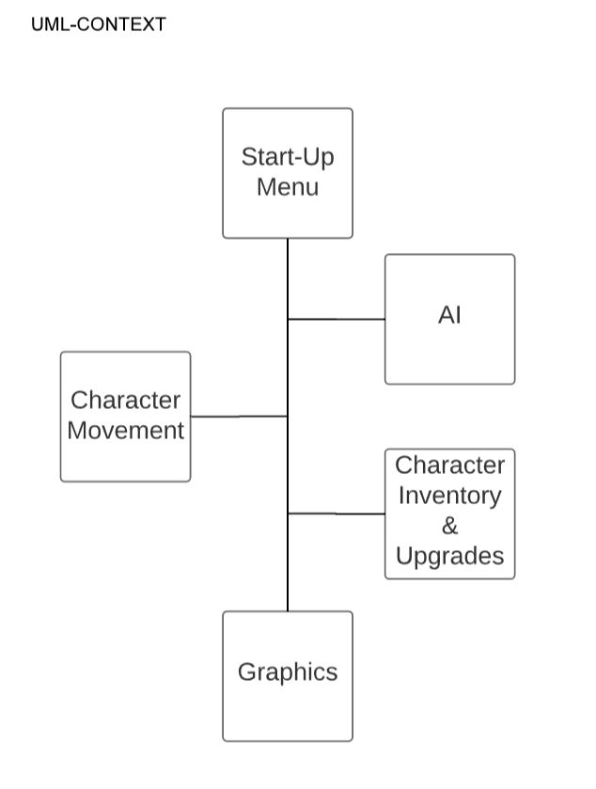

Set-Up

# 4. Systems Requirements

{Provide a Requirements overview by introducing the following requirement sections that correspond with the “user” functionality. There should be a 1-1 correspondence between your requirements sections below, your context diagram, your Business Objectives and your UML diagrams. Keep hardware, database, test data, and android versions to section 5. Add a new section for each category of your requirements. This is the heart of the SRA document, and hence the lengthiest, and should list all requirements of the system. **Please use the designated Requirements Form.**}

## 4.1 “Registration” Requirements

{List requirements}

## 4.2 “Data Maintenance” Requirements

{List requirements}

## 4.3 “Search” Requirements

{List requirements}

## 4.4 “Diet” Requirements

{List requirements}

## 4.5 “Vital Signs” Requirements

{List requirements}

## 4.6 “Medications” Requirements

{List requirements}

## 4.7 “Alerts” Requirements

{List requirements}

## 4.8 “Communication” Requirements

{List requirements}

## 4.9 “Login” Requirements

{List requirements}

**{Add as many sections as necessary, i.e. 4.10, 4.11 etc., each corresponding to a category of *user* functionality similar to sections above.}**

# 5. Software Processes and UML Diagrams

## 5.1 Hardware and Infrastructure

{Any hardware and infrastructure types/issues such as which version of android and other related material go here}

No hardware issues at the moment. Plan on using android version 4.0 Ice Cream Sandwhich. (Feel free to change this)

## 5.2 UML Diagrams

{UML diagrams go here. This section may take several pages, one UML diagram for each component. This was done in Increment 1, just copy paste here.}

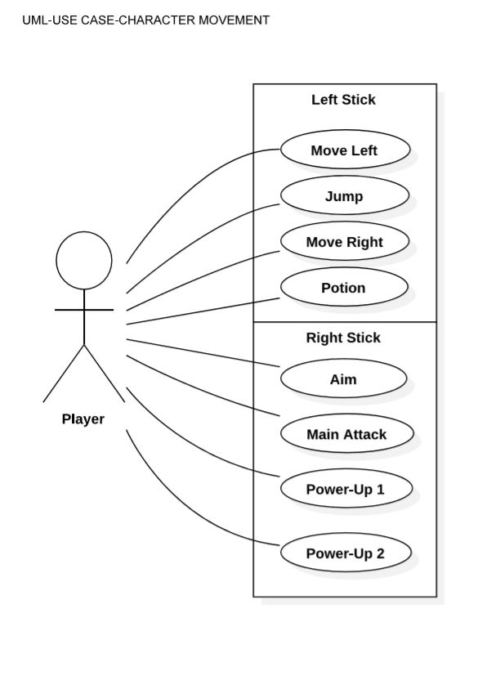

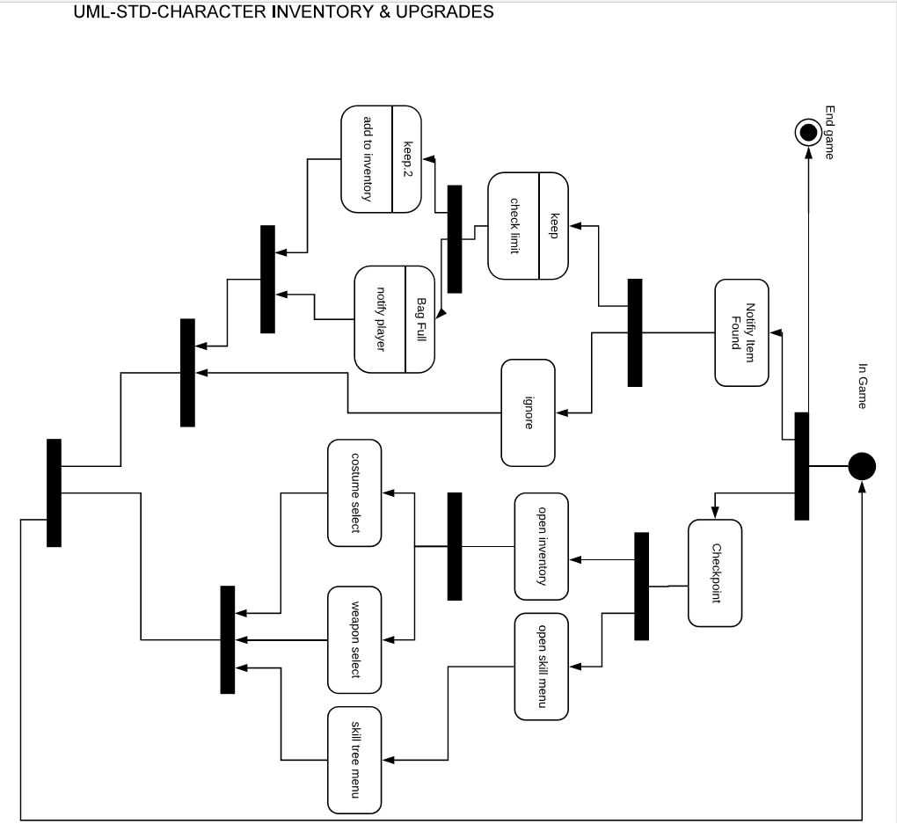

UML-ACTIVITY-CHARACTER INVENTORY & UPGRADES

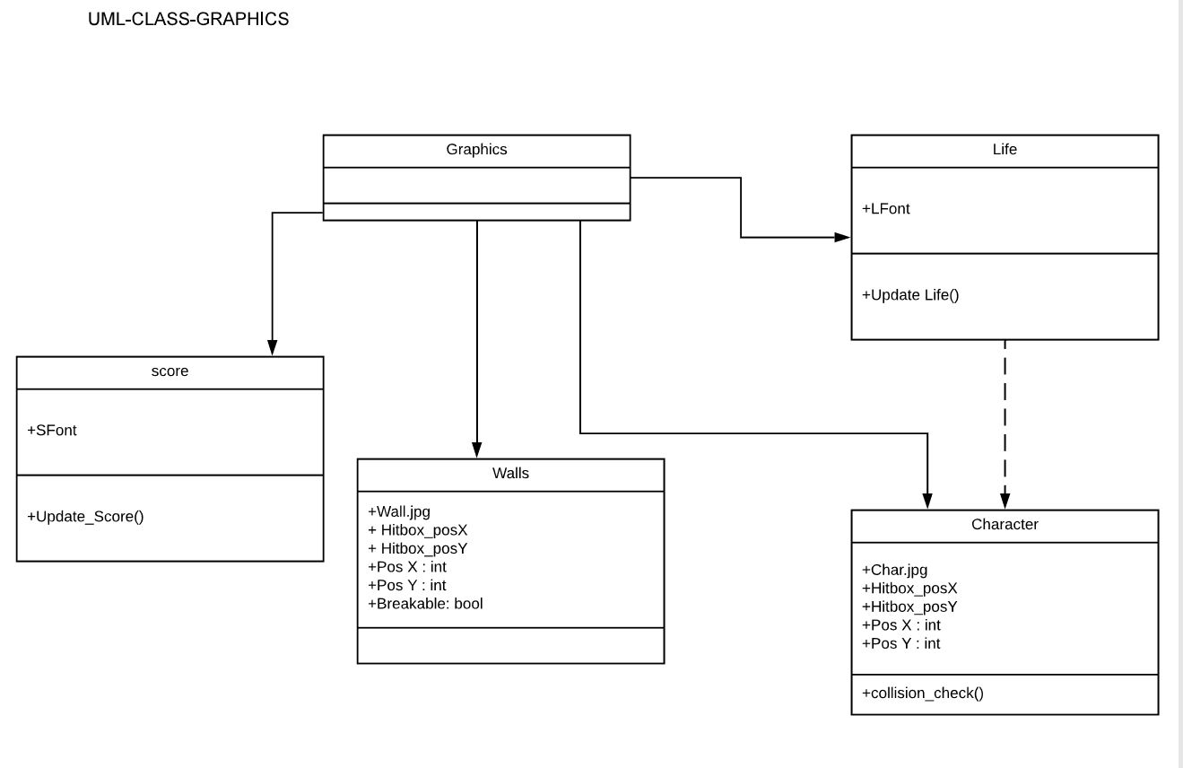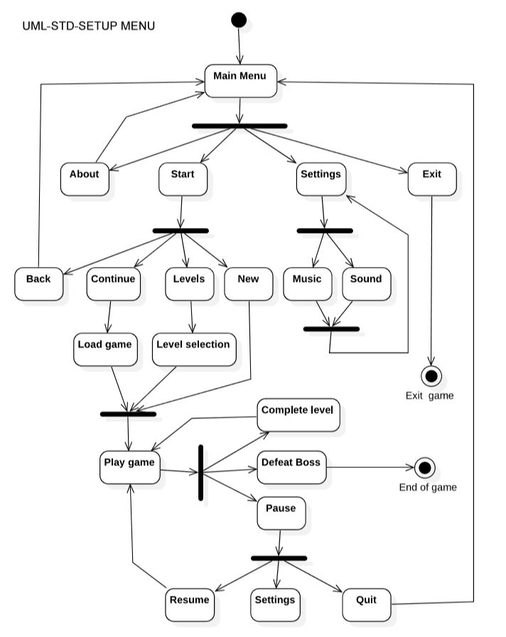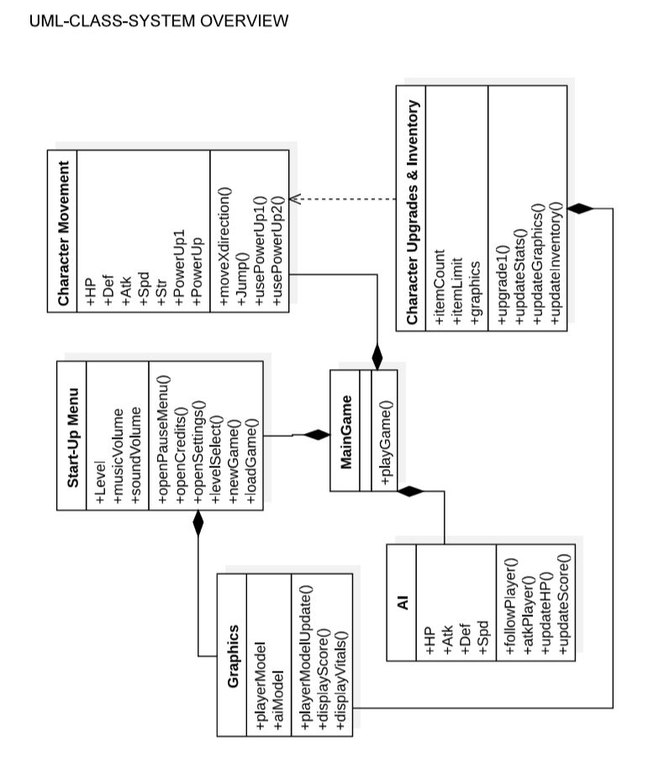

## 5.3 Test Plan

A Test Plan will be provided at a later stage.

## 5.4 Screen Shots

{Include any screen shots if you have. This may take several pages. If nothing available, mention “No screen shots available at this time”}

# 6. Assumptions and Constraints

## 6.1 ASSUMPTIONS

The following is a list of assumptions:

* Only people older than 18 can use this product

## 6.2 CONSTRAINTS

The following is a list of constraints:

* Team lacks android development skills

## 6.3 Out of Scope material

The following is a list of “out of scope” material:

* Post Project maintenance is not covered

# 7. Delivery and Schedule

{List all tasks/milestones from start of the project to the end with specific dates for both Anticipated Start & End Dates

|  |  |  |  |  |
| --- | --- | --- | --- | --- |
| Task/Milestone Description | Anticipated Start Date | Anticipated End Date | Status | Comments |
| Prepare UML diagrams | 9/14/2018 | 10/4/2018 | Complete | UML diagram delivered  Increment 1 Deliverable |
| SRA document (Includes project objectives, Requirements and UML diagrams) | 10/4/2018 | 10/25/2018 | In Progress | Deliverable will be the SRA document. All stakeholders agree on the content of the SRA by signing in section 8.  Increment 2 Deliverable |
| Design: Design big picture, define format, navigation and functionality to include | ? | ? | To Be Completed (TBC) |  |
| Implementation: Home screen design | ? | ? | TBC |  |
| Implementation: Login and registration | ? | ? | TBC |  |
| **…**  **List all required functionality and tasks**  **…** | ? | ? | ? |  |
| Test case design | 10/26/2018 | 11/15/2018 |  | Increment 3 Deliverable |
| External Documentation (i.e. User Manual) | 11/16/2018 | 12/4/2018 |  |  |
| Project presentation | 11/20/2018 | 12/4/2018 |  |  |
| Final Milestone: project delivery |  | 12/4/2018 |  | Increment 4 Deliverable |

# 8. Stakeholder Approval Form

|  |  |  |  |
| --- | --- | --- | --- |
| Stakeholder Name | Stakeholder Role | Stakeholder Comments | Stakeholder Approval Signature and Date |
| Bahram Khalili | Development Mgr |  |  |
| Akshit Singhal | Project Assistant |  |  |
| {Team member Name} | Developer |  |  |
| {Team member Name} | Developer |  |  |
| {Team member Name} | Developer |  |  |
| {Team member Name} | Developer |  |  |

# Appendix:

{Additional documents or references, if any, go here. If nothing to place in this appendix, just write “None”, do not remove appendix}