|  |  |  |  |  |
| --- | --- | --- | --- | --- |
|  |  | | | |
|  | |  | | |
| Project: | | StickJumpForce | | |
| Team No.: | | Team 10 | | |
| Class: | | CSE 3310; Fall 2018 | | |
| Module: | | System Requirements Analysis (SRA) | | |
| Deliverable: | | SRA Document | | |
| Version: | | [1.0] | Date: | [10/25/2018] |

Contributors:

Bhuwan KC

Cristian Garces

Diptin Dahal

Haris Queresi

Revision History

| Version number | Date | Originator | Reason for change | High level description of changes |
| --- | --- | --- | --- | --- |
| 1.0 | 10/25/2018 | Bhuwan,Cristian, Diptin, Haris | Initial draft |  |
| 1.1 | mm/dd/yyyy | Name(s) | Revision |  |
|  |  |  |  |  |
|  |  |  |  |  |

TABLE OF CONTENTS

1. Introduction and Project Overview 3

2. Objectives 4

2.1 BUSINESS Objectives 4

2.2 SYSTEM Objectives 4

3. Project Context Diagram 5

4. Systems Requirements 6

4.1 “MENU” Requirements 6

4.2 “AI” Requirements 6

4.3 “Graphics” Requirements 6

4.4 “Inventory” Requirements 6

5. Software Processes and UML Diagrams 8

5.1 Hardware and Infrastructure 8

5.2 UML Diagrams 8

5.3 Test Plan 8

5.4 Screen Shots 8

6. Assumptions and Constraints 9

6.1 ASSUMPTIONS 9

6.2 CONSTRAINTS 9

6.3 Out of Scope material 9

7. Delivery and Schedule 10

8. Stakeholder Approval Form 11

Appendix: 12

# 1. Introduction and Project Overview

StickJumpForce is a 2D fighting game, which allows user to control the Stick figure in the screen. The hero (stick figure) has ability to transform to different heroes from popular fighting anime and movies. And usually has to fight his way to the end from all the enemies who are attacking him with all the Jump Forces. The game is built for Android devices and expects user to have at least Android KitKat. The game is available for free download in android store.

# 2. Objectives

## 2.1 BUSINESS Objectives

The following is a list of business objectives:

**Objective 1**: Menu: This system provides all menus for the game and can be used at any point in time when application is running

**Objective 2**: AI: This component provides the natural game play.

**Objective 3:** Graphics: This component loads the levels and interface of game screen (screen user sees while playing a level) into an appealing matter.

**Objective 4:** Inventory: Allows manipulation of character inventory and ability to edit skill sets in the same ‘Character Customization’ tab.

**Objective 5:** Character Movement: This component allows the user to interact with the game environment and play the game.

## 2.2 SYSTEM Objectives

The following is a list of system objectives:

**Objective 1**: System will be an android application for mobile platform

**Objective 2**:

.

**Objective M**:

# 3. Project Context Diagram

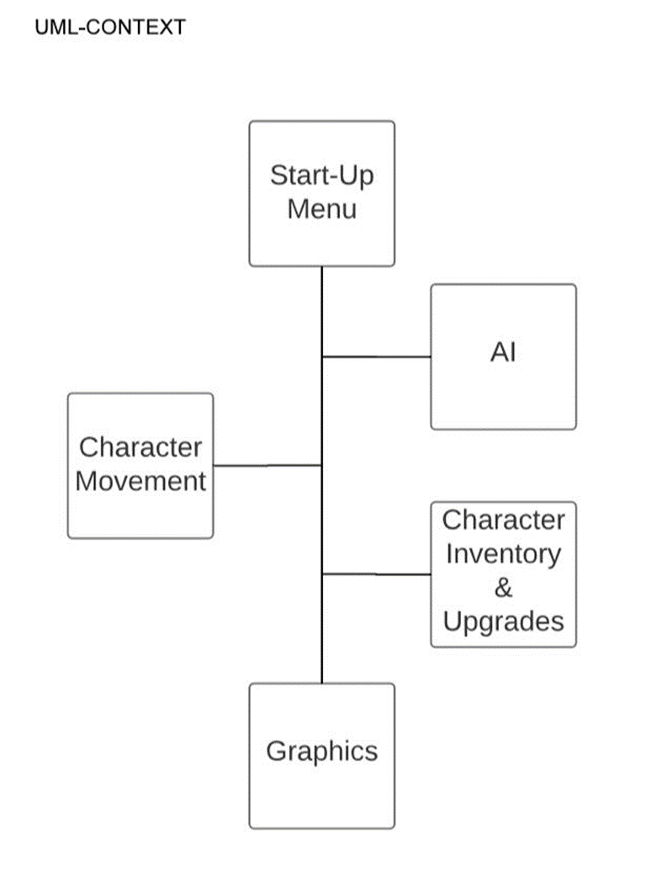

SetUp

# 4. Systems Requirements

## 4.1 “MENU” Requirements

4.11 “SETUP MENU” REQUIREMENT

|  |  |
| --- | --- |
| **Requirement Title:** | SetUp Menu |
| **Sequence No:** | 001 |
| **Short description:** | Provide user options to setup the game |
| **Description:** | Choose one of the following  Start – To start the game  Setting – To change game settings  About – To view credits  Exit – To exit the game  Provide a main menu with above buttons |
| **Pre-Conditions**: | None |
| **Post Conditions:** | Clicked Start – Display Game menu  Clicked Settings – Display Settings menu  Clicked About – Display a message box with credits  Clicked Exit – Exit the game |
| **Other attributes:** | Setup Menu is also referred as “Main Menu” |

4.12 GAME MENU” REQUIREMENT

|  |  |
| --- | --- |
| **Requirement Title:** | Game Menu |
| **Sequence No:** | 002 |
| **Short description:** | Provide user options to select game mode |
| **Description:** | Choose one of the following  Continue – To continue previous game  Levels – To select a particular level  New – To start a new game  Back – To return to the main menu  Provide a game menu with above buttons |
| **Pre-Conditions**: | Game Menu is displayed when user clicks start button on the main menu |
| **Post Conditions:** | Clicked Continue – Load previous game if any  Clicked Levels – Display levels and start new game on that level  Clicked New – Start a new game  Clicked Back – Return to the main menu |
| **Other attributes:** | None |

4.13 “PAUSE MENU” REQUIREMENT

|  |  |
| --- | --- |
| **Requirement Title:** | Pause Menu |
| **Sequence No:** | 003 |
| **Short description:** | Provide user with options to either change setting or to exit the game |
| **Description:** | Choose one of the following  Resume – To go back to the game play  Settings – To change game settings  Quit – To exit the current game  Provide a pause menu with above buttons |
| **Pre-Conditions**: | Pause Menu is displayed when user pauses a game |
| **Post Conditions:** | Clicked Resume – Go back to the game play  Clicked Settings – Display setting options Music and Sound, and let user adjust them  Clicked Quit – Save the current game and return to the Setup menu |
| **Other attributes:** | A pause menu can be displayed at any time during the game play if user hits pause |

## 4.2 “AI” Requirements

4.21 “AI GAMEPLAY” REQUIREMENTS

|  |  |
| --- | --- |
| **Requirement Title:** | AI Game Play |
| **Sequence No:** | 001 |
| **Short description:** | Control the game play (easy, difficult), allow power ups etc. |
| **Description:** | Provides the natural game flow for the user based on his ability of playing the game. If the player is struggling to kill easy enemies than regular power ups will be made available. |
| **Pre-Conditions**: | User should fight at least some enemies. |
| **Post Conditions:** | User gameplay data will be taken for continuous evaluation of gameplay. |
| **Other attributes:** | none |

4.22 “AI ENEMY CONTROL” REQUIREMENTS

|  |  |
| --- | --- |
| **Requirement Title:** | AI Enemy Control |
| **Sequence No:** | 002 |
| **Short description:** | Control the game enemy in the game. |
| **Description:** | This AI works as the brain of the enemy team in the game. This will decide when to bring more enemies and when to send the Boss enemy. Controls the following attributes of spun AI enemies:   * Speed: walk or run or idle * Attack * Defense * Get Hit/Death |
| **Pre-Conditions**: | User needs to interact with the game environment. |
| **Post Conditions:** |  |
| **Other attributes:** | Speed  Attack  Defense  Health |

4.22 “AI GOAL ORIENTED ACTION” REQUIREMENTS

|  |  |
| --- | --- |
| **Requirement Title:** | AI Goal Oriented Action |
| **Sequence No:** | 004 |
| **Short description:** | Computer will be able to fight user like a real enemy. |
| **Description:** | Provides the natural game flow for the user utilizing different strategies for making player to lose the game.  And also manipulates other version of Game AIs. |
| **Pre-Conditions**: | Must be ‘In-Game’ |
| **Post Conditions:** | Game ends if AI either wins or loses (Player is defeated, or all AI are defeated) |
| **Other attributes:** | None |

## 4.3 “Graphics” Requirements

|  |  |
| --- | --- |
| **Requirement Title:** | Graphics |
| **Sequence No:** | 001 |
| **Short description:** | Show player’s information |
| **Description:** | Show the following info:  Health  Magic  Experience  Points  Skills  Controller  Weapons  In game currency  Level  Picture of the player  Provide pause button that has settings, quit and save menu |
| **Pre-Conditions**: | Application is currently running |
| **Post Conditions:** | When the user touches one of the buttons then it either change weapons, go into skill tree, move the player, show health and magic in numbers, and show the current experience/ exp needed to level up |
| **Other attributes:** | None |

## 4.4 “Inventory” Requirements

|  |  |
| --- | --- |
| **Requirement Title:** | Inventory and upgrades |
| **Sequence No:** | 001 |
| **Short description:** | View Inventory and Upgrade skills or weapons |
| **Description:** | Player should be able to access their inventory to put items(costumes/weapons), take items out, use items from the inventory, and equip items to main inventory.  The inventory should make sure to check if there is space for more items before letting users put an item in  Notify if the inventory is full |
| **Pre-Conditions**: | Player should be at a checkpoint  Inventory icon should be clicked by the user to get into the menu  Inventory should not be full |
| **Post Conditions:** | Inventory close icon should be clicked by the user to leave |
| **Other attributes:** |  |

## 4.5 “Character Movement” Requirements

|  |  |
| --- | --- |
| **Requirement Title:** | Character Movement |
| **Sequence No:** | 001 |
| **Short description:** | Buttons (User interface) available for user while in game. |
| **Description:** | User (Player) will be able to move throughout the levels, attack enemies and use potions/abilities. |
| **Pre-Conditions**: | Game must not be paused and must be in a current level. |
| **Post Conditions:** | Shift position/use abilities/use potion(s) |
| **Other attributes:** | none |

# 5. Software Processes and UML Diagrams

## 5.1 Hardware and Infrastructure

No hardware issues at the moment. Plan on using android version kitkat

## 5.2 UML Diagrams

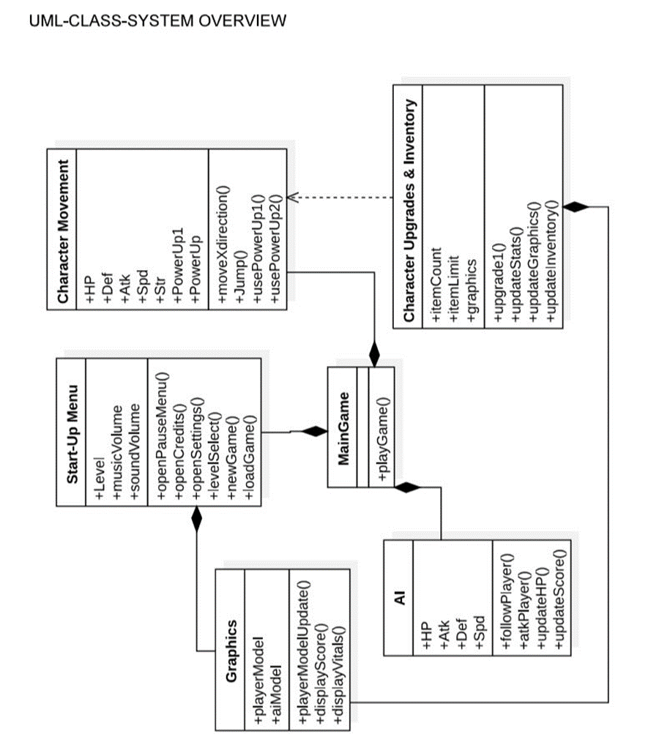

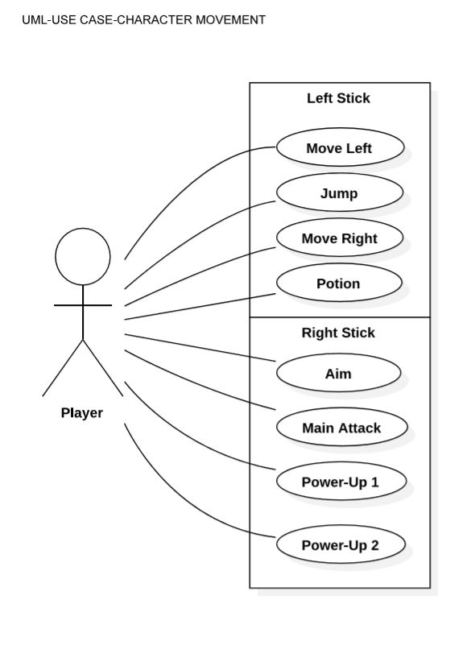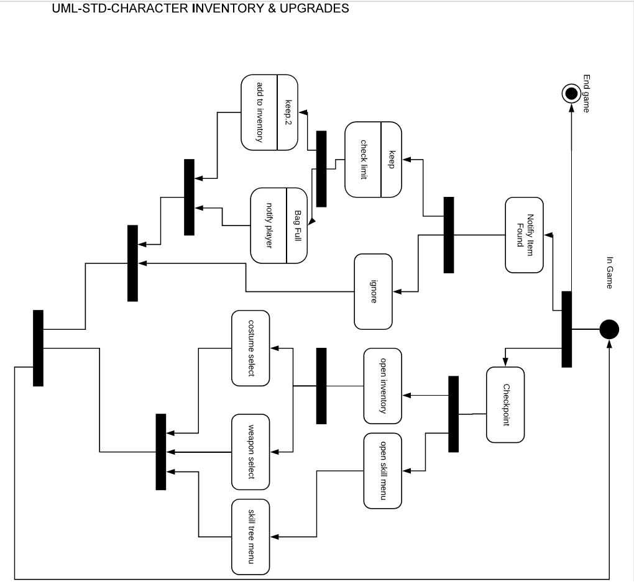

UML-STD-CHARACTER INVENTORY & UPGRADES

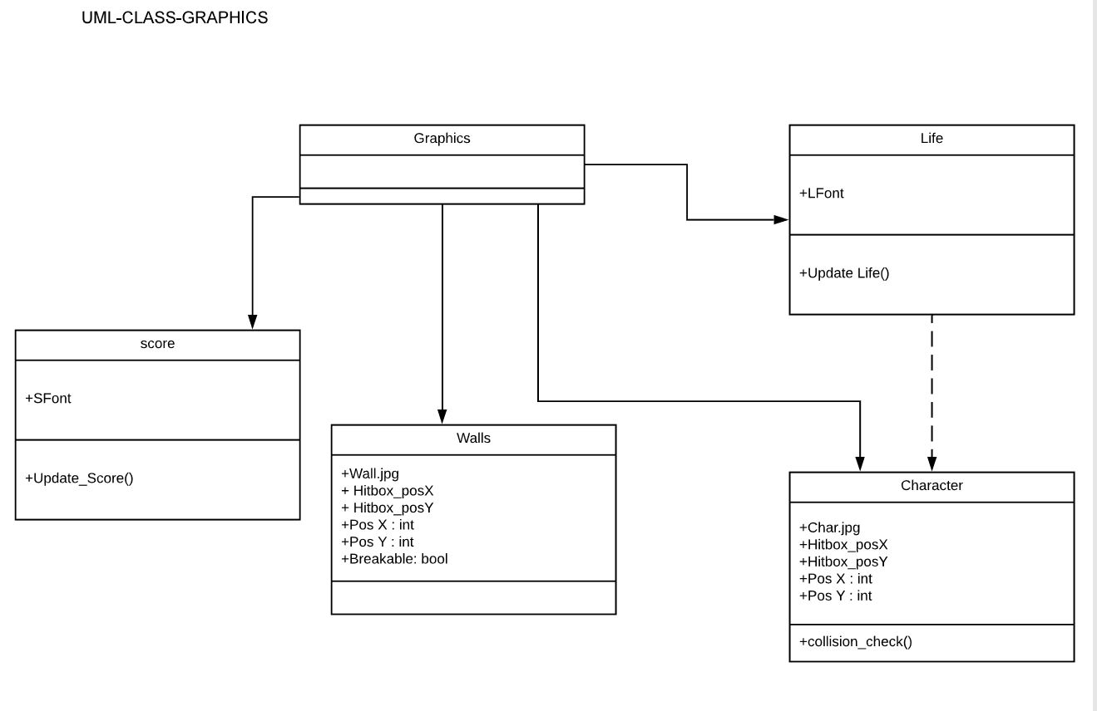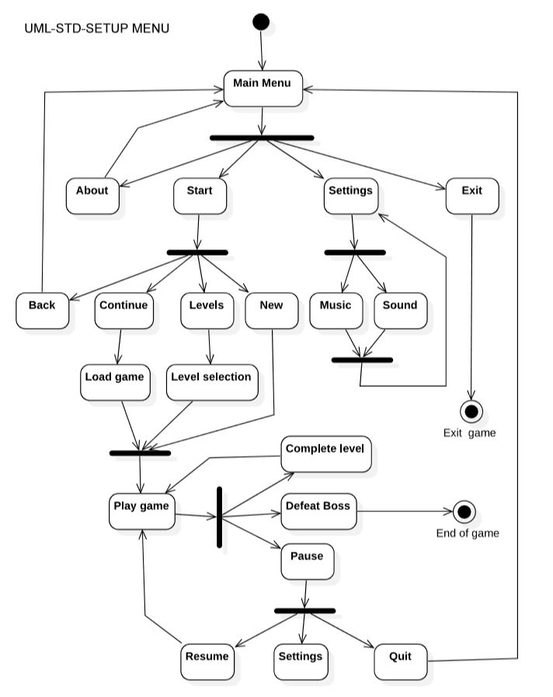

UML-ACTIVITY-SETUP MENU

## 5.3 Test Plan

A Test Plan will be provided at a later stage.

## 5.4 Screen Shots

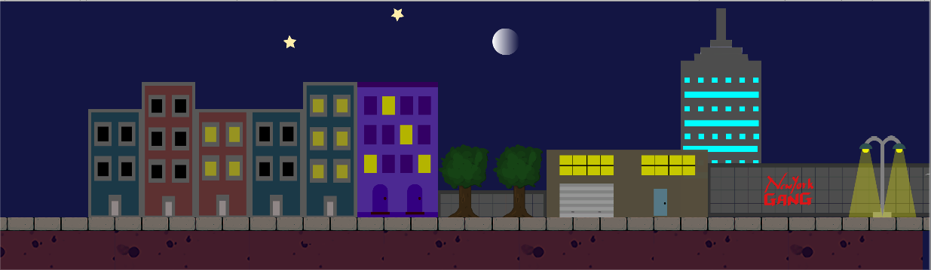

Screen shot – Level 1 preview

# 6. Assumptions and Constraints

## 6.1 ASSUMPTIONS

The following is a list of assumptions:

* People have an android device to play the game
* No external controller is attached.

## 6.2 CONSTRAINTS

The following is a list of constraints:

* Team lacks android development skills
* Team lacks graphics designing experience

## 6.3 Out of Scope material

The following is a list of “out of scope” material:

* Post Project maintenance is not covered

# 7. Delivery and Schedule

|  |  |  |  |  |
| --- | --- | --- | --- | --- |
| Task/Milestone Description | Anticipated Start Date | Anticipated End Date | Status | Comments |
| Prepare UML diagrams | 9/14/2018 | 10/4/2018 | Complete | UML diagram delivered  Increment 1 Deliverable |
| SRA document (Includes project objectives, Requirements and UML diagrams) | 10/4/2018 | 10/25/2018 | In Progress | Deliverable will be the SRA document. All stakeholders agree on the content of the SRA by signing in section 8.  Increment 2 Deliverable |
| Design: Design big picture, define format, navigation and functionality to include | 10/19/2018 | 10/26/2018 | In Progress | The design will be reviewed by all team members on the anticipated end date |
| Design: Level 1 scene | 10/26/2018 | 11/02/2018 | TBC |  |
| Test case design | 10/26/2018 | 11/15/2018 | TBC | Increment 3 Deliverable |
| Character design | 11/02/2018 | 11/09/2018 | TBC |  |
| Character movements | 11/09/2018 | 11/15/2018 | TBC |  |
| Inventories design | 11/09/2018 | 11/17/2018 | TBC |  |
| AI development | 11/12/2018 | 11/19/2018 | TBC |  |
| Design: Menu system | 11/15/2018 | 11/22/2018 | TBC |  |
| External Documentation (i.e. User Manual) | 11/16/2018 | 12/4/2018 | TBC |  |
| Project presentation | 11/20/2018 | 12/4/2018 | TBC |  |
| Final Milestone: project delivery |  | 12/4/2018 | TBC | Increment 4 Deliverable |

# 8. Stakeholder Approval Form

|  |  |  |  |
| --- | --- | --- | --- |
| Stakeholder Name | Stakeholder Role | Stakeholder Comments | Stakeholder Approval Signature and Date |
| Bahram Khalili | Development Mgr |  |  |
| Akshit Singhal | Project Assistant |  |  |
| Diptin Dahal | Developer |  |  |
| Bhuwan KC | Developer |  |  |
| Cristian Garces | Developer |  |  |
| Haris Queresi | Developer |  |  |

# Appendix:

None