Step by step guide to run the app  
  
1. Create a superuser

Open terminal and type: python manage.py createsuperuser  
  
Follow the steps and create a super username and password  
  
Go to <https://127.0.0.1:8000/admin>  
Enter the super user credentials. It will open the Django admin panel which can be used to manage users, files, shares, MFA and roles.

2. Go to <https://localhost:3000/login>:  
If you don’t already have an account, click on Register.   
Enter the details and click on Register.

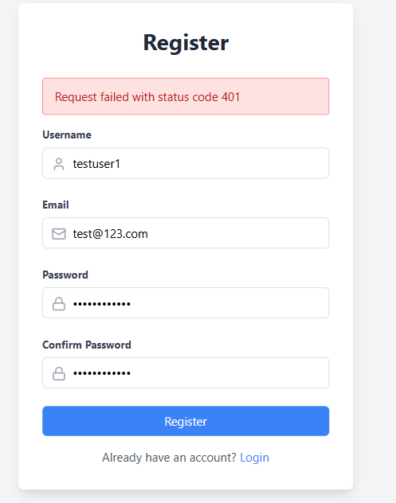

Once all details are entered, you will get “Registration Successful”  
  
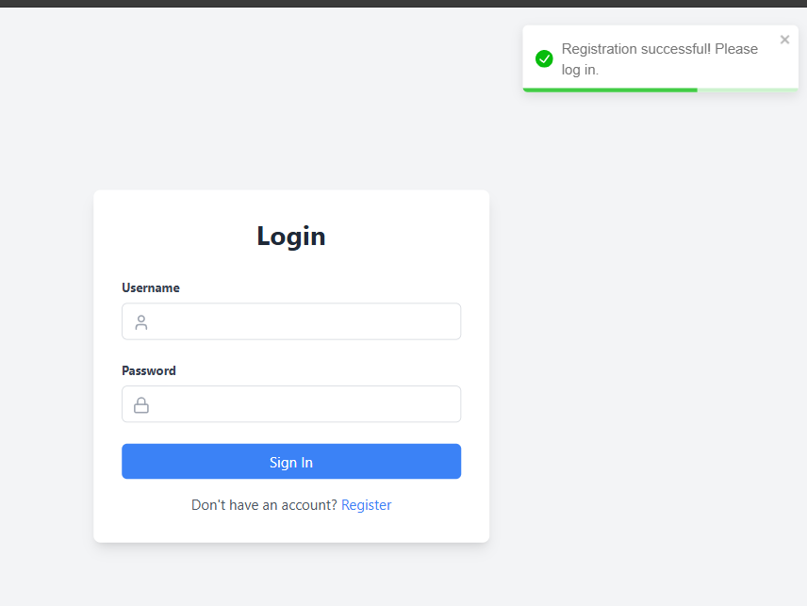

3. After this you’ll be redirected to login page. Enter the user credentials and click on login. You will land to the dashboard screen where you will have options to setup MFA and upload file.   
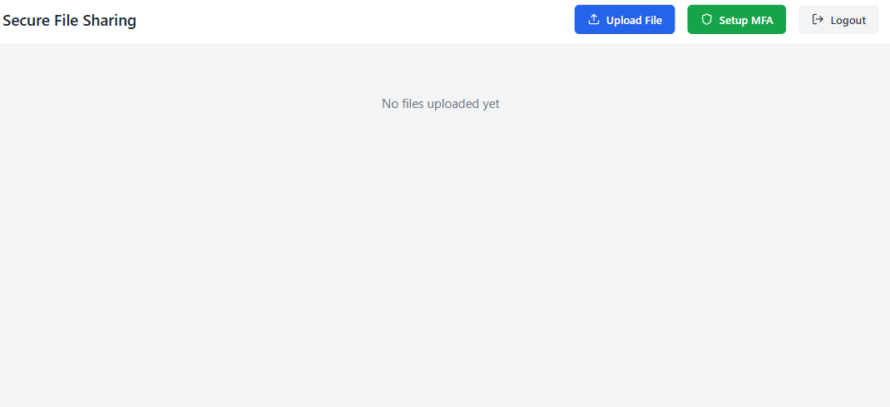

4. Let’s **Setup MFA**! Click on Setup MFA button. You will get a dialog to enable 2FA. Click on Enable 2FA.  
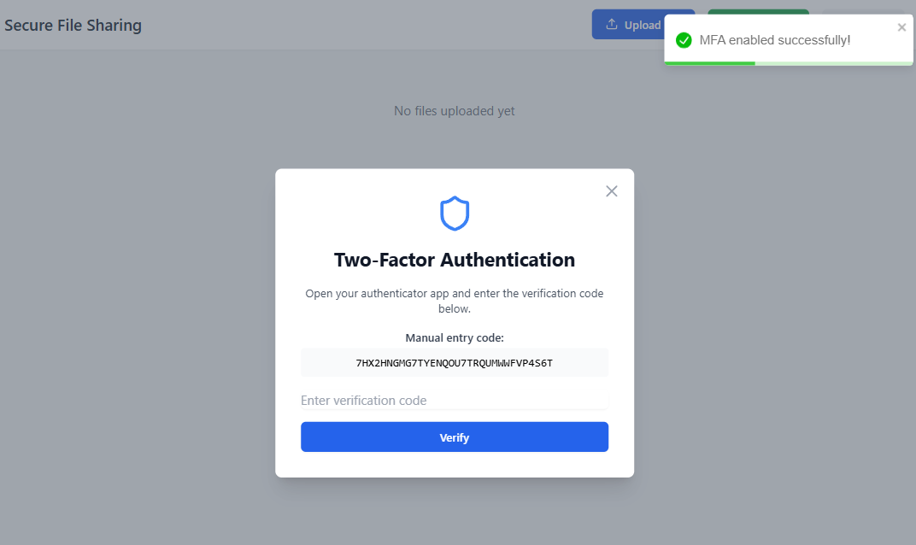  
  
5. You need to download an authenticator app. For this tutorial, we will be using the Google Authenticator app which is easily available on Play Store and App Store.

6. Once downloaded, open the app. Click on the **+** icon. Enter a setup key. Enter the following details:  
**Account name**: Any meaningful name which you can use to identify the user

**Your key**: Enter the Manual entry code that you will receive similar to the one shown in above image.

Click on Add.

7. You will get a 6-digit code. Enter the verification code in the dialog box and click on verify. Congrats you have successfully configured MFA! Now the next time you login, you will be asked to enter the Time based OTP (TOTP) on the authenticator app to login to the application post you enter the login credentials. You will get MFA verified successfully post verification. *Note: You need to be quick to do this step as the JWT token might expire soon.*

8. Once you have a MFA, you will have an option to disable the MFA as shown below:  
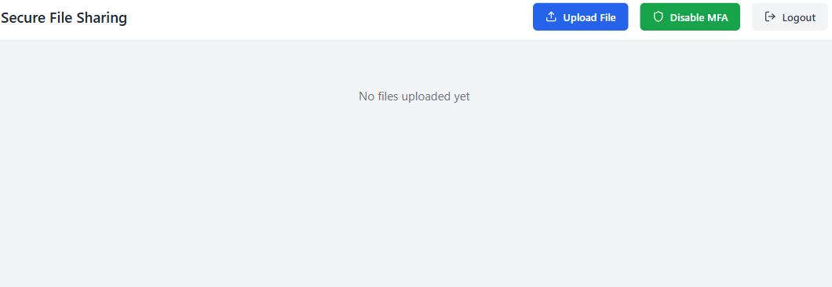

9. Let’s try uploading a file. Click on Upload File button and select the file to be uploaded. Once done, your file will be visible on the dashboard.

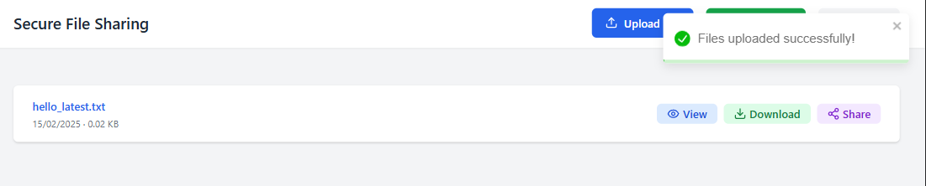

10. You can either wish to view, download or share the file. In the same dashboard, you will also see the shared files (files shared by other users).

11. Let’s try sharing a file with other user. Click on the share button. Select a user and set the expiry date and permission (View or Download). Click on the share button in the dialog box as shown:  
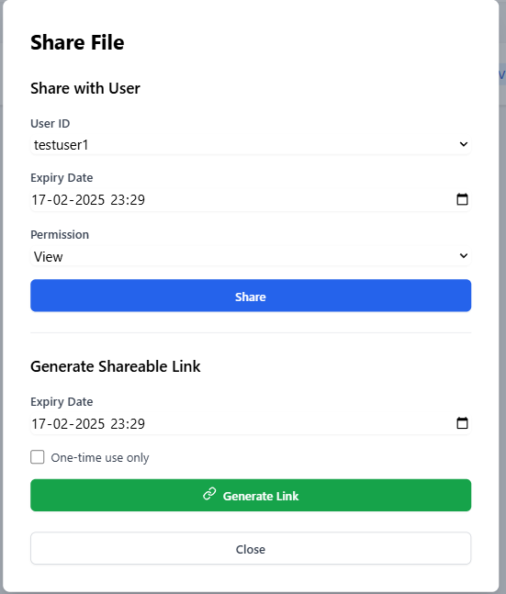

12. Once the file is shared with user, the shared file user will be able to view the files or download it based on the shared permission. In this case, since Permission is set to View, testuser1 will not be able to download or share the file.