# Task-1

**Aim:** Declare a variable using var, let, and const. Assign different data types to each variable and print their values.

**Theoretical Background:**

* var and let create variables that can be reassigned another value.
* const creates "constant" variables that cannot be reassigned another value.
* developers shouldn't use var anymore. They should use let or const instead.

**Source Code:**

<script>

        var var1=10;

        var var2=15;

        var sum=var1+var2;

        console.log(sum);

        let fname="pari";

        let lname="patel";

        let name=fname.concat( "",lname);

        console.log(name);

        const city=["ahmedabad","surat","vadodara"]

        console.log(city);

</script>

**Output:**

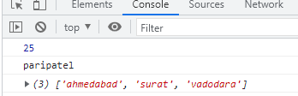

**Learning outcome(co):**

# Task-2

**Aim:** Write a function that takes two numbers as arguments and returns their sum, difference, product, and quotient using arithmetic operators.

**Theoretical Background:**

* Arithmetic Operators: These operators perform basic arithmetic operations on numerical values.
* Examples include addition (+), subtraction (-), multiplication (*), division (/), and modulus (%).

**Source Code:**

<script>

    console.log(fun(25,10));

    function fun( a, b){

   let sum= a+b ;

   let diff=b-a;

   let mul=a*b;

    let div=b/a

   console.log(sum);

   console.log(diff);

    console.log(mul);

    console.log(div);

   }

</script>

**Output:**

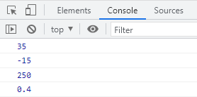

**Learning outcome(co):**

# Task-3

**Aim:** Write a program that prompts the user to enter their age. Based on their age, display

different messages:

○ If the age is less than 18, display "You are a minor."

○ If the age is between 18 and 65, display "You are an adult."

○ If the age is 65 or older, display "You are a senior citizen."

**Theoretical Background:**

**Source Code:**

<script>

        const age=14;

        if(age<18){

        console.log("You are a minor");

        }

        else if(age>18 && age<65)

        {

        console.log("You are an adult");

        } else

        {

        console.log("You are a senior citizen.")

        }

</script>

**Output:**

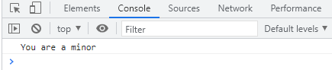

**Learning outcome(co):**

# Task-4

**Aim:** Write a function that takes an array of salary as an argument and returns the min/max salary in the array.

**Theoretical Background:**

**Source Code:**

<p>The salary is: [5600, 6800, 2300, 9000,]</p>

   <p id="result"></p>

   <script>

      let array = [5600, 6800, 2300, 9000,];

      let min = Math.min(...array);

      let max = Math.max(...array);

      document.getElementById('result').innerHTML = "The maximum salary is: <b>" + max + "</b><br>" + "The minimum salary is: <b>" + min + "</b>";

   </script>

**Output:**

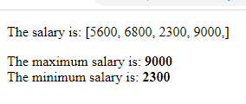

**Learning outcome(co):**

# Task-5

**Aim:** Create an array of your favorite books. Write a function that takes the array as an argument and displays each book title on a separate line.

**Theoretical Background:**

**Source Code:**

<script>

    function displayBooksForOfLoop(books) {

        for (var book of books) {

        console.log(book);

        }

        }

        // Example usage:

        var favoriteBooks = ["The Magic Tree.","Winter Fairy.","Tower To The Stars."];

        displayBooksForOfLoop(favoriteBooks);

</script>

**Output:**

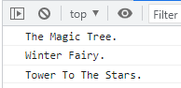

**Learning outcome(co):**

# Task-6

**Aim:** Declare a variable inside a function and try to access it outside the function. Observe the scope behavior and explain the results. [var vs let vs const]

**Theoretical Background:**

**Source Code:**

<script>

         function scopeWithVar() {

  var myVariable = "Hello";

}

scopeWithVar();

console.log(myVariable);

function scopeWithLet() {

  let myVariable = "Hello";

}

scopeWithLet();

console.log(myVariable);

function scopeWithConst() {

  const myVariable = "Hello";

}

scopeWithConst();

console.log(myVariable);

    </script>

**Output:**

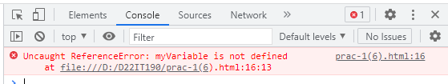

**Learning outcome(co):**

# Task-7

**Aim:** Create an HTML page with a button. Write JavaScript code that adds an event listener to the button and changes its text when clicked.

**Theoretical Background:**

**Source Code:**

 <h1>Button with Click Event Listener</h1>

    <button id="myButton">Click Me!</button>

    <script>

        const myButton = document.getElementById("myButton");

        myButton.addEventListener("click", function () {

            myButton.innerHTML = "I've been clicked!";

        });

    </script>

**Output:**

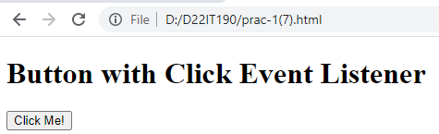

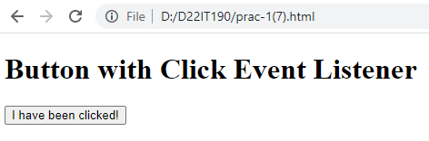

**Learning outcome(co):**

# Task-8

**Aim:** Write a function that takes a number as an argument and throws an error if the number is negative. Handle the error and display a custom error message.

**Theoretical Background:**

**Source Code:**

<script>

       function validateNumber(number) {

    "use strict";

    // Check if the number is negative.

    if (number < 0) {

      // Throw an error.

      throw new Error("The number must be non-negative.");

    }

  }

  // Handle the error.

  try {

    validateNumber(-1);

  } catch (error) {

    // Display the error message.

    console.error(error.message);

  }

    </script>

**Output:**

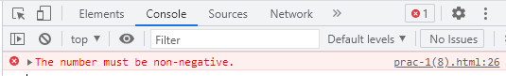

**Learning outcome(co):**

# Task-9

**Aim:** Write a function that uses set Timeout to simulate an asynchronous operation. Use a callback function to handle the result.

**Theoretical Background:**

**Source Code:**

<script>

        function simulateAsyncOperation(callback) {

  "use strict";

  // Simulate an asynchronous operation by waiting for 2 seconds.

  setTimeout(function () {

    callback("The asynchronous operation has completed.");

  }, 2000);

}

simulateAsyncOperation(function (result) {

  console.log(result);

});

</script>

**Output:**

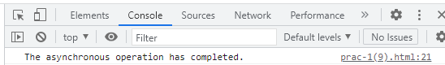

**Learning outcome(co):**