2017 Advanced Computer Networks Homework 1

M063040050 曾國維

**Part 1: Web Browsing (DNS, TCP)**

1. Find the first DNS request packet sent by the client. (Request for <cse.nsysu.edu.tw>)

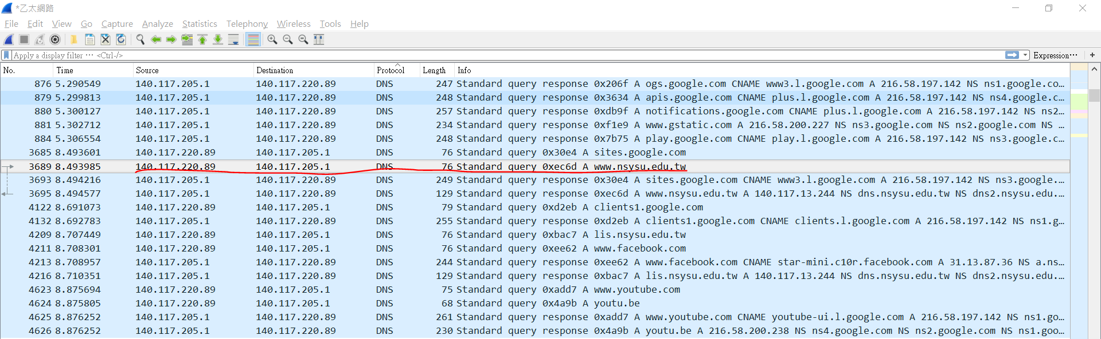

* 1. Examine the Ethernet

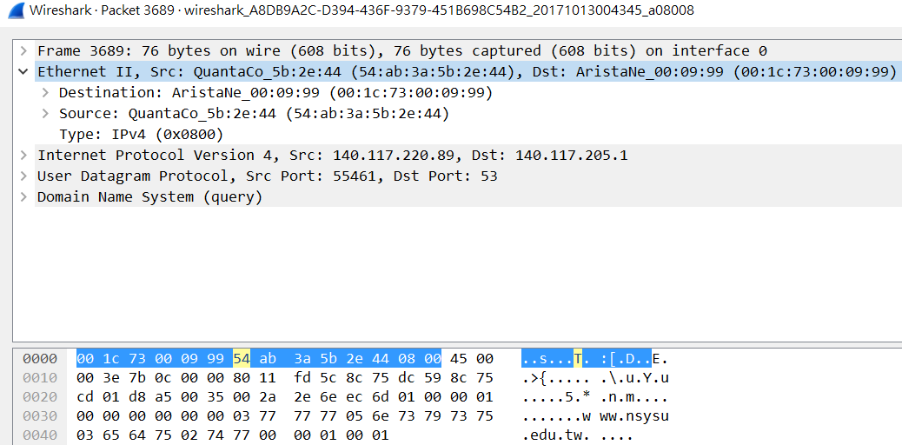

* + 1. What is the Ethernet address of the source and destination?

Ans: Source: 54:ab:3a:5b:2e:44

Destination: 00:1c:73:00:09:99

* + 1. What is the content of the type field in the Ethernet frame?

Ans: IPv4(0x0800)

* 1. Examine the Internet Protocol

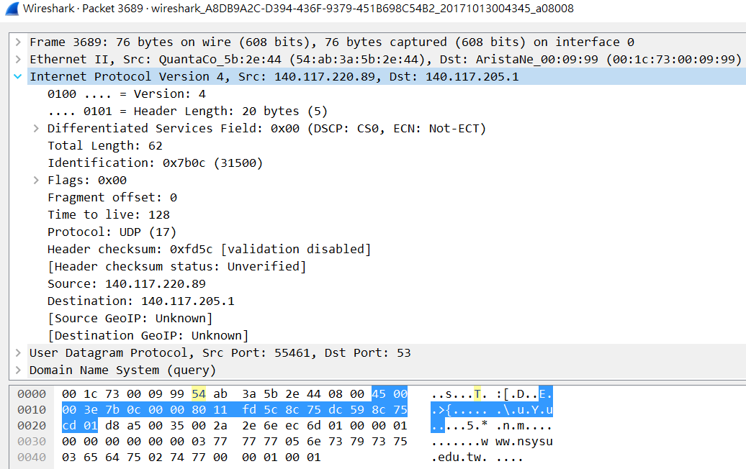

* + 1. What is the IP address of the source and destination?

Ans: Source: 140.117.220.89

Destination: 140.117.205.1

* + 1. What is the header length? What is the total packet length?

Ans: Header length: 5(20bytes)5

Packet length: 62

* + 1. Identify the protocol type field. What is the number and type of the protocol in the payload?

Ans: UDP(17)

* 1. Examine the User Datagram Protocol

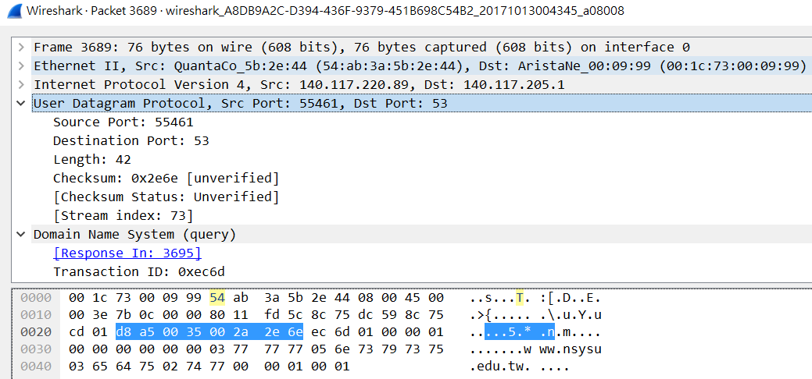

* + 1. Identify the client ephemeral port number and the server well-known port number.

Ans: client ephemeral port number:55461

server well-known port number:17

* + 1. What type of application layer protocol is in the payload?

Ans:由UDP port53可知，協定為DNS

* 1. Examine the Domain Name System (query)

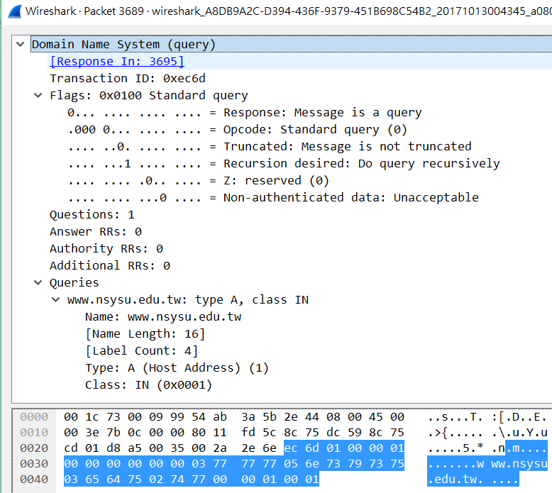

* + 1. What field indicates whether the message is a query or a response?

Ans:由Flags第1個bit可以知道message is a query

* + 1. What is the query transaction ID?

Ans: 0xec6d = 60525(10)

* + 1. Identify the fields that carry the type and class of the query.

And: Type:A

Class:IN

1. Find the DNS response packet which is response to the DNS request packet from the above question.

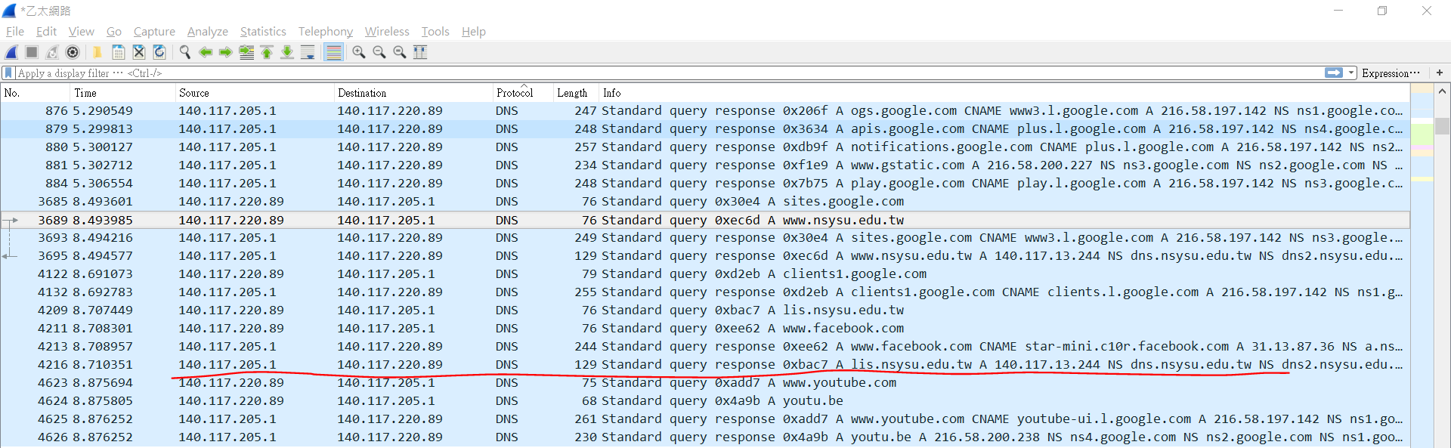

* 1. Examine the Ethernet
     1. What is the Ethernet address of the source and destination?
     2. What is the content of the type field in the Ethernet frame?
  2. Examine the Internet Protocol & Domain Name System (response)
     1. What is the IP address of the source and destination?
     2. What is the header length? What is the total packet length? Is it longer than the query?
     3. How many answers are provided in the response message? Compare the answers and their time-to-live values.

1. Find the first TCP packet sent by client. (The destination IP address is response from above question.)