Practical Exam-CIA-1 Problem Report

Problem-1

Problem 1: Canteen Token Billing (Units 1 & 2)
The college canteen issues a token number to every valid order and keeps a running total of sales. Write a program that reads orders, prints a bill line for each valid order and prints a summary at the end.

Menu (fixed)
Code | Item | Price (₹)
T | Tea | 10
C | Coffee | 15
S | Samosa | 12
P | Puff | 20

Output:
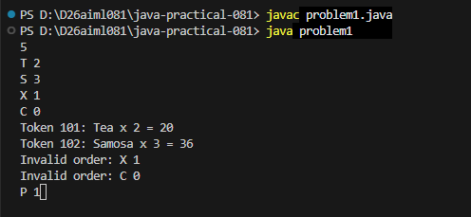

Problem-2

Problem 2: Feedback Formatter (Unit 3)
Students type their feedback quickly, so it often contains extra spaces and mixed letter case. Write a program that cleans one line of feedback and reports some statistics about it.

Output:
