WDF PRACTICAL – 1

1. Problem Definition
StudentHub is a student portal planned to provide a central place for students to access their profile, view events, submit feedback, and contact support. The project is started by identifying the main users, modules, navigation flow, and basic page structure.
For this project, seven main pages are planned: Login, Register, Home, Profile, Events, Feedback, and Contact Us.

2. User Roles
The initial StudentHub portal focuses on the following role:
- Student – can log in, access the home page, view and update the profile, view events, submit feedback, and contact support.

3. Key Modules
- Authentication – Login and Register
- Home – main student portal page
- Profile – view and update student information
- Events – view upcoming student events
- Feedback – submit feedback and rating
- Contact Us – send an enquiry to the support team

4. Page List
No. | Page | Purpose
1 | Login | Student login and entry point
2 | Register | Create a student account
3 | Home | Main portal and quick access
4 | Profile | View and update student information
5 | Events | View upcoming events
6 | Feedback | Submit student feedback
7 | Contact Us | Send an enquiry to support

5. Navigation Flow
Login → Register → Login → Home
After Login: Home → Profile / Events / Feedback / Contact Us
Logout → Login

6. Sitemap
The sitemap shows the relationship between the authentication pages and the main student portal pages.
StudentHub
├── Login
│ └── Register
│ └── Login
└── Home
├── Profile
├── Events
├── Feedback
├── Contact Us
└── Logout → Login

7. Low-Fidelity Wireframe
Simple text-based wireframes used for the initial page planning.
GITHUB
https://github.com/d26ce144-charu/StudentHub-WDF?utm_source=chatgpt.com
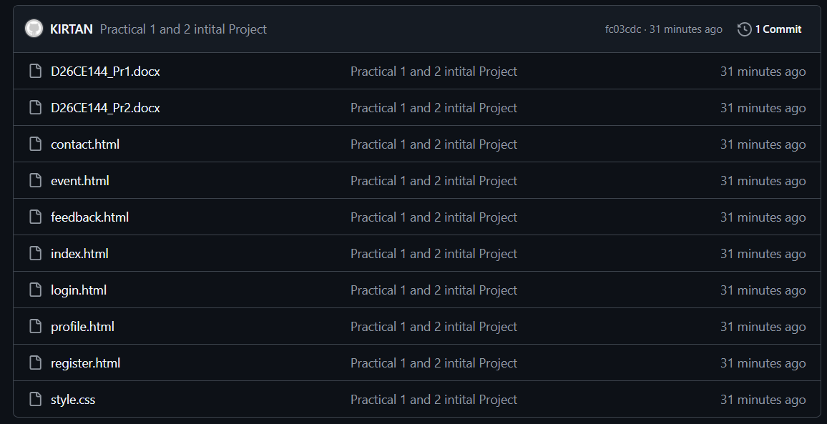

Login Page
+--------------------------------------+
| StudentHub |
| |
| Student Portal Login |
| |
| Email Address: [______________] |
| Password: [______________] |
| |
| [ Login ] |
| |
| Don't have an account? |
| [ Create an account ] |
+--------------------------------------+

Register Page
+--------------------------------------+
| StudentHub |
| |
| Create Student Account |
| |
| Full Name: [____________] |
| Student ID: [____________] |
| Email Address: [____________] |
| Course: [____________] |
| Semester: [ Select ▼ ] |
| Password: [____________] |
| Confirm Password:[____________] |
| |
| [ Create Account ] |
| |
| Already have account? [Login] |
+--------------------------------------+

Home Page
+------------------------------------------------+
| StudentHub Home Profile |
| Student Portal Events Feedback Contact |
+------------------------------------------------+
| |
| Welcome to StudentHub |
| |
| Your centralized student portal... |
| |
| Quick Access |
| +-------------+ +-------------+ +-----------+ |
| | My Profile | | Events | | Feedback | |
| | Open Profile| | View Events | | Give | |
| | | | | | Feedback | |
| +-------------+ +-------------+ +-----------+ |
| |
+------------------------------------------------+
| Footer: Copyright | Contact Us | Feedback |
+------------------------------------------------+

Profile Page
+------------------------------------------------+
| StudentHub Home Profile |
| Student Portal Events Feedback Contact |
+------------------------------------------------+
| Student Profile |
| |
| +------------+ +----------------------------+ |
| | Photo | | Profile Information | |
| | | | Name, ID, Email, Course | |
| +------------+ +----------------------------+ |
| |
| Update Profile |
| Full Name: [_______________________________] |
| Email: [_______________________________] |
| Course: [_______________________________] |
| Semester: [ Select ______________________ ] |
| |
| [ Update Profile ] |
+------------------------------------------------+
| Footer |
+------------------------------------------------+

Events Page
+------------------------------------------------+
| StudentHub Home Profile |
| Student Portal Events Feedback Contact |
+------------------------------------------------+
| Upcoming Events |
| |
| +--------------------------------------------+ |
| | Student Orientation Program | |
| | Date | Time | Venue | |
| | View Event Details | |
| +--------------------------------------------+ |
| |
| +--------------------------------------------+ |
| | Web Development Workshop | |
| | Date | Time | Venue | |
| | View Event Details | |
| +--------------------------------------------+ |
| |
| +--------------------------------------------+ |
| | Student Technology Seminar | |
| | Date | Time | Venue | |
| | View Event Details | |
| +--------------------------------------------+ |
+------------------------------------------------+

Feedback Page
+------------------------------------------------+
| StudentHub Home Profile |
| Student Portal Events Feedback Contact |
+------------------------------------------------+
| Student Feedback |
| |
| Name: [_______________________________] |
| |
| Rating: ( ) 1 Poor ( ) 2 Fair |
| ( ) 3 Good ( ) 4 Very Good |
| ( ) 5 Excellent |
| |
| Your Feedback: |
| +--------------------------------------------+ |
| | | |
| | | |
| +--------------------------------------------+ |
| |
| [ Submit Feedback ] |
+------------------------------------------------+

Contact Us Page
+------------------------------------------------+
| StudentHub Home Profile |
| Student Portal Events Feedback Contact |
+------------------------------------------------+
| Contact Us |
| |
| Contact Information |
| Email | Phone | Address |
| |
| Send an Enquiry |
| Full Name: [____________________________] |
| Email: [____________________________] |
| Subject: [____________________________] |
| Message: |
| +--------------------------------------------+ |
| | | |
| | | |
| +--------------------------------------------+ |
| |
| [ Send Message ] |
+------------------------------------------------+
| Footer |
+------------------------------------------------+

8. Key Questions / Analysis / Interpretation

Q1. What is URL and parts of URL?
URL stands for Uniform Resource Locator. It is the address used to locate a resource on the web. Common parts include the protocol (such as https), domain name, port when specified, path, query string, and fragment.
Example: https://www.example.com/students/profile?id=10#details
Protocol: https | Domain: www.example.com | Path: /students/profile | Query: ?id=10 | Fragment: #details

Q2. How does HTML file processed in web browser?
When an HTML file is opened, the browser reads the HTML source and parses the elements to create the Document Object Model (DOM). The browser then interprets the document structure and displays the page.

Q3. How will page navigation flow managed among all HTML pages?
Navigation is managed using HTML anchor tags with href attributes. Each link points to another HTML page in the project folder. The planned flow starts with Login, moves to Register when an account is needed, returns to Login, and then moves to Home. The main portal pages are connected through the navigation menu.

Q4. How will GitHub commits be maintained after each practical?
GitHub commits will be maintained after each practical by saving the completed work, committing the changes with a clear practical-related message, and pushing the commit to the project repository.
Example commit messages: Practical 1 completed, Practical 2 HTML pages added.

9. Requirement Summary
The initial StudentHub requirements are to provide a simple student portal with authentication pages, a home page, profile management, event viewing, feedback, and contact functionality. The seven-page structure is designed to keep navigation simple and clear.

10. Folder Structure
StudentHub/
├── index.html
├── login.html
├── register.html
├── profile.html
├── event.html
├── feedback.html
├── contact.html
├── images/
└── README.md

11. Post Laboratory Work
The practical submission contains the project requirements, sitemap, low-fidelity wireframes, folder structure, README information, and the project repository.

12. Conclusion
The StudentHub project foundation was prepared by defining the requirements, user role, modules, seven-page navigation flow, sitemap, wireframes, and project folder structure.

