Practical 3 — Responsive UI Design

Shared layout CSS
* {
box-sizing: border-box;
}

body {
min-height: 100vh;
margin: 0;
display: flex;
flex-direction: column;
font-family: Arial, sans-serif;
}

.container {
width: 100%;
max-width: 1140px;
margin: 0 auto;
padding: 28px 18px 48px;
flex: 1;
}

.header-container {
max-width: 1140px;
margin: 0 auto;
padding: 14px 24px;
display: flex;
align-items: center;
justify-content: space-between;
gap: 24px;
flex-wrap: wrap;
}

.main-nav ul {
display: flex;
align-items: center;
gap: 6px;
flex-wrap: wrap;
list-style: none;
}

.card-grid,
.event-list {
display: grid;
grid-template-columns: repeat(auto-fit, minmax(260px, 1fr));
gap: 22px;
}

.contact-layout,
.profile-top {
display: grid;
grid-template-columns: 1fr 1.35fr;
gap: 26px;
}

.info-grid {
display: grid;
grid-template-columns: 130px 1fr;
gap: 14px 16px;
}

.quick-access-content {
display: flex;
align-items: center;
justify-content: space-between;
gap: 24px;
flex-wrap: wrap;
}

@media (max-width: 900px) {
.contact-layout,
.profile-top {
grid-template-columns: 1fr;
}

.info-grid {
grid-template-columns: 110px 1fr;
}
}

@media (max-width: 720px) {
.header-container {
padding: 12px 18px;
}

.main-nav ul {
gap: 4px;
}

.container {
padding: 28px 18px 48px;
}
}

@media (max-width: 520px) {
.info-grid {
grid-template-columns: 1fr;
row-gap: 4px;
}

.footer-container {
flex-direction: column;
text-align: center;
}

.card-grid,
.event-list {
grid-template-columns: minmax(0, 1fr);
}
}

Home page layout
<main class="container">
<section class="hero">
<div class="hero-content">
<span class="hero-label">WELCOME TO YOUR CAMPUS</span>
<h2>Your Campus. Your Community.</h2>
<p>
Manage your student profile, discover campus events,
share feedback, and stay connected.
</p>
<div class="hero-actions">
<a href="event.html" class="primary-button">Explore Events</a>
<a href="register.html" class="secondary-button">Create Account</a>
</div>
</div>
</section>

<section class="features-section">
<h2 class="page-title">Everything You Need</h2>
<div class="card-grid">
<article class="card">
<h3>Your Profile</h3>
<p>Keep your student information organized.</p>
<a href="profile.html" class="card-link">View Dashboard</a>
</article>
<article class="card">
<h3>Campus Events</h3>
<p>Discover activities and opportunities on campus.</p>
<a href="event.html" class="card-link">Discover Events</a>
</article>
<article class="card">
<h3>Share Feedback</h3>
<p>Help improve your student experience.</p>
<a href="feedback.html" class="card-link">Give Feedback</a>
</article>
</div>
</section>
</main>
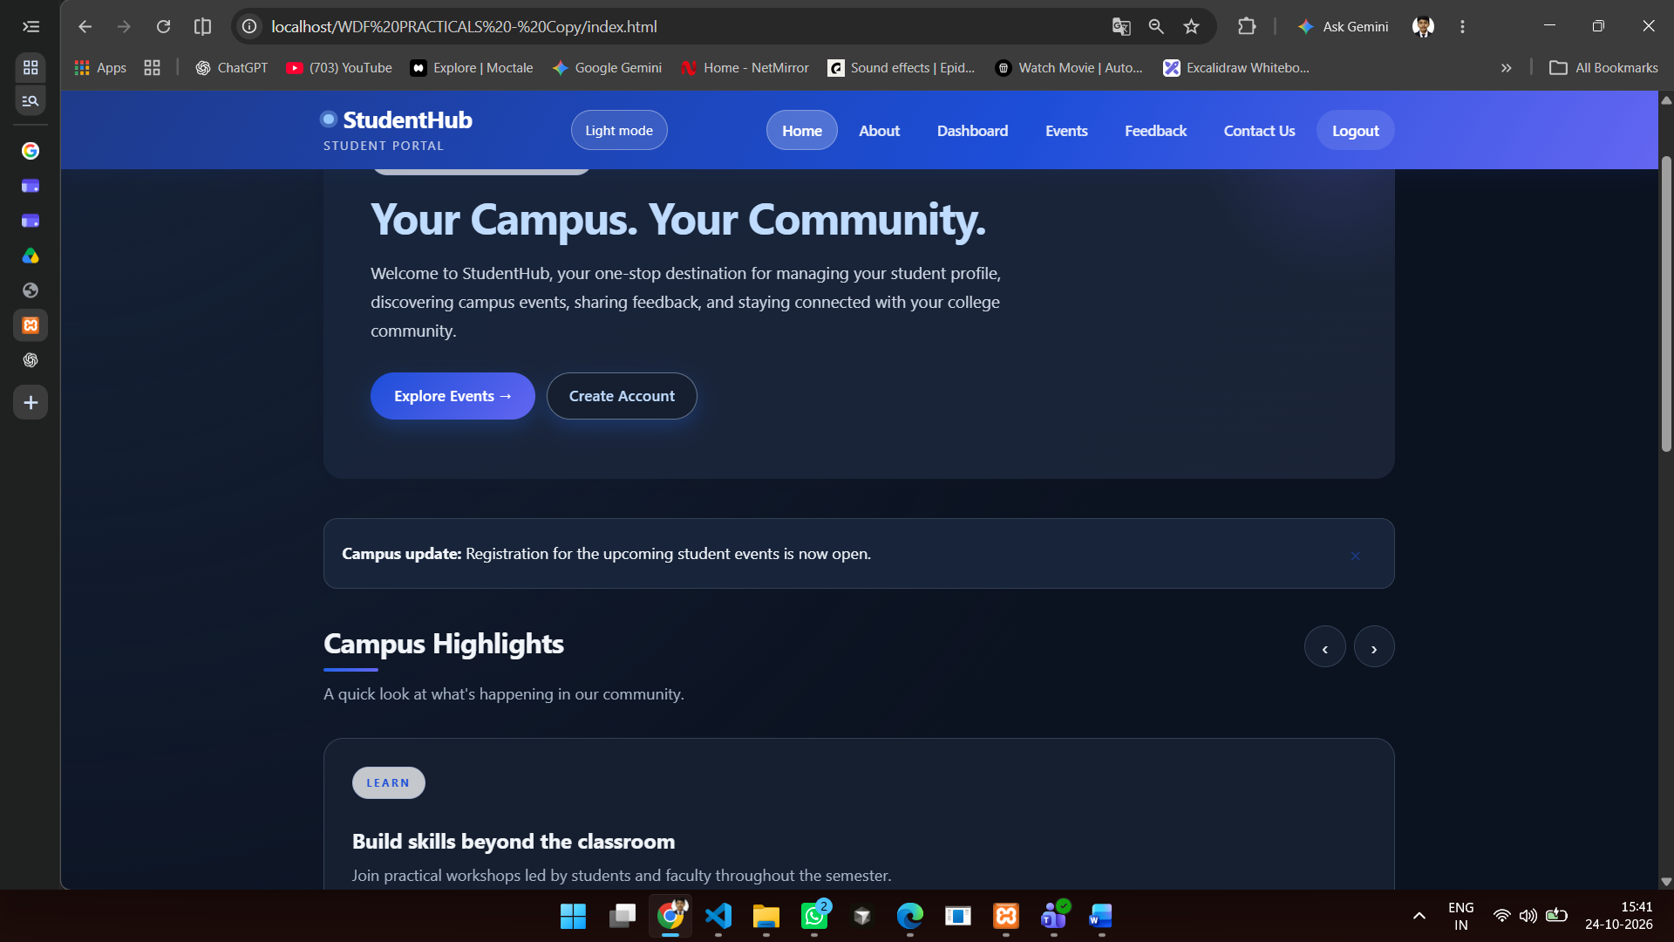

About page layout
<main class="container">
<section class="hero">
<div class="hero-content">
<span class="hero-label">ABOUT STUDENTHUB</span>
<h2>Your campus, all in one place.</h2>
<p>
StudentHub brings student profiles, campus events, and
feedback tools together in one responsive portal.
</p>
<a href="register.html" class="primary-button">Join StudentHub</a>
</div>
</section>

<section class="features-section">
<h2 class="page-title">Designed for student life</h2>
<div class="card-grid">
<article class="card">
<h3>A profile that stays current</h3>
<p>Keep your student information organized.</p>
</article>
<article class="card">
<h3>Campus activities</h3>
<p>Discover events and workshops.</p>
</article>
<article class="card">
<h3>Student voice</h3>
<p>Share feedback and get help.</p>
</article>
</div>
</section>
</main>
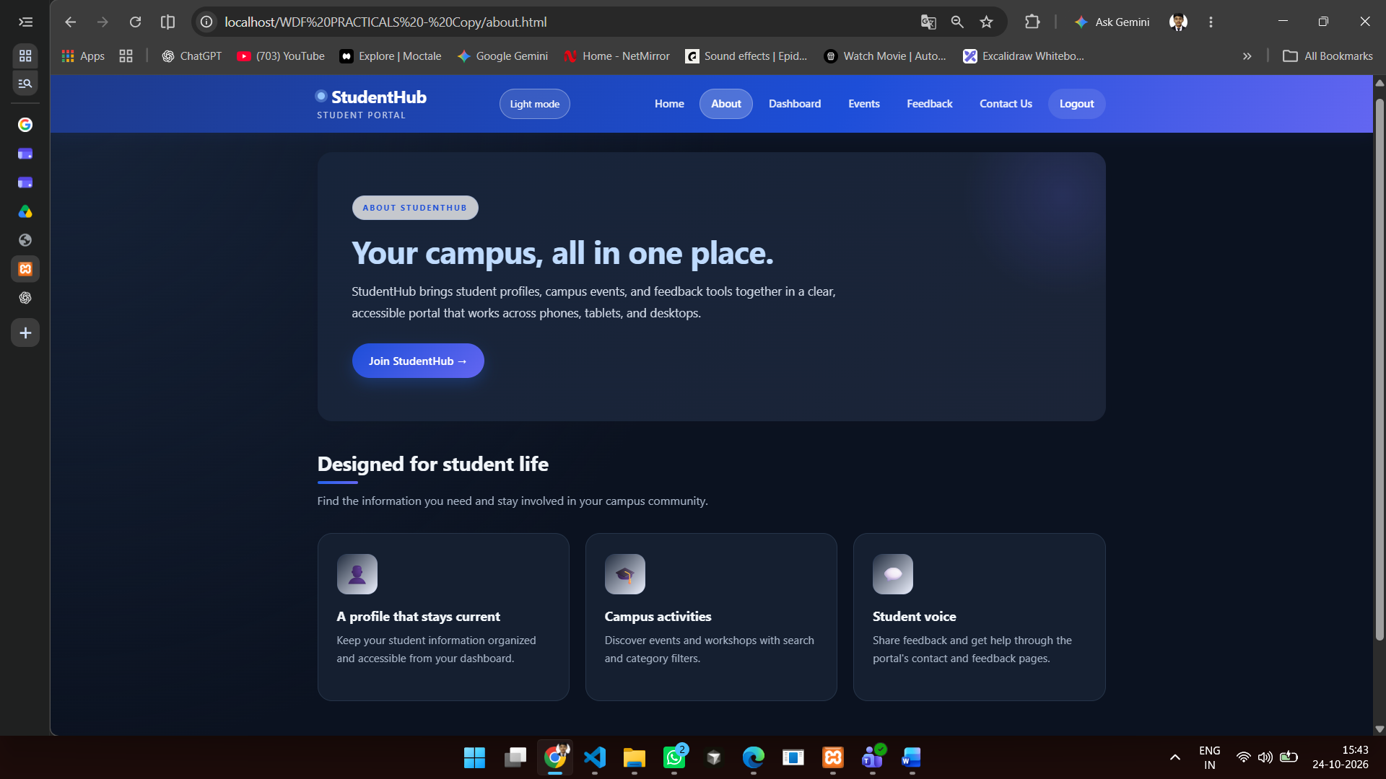

Dashboard layout
<main class="container">
<div class="page-heading">
<h2>Student Dashboard</h2>
<p>View and update your student information.</p>
</div>

<section class="profile-top">
<article class="profile-card">
<div class="profile-placeholder" id="profileInitials">ST</div>
<h3 id="displayName">Student Name</h3>
<p id="displayStudentId">Student ID</p>
</article>

<article class="information-card">
<h3>Profile Information</h3>
<div class="info-grid">
<div class="info-label">Full Name</div>
<div class="info-value" id="infoName">Student Name</div>
<div class="info-label">Email</div>
<div class="info-value" id="infoEmail">student@example.com</div>
<div class="info-label">Course</div>
<div class="info-value" id="infoCourse">Course</div>
</div>
</article>
</section>
</main>
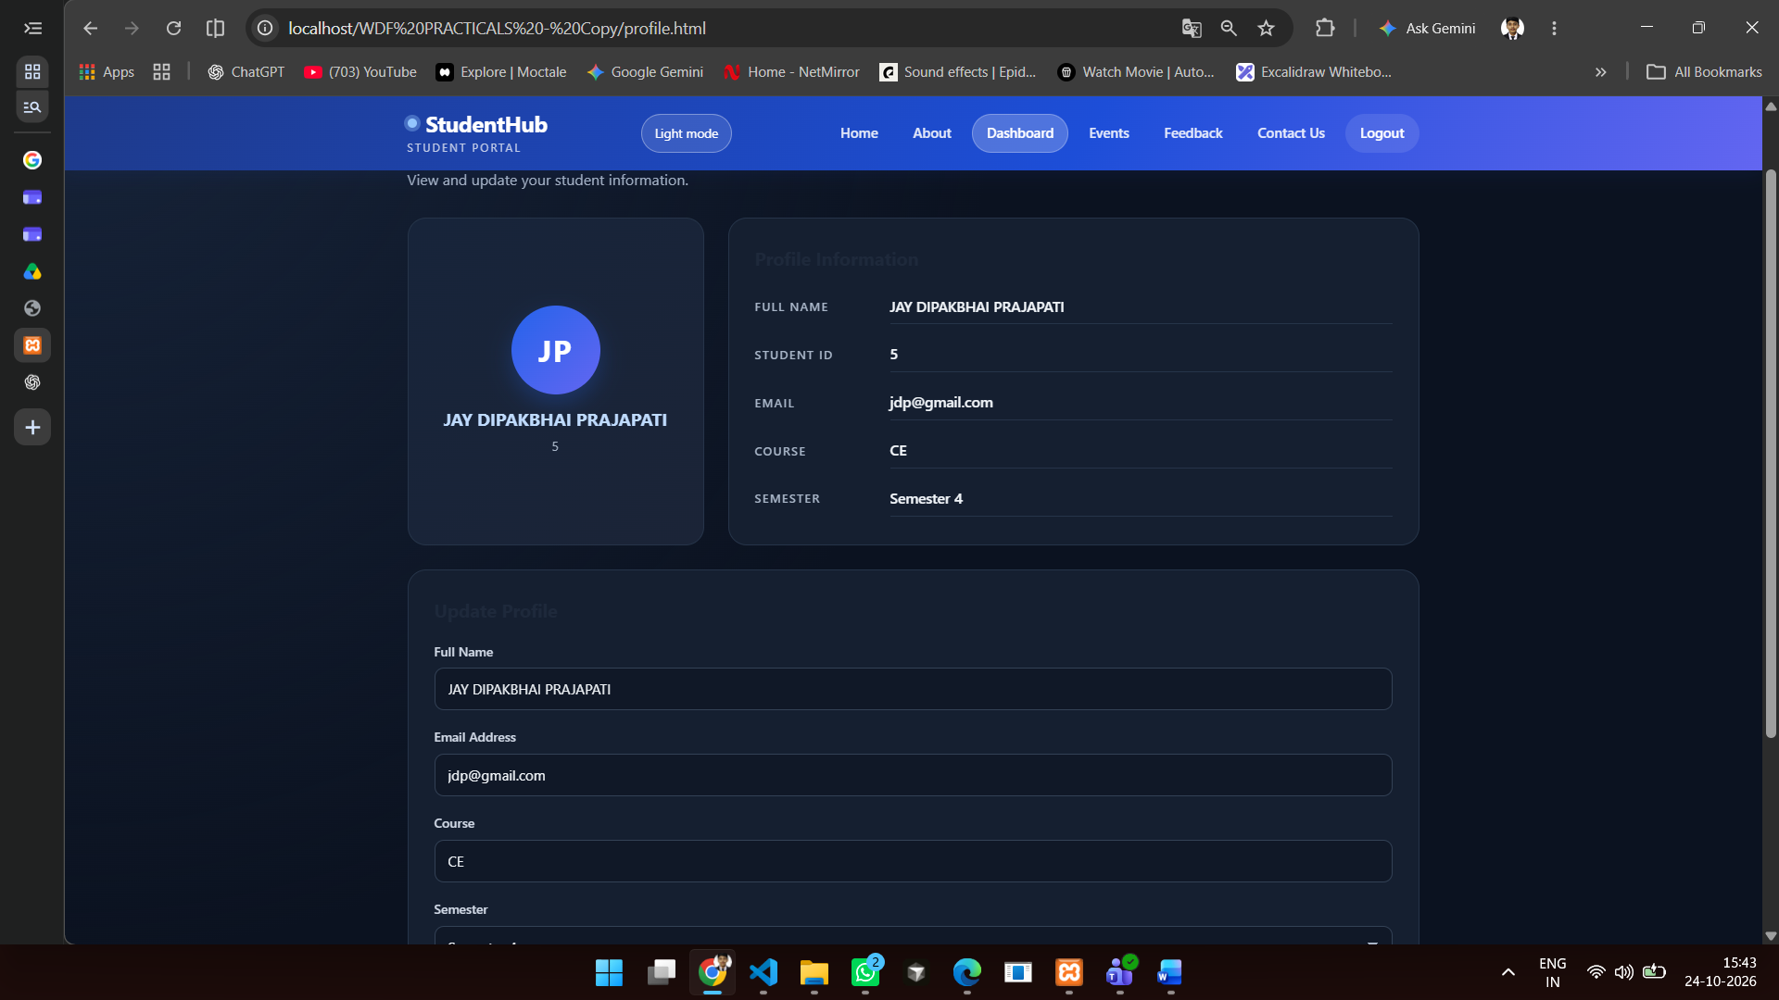

Mobile hamburger navigation — HTML
<div class="header-actions">
<button class="menu-toggle"
type="button"
aria-controls="site-navigation"
aria-expanded="false">
<span aria-hidden="true">☰</span>
<span class="visually-hidden">Toggle navigation</span>
</button>
<button class="theme-toggle" type="button" aria-pressed="false">
Dark mode
</button>
</div>

<nav class="main-nav" id="site-navigation" aria-label="Main navigation">
<ul>
<li><a href="index.html">Home</a></li>
<li><a href="about.html">About</a></li>
<li><a href="profile.html">Dashboard</a></li>
<li><a href="event.html">Events</a></li>
</ul>
</nav>
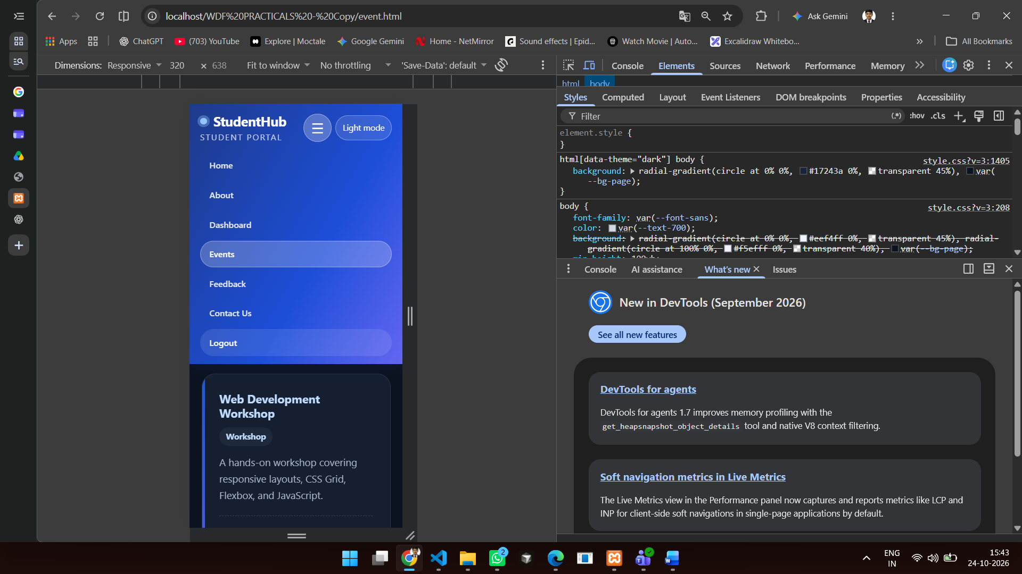

Mobile hamburger navigation — CSS
.menu-toggle {
display: none;
}

@media (max-width: 720px) {
.menu-toggle {
display: inline-flex;
}

.main-nav {
display: none;
flex: 0 0 100%;
width: 100%;
}

.main-nav.is-open {
display: block;
}

.main-nav ul {
align-items: stretch;
flex-direction: column;
}

.main-nav a {
display: block;
padding: 10px 14px;
}
}

Practical 4 — JavaScript DOM Manipulation and UI Interactivity

Homepage interactive components — HTML
<aside class="notice-banner" id="noticeBanner" role="status">
<p><strong>Campus update:</strong> Event registration is open.</p>
<button class="notice-dismiss" type="button" aria-label="Dismiss notification">
&times;
</button>
</aside>

<section class="highlights-section" aria-labelledby="highlights-title">
<h2 id="highlights-title">Campus Highlights</h2>

<div class="slider-controls">
<button type="button" data-slide="previous" aria-label="Previous highlight">‹</button>
<button type="button" data-slide="next" aria-label="Next highlight">›</button>
</div>

<div class="highlight-slider" aria-live="polite">
<article class="highlight-slide is-active">
<h3>Build skills beyond the classroom</h3>
<p>Join practical campus workshops.</p>
</article>
<article class="highlight-slide">
<h3>Find your campus community</h3>
<p>Meet classmates and discover student activities.</p>
</article>
<article class="highlight-slide">
<h3>Your ideas help shape the experience</h3>
<p>Share feedback with StudentHub.</p>
</article>
</div>
</section>

<section class="faq-section" aria-labelledby="faq-title">
<h2 id="faq-title">Frequently Asked Questions</h2>
<details class="faq-item">
<summary>How do I update my student information?</summary>
<p>Open your Dashboard and use the Update Profile form.</p>
</details>
<details class="faq-item">
<summary>Where can I find upcoming activities?</summary>
<p>Visit the Events page to search and filter campus activities.</p>
</details>
</section>

<dialog class="welcome-modal" id="welcomeModal" aria-labelledby="modal-title">
<button class="modal-close" type="button" aria-label="Close welcome message">
&times;
</button>
<h2 id="modal-title">Welcome to your campus community</h2>
<p>Discover events and stay connected with StudentHub.</p>
<a class="primary-button" href="event.html">Explore events</a>
</dialog>

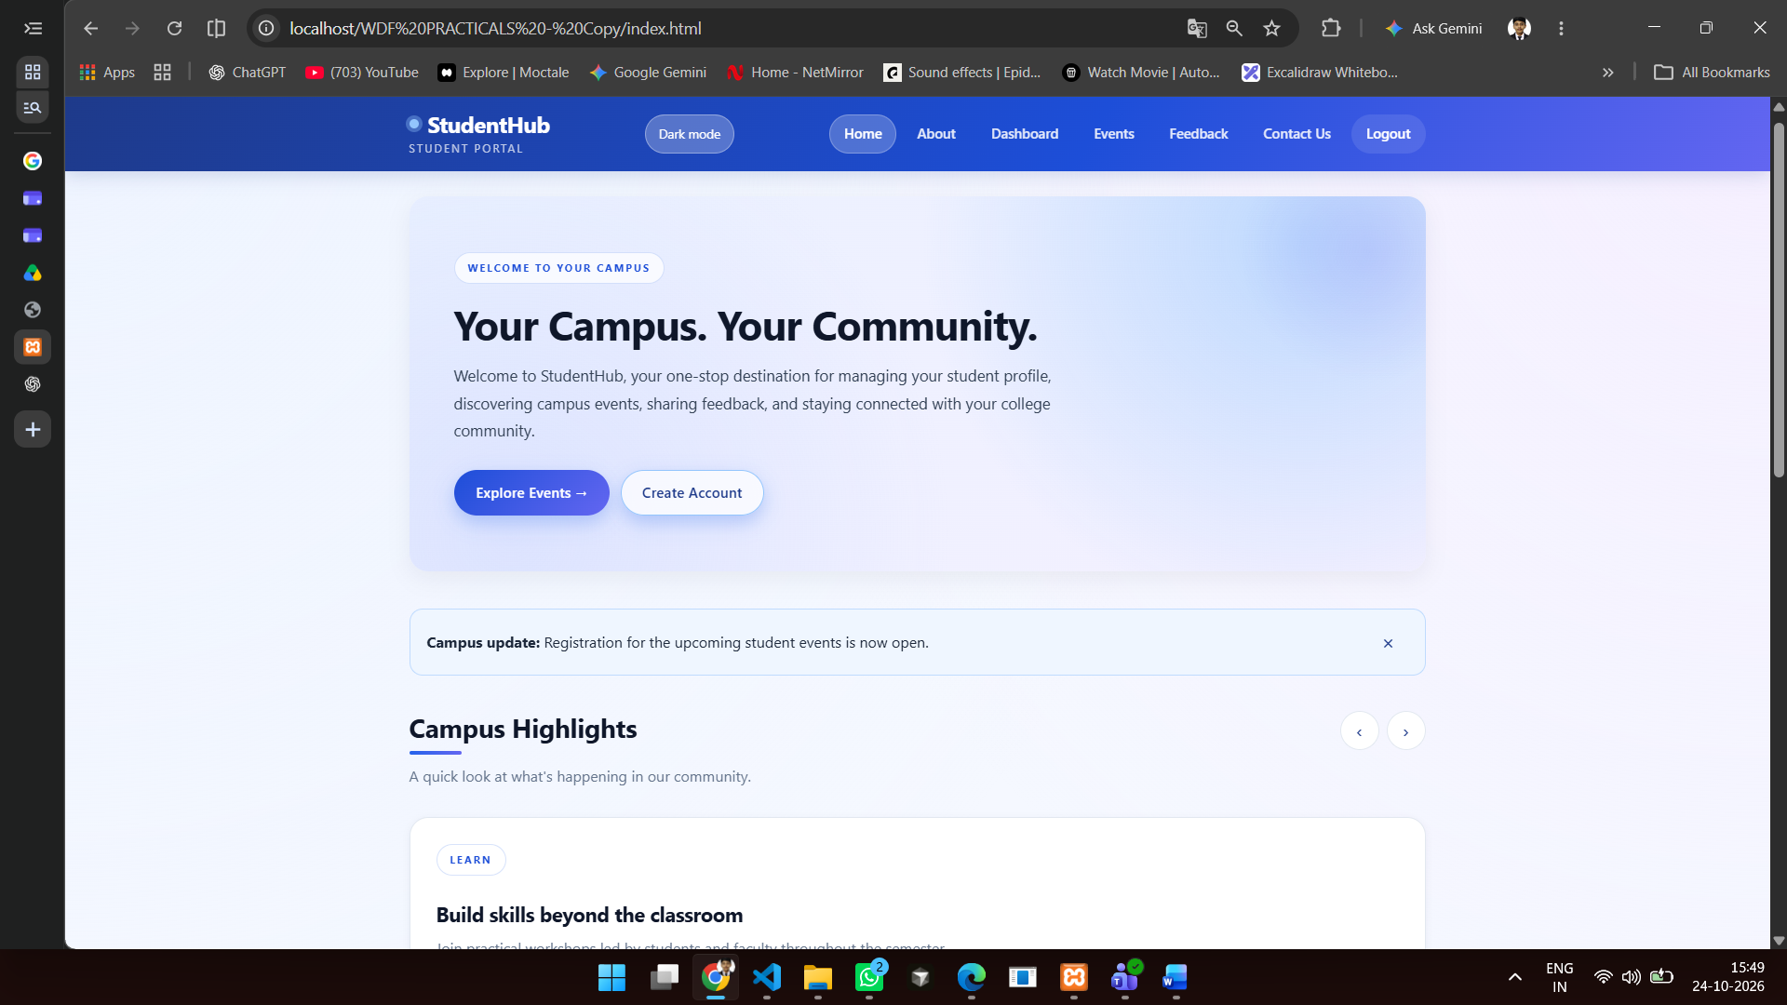
Light mode
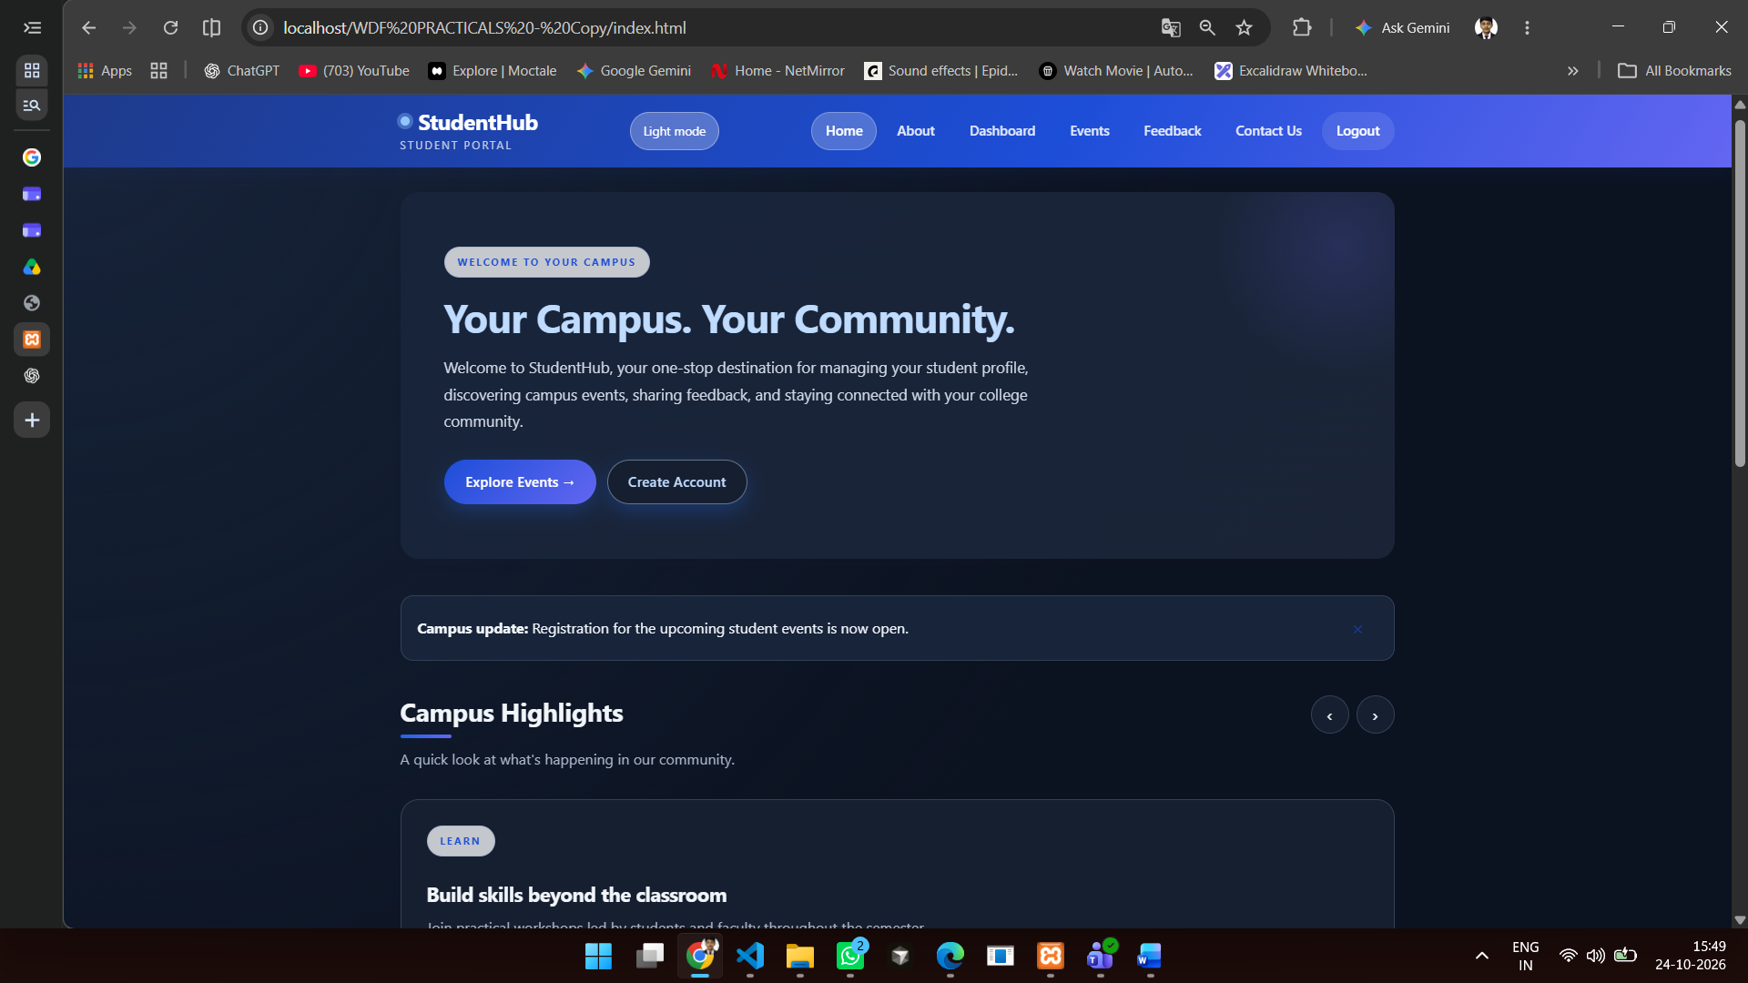
Dark mode

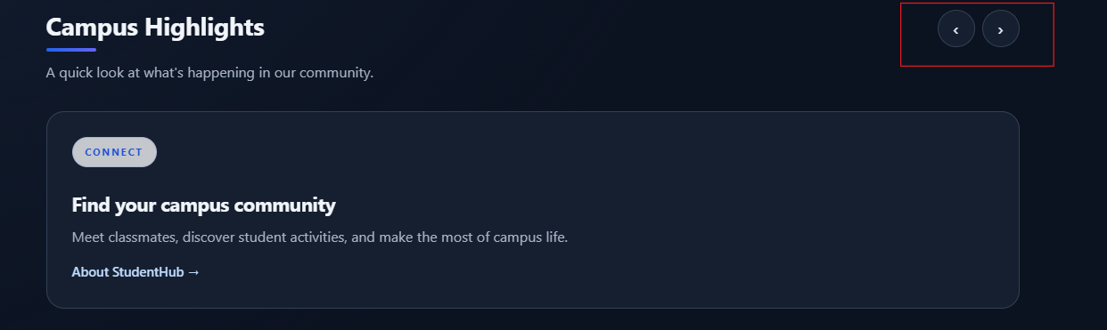
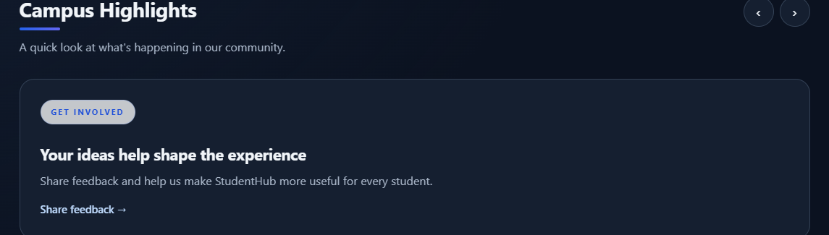
Slider

JavaScript interactions
document.addEventListener("DOMContentLoaded", () => {
const themeButtons = document.querySelectorAll(".theme-toggle");

function setTheme(theme) {
document.documentElement.dataset.theme = theme;
localStorage.setItem("studenthub-theme", theme);

themeButtons.forEach((button) => {
const isDark = theme === "dark";
button.textContent = isDark ? "Light mode" : "Dark mode";
button.setAttribute("aria-pressed", String(isDark));
});
}

setTheme(localStorage.getItem("studenthub-theme") === "dark" ? "dark" : "light");

themeButtons.forEach((button) => {
button.addEventListener("click", () => {
const nextTheme =
document.documentElement.dataset.theme === "dark" ? "light" : "dark";
setTheme(nextTheme);
});
});

document.querySelectorAll(".menu-toggle").forEach((button) => {
const navigation = document.getElementById(button.getAttribute("aria-controls"));

if (!navigation) return;

button.addEventListener("click", () => {
const isOpen = navigation.classList.toggle("is-open");
button.setAttribute("aria-expanded", String(isOpen));
});
});

const notice = document.getElementById("noticeBanner");
notice?.querySelector(".notice-dismiss")?.addEventListener("click", () => {
notice.hidden = true;
});

const slides = [...document.querySelectorAll(".highlight-slide")];
let activeSlide = slides.findIndex((slide) => slide.classList.contains("is-active"));

document.querySelectorAll("[data-slide]").forEach((button) => {
button.addEventListener("click", () => {
if (slides.length === 0) return;

slides[activeSlide].classList.remove("is-active");
const step = button.dataset.slide === "next" ? 1 : -1;
activeSlide = (activeSlide + step + slides.length) % slides.length;
slides[activeSlide].classList.add("is-active");
});
});

const modal = document.getElementById("welcomeModal");
const closeButton = modal?.querySelector(".modal-close");

if (modal instanceof HTMLDialogElement &&
!sessionStorage.getItem("welcome-seen")) {
window.setTimeout(() => {
if (!modal.open) modal.showModal();
}, 900);

modal.addEventListener("close", () => {
sessionStorage.setItem("welcome-seen", "true");
});

closeButton?.addEventListener("click", () => modal.close());
}
});

Practical 5 — Registration Form and Validation

Registration form — HTML
<form id="registerForm" action="php/register.php" method="POST" novalidate>
<div class="form-group">
<label for="fullname">Full Name</label>
<input type="text" id="fullname" name="fullname"
autocomplete="name" required>
</div>

<div class="form-group">
<label for="register-email">Email Address</label>
<input type="email" id="register-email" name="email"
autocomplete="email" required>
</div>

<div class="form-group">
<label for="mobile">Mobile Number</label>
<input type="tel" id="mobile" name="mobile"
inputmode="numeric" maxlength="10" required>
</div>

<div class="form-group">
<label for="course">Course</label>
<input type="text" id="course" name="course" required>
</div>

<div class="form-group">
<label for="year">Year of Study</label>
<select id="year" name="year" required>
<option value="">Select Year</option>
<option value="1">First Year</option>
<option value="2">Second Year</option>
<option value="3">Third Year</option>
<option value="4">Fourth Year</option>
</select>
</div>

<div class="form-group">
<label for="register-password">Password</label>
<input type="password" id="register-password" name="password"
minlength="8" autocomplete="new-password" required>
</div>

<div class="form-group">
<label for="confirm-password">Confirm Password</label>
<input type="password" id="confirm-password" name="confirm-password"
autocomplete="new-password" required>
</div>

<fieldset class="choice-group">
<legend>Gender</legend>
<label><input type="radio" name="gender" value="female" required> Female</label>
<label><input type="radio" name="gender" value="male"> Male</label>
<label><input type="radio" name="gender" value="other"> Other</label>
<label><input type="radio" name="gender" value="prefer-not-to-say">
Prefer not to say
</label>
</fieldset>

<div class="terms-group">
<label for="terms">
<input type="checkbox" id="terms" name="terms"
value="accepted" required>
I accept the terms and conditions.
</label>
</div>

<button type="submit" class="submit-button">Create Account</button>
<p id="registerMessage" class="form-message" role="alert"></p>
</form>

JavaScript validation
document.addEventListener("DOMContentLoaded", () => {
const form = document.getElementById("registerForm");
const message = document.getElementById("registerMessage");

if (!form || !message) return;

const rules = [
{
name: "fullname",
pattern: /^[\p{L}][\p{L}\s'.-]*$/u,
message: "Enter a valid name."
},
{
name: "email",
pattern: /^[^\s@]+@[^\s@]+\.[^\s@]{2,}$/,
message: "Enter a valid email address."
},
{
name: "mobile",
pattern: /^[6-9]\d{9}$/,
message: "Enter a valid 10-digit mobile number."
},
{
name: "course",
pattern: /^[\p{L}\p{N}][\p{L}\p{N}\s&'().-]*$/u,
message: "Enter a valid course name."
},
{
name: "year",
pattern: /^[1-4]$/,
message: "Select your year of study."
},
{
name: "password",
pattern: /^(?=.*[A-Za-z])(?=.*\d).{8,}$/,
message: "Password must be at least 8 characters and include a letter and a number."
}
];

function showError(text, field) {
message.textContent = text;
message.className = "form-message error";
field?.focus();
}

form.addEventListener("submit", async (event) => {
event.preventDefault();
message.textContent = "";

for (const rule of rules) {
const field = form.elements.namedItem(rule.name);

if (!rule.pattern.test(field.value.trim())) {
showError(rule.message, field);
return;
}
}

const password = form.elements.namedItem("password");
const confirmPassword = form.elements.namedItem("confirm-password");
const gender = form.querySelector('input[name="gender"]:checked');
const terms = document.getElementById("terms");

if (password.value !== confirmPassword.value) {
showError("Passwords do not match.", confirmPassword);
return;
}

if (!gender) {
showError("Select a gender option to continue.",
form.querySelector('input[name="gender"]'));
return;
}

if (!terms.checked) {
showError("Please accept the terms and conditions.", terms);
return;
}

try {
const response = await fetch(form.action, {
method: "POST",
body: new FormData(form)
});
const result = await response.json();

if (!result.success) {
showError(result.message, null);
return;
}

message.textContent = "Account created successfully.";
message.className = "form-message success";
form.reset();
} catch (error) {
console.error(error);
showError("Unable to connect to the server. Please try again.", null);
}
});
});
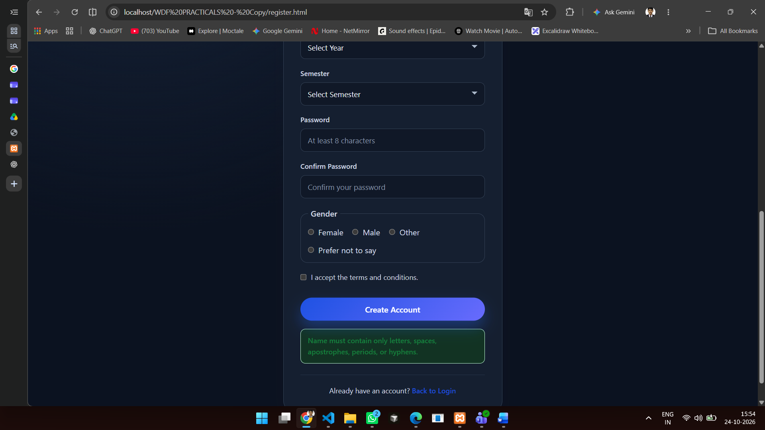
NAME ERROR
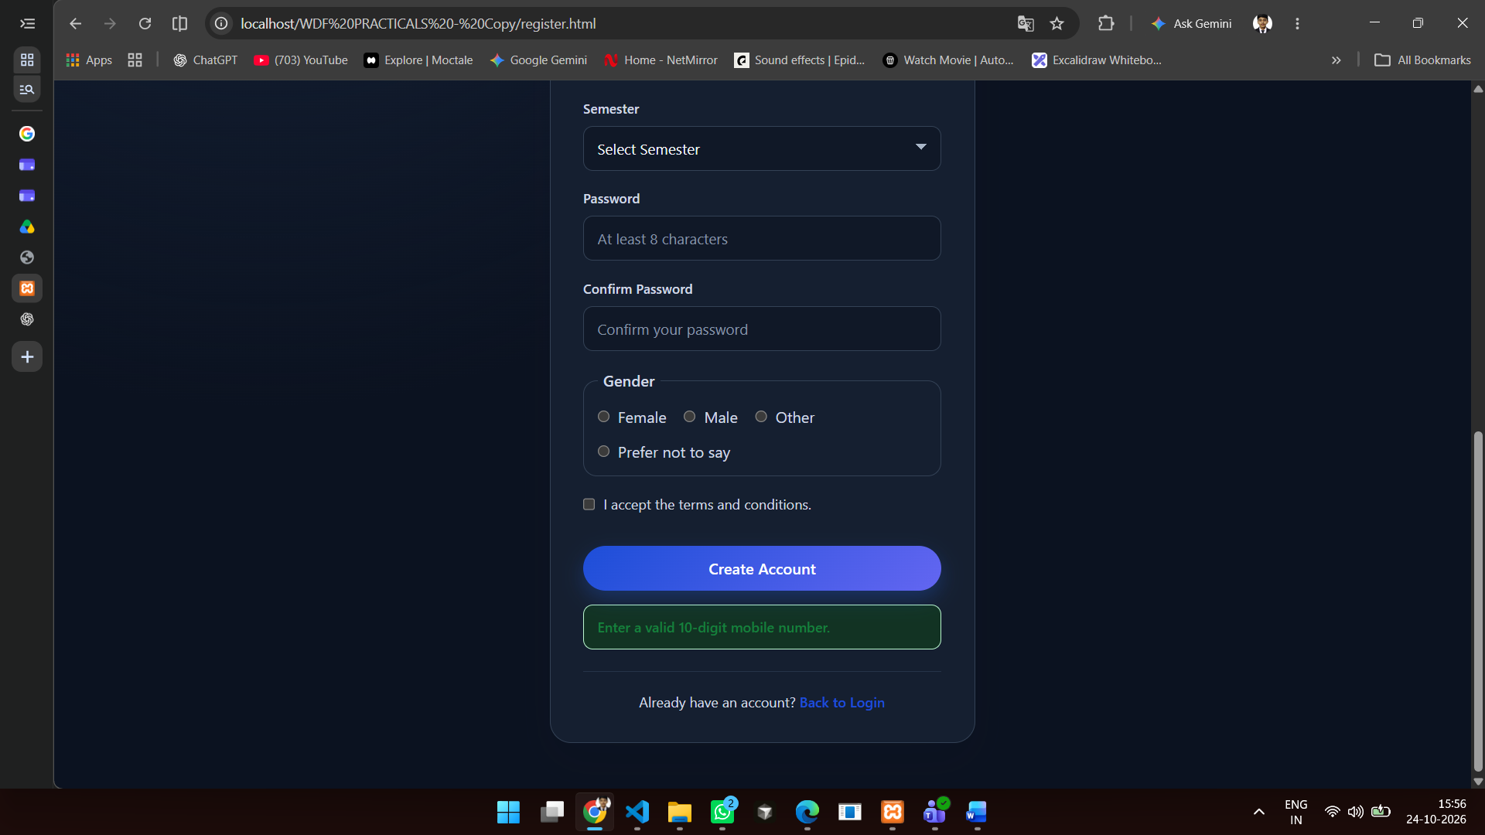
MOBILE ERROR
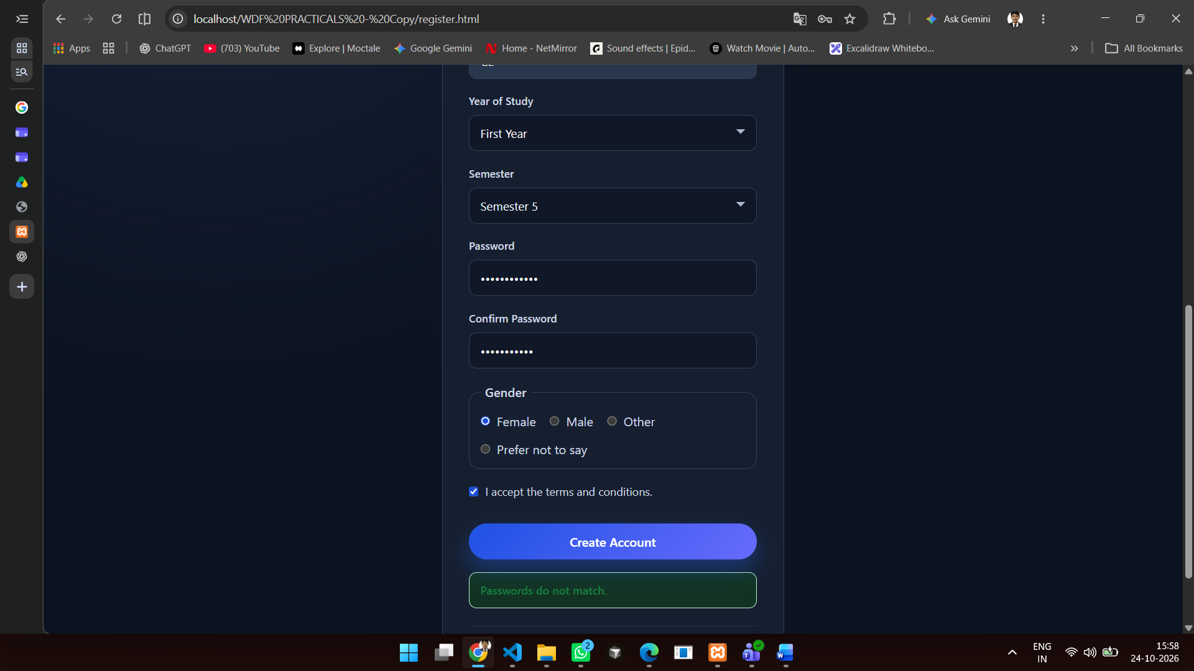
PASSWORD ERROR

Practical 6 — Fetch JSON, Search, Filter, Sort, and Pagination

Events page controls — HTML
<section class="event-tools" aria-label="Search and filter events">
<div class="form-group">
<label for="eventSearch">Search events</label>
<input type="search" id="eventSearch"
placeholder="Search by name, venue, or description">
</div>

<div class="form-group">
<label for="eventCategory">Category</label>
<select id="eventCategory">
<option value="all">All categories</option>
</select>
</div>

<div class="form-group">
<label for="eventSort">Sort by</label>
<select id="eventSort">
<option value="date-asc">Date: soonest first</option>
<option value="date-desc">Date: latest first</option>
<option value="title-asc">Name: A to Z</option>
<option value="title-desc">Name: Z to A</option>
</select>
</div>
</section>

<p id="eventStatus" class="event-status" role="status">Loading events...</p>
<section class="event-list" id="eventList" aria-label="Upcoming student events"></section>
<nav class="pagination" id="eventPagination" aria-label="Event pages"></nav>

<script src="js/events.js"></script>

data/events.json
[
{
"title": "Student Orientation Program",
"description": "Welcome program for students with information about academic and campus activities.",
"date": "2026-11-05",
"time": "10:00 AM",
"venue": "Main Auditorium",
"category": "Campus"
},
{
"title": "Web Development Workshop",
"description": "A hands-on workshop covering responsive layouts, CSS Grid, Flexbox, and JavaScript.",
"date": "2026-11-12",
"time": "11:00 AM",
"venue": "Computer Laboratory",
"category": "Workshop"
},
{
"title": "Student Technology Seminar",
"description": "Explore emerging technologies, student projects, and career opportunities.",
"date": "2026-11-19",
"time": "2:00 PM",
"venue": "Seminar Hall",
"category": "Seminar"
},
{
"title": "Campus Cultural Evening",
"description": "An evening of student performances, music, and cultural activities.",
"date": "2026-11-26",
"time": "5:30 PM",
"venue": "Open-Air Theatre",
"category": "Campus"
},
{
"title": "Introduction to UI Design",
"description": "Learn the principles of accessible, mobile-first interface design.",
"date": "2026-12-03",
"time": "1:00 PM",
"venue": "Design Studio",
"category": "Workshop"
},
{
"title": "Student Project Showcase",
"description": "Meet student teams and see projects created across the academic year.",
"date": "2026-12-10",
"time": "10:30 AM",
"venue": "Innovation Centre",
"category": "Showcase"
},
{
"title": "Career Readiness Seminar",
"description": "Practical guidance on resumes, interviews, and preparing for internships.",
"date": "2026-12-17",
"time": "2:30 PM",
"venue": "Seminar Hall",
"category": "Seminar"
}
]

js/events.js
document.addEventListener("DOMContentLoaded", async () => {
const eventList = document.getElementById("eventList");
const eventStatus = document.getElementById("eventStatus");
const searchInput = document.getElementById("eventSearch");
const categorySelect = document.getElementById("eventCategory");
const sortSelect = document.getElementById("eventSort");
const pagination = document.getElementById("eventPagination");

if (!eventList || !eventStatus || !searchInput ||
!categorySelect || !sortSelect || !pagination) {
return;
}

const pageSize = 3;
let events = [];
let currentPage = 1;

function createMeta(label, value) {
const paragraph = document.createElement("p");
const strong = document.createElement("strong");

strong.textContent = `${label}: `;
paragraph.append(strong, document.createTextNode(value));

return paragraph;
}

function getVisibleEvents() {
const searchTerm = searchInput.value.trim().toLocaleLowerCase();
const selectedCategory = categorySelect.value;

const filteredEvents = events
.filter((item) =>
selectedCategory === "all" ||
item.category === selectedCategory
)
.filter((item) =>
[item.title, item.description, item.venue, item.category]
.some((value) =>
value.toLocaleLowerCase().includes(searchTerm)
)
);

filteredEvents.sort((first, second) => {
switch (sortSelect.value) {
case "date-desc":
return second.date.localeCompare(first.date);
case "title-asc":
return first.title.localeCompare(second.title);
case "title-desc":
return second.title.localeCompare(first.title);
default:
return first.date.localeCompare(second.date);
}
});

return filteredEvents;
}

function render() {
const visibleEvents = getVisibleEvents();
const pageCount = Math.ceil(visibleEvents.length / pageSize);

currentPage = Math.min(currentPage, Math.max(pageCount, 1));

const pageEvents = visibleEvents.slice(
(currentPage - 1) * pageSize,
currentPage * pageSize
);

eventList.replaceChildren();
pagination.replaceChildren();

if (visibleEvents.length === 0) {
eventStatus.textContent =
"No events match your search. Try another keyword or category.";
return;
}

eventStatus.textContent =
`Showing ${pageEvents.length} of ${visibleEvents.length} events.`;

pageEvents.forEach((item) => {
const article = document.createElement("article");
article.className = "event-card";

const title = document.createElement("h3");
title.textContent = item.title;

const description = document.createElement("p");
description.textContent = item.description;

const category = document.createElement("span");
category.className = "event-category";
category.textContent = item.category;

const meta = document.createElement("div");
meta.className = "event-meta";
meta.append(
createMeta("Date", new Intl.DateTimeFormat(undefined, {
day: "numeric",
month: "long",
year: "numeric"
}).format(new Date(`${item.date}T00:00:00`))),
createMeta("Time", item.time),
createMeta("Venue", item.venue)
);

article.append(title, category, description, meta);
eventList.append(article);
});

for (let page = 1; page <= pageCount; page += 1) {
const button = document.createElement("button");
button.type = "button";
button.className = "pagination-button";
button.textContent = String(page);
button.setAttribute("aria-label", `Page ${page}`);
button.setAttribute("aria-current", String(page === currentPage));
button.disabled = page === currentPage;

button.addEventListener("click", () => {
currentPage = page;
render();
});

pagination.append(button);
}
}

try {
const response = await fetch("data/events.json");

if (!response.ok) {
throw new Error(`Event request failed: ${response.status}`);
}

const data = await response.json();

if (!Array.isArray(data)) {
throw new Error("Event data must be a JSON array.");
}

events = data.filter((item) =>
item &&
typeof item.title === "string" &&
typeof item.description === "string" &&
typeof item.date === "string" &&
typeof item.time === "string" &&
typeof item.venue === "string" &&
typeof item.category === "string"
);

[...new Set(events.map((item) => item.category))]
.sort()
.forEach((category) => {
const option = document.createElement("option");
option.value = category;
option.textContent = category;
categorySelect.append(option);
});

if (events.length === 0) {
throw new Error("No valid event records were found.");
}

searchInput.addEventListener("input", () => {
currentPage = 1;
render();
});

categorySelect.addEventListener("change", () => {
currentPage = 1;
render();
});

sortSelect.addEventListener("change", () => {
currentPage = 1;
render();
});

render();
} catch (error) {
console.error(error);
eventStatus.textContent =
"Events could not be loaded. Please try again later.";
eventStatus.classList.add("error");
}
});
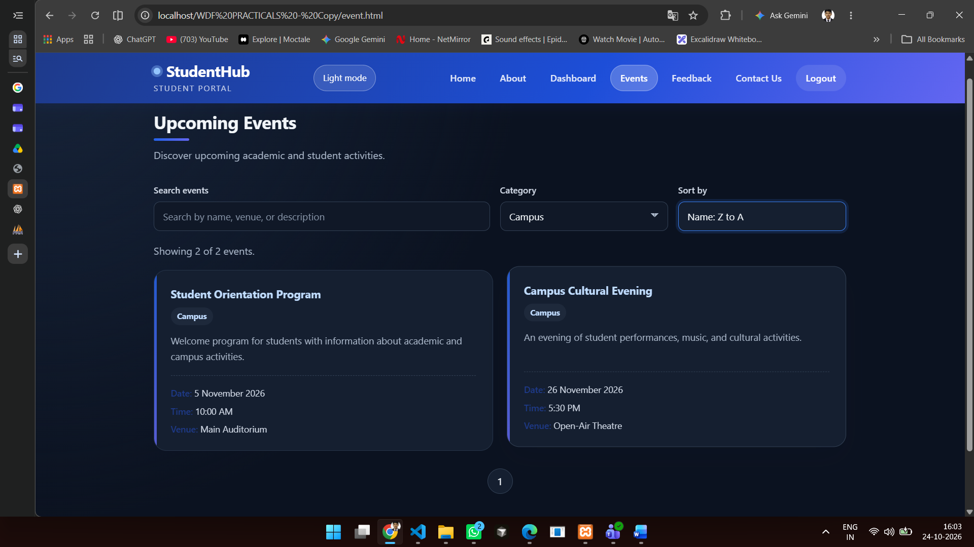
FILTER CATGORY AND SORT WISE
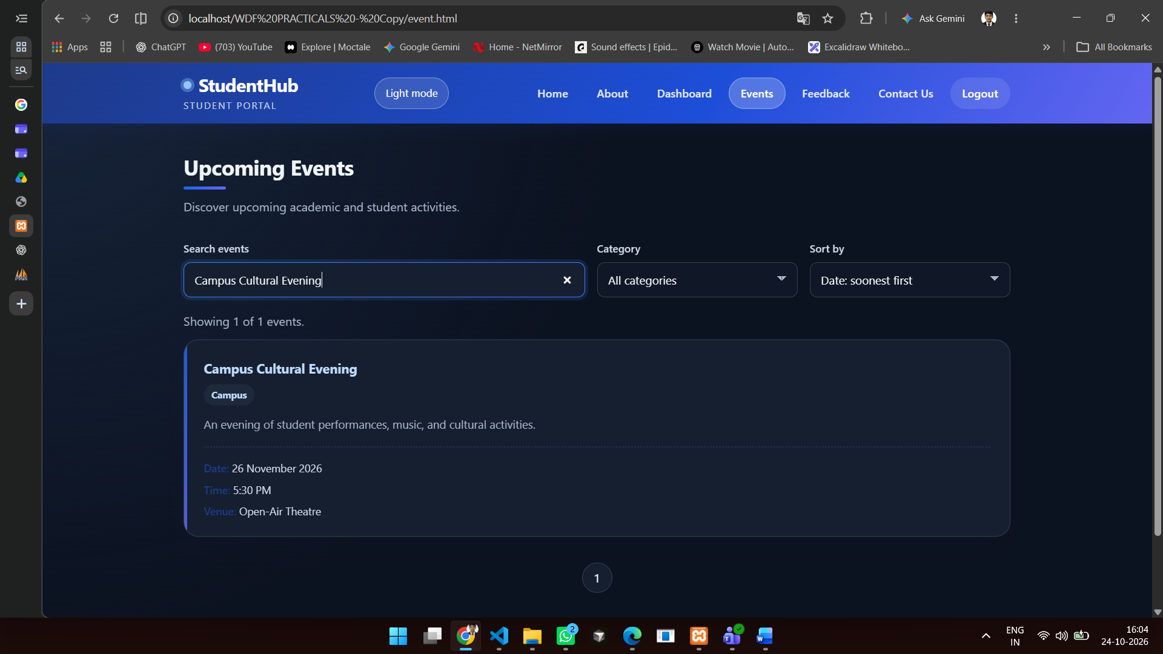
NAME WISE

