WDF PRACTICAL – 2

1. Problem Definition
Develop static HTML5 skeletons for the StudentHub student portal using semantic HTML5 elements and an accessibility-ready structure. The practical implements seven connected pages: Login, Register, Home, Profile, Events, Feedback, and Contact Us.
Login is the entry page. A new user can move to Register, return to Login after registration, and then continue to Home. Portal pages use a consistent header, navigation, main content, and footer.

2. Key Questions / Analysis / Interpretation

Q1. Are semantic tags such as header, nav, main, section, article, aside, and footer used properly?
Yes. Semantic tags describe the purpose of webpage regions. <header> contains portal identity, <nav> contains navigation, <main> contains unique page content, <section> groups related content, <article> represents individual content items such as events, <aside> can contain supplementary information, and <footer> contains footer information.

Q2. Are form labels, headings, image alt text, and navigation links accessible?
Yes. Form controls use explicit labels, headings provide a logical hierarchy, images use descriptive alt text, and navigation links use meaningful names. Required fields and suitable HTML input types are also used.

Q3. Is the page structure consistent across all pages?
Yes. Authenticated portal pages follow the same general structure: header, navigation, main content, and footer. Login and Register remain simple entry/authentication pages.

3. Key Skills Addressed
- HTML5 semantic elements
- Accessibility basics
- Form labels and input types
- Page linking and navigation
- Content hierarchy
- Consistent page structure

4. Applications
Static website foundations and accessible UI design.

5. Learning Outcome
Students will be able to create clean, linked, semantic, and accessibility-ready HTML5 page structures.

6. Tools / Technology Used
VS Code, HTML5, and a web browser.

7. Source Code
The following is the static HTML5 source used for the StudentHub practical. No CSS or JavaScript is required.

login.html
<!DOCTYPE html>
<html lang="en">
<head>
<meta charset="UTF-8">
<meta name="viewport" content="width=device-width, initial-scale=1.0">
<title>StudentHub | Login</title>
</head>
<body>
<header><h1>StudentHub</h1></header>
<main>
<section aria-labelledby="login-heading">
<h2 id="login-heading">Student Portal Login</h2>
<form action="index.html" method="get">
<p><label for="email">Email Address</label>
<input type="email" id="email" name="email" required></p>
<p><label for="password">Password</label>
<input type="password" id="password" name="password" required></p>
<button type="submit">Login</button>
</form>
<p>Don't have an account? <a href="register.html">Create an account</a></p>
</section>
</main>
</body>
</html>

register.html
<!DOCTYPE html>
<html lang="en">
<head>
<meta charset="UTF-8">
<meta name="viewport" content="width=device-width, initial-scale=1.0">
<title>StudentHub | Register</title>
</head>
<body>
<header><h1>StudentHub</h1></header>
<main>
<section aria-labelledby="register-heading">
<h2 id="register-heading">Create Your Student Account</h2>
<form action="login.html" method="get">
<p><label for="full-name">Full Name</label>
<input type="text" id="full-name" name="full-name" required></p>
<p><label for="student-id">Student ID</label>
<input type="text" id="student-id" name="student-id" required></p>
<p><label for="register-email">Email Address</label>
<input type="email" id="register-email" name="email" required></p>
<p><label for="course">Course</label>
<input type="text" id="course" name="course" required></p>
<p><label for="semester">Semester</label>
<select id="semester" name="semester" required>
<option value="">Select Semester</option>
<option>Semester 1</option><option>Semester 2</option>
<option>Semester 3</option><option>Semester 4</option>
<option>Semester 5</option><option>Semester 6</option>
<option>Semester 7</option><option>Semester 8</option>
</select></p>
<p><label for="register-password">Password</label>
<input type="password" id="register-password" name="password" required></p>
<p><label for="confirm-password">Confirm Password</label>
<input type="password" id="confirm-password" name="confirm-password" required></p>
<button type="submit">Create Account</button>
</form>
<p>Already have an account? <a href="login.html">Back to Login</a></p>
</section>
</main>
</body>
</html>

index.html
<!DOCTYPE html>
<html lang="en">
<head>
<meta charset="UTF-8">
<meta name="viewport" content="width=device-width, initial-scale=1.0">
<title>StudentHub | Home</title>
</head>
<body>
<header>
<h1>StudentHub</h1><p>Student Portal</p>
<nav aria-label="Main navigation">
<ul>
<li><a href="index.html">Home</a></li>
<li><a href="profile.html">Profile</a></li>
<li><a href="event.html">Events</a></li>
<li><a href="feedback.html">Feedback</a></li>
<li><a href="contact.html">Contact Us</a></li>
<li><a href="login.html">Logout</a></li>
</ul>
</nav>
</header>
<main id="main-content">
<section aria-labelledby="welcome-heading">
<h2 id="welcome-heading">Welcome to StudentHub</h2>
<p>Your centralized student portal for managing your profile, viewing events,
submitting feedback, and accessing student services.</p>
</section>
<section aria-labelledby="quick-access-heading">
<h2 id="quick-access-heading">Quick Access</h2>
<article><h3>My Profile</h3><p>View and update your student information.</p>
<a href="profile.html">Open Profile</a></article>
<article><h3>Events</h3><p>View upcoming student events and activities.</p>
<a href="event.html">View Events</a></article>
<article><h3>Feedback</h3><p>Share your experience and suggestions.</p>
<a href="feedback.html">Give Feedback</a></article>
</section>
</main>
<footer><p>&copy; 2026 StudentHub. All rights reserved.</p>
<a href="contact.html">Contact Us</a> | <a href="feedback.html">Feedback</a></footer>
</body>
</html>

profile.html
<!DOCTYPE html>
<html lang="en">
<head>
<meta charset="UTF-8">
<meta name="viewport" content="width=device-width, initial-scale=1.0">
<title>StudentHub | Profile</title>
</head>
<body>
<header>
<h1>StudentHub</h1><p>Student Portal</p>
<nav aria-label="Main navigation">
<ul>
<li><a href="index.html">Home</a></li>
<li><a href="profile.html">Profile</a></li>
<li><a href="event.html">Events</a></li>
<li><a href="feedback.html">Feedback</a></li>
<li><a href="contact.html">Contact Us</a></li>
<li><a href="login.html">Logout</a></li>
</ul>
</nav>
</header>
<main>
<section aria-labelledby="profile-heading">
<h2 id="profile-heading">Student Profile</h2>
<article>
<h3>Student Profile Photo</h3>
<img src="images/profile-placeholder.png" alt="Student profile photo placeholder" width="160" height="160">
</article>
<article>
<h3>Profile Information</h3>
<dl>
<dt>Full Name</dt><dd>Student Name</dd>
<dt>Student ID</dt><dd>STU0001</dd>
<dt>Email</dt><dd>student@example.com</dd>
<dt>Course</dt><dd>Computer Science</dd>
<dt>Semester</dt><dd>Semester 5</dd>
</dl>
</article>
</section>
<section aria-labelledby="update-heading">
<h2 id="update-heading">Update Profile</h2>
<form action="profile.html" method="get">
<p><label for="profile-name">Full Name</label>
<input type="text" id="profile-name" name="full-name" value="Student Name"></p>
<p><label for="profile-email">Email Address</label>
<input type="email" id="profile-email" name="email" value="student@example.com"></p>
<p><label for="profile-course">Course</label>
<input type="text" id="profile-course" name="course" value="Computer Science"></p>
<p><label for="profile-semester">Semester</label>
<select id="profile-semester" name="semester">
<option>Semester 1</option><option>Semester 2</option><option>Semester 3</option>
<option>Semester 4</option><option selected>Semester 5</option>
<option>Semester 6</option><option>Semester 7</option><option>Semester 8</option>
</select></p>
<button type="submit">Update Profile</button>
</form>
</section>
</main>
<footer><p>&copy; 2026 StudentHub. All rights reserved.</p>
<a href="contact.html">Contact Us</a> | <a href="feedback.html">Feedback</a></footer>
</body>
</html>

event.html
<!DOCTYPE html>
<html lang="en">
<head>
<meta charset="UTF-8">
<meta name="viewport" content="width=device-width, initial-scale=1.0">
<title>StudentHub | Events</title>
</head>
<body>
<header><h1>StudentHub</h1><p>Student Portal</p><nav aria-label="Main navigation">
<ul>
<li><a href="index.html">Home</a></li>
<li><a href="profile.html">Profile</a></li>
<li><a href="event.html">Events</a></li>
<li><a href="feedback.html">Feedback</a></li>
<li><a href="contact.html">Contact Us</a></li>
<li><a href="login.html">Logout</a></li>
</ul>
</nav></header>
<main>
<section aria-labelledby="events-heading">
<h2 id="events-heading">Upcoming Events</h2>
<article><h3>Student Orientation Program</h3>
<p>Welcome program for students with information about academic and campus activities.</p>
<dl><dt>Date</dt><dd>25 August 2026</dd><dt>Time</dt><dd>10:00 AM</dd>
<dt>Venue</dt><dd>Main Auditorium</dd></dl>
<a href="#">View Event Details</a></article>
<article><h3>Web Development Workshop</h3>
<p>A workshop focused on modern web development concepts and practical implementation.</p>
<dl><dt>Date</dt><dd>5 September 2026</dd><dt>Time</dt><dd>11:00 AM</dd>
<dt>Venue</dt><dd>Computer Laboratory</dd></dl>
<a href="#">View Event Details</a></article>
<article><h3>Student Technology Seminar</h3>
<p>A seminar covering emerging technologies and career opportunities for students.</p>
<dl><dt>Date</dt><dd>15 September 2026</dd><dt>Time</dt><dd>2:00 PM</dd>
<dt>Venue</dt><dd>Seminar Hall</dd></dl>
<a href="#">View Event Details</a></article>
</section>
</main>
<footer><p>&copy; 2026 StudentHub. All rights reserved.</p>
<a href="contact.html">Contact Us</a> | <a href="feedback.html">Feedback</a></footer>
</body>
</html>

feedback.html
<!DOCTYPE html>
<html lang="en">
<head>
<meta charset="UTF-8">
<meta name="viewport" content="width=device-width, initial-scale=1.0">
<title>StudentHub | Feedback</title>
</head>
<body>
<header><h1>StudentHub</h1><p>Student Portal</p><nav aria-label="Main navigation">
<ul>
<li><a href="index.html">Home</a></li>
<li><a href="profile.html">Profile</a></li>
<li><a href="event.html">Events</a></li>
<li><a href="feedback.html">Feedback</a></li>
<li><a href="contact.html">Contact Us</a></li>
<li><a href="login.html">Logout</a></li>
</ul>
</nav></header>
<main>
<section aria-labelledby="feedback-heading">
<h2 id="feedback-heading">Student Feedback</h2>
<p>Your feedback helps us improve the StudentHub portal.</p>
<form action="#" method="post">
<p><label for="feedback-name">Name</label>
<input type="text" id="feedback-name" name="name" required></p>
<fieldset><legend>Rating</legend>
<label><input type="radio" name="rating" value="1" required> 1 - Poor</label><br>
<label><input type="radio" name="rating" value="2"> 2 - Fair</label><br>
<label><input type="radio" name="rating" value="3"> 3 - Good</label><br>
<label><input type="radio" name="rating" value="4"> 4 - Very Good</label><br>
<label><input type="radio" name="rating" value="5"> 5 - Excellent</label>
</fieldset>
<p><label for="feedback-message">Your Feedback</label><br>
<textarea id="feedback-message" name="feedback" rows="7" cols="60" required></textarea></p>
<button type="submit">Submit Feedback</button>
</form>
</section>
</main>
<footer><p>&copy; 2026 StudentHub. All rights reserved.</p>
<a href="contact.html">Contact Us</a> | <a href="feedback.html">Feedback</a></footer>
</body>
</html>

contact.html
<!DOCTYPE html>
<html lang="en">
<head>
<meta charset="UTF-8">
<meta name="viewport" content="width=device-width, initial-scale=1.0">
<title>StudentHub | Contact Us</title>
</head>
<body>
<header><h1>StudentHub</h1><p>Student Portal</p><nav aria-label="Main navigation">
<ul>
<li><a href="index.html">Home</a></li>
<li><a href="profile.html">Profile</a></li>
<li><a href="event.html">Events</a></li>
<li><a href="feedback.html">Feedback</a></li>
<li><a href="contact.html">Contact Us</a></li>
<li><a href="login.html">Logout</a></li>
</ul>
</nav></header>
<main>
<section aria-labelledby="contact-heading">
<h2 id="contact-heading">Contact Us</h2>
<p>Contact the StudentHub support team for assistance, questions, or enquiries.</p>
</section>
<section aria-labelledby="contact-info-heading">
<h2 id="contact-info-heading">Contact Information</h2>
<address>
<p><strong>Email:</strong> <a href="mailto:support@studenthub.example">support@studenthub.example</a></p>
<p><strong>Phone:</strong> <a href="tel:+911234567890">+91 12345 67890</a></p>
<p><strong>Address:</strong> StudentHub Support Centre, University Campus</p>
</address>
</section>
<section aria-labelledby="enquiry-heading">
<h2 id="enquiry-heading">Send an Enquiry</h2>
<form action="#" method="post">
<p><label for="contact-name">Full Name</label>
<input type="text" id="contact-name" name="name" required></p>
<p><label for="contact-email">Email Address</label>
<input type="email" id="contact-email" name="email" required></p>
<p><label for="contact-subject">Subject</label>
<input type="text" id="contact-subject" name="subject" required></p>
<p><label for="contact-message">Message</label><br>
<textarea id="contact-message" name="message" rows="8" cols="60" required></textarea></p>
<button type="submit">Send Message</button>
</form>
</section>
</main>
<footer><p>&copy; 2026 StudentHub. All rights reserved.</p>
<a href="contact.html">Contact Us</a> | <a href="feedback.html">Feedback</a></footer>
</body>
</html>

8. Accessibility Checklist
- Semantic elements such as header, nav, main, section, article and footer are used.
- Form fields have explicit labels connected through for/id attributes.
- Headings follow a logical hierarchy.
- Images include descriptive alt text.
- Navigation links use clear and meaningful names.
- Navigation landmarks use aria-label where useful.
- Required fields use the required attribute.
- Appropriate input types such as email and password are used.
- The general structure remains consistent across portal pages.

9. Page Linking / Navigation Flow
Login → Register → Login → Home → Profile / Events / Feedback / Contact Us. The portal navigation connects the main pages, while Logout returns to Login.

10. Static Page Screenshots
Insert the browser screenshots of the seven implemented pages below. These are the same pages used for the practical demonstration.
LOGIN
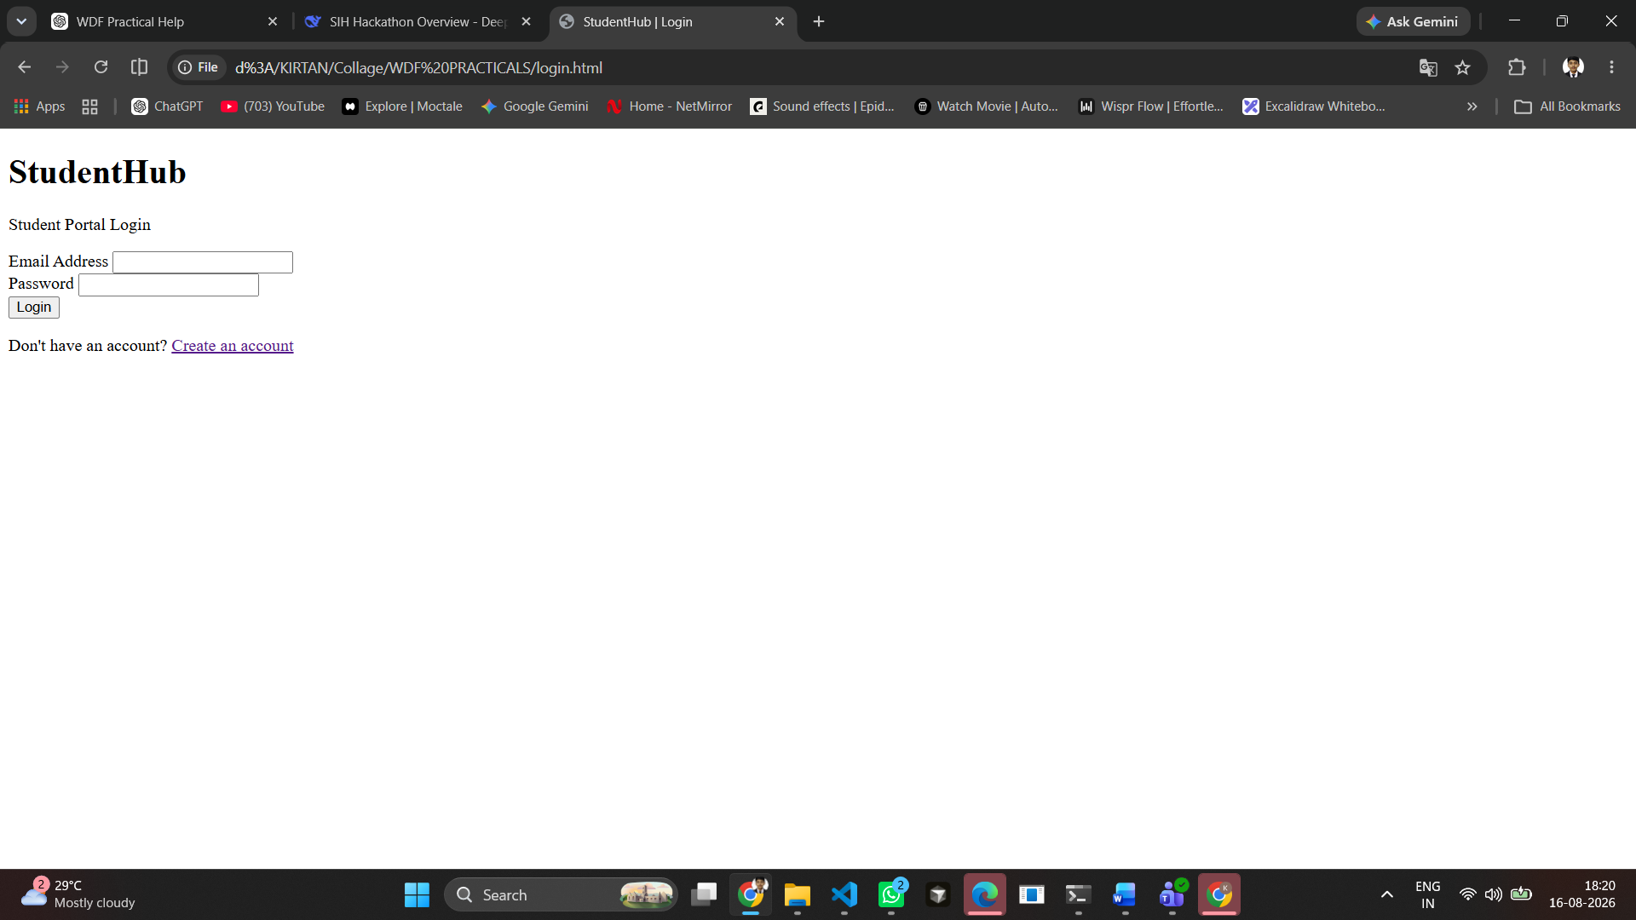

REGISTER
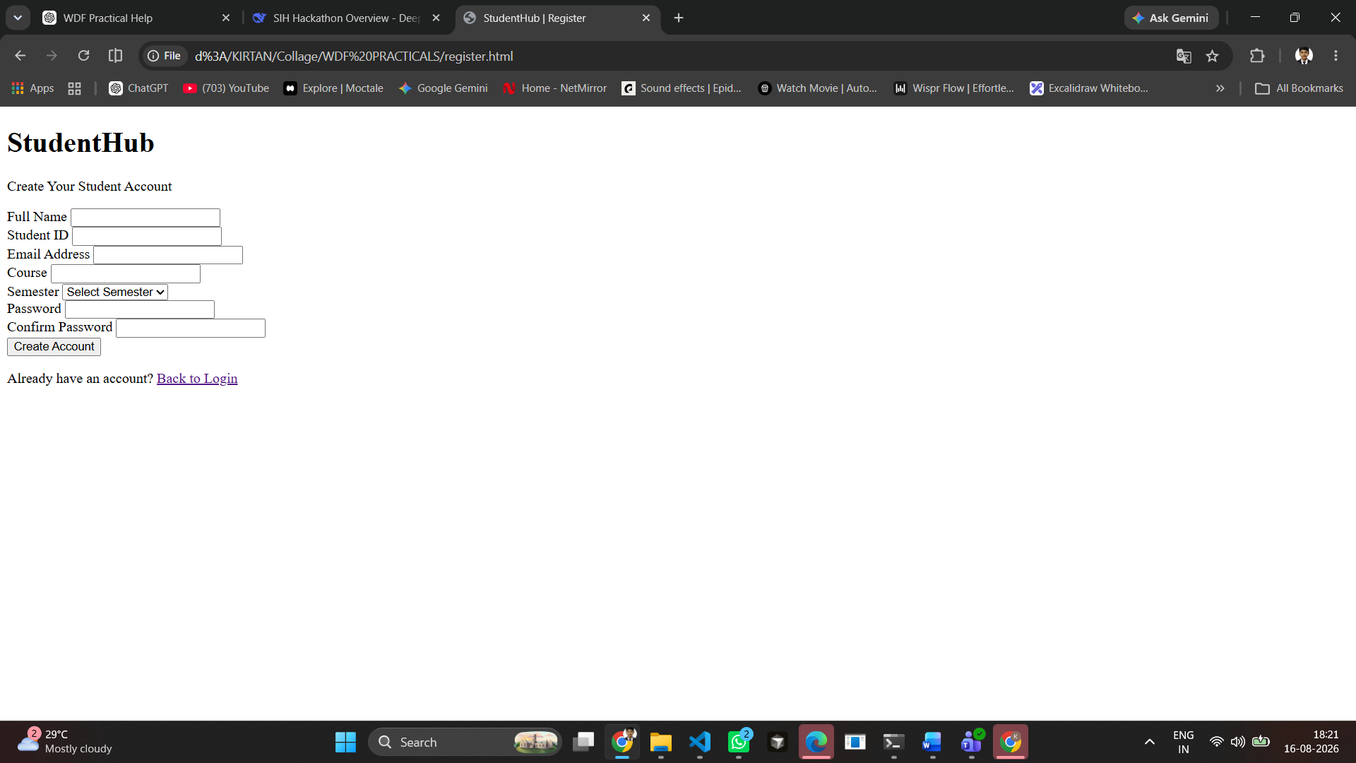
HOME
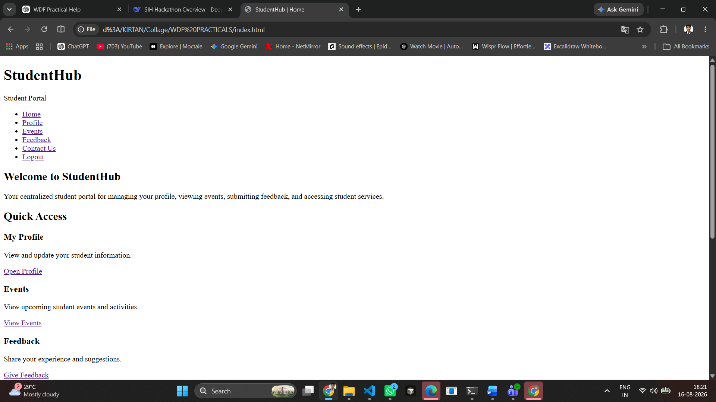

PROFILE
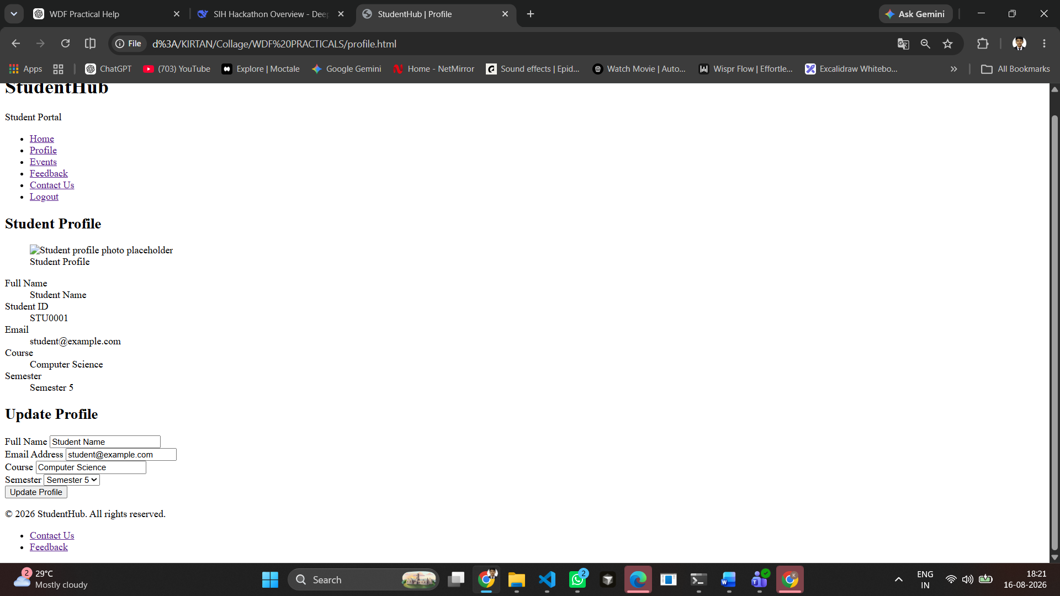
EVENTS
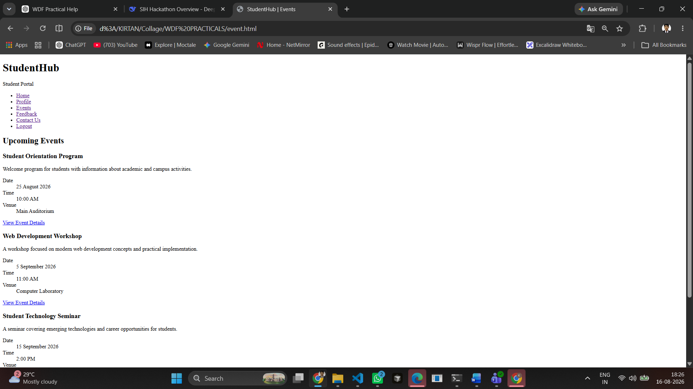

FEEDBACK
CONTACT US
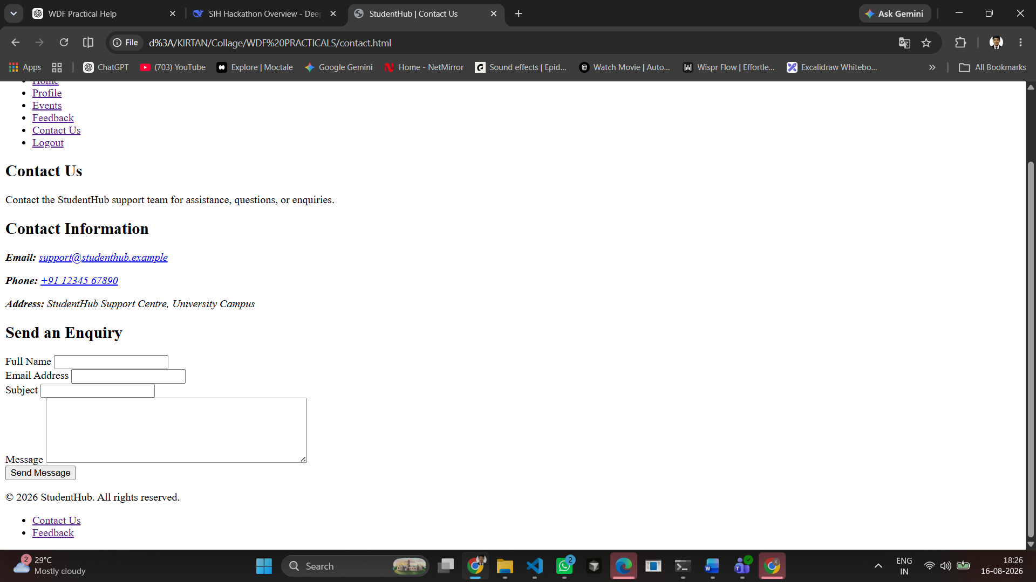

11. Conclusion
The StudentHub static pages were developed using HTML5 semantic elements, accessible form structures, meaningful navigation links, and a consistent page hierarchy. The seven pages are connected and provide the required static website foundation.

