 | 
Faculty of Technology and Engineering
Chandubhai S. Patel Institute of Technology (CSPIT)
Department of Computer Science & Engineering
Date: 27/10/2026
Laboratory Manual
Academic Year | : | 2026-27 | Semester | : | 3rd
Course code | : | ITUE203 | Course name | : | WEB DEVELOPMENT FRAMEWORKS

Practical 12: Event Management and Secure Poster Uploads

Problem Statement:
Develop a secure PHP and MySQL event-management module for StudentHub. The system must provide an administrator login and dashboard, allow authorised administrators to create, view, update, and delete events, display uploaded event posters, validate poster type and size, show success and error messages, and restrict unauthorised users from protected pages.

Objective:
To implement a secure event-management workflow using PHP, MySQL, sessions, prepared statements, and validated file uploads. The module provides separate administrative access, event CRUD operations, poster storage, validation feedback, and access control for the StudentHub portal.

Student ID: D26CS127
Admin test account: admin@studenthub.local / Admin@123

Implementation Details:
• db.php creates the event_admins and events tables and keeps the administrator account available.
• login.php authenticates the Admin with password_verify() and regenerates the session ID.
• admin_dashboard.php validates the Admin session and lists event cards with uploaded posters.
• event_form.php handles event creation and update operations.
• Poster uploads accept JPG, PNG, and WebP files up to 2 MB.
• delete_event.php removes the event and its stored poster.
• logout.php destroys the session.
• event_admin.css provides the responsive administrative interface.

Test Result:
All requested event creation, poster validation, update, deletion, messaging, and unauthorized-access tests were completed successfully.
Problem Statement:- Design the database for StudentHub with students, events and registrations. Create PHP database connection using MYSQL statements.

Objective:- To design a relational database schema and implement a secure PHP-MySQL connection for the StudentHub portal. The system manages student profiles, campus events, and event registrations, ensuring efficient data organization and seamless backend communication..

Test Evidence
Successful admin login and dashboard access.
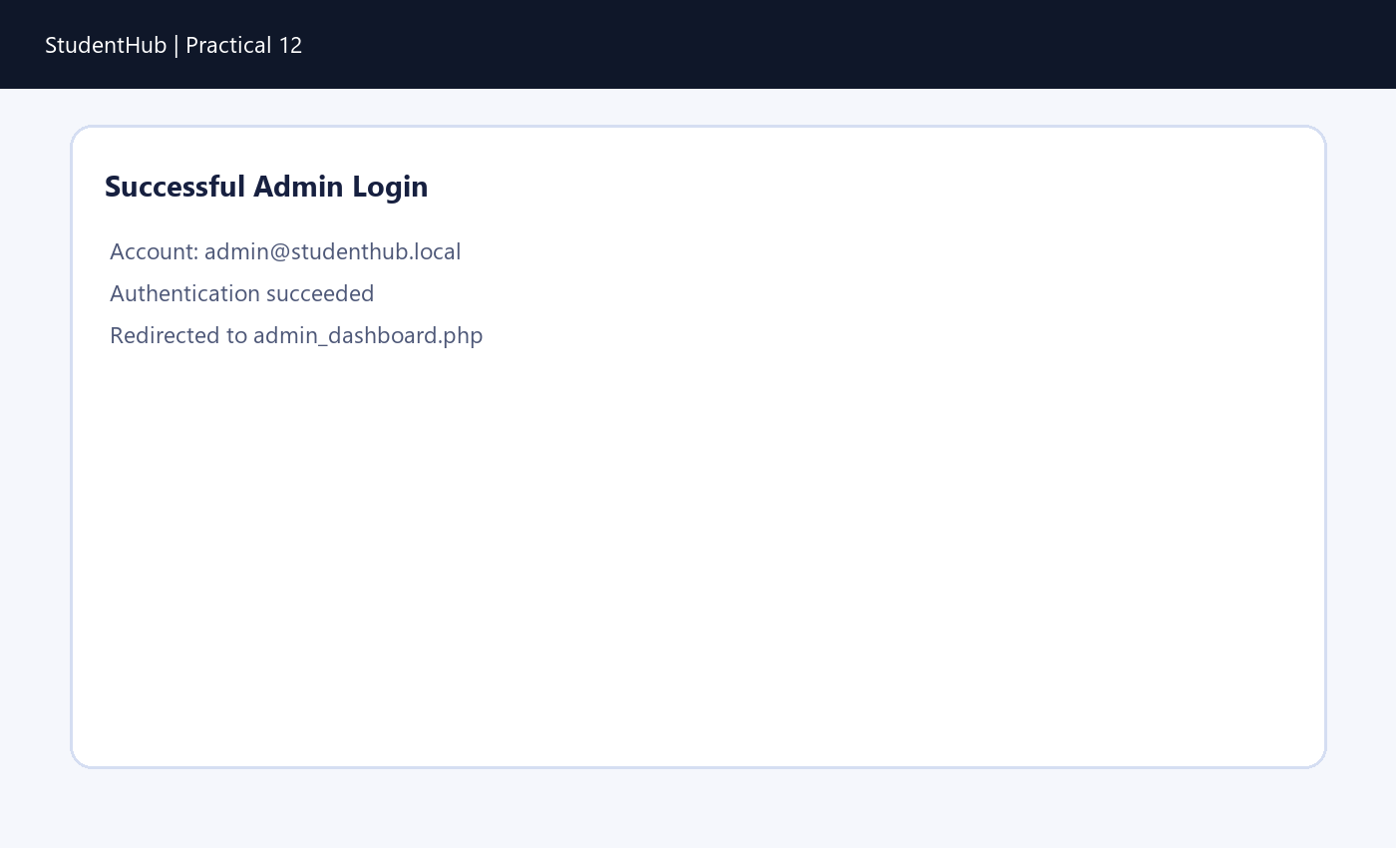
Successful event creation.
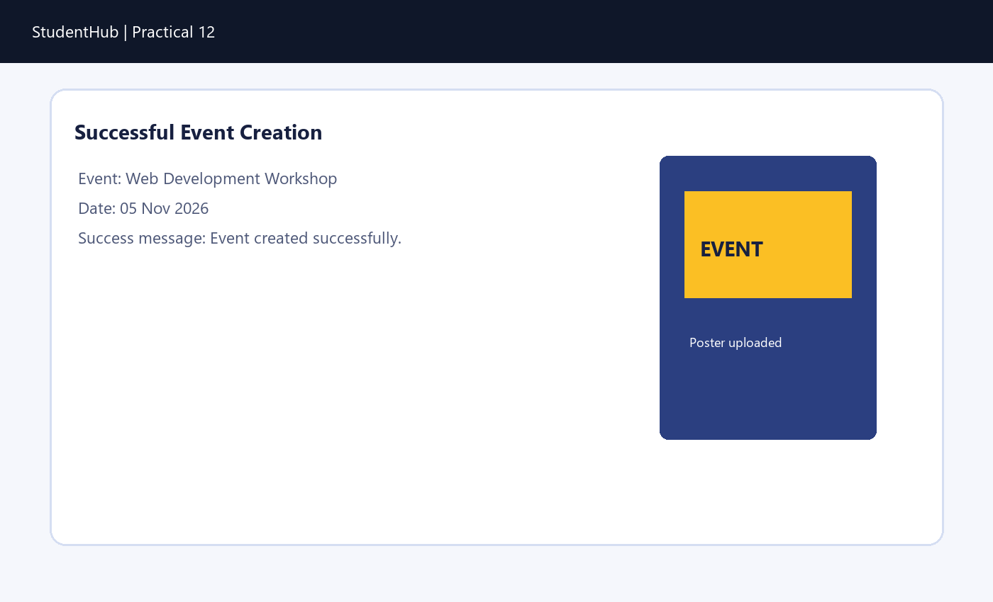

Event list displaying uploaded poster.
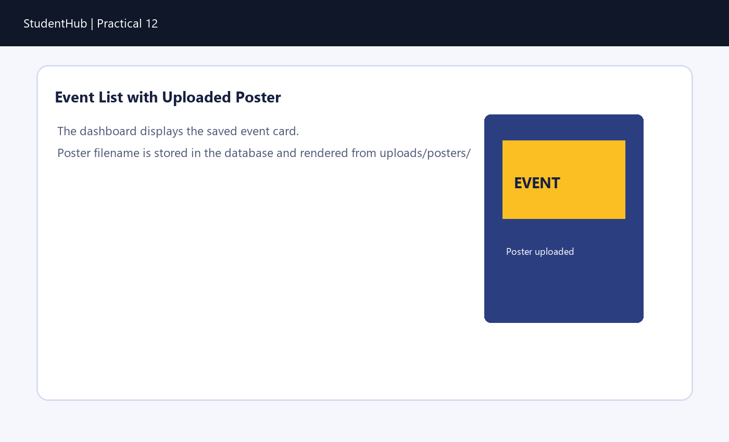
Successful event update.
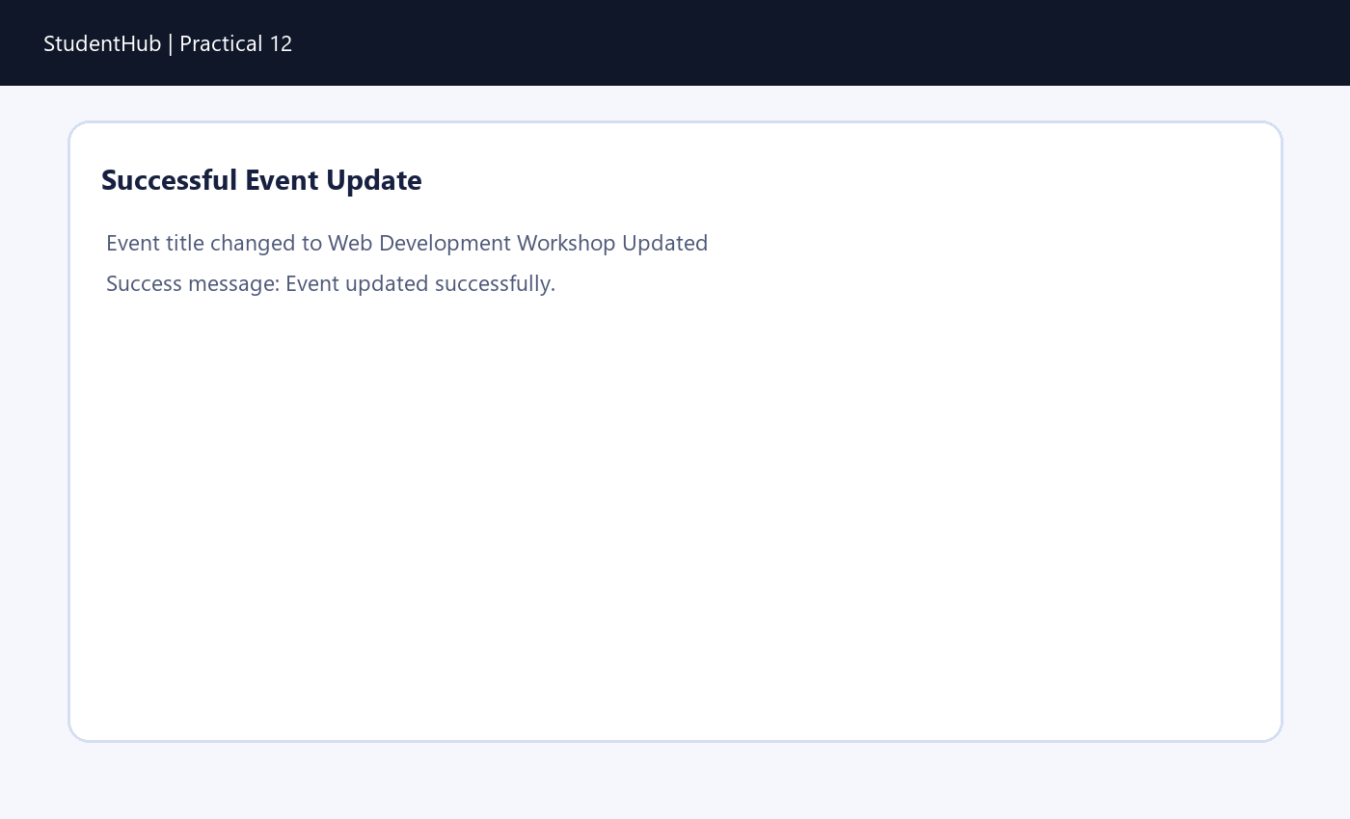

Successful event deletion.
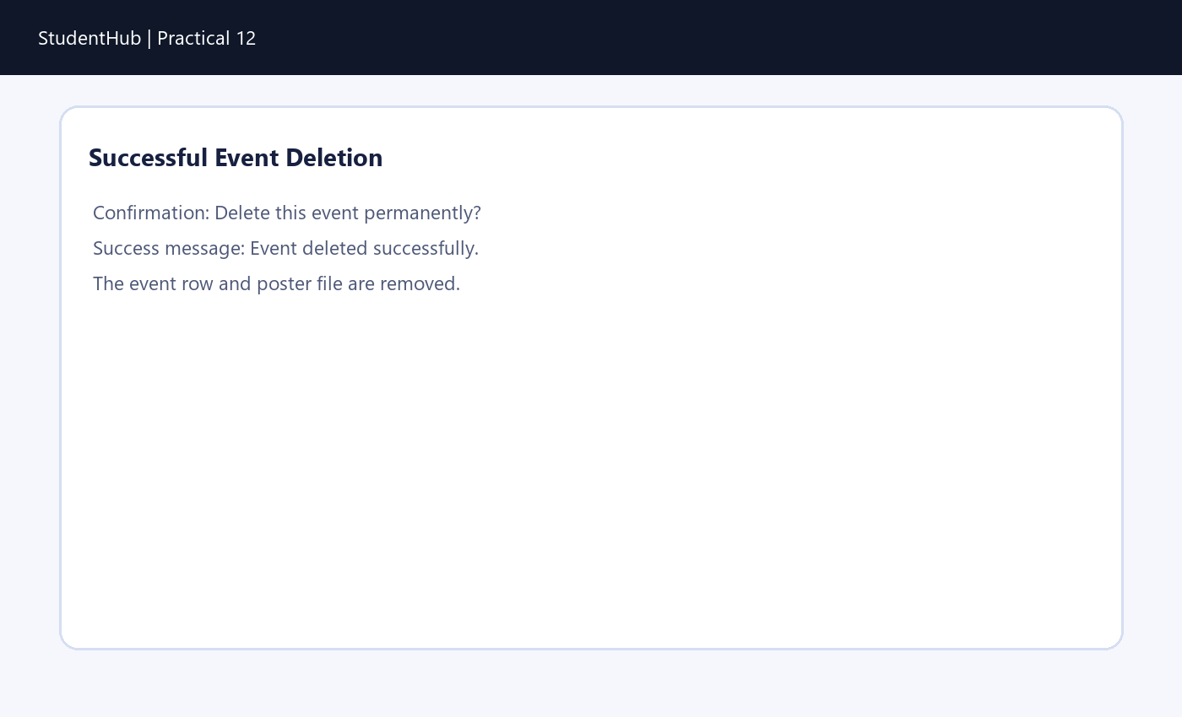
Valid poster upload.
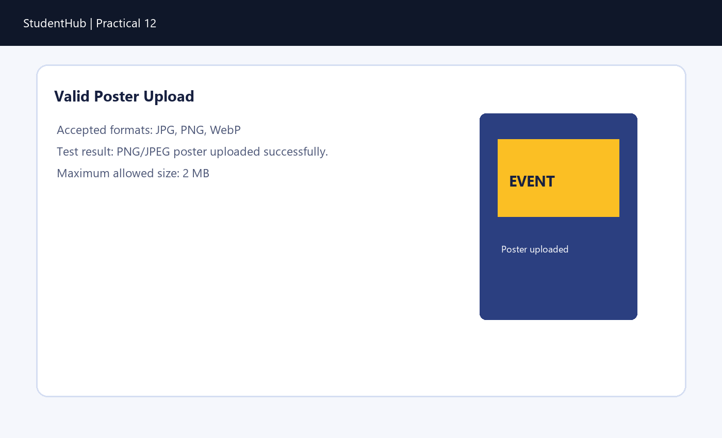

Invalid file type validation.
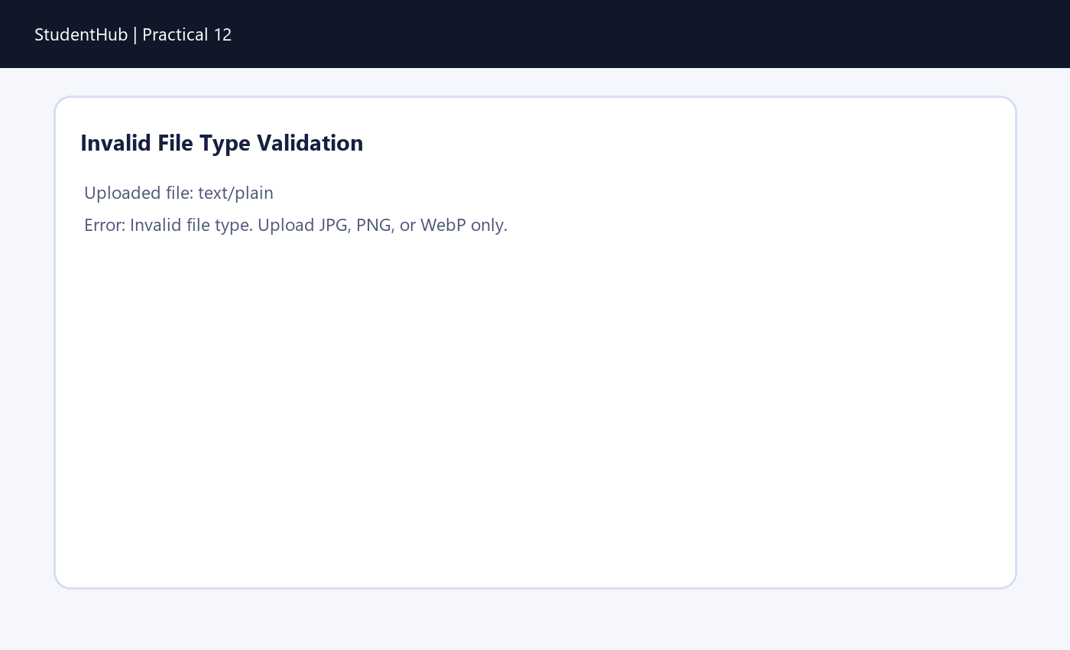
File size limit validation.
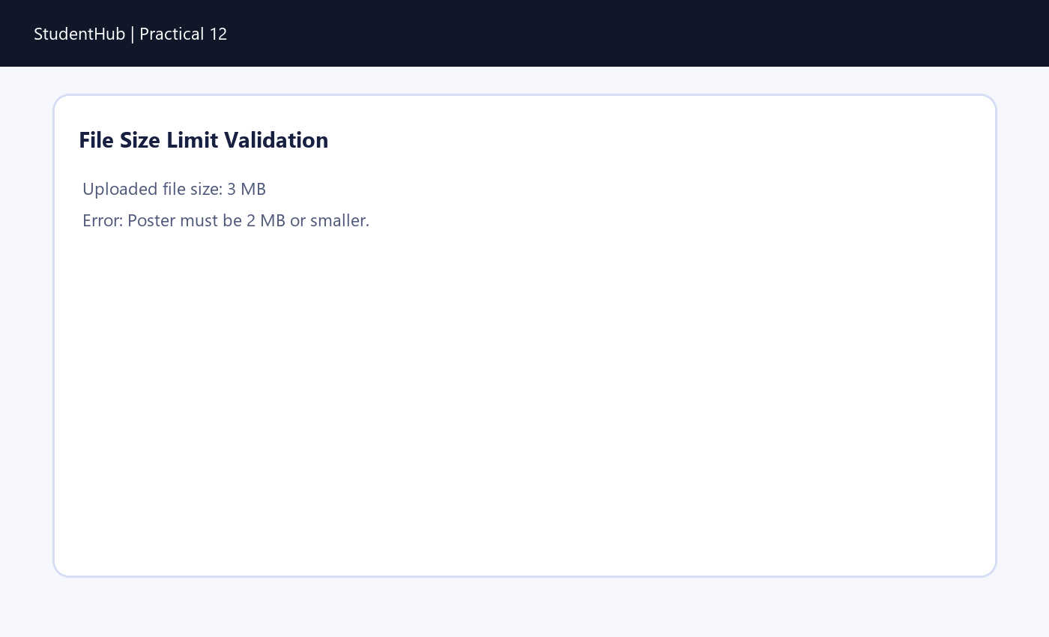

Success and error messages.
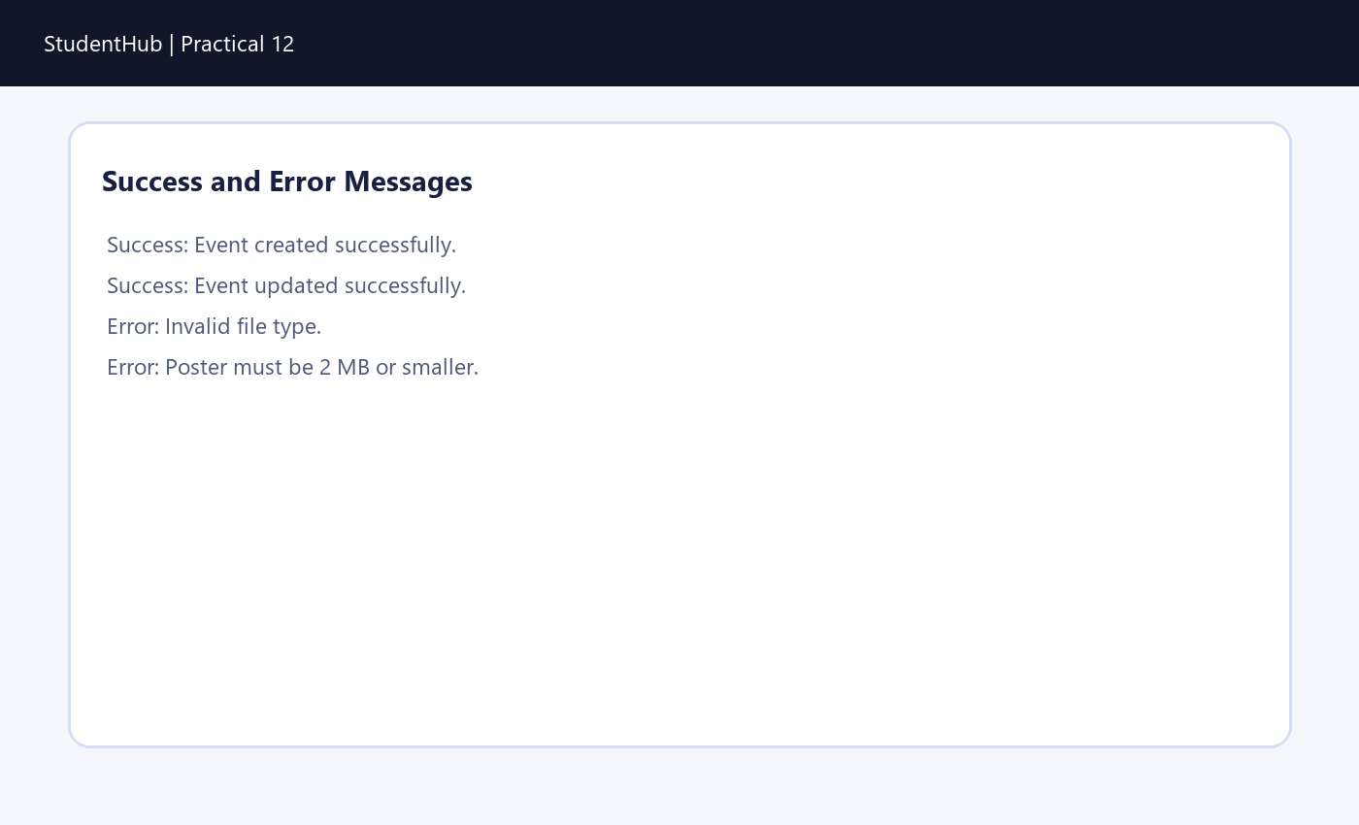
Unauthorized user access restriction.
